**SMOKIN' ACES**

**Coffee Shop**

**Shubham Vyas**

**Satya Chippada**

**Milestone no. 2**

**Due date: Feb 23, 2015**

1. **Progress Since Last Milestone:**

Created a new ASP.NET website for the project in Visual Studio 2012

* With a professional looking interface for the application ( chosen from the templates in freewebsitetemplates.com)
* Created one master page for use in the web application
* Created some .aspx pages to fulfill some of the functionality as described in the project milstone-1 ---> menu, locations

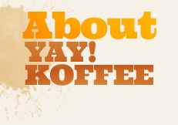 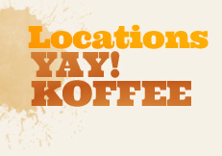  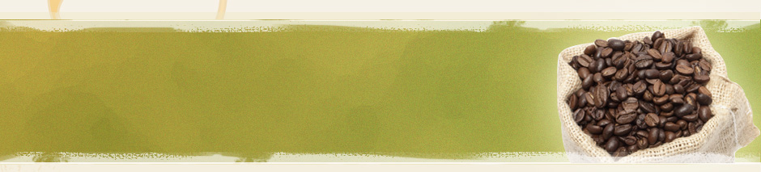

* Some pages created with no dynamic content, but just to show the functionality to be added in later milestones
* In the later milestones we are will be adding pages to place the order(dine in or take away), to show the order totals, then the payment information page and so on

1. **Problems Encountered/Questions**

No specific problems as such, but we realized that we need a more elaborate design and functional specifications of the website so that we know exactly how many pages to create.