UNIT-I

CHAPTER – 3

Operating System Structures: Operating-System Services, User and Operating-System Interface, System Calls, Operating-System Structure, Types of OS.

Operating System Services
- An Operating System provides services to both the users and the programs.
- It provides programs an environment to execute.
- It provides users the services to execute the programs in a convenient manner.

Following are a few common services provided by an operating system.
- Program execution
- I/O operations
- File System manipulation
- Communication
- Error Detection
- Resource Allocation
- Protection

- Program execution :
- Operating systems handle many kinds of activities from user programs to system programs like printer spooler, name servers, file server, etc. Each of these activities is encapsulated as a process.
- A process includes the complete execution context (code to execute, data to manipulate, registers, OS resources in use).
The major activities of an operating system with respect to program management:
- Loads a program into memory.
- Executes the program.
- Handles program's execution.
- Provides a mechanism for process synchronization.
- Provides a mechanism for process communication.
- Provides a mechanism for deadlock handling.

- I/O Operation:
- An I/O subsystem comprises of I/O devices and their corresponding driver software.
- Drivers hide the peculiarities of specific hardware devices from the users.
- An Operating System manages the communication between user and device drivers.
- I/O operation means read or write operation with any file or any specific I/O device.
- Operating system provides the access to the required I/O device when required.

(c ) File system manipulation:
- A file represents a collection of related information. Computers can store files on the disk (secondary storage), for long-term storage purpose. Examples of storage media include magnetic tape, magnetic disk and optical disk drives like CD, DVD. Each of these media has its own properties like speed, capacity, data transfer rate and data access methods.
- A file system is normally organized into directories for easy navigation and usage. These directories may contain files and other directions.
- The major activities of an operating system with respect to file management:
- Program needs to read a file or write a file.
- The operating system gives the permission to the program for operation on file.
- Permission varies from read-only, read-write, denied and so on.
- Operating System provides an interface to the user to create/delete files.
- Operating System provides an interface to the user to create/delete directories.
- Operating System provides an interface to create the backup of file system.

- Communication:
- In case of distributed systems which are a collection of processors that do not share memory, peripheral devices, or a clock, the operating system manages communications between all the processes. Multiple processes communicate with one another through communication lines in the network.
- The OS handles routing and connection strategies, and the problems of contention and security.
- The major activities of an operating system with respect to communication :
- Two processes often require data to be transferred between them.
- Both the processes can be on one computer or on different computers, but are connected through a computer network.
- Communication may be implemented by two methods, either by Shared Memory or by Message Passing.

- Error handling
- Errors can occur anytime and anywhere. An error may occur in CPU, in I/O devices or in the memory hardware.
- The major activities of an operating system with respect to error handling :
- The OS constantly checks for possible errors.
- The OS takes an appropriate action to ensure correct and consistent computing.

- Resource Management
- In case of multi-user or multi-tasking environment, resources such as main memory, CPU cycles and files storage are to be allocated to each user or job.
- The major activities of an operating system with respect to resource management :
- The OS manages all kinds of resources using schedulers.
- CPU scheduling algorithms are used for better utilization of CPU.

- Protection:
- Considering a computer system having multiple users and concurrent execution of multiple processes, the various processes must be protected from each other's activities.
- Protection refers to a mechanism or a way to control the access of programs, processes, or users to the resources defined by a computer system.
- The major activities of an operating system with respect to protection –
- The OS ensures that all access to system resources is controlled.
- The OS ensures that external I/O devices are protected from invalid access attempts.
- The OS provides authentication features for each user by means of passwords.

Operating System Calls

System Call:
- A system call is a method for a computer program to request a service from the kernel of the operating system on which it is running.
- A system call is a method of interacting with the operating system via programs.
- A system call is a request from computer software to an operating system's kernel.
- System calls can be grouped roughly into six major categories: process control, file manipulation, device manipulation, information maintenance, communications, and protection.

- Process control
◦ end, abort
◦ load, execute
◦ create process, terminate process
◦ get process attributes, set process attributes
◦ wait for time
◦ wait event, signal event
◦ allocate and free memory

- File management
◦ create file, delete file
◦ open, close
◦ read, write, reposition
◦ get file attributes, set file attributes

- Device management
◦ request device, release device
◦ read, write, reposition
◦ get device attributes, set device attributes
◦ logically attach or detach devices

- Information maintenance
◦ get time or date, set time or date
◦ get system data, set system data
◦ get process, file, or device attributes
◦ set process, file, or device attributes

- Communications
◦ create, delete communication connection
◦ send, receive messages
◦ transfer status information
◦ attach or detach remote device
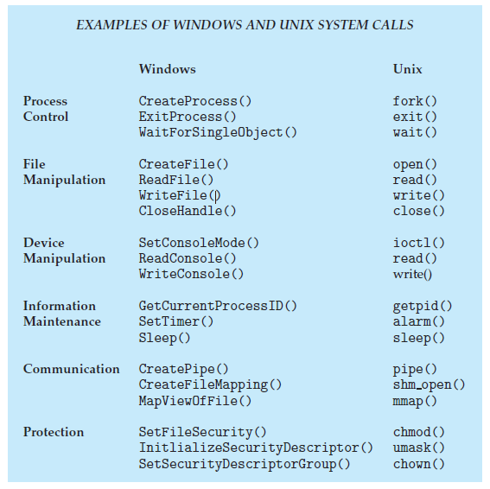

Operating-System Structure
- The general-purpose OS is very large program.Various ways to represent the operating system structure are:

  - Simple structure orMS-DOS:

Fig:MS DOS

- In MS-DOS, the interfaces and levels of functionality are not well separated.
- For instance, application programs are able to access the basic I/O routines to write directly to the display and disk drives.
- Such freedom leaves MS-DOS vulnerable to errant (or malicious) programs, causing entire system crashes when user programs fail.
- Of course, MS-DOS was also limited by the hardware of its era.
- Because the Intel 8088 for which it was written provides no dual mode and no hardware protection, the designers of MS-DOS had no choice but to leave the base hardware accessible.

  - More complex -- UNIX

Fig:Unix OS

- UNIX initially was limited by hardware functionality.
- It consists of two separable parts: the kernel and the system programs.
- The kernel is further separated into a series of interfaces and device drivers, which have been added and expanded over the years as UNIX has evolved.
- The kernel provides the file system, CPU scheduling, memory management, and other operating-system functions through system calls.
- Taken in sum, that is an enormous amount of functionality to be combined into one level. This monolithic structure was difficult to implement and maintain.
- It had a distinct performance advantage, however: there is very little overhead in the system call interface or in Communication within the kernel.

  - Layered – an abstraction

Fig:Layered OS

- The operating system is divided into a number of layers (levels), each built on top of lower layers.
- The bottom layer (layer 0), is the hardware; the highest (layer N) is the user interface.
- With modularity, layers are selected such that each uses functions (operations) and services of only lower-level layers

  - Microkernel -Mach

Fig:Micro Kernel

- The main function of the microkernel is to provide communication between the client program and the various services that are also running in user space.
- Communication is provided through message passing.
- An operating system called Mach that modularized the kernel using the microkernel approach.

  - Modules
Fig:Kernel Module

- The best current methodology for operating-system design involves using loadable kernel modules.
- Here, the kernel has a set of core components and links in additional services via modules, either at boot time or during run time.
- The Solaris operating system structure, shown in Fig is organized around a core kernel with seven types of loadable kernel modules:
  - Scheduling classes
  - File systems
  - Loadable system calls
  - Executable formats
  - STREAMS modules
  - Miscellaneous
  - Device and bus drivers

This type of design is common in modern implementations of UNIX, such as Solaris, Linux, and Mac OS X, as well as Windows.
  - Hybrid System

- Most modern operating systems are actually not one pure model Hybrid combines multiple approaches to address performance, security, usability needs.
- We explore the structure of three hybrid systems: the Apple Mac OS X operating system and the two most prominent mobile operating systems—iOS and Android.

  - Apple Mac OS X:

Fig: Mac OS X Structure

The Apple Mac OS X operating system uses a hybrid structure.
- The top layers include the Aqua user interface and a set of application environments and services.
- Notably, the Cocoa environment specifies an API for the Objective-C programming language, which is used for writing Mac OS X applications.
- Below these layers is the kernel environment, which consists primarily of the Mach micro kernel and the BSD UNIX kernel.
- Mach provides memory management; support for remote procedure calls (RPCs) and inter process communication (IPC) facilities, including message passing; and thread scheduling.
- The BSD component provides a BSD command-line interface, support for networking and file systems, and an implementation of POSIX APIs, including Pthreads.
- In addition to Mach and BSD, the kernel environment provides an I/O kit for development of device drivers and dynamically loadable modules (which Mac OS X refers to as kernel extensions).

  - iOS:

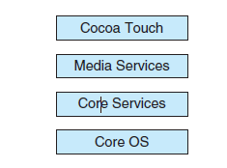
Figure: Architecture of Apple’s iOS.
- iOS is a mobile operating system designed by Apple to run its smartphone, the iPhone, as well as its tablet computer, the iPad.
- iOS is structured on the MacOS X operating system, with added functionality pertinent to mobile devices, but does not directly run Mac OS X applications.
- Cocoa Touch is an API for Objective-C that provides several frameworks for developing applications that run on iOS devices.
- The fundamental difference between Cocoa, mentioned earlier, and Cocoa Touch is that the latter provides support for hardware features unique to mobile devices, such as touch screens.
- The media services layer provides services for graphics, audio, and video.
- The core services layer provides a variety of features, including support for cloud computing and databases.
- The bottom layer represents the core operating system, which is based on the kernel environment shown in Figure.

  - Android

Figure:Architecture of Google’s Android.
- The Android operating system was designed by the Open Handset Alliance(led primarily by Google) and was developed for Android smartphones and tablet computers.
- Whereas iOS is designed to run on Apple mobile devices and is close-sourced, Android runs on a variety of mobile platforms and is open-sourced, partly explaining its rapid rise in popularity.
- Android is similar to iOS in that it is a layered stack of software that provides a rich set of frameworks for developing mobile applications.
- At the bottom of this software stack is the Linux kernel, although it has been modified by Google and is currently outside the normal distribution of Linux releases.
- Linux is used primarily for process, memory, and device-driver support for hardware and has been expanded to include power management.
- The Android runtime environment includes a core set of libraries as well as the Dalvik virtual machine.
- Software designers for Android devices develop applications in the Java language.
- However, rather than using the standard Java API, Google has designed a separate Android API for Java development.
- The Java class files are first compiled to Java bytecode and then translated into an executable file that runs on the Dalvik virtual machine.
- The Dalvik virtual machine was designed for Android and is optimized for mobile devices with limited memory and CPU processing capabilities.
- The set of libraries available for Android applications includes frame works for developing web browsers (webkit), database support (SQLite), and multimedia.
- The libc library is similar to the standard C library but is much smaller and has been designed for the slower CPUs that characterize mobile devices.

Types of Operating Systems
- Operating systems are there from the very first computer generation and they keep evolving with time.
- In this, we will discuss some of the important types of operating systems which are most commonly used.

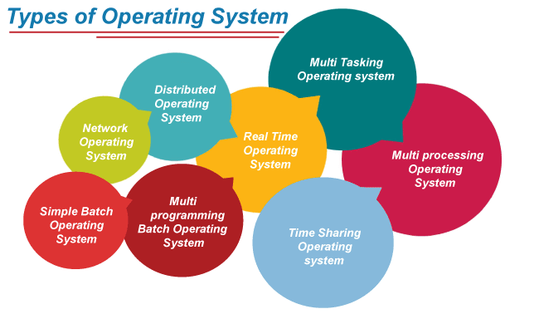

Batch Operating System
In the 1970s, Batch processing was very popular. In this technique, similar types of jobs were batched together and executed in time. People were used to having a single computer which was called a mainframe.
In Batch operating system, access is given to more than one person; they submit their respective jobs to the system for the execution.
The system put all of the jobs in a queue on the basis of first come first serve and then executes the jobs one by one. The users collect their respective output when all the jobs get executed.
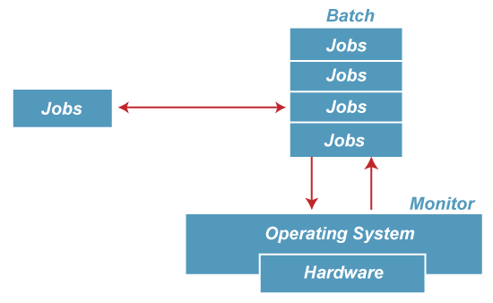

The purpose of this operating system was mainly to transfer control from one job to another as soon as the job was completed. It contained a small set of programs called the resident monitor that always resided in one part of the main memory. The remaining part is used for servicing jobs.
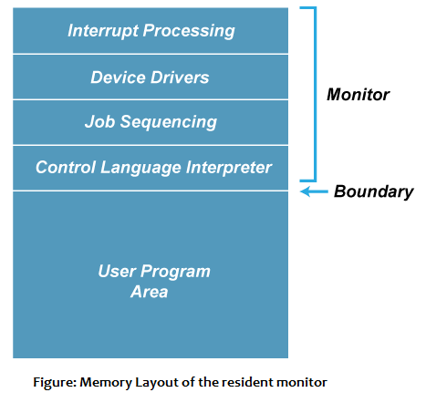

Advantages of Batch OS
- The use of a resident monitor improves computer efficiency as it eliminates CPU time between two jobs.

Disadvantages of Batch OS
1. Starvation
Starvation is the problem that occurs when high priority processes keep executing and low priority processes get blocked for indefinite time.
That is , Batch processing suffers from starvation.
For Example:
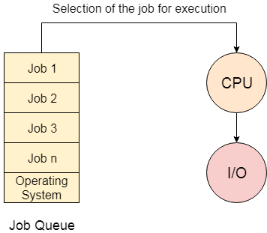
There are five jobs J1, J2, J3, J4, and J5, present in the batch. If the execution time of J1 is very high, then the other four jobs will never be executed, or they will have to wait for a very long time. Hence the other processes get starved.
2. Not Interactive
Batch Processing is not suitable for jobs that are dependent on the user's input. If a job requires the input of two numbers from the console, then it will never get it in the batch processing scenario since the user is not present at the time of execution.

Multiprogramming Operating System
Multiprogramming is an extension to batch processing where the CPU is always kept busy. Each process needs two types of system time: CPU time and IO time.
In a multiprogramming environment, when a process does its I/O, The CPU can start the execution of other processes. Therefore, multiprogramming improves the efficiency of the system.
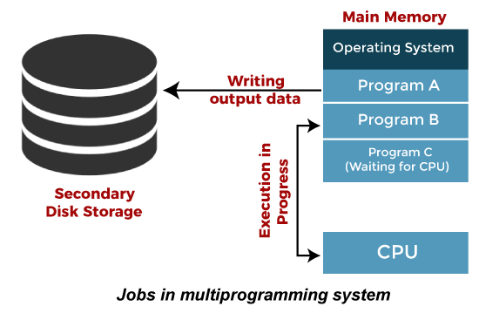

Advantages of Multiprogramming OS
- Throughout the system, it increased as the CPU always had one program to execute.
- Response time can also be reduced.

Disadvantages of Multiprogramming OS
- Multiprogramming systems provide an environment in which various systems resources are used efficiently, but they do not provide any user interaction with the computer system.

Multiprocessing Operating System
In Multiprocessing, Parallel computing is achieved. There are more than one processors present in the system which can execute more than one process at the same time. This will increase the throughput of the system.
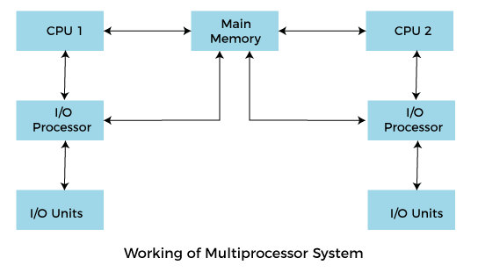
In Multiprocessing, Parallel computing is achieved. More than one processor present in the system can execute more than one process simultaneously, which will increase the throughput of the system.
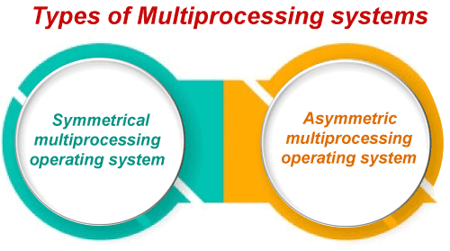
Advantages of Multiprocessing operating system:
- Increased reliability: Due to the multiprocessing system, processing tasks can be distributed among several processors. This increases reliability as if one processor fails, the task can be given to another processor for completion.
- Increased throughout: As several processors increase, more work can be done in less.
Disadvantages of Multiprocessing operating System
- Multiprocessing operating system is more complex and sophisticated as it takes care of multiple CPUs simultaneously.

Multitasking Operating System
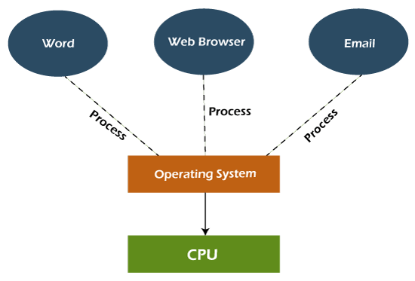
The multitasking operating system is a logical extension of a multiprogramming system that enables multiple programs simultaneously. It allows a user to perform more than one computer task at the same time.

Advantages of Multitasking operating system
- This operating system is more suited to supporting multiple users simultaneously.
- The multitasking operating systems have well-defined memory management.

Disadvantages of Multitasking operating system
- The multiple processors are busier at the same time to complete any task in a multitasking environment, so the CPU generates more heat.

Difference between multitasking and multiprogramming

Multiprogramming:

When multiple programs execute at a time on a single device, it is multiprogramming.

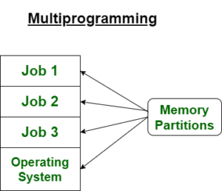

Multitasking:

When a single resource is used to process multiple tasks then it is multitasking.

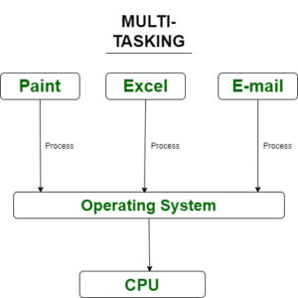

Network Operating System
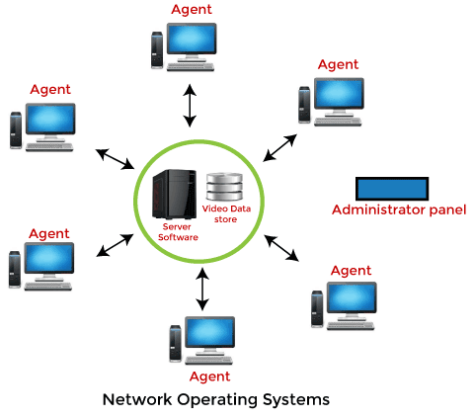
An Operating system, which includes software and associated protocols to communicate with other computers via a network conveniently and cost-effectively, is called Network Operating System.
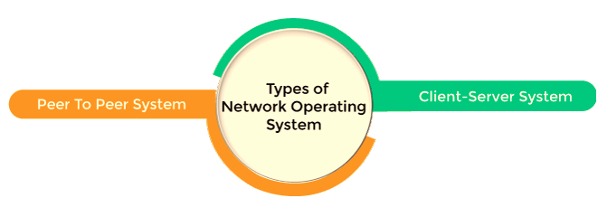

Advantages of Network Operating System
- In this type of operating system, network traffic reduces due to the division between clients and the server.
- This type of system is less expensive to set up and maintain.

Disadvantages of Network Operating System
- In this type of operating system, the failure of any node in a system affects the whole system.
- Security and performance are important issues. So trained network administrators are required for network administration.

Real Time Operating System
In Real-Time Systems, each job carries a certain deadline within which the job is supposed to be completed, otherwise, the huge loss will be there, or even if the result is produced, it will be completely useless.
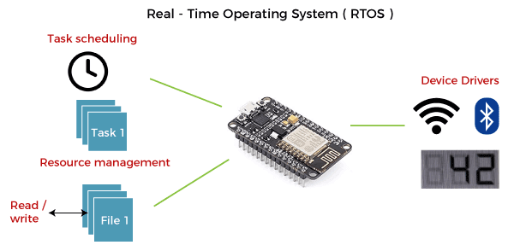
The Application of a Real-Time system exists in the case of military applications, if you want to drop a missile, then the missile is supposed to be dropped with a certain precision.
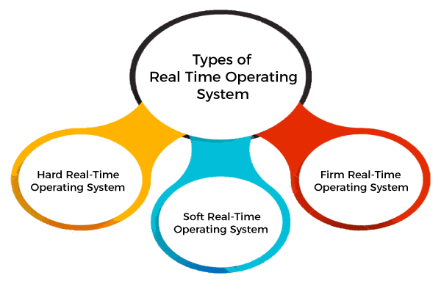

Advantages of Real-time operating system:
- Easy to layout, develop and execute real-time applications under the real-time operating system.
- In a Real-time operating system, the maximum utilization of devices and systems.

Disadvantages of Real-time operating system:
- Real-time operating systems are very costly to develop.
- Real-time operating systems are very complex and can consume critical CPU cycles.

Time-Sharing Operating System
In the Time Sharing operating system, computer resources are allocated in a time-dependent fashion to several programs simultaneously. Thus it helps to provide a large number of user's direct access to the main computer. It is a logical extension of multiprogramming. In time-sharing, the CPU is switched among multiple programs given by different users on a scheduled basis.
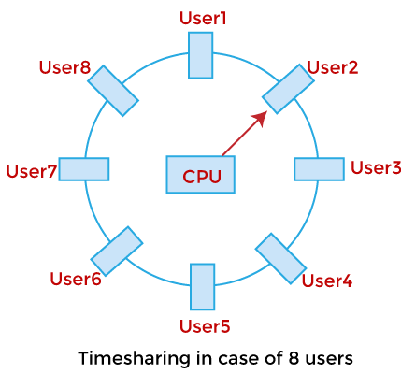

A time-sharing operating system allows many users to be served simultaneously, so sophisticated CPU scheduling schemes and Input/output management are required.
Time-sharing operating systems are very difficult and expensive to build.

Advantages of Time Sharing Operating System
- The time-sharing operating system provides effective utilization and sharing of resources.
- This system reduces CPU idle and response time.

Disadvantages of Time Sharing Operating System
- Data transmission rates are very high in comparison to other methods.
- Security and integrity of user programs loaded in memory and data need to be maintained as many users access the system at the same time.

Distributed Operating System
The Distributed Operating system is not installed on a single machine, it is divided into parts, and these parts are loaded on different machines. A part of the distributed Operating system is installed on each machine to make their communication possible. Distributed Operating systems are much more complex, large, and sophisticated than Network operating systems because they also have to take care of varying networking protocols.
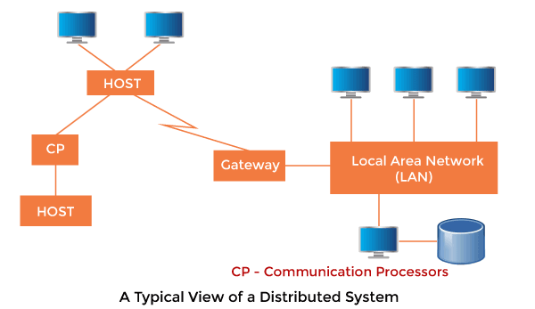

Advantages of Distributed Operating System
- The distributed operating system provides sharing of resources.
- This type of system is fault-tolerant.

Disadvantages of Distributed Operating System
- Protocol overhead can dominate computation cost.

User and Operating-System Interface
- We mentioned earlier that there are several ways for users to interface with the operating system.
- Here, we discuss two fundamental approaches.
- One provides a command-line interface, or that allows users to directly enter commands to be performed by the operating system.
- The other allows users to interface with the operating system via a graphical user interface, or GUI.

User Operating System Interface -CLI
- Command Line Interface (CLI) or command interpreter allows direct command entry.
- Sometimes implemented in kernel, sometimes by systems program.
- Sometimes multiple flavors implemented –shells.
- Primarily fetches a command from user and executes it.
- Sometimes commands built-in, sometimes just names of programs.

User Operating System Interface -GUI
- User-friendly desktop metaphor interface.
- Usually mouse, keyboard, and monitor.
- Icons represent files, programs, actions, etc.
- Various mouse buttons over objects in the interface cause various actions (provide information, options, execute function, open directory (known as a folder).
- Invented at Xerox PARC.

Many systems now include both CLI and GUI interfaces

- Microsoft Windows is GUI with CLI ―command‖ shell.
- Apple Mac OS X as ―Aqua‖ GUI interface with UNIX kernel underneath and shells available.
- Solaris is CLI with optional GUI interfaces (Java Desktop, KDE).

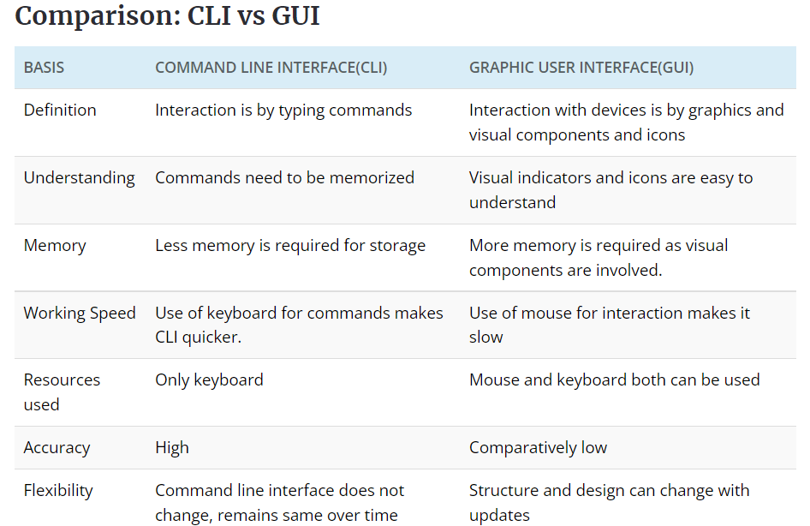

Differences between user mode and kernel mode
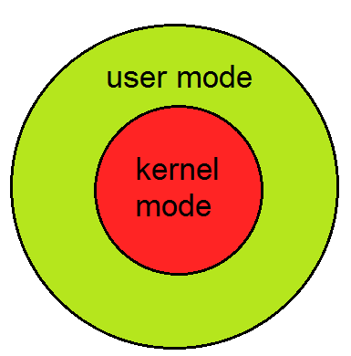
Fig:Abstraction View of OS
- Different modes supported by the operating system are:

Kernel Mode:
- When CPU is in kernel mode, the code being executed can access any memory address and any hardware resource.
- Hence kernel mode is a very privileged and powerful mode.
- If a program crashes in kernel mode, the entire system will be halted.

User Mode:
- When CPU is in user mode, the programs don’t have direct access to memory and hardware resources.
- In user mode, if any program crashes, only that particular program is halted.
- That means the system will be in a safe state even if a program in user mode crashes.
- Hence, most programs in an OS run in user mode.

