Applets
- An applet is a Java program that can be embedded (insert or place or set) into a web page.
- It runs inside the web browser and works at client side.
- An applet is embedded in an HTML page using the APPLET or OBJECT tag and hosted on a web server.
- Applets are used to make the website more dynamic and entertaining.
- An applet is a Java class that extends the java.applet.Applet class.
- A main() method is not invoked on an applet, and an applet class will not define main().

Advantage of Applets:
There are many advantages of applet. They are as follows:
- It works at client side, so less response time.
- Secured.
- It can be executed by browsers running under many platforms, including Linux, Windows, Mac Os etc.
- Execution of applets is easy in a Web browser and does not require any installation or deployment procedure in real time programming (where as servlets require).
- Writing and displaying (just opening in a browser) graphics and animations is easier than applications.
Limitations of Applets:
- Applets cannot read from or write to hard disk files.
- Applet methods cannot be native.
- Applets should not attempt to create socket connections.
- Applets cannot read system properties.
- Applets cannot use any software available on the system (except browser execution area).
- Cannot create objects of applications available on the system by composition.
- Plugin is required at client browser to execute applet.
Differences between Applets and Application Programs:
Applet programs | Application programs
Small Program. | Large Program.
Used to run a program on client Browser. | Can be executed on standalone computer system.
Applet is portable and can be executed by any JAVA supported browser. | Need JDK, JRE, JVM installed on client machine.
Applet applications are executed in a Restricted Environment. | Application can access all the resources of the computer.
Applets are created by extending the java.applet.Applet | Applications are created by writing public static void main (String [] s) method.
Applet application has 5 methods which will be automatically invoked on occurrence of specific event. | Application has a single start point which is main method.
Example:  import java.awt.*;  import java.applet.*;  public class Myclass extends Applet  {  public void init() { }  public void start() { }  public void stop() {}  public void destroy() {}  public void paint(Graphics g) {}  } | public class MyClass  {  public static void main(String args[]) {}  }

Applet’s Life Cycle:
- These methods are known as life cycle methods. These methods are defined in java.applet.Applet class except paint() method. The paint() method is defined in java.awt.Component class, an indirect super class of Applet.

Description of Life Cycle methods:
- Even though, the methods are called automatically by the browser, the programmer should know well when they are called and what he can do with the methods. Following is the schematic representation of the methods.
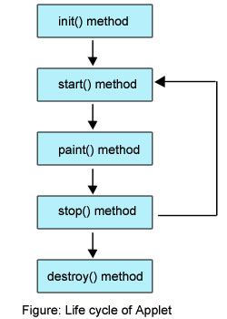

Brief Description of Life Cycle Methods:

- init() method is called at the time of starting the execution. This is called only once in the life cycle.
- start() method is called by the init() method. This method is called a number of times in the life cycle; whenever the applet is deiconifed , to make the applet active.
- paint() method is called by the start() method. This is called number of times in the execution.
- stop() method is called whenever the applet window is iconified to inactivate the applet. This method is called number of times in the execution.
- destroy() method is called when the applet is closed. This method is called only once in the life cycle.

What is HTML?
- HTML stands for Hyper Text Markup Language.
- HTML is the standard markup language for creating Web pages.
- HTML describes the structure of a Web page.
- HTML consists of a series of elements.
- HTML elements tell the browser how to display the content.
- HTML elements label pieces of content such as "this is a heading", "this is a paragraph", "this is a link", etc.

The HTML APPLET Tag

Sun currently recommends that the APPLET tag be used to start an applet from both an HTML document and from an applet viewer. An applet viewer will execute each APPLET tag that it finds in a separate window, while web browsers will allow many applets on a single page. So far, we have been using only a simplified form of the APPLET tag. The syntax for a fuller form of the APPLET tag is shown here. Bracketed items are optional.

< APPLET
[CODEBASE = codebaseURL]
CODE = appletFile
[ALT = alternateText]
[NAME = appletInstanceName]
WIDTH = pixels HEIGHT = pixels
[ALIGN = alignment]
[VSPACE = pixels] [HSPACE = pixels]
[< PARAM NAME = AttributeName VALUE = AttributeValue>]
[< PARAM NAME = AttributeName2 VALUE = AttributeValue>]
. . .
[HTML Displayed in the absence of Java]
</APPLET>
Let’s take a look at each part now.

CODEBASE : CODEBASE is an optional attribute that specifies the base URL of the applet code, which is the directory that will be searched for the applet’s executable class file (specified by the CODE tag). The HTML document’s URL directory is used as the CODEBASE if this attribute is not specified. The CODEBASE does not have to be on the host from which the HTML document was read.

CODE CODE is a required attribute that gives the name of the file containing your applet’s compiled .class file. This file is relative to the code base URL of the applet, which is the directory that the HTML file was in or the directory indicated by CODEBASE if set.

ALT The ALT tag is an optional attribute used to specify a short text message that should be displayed if the browser recognizes the APPLET tag but can’t currently run Java applets. This is distinct from the alternate HTML you provide for browsers that don’t support applets.

NAME NAME is an optional attribute used to specify a name for the applet instance. Applets must be named in order for other applets on the same page to find them by name and communicate with them. To obtain an applet by name, use getApplet( ), which is defined by the AppletContext interface.

WIDTH and HEIGHT WIDTH and HEIGHT are required attributes that give the size (in pixels) of the applet display area.

ALIGN ALIGN is an optional attribute that specifies the alignment of the applet. This attribute is treated the same as the HTML IMG tag with these possible values: LEFT, RIGHT, TOP, BOTTOM, MIDDLE, BASELINE, TEXTTOP, ABSMIDDLE, and ABSBOTTOM.

VSPACE and HSPACE These attributes are optional. VSPACE specifies the space, in pixels, above and below the applet. HSPACE specifies the space, in pixels, on each side of the applet. They’re treated the same as the IMG tag’s VSPACE and HSPACE attributes.

PARAM NAME and VALUE The PARAM tag allows you to specify applet-specific arguments in an HTML page. Applets access their attributes with the getParameter( ) method.

Other valid APPLET attributes include ARCHIVE, which lets you specify one or more archive files, and OBJECT, which specifies a saved version of the applet. In general, an APPLET tag should include only a CODE or an OBJECT attribute, but not both.

Example 1 : (Applets can be run inside the applet window or Command prompt)
/*<applet code="MyApplet1" width=300 height=100></applet>*/
import java.awt.*;
import java.applet.*;
public class MyApplet1 extends Applet
{
public void paint(Graphics g)
{
g.drawString("welcome",500,500);
}
}
Output:
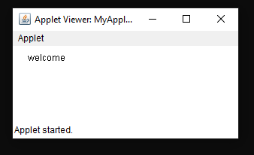

Example 2 : (Applets can be run inside the web browser window )
MyApplet1.java
import java.awt.*;
import java.applet.*;
public class MyApplet1 extends Applet
{
public void paint(Graphics g)
{
g.drawString("welcome",500,500);
}
} MyApplet1.html

<html>
<head>
<title>Hello-World Applet</title>
</head>
<body>
<h3>Applets can be run inside the web Page:</h3>
<applet code="MyApplet1.class" width="400" height="150"
alt="Error loading applet!">
</applet>
</body>
</html>

Output:

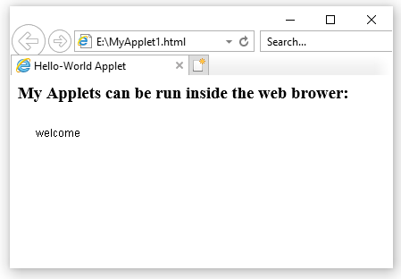

Example 3:
/*<applet code="MyApplet2" width=300 height=100></applet>*/

import java.io.*;
import java.awt.*;
import java.applet.*;

public class MyApplet2 extends Applet
{
public void init()
{
System.out.println("init");
}
public void start()
{
System.out.println("start");
}
public void stop()
{
System.out.println("stop");
}
public void destroy()
{
System.out.println("destroy");
}
public void paint(Graphics g)
{
System.out.println("paint");
}
}

Output:
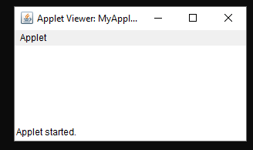
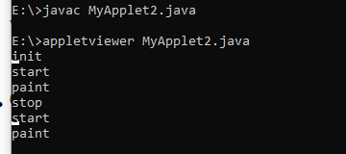

Requesting Repainting:

- As a general rule, an applet writes to its window only when its update ( ) or paint ( ) method is called by the AWT. Whenever your applet needs to update the information displayed in its window, it simply calls repaint ( ).
- The repaint( ) method is defined by the AWT. It causes the AWT run-time system to execute a call to your applet’s update( ) method, which, in its default implementation, calls paint( ). Thus, for another part of your applet to output to its window, simply store the output and then call repaint( ).
- Calling repaint( ) is essentially a request that your applet be repainted sometime soon.

Passing Parameters to Applets:

- To pass the parameters to the Applet we need to use the param attribute of <applet> tag.
- To retrieve a parameter's value, we need to use the getParameter() method of Applet class.
- Thus, for numeric and boolean values, you will need to convert their string representations into their internal formats.
- Here is an example that demonstrates passing parameters:
import java.applet.*;
import java.awt.*;
import java.io.*;

/*<applet code="ParamDemo" width=300 height=100 >
<param name="name" value="Sivaumar">
<param name="designation" value="assistant professor">
<param name="department" value="cse">
<param name="college" value="rvr&jcce">
<param name="salary" value=75000>
</applet>*/
public class ParamDemo extends Applet
{
public void paint(Graphics g)
{
//int d=0;
g.drawString("name :"+getParameter("name"),50,50);
g.drawString("designation :"+getParameter("designation"),50,50);
g.drawString("department :"+getParameter("department"),50,50);
g.drawString("college :"+getParameter("college"),50,50);
d=Integer.parseInt(getParameter("salary"));
g.drawString("salary :"+d,50,100);
}
}
Output:

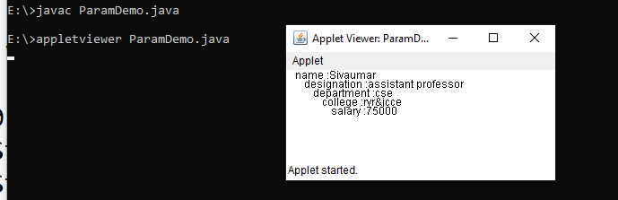

Graphics class

The Graphics class defines a number of drawing functions. Each shape can be drawn edge-only or filled. Objects are drawn and filled in the currently selected graphics color, which is black by default. When a graphics object is drawn that exceeds the dimensions of the window, output is automatically clipped.
Let’s take a look at several of the drawing methods.
Drawing Lines:

→Lines are drawn by means of the drawLine( ) method, shown here:

void drawLine(int startX, int startY, int endX, int endY)

drawLine( ) displays a line in the current drawing color that begins at startX,startY and ends at endX,endY.

The following applet draws several lines:
// Draw lines
import java.awt.*;
import java.applet.*;
/*
<applet code="Lines" width=300 height=200>
</applet>
*/
public class Lines extends Applet {
public void paint(Graphics g) {
setBackground(Color.cyan);
setForeground(Color.red);
g.drawLine(0, 0, 100, 100);
g.drawLine(0, 100, 100, 0);
g.drawLine(40, 25, 250, 180);
g.drawLine(75, 90, 400, 400);
g.drawLine(20, 150, 400, 40);
g.drawLine(5, 290, 80, 19);
}
}
Sample output from this program is shown here:

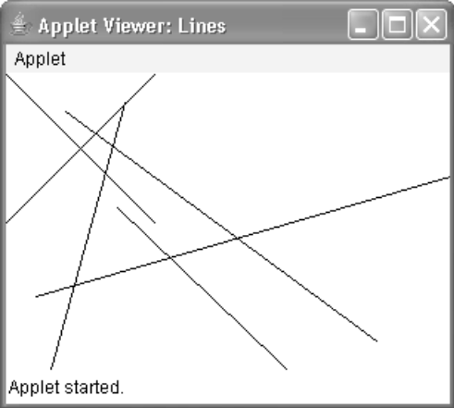

Drawing Rectangles:

→The drawRect( ) and fillRect( ) methods display an outlined and filled rectangle, respectively.They are shown here:

void drawRect(int top, int left, int width, int height)
void fillRect(int top, int left, int width, int height)

The upper-left corner of the rectangle is at top,left. The dimensions of the rectangle are specified by width and height.

→To draw a rounded rectangle, use drawRoundRect( ) or fillRoundRect( ), both shown here:

void drawRoundRect(int top, int left, int width, int height,int xDiam, int yDiam)
void fillRoundRect(int top, int left, int width, int height,int xDiam, int yDiam)

A rounded rectangle has rounded corners. The upper-left corner of the rectangle is at top, left.The dimensions of the rectangle are specified by width and height. The diameter of the rounding arc along the X axis is specified by xDiam. The diameter of the rounding arc along the Y axis is specified by yDiam.

The following applet draws several rectangles:
// Draw rectangles
import java.awt.*;
import java.applet.*;
/*
<applet code="Rectangles" width=300 height=200>
</applet>
*/
public class Rectangles extends Applet {
public void paint(Graphics g) {
g.drawRect(10, 10, 60, 50);
g.fillRect(100, 10, 60, 50);
g.drawRoundRect(190, 10, 60, 50, 15, 15);
g.fillRoundRect(70, 90, 140, 100, 30, 40);
}
}
Sample output from this program is shown here:

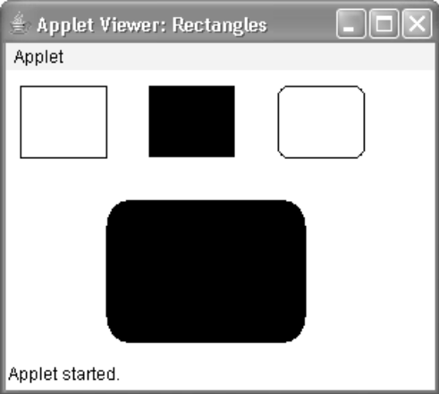

Drawing Ellipses and Circles:

→To draw an ellipse, use drawOval( ). To fill an ellipse, use fillOval( ). These methods are shown here:

void drawOval(int top, int left, int width, int height)

void fillOval(int top, int left, int width, int height)

The ellipse is drawn within a bounding rectangle whose upper-left corner is specified by top,left and whose width and height are specified by width and height. To draw a circle, specify a square as the bounding rectangle.
The following program draws several ellipses:
// Draw Ellipses
import java.awt.*;
import java.applet.*;
/*
<applet code="Ellipses" width=300 height=200>
</applet>
*/
public class Ellipses extends Applet {
public void paint(Graphics g) {
g.drawOval(10, 10, 50, 50);
g.fillOval(100, 10, 75, 50);
g.drawOval(190, 10, 90, 30);
g.fillOval(70, 90, 140, 100);
}
}
Sample output from this program is shown here:
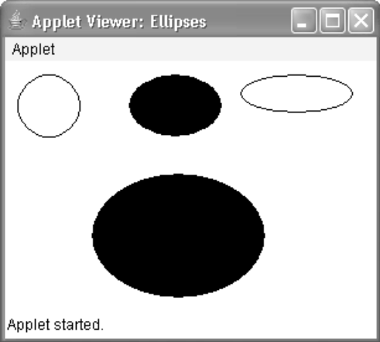

Drawing Arcs:

→Arcs can be drawn with drawArc( ) and fillArc( ), shown here:

void drawArc(int top, int left, int width, int height, int startAngle,int sweepAngle)
void fillArc(int top, int left, int width, int height, int startAngle,int sweepAngle)

The arc is bounded by the rectangle whose upper-left corner is specified by top,left and whose width and height are specified by width and height. The arc is drawn from startAngle through the angular distance specified by sweepAngle. Angles are specified in degrees. Zero degrees is on the horizontal, at the three o’clock position. The arc is drawn counterclockwise if sweepAngle is positive, and clockwise if sweepAngle is negative. Therefore, to draw an arc from twelve o’clock to six o’clock, the start angle would be 90 and the sweep angle 180.

The following applet draws several arcs:
// Draw Arcs
import java.awt.*;
import java.applet.*;
/*
<applet code="Arcs" width=300 height=200>
</applet>
*/
public class Arcs extends Applet {
public void paint(Graphics g) {
g.drawArc(10, 40, 70, 70, 0, 75);
g.fillArc(100, 40, 70, 70, 0, 75);
g.drawArc(10, 100, 70, 80, 0, 175);
g.fillArc(100, 100, 70, 90, 0, 270);
g.drawArc(200, 80, 80, 80, 0, 180);
}
}
Sample output from this program is shown here:
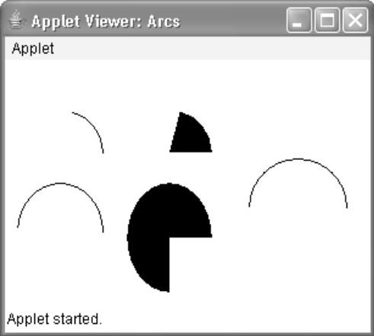

Drawing Polygons:

→It is possible to draw arbitrarily shaped figures using drawPolygon( ) and fillPolygon( ),shown here:

void drawPolygon(int x[ ], int y[ ], int numPoints)
void fillPolygon(int x[ ], int y[ ], int numPoints)
The polygon’s endpoints are specified by the coordinate pairs contained within the x and y arrays. The number of points defined by x and y is specified by numPoints. There are alternative forms of these methods in which the polygon is specified by a Polygon object.
The following applet draws an hourglass shape:

// Draw Polygon
import java.awt.*;
import java.applet.*;
/*
<applet code="HourGlass" width=230 height=210>
</applet>
*/
public class HourGlass extends Applet {
public void paint(Graphics g) {
int xpoints[] = {30, 200, 30, 200, 30};
int ypoints[] = {30, 30, 200, 200, 30};
int num = 5;
g.drawPolygon(xpoints, ypoints, num);
}
}
Sample output from this program is shown here:

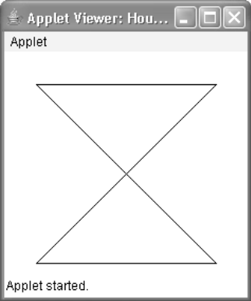

Color class

→Color defines several constants to specify a number of common colors.

- You can also create your own colors, using one of the color constructors. Three commonly used forms are shown here:

Color(int red, int green, int blue)
Color(int rgbValue)
Color(float red, float green, float blue)

- The first constructor takes three integers that specify the color as a mix of red, green, and blue. These values must be between 0 and 255, as in this example:

new Color(255, 100, 100); // light red

- The second color constructor takes a single integer that contains the mix of red, green, and blue packed into an integer. The integer is organized with red in bits 16 to 23, green in bits 8 to 15, and blue in bits 0 to 7. Here is an example of this constructor:

int newRed = (0xff000000 | (0xc0 << 16) | (0x00 << 8) | 0x00);
Color darkRed = new Color(newRed);

- The final constructor, Color(float, float, float), takes three float values (between 0.0 and 1.0) that specify the relative mix of red, green, and blue.

→Once you have created a color, you can use it to set the foreground and/or background color by using the setForeground( ) and setBackground( ) methods.

- To set the background color, use setBackground( ).
- To set the foreground color, use setForeground( ).

These methods are defined by Component, and they have the following general forms:

void setBackground(Color newColor)
void setForeground(Color newColor)

Here, newColor specifies the new color. The class Color defines the constants shown here that can be used to specify colors:

Examples: The following example sets the background color to green and the text color to red:

setBackground(Color.green);
setForeground(Color.red);

A good place to set the foreground and background colors is in the init( ) method. Of course, you can change these colors as often as necessary during the execution of your applet.

You can obtain the current settings for the background and foreground colors by calling:
getBackground( ) and getForeground( ), respectively. They are also defined by Component
and are shown here:

Color getBackground( )
Color getForeground( )

Here is a very simple applet that sets the background color to cyan, the foreground color to red, and displays a message that illustrates the order in which the init( ), start( ), and paint( ) methods are called when an applet starts up:

/* A simple applet that sets the foreground and background colors and outputs a string. */
import java.awt.*;
import java.applet.*;
/*
<applet code="Sample" width=300 height=50>
</applet>
*/
public class Sample extends Applet{
String msg;
// set the foreground and background colors.
public void init() {
setBackground(Color.cyan);
setForeground(Color.red);
msg = "Inside init( ) --";
}
// Initialize the string to be displayed.
public void start() {
msg += " Inside start( ) --";
}
// Display msg in applet window.
public void paint(Graphics g) {
msg += " Inside paint( ).";
g.drawString(msg, 10, 30);
}
}
You can also select it as the current drawing color.
→The Color class defines several methods that help manipulate colors. They are examined here. Using Hue, Saturation, and Brightness

- The hue-saturation-brightness (HSB) color model is an alternative to red-green-blue (RGB) for specifying particular colors. Figuratively, hue is a wheel of color. The hue is specified with a number between 0.0 and 1.0 (the colors are approximately red, orange, yellow, green, blue, indigo, and violet).

- The Saturation is another scale ranging from 0.0 to 1.0, representing light pastels to intense hues.

- The Brightness values also range from 0.0 to 1.0, where 1 is bright white and 0 is black.

- Color supplies two methods that let you convert between RGB and HSB. They are shown here:

static int HSBtoRGB(float hue, float saturation, float brightness)
static float[ ] RGBtoHSB(int red, int green, int blue, float values[ ])

- HSBtoRGB( ) returns a packed RGB value compatible with the Color(int) constructor.
- RGBtoHSB( ) returns a float array of HSB values corresponding to RGB integers. If values is not null, then this array is given the HSB values and returned. Otherwise, a new array is created and the HSB values are returned in it. In either case, the array contains the hue at index 0, saturation at index 1, and brightness at index 2.

→getRed( ), getGreen( ), getBlue( )

You can obtain the red, green, and blue components of a color independently using getRed( ), getGreen( ), and getBlue( ), shown here:

int getRed( )
int getGreen( )
int getBlue( )

Each of these methods returns the RGB color component found in the invoking Color object in the lower 8 bits of an integer.
→getRGB( )

To obtain a packed, RGB representation of a color, use getRGB( ), shown here:
int getRGB( )

Setting the Current Graphics Color

By default, graphics objects are drawn in the current foreground color.
You can change this color by calling the Graphics method setColor( ):

void setColor(Color newColor)
Here, newColor specifies the new drawing color.

You can obtain the current color by calling getColor( ), shown here: getColor( )

Example:
The following applet constructs several colors and draws various objects using these colors:
// Demonstrate color.
import java.awt.*;
import java.applet.*;
/*
<applet code="ColorDemo" width=300 height=200>
</applet>
*/
public class ColorDemo extends Applet {
// draw lines
public void paint(Graphics g) {
Color c1 = new Color(255, 100, 100);
Color c2 = new Color(100, 255, 100);
Color c3 = new Color(100, 100, 255);
g.setColor(c1);
g.drawLine(0, 0, 100, 100);
g.drawLine(0, 100, 100, 0);
g.setColor(c2);
g.drawLine(40, 25, 250, 180);
g.drawLine(75, 90, 400, 400);
g.setColor(c3);
g.drawLine(20, 150, 400, 40);
g.drawLine(5, 290, 80, 19);
g.setColor(Color.red);
g.drawOval(10, 10, 50, 50);
g.fillOval(70, 90, 140, 100);
g.setColor(Color.blue);
g.drawOval(190, 10, 90, 30);
g.drawRect(10, 10, 60, 50);
g.setColor(Color.cyan);
g.fillRect(100, 10, 60, 50);
g.drawRoundRect(190, 10, 60, 50, 15, 15);
}
}

