Output:

1.

a

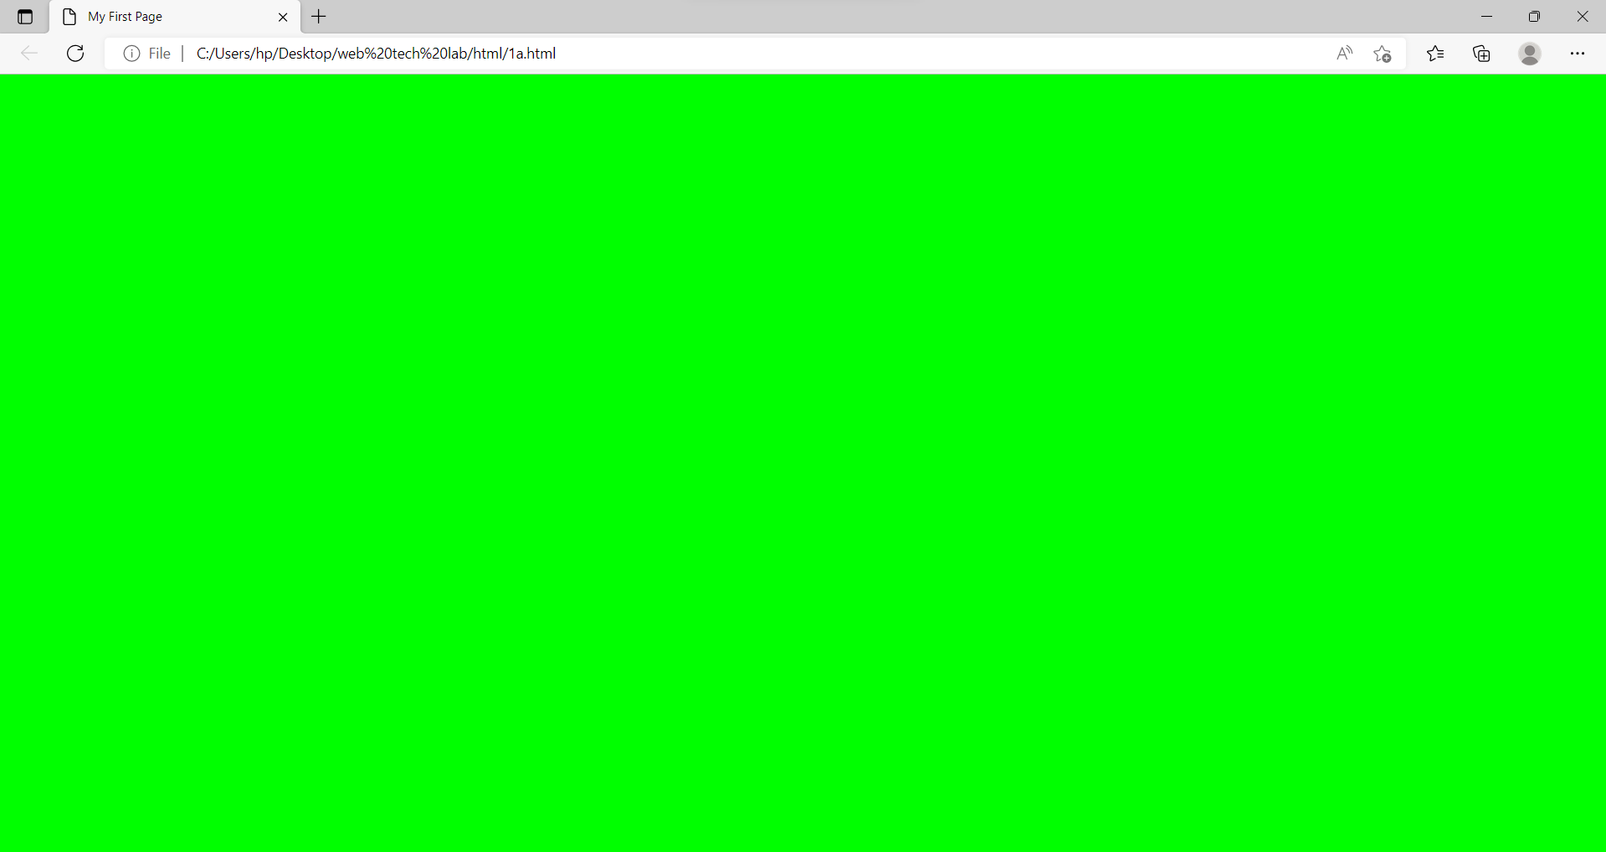

**Web Technology Lab**

**Lab cycle – 1**

1).

a. Create a web page having the background in green and title “My First Page”.

Source code:

<html>

<head>

<title>My First Page</title>

</head>

<body style="background-color: #00FF00;">

</body>

</html>

b

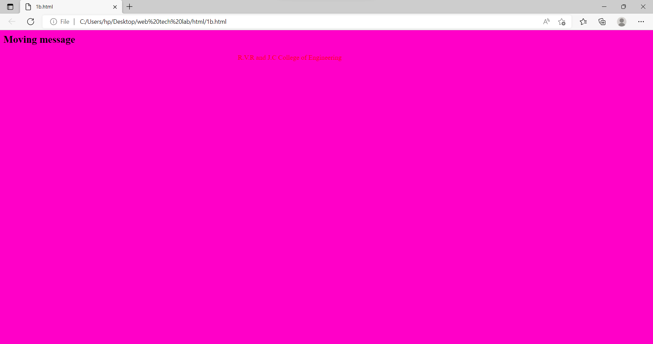

b. Create a web page of pink colour and display a moving message in red colour.

Source code:

<html>

<head>

</head>

<body style="background-color: #ff00c8;">

<h2>Moving message</h2>

<marquee style="color:#ff0000;">

R.V.R and J.C College of Engineering

</marquee>

</body>

</html>

c

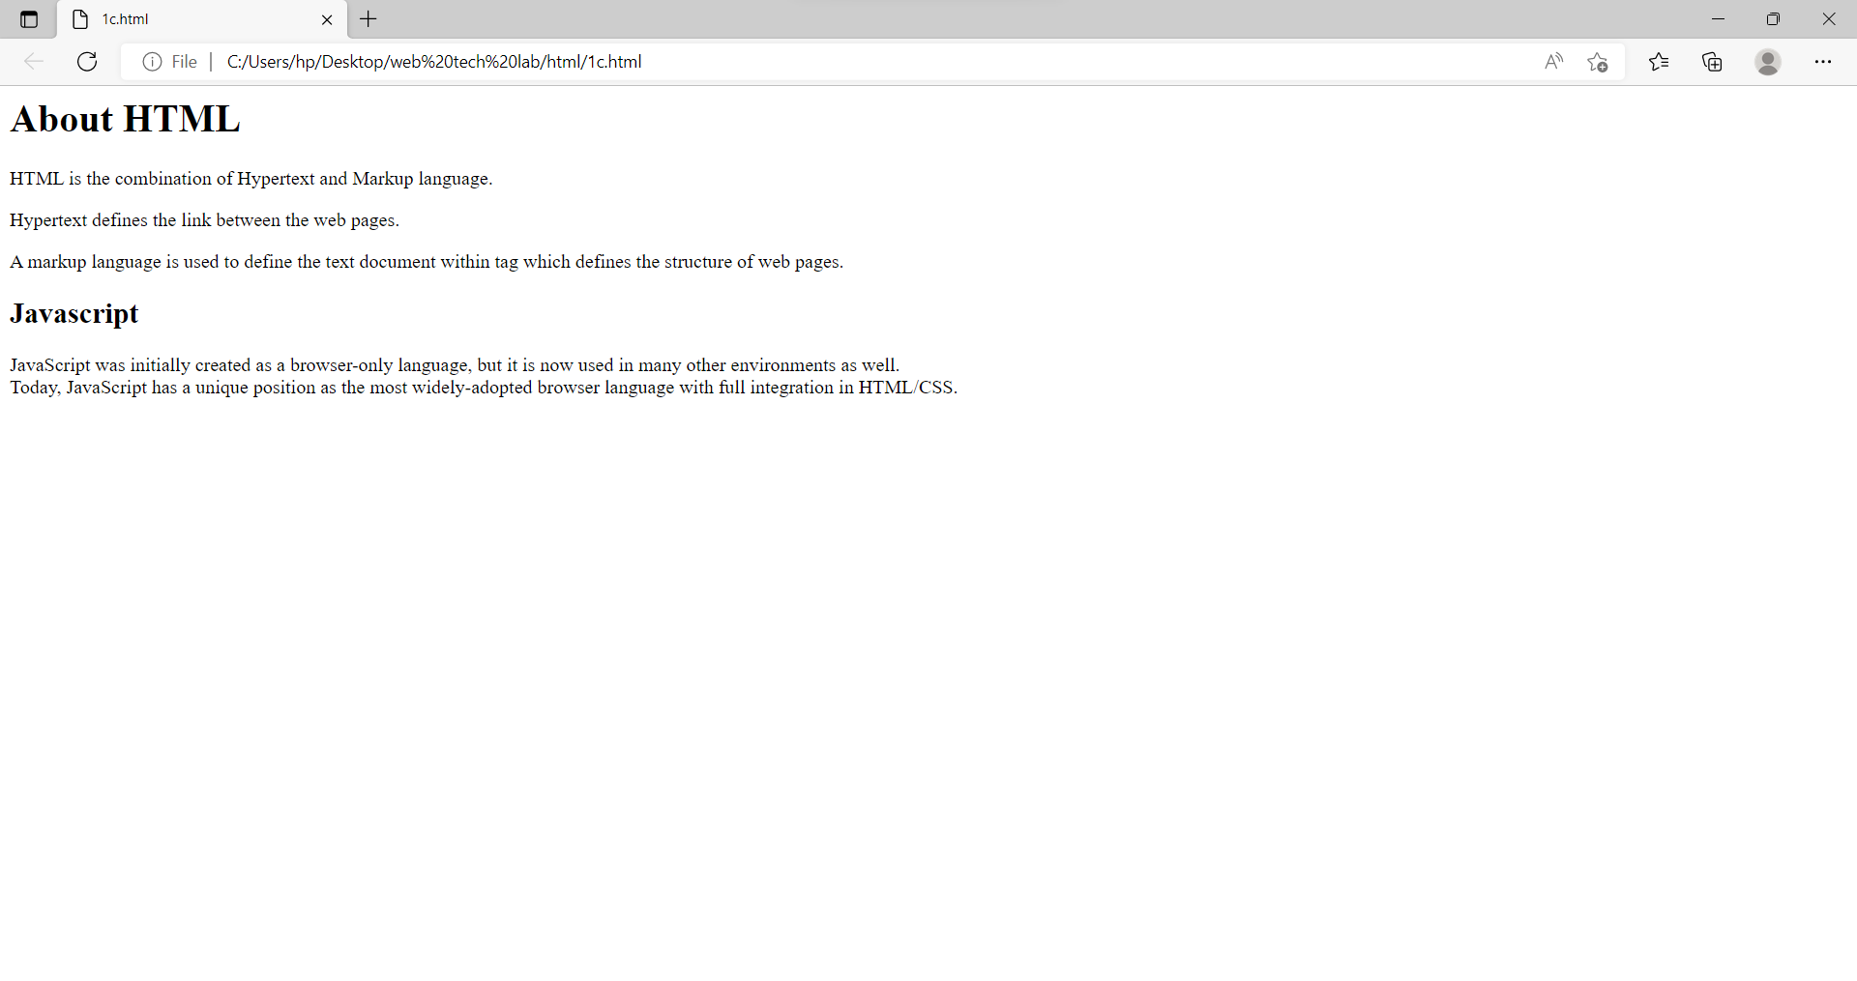

c. Design a web page containing text, in form of paragraphs giving suitable heading style.

Source code:

<html>

<head>

</head>

<body>

<h1>About HTML</h1>

<p>HTML is the combination of Hypertext and Markup language.</p>

<p>Hypertext defines the link between the web pages.</p>

<p>A markup language is used to define the text document within tag which defines the structure of web pages.</p>

<h2>Javascript</h2>

<p>JavaScript was initially created as a browser-only language, but it is now used in many other environments as well.<br>Today, JavaScript has a unique position as the most widely-adopted browser language with full integration in HTML/CSS.</p>

</body>

</html>

Output:

2.

a

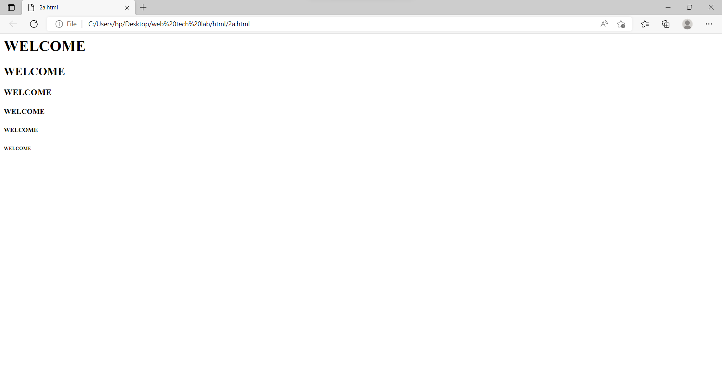

2.

a. Create a web page which displays WELCOME text using heading tags(h1 to h6)

Source code:

<html>

<head>

</head>

<body>

<h1>WELCOME</h1>

<h2>WELCOME</h2>

<h3>WELCOME</h3>

<h4>WELCOME</h4>

<h5>WELCOME</h5>

<h6>WELCOME</h6>

</body>

</html>

b

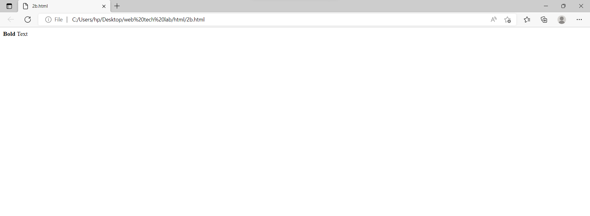

b. Create a web page which displays WELCOME text using tag

Source code:

<html>

<head>

</head>

<body>

<p><b>Bold</b> Text</p>

</body>

</html>

c

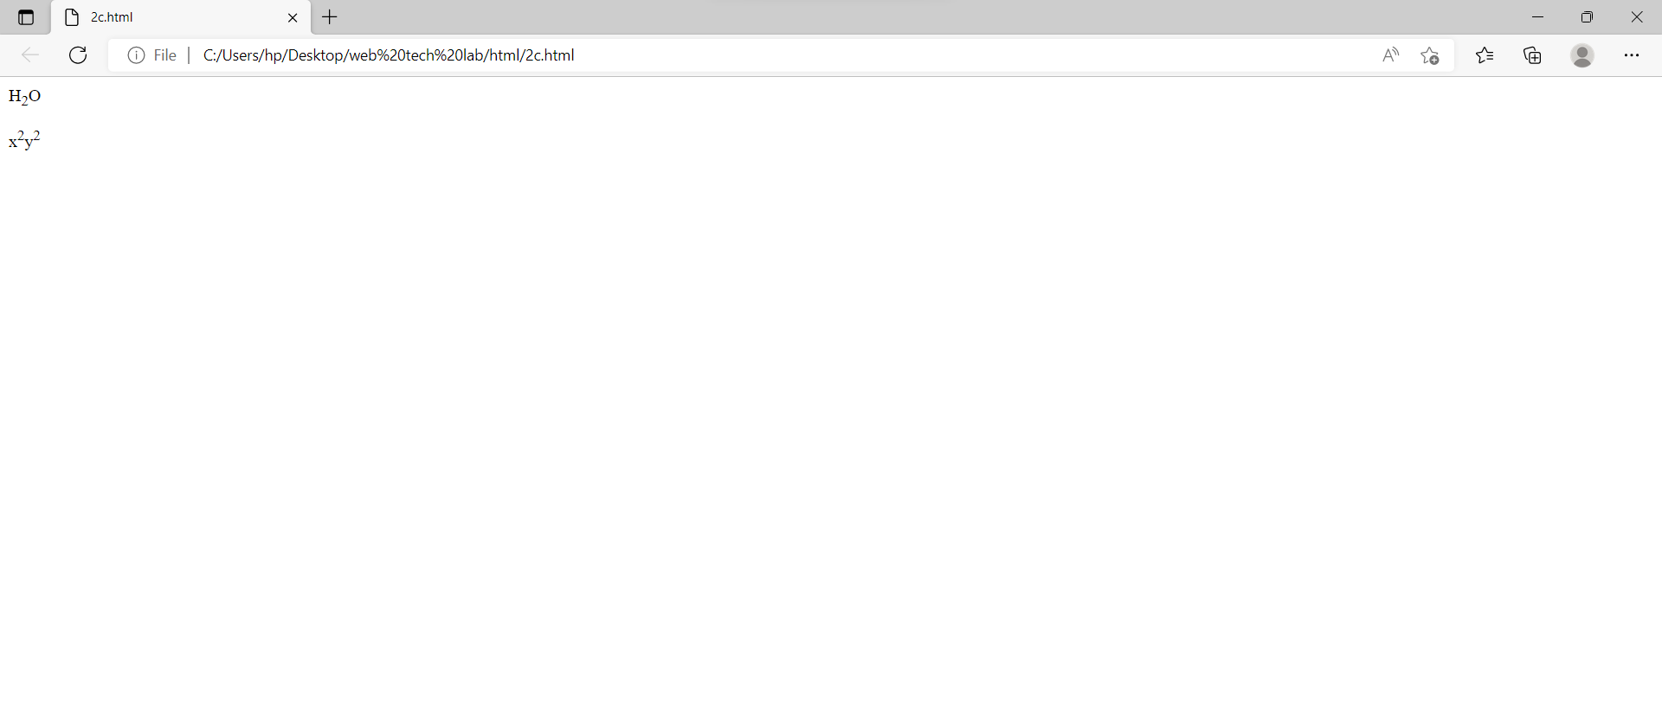

c. Create a web page which displays h2o and x2+y2 using tag

Source code:

<html>

<head>

</head>

<body>

<p>H<sub>2</sub>O</p>

<p>x<sup>2</sup>y<sup>2</sup></p>

</body>

</html>

Output:

3.

a

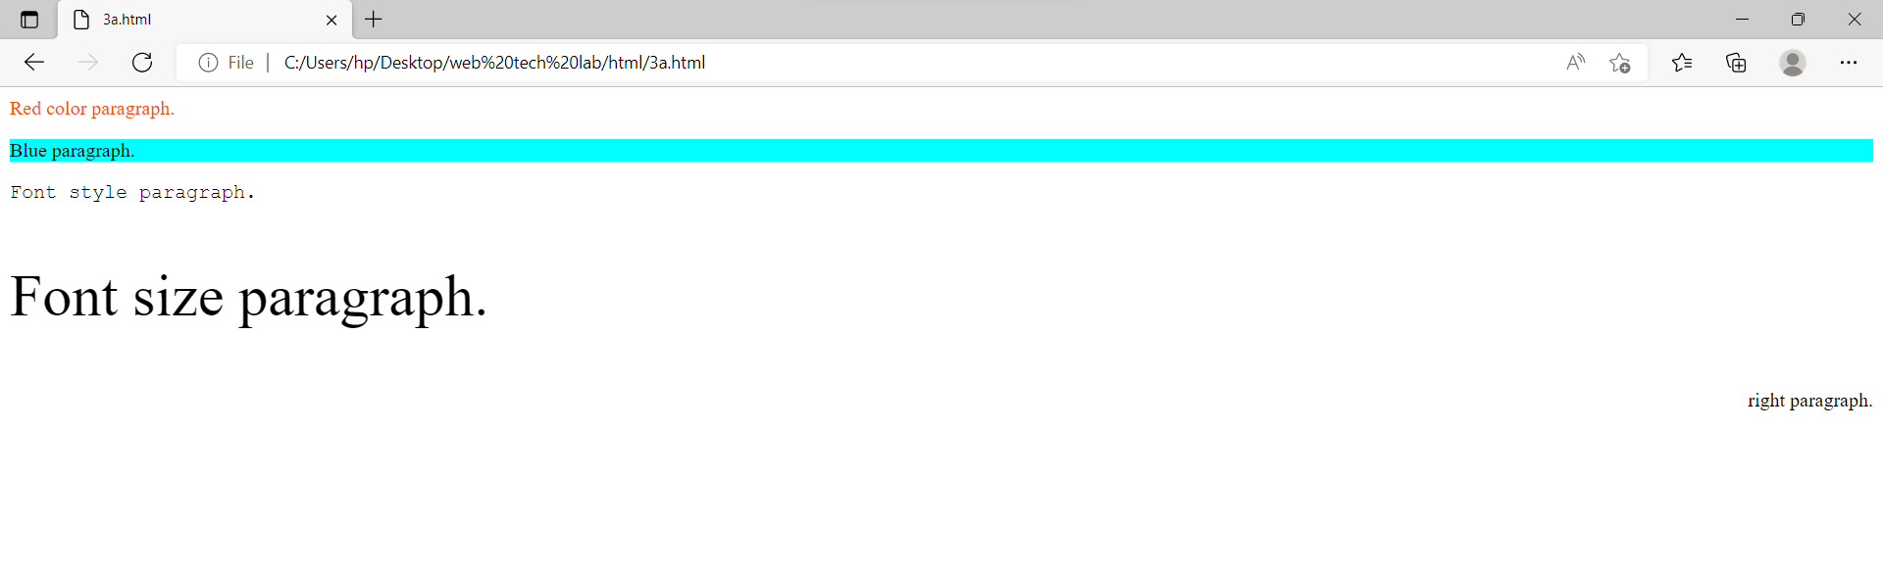

3.

a. Create a web page to show different attributes of Font tag.

Source code:

<html>

<head>

</head>

<body>

<p style=color:#ff4d00>Red color paragraph.</p>

<p style=background-color:aqua>Blue paragraph.</p>

<p style="font-family:courier;">Font style paragraph.</p>

<p style="font-size:300%;">Font size paragraph.</p>

<p style="text-align:right;">right paragraph.</p>

</body>

</html>

b

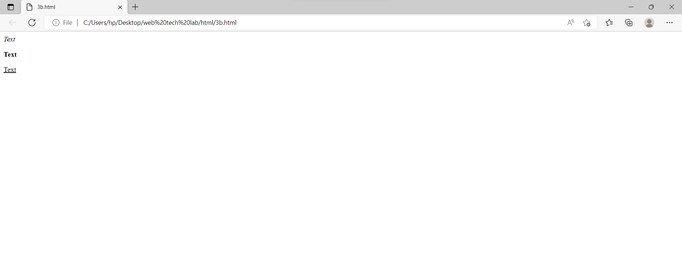

b. Create a web page to show different attributes: italics, bold, underline.

Source code:

<html>

<head>

</head>

<body>

<p><i>Text</i></p>

<p><b>Text</b></p>

<p><u>Text</u></p>

</body>

</html>

c

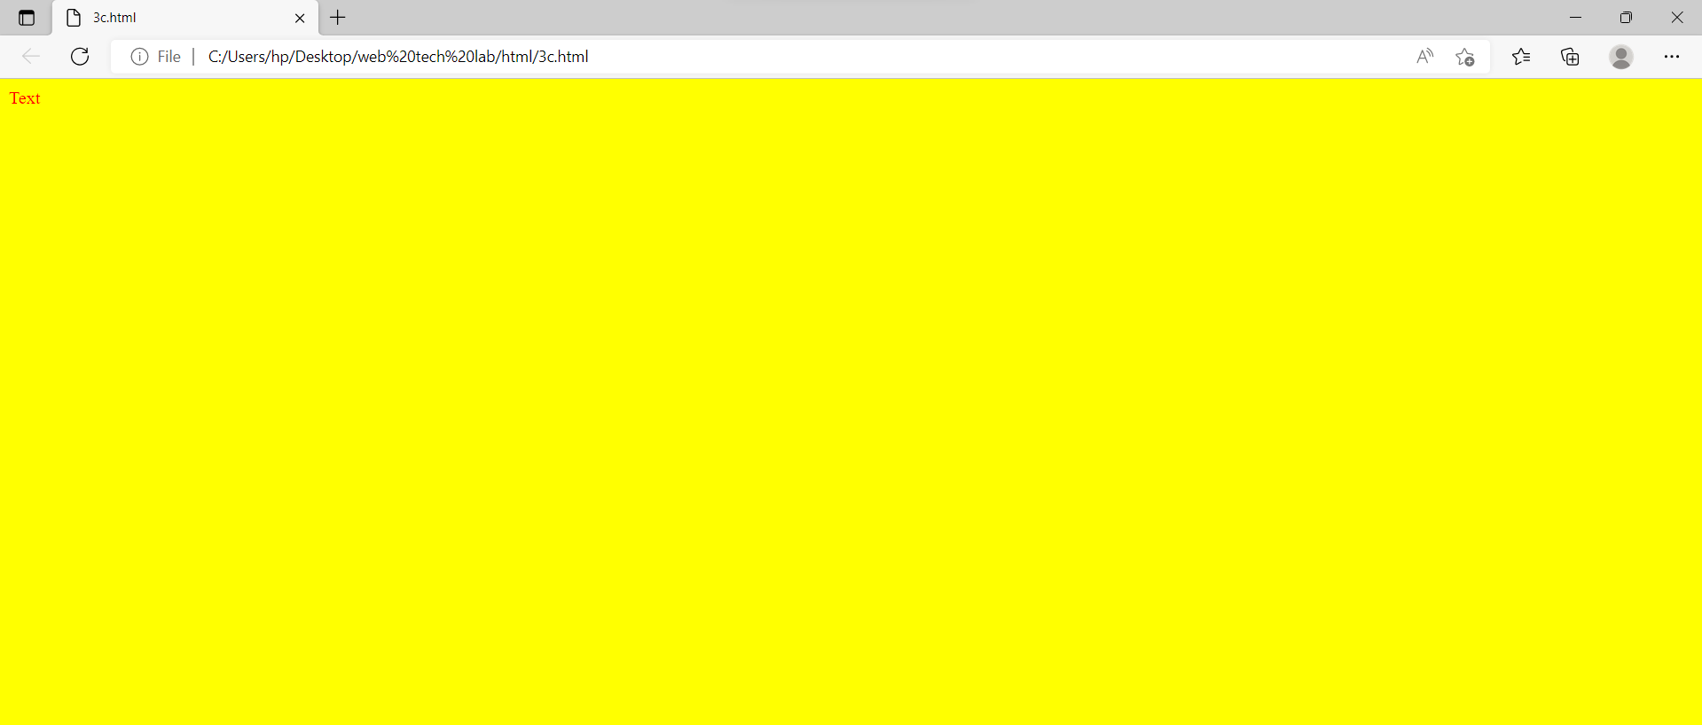

c. Design a web page having background colour yellow and giving text colour red.

Source code:

<html>

<head>

</head>

<body style="background-color:yellow">

<p style="color:red">Text</p>

</body>

</html>

Output:

4.

a

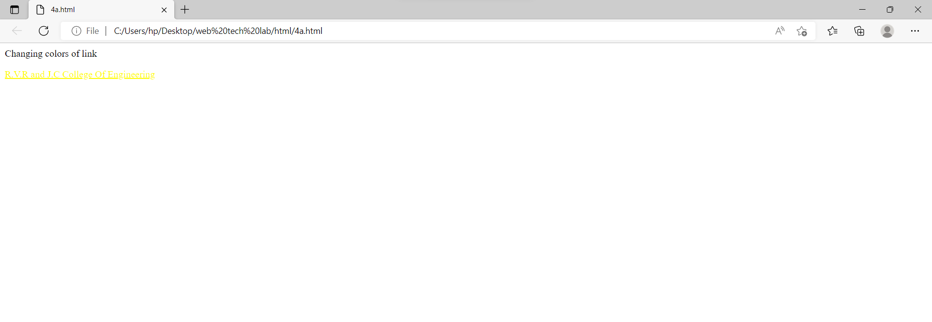

4.

a. Create a web page using href attribute of anchor tag & the attribute: alink, vlink etc.

Source code:

<html>

<head>

<style>

a:link {

color: rgb(255, 0, 0);

background-color: transparent;

text-decoration: underline;

}

a:visited {

color: #fffb00;

background-color: transparent;

text-decoration: none;}

a:hover {

color: hsl(130, 100%, 50%);

background-color: transparent;

text-decoration: underline;}

a:active {

color: hwb(183 0% 0%);

background-color: transparent;

text-decoration: none;}

</style>

</head>

<body>

<p>Changing colors of link</p>

<a href="https://rvrjcce.ac.in/" target="_blank">R.V.R and J.C College Of Engineering</a>

</body>

</html>

b

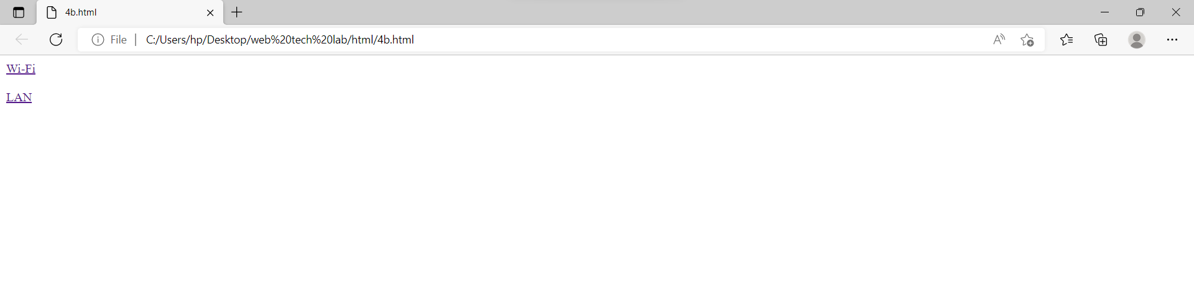

b. Create links on the words e.g. ―Wi-Fi and ―LAN‖ to link them to Wikipedia pages.

Source code:

<html>

<head>

</head>

<body>

<a href="https://en.wikipedia.org/wiki/Wi-Fi">Wi-Fi</a><br><br>

<a href="https://en.wikipedia.org/wiki/Local_area_network">LAN</a>

</body>

</html>

c

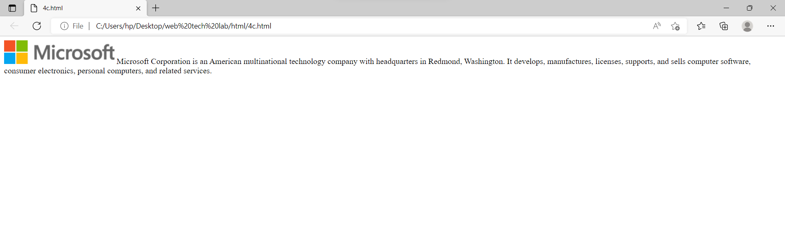

c. Create a web page with appropriate content and insert an image towards the lefthand side of the page. When user clicks on the image, it should open another Web page.

Source code:

<html>

<head>

</head>

<body>

<p style="text-align:left;"><a href="https://www.microsoft.com/en-in/"><img src="https://img-prod-cms-rt-microsoft-com.akamaized.net/cms/api/am/imageFileData/RE1Mu3b?ver=5c31"></a>

Microsoft Corporation is an American multinational technology company with headquarters in Redmond, Washington.

It develops, manufactures, licenses, supports, and sells computer software, consumer electronics, personal computers, and related services.</p>

</body>

</html>

Output:

5.

a

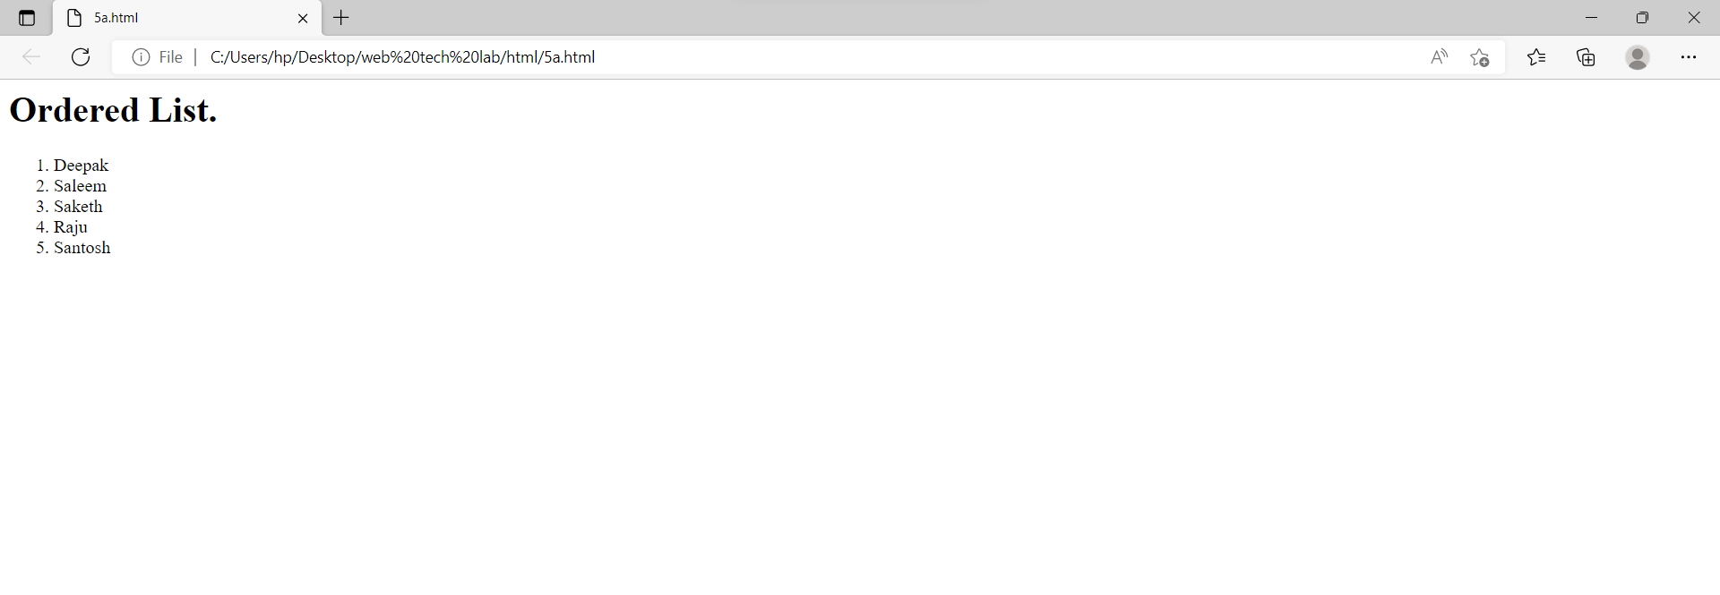

5.

a. Create a web page, showing an ordered list of the names of five of your friends.

Source code:

<html>

<head>

</head>

<body>

<h1>Ordered List.</h1>

<ol>

<li>Deepak</li>

<li>Saleem</li>

<li>Saketh</li>

<li>Raju</li>

<li>Santosh</li>

</ol>

</body>

</html>

b

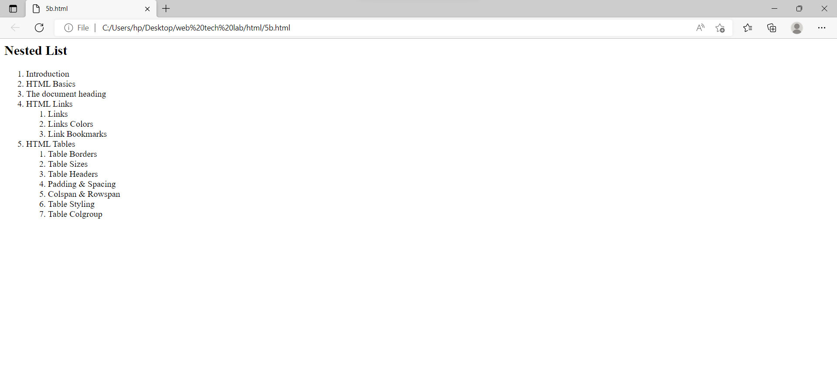

b. Create a web page containing a nested list showing the content page of any book

Source code:

<html>

<head>

</head>

<body>

<h2>Nested List</h2>

<ol>

<li>Introduction</li>

<li>HTML Basics</li>

<li>The document heading</li>

<li>HTML Links</li>

<ol>

<li>Links</li>

<li>Links Colors</li>

<li>Link Bookmarks</li>

</ol>

<li>HTML Tables</li>

<ol>

<li>Table Borders</li>

<li>Table Sizes</li>

<li>Table Headers</li>

<li>Padding & Spacing</li>

<li>Colspan & Rowspan</li>

<li>Table Styling</li>

<li>Table Colgroup</li>

</ol>

</ol>

</body>

</html>

c

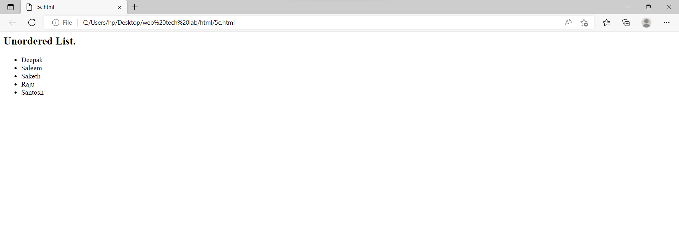

c. Create a web page, showing an unordered list of names of five of your friends

Source code:

<html>

<head>

</head>

<body>

<h2>Unordered List.</h2>

<ul>

<li>Deepak</li>

<li>Saleem</li>

<li>Saketh</li>

<li>Raju</li>

<li>Santosh</li>

</ul>

</body>

</html>

Output:

6.

a

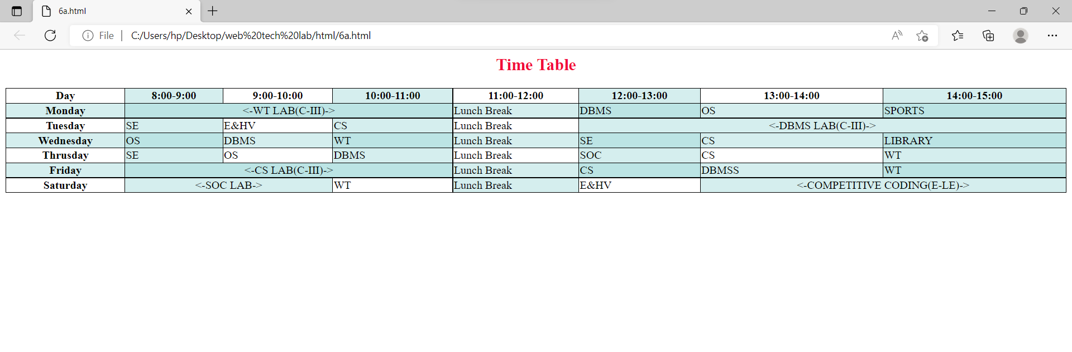

6.

a. Create a table to show your class timetable using rowspan and colspan attributes.

Source code:

<html>

<head>

<style>

table, th, td {

border: 1px solid black;

border-collapse: collapse;

}

tr:nth-child(even) {

background-color: rgba(150, 212, 212, 0.4);

}

th:nth-child(even),td:nth-child(even) {

background-color: rgba(150, 212, 212, 0.4);

}

</style>

</head>

<body>

<h2 style="color:#f20c36; text-align:center;">Time Table</h2>

<table style="width:100%">

<tr>

<th>Day</th>

<th>8:00-9:00</th>

<th>9:00-10:00</th>

<th>10:00-11:00</th>

<th>11:00-12:00</th>

<th>12:00-13:00</th>

<th>13:00-14:00</th>

<th>14:00-15:00</th>

</tr>

<tr>

<th>Monday</th>

<td colspan="3" style="text-align:center;"><-WT LAB(C-III)-></td>

<td>Lunch Break</td>

<td>DBMS</td>

<td>OS</td>

<td>SPORTS</td>

</tr>

<tr>

<th>Tuesday</th>

<td>SE</td>

<td>E&HV</td>

<td>CS</td>

<td>Lunch Break</td>

<td colspan="3" style="text-align:center;"><-DBMS LAB(C-III)-></td>

</tr>

<tr>

<th>Wednesday</th>

<td>OS</td>

<td>DBMS</td>

<td>WT</td>

<td>Lunch Break</td>

<td>SE</td>

<td>CS</td>

<td>LIBRARY</td>

</tr>

<tr>

<th>Thrusday</th>

<td>SE</td>

<td>OS</td>

<td>DBMS</td>

<td>Lunch Break</td>

<td>SOC</td>

<td>CS</td>

<td>WT</td>

</tr>

<tr>

<th>Friday</th>

<td colspan="3" style="text-align:center;"><-CS LAB(C-III)-></td>

<td>Lunch Break</td>

<td>CS</td>

<td>DBMSS</td>

<td>WT</td>

</tr>

<tr>

<th>Saturday</th>

<td colspan="2" style="text-align:center;"><-SOC LAB-></td>

<td>WT</td>

<td>Lunch Break</td>

<td>E&HV</td>

<td colspan="2" style="text-align:center;"><-COMPETITIVE CODING(E-LE)-></td>

</tr>

</table>

</body>

</html>

b

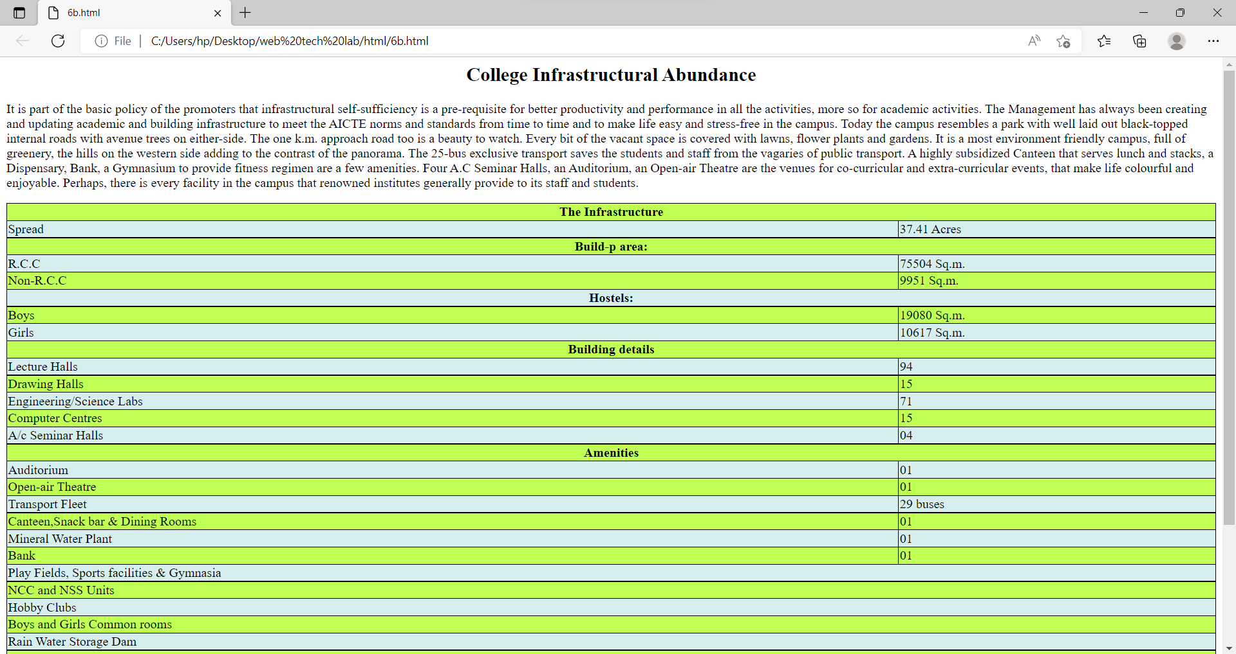

b. Use tables to provide layout to your HTML page describing your college infrastructure.

Source code:

<html>

<head>

<style>

table, th, td {

border: 1px solid black;

border-collapse: collapse;

}

tr:nth-child(even) {

background-color: #D6EEEE;

}

tr:nth-child(odd) {

background-color: #c0ff54;

}

</style>

</head>

<body>

<h2 style="text-align: center;">College Infrastructural Abundance</h2>

<p>It is part of the basic policy of the promoters that infrastructural self-sufficiency is a pre-requisite for better productivity and performance in all the activities, more so for academic activities. The Management has always been creating and updating academic and building infrastructure to meet the AICTE norms and standards from time to time and to make life easy and stress-free in the campus.

Today the campus resembles a park with well laid out black-topped internal roads with avenue trees on either-side. The one k.m. approach road too is a beauty to watch. Every bit of the vacant space is covered with lawns, flower plants and gardens. It is a most environment friendly campus, full of greenery, the hills on the western side adding to the contrast of the panorama.

The 25-bus exclusive transport saves the students and staff from the vagaries of public transport. A highly subsidized Canteen that serves lunch and stacks, a Dispensary, Bank, a

Gymnasium to provide fitness regimen are a few amenities. Four A.C Seminar Halls, an Auditorium, an Open-air Theatre are the venues for co-curricular and extra-curricular events, that make life

colourful and enjoyable. Perhaps, there is every facility in the campus that renowned institutes generally provide to its staff and students.</p>

<table style="width:100%">

<tr><th colspan="2">The Infrastructure</th></tr>

<tr><td>Spread </td><td> 37.41 Acres</td></tr>

<tr><th colspan="2">Build-p area:</th></th></tr>

<tr><td>R.C.C</td><td>75504 Sq.m.</td></tr>

<tr><td>Non-R.C.C</td><td>9951 Sq.m.</td></tr>

<tr><th colspan="2">Hostels:</th></tr>

<tr><td>Boys</td><td>19080 Sq.m.</td></tr>

<tr><td>Girls</td><td>10617 Sq.m.</td></tr>

<tr><th colspan="2">Building details</th></tr>

<tr><td>Lecture Halls</td><td>94</td></tr>

<tr><td>Drawing Halls</td><td>15</td></tr>

<tr><td>Engineering/Science Labs</td><td>71</td></tr>

<tr><td>Computer Centres</td><td>15</td></tr>

<tr><td>A/c Seminar Halls</td><td>04</td></tr>

<tr><th colspan="2">Amenities</th></tr>

<tr><td>Auditorium</td><td>01</td></tr>

<tr><td>Open-air Theatre</td><td>01</td></tr>

<tr><td>Transport Fleet</td><td>29 buses</td></tr>

<tr><td>Canteen,Snack bar & Dining Rooms</td><td>01</td></tr>

<tr><td>Mineral Water Plant</td><td>01</td></tr>

<tr><td>Bank</td><td>01</td></tr>

<tr><td colspan="2">Play Fields, Sports facilities & Gymnasia</td></tr>

<tr><td colspan="2">NCC and NSS Units</td></tr>

<tr><td colspan="2">Hobby Clubs</td></tr>

<tr><td colspan="2">Boys and Girls Common rooms</td></tr>

<tr><td colspan="2">Rain Water Storage Dam</td></tr>

<tr><th colspan="2">Library</th?</tr>

<tr><td>Area</td><td>1766 Sq.mt.</td></tr>

<tr><td>Volume</td><td>1,04,018</td></tr>

<tr><td>Tiles</td><td>29,165</td></tr>

<tr><td>Journals</td><td>114</td></tr>

<tr><td colspan="2">Internet / Intranet access</td></tr>

<tr><td colspan="2">Computerized Services</td></tr>

<tr><td colspan="2">INDEST Membership</td></tr>

<tr><td>Qualified Library Staff</td><td>07</td></tr>

</table>

</body>

</html>

c

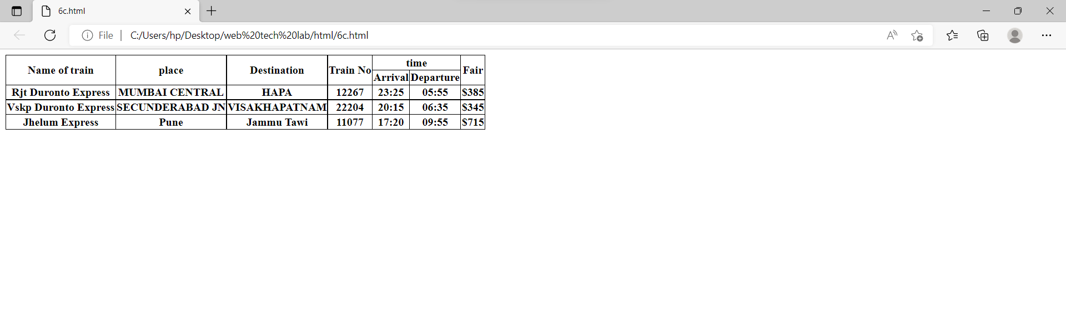

c. Create a web page in the following table fields

|  |  |  |  |  |  |  |  |  |  |  |
| --- | --- | --- | --- | --- | --- | --- | --- | --- | --- | --- |
| |  |  |  | | --- | --- | --- | | Name of train |  |  | | place | Destination | |  | | --- | | Train No | | Time | | Fare |
| Arrival | Departure |  |

Source code:

<html>

<head>

<style>

table, th, td {

border: 1px solid black;

border-collapse: collapse;

}

</style>

</head>

<body>

<table>

<tr>

<th rowspan="2">Name of train</th>

<th rowspan="2">place</th>

<th rowspan="2">Destination</th>

<th rowspan="2">Train No</th>

<th colspan="2">time</th>

<th rowspan="2">Fair</th>

</tr>

<tr>

<th>Arrival</th>

<th>Departure</th>

</tr>

<tr>

<th>Rjt Duronto Express</th>

<th>MUMBAI CENTRAL</th>

<th>HAPA</th>

<th>12267</th>

<th>23:25</th>

<th>05:55</th>

<th>$385</th>

</tr>

<tr>

<th>Vskp Duronto Express</th>

<th>SECUNDERABAD JN</th>

<th>VISAKHAPATNAM</th>

<th>22204</th>

<th>20:15</th>

<th>06:35</th>

<th>$345</th>

</tr>

<tr>

<th>Jhelum Express</th>

<th>Pune</th>

<th>Jammu Tawi</th>

<th>11077</th>

<th>17:20</th>

<th>09:55</th>

<th>$715</th>

</tr>

</table>

</body>

</html>

Output:

7.

a

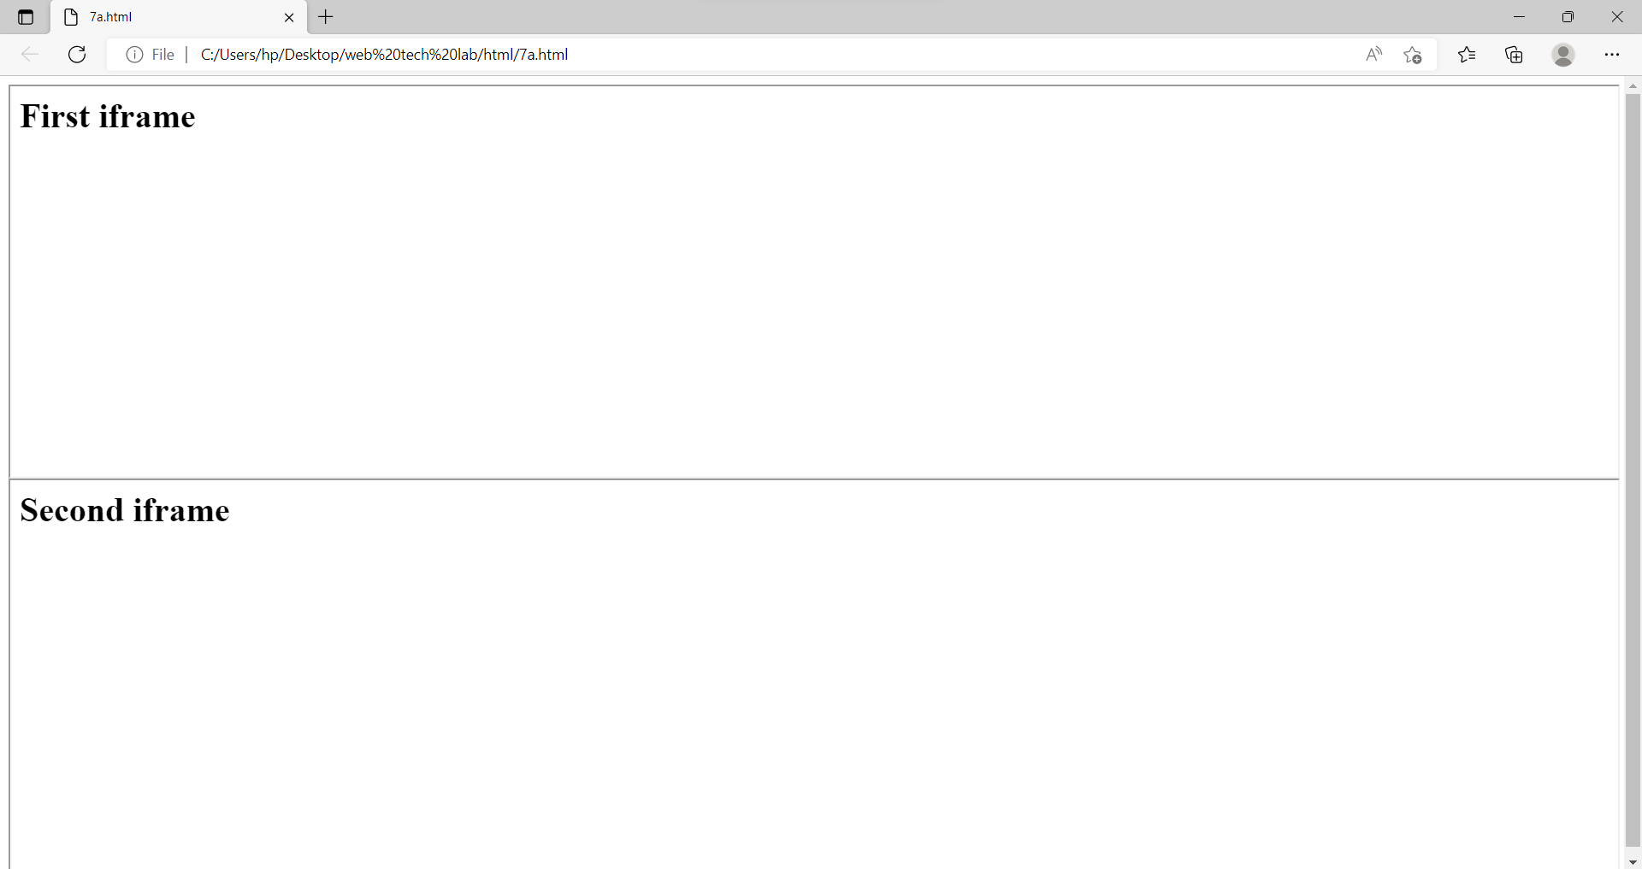

7.

a. Develop a web page having two frames that divide the Web page into two equal rows.

Source code:

<html>

<head>

</head>

<body>

<iframe src="7aa.html" height=50% width=100%></iframe>

<iframe src="7ab.html" height=50% width=100%></iframe>

</body>

</html>

<html>

<head>

</head>

<body>

<h1>First iframe</h1>

</body>

</html>

<html>

<head>

</head>

<body>

<h1>Second iframe</h1>

</body>

</html>

b

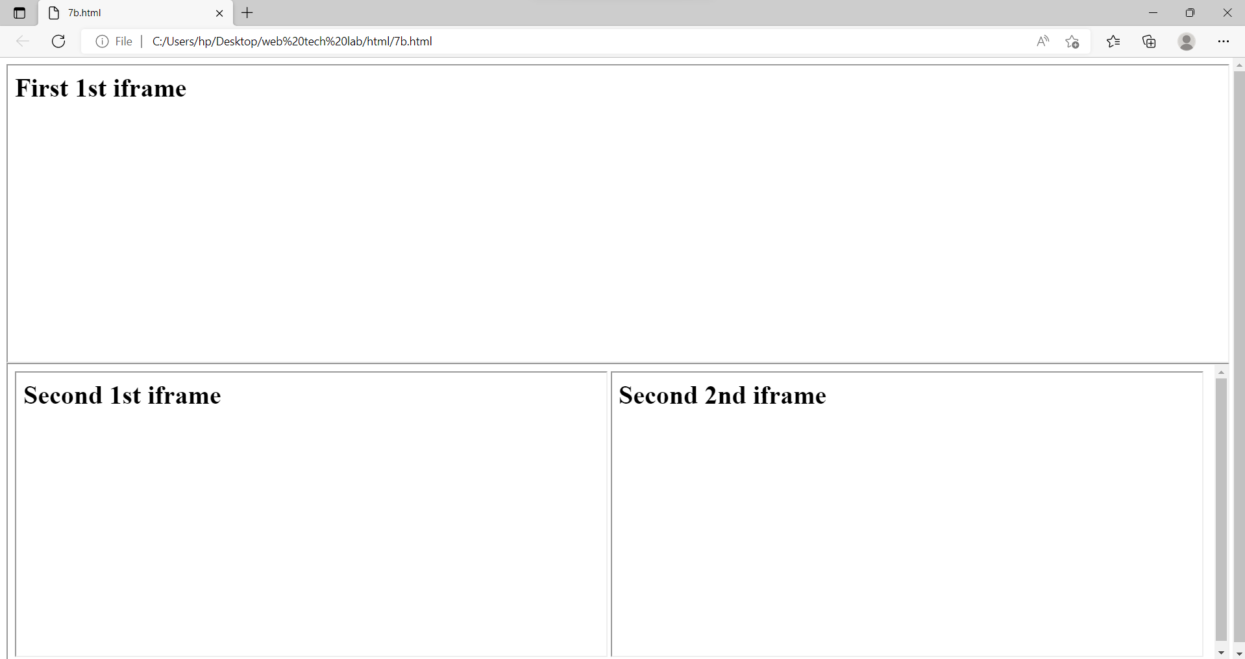

b. Develop a web page having two frames that divide the Web page into two equal rows and then divide the second row into two equal columns.

Source code:

<html>

<head>

</head>

<body>

<iframe src="7ba.html" height=50% width=100%></iframe>

<iframe src="7bb.html" height=50% width=100%></iframe>

</body>

</html>

<html>

<head>

</head>

<body>

<h1>First 1st iframe</h1>

</body>

</html>

<html>

<head>

</head>

<body>

<iframe src="7b1.html" height=100% width=49.4%></iframe>

<iframe src="7b2.html" height=100% width=49.4%></iframe>

</body>

</html>

<html>

<head>

</head>

<body>

<h1>Second 1st iframe</h1>

</body>

</html>

<html>

<head>

</head>

<body>

<h1>Second 2nd iframe</h1>

</body>

</html>

c

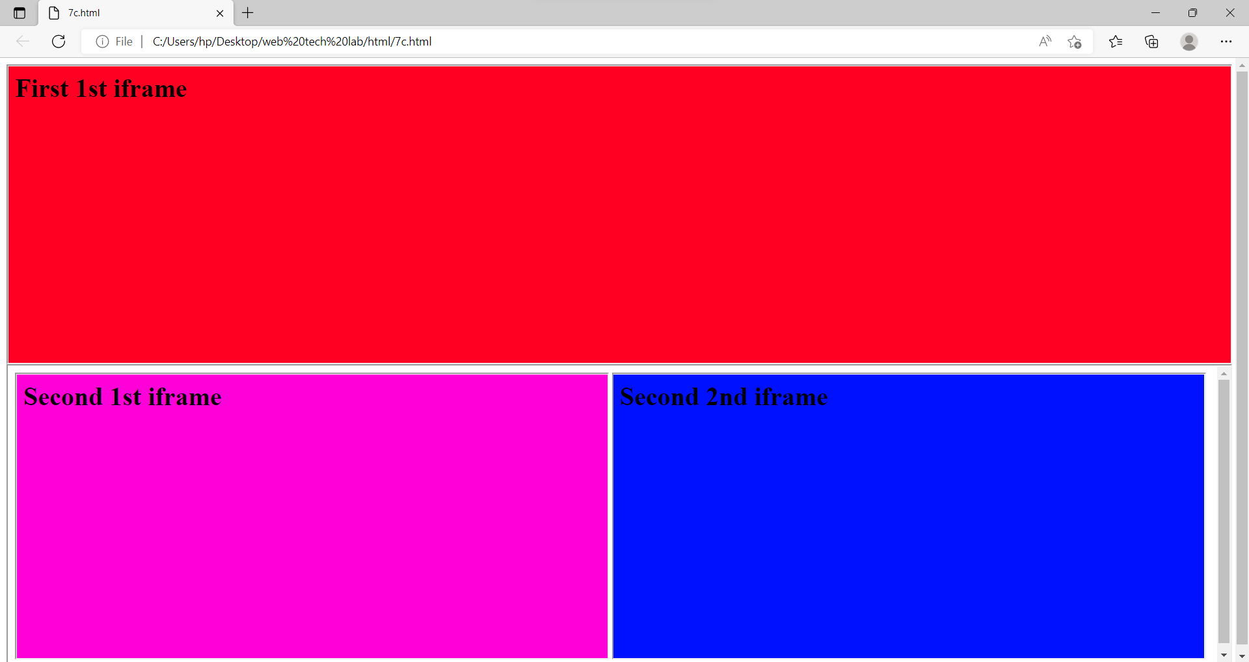

c. Develop a web page having frames as described in the above web page and then fill each frame with a different background colour

Source code:

<html>

<head>

</head>

<body>

<iframe src="7ca.html" height=50% width=100%></iframe>

<iframe src="7cb.html" height=50% width=100%></iframe>

</body>

</html>

<html>

<head>

</head>

<body style="background-color:#ff0022">

<h1>First 1st iframe</h1>

</body>

</html>

<html>

<head>

</head>

<body>

<iframe src="7c1.html" height=100% width=49.4%></iframe>

<iframe src="7c2.html" height=100% width=49.4%></iframe>

</body>

</html>

<html>

<head>

</head>

<body style="background-color:#ff00d9">

<h1>Second 1st iframe</h1>

</body>

</html>

<html>

<head>

</head>

<body style="background-color:#0011ff">

<h1>Second 2nd iframe</h1>

</body>

</html>

Output:

8.

a

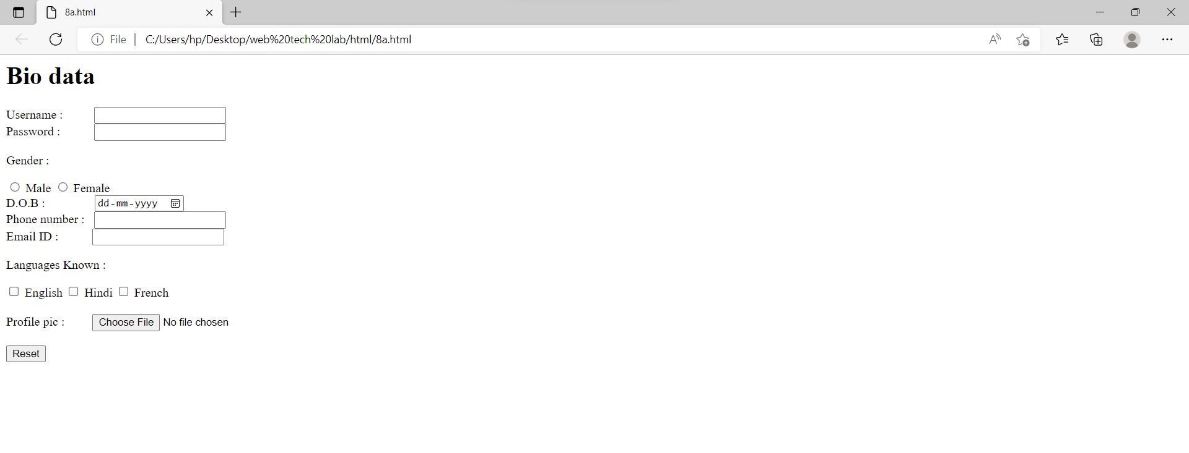

8.

a. Create your bio-data form on a web page using all input types

Source code:

<html>

<head>

</head>

<body>

<h1>Bio data</h1>

<form>

<label for="name">Username : &nbsp;&nbsp;&nbsp;&nbsp;&nbsp;&nbsp;&nbsp;&nbsp;</label>

<input type="text" id="name" name="name"><br>

<label for="key">Password : &nbsp;&nbsp;&nbsp;&nbsp;&nbsp;&nbsp;&nbsp;&nbsp;&nbsp;</label>

<input type="password" id="key" name="key"><br>

<p>Gender : </p>

<input type="radio" id="Male" name="gender" value="Male">

<label for="Male">Male </label>

<input type="radio" id="Female" name="gender" value="Female">

<label for="Female">Female </label><br>

<label for="dob">D.O.B : &nbsp;&nbsp;&nbsp;&nbsp;&nbsp;&nbsp;&nbsp;&nbsp;&nbsp;&nbsp;&nbsp;&nbsp;&nbsp;&nbsp;</label>

<input type="date" id="dob" name="dob"><br>

<label for="numb">Phone number : &nbsp;</label>

<input type="number" id="numb" name="numb"><br>

<label for="email">Email ID : &nbsp;&nbsp;&nbsp;&nbsp;&nbsp;&nbsp;&nbsp;&nbsp;&nbsp;</label>

<input type="email" id="email" name="email"><br>

<p>Languages Known : </p>

<input type="checkbox" id="lan1" name="language" value="English">

<label for="lan1">English</label>

<input type="checkbox" id="lan2" name="language" value="Hindi">

<label for="lan2">Hindi</label>

<input type="checkbox" id="lan3" name="language" value="French">

<label for="lan3">French</label><br><br>

<label for="myfile">Profile pic : &nbsp;&nbsp;&nbsp;&nbsp;&nbsp;&nbsp;&nbsp;</label>

<input type="file" id="myfile" name="myfile"><br><br>

<input type="reset">

</form>

</body>

</html>

b

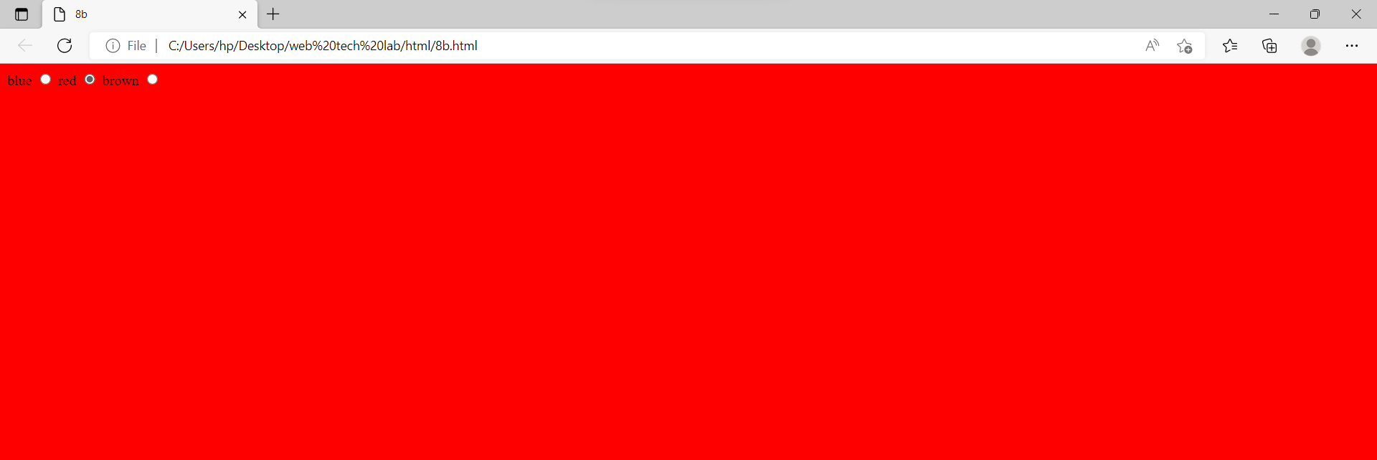

b. Create a web page having radio buttons labeled as name of colours. Clicking on each radio button should change the colour of the Web page

Source code:

<!DOCTYPE html>

<html lang="en" dir="ltr">

<head>

<meta charset="utf-8">

<title>8b</title>

</head>

<body id="background">

<label>blue</label>

<input type="radio" onclick="change_color('blue');" name="color" id="blue">

<label>red</label>

<input type="radio" onclick="change_color('red');" name="color" id="red">

<label>brown</label>

<input type="radio" onclick="change_color('brown');" name="color" id="brown">

<script type="text/javascript">

function change_color(newcolor){

var element=document.getElementById('background').style.background=newcolor;

}

</script>

</body>

</html>

c

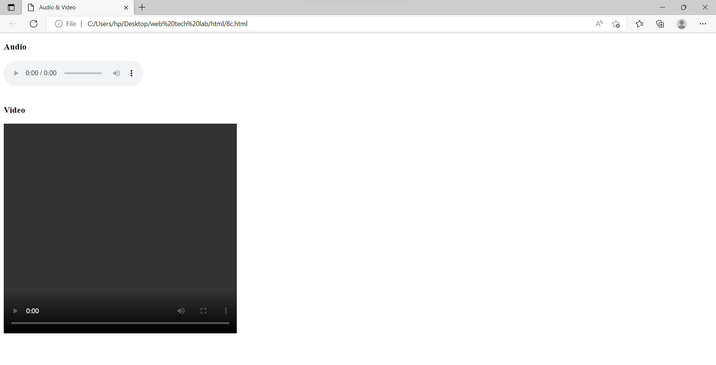

c. Embed Audio and Video into your web page

Source code:

<!DOCTYPE html>

<html lang="en" dir="ltr">

<head>

<meta charset="utf-8">

<title>Audio & Video</title>

</head>

<body>

<h3>Audio</h3>

<audio src="1.mp3" controls="controls" width="50" heigth="50">

</audio>

<br>

<br>

<h3>Video</h3>

<video src="" controls="controls" width="500" height="450">

</video>

</body>

</html>

Output:

9.

a

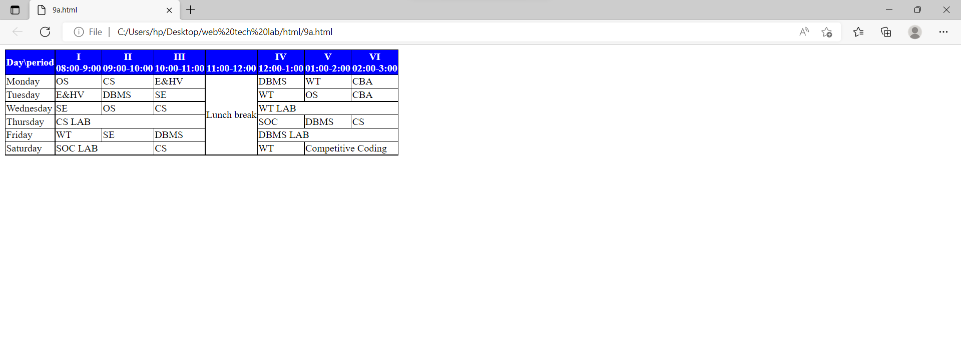

9.

Create a webpage which displays the class time table and apply the following effects on the table:

a. For the table header apply blue as the background colour and white for the colour of the text in the table header.

Source code:

<!DOCTYPE html>

<html>

<head>

<style>

th

{

background-color:blue;

color:white;

border:1px solid black;

border-collapse:collapse;

}

table,td

{

border:1px solid black;

border-collapse:collapse;

}

</style>

</head>

<body>

<table>

<tr>

<th>Day\period</th>

<th>I<br>08:00-9:00</th>

<th>II<br>09:00-10:00</th>

<th>III<br>10:00-11:00</th>

<th><br>11:00-12:00</th>

<th>IV<br>12:00-1:00</th>

<th>V<br>01:00-2:00</th>

<th>VI<br>02:00-3:00</th>

</tr>

<tr>

<td>Monday</td>

<td>OS</td>

<td>CS</td>

<td>E&HV</td>

<td rowspan=6>Lunch break</td>

<td>DBMS</td>

<td>WT</td>

<td>CBA</td>

</tr>

<tr>

<td>Tuesday</td>

<td>E&HV</td>

<td>DBMS</td>

<td>SE</td>

<td>WT</td>

<td>OS</td>

<td>CBA</td>

</tr>

<tr>

<td>Wednesday</td>

<td>SE</td>

<td>OS</td>

<td>CS</td>

<td colspan=3>WT LAB</td>

</tr>

<tr>

<td>Thursday</td>

<td colspan=3>CS LAB</td>

<td>SOC</td>

<td>DBMS</td>

<td>CS</td>

</tr>

<tr>

<td>Friday</td>

<td>WT</td>

<td>SE</td>

<td>DBMS</td>

<td colspan=3>DBMS LAB</td>

</tr>

<tr>

<td>Saturday</td>

<td colspan=2>SOC LAB</td>

<td>CS</td>

<td>WT</td>

<td colspan=2>Competitive Coding</td>

</tr>

</table>

</body>

</html>

b

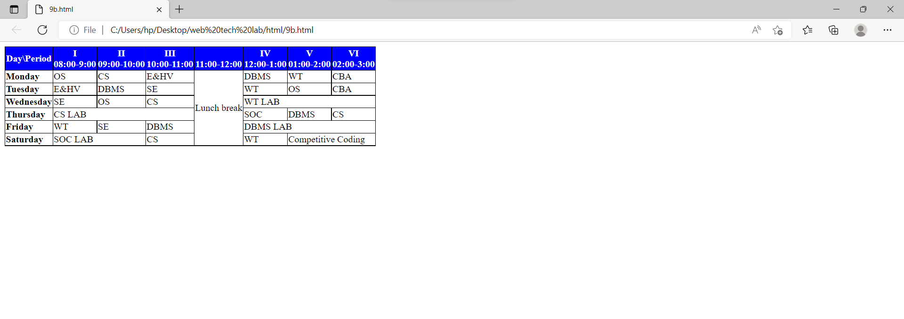

b. Display days in a week (Mon, Tue etc...) in bold format with the first letter in the day name in uppercase.

Source code:

<!DOCTYPE html>

<html>

<head>

<style>

th

{

background-color:blue;

color:white;

border:1px solid black;

border-collapse:collapse;

}

table,td

{

border:1px solid black;

border-collapse:collapse;

}

</style>

</head>

<body>

<table>

<tr>

<th>Day\Period</th>

<th>I<br>08:00-9:00</th>

<th>II<br>09:00-10:00</th>

<th>III<br>10:00-11:00</th>

<th><br>11:00-12:00</th>

<th>IV<br>12:00-1:00</th>

<th>V<br>01:00-2:00</th>

<th>VI<br>02:00-3:00</th>

</tr>

<tr>

<td><b><span style="text-transform:uppercase;">M</span>onday</b></td>

<td>OS</td>

<td>CS</td>

<td>E&HV</td>

<td rowspan=6>Lunch break</td>

<td>DBMS</td>

<td>WT</td>

<td>CBA</td>

</tr>

<tr>

<td><b><span style="text-transform:uppercase;">T</span>uesday</b></td>

<td>E&HV</td>

<td>DBMS</td>

<td>SE</td>

<td>WT</td>

<td>OS</td>

<td>CBA</td>

</tr>

<tr>

<td><b><span style="text-transform:uppercase;">W</span>ednesday</b></td>

<td>SE</td>

<td>OS</td>

<td>CS</td>

<td colspan=3>WT LAB</td>

</tr>

<tr>

<td><b><span style="text-transform:uppercase;">T</span>hursday</b></td>

<td colspan=3>CS LAB</td>

<td>SOC</td>

<td>DBMS</td>

<td>CS</td>

</tr>

<tr>

<td><b><span style="text-transform:uppercase;">F</span>riday</b></td>

<td>WT</td>

<td>SE</td>

<td>DBMS</td>

<td colspan=3>DBMS LAB</td>

</tr>

<tr>

<td><b><span style="text-transform:uppercase;">S</span>aturday</b></td>

<td colspan=2>SOC LAB</td>

<td>CS</td>

<td>WT</td>

<td colspan=2>Competitive Coding</td>

</tr>

</table>

</body>

</html>

c

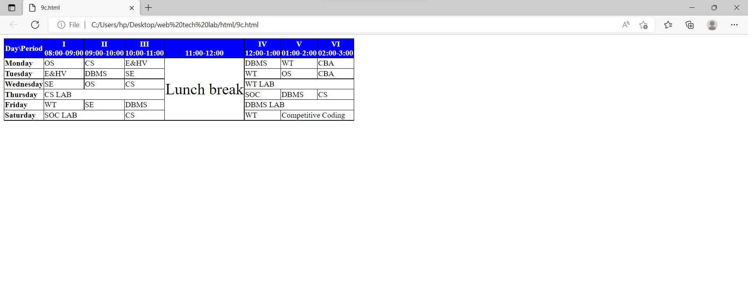

c. Display lunch slightly in bigger font other than the remaining text.

Source code:

<html>

<head>

<style>

th

{

background-color:blue;

color:white;

border:1px solid black;

border-collapse:collapse;

}

table,td

{

border:1px solid black;

border-collapse:collapse;

}

</style>

</head>

<body>

<table>

<tr>

<th>Day\Period</th>

<th>I<br>08:00-09:00</th>

<th>II<br>09:00-10:00</th>

<th>III<br>10:00-11:00</th>

<th><br>11:00-12:00</th>

<th>IV<br>12:00-1:00</th>

<th>V<br>01:00-2:00</th>

<th>VI<br>02:00-3:00</th>

</tr>

<tr>

<td><b><span style="text-transform:uppercase;">M</span>onday</b></td>

<td>OS</td>

<td>CS</td>

<td>E&HV</td>

<td rowspan=6><font size="+3">Lunch break</font></td>

<td>DBMS</td>

<td>WT</td>

<td>CBA</td>

</tr>

<tr>

<td><b><span style="text-transform:uppercase;">T</span>uesday</b></td>

<td>E&HV</td>

<td>DBMS</td>

<td>SE</td>

<td>WT</td>

<td>OS</td>

<td>CBA</td>

</tr>

<tr>

<td><b><span style="text-transform:uppercase;">W</span>ednesday</b></td>

<td>SE</td>

<td>OS</td>

<td>CS</td>

<td colspan=3>WT LAB</td>

</tr>

<tr>

<td><b><span style="text-transform:uppercase;">T</span>hursday</b></td>

<td colspan=3>CS LAB</td>

<td>SOC</td>

<td>DBMS</td>

<td>CS</td>

</tr>

<tr>

<td><b><span style="text-transform:uppercase;">F</span>riday</b></td>

<td>WT</td>

<td>SE</td>

<td>DBMS</td>

<td colspan=3>DBMS LAB</td>

</tr>

<tr>

<td><b><span style="text-transform:uppercase;">S</span>aturday</b></td>

<td colspan=2>SOC LAB</td>

<td>CS</td>

<td>WT</td>

<td colspan=2>Competitive Coding</td>

</tr>

</table>

</body>

</html>

Output:

10.

a

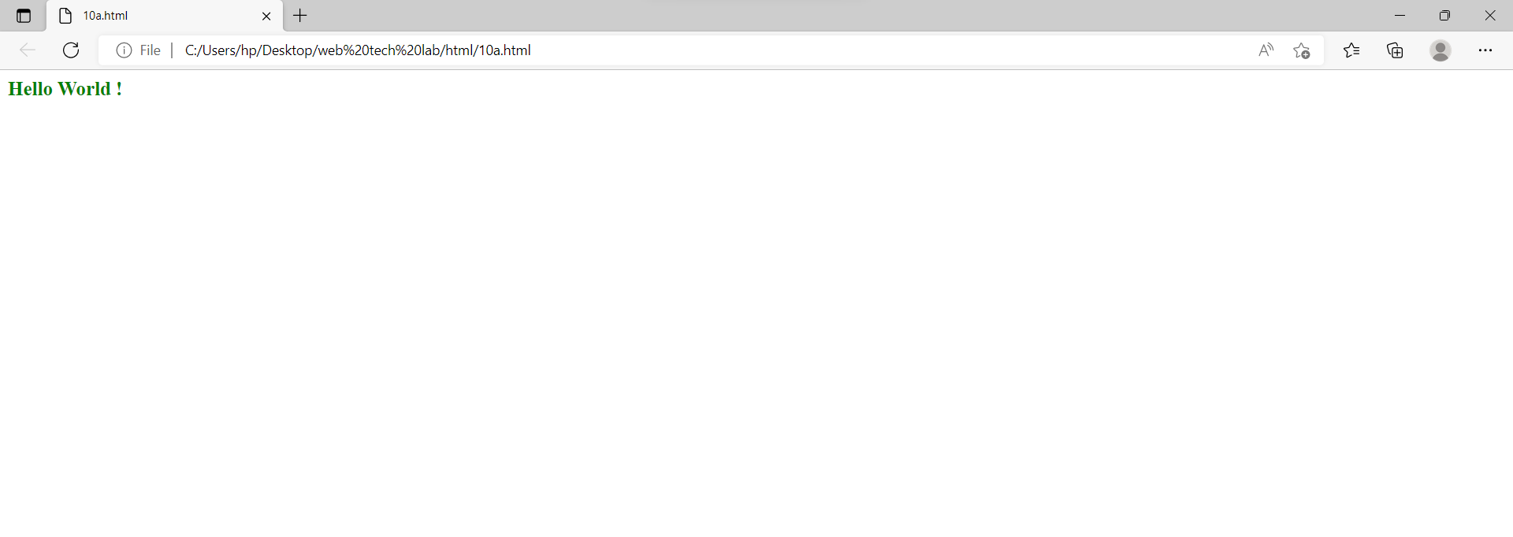

10.

a. Create a webpage which displays "Hello World" with font size 20 pixels, bold format, in "Times New Roman" font and green in colour using inline CSS, embedded CSS and external CSS.

Source code:

<html>

<head>

<style>

p{

color:green;

font-style:"Times New Roman";

font-size:20px;

font-weight: bold;

}

</style>

</head>

<body>

<p>Hello World !</p>

</body>

</html>

b

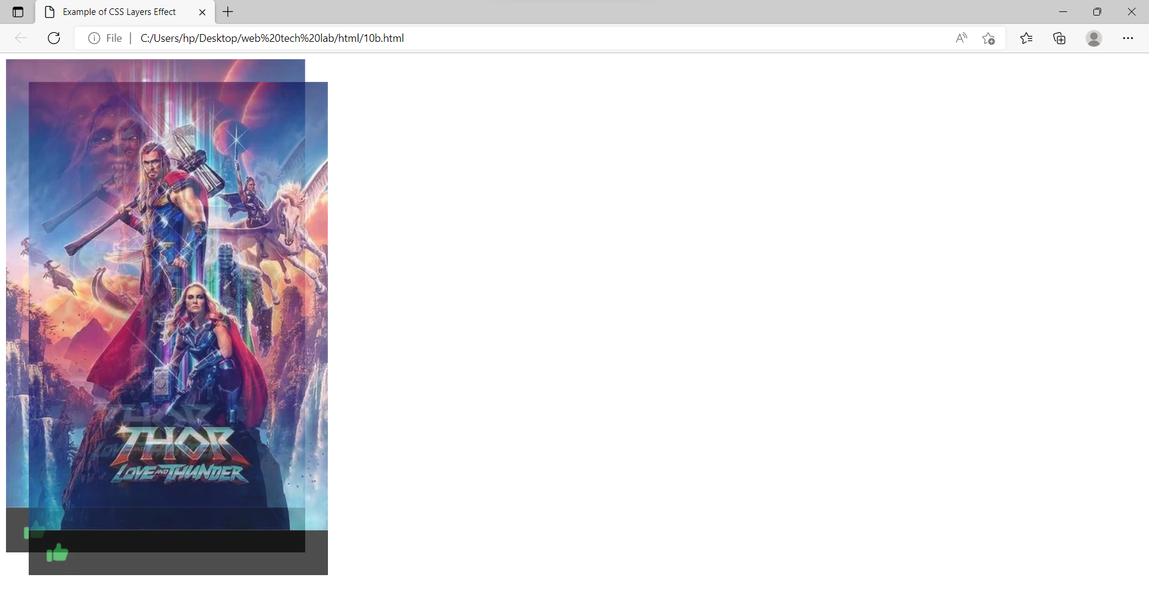

b. Create a web page containing two images, where one image overlaps another image by using the z-index CSS property.

Source code:

<html>

<head>

<title>Example of CSS Layers Effect</title>

<style>

.container{

position: relative;

}

.box{

width: 150px;

height: 150px;

opacity: 0.7;

position: absolute;

}

.red{

z-index: 1;

}

.green{

top: 30px;

left: 30px;

background: #00ff00;

z-index: 2;

}

</style>

</head>

<body>

<div class="container">

<div class="box red"><img src="https://assets-in.bmscdn.com/discovery-catalog/events/tr:w-400,h-600,bg-CCCCCC:w-400.0,h-660.0,cm-pad_resize,bg-000000,fo-top:oi-discovery-

catalog@@icons@@like_202006280402.png,ox-24,oy-617,ow-29:q-80/et00302403-jmbsnyjdek-portrait.jpg" alt="W3Schools.com"></div>

<div class="box green"><img src="https://assets-in.bmscdn.com/discovery-catalog/events/tr:w-400,h-600,bg-CCCCCC:w-400.0,h-660.0,cm-pad_resize,bg-000000,fo-top:oi-discovery-catalog@@icons@@like_202006280402.png,ox-24,oy-617,ow-29:q-80/et00302403-jmbsnyjdek-portrait.jpg" alt="W3Schools.com"></div>

</div>

</body>

</html>

c

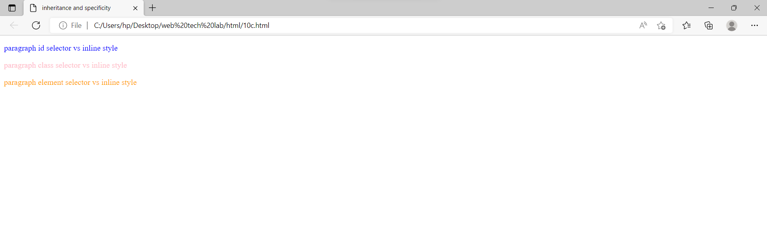

c. Demonstrate the usage of CSS Inheritance and Specificity with an example.

Source code:

<html>

<head>

<title>inheritance and specificity</title>

<style>

#id

{

color:red;

}

class

{

color:tomato;

}

p

{

color:cyan;

}

</style>

</head>

<body>

<p class="id" style="color:blue;" >paragraph id selector vs inline style</p>

<p class="class" style="color:pink;">paragraph class selector vs inline style</p>

<p style="color:orange;">paragraph element selector vs inline style</p>

</body>

</html>

Output:

11.

a

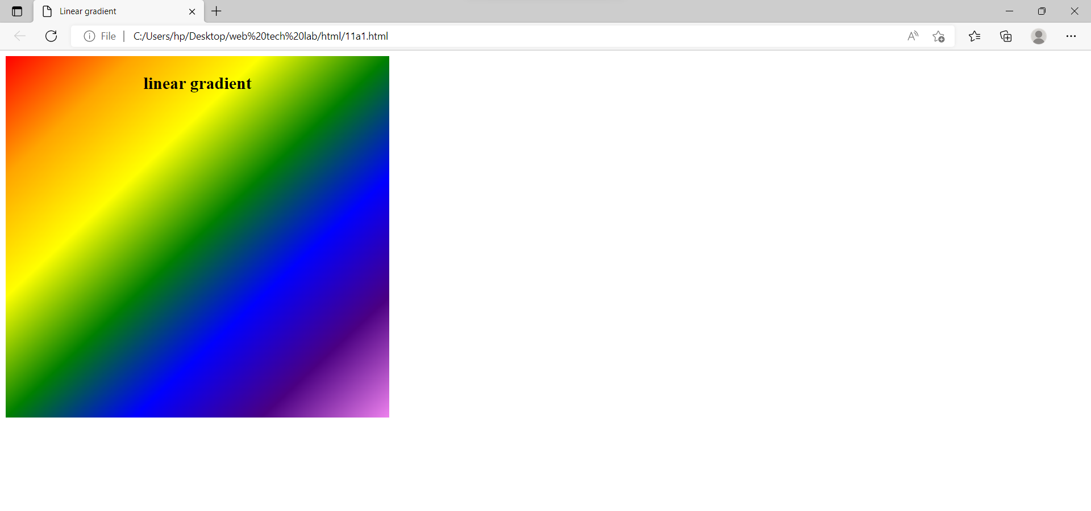

11.

a. Create a div element with a width and height of 500px. Create a diagonal linear gradient using the colors of the rainbow—Red, Orange, Yellow, Green, Blue, Indigo, Violet. (Linear Gradient)

Source code:

<!DOCTYPE html>

<html>

<head>

<title>webpage</title>

<style>

div

{

width=500px;

height:400px;

border:3px solid black;

margin:10px;

padding:5px;

background-image:linear-gradient(to bottom right,red,orange,yellow,green,blue,indigo,violet);

}

</style>

</head>

<body>

<div></div>

</body>

</html>

<!DOCTYPE html>

<html lang="en" dir="ltr">

<head>

<meta charset="utf-8">

<title>Linear gradient</title>

<style type="text/css">

#angle{

width:500px;

height:500px;

border:3px solidpurple;

padding: 5px 20px;

text-align:center;

background:linear-gradient(to bottom right,red,orange,yellow,green,blue,indigo,violet);

}

</style>

</head>

<body>

<div id="angle">

<h2>

linear gradient

</h2>

</div>

</body>

</html>

b

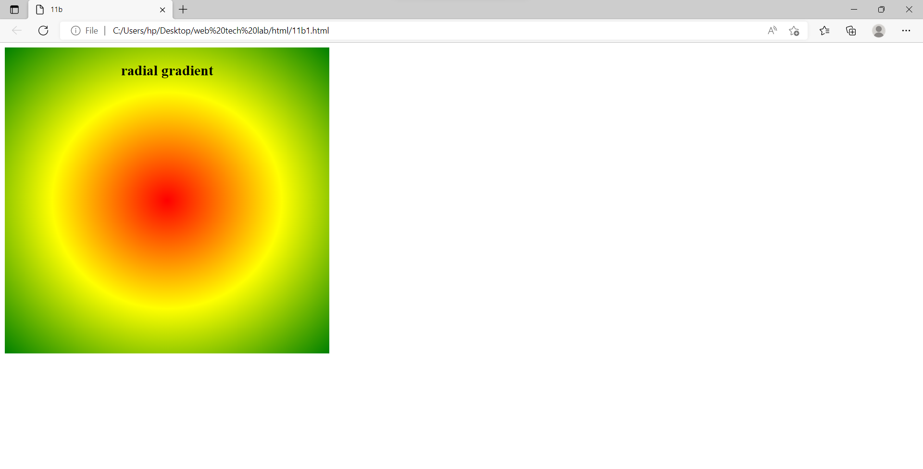

b. Create a div element with a width and height of 500px. Create a radial gradient with three colors. Start the gradient in the bottom-left corner with the colors changing as they move along the gradient line to the right. (Radial Gradient)

Source code:

<!DOCTYPE html>

<html>

<head>

<title>web page</title>

<style>

div

{

width:500px;

height:500px;

border:1px solid black;

padding:5px 5px;

margin:50px 50px;

background-image:radial-gradient(ellipse at bottom left ,yellow,red,blue);

}

</style>

</head>

<body>

<div></div>

</body>

</html>

<!DOCTYPE html>

<html lang="en" dir="ltr">

<head>

<meta charset="utf-8">

<title>11b</title>

<style type="text/css">

#angle{

width:500px;

height:500px;

border:3px solidpurple;

padding: 5px 20px;

text-align:center;

background:radial-gradient(red,yellow,green);

}

</style>

</head>

<body>

<div id="angle">

<h2>

radial gradient

</h2>

</div>

</body>

</html>

c

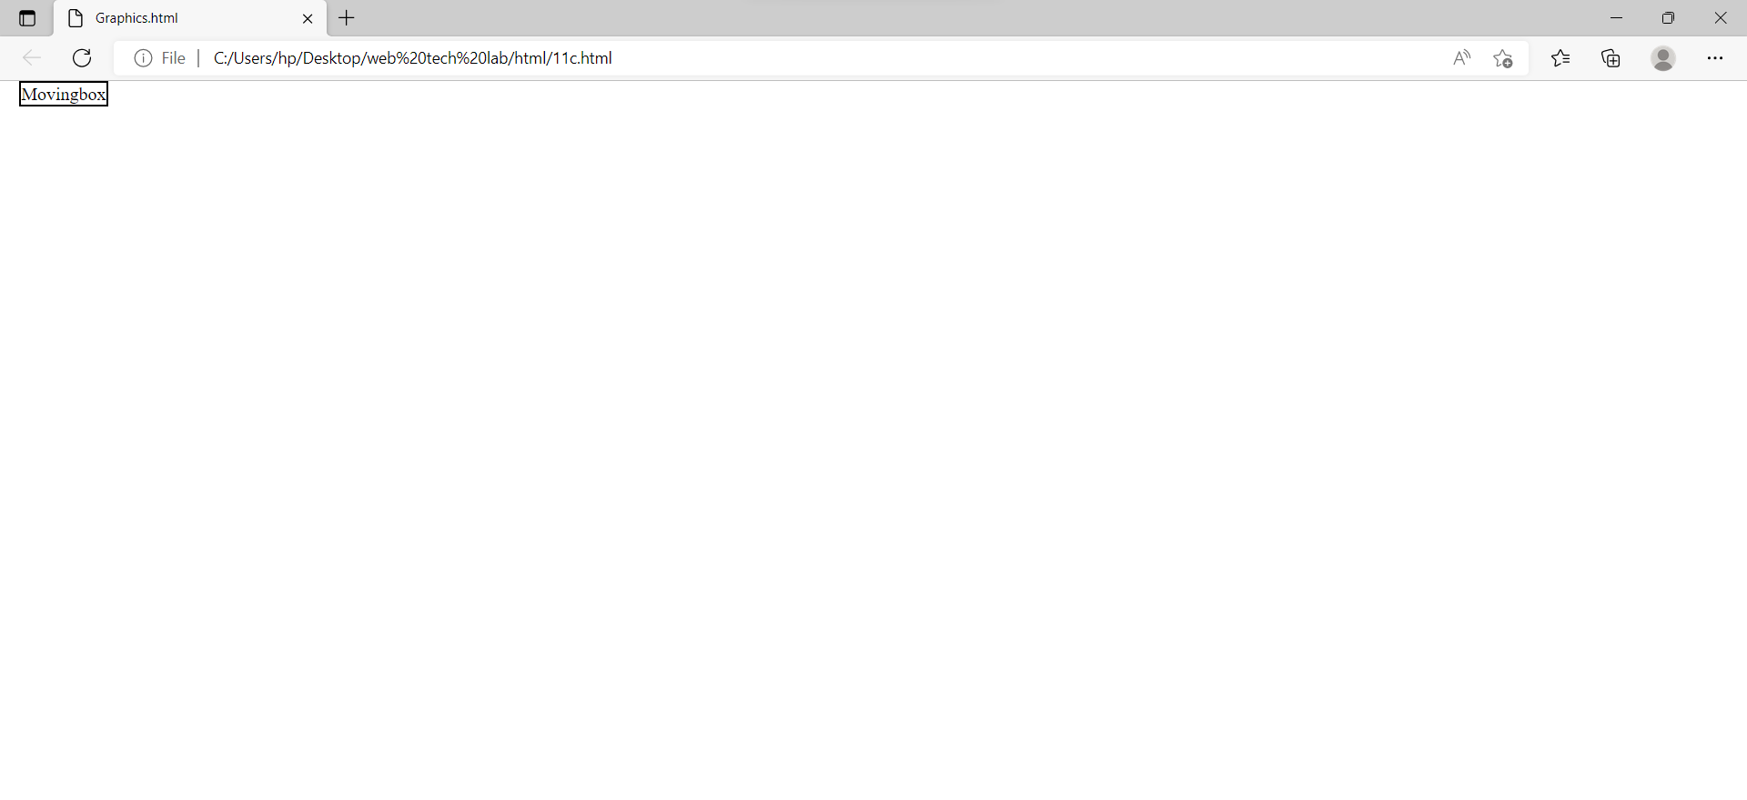

c. Create an infinite animation of an element moving in a square pattern. (Animation)

Source code:

<html lang="en" ><head>

<title>Graphics.html</title>

<style type = "text/css">

@-webkit-keyframes anim { 0% {left :0px; top: 0px;}

25% {left :100px; top: 0px;}

50% {left :100px; top: 100px;}

75% {left :0px; top: 100px;}

100% {left: 0px; top: 0px;} }

@keyframes anim{ 0% {left :0px; top: 0px;}

25% {left :100px; top: 0px;}

50% {left :100px; top: 100px;}

75% {left :0px; top: 100px;}

100% {left: 0px; top: 0px;} }

@-moz-keyframes anim { 0% {left :0px; top: 0px;}

25% {left :100px; top: 0px;}

50% {left :100px; top: 100px;}

75% {left :0px; top: 100px;}

100% {left: 0px; top: 0px;} }

@-o-keyframes anim { 0% {left :0px; top: 0px;}

25% {left :100px; top: 0px;}

50% {left :100px; top: 100px;}

75% {left :0px; top: 100px;}

100% {left: 0px; top: 0px;} }

#box { position: absolute; border: 2px solid black; -moz-animation: anim 5s linear infinite; -o-animation: anim 5s linear infinite; animation: anim 5s linear infinite; }

</style>

</head><body> <div id = "box"> Movingbox</div></body></html>

Output:

1.

a

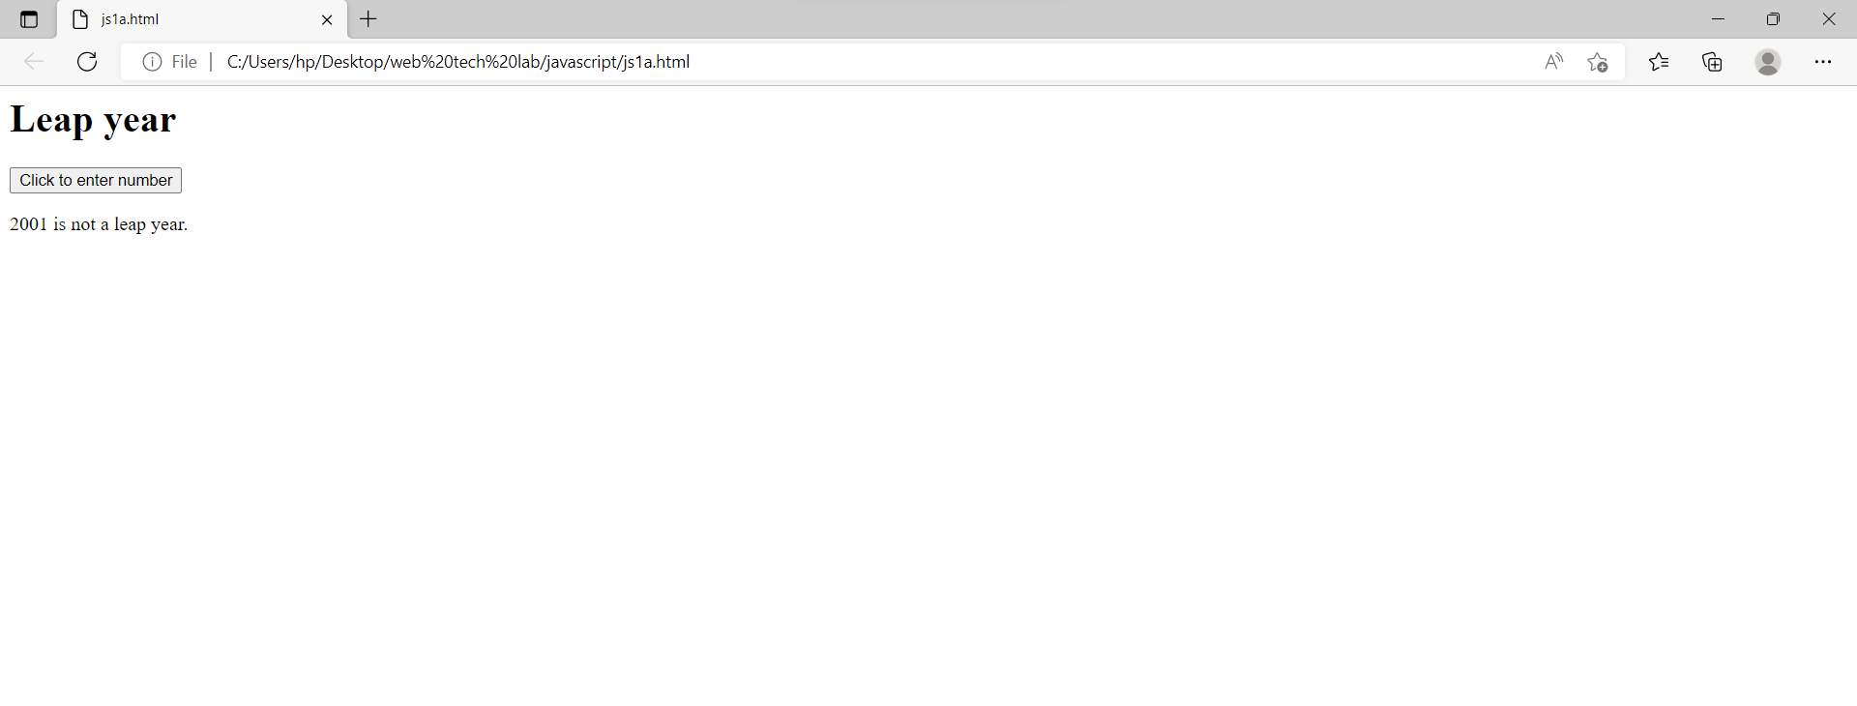

**Lab cycle – 2**

1. Write a java scripts to

a) Find the given year is leap year or not

Source code:

<html>

<head>

</head>

<body>

<h1>Leap year</h1>

<button onclick="leap_year()">Click to enter number</button>

<p id="demo"></p>

<script>

function leap_year(){

let num = prompt("Enter number :",);

if ((num%4 == 0 && num%100 != 0) || (num%400 == 0)){

document.getElementById("demo").innerHTML = num+" is a leap year.";

}

else{

document.getElementById("demo").innerHTML = num+" is not a leap year.";

}

}

</script>

</body>

</html>

b

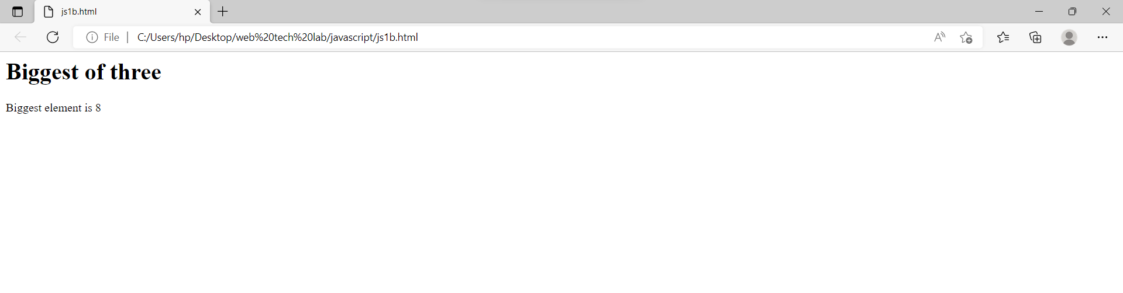

b) Compute the biggest of three numbers

Source code:

<html>

<head>

</head>

<body>

<h1>Biggest of three</h1>

<p id="demo"><p>

<script>

let n1 = prompt("Enter 1st number :",);

let n2 = prompt("Enter 2nd number :",);

let n3 = prompt("Enter 3rd number :",);

if(n1>=n2 && n1>=n3){

document.getElementById("demo").innerHTML = "Biggest element is " + n1;

}

else if(n2>=n1 && n2>=n3){

document.getElementById("demo").innerHTML = "Biggest element is " + n2;

}

else{

document.getElementById("demo").innerHTML = "Biggest element is " + n3;

}

</script>

</body>

</html>

c

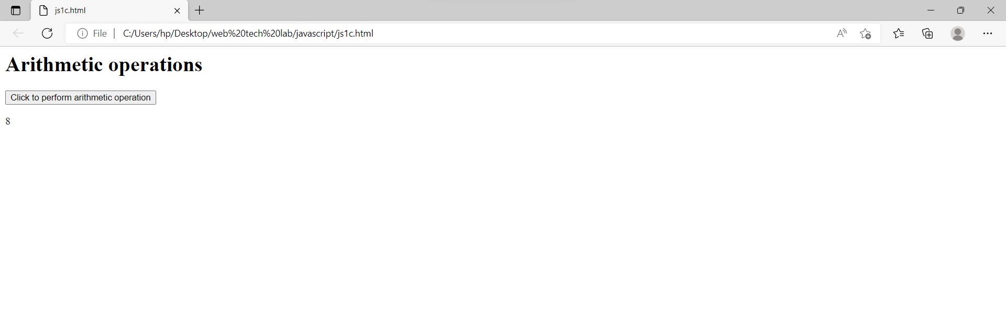

c) Perform the arithmetic operations using switch statement

Source code:

<html>

<body>

<h1>Arithmetic operations</h1>

<button onclick="cal()">Click to perform arithmetic operation</button>

<p id="demo"></p>

<script>

function cal(){

let n1 = prompt("Enter 1st number :",);

let n2 = prompt("Enter 2nd number :",);

let c = prompt("Enter 1 to Add, 2 to Subtract, 3 to Multiply, 4 to Divide",);

n1 = Number(n1);

n2 = Number(n2);

switch (Number(c)){

case 1:

document.getElementById("demo").innerHTML = n1+n2;

break;

case 2:

document.getElementById("demo").innerHTML = n1-n2;

break;

case 3:

document.getElementById("demo").innerHTML = n1*n2;

break;

case 4:

document.getElementById("demo").innerHTML = n1/n2;

break;

}

} </script></body></head>

Output:

2.

a

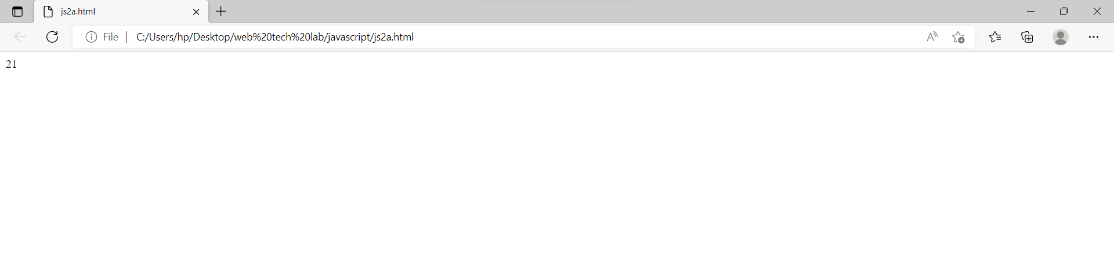

2. Write a java script to

a) Calculate the sum of the digits of a give number

Source code:

<html>

<head>

</head>

<body>

<p id="demo"></p>

<script>

let a = prompt("Enter string number :",);

let s = 0;

for(let i=0;i<a.length;i++){

s = s + Number(a[i]);

}

document.getElementById("demo").innerHTML = s;

</script>

</body>

</html>

b

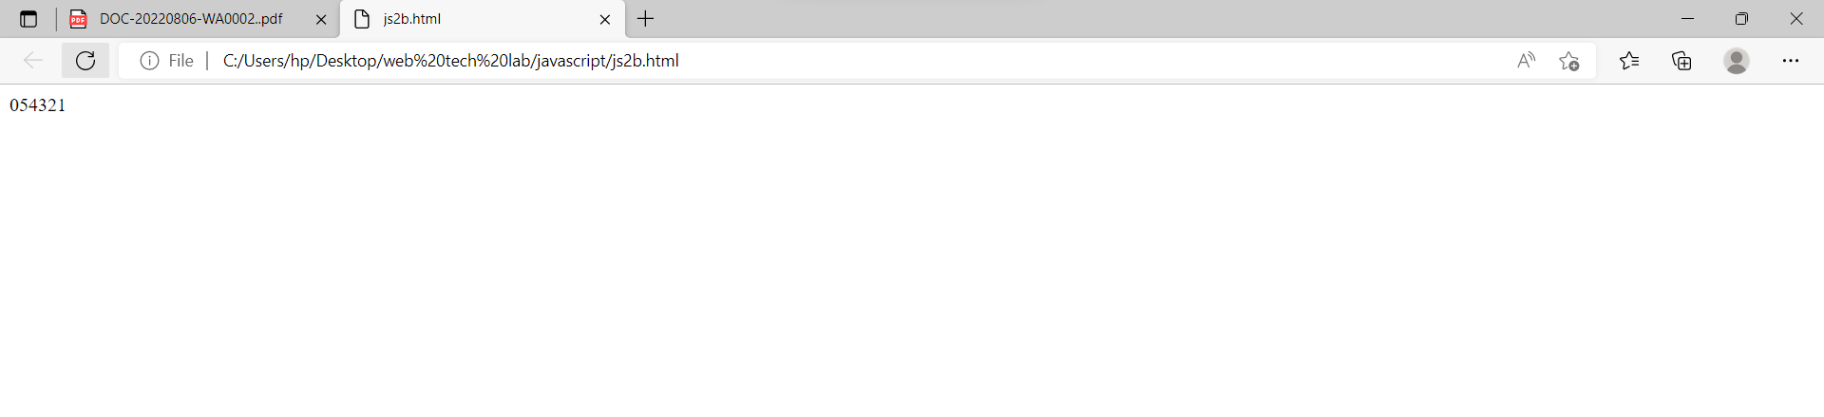

b) Reverse of a given number

Source code:

<html>

<body>

<p id="demo"></p>

<script>

let a = prompt("Enter number :",);

let c = 0;

for(let i = a.length-1; i >= 0; i--){

c = c + a[i];

}

document.getElementById("demo").innerHTML = c;

</script>

</body>

</html>

c

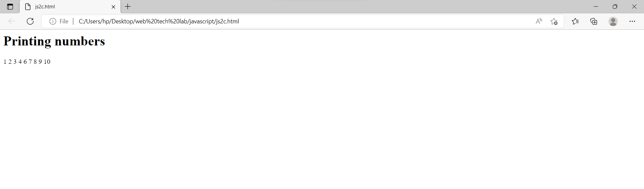

c) Print the first 10 natural numbers except 5

Source code:

<html>

<head>

</head>

<body>

<h1>Printing numbers</h1>

<script>

for(let i = 1; i <= 10; i++){

if (i!=5){

document.write(i+" ");}

}

</script>

</body></html>

Output:

3.

a

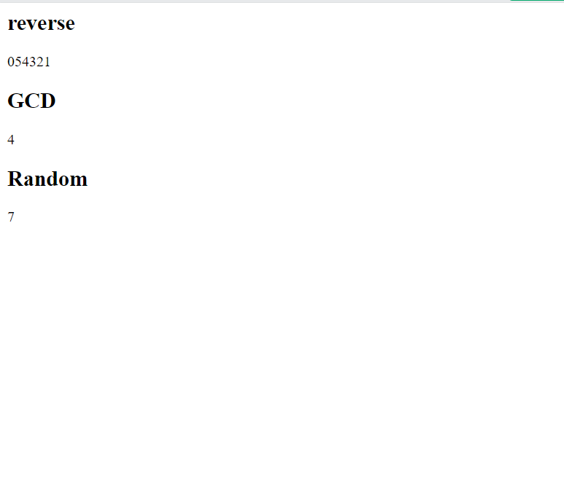

3. Write a java script to

a) functions (GCD, reverse, random numbers)

Source code:

<html>

<body>

<h2>reverse</h2>

<p id="demo"></p>

<h2>GCD</h2>

<p id="demo1"></p>

<h2>Random</h2>

<p id="demo2"></p>

<script>

function reverse(){

let a = prompt("Enter number :",);

let c = 0;

for(let i = a.length-1; i >= 0; i--){

c = c + a[i];

}

return c;

}

function gcd1(){

let a = prompt("Enter number a :",);

let b = prompt("Enter number b :",);

let result=0;

if (a<b){

result=a; }

else{

result=b;

}

while (result > 0) {

if (a % result == 0 && b % result == 0) {

break;

}

result=result-1;

}

return result;

}

function random(){

return Math.floor(Math.random() * 10);

}

document.getElementById("demo").innerHTML = reverse();

document.getElementById("demo1").innerHTML = gcd1();

document.getElementById("demo2").innerHTML = random();

</script>

</body>

</html>

b

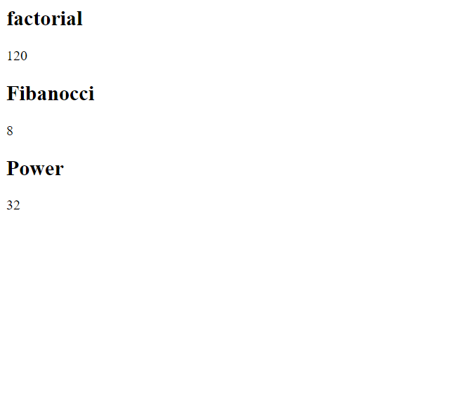

b)recursive function(factorial, Fibonacci , power)

Source code:

<html>

<body>

<h2>factorial</h2>

<p id="demo"></p>

<h2>Fibanocci</h2>

<p id="demo1"></p>

<h2>Power</h2>

<p id="demo2"></p>

<script>

function factorial(a){

if (a<=1){

return 1*a;

}

else{

return factorial(a-1)*a;

}

}

function fibonacci(x){

if(x==0){

return 0;

}

else if(x==1){

return 1;

}

else{

return (fibonacci(x-1) + fibonacci(x-2));

}}

function power(a,b){

if(b>=1){

return a*power(a,b-1);

}

else{

return 1;

}

}

document.getElementById("demo").innerHTML = factorial(5);

document.getElementById("demo1").innerHTML = fibonacci(6);

document.getElementById("demo2").innerHTML = power(2,5);

</script>

</body>

</html>

c

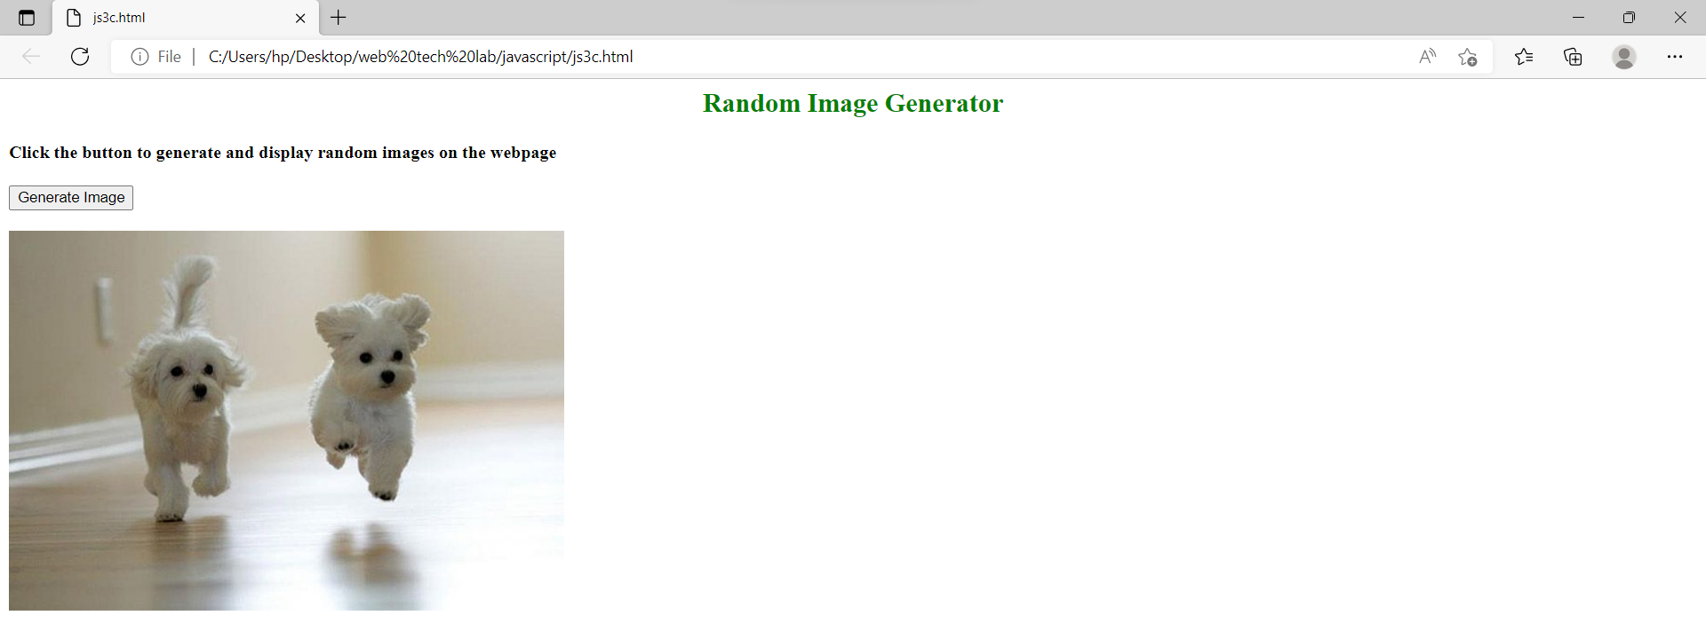

c) Display a random Image by clicking a button

Source code:

<html><body>

<script>

function getRandomImage() {

var randomImage = new Array();

randomImage[0] = "https://images.pexels.com/photos/858115/pexels-photo-858115.jpeg?auto=compress&cs=tinysrgb&dpr=1&w=500";

randomImage[1] = "http://www.petsworld.in/blog/wp-content/uploads/2014/09/running-cute-puppies.jpg";

randomImage[2] = "https://images.pexels.com/photos/142497/pexels-photo-142497.jpeg?auto=compress&cs=tinysrgb&dpr=1&w=500";

randomImage[3] = "https://images.unsplash.com/photo-1543877087-ebf71fde2be1?ixlib=rb-1.2.1&ixid=eyJhcHBfaWQiOjEyMDd9&auto=format&fit=crop&w=500&q=60";

randomImage[4] = "https://wi.wallpapertip.com/wsimgs/156-1565522_puppies-desktop-wallpaper-desktop-background-puppies.jpg";

randomImage[5] = "https://images.unsplash.com/photo-1501265976582-c1e1b0bbaf63?ixlib=rb-1.2.1&ixid=eyJhcHBfaWQiOjEyMDd9&auto=format&fit=crop&w=500&q=60";

var number = Math.floor(Math.random()*randomImage.length);

return document.getElementById("result").innerHTML = '<img src="'+randomImage[number]+'" />';

}

</script>

<body>

<center><h2 style="color:green"> Random Image Generator </h2></center>

<h4> Click the button to generate and display random images on the webpage </h4>

<button onclick = "setInterval(getRandomImage, 2000)"> Generate Image </button>

<br> <br>

<span id="result" align="center"> </span> </body></html>

Output:

4.

a

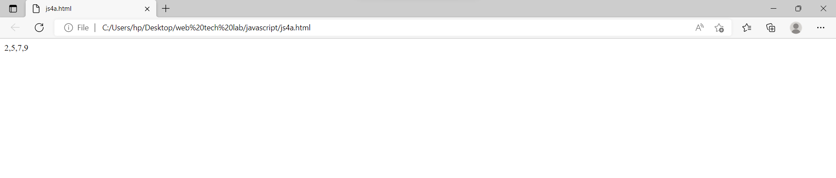

4. Write a java script to

a) Sort the array element using bubble sort technique

Source code:

<html>

<body>

<script>

let arr = [];

let n = prompt("Enter number of elements ",);

n = Number(n);

for(i=0; i<n; i++){

let a = prompt("Enter number "+(i+1)+" :",);

arr[i] = Number(a);

}

function bubble_sort(){

let j = 0;

let k = 0;

for(j=0; j<n; j++){

for(k=0; k<n-j; k++){

if(arr[k]>arr[k+1]){

let temp = arr[k];

arr[k] = arr[k+1];

arr[k+1] = temp;

}

}

}

}

bubble_sort();

document.write(arr);

</script> </body></html>

b

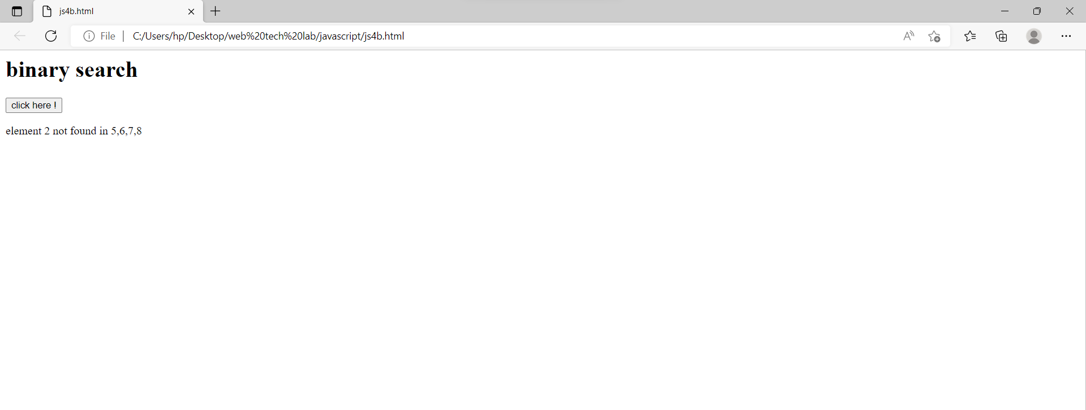

b) Search a given element in the set of elements using binary search technique.

Source code:

<html>

<body>

<h1> binary search </h1>

<button onclick="func()">click here !</button>

<p id="demo"></p>

<script> function func(){

var n = parseInt(prompt("enter the size")); var a = new Array(n);

var i,j,mid,high,low; var res_index=-1;

for(i=0;i<n;i++){

a[i]=parseInt(prompt("enter the number"));}

a.sort(); low=0; high=n-1; var flag=1;

var ele = parseInt(prompt("enter the value to be searched"));

while(low<=high && flag==1){

mid=Math.floor((low+high)/2); if(a[mid]==ele){

res_index=mid; flag=0;}

else if(a[mid]<ele){

low=mid+1;}

else{

high=mid-1;

}}

if(res_index==-1){

document.getElementById("demo").innerHTML="element "+ele+" not found in "+a ;}

else{

document.getElementById("demo").innerHTML="element "+ele+" found at position "+(res_index+1)+" in "+a;

}}

</script></body></html>

C

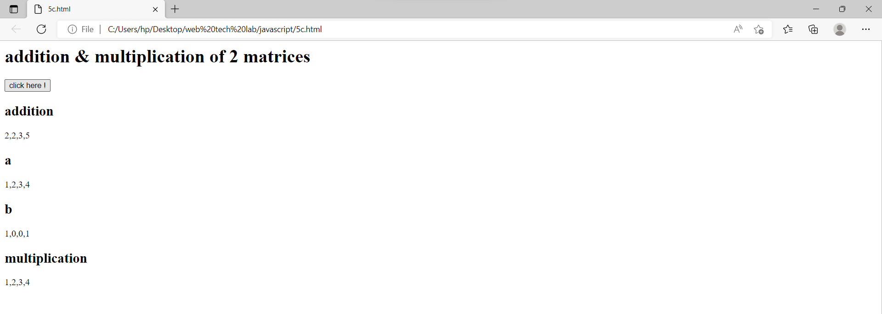

c) Compute i) addition of two matrices ii) multiplication of two matrices

Source code:

<html>

<body>

<h1> addition & multiplication of 2 matrices</h1>

<button onclick="func()"> click here ! </button>

<h2> result</h2>

<p id="demo"></p>

<h2> a </h2>

<p id="a1"></p>

<h2> b </h2>

<p id="b1"></p>

<h2> multiplication </h2>

<p id="mult"></p>

<script> function func()

{

n=parseInt(prompt("enter the dimenison of array")); var a = new Array(n);

var b = new Array(n); var c = new Array(n); var mul = new Array(n); var i,j,k;

for(i=0;i<n;i++){

a[i]=new Array(n); b[i]=new Array(n); c[i]=new Array(n); mul[i]=new Array(n);

}

for(i=0;i<n;i++){

for(j=0;j<n;j++){

a[i][j]=parseInt(prompt("enter the value for matrix a"));

}}

for(i=0;i<n;i++){

for(j=0;j<n;j++){

b[i][j]=parseInt(prompt("enter the value for matrix b"));

}}

for(i=0;i<n;i++){

for(j=0;j<n;j++){

c[i][j]=a[i][j]+b[i][j];

}}

for(i=0;i<n;i++){

for(j=0;j<n;j++){

mul[i][j]=0; for(k=0;k<n;k++){

mul[i][j]+=a[i][k]*b[k][j];

}}}

document.getElementById("demo").innerHTML=c; document.getElementById("mult").innerHTML=mul; document.getElementById("a1").innerHTML=a; document.getElementById("b1").innerHTML=b;

}

</script>

</body>

</html>

Output:

5.

a

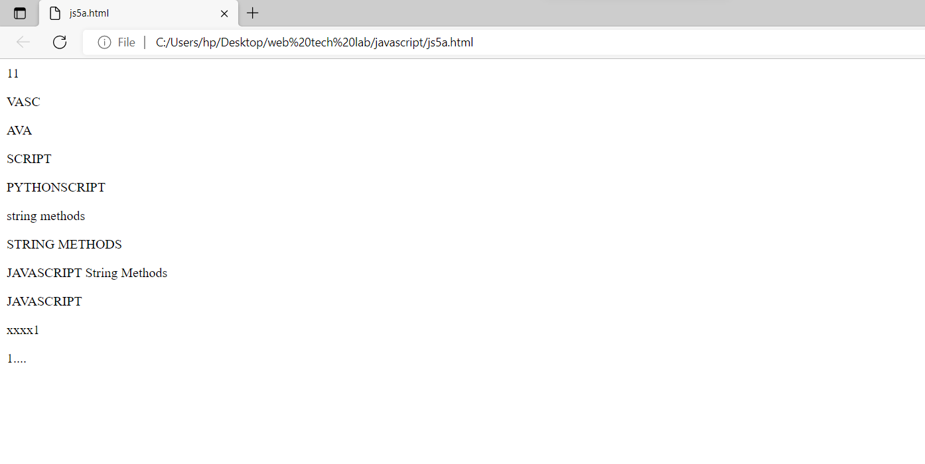

5. Write a java script to

a) implement string operations using String object

Source code:

<html><body>

<p id="demo1"></p><p id="demo2"></p>

<p id="demo3"></p>

<p id="demo4"></p>

<p id="demo5"></p>

<p id="demo6"></p>

<p id="demo7"></p>

<p id="demo8"></p>

<p id="demo9"></p>

<p id="demo10"></p>

<p id="demo11"></p>

<script>

let string1 = "JAVASCRIPT ";

let string2 = "String Methods";

let string3 = "1";

document.getElementById("demo1").innerHTML=string1.length;

document.getElementById("demo2").innerHTML=string1.slice(2,6);

document.getElementById("demo3").innerHTML=string1.substring(1,4);

document.getElementById("demo4").innerHTML=string1.substr(4,8);

document.getElementById("demo5").innerHTML=string1.replace("JAVA","PYTHON");

document.getElementById("demo6").innerHTML=string2.toLowerCase();

document.getElementById("demo7").innerHTML=string2.toUpperCase();

document.getElementById("demo8").innerHTML=string1.concat(" ",string2);

document.getElementById("demo9").innerHTML=string1.trim();

document.getElementById("demo10").innerHTML=string3.padStart(5,"x");

document.getElementById("demo11").innerHTML=string3.padEnd(5,".");

</script> </body></html>

b

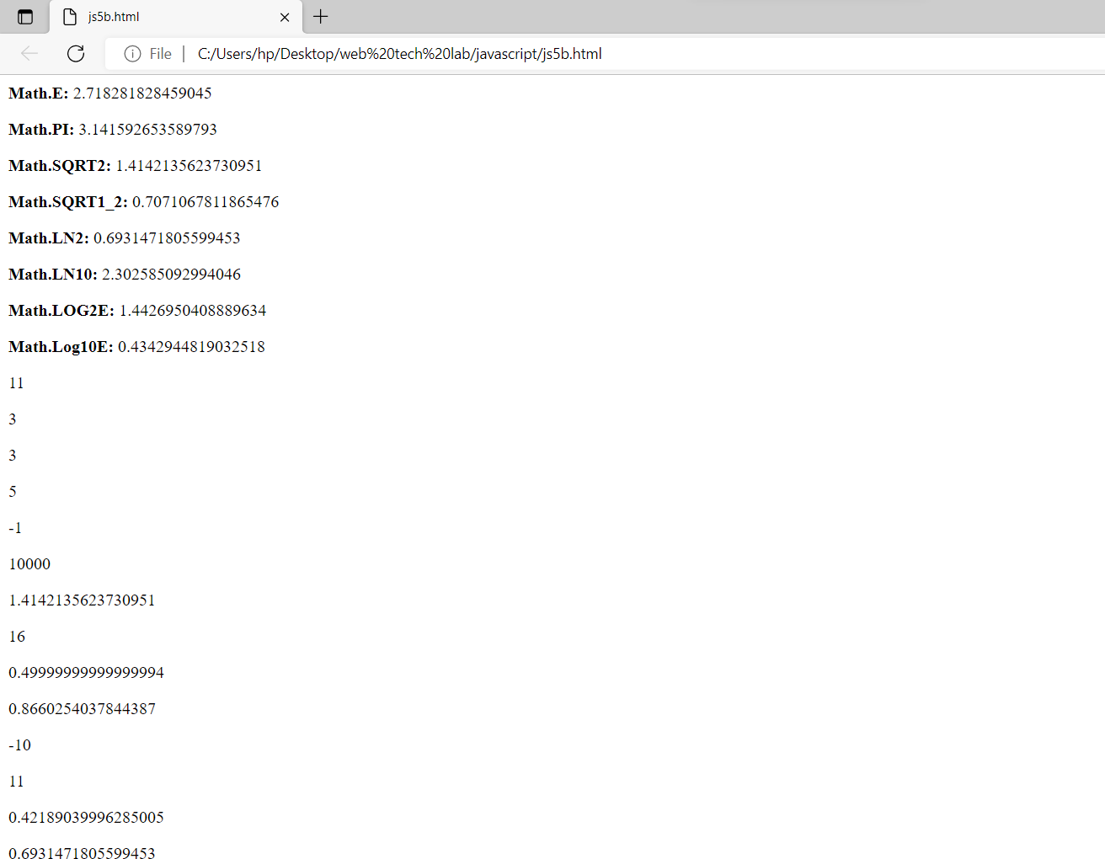

b) implement the mathematical operations using Math object

Source code:

<html>

<head></head>

<body>

<p id="demo"></p>

<p id="demo1"></p>

<p id="demo2"></p>

<p id="demo3"></p>

<p id="demo4"></p>

<p id="demo5"></p>

<p id="demo6"></p>

<p id="demo7"></p>

<p id="demo8"></p>

<p id="demo9"></p>

<p id="demo10"></p>

<p id="demo11"></p>

<p id="demo12"></p>

<p id="demo13"></p>

<p id="demo14"></p>

<p id="demo15"></p>

<script>

document.getElementById("demo").innerHTML =

"<p><b>Math.E:</b> " + Math.E + "</p>" +

"<p><b>Math.PI:</b> " + Math.PI + "</p>" +

"<p><b>Math.SQRT2:</b> " + Math.SQRT2 + "</p>" +

"<p><b>Math.SQRT1_2:</b> " + Math.SQRT1_2 + "</p>" +

"<p><b>Math.LN2:</b> " + Math.LN2 + "</p>" +

"<p><b>Math.LN10:</b> " + Math.LN10 + "</p>" +

"<p><b>Math.LOG2E:</b> " + Math.LOG2E + "</p>" +

"<p><b>Math.Log10E:</b> " + Math.LOG10E + "</p>";

document.getElementById("demo1").innerHTML = Math.round(10.6);

document.getElementById("demo2").innerHTML = Math.ceil(2.123456);

document.getElementById("demo3").innerHTML = Math.floor(3.9876);

document.getElementById("demo4").innerHTML = Math.trunc(5.853);

document.getElementById("demo5").innerHTML = Math.sign(-10);

document.getElementById("demo6").innerHTML = Math.pow(-10,4);

document.getElementById("demo7").innerHTML = Math.sqrt(2);

document.getElementById("demo8").innerHTML = Math.abs(-16);

document.getElementById("demo9").innerHTML = Math.sin(30 * Math.PI/180);

document.getElementById("demo10").innerHTML = Math.cos(30 * Math.PI/180);

document.getElementById("demo11").innerHTML = Math.min(-10,3,8,4,11,7);

document.getElementById("demo12").innerHTML = Math.max(-10,3,8,4,11,7);

document.getElementById("demo13").innerHTML = Math.random();

document.getElementById("demo14").innerHTML = Math.log(2);

document.getElementById("demo15").innerHTML = Math.log2(2);

</script>

</body>

</html>

c

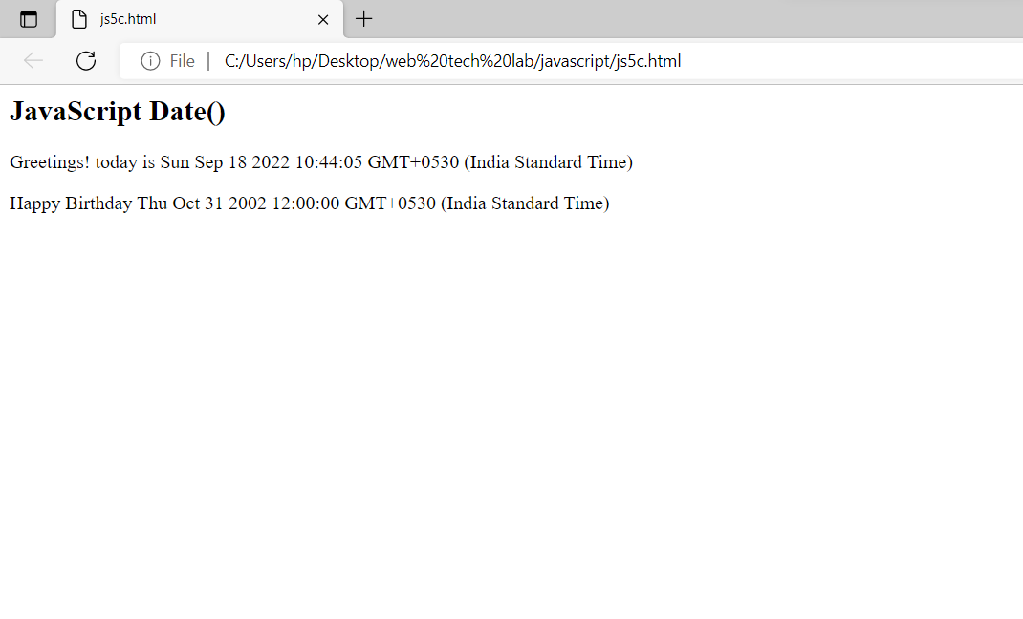

c) display Greeting messages using Date object

Source code:

<html>

<body>

<h2>JavaScript Date()</h2>

<p id="demo"></p>

<p id="demo1"></p>

<script>

const d1 = new Date();

document.getElementById("demo").innerHTML = "Greetings! today is "+d1;

const d2 = new Date("October 31, 2002 12:00:00");

document.getElementById("demo1").innerHTML = "Happy Birthday "+d2;

</script>

</body>

</html>

Output:

6

a

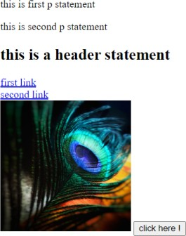

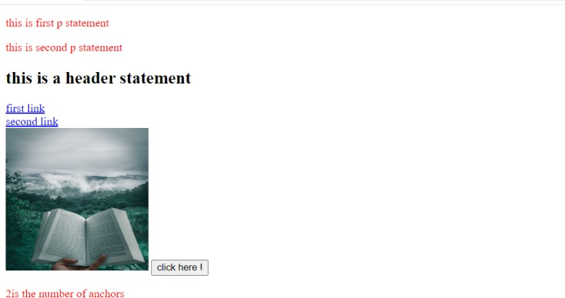

6. demonstrate collect objects

a) All collection

Source code:

<html>

<body>

<p> this is first p statement </p>

<p> this is second p statement </p>

<h2> this is a header statement </h2>

<ahref="https://www.w3schools.com/Js/js_htmldom_collections.asp"> first link </a>

<br>

<ahref="https://www.google.com/"> second link</a>

<br>

<imgid="d"src="C:\Users\keert\OneDrive\Desktop\New folder\img1.jpg"width=200pxheight=200px>

<buttononclick="func()">click here !</button>

<pid="demo"></p>

<script> functionfunc()

{

varcollect=document.getElementsByTagName("p"); vari;

for(i=0;i<collect.length;i++)

{

collect[i].style.color = "red";

}

varcolle=document.getElementsByTagName("a"); document.getElementById("demo").innerHTML=colle.length+ "is the number of anchors"; document.getElementById("d").src="C:\\Users\\keert\\OneDrive\\Desktop\\New folder\\img2.jpg";

}

</script>

</body>

</html>

b

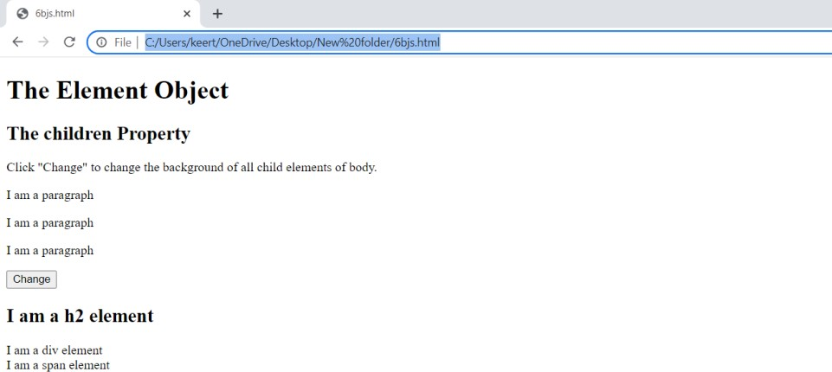

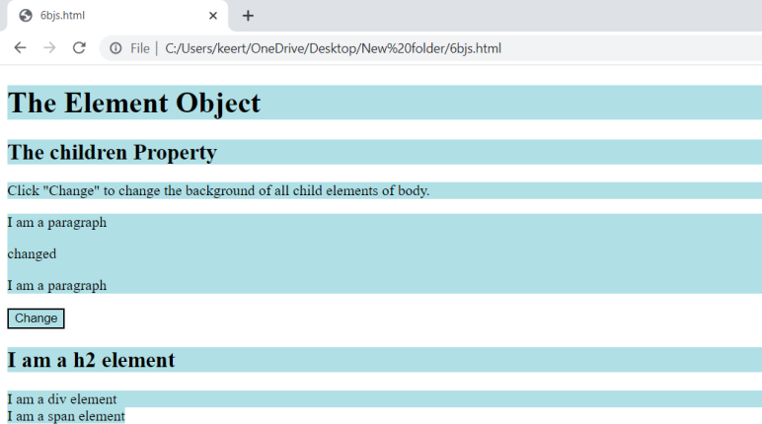

b) Children collection

Source code:

<html>

<body>

<h1>The Element Object</h1>

<h2>The children Property</h2>

<p>Click "Change" to change the background of all child elements of body.</p>

<divid="myDIV">

<p>I am a paragraph</p>

<p>I am a paragraph</p>

<p>I am a paragraph</p>

</div>

<buttononclick="myFunction()">Change</button>

<h2>I am a h2 element</h2>

<div>I am a div element</div>

<span>I am a span element</span>

<script> functionmyFunction() {

constcollect = document.getElementById("myDIV").children; collect[1].innerHTML = "changed";

constcollection = document.body.children; for (leti = 0; i<collection.length; i++) {

collection[i].style.backgroundColor = "powderblue";

}

}

</script>

</body>

</html>

c

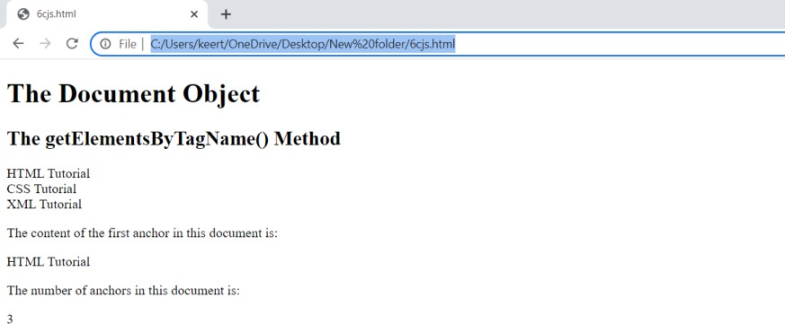

c) Anchor collection

Source code:

<html>

<body>

<h1>The Document Object</h1>

<h2>The getElementsByTagName() Method</h2>

<aname="html">HTML Tutorial</a><br>

<aname="css">CSS Tutorial</a><br>

<aname="xml">XML Tutorial</a><br>

<p>The content of the first anchor in this document is:</p>

<pid="demo"></p>

<p>The number of anchors in this document is:</p>

<pid="demo1"></p>

<script>

letcontent = document.getElementsByTagName("a")[0].innerHTML;

document.getElementById("demo").innerHTML = content;

letnum = document.anchors.length;

document.getElementById("demo1").innerHTML = num;

</script>

</body>

</html>

Output:

7

a

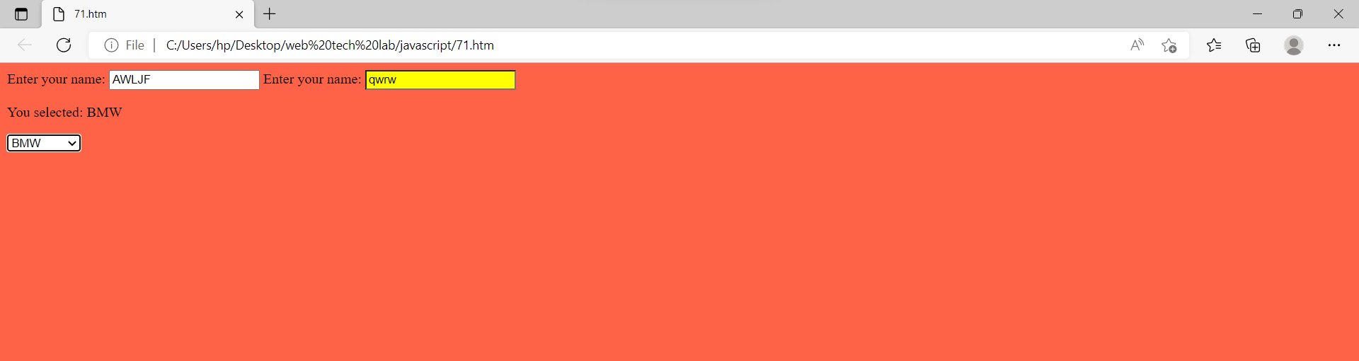

7. Demonstrate event model

a) Form events (onchange, onfocus ,onblur)

Source code:

<html>

<body style="background-color:tomato;">

Enter your name: <input type="text" id="fname" onblur="myFunction()">

Enter your name: <input type="text" onfocus="mFunction(this)">

<p id="demo"></p>

<select id="mySelect" onchange="yFunction()">

<option value="Audi">Audi</option>

<option value="BMW">BMW</option>

<option value="Mercedes">Mercedes</option>

<option value="Volvo">Volvo</option>

</select>

<script>

function mFunction(x) {

x.style.background = "yellow";

}

function myFunction() {

var x = document.getElementById("fname");

x.value = x.value.toUpperCase();

}

function yFunction() {

var x = document.getElementById("mySelect").value;

document.getElementById("demo").innerHTML = "You selected: " + x;

}

</script>

</body>

</html>

b

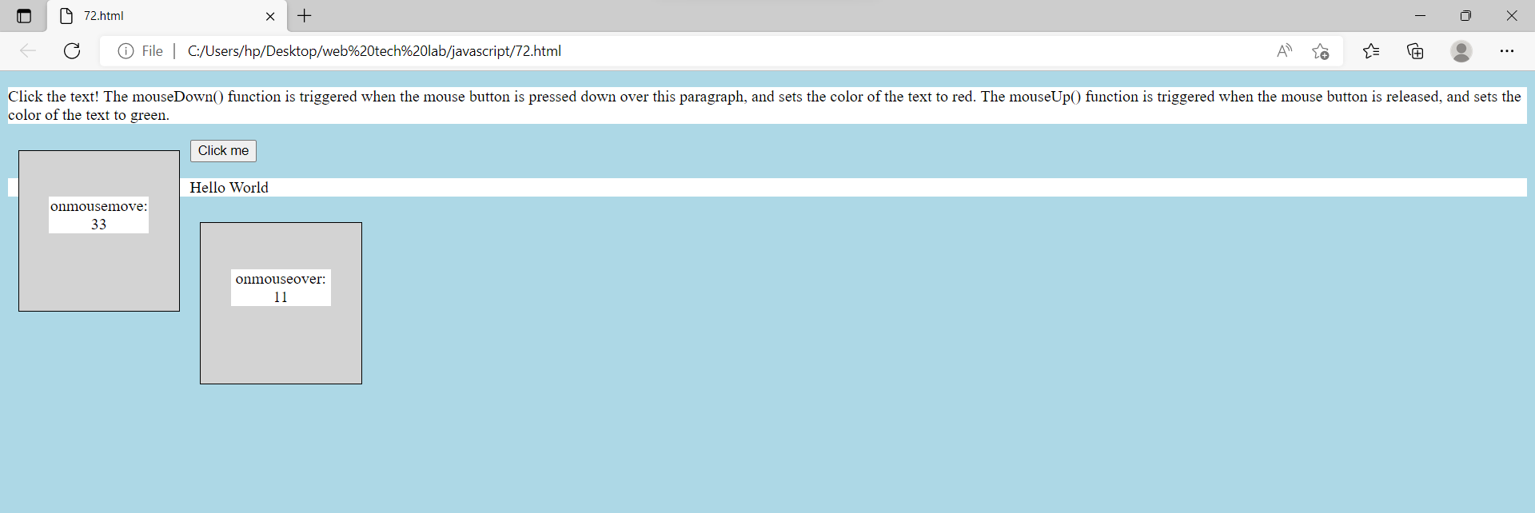

b) Mouse events (onclick, onmouesedown, onmoueseup, onmouesemove, onmoueseover)

Source code:

<html>

<head>

<style>

div {

width: 100px;

height: 100px;

border: 1px solid black;

margin: 10px;

float: left;

padding: 30px;

text-align: center;

background-color: lightgray;

}

p {

background-color: white;}

body{

background-color:lightblue;

}

</style>

</head>

<body>

<p id="myP" onmousedown="mouseDown()" onmouseup="mouseUp()">Click the text! The mouseDown() function is triggered when the mouse button is pressed down over this paragraph, and sets the color of the text to red. The mouseUp() function is triggered when the mouse button is released, and sets the color of the text to green.

</p>

<div onmousemove="myMoveFunction()">

<p>onmousemove: <br> <span id="demo">Mouse over me!</span></p>

</div>

<button onclick="myFunction()">Click me</button>

<p id="demo2"></p>

<div onmouseover="myOverFunction()">

<p>onmouseover: <br> <span id="demo3">Mouse over me!</span></p>

</div>

<script>

var x = 0;

var y = 0;

var z = 0;

function myMoveFunction() {

document.getElementById("demo").innerHTML = z+=1;

}

function myOverFunction() {

document.getElementById("demo3").innerHTML = y+=1;

}

function mouseDown() {

document.getElementById("myP").style.color = "red";

}

function mouseUp() {

document.getElementById("myP").style.color = "green";

}

function myFunction() {

document.getElementById("demo2").innerHTML = "Hello World";

}

</script>

</body>

</html>

c

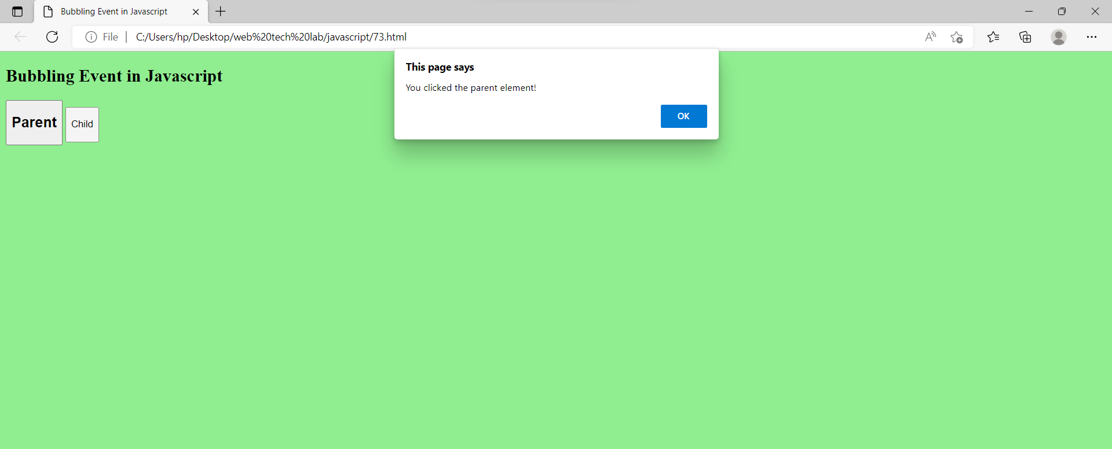

c) Event bubbling

Source code:

<html>

<head>

<title>Bubbling Event in Javascript

</title>

</head>

<body style="background-color:lightgreen;">

<h2>Bubbling Event in Javascript</h2>

<div id="parent">

<button>

<h2>Parent</h2>

</button>

<button id="child">

<p>Child</p>

</button>

</div><br>

<script>

document.getElementById(

"child").addEventListener("click", function () {

alert("You clicked the Child element!");

}, false);

document.getElementById(

"parent").addEventListener("click", function () {

alert("You clicked the parent element!");

}, false);

</script>

</body>

</html>

**Lab cycle – 3**

8. Write a valid XML document using DTD

Source code:

<?xml version = "1.0" encoding = "UTF-8" standalone = "yes" ?>

<!DOCTYPE address [

<!ELEMENT address (name,company,phone)>

<!ELEMENT name (#PCDATA)>

<!ELEMENT company (#PCDATA)>

<!ELEMENT phone (#PCDATA)>

]>

<address>

<name>Tanmay Patil</name>

<company>TutorialsPoint</company>

<phone>(011) 123-4567</phone>

</address>

Output:

9

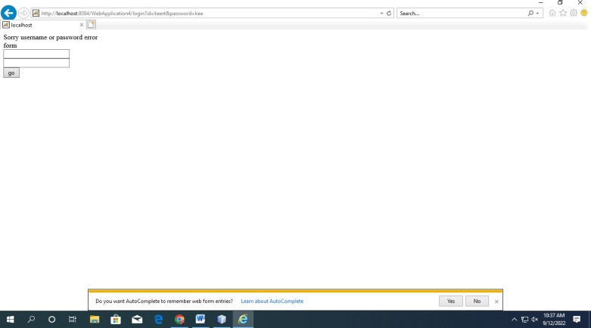

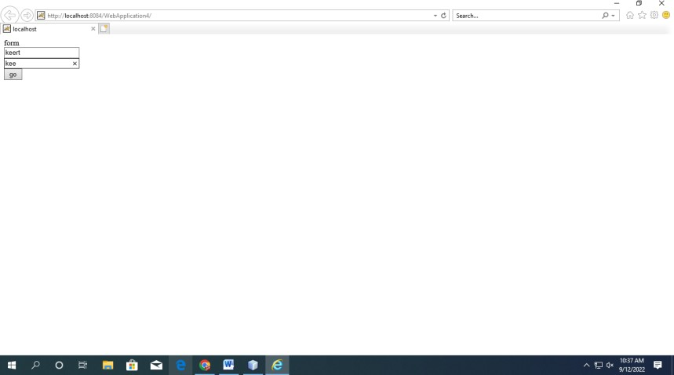

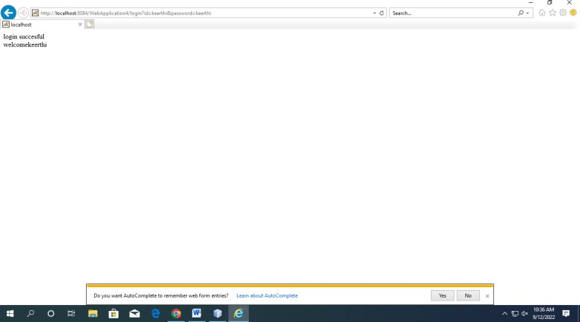

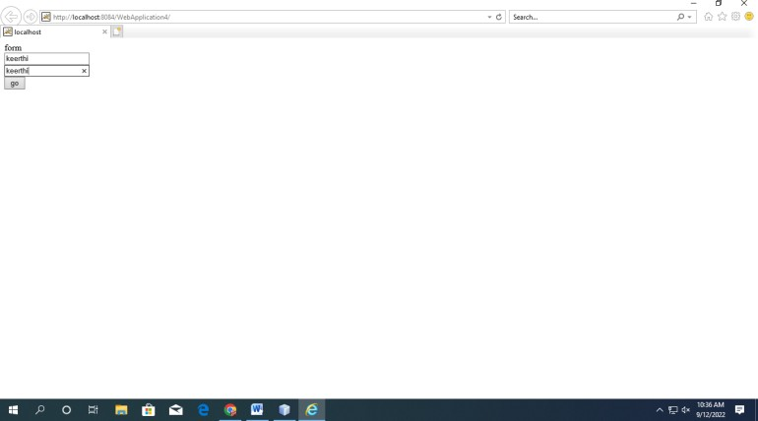

9. Write a servlet program to validate a user

Source code:

loginservelet.java

import java.io.IOException; import java.io.PrintWriter;

import javax.servlet.RequestDispatcher; import javax.servlet.ServletException; import javax.servlet.http.HttpServlet;

import javax.servlet.http.HttpServletRequest; import javax.servlet.http.HttpServletResponse; public class LoginServelet extends HttpServlet

{

public void service(HttpServletRequest req,HttpServletResponse res) throws ServletException,IOException

{

PrintWriter out = res.getWriter(); String name = req.getParameter("id");

String pass = req.getParameter("password"); if(name.equals("keerthi") && pass.equals("keerthi"))

{

out.println("login succesful"+"<br>"); out.println("welcome"+name);

}

else

{

out.print("Sorry username or password error"+"<br>"); RequestDispatcher rd=req.getRequestDispatcher("index.html"); rd.include(req,res);

}

}

}

index.html

<!DOCTYPE HTML PUBLIC "-//W3C//DTD HTML 4.01 Transitional//EN">

<html>

<head>

<title></title>

<meta http-equiv="Content-Type" content="text/html; charset=UTF-8">

</head>

<body> form

<form action="login" method="get">

<input type="text" name="id"/>

<br>

<input type="text" name="password"/>

<br>

<input type="submit" value="go"/>

</form>

</body>

</html>

web.xml

<servlet>

<servlet-name>abc</servlet-name>

<servlet-class>LoginServelet</servlet-class>

</servlet>

<servlet-mapping>

<servlet-name>abc</servlet-name>

<url-pattern>/login</url-pattern>

</servlet-mapping>

Output:

10

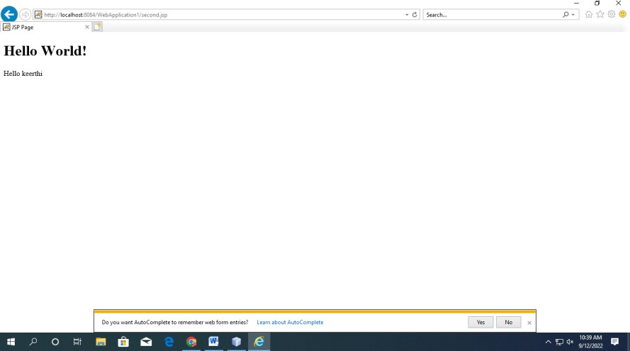

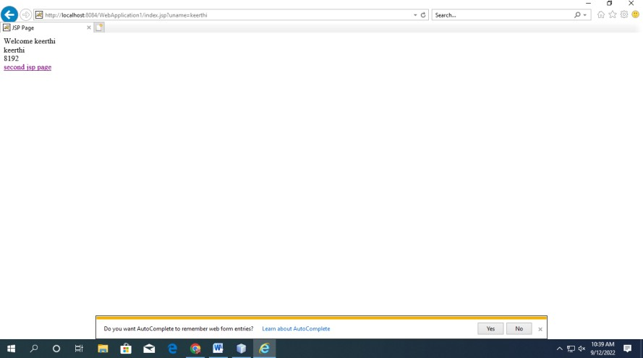

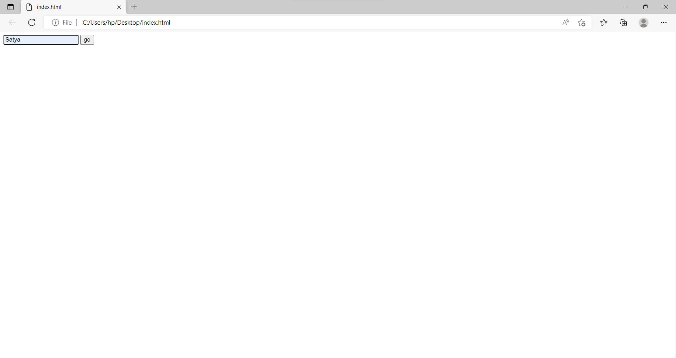

10. Write a JSP program on Implicit objects

Source code:

index.jsp

<%

int k =9; request.setAttribute("k",k);

String name=request.getParameter("uname"); out.print("Welcome "+name+"<br>");

String s = config.getInitParameter("name");

String dri = application.getInitParameter("name"); String nam = (String)session.getAttribute("name"); out.println(dri+"<br>"); out.println(response.getBufferSize());

pageContext.setAttribute("user",name,PageContext.SESSION_SCOPE);

//response.sendRedirect("http://www.google.com");

%>

<br>

<a href="second.jsp">second jsp page</a>

web.xml

<context-param>

<param-name>name</param-name>

<param-value>keerthi</param-value>

</context-param> index.html

<!DOCTYPE HTML PUBLIC "-//W3C//DTD HTML 4.01 Transitional//EN">

<html>

<head>

<title></title>

<meta http-equiv="Content-Type" content="text/html; charset=UTF-8">

</head>

<body>

<form action="index.jsp">

<input type="text" name="uname">

<input type="submit" value="go"><br/>

</form>

</body>

</html>

second.jsp

<%@page contentType="text/html" pageEncoding="UTF-8"%>

<!DOCTYPE HTML PUBLIC "-//W3C//DTD HTML 4.01 Transitional//EN" "http://www.w3.org/TR/html4/loose.dtd">

<html>

<head>

<meta http-equiv="Content-Type" content="text/html; charset=UTF-8">

<title>JSP Page</title>

</head>

<body>

<h1>Hello World!</h1>

<%

String name=(String)pageContext.getAttribute("user",PageContext.SESSION_SCOPE); out.print("Hello "+name);

%>

</body>

</html>

Output:

11

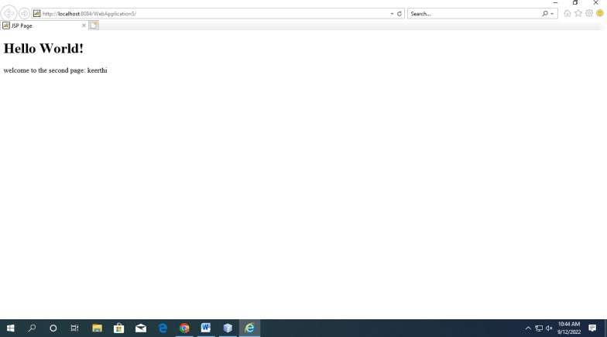

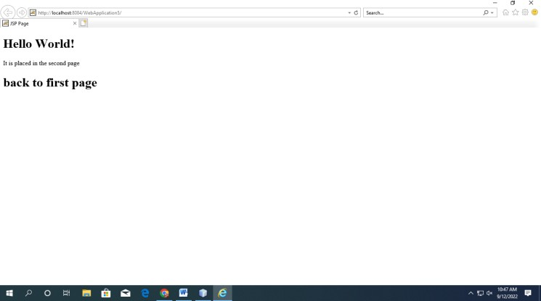

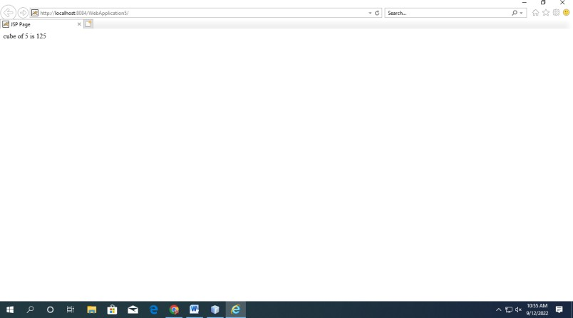

11. Write a JSP program on Action tags.

Source code:

<%@page contentType="text/html" pageEncoding="UTF-8"%>

<!DOCTYPE HTML PUBLIC "-//W3C//DTD HTML 4.01 Transitional//EN" "http://www.w3.org/TR/html4/loose.dtd">

<html><head>

<meta http-equiv="Content-Type" content="text/html; charset=UTF-8">

<title>JSP Page</title>

</head><body>

<h1>Hello World!</h1>

<jsp:forward page="second.jsp">

<jsp:param name="name" value="keerthi"/>

</jsp:forward>

</body></html>

second.jsp

<%@page contentType="text/html" pageEncoding="UTF-8"%>

<!DOCTYPE HTML PUBLIC "-//W3C//DTD HTML 4.01 Transitional//EN" "http://www.w3.org/TR/html4/loose.dtd">

<html>

<head>

<meta http-equiv="Content-Type" content="text/html; charset=UTF-8">

<title>JSP Page</title>

</head>

<body>

<h1>Hello World!</h1>

<%

out.println("welcome to the second page: "+request.getParameter("name"));

%></body></html>

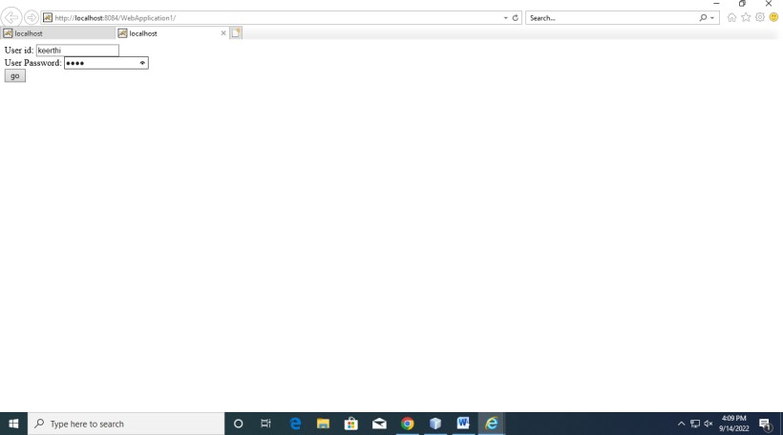

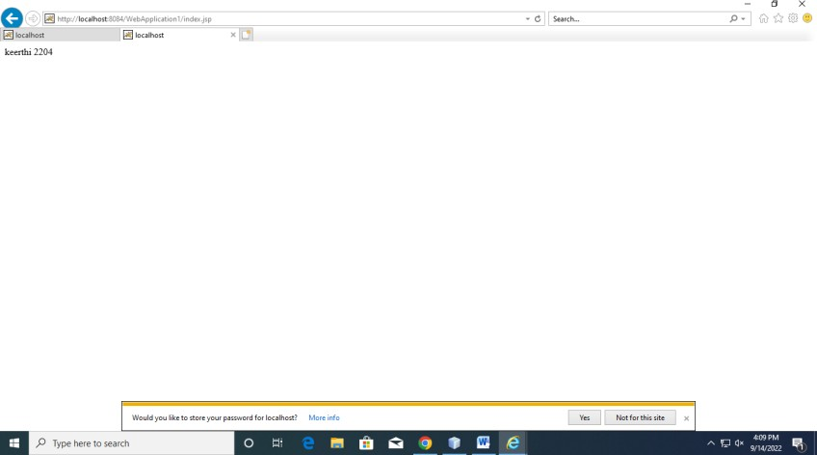

<%@page contentType="text/html" pageEncoding="UTF-8"%>

<!DOCTYPE HTML PUBLIC "-//W3C//DTD HTML 4.01 Transitional//EN" "http://www.w3.org/TR/html4/loose.dtd">

<html>

<head>

<meta http-equiv="Content-Type" content="text/html; charset=UTF-8">

<title>JSP Page</title>

</head>

<body>

<jsp:include page="second.jsp"/>

<h1> back to first page </h1>

</body>

</html>

<%@page contentType="text/html" pageEncoding="UTF-8"%>

<!DOCTYPE HTML PUBLIC "-//W3C//DTD HTML 4.01 Transitional//EN" "http://www.w3.org/TR/html4/loose.dtd">

<html>

<head>

<meta http-equiv="Content-Type" content="text/html; charset=UTF-8">

<title>JSP Page</title>

</head>

<body>

<h1>Hello World!</h1>

<% out.print("It is placed in the second page"); %>

</body>

</html>

<jsp:useBean id="obj" class="com.WebApplication5.cube"/>

<%

int m=obj.cube(5); out.print("cube of 5 is "+m);

%>

package com.WebApplication5;

/*

* To change this template, choose Tools | Templates

* and open the template in the editor.

*/

/**

*

* @author exam2

*/

public class cube { public int cube(int n)

{

return n*n*n;

}

}

<jsp:useBean id="user" class="com.WebApplication1.Details">

</jsp:useBean>

<jsp:setProperty property="*" name="user"/>

<jsp:getProperty property="id" name="user"/>

<jsp:getProperty property="password" name="user"/>

package com.WebApplication1; public class Details {

String id,password;

public void setId(String id){

this.id=id;

}

public String getId(){

return id;

}

public void setPassword(String password){

this.password=password;

}

public String getPassword(){

return password;

}}

<form action="index.jsp" method="post">

User id: <input type="text" name="id"><br>

User Password: <input type="password" name="password"><br>

<input type="submit" value="go">

</form>

Output:

12

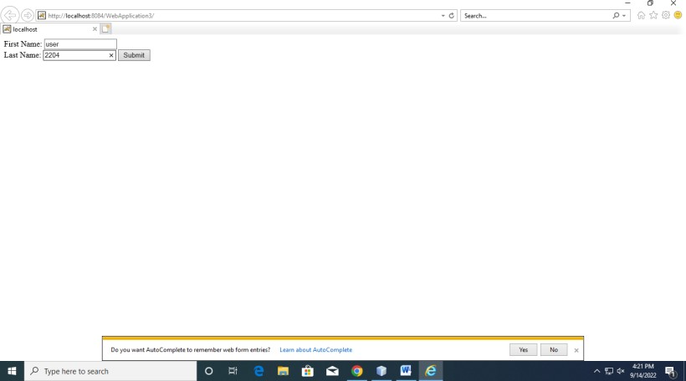

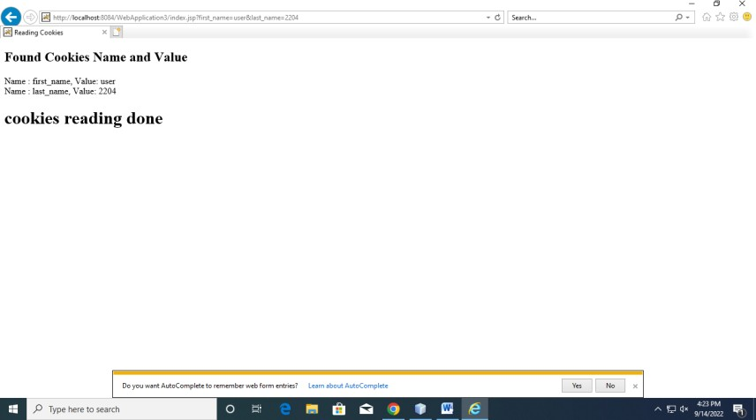

12. Demonstrate cookies and session information using JSP

Source code:

<html>

<head>

<title>Reading Cookies</title>

</head>

<body>

<%

// Create cookies for first and last names.

Cookie firstName = new Cookie("first_name", request.getParameter("first_name")); Cookie lastName = new Cookie("last_name", request.getParameter("last_name"));

// Set expiry date after 24 Hrs for both the cookies. firstName.setMaxAge(60*60*24); lastName.setMaxAge(60*60*24);

// Add both the cookies in the response header. response.addCookie( firstName ); response.addCookie( lastName );

Cookie cookie; Cookie[] cookies;

cookies = request.getCookies();

if( cookies != null ) {

out.println("<h2> Found Cookies Name and Value</h2>");

for (int i = 0; i < cookies.length; i++) { cookie = cookies[i];

out.print("Name : " + cookie.getName( ) + ", "); out.print("Value: " + cookie.getValue( )+" <br/>");

}

} else {

out.println("<h2>No cookies founds</h2>");

}

%>

<h1> cookies reading done </h1

<form action = "index.jsp" method = "GET">

First Name: <input type = "text" name = "first_name">

<br />

Last Name: <input type = "text" name = "last_name" />

<input type = "submit" value = "Submit" />

</form>