Copilot Wave 2, Sept 2024

Understand and Explore opportunities of Microsoft Copilot Wave 2, especially for personal use.

Summary of a weeks’ worth of research.

# Version Information

Draft version. Alpha, 1.0 (Satya Komatineni), 9/19/2024

Started: 9/19/24, Expected completion: On going.

Location: tbd

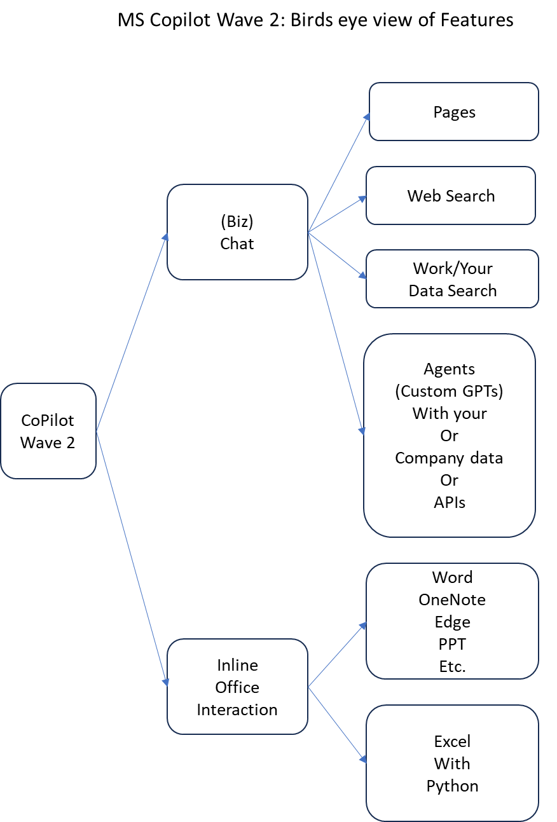

Contents

Version Information 1

Goal: Explore Copilot Wave 2 Opportunities 3

Release dates of Wave 2 3

Why is this release significant (and Wave 2 Feature List) 3

Need for mining in chat threads 3

Need to search the Web and Work 3

Inline work with Word, PPT, and other Office 354 apps 3

Excel and Python inline GenAI collaboration 4

Agentic world 4

Challenges 5

Availability Challenges for Personal Use 5

Opportunity Challenges 6

Early Adapter Challenges 6

Experiences with Entra identity 6

Early experience with 365 Copilot Pro Chat 6

Desktop version of CoPilot Pro 7

Pages feature not available yet 7

Notebook feature 7

Experience with writing in Word 7

Side by side chat interface 7

Inline interface 7

Similar Technologies 8

Related Technologies 8

References 8

Basic announcements 8

Home pages 8

Support forums 9

Claude artifacts 9

Microsoft loop 9

# Goal: Explore Copilot Wave 2 Opportunities

Understand and Explore opportunities of Microsoft Copilot Wave 2, especially for personal use.

1. What are the release dates of Wave 2
2. General availability
3. Personal use vs corporate use
4. Key URLs
5. Key Features
6. Implications for individuals and organizations
7. Current challenges

# Release dates of Wave 2

Microsoft Copilot's Wave 2 was officially announced on September 16, 2024. The updates are rolling out in stages, with some features becoming generally available by the end of September 2024.

These updates are generally considered very impressive both for enterprise and personal consumers.

It is not clear, however, if all the features will be available for personal use!

# Why is this release significant (and Wave 2 Feature List)

At its core this release brings 3 critical things together

1. Chat
2. Working with Office 365 documents
3. Exploring user content through agents: Be it personal or organizational

Let’s talk first what would one want in each of these areas.

## Need for mining in chat threads

In modern AI chats, you have threaded chats. As you explore a topic in a chat thread, you want to extract key pieces from that chat thread and move it to a separate area of the screen so that at the end of the chat, the key elements are aggregated.

Microsoft is bringing this capability as what they call “Pages”.

## Need to search the Web and Work

You also want the chat to search the web and your personal data to answer questions.

Together all 3, MS is calling them “Web + Work + Pages”

## Inline work with Word, PPT, and other Office 354 apps

For knowledge workers lately the workflow seems a bit like this

1. Access an AI Chat
2. Ask questions
3. Copy the data
4. And work with a target application like Word, Markdown, PPT, Excel, Vscode etc.
5. And repeat this loop

The coding copilots have integrated this experience into code editors for programming needs.

You want a similar experience with Office apps that one uses very often.

Wave 2 brings this inline experience with the office apps.

## Excel and Python inline GenAI collaboration

This has been taken to a nice end with Excel.   
Now with this wave2 release you can use English to interact with the excel sheets in real time and juxtaposed.

This ability can create new sheets, update sheets, create columns, create graphs, or even do some data science analytics.

## Agentic world

If you are familiar with Custom GPTs in the ChatGPT space, you can see the opportunities for a GenAI chat.

This approach allows one to talk to documents of their choosing, or search the web, or interact with company data, be them databases, APIs, or office documents.

These agents can be developed with prompts or programming and then interact with users in chats or in Teams as participants.

Here is a visual scope of this Wave 2 below



# Challenges

It is only a few days the announcements came out.

There are several challenges I am facing now and will likely face.

Here is a rundown.

## Availability Challenges for Personal Use

It is not clear at all how many of these features are also available for personal users.

I have Office365 Family pack.

Thinking that CoPilot Pro will have these features first, I chatted with a live MS Sales agent to inquire if these features, especially the “Pages”, is available for personal use.

I was shown some documentation that seemed to indicate that and so I bought it.

Pages is not available as far as I can tell, yet, in my instance.

There were some indications of having a “tenant (org)” in Azure and having an id at the MS identity system “entra.microsoft.com” would enable these features.

After a lengthy battle with my personal email and Entra, I still couldn’t get some of these features.

I haven’t experimented yet with excel and python.

I will wait for a few weeks to see the “availability” picture better.

## Opportunity Challenges

It is also not clear how effective is the inline ability to update the Office365 documents.

If Github Copilot is an indicator, it is likely a 50/50 proposition at best.

But who knows, they might surprise me.

Now there are several learning sites from MS where several use cases are presented. Perhaps one can go and explore this to use this feature more effectively.

## Early Adapter Challenges

The entire paradigm across all the wave 2 features is very large surface.

I expect a year or two before these mature for their full effect.

Perhaps no immediate “killer app” here, for all things here are possible with a bit of manual work.

So, it is super nice to have, but not the end of the world!

# Experiences with Entra identity

Perhaps this is a large topic how MS is managing personal and organizational identities.

The idea is that each organization has its identity domain.

There seems to be a way to get an entra id for individuals as well. They are inventing some kind of a dedicated domain based on login emails.

Very convoluted.

Perhaps I lack understanding.

# Early experience with 365 Copilot Pro Chat

Too early to tell for me yet. Initial reactions below.

## Desktop version of CoPilot Pro

I have installed the desktop version for windows 11.

Following the better experience of desktop versions of MS Teams or MS One Note, lead me to that.

Seems ok.

I haven’t used plugins or any of the advanced features.

## Pages feature not available yet

My primary reason for buying the copilot pro is to test out the “Pages” feature.

As indicated, either it doesn’t have it in the personal edition or the roll out is not complete.

From a pure search and answering perspective, ChatGPT seem to have a better understanding of my question and answers.

## Notebook feature

For certain use cases the notebook feature may be useful.

This has a two pane UI where the prompt stays editable between conversations. The output is constantly refined.

Clearly useful for code generation where a refined prompt gives a newer updated code.

I could imagine being useful for article writing as well.

For me, I need to use it more to see if this type of interaction is better.

Note: The references section in this article is created by using this Notebook and the inline Copilot feature.

# Experience with writing in Word

This article itself I wrote with CoPilot assistance.

It has two features.

## Side by side chat interface

The right-side pane where you can ask any general-purpose questions. Like a side-by-side chat. For some reason this chat seems to be more concerned with the document rather than the general web.

## Inline interface

The icon that shows up after each line in the document itself seems to be lot more useful.

For example, I can click on it, and tell it format some references I have into a tabular format. And it does it well.

It can also create a table with specific rows and columns and a header row by telling it in English

More to explore, for sure.

# Similar Technologies

You may want to research the following topics as a follow on

1. Claude artifacts
2. Microsoft loop

# Related Technologies

The following are related technologies in Microsoft you want to research further

1. Azure and Tenants
2. Microsoft Identity Management, Entra.microsoft.com
3. Microsoft authenticator on the Mobile device

# References

## Basic announcements

|  |  |
| --- | --- |
| Title | URL |
| Microsoft Copilot's Wave 2 is here. Everything you need to know. | <https://www.zdnet.com/article/microsoft-copilots-wave-2-is-here-everything-you-need-to-know/> |
| Microsoft 365 Copilot Wave 2 announcement with features | <https://www.microsoft.com/en-us/microsoft-365/blog/2024/09/16/microsoft-365-copilot-wave-2-pages-python-in-excel-and-agents/?culture=en-us&country=us> |

## Home pages

|  |  |
| --- | --- |
| Title | URL |
| Web access URL for Copilot:  Microsoft Copilot: Your everyday AI companion | <https://copilot.microsoft.com/> |
| Wave 2 announcement:  Microsoft 365 Copilot Wave 2: Pages, Python in Excel, and agents | <https://www.microsoft.com/en-us/microsoft-365/blog/2024/09/16/microsoft-365-copilot-wave-2-pages-python-in-excel-and-agents/> |
| Home page of Copilot for Work | <https://www.microsoft.com/en-us/microsoft-365/copilot/copilot-for-work> |
| Copilot Pro Desktop App (from MS store) | <https://www.microsoft.com/en-us/store/b/copilotpro> |

## Support forums

|  |  |
| --- | --- |
| Title | URL |
| Welcome to the Microsoft 365 Copilot community! | <https://techcommunity.microsoft.com/t5/microsoft-365-copilot/welcome-to-the-microsoft-365-copilot-community/m-p/3853223> |
| Welcome to the Microsoft 365 Copilot community | <https://techcommunity.microsoft.com/t5/microsoft-365-copilot/welcome-to-the-microsoft-365-copilot-community/m-p/4165666> |

## Claude artifacts

|  |  |
| --- | --- |
| Title | Link |
| What are Artifacts and how do I use them? | <https://support.anthropic.com/en/articles/9487310-what-are-artifacts-and-how-do-i-use-them> |
| Claude Artifacts 101: Types, Use Cases, Sharing, and More | <https://www.datacamp.com/blog/claude-artifacts-introduction> |
| Claude Artifacts | ClaudeFinds | <https://www.claudefinds.com/> |
| Artifacts are Claude AI’s most useful feature. Here’s how … | <https://www.descript.com/blog/article/artifacts-claude-ai> |

## Microsoft loop

|  |  |
| --- | --- |
| Title | URL |
| Get started with Microsoft Loop | <https://support.microsoft.com/en-us/office/get-started-with-microsoft-loop-9f4d8d4f-dfc6-4518-9ef6-069408c21f0c> |
| Microsoft Loop Learning Resources | <https://loop.cloud.microsoft/learn> |