Enterprise Architecture – Managing Special Projects through MS Teams

# Version Information

Satya Komatineni, 9/6/24

Alpha, read 1. (I expect a couple of more releases)

Contents

Version Information 1

Abstract 2

Introduction and Background 2

Limited usage of MS Teams today 3

Mature usage pattern for MS Teams 3

Drawbacks of MS Teams to Overcome 3

Role of Enterprise Architecture (EA) 4

Nature of Special Projects 4

Static MS Team Structure 4

Need for Dynamic MS Teams 4

Prescription 6

Tangible Benefits 7

Disclaimer: Not a replacement for SDLC or Agile Tools 7

OneNote 7

Annoyances of OneNote 8

Structure of a Notebook of OneNote 8

# Abstract

MS Teams is routinely used for setting up online meetings. A lesser-known fact is it is a good tool for managing projects as well. Due to some of its peculiarities and challenges IT is not commonly using it in that capacity.

This article is a step-by-step guide for:

1. How to manage projects with MS teams
2. How to overcome or supplement the current challenges with MS Teams
3. Understand that “Teams are DYNAMIC and not STATIC (reflecting only the org structure)”

# Introduction and Background

Microsoft Teams is now widely used in large IT organizations. It is significantly supplanting outlook as a collaborative tool. Its ability to create a team of people and manage their files and communications has proven to be useful in projects.

Here are some possibilities for expert users of MS Teams (Desktop version) in managing projects:

1. 80 to 90% of the communications can take place in Teams chats with more efficacy than outlook
2. Most files can be managed inside of MS Teams
3. Permissions to the team and files can be controlled by the Team itself
4. The OneNote desktop is also integrated into MS Teams allowing for common messaging, instructions, timelines, etc.
5. Setting up meetings has become significantly better with its integration with outlook

## Limited usage of MS Teams today

Here is what MS teams is used most often for, today:

1. Setting up online meetings
2. Create “static” teams that reflect the Org structure, and may be use Channels for communication

## Mature usage pattern for MS Teams

More mature use for MS Teams is rather:

1. Expand it to “Dynamic teams” that cross org boundaries and exist only for the life of a project, be it in weeks or months.
2. Divert most communication through chats (Channels have some problems now)
3. Use “files” at the default channel/team level to create/update/share decks, documents, or spreadsheets
4. Use OneNote (as the Wiki is deprecated) to distribute persistent knowledge like annotated links to existing files, or instructions, timelines, etc.

## Drawbacks of MS Teams to Overcome

Here are some significant drawbacks of MS teams to fully realize the mature use above.

They are

1. Channels
   1. The way channels shrink messages makes them hard to read top to bottom (As of now, I do not know if there is a setting to fix this)
   2. Channels security is also largely controlled by the Team level security and cannot bring in a new SME quickly for a chat without explicitly allowing his permissions at the team or channel level.
2. Links
   1. Links to channels, posts, files, folders, OneNote behave inconsistently between the web version and the desktop version
   2. Especially, most useful Folders links route the user to the web based “SharePoint” of the organization as opposed to the “MS Teams Desktop”. This is truly annoying for the file and folder interface in MS Teams Desktop is so intuitive.
3. Chats
   1. The good
      1. Folks can be added and removed much more easily
      2. The readability of Chats is good, as it should be
   2. Not so good
      1. They don’t have links ☹
      2. The challenge of “Channels” forces us to use Chats
      3. However, chats are not linked to the Team (a work around is needed)

# Role of Enterprise Architecture (EA)

In addition to the long term strategic and architectural goals of the EA, they often get Special short-term projects from leadership.

## Nature of Special Projects

Here is how this role works:

1. Work with multiple teams to reach a short-term goal for senior leadership
2. Input to this process can be RFPs, Decks, Spread sheets, PDFs, and Documents
3. These artifacts tend to be files, especially Office 365
4. The teams will also need to work collaboratively to produce similar artifacts

## Static MS Team Structure

Like any other organizational team, EA is set up with a fixed org structure.

The team will work their deliverables and responsibilities via an MS Team that is set up with membership limited to the EA team.

This MS team setup is private.

As Special projects require access and collaboration with folks outside of the EA, this private EA team is ineffective in executing that project.

## Need for Dynamic MS Teams

Primary requirements of communication between the team that is formed with ad hoc members are

1. Files
2. Common instructions
3. Chats and collaboration that can change quickly

A static team fails in all these aspects.

A possible way to do this with a static team may look like this

1. Files: keep in the EA team and control their permissions individually across the ad hoc team members
2. Common instructions: Use a “separate OneNote notebook” and give permissions to that one notebook to the ad hoc team members
3. Use chats as they will work outside of an MS Team anyway

The main draw back with this approach where one doesn’t have to create a new MS Team for each Special project, is the control of the permissions. It is a bit tedious to do it.

As more Special projects come along, they all get mixed up in one name space.

It is lot cleaner to create a new MS Team dedicated for that Special Project and that naturally lends itself to provide controls for membership, files, and notebooks.

Key realization: You create MORE MS Teams, even for small projects.

If in doubt, whether a given effort involves other teams or not, create a new MS Team.

# Prescription

Before a step-by-step architecture is drawn out, here are high level principles of this architecture of MS Teams for Special projects

1. Use the desktop version of MS Teams (Everything seem to work better)
2. Use the desktop version of OneNote for managing one or more notebooks
3. Use Chats and not Channels or Outlook for communication

Here is what the MS Teams architecture looks like for these Special Projects (Or any small multi-team project)

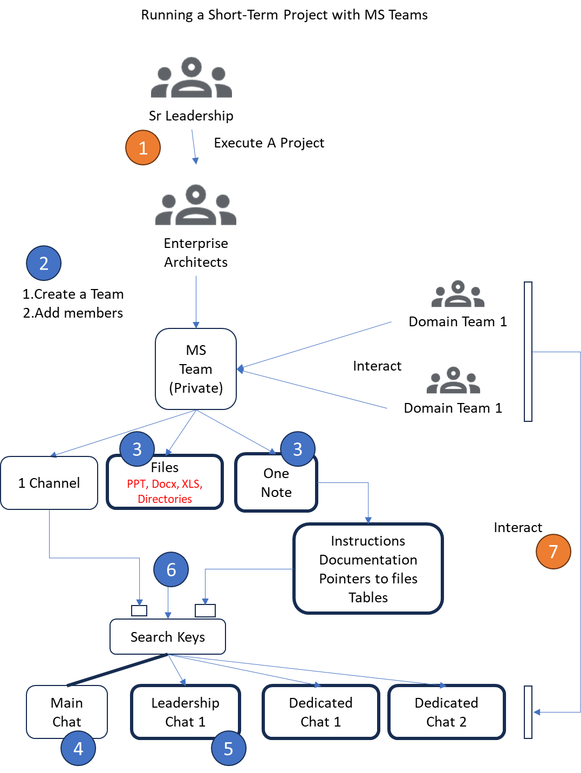

Here is what to be done and how this works

1. Beginning of a Special Project
2. EA identifies the cross-domain teams and folks that need to work on this effort. EA then creates a new MS Team private project. Adds members and owners to the Team.
3. The default channel “General” is used as the “anchor” to host all files related to this effort. Directories and sub directories in this file system hold the assets both inputs, outputs, and working. EA also creates a notebook via OneNote and names it accordingly. This notebook is where all long-lasting information is distributed from. However, the “Posts” on the “General” Channel are rarely used. (See later what needs to be the pinned message in this Post)
4. Create a main “chat” for collaboration and add members as you feel necessary. Typically, these chats match up with the meetings and key sub tasks for this project. The main chat may have most folks of the project.
5. Create sub chats based on rerunning meetings or topics that needs to be independently worked by smaller teams
6. Search keys: This is a work around of my “feeble” design. As chats are not linked to the MS team, and we adapted them for their convenience, we need to find a way to find them in the long chat universe. For this I put a message that looks like “search-key: my-special-chat” that is then pinned in that chat with links back to the MS Team. This backlink is used to reach the file system. The search-keys are then saved in the “General” channel Posts, and in the OneNote long-lasting instructions
7. The members of the project then interact with all the following assets
   1. Files and folders in the “General” Channel
   2. OneNote instructions and annotated file links
   3. Find Chats via their search keys and collaborate with others on that chat

# Tangible Benefits

1. You no longer need a local file system to work with project assets
2. Creating, updating, viewing decks and documents is automatic and multiple folks can do it seamlessly
3. Although not good for everything, OneNote works well in quickly distributing knowledge
4. Chats work well (You can largely move away from Outlook except for a few messages that you can do only via email)
5. You are also saved from the email webs and attaching endless documents in emails
6. Much better control to the EA that is orchestrating the work

# Disclaimer: Not a replacement for SDLC or Agile Tools

Note: This is not a replacement for traditional SDLC or Agile PM tools.

# OneNote

For me, these are the best practices when it comes to OneNote

1. Use it
2. Use the desktop version (web version has too many left and right tabs). It looks better visually
3. Have the whole team contribute to content
4. Use tables for links or document references. Table structure gives you more freedom to type in its constrained structure.
5. You can easily attach architectural diagrams
6. You can “print” your decks or “print” anything to OneNote. Comes handy sometimes to quickly go over content without opening PPTs etc, esp. in a Team environment.

## Annoyances of OneNote

1. Its page design is open, and if you want to quickly add content, you must explicitly worry about visual details such as placement tables etc.
2. Pages can look a bit dated
3. Not as convenient as a wiki
4. TOC contents on a given page doesn’t exist

## Structure of a Notebook of OneNote

1. Notebook at the highest level. You can create multiple books. Each book shows up as a file in SharePoint
2. A notebook has “sections”. These show up as tabs in desktop and as left side menus in web
3. Each section has multiple “pages”
4. You typically create multiple pages in a “section”.
5. You will get used to this structure, just know that that is the hierarchy.