Pharmacy Coupons – A Healthcare Journey

# Version Information

Draft version. Beta, 1.2 (Satya Komatineni), 8/17/2024

Started: 8/15/24, Expected completion: On going.

**Status: Second of 3 reads**

Contents

Version Information 1

Goal/Note 3

Target Audience: Health IT 3

Healthcare Industry Terminology 3

Caution: This is merely a Preliminary Understanding Article 3

What Are Pharmacy Coupons? 3

Nature of these coupon medications 4

Specialty Medications: 4

Cancer Treatments: 4

Orphan Drugs: 4

Chronic Disease Medications 4

Other Examples 5

The recent 2024 Medicare Prescription drug debate 5

The list of drugs 5

How Do They Work? 6

Who Offers and Who Pays? 6

Who Offers 6

Who Pays 6

How Does Money Flow? An Example 7

General money flow in a pharmacy transaction 7

A Scenario: with and without a coupon 8

Without a Coupon: 8

With a Coupon: 8

Critique of Coupons 8

Artificial Inflation of Prices 8

Cost shifting to Payer case: Counts coupon towards meeting deductible 8

Cost shifting to the Patient case: Does not count coupon as part of deductible 9

Slower adoption of Generics 9

Why Does Medicare Prevent Pharmacy Coupons? 9

Despite the Difficulties, Are There Benefits to Coupons? 9

Immediate Financial Relief 9

Improving Medication Adherence 9

Bridge Gaps in Coverage 9

Cost Shifting in More Detail, Between Patient and Payer 9

With Coupons 9

Without Coupons 10

Usage of coupons 10

What Do the Pictures Look Like If There Are Coupons and If There Are No Coupons? 10

With Coupons 10

Without Coupons 10

When Do Coupons Genuinely Make Sense? 10

How Would You Design Coupons in an Ethical Way? So That They Are Truly Beneficial Without Subversion? 11

About PBMs, A quick intro 11

Role of PBMS 11

Key PBMS in the industry 11

Industry references 12

# Goal/Note

Understand the following questions about pharmacy coupons, the good and the bad.

1. What are pharmacy coupons?
2. How do they work?
3. Who offers and who pays?
4. How does money flow? An example
5. Significant critique of pharmacy coupons
6. Why does Medicare prevent them?
7. Despite the difficulties, are there benefits?
8. Explanation of cost shifting in more detail, between patient and payer, the consequences.
9. What does the picture look like if there are coupons and there are no coupons?
10. When do coupons genuinely make sense?
11. How would you design coupons in an ethical way so that they are truly beneficial without subversion?

# Target Audience: Health IT

1. Architects
2. Analysts
3. Managers
4. Testers

# Healthcare Industry Terminology

1. Payer – Health Insurance company
2. Provider – Physicians
3. Pharmacy – Drug store
4. PBM – Pharmacy Benefit Managing companies (They aggregate and manage pharmacies for a Payer for a fee. Interactions between Payers, Drug manufacturers, Pharmacies, and PBMs are quite complex)

# Caution: This is merely a Preliminary Understanding Article

This is a preliminary understanding article.

Verify and validate content independently after your read.

# What Are Pharmacy Coupons?

Pharmacy coupons are offered by pharmaceutical manufacturers to help **reduce the out-of-pocket costs** for patients or induce them to purchase prescription medications.

These are applied at the point of sale to the member.

# Nature of these coupon medications

These medications typically have the following characteristics

1. Chronic conditions like Diabetes where these medications must be taken for a lifetime (Chronic)
2. High cost of research and production (Specialty)
3. Limited coverage by insurance

Let’s get a sense of what these medications are.

## Specialty Medications:

Biologics: These are complex, high-cost drugs derived from living organisms, used to treat conditions such as

1. Rheumatoid arthritis
2. Multiple sclerosis
3. Cancer drugs. Examples include Humira (adalimumab), Enbrel (etanercept), and Rituxan (rituximab).

## Cancer Treatments:

Many oncology drugs, especially targeted therapies and immunotherapies are expensive and often have no generic equivalents.

Examples include

1. Keytruda (pembrolizumab)
2. Opdivo (nivolumab).

## Orphan Drugs:

Medications for rare diseases have high costs due to the small patient populations.

Examples include

1. Spinraza (nusinersen) for spinal muscular atrophy
2. and Soliris (eculizumab) for paroxysmal nocturnal hemoglobinuria.

## Chronic Disease Medications

Drugs for autoimmune disorders require long term use and are expensive:

1. Drugs for conditions like psoriasis
2. Crohn’s disease
3. Lupus
4. Some examples include
   1. Stelara (ustekinumab)
   2. and Cosentyx (secukinumab).

For diabetes: Insulin and newer diabetes medications like

1. Trulicity (dulaglutide)
2. or Jardiance (empagliflozin)

For HIV/AIDS: Antiretroviral drugs, which must be taken daily for life, can be costly.

Examples include

1. Truvada (emtricitabine/tenofovir)
2. and Genvoya (elvitegravir/cobicistat/emtricitabine/tenofovir alafenamide).

## Other Examples

**Mental Health Medications:** Newer antidepressants and antipsychotics (e.g., Abilify, Viibryd).

**Hepatitis C Treatments:** Costly direct-acting antivirals (e.g., Harvoni).

**Respiratory Medications:** Inhalers and biologics for asthma and COPD (e.g., Symbicort, Dupixent).

**Fertility Treatments:** Hormonal drugs for fertility (e.g., Gonal-F).

**Multiple Sclerosis Therapies:** Disease-modifying treatments (e.g., Tecfidera).

**Weight Loss Medications:** Anti-obesity drugs (e.g., Saxenda).

**Pain Management:** Specialty painkillers and chronic pain treatments (e.g., Lyrica).

## The recent 2024 Medicare Prescription drug debate

The recent agreement between Medicare and pharmaceutical manufacturers involves negotiating lower prices for ten high-cost prescription drugs as part of the Inflation Reduction Act.

This negotiation is aimed at reducing out-of-pocket costs for Medicare beneficiaries and saving billions for the Medicare program.

The new prices, which will be implemented in 2026, will significantly reduce the cost of these drugs, **with discounts ranging from 38% to 79%** off the current list prices.

## The list of drugs

1. **Eliquis**: For blood clot prevention, costs $**521** per month, typically taken long-term for chronic conditions like atrial fibrillation.
2. **Jardiance**: For diabetes and heart failure, costs $**573** per month, usually taken long-term for chronic management.
3. **Xarelto**: For blood clot prevention, costs $**517** per month, generally taken long-term for conditions like deep vein thrombosis.
4. **Januvia**: For diabetes, costs $**527** per month, typically taken long-term as part of diabetes care.
5. **Farxiga**: For diabetes and heart failure, costs $**556** per month, generally taken long-term.
6. **Entresto**: For heart failure, costs $**628** per month, usually taken long-term.
7. **Enbrel**: For rheumatoid arthritis and psoriasis, costs $**7,106** per month, typically taken long-term.
8. **Imbruvica**: For blood cancers, costs $**14,934** per month, often taken long-term.
9. **Stelara**: For psoriasis and Crohn’s disease, costs $**13,836** per month, generally taken long-term.
10. **NovoLog**: For diabetes, costs **$495** per month, typically taken long-term.

# How Do They Work?

Pharmacy coupons are typically available through the manufacturer’s website, healthcare providers, or directly at the pharmacy.

When a patient presents the coupon, it is applied to reduce the amount they need to pay out-of-pocket. The manufacturer then covers the difference between what the patient pays and the amount that would have been their responsibility under their insurance plan.

For example, if a medication has a $100 copay under the patient’s insurance plan, a coupon might reduce this copay to $20. The manufacturer pays the remaining $80, ensuring the patient gets the medication at a reduced cost.

The insurance company still pays the agreed upon price to the drug store through the PBM.

# Who Offers and Who Pays?

## Who Offers

Pharmaceutical companies are the primary issuers of pharmacy coupons. They offer discounts genuinely for affordability or as part of their marketing strategies to retain or increase market share, particularly for brand-name drugs facing competition from generics or other brands. Both scenarios could be at play.

## Who Pays

While the patient pays a reduced amount out-of-pocket, the balance that would have been paid by the patient is covered by the manufacturer. However, the insurance company (payer) still pays the agreed-upon share of the drug's price based on the insurance contract, which can be substantial.

This coupon payment flow is shown in the following interaction diagram

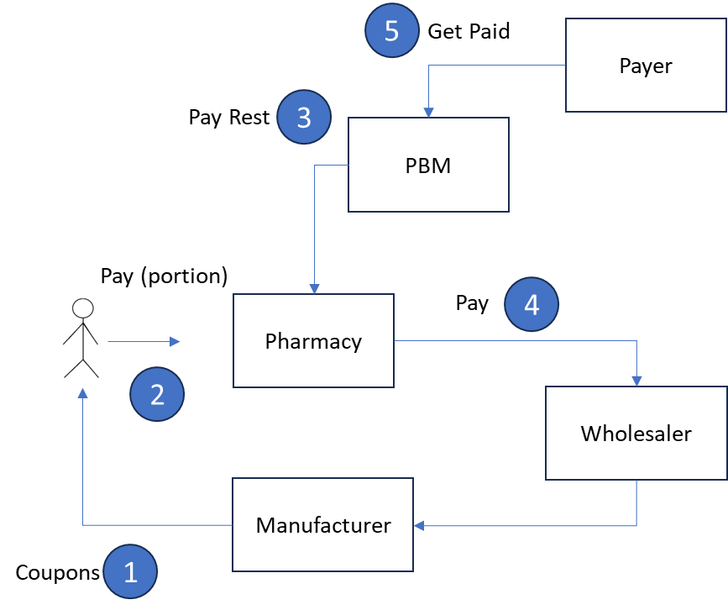

The steps are

1. The manufacturer sets prices for the drug and offers coupons directly or via a provider to the patients. These coupons are often towards out-of-pocket costs, for the rest is paid by the Payer and Manufacturers have little incentive lower the cost for the Payer.
2. Patient visits the pharmacy and pays the reduced portion to the pharmacy based on the coupon.
3. Pharmacy gets paid the insurance portion by the PBM (this value does not change in case of coupons typically)
4. PBM with its arrangements with the Payer gets reimbursed for this amount in terms of bulk cost, service fees etc.
5. Ultimately the manufacturer must get the payments. The pharmacy through the wholesalers pays the adjusted price to the manufacturer (minus the coupon)

# How Does Money Flow? An Example

It is good to understand how the money flows with coupons to grasp the nuances of coupons how they influence or shift cost burdens, and ultimately some of the health care cost.

## General money flow in a pharmacy transaction

1. Patient pays the drug store their share
2. PBM pays the allowed amount (negotiated drug price) to the pharmacy
3. PBM bills the Insurer
4. Insurer pays the PBM either wholesale (usually), retail, along with any service fees

## A Scenario: with and without a coupon

Consider a scenario where a medication costs $500, and the patient’s insurance plan requires a 20% copay ($100).

### Without a Coupon:

The patient pays $100 to the pharmacy (because it is patient’s share, be it out of pocket or coinsurance)

The insurance company pays $400 to the pharmacy, or PBM, or the Manufacturer (through their arrangements)

The manufacturer receives $500. (minus the drug store and PBM cuts)

### With a Coupon:

The coupon reduces the patient’s copay to $20.

The patient pays $20 to the drug store.

The manufacturer covers the $80 difference.

The insurance company still pays $400.

Of course, the money movement still follows through PBMs.

# Critique of Coupons

Implications of coupons when misused are the following

1. Artificial Price increases as Payers can be seen as profitable companies.
2. Costs tend to shift to patients (through unmet deductibles if not counted) or Payers (through met deductibles if counted)

## Artificial Inflation of Prices

Manufacturers can increase prices knowing that patients can afford to pay through coupons in the short run but have insurers pay in the long term (Remember the Chronic need!)

This also increases premiums for other customers in subsequent years.

## Cost shifting to Payer case: Counts coupon towards meeting deductible

If the patient pays only $100 from out of pocket, and manufacturer pays $400 towards the out of pocket, a payer may still count this as meeting a deductible of $500.

So, the payer quickly starts picking up the tab much sooner and starts paying the manufacturer the full price, for patient has no more responsibility, having met the deductible.

Moreover, for patients that don’t use coupons, the total cost of medical care be it insurer provided or self-paid goes up.

## Cost shifting to the Patient case: Does not count coupon as part of deductible

If the payer realizes this, and only gives credit to what the patient pays, and not the coupon, the patient will still have the deductible unmet and will continue to pay for their medical expenses.

## Slower adoption of Generics

As the payer is putting the bill, a patient may still insist on brand name drugs.

# Why Does Medicare Prevent Pharmacy Coupons?

Medicare, along with other government programs like Medicaid, prohibits the use of manufacturer coupons.

Their reasons are similar

1. Allowing coupons could shift Costs to Medicare (being a Payer).
2. Slower adoption to generics

# Despite the Difficulties, Are There Benefits to Coupons?

There may be some, in genuine cases.

## Immediate Financial Relief

Coupons can make expensive medications affordable for patients who might otherwise not be able to afford them, ensuring they receive necessary treatment.

Sometimes the cost of the drug is inherently expensive.

## Improving Medication Adherence

By reducing out-of-pocket costs, coupons can help patients adhere to their prescribed medication regimens, improving health outcomes and potentially reducing overall healthcare costs associated with untreated conditions.

## Bridge Gaps in Coverage

Coupons can provide critical support for patients who are between insurance plans or facing temporary financial difficulties, ensuring they do not have to go without their medications.

# Cost Shifting in More Detail, Between Patient and Payer

Few thoughts.

## With Coupons

The immediate out-of-pocket cost is shifted from the patient to the manufacturer, and indirectly to the payer (insurance company). While the patient benefits from reduced costs at the pharmacy, the insurer still pays a significant portion of the drug's cost. This increased burden on payers can lead to higher premiums and out-of-pocket costs for all insured members in the long term.

## Without Coupons

The patient bears the full cost until their deductible is met, ensuring that cost-sharing mechanisms are intact. This encourages the use of more cost-effective treatments and keeps the overall cost burden more balanced between the patient and the payer.

However, there may be genuine cases as listed before, where the patients cannot afford the medications without coupons.

## Usage of coupons

On average, it's estimated that 10% to 20% of patients utilize manufacturer coupons for their prescription medications. This percentage can vary depending on the drug type, with higher usage rates for expensive brand-name or specialty medications, especially those without generic alternatives.

In some cases, for high-cost specialty drugs, the usage of coupons can be even higher, potentially reaching 20% to 30%. The exact percentage depends on factors such as the availability of alternatives, insurance coverage, and the specific therapeutic area.

# What Do the Pictures Look Like If There Are Coupons and If There Are No Coupons?

So, coupons or no coupons?

## With Coupons

**Patient**: Lower immediate costs, but potential for higher long-term expenses as premiums rise.

**Payer**: Higher overall costs due to the continued use of expensive brand-name drugs, leading to potential increases in premiums and cost-sharing requirements.

**Manufacturer**: Maintains or increases market share but may use coupons to justify high drug prices.

## Without Coupons

**Patient**: More consistent and predictable out-of-pocket expenses, but potentially higher upfront costs, especially for expensive medications. May suffer under some circumstances.

**Payer**: True drug costs

**Manufacturer**: Faces pressure to lower drug prices, especially if patients and providers shift to more cost-effective alternatives.

# When Do Coupons Genuinely Make Sense?

Caution: Opinion

Coupons make the sense, may be, in the following scenarios:

**When No Alternatives Exist**: If there are no generic or less expensive alternatives, coupons can provide essential financial relief to patients needing costly brand-name medications.

**For Chronic Conditions:** Coupons can help patients manage long-term expenses for chronic conditions, making ongoing treatment more affordable and consistent.

**For Bridging Short-Term Gaps:** Coupons can be crucial for patients who are facing temporary financial hardship or transitioning between insurance plans, ensuring they do not have to skip or delay necessary treatments.

Counter arguments that coupons may not have the expected influence:

1. Only 10 to 20% use them
2. That means the market dynamics ought to be still at play as if coupons don’t play a role
3. Perhaps their role and their influence may be small

# How Would You Design Coupons in an Ethical Way? So That They Are Truly Beneficial Without Subversion?

Caution: opinion

Question is “How would you design coupons in an Ethical way, so that they are beneficial Without subversion?”

To design coupons ethically, some thoughts:

**Inherent price:** Coupons should be offered in the context of transparent pricing, where the list price of the drug reflects its true value and worth, not an inflated figure designed to exploit the system.

**Financial hardship:** Address explicitly for financial hardship and not as a ploy for market share.

**Include in Deductible Calculation:** Although controversial, count the coupon as having met the deductible, for its main goal is patient benefit. (if the drug is priced genuinely this is a smaller and justified burden)

**Protect Generics:** Let the coupon program not dissuade from the adoption of generics

# About PBMs, A quick intro

Let’s refresh the role of PBMS in the healthcare industry briefly.

## Role of PBMS

They offer the following services to a Payer

1. Negotiate drug prices with manufacturers to reduce medical cost to the payer
2. Manage a network of pharmacies and be the intermediaries between payer and pharmacies
3. Check eligibility and other things at point of sale
4. Pay and Process claims from pharmacies

## Key PBMS in the industry

1. CVS Caremark
2. Express Scripts (Cigna)
3. Optum Rx (United Health)
4. Prime (Bluecross Health plans)
5. MedImpact (Independent)

# Industry references

1. PBM Basics
   1. from Pharmacists Society of NY
   2. Link: <https://www.pssny.org/page/PBMBasics>.
   3. There is an excellent diagram showing the flow of product, money, and contracts here
   4. Future Search term: Money flow between PBMs, Payers, and Pharmacies
2. On PBMs from CAP (Center for American Progress)
   1. Link: <https://www.americanprogress.org/article/5-things-to-know-about-pharmacy-benefit-managers/>
   2. A nonpartisan policy institute
   3. 5 Things To Know About Pharmacy Benefit Managers
   4. Key terms
   5. Available Transparency in their practices
   6. Price movements due to consolidation
   7. **Money flows**
   8. Reforms
   9. Broader health policy resources
3. A primer on drug pricing from USC
   1. Link: <https://healthpolicy.usc.edu/article/follow-the-money-the-flow-of-funds-in-the-pharmaceutical-distribution-system/>
   2. Money flow
   3. Profit distribution, cost