Table of Contents
1. Introduction 4
2. What is Printer? 4
3. Printer & Its Parts 5
3.1. Various working parts of Printers 5
4. Printer Types 7
4.1. Non-Impact Printers 8
4.1.1. Inkjet Printers 8
4.1.2. Laser Printers 8
4.1.3. Solid Ink Printers 8
4.1.4. Dye-Sublimation Printers 8
4.1.5. Thermal Wax Printers 8
4.1.6. Thermal Autochrome Printers 9
4.2. Impact Printers 9
4.2.1. Impact - Character Printer 9
4.2.2. Impact - Line printer 10
4.3. Inkjet Printer (Non-Impact) 11
4.3.1. What is Inkjet Printer? 11
4.3.2. Functionality 11
4.3.3. Print Head Assembly/Paper Feed Assembly 12
4.3.4. What part of printer is print head? 13
4.3.5. Heat vs. Vibration 14
4.3.6. Printing Process 15
4.3.7. Benefits of using Inkjet Printers 16
4.3.8. Limitations of Inkjet Printer 16
4.4. LaserJet Printer (non-impact) 16
4.4.1. LaserJet Printer Functionality 17
4.4.2. Structure of a LaserJet Print Head 19
4.4.3. Advantages of LaserJet Printer 19
4.5. Difference Between Inkjet & Laserjet 20
5. How do I connect my PC to my Printer? 20
5.1 Basic Requirements 21
5.1.1. For Wired connections 21
5.1.2 For Wireless connections 21
5.2. Detailed Connection Methods 21
5.2.1. For USB Connection Process 21
5.2.2. For Wireless Connection Process 22
5.2.3. For Network Printer Connection Process 22
6. HP Printers 23
6.1. Introduction to HP Printers 23
6.2. Types of HP Printers 23
6.3. Key Features of HP Printers 23
6.4. Key Points 24
7. Detailed Language Information 29
8. Function set with brief details 41
Annexure – 1 45
9. HP Printer Feature details 45
Annexure – 2 48
10. How do various printers work? 48
10.1. How Does an Inkjet Printer Work? 48
10.1.1. Parts Inside an Inkjet Print Engine 49
10.1.2. The Inkjet printing process 49
10.2. How does a Laser Printer work? 49
10.2.1. Parts Inside A Laser Print Engine 50
10.2.2. The Laser Printing Process 50
10.3. How Does A Dot Matrix Printer Work? 50
10.3.1. Parts Inside A Dot Matrix Print Engine 50
10.3.2. Dot Matrix Printing Process 51
10.4. How Does A Solid Ink Printer Work? 51
10.4.1. Parts Inside A Solid Wax Ink Print Engine 51
10.4.2. Solid Ink printing process 51
10.5. How Does a Thermal Printer work? 52
10.5.1. Parts Inside A Thermal Print Engine 52
10.5.2. Thermal Printing Process 52
Annexure – 3 52
11. How to Print a Document from Your Computer 52

Introduction

Strings Team – Empowering User-Printer Communication
At Strings Team, we don’t just write content, we bridge the gap between users and technology. Our mission is to transform complex printer interactions into seamless, intuitive experiences through clear, engaging, and purposeful communication.
What We Do
We design and deliver interactive, user-centric content that guides, informs, and supports users at every step of their printing journey.
- Understandable – We simplify technical language into clear, actionable messages.
- Interactive – We create content that responds to user needs in real time.
- Empowering – We help users feel confident and in control of their devices.
Our client
HP Inc. (HP) – A global leader in printing innovation.
Our Product Focus
- Home Printing Solutions – Making everyday printing effortless for families and individuals.
- Graphic Business Solutions – Supporting professionals with precision and performance.
- Office Printing Solutions – Enhancing productivity in dynamic work environments.
Our Impact
We don’t just write, we enhance user satisfaction, reduce support calls and elevate brand experience through every word we craft.

What is Printer?

Printer is a peripheral machine which makes a persistent representation of graphics or text, usually on paper.
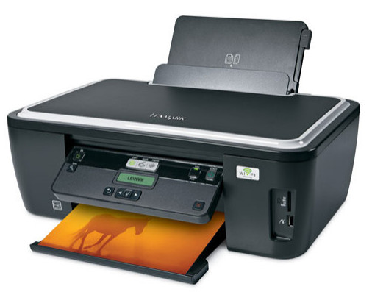
A printer is a device that accepts text and graphics output from a computer, and it transfers this information to paper, sheets. Printers can print any information that has been passed to it, whether it be Text, Numbers or Images. It depends on the type of printer that what quality or color the printed matter would be.

Printer & Its Parts

The way in which printers work is quite simple. In short, printers work by converting digital images and text into physical copies. They do this using a driver or specialized software that has been designed to convert the file into a language that the printer can understand. The image or text is then recreated on to the page using a series of miniscule dots.

The only real difference that separates the various types of machines available is the method in which the dots are transferred onto the page.

Various working parts of Printers
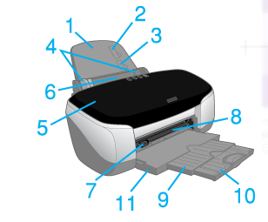
- Paper support: Supports the paper loaded in the sheet feeder.
- Paper stopper (upper): Helps load the No.10 and DL envelopes correctly.
- Paper stopper (lower): Helps load the C6 envelopes correctly.
- Edge guides: Help load the paper straight. Adjust the left edge guide to fit the width of your paper.
- Printer cover: Covers the printing mechanism. Open only when installing or replacing ink cartridges.
- Sheet feeder: Holds the blank paper and automatically feeds the paper during printing.
- Automatic roll paper cutter connector: Connects the Automatic Roll Paper Cutter.
- Matte board feeder: Holds the CD-R tray and the matte board and feeds them using the front sheet feeder.
- Output tray: Receives the ejected paper.
- Output tray extension: Supports the ejected paper.
- Hole Punch: Connects the Photo Catcher.

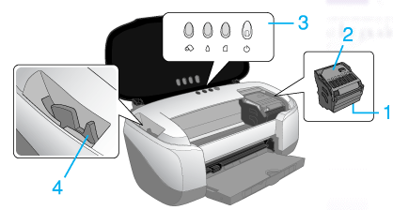
- Print head: Delivers ink to the page. The core of an inkjet printer, the print head contains a series of nozzles that are used to spray drops of ink.
- Cartridge cover: Covers the ink cartridges. Open only when installing or replacing ink cartridges.
- Control panel: Controls various printer functions. See the next section for details.
- Adjust lever: Adjusts the distance between the print head and the paper to prevent smearing. Adjust the Envelope position of the lever should ink appear to smear across your document when printing on matte board, or envelopes. Adjust the lever to the CD-R tray position when printing on CD-R. Adjust the lever to the open position when you load or remove some kinds of paper
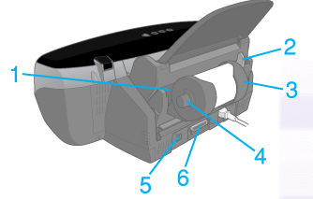

- Roll paper feeder: Holds the roll paper and automatically feeds it after holding the roll paper with your hand for three seconds.
- Roll paper edge guides: Helps load the roll paper straight. Adjust the edge guide to fit the width of your paper.
- Roll paper holder: Attaches to the printer and holds the roll paper.
- Roll paper knob: Turn to roll up the roll paper.
Interface port(s) - The parallel port is still used by many printers, but most newer printers use the USB port. A few printers connect using a serial port or small computer system interface (SCSI) port.
- USB interface cable connector: Used to connect the USB cable to the computer and the printer.
- Parallel interface cable connector: Used to connect the parallel cable to the computer and the printer.

Power supply - While earlier printers often had an external transformer, most printers sold today use a standard power supply that is incorporated into the printer itself.
Control circuitry - A small but sophisticated amount of circuitry is built into the printer to control all the mechanical aspects of operation, as well as decode the information sent to the printer from the computer.

Printer Types
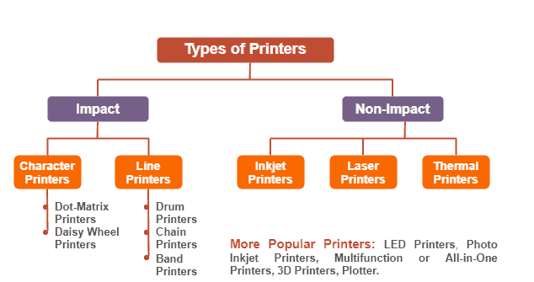

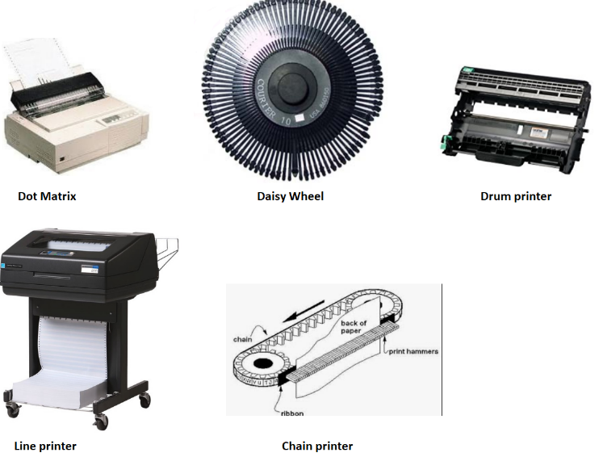

Non-Impact Printers
Non-impact printers create figures and pictures without any connection between the printing device and the paper, i.e., do not touch the paper when creating an image

Inkjet Printers
Use a series of nozzles to spray drops of ink directly on the paper.

Laser Printers
Use dry ink (toner), static electricity, and heat to place and bond the ink onto the paper.

Solid Ink Printers
Contain sticks of wax-like ink that are melted and applied to the paper. The ink then hardens in place.

Dye-Sublimation Printers
These printers have a long roll of transparent film that resembles sheets of red-, blue-, yellow- and gray-colored cellophane stuck together end to end. Embedded in this film are solid dyes corresponding to the four basic colors used in printing: cyan, magenta, yellow and black (CMYK).
The print head uses a heating element that varies in temperature, depending on the amount of a particular color that needs to be applied. The dyes vaporize and permeate the glossy surface of the paper before they return to solid form. The printer does a complete pass over the paper for each of the basic colors, gradually building the image.

Thermal Wax Printers
These printers are something of a hybrid of dye-sublimation and solid ink technologies. They use a ribbon with alternating CMYK color bands. The ribbon passes in front of a print head that has a series of tiny, heated pins. The pins cause the wax to melt and adhere to the paper, where it hardens in place.

Thermal Autochrome Printers
These printers have the color in the paper instead of in the printer. There are three layers (cyan, magenta and yellow) in the paper, and each layer is activated by the application of a specific amount of heat. The print head has a heating element that can vary in temperature. The print head passes over the paper three times, providing the appropriate temperature for each color layer as needed.

Impact Printers
Impact printers create pictures and figures by hitting a device such as a wheel or a print hammer against an inked ribbon.

Impact - Character Printer
Character printers are basically computerized typewriters. They have a ball or series of bars with actual characters (letters and numbers) embossed on the surface. The appropriate character is struck against the ink ribbon, transferring the character's image to the paper.
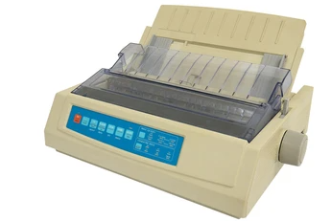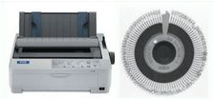
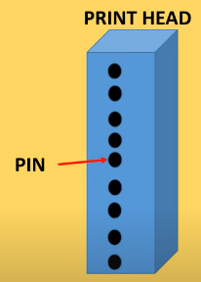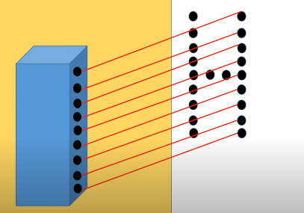

A character printer prints one character at a time instead of one line at a time

Dot Matrix Printer
Dot matrix printing uses a print head that moves back-and-forth, or in an up-and-down motion, on the page and prints by impact, striking an ink-soaked cloth ribbon against the paper, much like the print mechanism on a typewriter.
OR
Printers use a series of small pins to strike a ribbon coated with ink, causing the ink to transfer to the paper at the point of impact.

Daisy-Wheel Printer
The wheel is used in a computer printer called a daisy-wheel printer. To print, the wheel is rotated until the correct character faces the paper; a hammer strikes the character against an ink-coated ribbon and paper. The daisy wheel is mounted on a carriage that types the characters in lines.

Impact - Line printer
A line printer prints one entire line of text before advancing to another line.
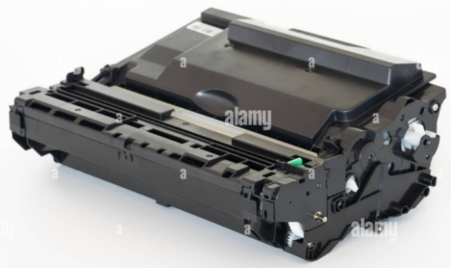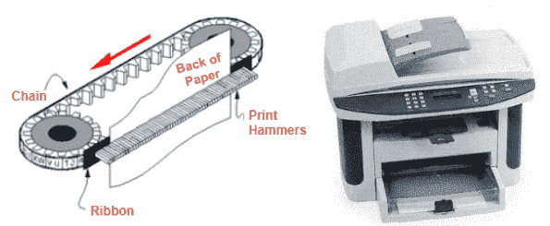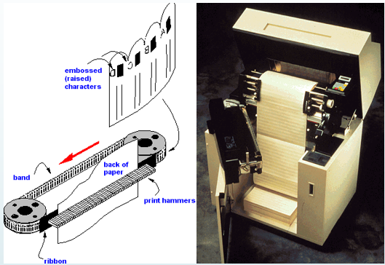

Drum Printer
A wide-format inkjet printer. a line printer that uses a rotating drum with raised characters, against which the paper is pressed.

Chain Printer
A line printer in which the printing element is type carried on a continuous chain.

Band Printer
A line printer that uses a metal band, or loop, of type characters as its printing mechanism. The band contains a fixed set of embossed characters that can only be changed by replacing the band. The band spins horizontally around a set of hammers, one for each print column.

Inkjet Printer (Non-Impact)

What is Inkjet Printer?

An inkjet printer is a computer accessory that creates physical copies of text documents or photos by spraying ionized ink droplets directed by magnetic plates onto paper.
A standard inkjet printer can produce color prints with a resolution of 1200 x 1440 dpi, which is sufficient for printing photos larger than 5 x 7 inches. However, for projects that demand higher print quality on a larger scale, some inkjet printers offer resolutions up to 5760 x 1440 dpi.
Many models include other devices such as:
- Scanner
- Photocopier
- Dedicated Fax machine along with printer in a single machine
Some of the recognizable inkjet printer brands and models include - Epson XP, Canon Pixma and HP DeskJet for home office printing, and the Canon ImageCLASS and HP OfficeJet all-in-one printers for business use.
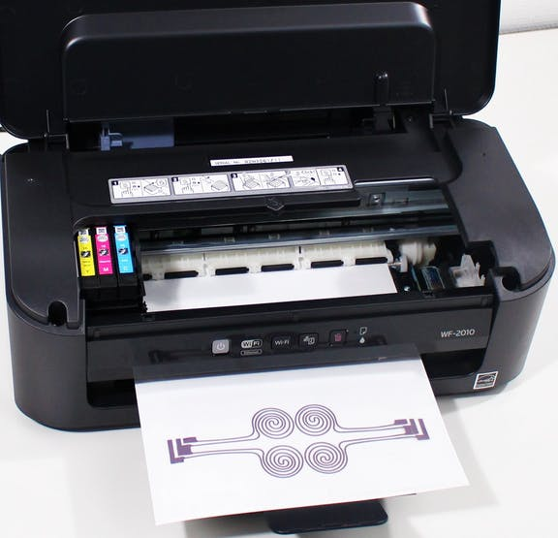

Functionality
The print head has several tiny nozzles, also called jets. As the paper moves past the print head, the nozzles spray ink onto it, forming the characters and images.
Inkjet machines use a liquid ink produced either by either a colored dye or a liquid that contains solid pigments in suspension.
As the print head moves horizontally in the machine, the paper passes through perpendicular to it.
As the page passes through, the individual holes in the print head are activated (usually by heat electrical current depending on the manufacturer) and a small drop of ink is pushed out onto the page.
This process if performed at high speed with thousands of droplets that form together to recreate the digital text or image that is being transferred onto the media.

Print Head Assembly/Paper Feed Assembly

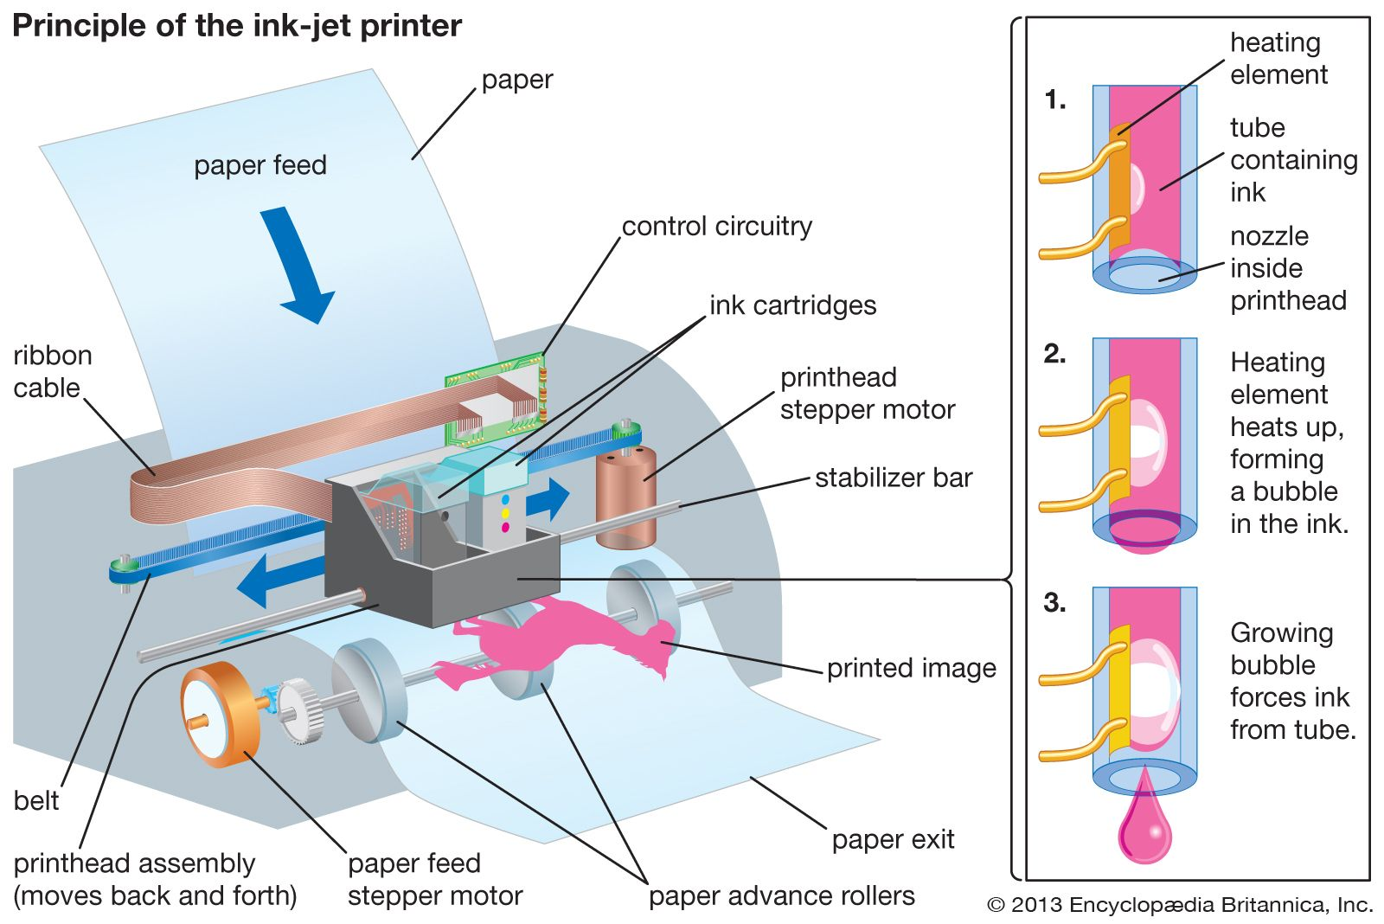

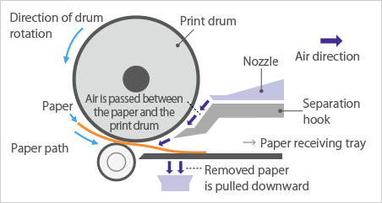
- Ink cartridges - Depending on the manufacturer and model of the printer, ink cartridges come in various combinations, such as separate black and color cartridges, color and black in a single cartridge or even a cartridge for each ink color. The cartridges of some inkjet printers include the print head itself.
- Print head stepper motor – A stepper motor moves the print head assembly (print head and ink cartridges) back and forth across the paper. Some printers have another stepper motor to park the print head assembly when the printer is not in use. Parking means that the print head assembly is restricted from accidentally moving, like a parking brake on a car.
- Belt - A belt is used to attach the print head assembly to the stepper motor.
- Stabilizer bar - The print head assembly uses a stabilizer bar to ensure that movement is precise and controlled.
- Paper tray/feeder - Most inkjet printers have a tray that you load the paper into. Some printers dispense with the standard tray for a feeder instead. The feeder typically snaps open at an angle on the back of the printer, allowing you to place paper in it. Feeders generally do not hold as much paper as a traditional paper tray.
- Rollers - A set of rollers pull the paper in from the tray or feeder and advance the paper when the print head assembly is ready for another pass.
- Paper feed stepper motor - This stepper motor powers the rollers to move the paper in the exact increment needed to ensure a continuous image is printed.

What part of printer is print head?
The structure of a print head can vary depending on the type of printer (inkjet, laser, etc.), but here's an overview of the main components typically found in an inkjet print head, which is one of the most common types:
Components of an Inkjet Print Head
- Nozzles:
These are tiny openings that spray ink onto the paper. The number and size of nozzles can affect print quality and speed.
- Ink Chambers:
These hold the ink before it is ejected through the nozzles. Each color usually has its own chamber in color printers.
- Heating Element (for Thermal Inkjet):
In thermal inkjet printers, a heating element heats the ink to create a bubble that forces a droplet of ink out of the nozzle.
- Piezoelectric Element (for Piezoelectric Inkjet):
In piezoelectric printers, a piezoelectric crystal changes shape when an electric current is applied, forcing ink out of the nozzle.
- Wiring and Control Circuitry:
These components control the timing and sequence of ink ejection, ensuring precise placement of droplets on the paper.
- Filter:
Filters are often included to prevent clogs by removing particles from the ink before it reaches the nozzles.

Heat vs. Vibration
Different types of inkjet printers form their droplets of ink in different ways. There are two main inkjet technologies currently used by printer manufacturers:
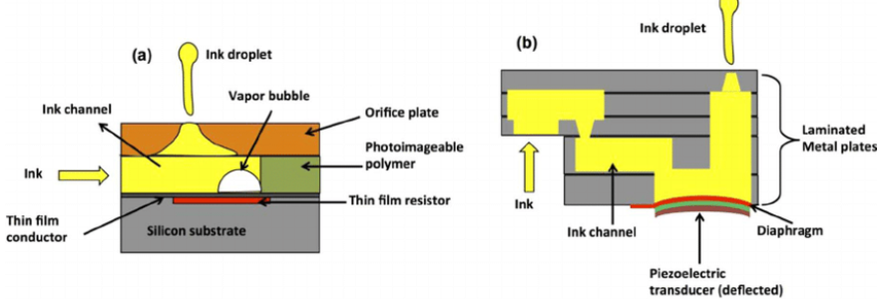

Thermal Bubble
- Used by manufacturers such as Canon and Hewlett Packard, this method is commonly referred to as bubble jet.
- In a thermal inkjet printer, tiny resistors create heat, and this heat vaporizes ink to create a bubble.
- As the bubble expands, some of the ink is pushed out of a nozzle onto the paper.
- When the bubble "pops" (collapses), a vacuum is created.
- This pulls more ink into the print head from the cartridge.
- A typical bubble jet print head has 300 or 600 tiny nozzles, and all of them can fire a droplet simultaneously.

Piezoelectric
- Patented by Epson, this technology uses piezo crystals.
- A crystal is located at the back of the ink reservoir of each nozzle.
- The crystal receives a tiny electric charge that causes it to vibrate.
- When the crystal vibrates inward, it forces a tiny amount of ink out of the nozzle.
- When it vibrates out, it pulls some more ink into the reservoir to replace the ink sprayed out.

Printing Process
- The software application you are using sends the data to be printed to the printer driver.
- The driver translates the data into a format that the printer can understand and checks to see that the printer is online and available to print.
- The data is sent by the driver from the computer to the printer via the connection interface (parallel, USB, etc.).
- The printer receives the data from the computer. It stores a certain amount of data in a buffer. The buffer can range from 512 KB random access memory (RAM) to 16 MB RAM, depending on the model. Buffers are useful because they allow the computer to finish with the printing process quickly, instead of having to wait for the actual page to print. A large buffer can hold a complex document or several basic documents.
- If the printer has been idle for a period of time, it will normally go through a short clean cycle to make sure that the print head(s) are clean. Once the clean cycle is complete, the printer is ready to begin printing.
- The control circuitry activates the paper feed stepper motor. This engages the rollers, which feed a sheet of paper from the paper tray/feeder into the printer. A small trigger mechanism in the tray/feeder is depressed when there is paper in the tray or feeder. If the trigger is not depressed, the printer lights up the "Out of Paper" LED and sends an alert to the computer.
- Once the paper is fed into the printer and positioned at the start of the page, the print head stepper motor uses the belt to move the print head assembly across the page. The motor pauses for the merest fraction of a second each time that the print head sprays dots of ink on the page and then moves a tiny bit before stopping again. This stepping happens so fast that it seems like a continuous motion.
- Multiple dots are made at each stop. It sprays the CMYK colors in precise amounts to make any other color imaginable.
- At the end of each complete pass, the paper feed stepper motor advances the paper a fraction of an inch. Depending on the inkjet model, the print head is reset to the beginning side of the page, or, in most cases, simply reverses direction and begins to move back across the page as it prints.
- This process continues until the page is printed. The time it takes to print a page can vary widely from printer to printer. It will also vary based on the complexity of the page and size of any images on the page. For example, a printer may be able to print 16 pages per minute (PPM) of black text but take a couple of minutes to print one, full-color, page-sized image.
- Once the printing is complete, the print head is parked. The paper feed stepper motor spins the rollers to finish pushing the completed page into the output tray. Most printers today use inks that are very fast-drying, so that you can immediately pick up the sheet without smudging it.

Benefits of using Inkjet Printers
The foremost advantage of Inkjet printer is that most of them are inexpensive. Even the most affordable inkjet printers meet the needs of most personal computer users.
High-end inkjet printers can render digital images on specialized paper, achieving quality that competes with professionally printed glossy or matte photographs.
Few notable advantages:
- Easy to use
- Low cost
- High quality of output, capable of printing fine and smooth details
- Capable of printing in vivid colour, good for printing pictures
- Reasonably fast
- No warm-up time
- Quiter than dot matrix printer

Limitations of Inkjet Printer
- The printer ink requires a little time to dry. Also, the print head is less durable, prone to clogging and damage.
- Sufficient drying time is particularly important when the printout includes large areas of solid black or colour ink.
- Most of the inkjet printers are slow and are not designed for high-volume print jobs.
- Although inkjet printers may seem like a more affordable choice for a home office or small business initially, they tend to be more expensive to operate in the long run compared to laser printers.

LaserJet Printer (non-impact)
A laser machine uses dots made up of toner – a fine powder of solid particles. Uses a light source (laser/LED), drum (mono) or multiple drums (color) and toner.
A LaserJet is a printer that uses a laser beam to create high-quality text and images on paper. It operates by using a combination of electrostatically charged toner and a heated fuser to transfer the toner onto the paper.
It uses a non-impact photocopier technology where there are no keys striking the paper. Laser printers are known for their fast-printing speeds, sharp output, and reliability.
Some of the types of LaserJet printers based on colour, size and function are:
- Monochrome Laser Printer
- Colour Laser Printer
- Compact Laer Printer
- Multifunctional Laser Printer
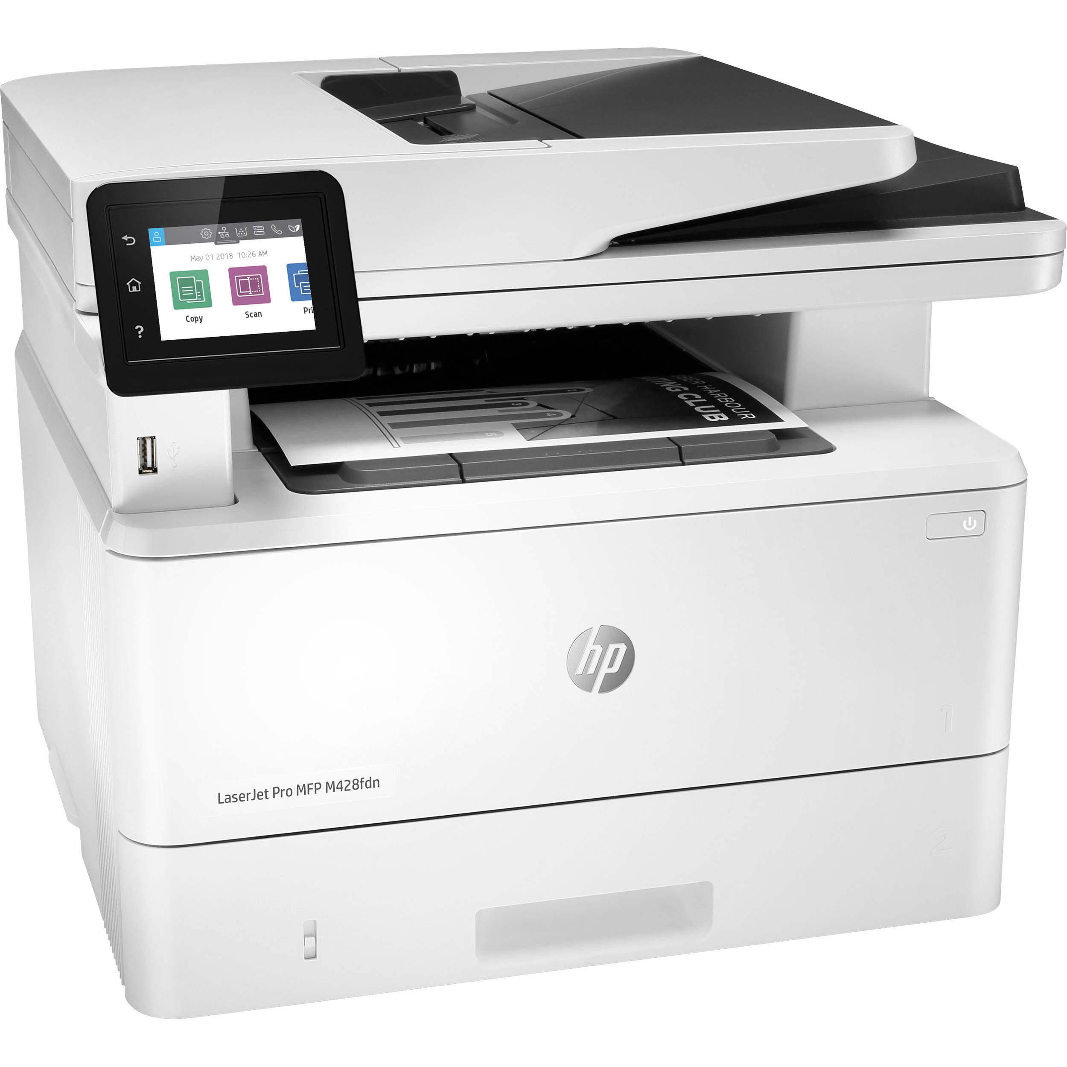

LaserJet Printer Functionality

In order to create an image on the page, the drum is first charged and then the laser or LED is shone onto the drum in the outline of the intended image.
The toner itself is attracted to areas of the drum that have the charge knocked off and a series of rollers transfer the powder from the toner cartridge and presents it at the drum.
The areas that are charged repel the toner and the area that is not attracts the toner particles which are pulled onto the drum and stick to the parts that make up the image.
At the same time, the paper is also transported to meet the drum, which, in turn, transfers the image across to the page itself.
The paper is then passed through a fuser unit (hot roller) which applies heat and pressure to melt the toner particles so that they stick to the page and create a finished image.
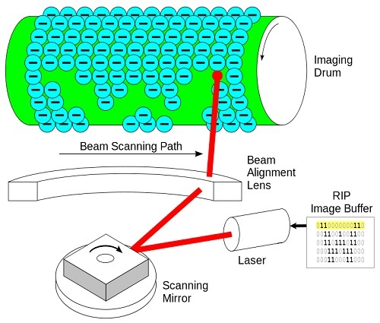

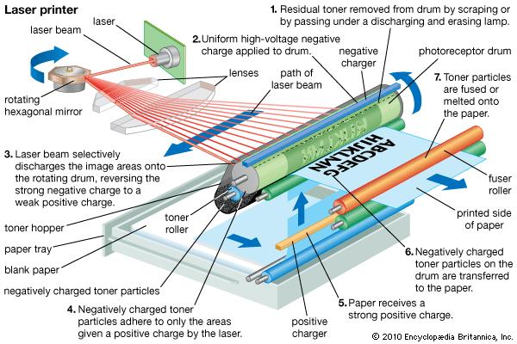

LaserJet includes monochrome, colour, multifunction and wide-format printers. Each type serves specific needs like:
- black and white printing,
- vibrant colour output,
- Versatile functionality,
- Large format printing requirements etc.
LaserJet printers have fast-printing speed, high quality and sharp prints. The toner cartridges are easy to maintain. These are cost-effective printers with multifunctional capabilities like duplex printing, scanning, wireless printing, USB connectivity etc.

Structure of a LaserJet Print Head
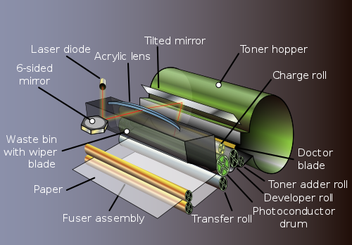
For laser printers, the print head structure is quite different:
- Laser Diode:
- A laser beam is generated by a laser diode, which is directed onto a rotating mirror to scan across the drum.
- Photoconductor Drum:
- This drum is coated with a photosensitive material that holds an electrostatic charge. The laser alters the charge on the drum to create an image.
- Developer Unit:
- This unit applies toner to the charged areas of the drum, transferring the toner to the paper during the printing process.
- Transfer Roller:
- This component transfers the toner from the drum onto the paper.
- Fuser Unit:
- The fuser uses heat and pressure to permanently bond the toner to the paper.

Advantages of LaserJet Printer
The LaserJet Printers are known for their productivity. The print speed is fast besides having a toner with capacity larger than the inkjet printer. The paper cassette has a large capacity, reducing the amount of time spent reloading paper.
Laser printers excel in text sharpness and colour intensity. Additionally, they offer long-lasting prints with resistance to UV and moisture. Some models can achieve incredibly fast print speeds, nearing one page per second.
Few notable advantages are:
- High printing speed
- Less noisy
- Ability to load large amount of sheets
- No Splatter (unlike Inkjet printers)
- Double-sided printing possible
- Better resolution

Difference Between Inkjet & Laserjet
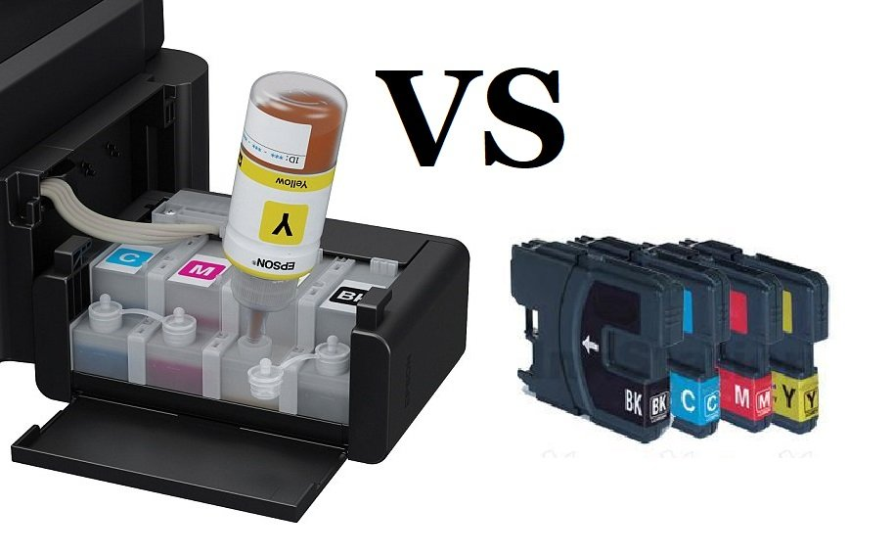
Sl. No. | Inkjet Printer | LaserJet Printer
1. | An inkjet printer produces hard copies by jetting ink onto paper. | A laser printer provides the output through a laser and an electrical charge model.
2. | It is affordable as compared to the laser printer. | It is expensive.
3. | On an inkjet printer, a nozzle is placed through which the process of spraying the ink onto the paper gets executed. | In laser printers, there is no nozzle placed.
4. | In an inkjet printer, the cartridges contain ink in liquid form, and it can dry out easily if we don’t use it for a lengthy period. | In a laser printer, the ink is available in the form of powder. There is no issue of drying out.
5. | Here we need to refill the ink quickly, which is expensive. | Here, we don’t have to refill the ink quickly.
6. | Example: HP Deskjet 1112 printer, Epson L361 printer, Epson L130 single-function printer. | Example: HP LaserJet printer.

How do I connect my PC to my Printer?
Connecting your PC to your printer is generally a straightforward process. One common method is to use a USB cable. Just plug one end of the cable into your printer and the other end into your computer's USB port. You may need to install the necessary drivers and software to connect your devices, which can typically be found online.
Another option is to use a wireless connection if your printer supports it. This can be done by connecting your printer to your Wi-Fi network and then connecting your computer to the same network. Overall, there are multiple ways to connect your PC to your printer, and the process should be relatively simple to complete.

5.1 Basic Requirements
- Your printer and computer
- Power cable and outlet access
- Printer documentation and drivers
- Administrator access to your computer
- Stable work surface near your computer

5.1.1. For Wired connections
- High-quality USB cable (preferably with gold-plated connectors)
- Available USB port on your computer
- USB hub (if needed for additional ports)
- Network cable (for ethernet connections)

5.1.2 For Wireless connections
- Active wireless network
- Network name (SSID) and password
- Router with WPS capability (optional)
- Mobile device for wireless setup (some models)
- Strong Wi-Fi signal in printer location

5.2. Detailed Connection Methods
Proper printer placement is crucial for its reliable operation. After the initial printer setup, follow the below steps to connect your PC with printer.

5.2.1. For USB Connection Process
This is quite a straightforward connection method

5.2.1.1. Preparation
- Ensure printer is powered on
- Close all applications on computer
- Log in with administrator rights
- Locate USB ports on both devices

5.2.1.2 Connection Steps
- Connect USB cable to printer first
- Connect another end to computer
- Wait for device recognition
- Follow any on-screen prompts
- Install drivers if needed

5.2.1.3. Driver Installation
- Allow automatic driver installation
- Download latest drivers if needed
- Run driver installer as administrator
- Accept security prompts
- Wait for installation completion

5.2.2. For Wireless Connection Process

5.2.2.1. Network Preparation
- Verify network compatibility
- Check signal strength
- Note network credentials
- Enable WPS if available
- Update router firmware

5.2.2.2. Printer Configuration
- Access wireless setup menu
- Select network connection type
- Choose your network SSID
- Enter network password
- Verify connection success

5.2.2.3. Computer Configuration
- Open printer settings
- Add new printer
- Select wireless printer
- Install network drivers
- Test connection

5.2.3. For Network Printer Connection Process
These are for office environment or for shared printers.

5.2.3.1. Infrastructure Requirements
- Ethernet network availability
- DHCP server configuration
- Network printer policies
- Print server (if used)
- Adequate bandwidth

5.2.3.2. Physical Connection
- Connect network cable
- Verify link lights
- Obtain IP address
- Document network location
- Test network connectivity

5.2.3.3. Printer Configuration
- Set static IP (if needed)
- Configure network protocols
- Set security options
- Enable printer sharing
- Configure access controls

HP Printers

Introduction to HP Printers
Hewlett-Packard (HP) is one of the leading manufacturers of printers, known for their reliability, efficiency, and innovation. HP offers a wide range of printers designed for home, office, and industrial use, incorporating advanced features such as wireless connectivity, high-speed printing, and eco-friendly technologies.
HP offers a vast range of products across different categories, including printers, laptops, desktops, monitors, accessories, and enterprise solutions. Below is a categorized HP Products & Assets List along with their Impact Analysis based on efficiency, business value, and sustainability.

Types of HP Printers
- Inkjet Printers – Ideal for home and small office use, these printers provide high-quality color and black-and-white prints.
- Laser Printers – Best suited for businesses requiring fast and cost-effective printing, especially for large volumes.
- All-in-One (AIO) Printers – These multifunction devices combine printing, scanning, copying, and faxing into a single unit.
- Photo Printers – Designed for professional and high-quality photo printing.
- Large Format & Industrial Printers – Used for specialized tasks such as posters, banners, and commercial applications.

Key Features of HP Printers
- HP Smart App for mobile printing and remote management.
- Wireless & Bluetooth Connectivity for easy access from multiple devices.
- HP Instant Ink Subscription for automatic ink delivery.
- Energy-efficient & Eco-friendly Printing with sustainable materials.
- Advanced Security Features for protecting sensitive data.
HP printers continue to evolve, incorporating AI-driven capabilities and cloud-based solutions to enhance user experience. Whether for personal or business use, HP printers offer a reliable and innovative printing solution8.4.

Key Points
- Printing: Duplex/Simplex: HP printers support both one-sided (simplex) and two-sided (duplex) printing through driver settings, including auto or manual duplex and binding options. Pro Select (Zelus), Workflow UI (Jupiter), and LFP (Ulysses) models all support duplex printing for better efficiency and paper use.
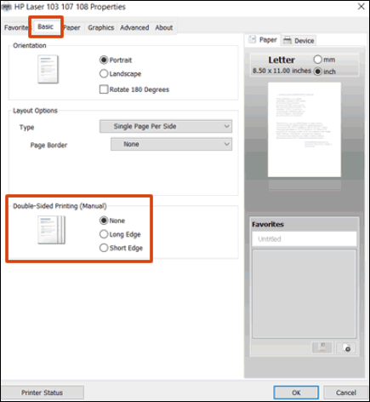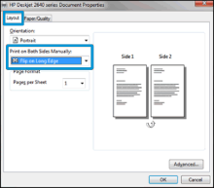
- ADF - HP printers with an Automatic Document Feeder (ADF) can scan, copy, or fax multiple pages on their own, without needing to load each page by hand. Some models support two-sided (duplex) scanning, but Pro Select (Zelus/Ulysses) and Workflow UI (Jupiter/Beam SF) don’t have ADF. LFP models do support ADF with single-sided (simplex) scanning, making it easier to scan several pages quickly.
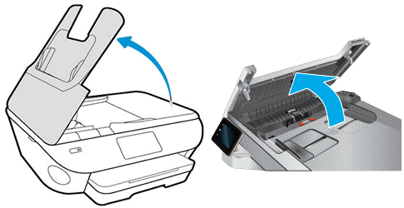
- Connectivity - These printers offer different ways to connect like USB for direct use, Wi-Fi for wireless printing and Ethernet for printing over a network. Some models also support Bluetooth, Wi-Fi Direct and mobile printing apps like HP Smart. These options let users print easily from phones, tablets or computers at home or in the office.
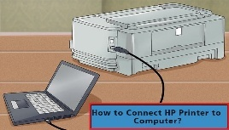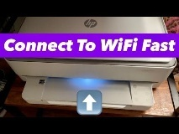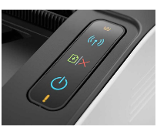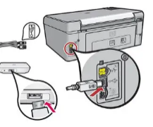

- Print Technology: HP printers use different print technologies to transfer ink or toner onto paper. Models like Pro Select (Zelus) and Jupiter use IIC (Inkjet Industrial Color) for sharp color prints, often in small businesses or offices. Other printers may use laser or standard inkjet methods and many also support scanning, copying and faxing.
- Tray: The paper tray in printers holds the paper and automatically feeds it into the printer for printing. It helps keep the paper steady and in place. Pro Select and Workflow UI models usually have 3 trays for handling different paper types, while LFP models come with 1 tray, mainly for large or special prints.
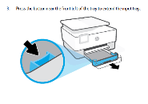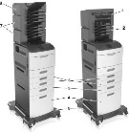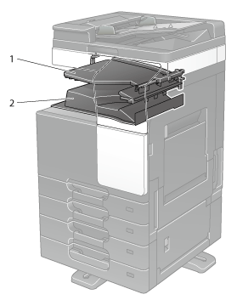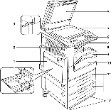
- Photo Tray: The Photo Tray in the printers holds small-size photo paper (like 4x6 or 5x7 inches) for high-quality photo printing. It works separately from the main tray and allows quick prints without reloading. This is common in Pro Select, LFP, and Workflow UI models for easy photo output.
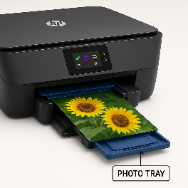

- ADF Sensor: The ADF sensor checks if paper is placed correctly in the feeder and helps prevent jams or misfeeds for smooth, two-sided scanning. It's especially helpful in Pro Select, LFP, and Workflow UI models that handle large or frequent scan jobs.
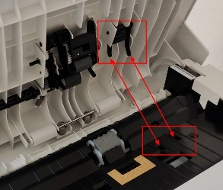

- Scanner Glass: These printers with scanner glass let users scan, copy or send documents via email or fax using the control panel or connected software. While most Pro Select and Workflow UI models lack this feature, several LFP and Enterprise models support it for high-quality, manual scans ideal for fragile or single-sheet items.
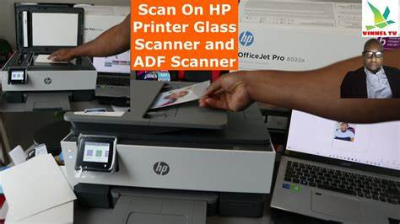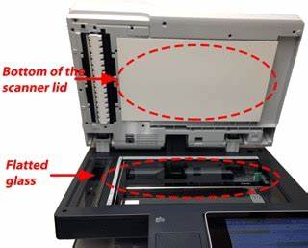

- PDL package: PDL (Page Description Language) packages in HP printers support basic functions like print, scan, copy and sometimes fax. They use languages like PCL to process documents, with some models also offering duplex, network, and photo printing features.
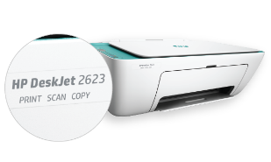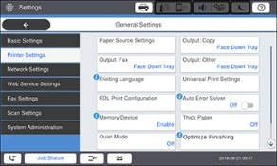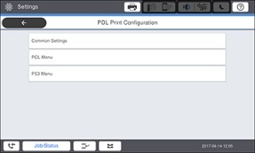
- USB host (USB Print): The paper tray in HP printers holds the paper and automatically feeds it into the printer for printing. It helps keep the paper steady and in place. Pro Select and Workflow UI models usually have 3 trays for handling different paper types, while LFP models come with 1 tray, mainly for large or special prints.
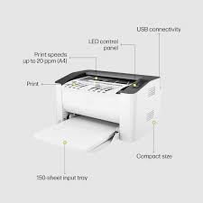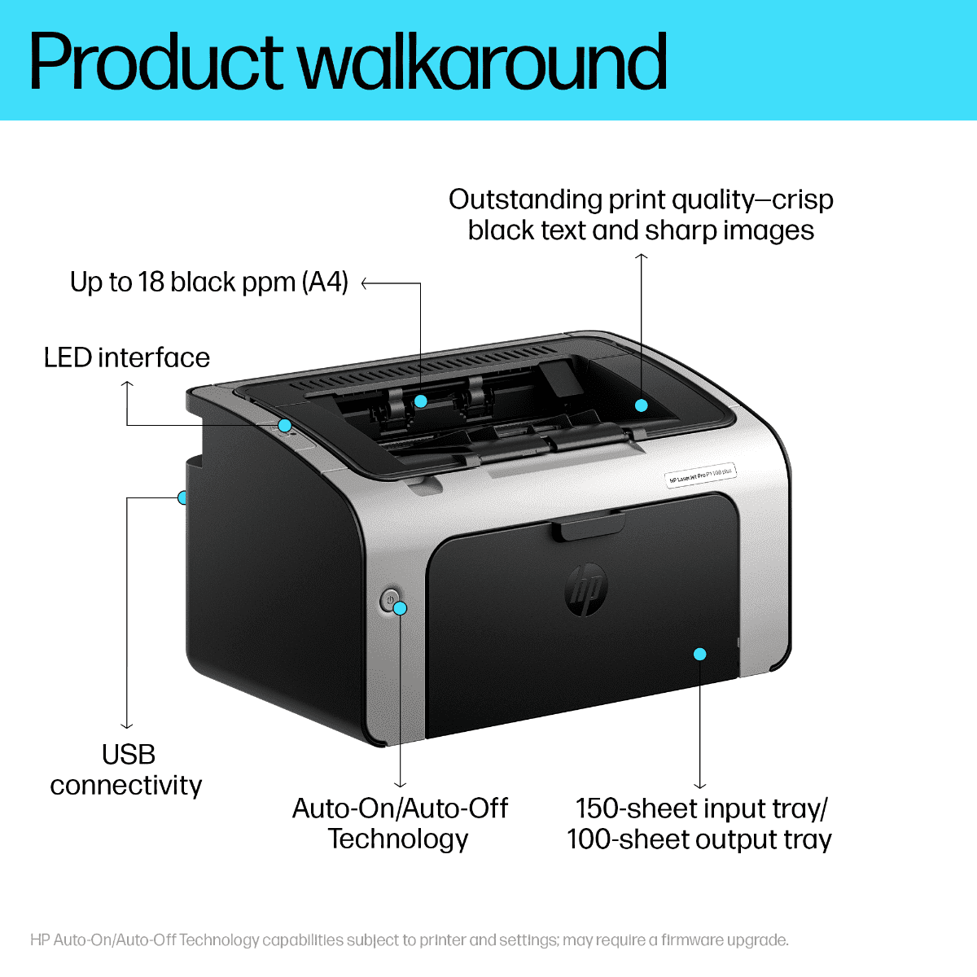

- Rear USB host (Job Storage): Rear USB host (Job Storage) lets users save print jobs on a USB drive or printer storage for later or secure printing. It's supported in ProSelect (Zelus) and Workflow UI (Ulysses) models but not in LFP (Jupiter).
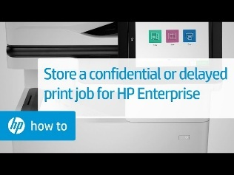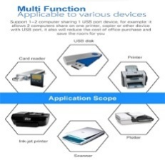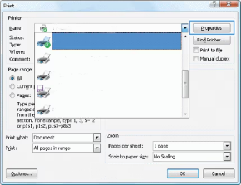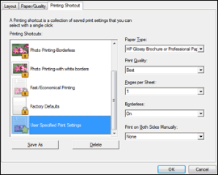
- External Keyboard: These printers with external keyboard support mainly use it for quick shortcuts like printing (Ctrl+P) or copying (Ctrl+C). Some models may offer limited scanning or faxing via keyboard but it’s mostly for simple, fast access to common tasks but not full control of printer functions.
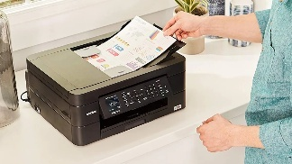
- Fax: These printers with fax features let you send and receive documents through a phone line. They can scan and fax documents or print incoming faxes. Models under ProSelect (Zelus), Workflow UI (Ulysses), and LFP (Jupiter) may support this with setup like phone line connection and fax settings.

- Print Engine (platform): HP printer print engines support print, scan, copy, and sometimes fax in one unit. They turn digital files into paper output, managing quality, speed, and paper features like duplexing and ADF. These functions apply to ProSelect (Zelus), Workflow UI (Ulysses), and LFP (Jupiter) models.
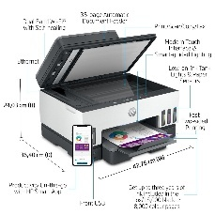
- Ethernet: HP printers with Ethernet let you connect the printer to a network using a cable, so multiple devices can share it. To confirm Ethernet support, please check the “Ethernet” row in the file for ProSelect (Zelus), Workflow UI (Ulysses), and LFP (Jupiter).
- Wireless LED: Wireless LED printers usually come with print, scan and copy features and some can also fax. They connect to phones or computers wirelessly, making it easy to print or scan from anywhere. These printers are known for sharp prints, quick performance and low power use.
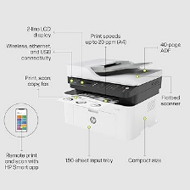
- Bluetooth: Bluetooth-enabled HP printers support wireless printing and setup from nearby devices, especially when Wi-Fi isn't available. The "Move and Cut" feature helps transfer printed content and cut paper as needed, making the device flexible for tight or shifting spaces like Pro Select or LFP setups.
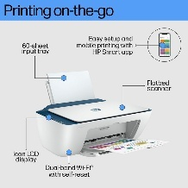
- Print Technology: HP printers use Thermal Inkjet or PageWide technology to ensure accurate printhead movement and precise cutting, which is essential for clean, fast output in models like Pro Select, LFP. These models support "Move and Cut" features for resizing, repositioning, and trimming parts of images or documents, making it easy to create custom or large-format prints through a user-friendly interface.
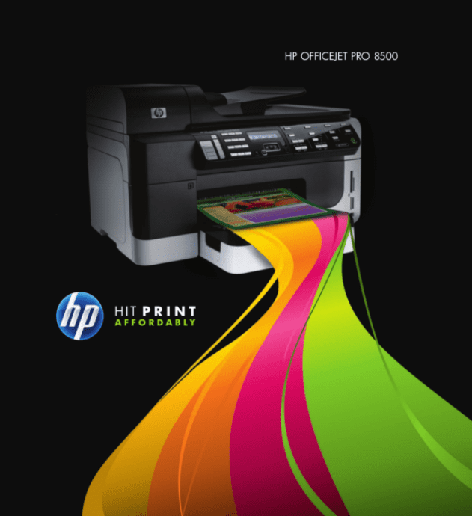f

- Cartridges/Toner Order: HP printers help you check ink or toner levels and reorder easily, often through the HP Smart app or Instant Ink. To find the right cartridge, check your printer’s manual, app or HP website for the type, model number and page yield.
- Finisher: These printers with finisher options can staple, hole-punch, fold, or stack papers after printing. These features help create ready-to-use documents like reports or booklets. They’re great for saving time in busy office environments with lots of printing.
- ADF Sheets: HP printers with ADF can scan, copy, or fax many pages automatically without reloading. Depending on the model, maximum they hold 20 to 100 sheets, making them useful for big jobs in busy offices.
- Fax contacts: All-in-one printers can send and receive maximum faxes, including digital and network faxing. Some models support PC faxing and walk-up color faxing. You can also save contacts in memory, making it faster to fax frequently used numbers or groups.
- Copies (Copy/Print): This printer lets you choose maximum no of copies or prints to make at once, usually up to 99 or more. This helps save time when printing or copying large sets without repeating the steps.
- Predecessor Product Name: The Predecessor Product Name shows which older model the current HP printer replaced, helping users compare features and upgrades. Older models like the Officejet G series supported print, scan, copy, and sometimes fax, with options for network and USB use.
- Pen Alignment: Pen alignment (or printhead alignment) helps HP printers adjust ink cartridges for sharp, accurate prints. It’s done during setup or after changing cartridges by printing a test page through the control panel or HP software.
- Job Concurrency: HP printers with job concurrency can handle multiple tasks at once, like printing and scanning together. This speeds up work and reduces wait time, making them ideal for busy offices with high print volumes.
- Paper/Substrate orientation for Move and Cut: HP printers use alignment features to detect and position paper accurately before cutting, ensuring precise results—especially for large or custom prints. You can select orientation, paper size, and use finishing tools like staplers or stackers to manage output neatly.
- Substrate (media type): HP printers adjust to different media types like paper, vinyl (large-format printers to print designs, images, or text onto vinyl material, typically for applications like signage, decals, and vehicle wraps) or fabric using features like paper trays, media settings and special print modes. Printers with Move and Cut support shift and cut materials accurately based on the type loaded, ensuring smooth handling and sharp results.
Feature | Paper/Substrate Orientation for Move and Cut | Substrate (Media Type)
Purpose | Aligns and positions the paper correctly before printing and cutting | Detects and adjusts settings based on the type of material used
Function | Ensures accurate cutting by setting paper direction and using alignment tools | Optimizes printing and cutting for materials like paper, vinyl, or fabric
Use Case | Ideal for large or custom-sized prints requiring precise cutting | Useful for various applications like signage, decals, or fabric prints
Additional Features | May include options for paper size, orientation, and output finishing tools | Works with media settings, paper trays, and print modes based on material type

- Instant Ink: HP Instant Ink offers flexibility. It can switch printers or change plans anytime to match your needs. Printers with Move and Cut support use this service to auto-order ink, even during big or specialized print jobs like cutting vinyl or fabric, so you never run out.
- Yeti/HP+: HP+ (Yeti) printers with the HP Smart app offer “Move and Cut” tools like cropping or rearranging pages before printing. These smart features also include cloud printing, security and Instant Ink support, helping ensure smooth, updated and connected printing from anywhere.
- PaaS: PaaS (Platform as a Service) in HP printers supports Move and Cut by enabling cloud-based tools and services that manage printing and cutting tasks remotely. It allows users to send jobs, track status, and update settings from a central platform. This improves workflow, accuracy, and control, especially for large or custom print-and-cut projects.
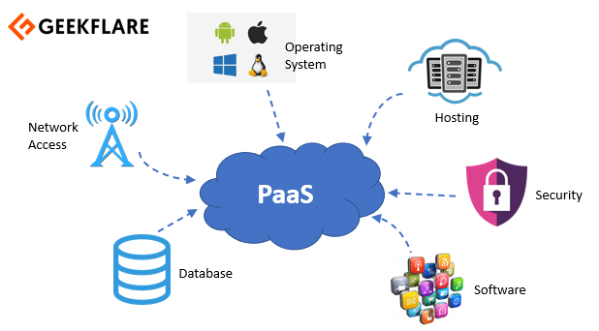

Detailed Language Information
- Locations: The file lists country and region-specific details that affect how HP printers handle settings like date and time formats, system of measurement (metric or US), and paper standards. It includes ISO codes and internal string IDs used for localization and setup consistency across different regions.
Country/Region | ISO 3166-1 Alpha-2 Code | String Id | Date Format | Time Format | System of Measurement | Paper
_Cuba | _CU | _cCountryRegionCuba | DDMMMYYYY | 12 | METRIC | ISO
_Iran | _IR | _cCountryRegionIran | YYYYMMMDD | 24 | METRIC | ISO
_North Korea | _KP | _cCountryRegionNorthKorea | YYYYMMMDD | 12 | METRIC | ISO
_Sudan | _SD | _cCountryRegionSudan | DDMMMYYYY | 12 | METRIC | ISO
_Syria | _SY | _cCountryRegionSyria | DDMMMYYYY | 12 | METRIC | ISO
Afghanistan | AF | cCountryRegionAfghanistan | YYYYMMMDD | 12 | METRIC | ISO
Albania | AL | cCountryRegionAlbania | DDMMMYYYY | 12 | METRIC | ISO
Algeria | DZ | cCountryRegionAlgeria | DDMMMYYYY | 12 | METRIC | ISO
American Samoa | AS | cCountryRegionAmericanSamoa | MMMDDYYYY | 12 | METRIC | ISO
Andorra | AD | cCountryRegionAndorra | DDMMMYYYY | 24 | METRIC | ISO
Angola | AO | cCountryRegionAngola | DDMMMYYYY | 24 | METRIC | ISO
Anguilla | AI | cCountryRegionAnguilla | DDMMMYYYY | 24 | METRIC | ANSI
Antarctica | AQ | cCountryRegionAntarctica | DDMMMYYYY | 24 | METRIC | ISO
Antigua and Barbuda | AG | cCountryRegionAntiguaAndBarbuda | DDMMMYYYY | 24 | METRIC | ANSI
Argentina | AR | cCountryRegionArgentina | DDMMMYYYY | 24 | METRIC | ISO
Armenia | AM | cCountryRegionArmenia | DDMMMYYYY | 12 | METRIC | ISO
Aruba | AW | cCountryRegionAruba | DDMMMYYYY | 24 | METRIC | ANSI
Australia | AU | cCountryRegionAustralia | DDMMMYYYY | 12 | METRIC | ISO
Austria | AT | cCountryRegionAustria | DDMMMYYYY | 24 | METRIC | ISO
Azerbaijan | AZ | cCountryRegionAzerbaijan | DDMMMYYYY | 24 | METRIC | ISO
Bahamas | BS | cCountryRegionBahamas | DDMMMYYYY | 24 | METRIC | ANSI
Bahrain | BH | cCountryRegionBahrain | DDMMMYYYY | 12 | METRIC | ISO
Bangladesh | BD | cCountryRegionBangladesh | DDMMMYYYY | 12 | METRIC | ISO
Barbados | BB | cCountryRegionBarbados | DDMMMYYYY | 24 | METRIC | ANSI
Belarus | BY | cCountryRegionBelarus | DDMMMYYYY | 24 | METRIC | ISO
Belgium | BE | cCountryRegionBelgium | DDMMMYYYY | 24 | METRIC | ISO
Belize | BZ | cCountryRegionBelize | DDMMMYYYY | 24 | METRIC | ANSI
Benin | BJ | cCountryRegionBenin | DDMMMYYYY | 24 | METRIC | ISO
Bermuda | BM | cCountryRegionBermuda | DDMMMYYYY | 24 | METRIC | ANSI
Bhutan | BT | cCountryRegionBhutan | YYYYMMMDD | 12 | METRIC | ISO
Bolivia | BO | cCountryRegionBolivia | DDMMMYYYY | 12 | METRIC | ISO
Bonaire, Sint Eustatius, and Saba | BQ | cCountryRegionBonaireSintEustatiusSaba | DDMMMYYYY | 24 | METRIC | ANSI
Bosnia and Herzegovina | BA | cCountryRegionBosniaAndHerzegovina | DDMMMYYYY | 24 | METRIC | ISO
Botswana | BW | cCountryRegionBotswana | DDMMMYYYY | 24 | METRIC | ISO
Brazil | BR | cCountryRegionBrazil | DDMMMYYYY | 24 | METRIC | ISO
British Virgin Islands | VG | cCountryRegionBritishVirginIslands | DDMMMYYYY | 24 | METRIC | ANSI
Brunei | BN | cCountryRegionBrunei | DDMMMYYYY | 24 | METRIC | ISO
Bulgaria | BG | cCountryRegionBulgaria | DDMMMYYYY | 24 | METRIC | ISO
Burkina Faso | BF | cCountryRegionBurkinaFaso | DDMMMYYYY | 24 | METRIC | ISO
Burundi | BI | cCountryRegionBurundi | DDMMMYYYY | 24 | METRIC | ISO
Cambodia | KH | cCountryRegionCambodia | DDMMMYYYY | 12 | METRIC | ISO
Cameroon | CM | cCountryRegionCameroon | DDMMMYYYY | 24 | METRIC | ISO
Canada | CA | cCountryRegionCanada | DDMMMYYYY | 12 | METRIC | ANSI
Cape Verde | CV | cCountryRegionCapeVerde | DDMMMYYYY | 24 | METRIC | ISO
Cayman Islands | KY | cCountryRegionCaymanIslands | DDMMMYYYY | 24 | METRIC | ANSI
Central African Republic | CF | cCountryRegionCentralAfricanRepublic | DDMMMYYYY | 24 | METRIC | ISO
Chad | TD | cCountryRegionChad | DDMMMYYYY | 12 | METRIC | ISO
Chile | CL | cCountryRegionChile | DDMMMYYYY | 24 | METRIC | ANSI
China | CN | cCountryRegionChina | YYYYMMMDD | 12 | METRIC | ISO
Colombia | CO | cCountryRegionColombia | DDMMMYYYY | 12 | METRIC | ANSI
Comoros | KM | cCountryRegionComoros | DDMMMYYYY | 24 | METRIC | ISO
Costa Rica | CR | cCountryRegionCostaRica | DDMMMYYYY | 12 | METRIC | ANSI
Croatia | HR | cCountryRegionCroatia | DDMMMYYYY | 24 | METRIC | ISO
Curaçao | CW | cCountryRegionCuracao | DDMMMYYYY | 24 | METRIC | ANSI
Cyprus | CY | cCountryRegionCyprus | DDMMMYYYY | 12 | METRIC | ISO
Czech Republic | CZ | cCountryRegionCzechRepublic | DDMMMYYYY | 24 | METRIC | ISO
Democratic Republic of the Congo | CD | cCountryRegionDemocraticRepublicOfTheCongo | DDMMMYYYY | 24 | METRIC | ISO
Denmark | DK | cCountryRegionDenmark | DDMMMYYYY | 24 | METRIC | ISO
Djibouti | DJ | cCountryRegionDjibouti | DDMMMYYYY | 12 | METRIC | ISO
Dominica | DM | cCountryRegionDominica | DDMMMYYYY | 24 | METRIC | ANSI
Dominican Republic | DO | cCountryRegionDominicanRepublic | DDMMMYYYY | 12 | METRIC | ANSI
Ecuador | EC | cCountryRegionEcuador | DDMMMYYYY | 12 | METRIC | ISO
Egypt | EG | cCountryRegionEgypt | DDMMMYYYY | 12 | METRIC | ISO
El Salvador | SV | cCountryRegionElSalvador | DDMMMYYYY | 12 | METRIC | ANSI
Equatorial Guinea | GQ | cCountryRegionEquatorialGuinea | DDMMMYYYY | 24 | METRIC | ISO
Eritrea | ER | cCountryRegionEritrea | DDMMMYYYY | 12 | METRIC | ISO
Estonia | EE | cCountryRegionEstonia | DDMMMYYYY | 24 | METRIC | ISO
Eswatini | SZ | cCountryRegionSwaziland | DDMMMYYYY | 24 | METRIC | ISO
Ethiopia | ET | cCountryRegionEthiopia | DDMMMYYYY | 12 | METRIC | ISO
Falkland Islands | FK | cCountryRegionFalklandIslands | DDMMMYYYY | 24 | METRIC | ISO
Faroe Islands | FO | cCountryRegionFaroeIslands | DDMMMYYYY | 24 | METRIC | ISO
Federated States of Micronesia | FM | cCountryRegionFederatedStatesOfMicronesia | MMMDDYYYY | 24 | METRIC | ISO
Fiji | FJ | cCountryRegionFiji | DDMMMYYYY | 24 | METRIC | ISO
Finland | FI | cCountryRegionFinland | DDMMMYYYY | 24 | METRIC | ISO
France | FR | cCountryRegionFrance | DDMMMYYYY | 24 | METRIC | ISO
French Guiana | GF | cCountryRegionFrenchGuiana | DDMMMYYYY | 24 | METRIC | ANSI
French Polynesia | PF | cCountryRegionFrenchPolynesia | DDMMMYYYY | 24 | METRIC | ISO
Gabon | GA | cCountryRegionGabon | DDMMMYYYY | 24 | METRIC | ISO
Gambia | GM | cCountryRegionGambia | DDMMMYYYY | 12 | METRIC | ISO
Georgia | GE | cCountryRegionGeorgia | DDMMMYYYY | 24 | METRIC | ISO
Germany | DE | cCountryRegionGermany | DDMMMYYYY | 24 | METRIC | ISO
Ghana | GH | cCountryRegionGhana | DDMMMYYYY | 12 | METRIC | ISO
Gibraltar | GI | cCountryRegionGibraltar | DDMMMYYYY | 24 | METRIC | ISO
Greece | GR | cCountryRegionGreece | DDMMMYYYY | 12 | METRIC | ISO
Greenland | GL | cCountryRegionGreenland | DDMMMYYYY | 24 | METRIC | ISO
Grenada | GD | cCountryRegionGrenada | DDMMMYYYY | 24 | METRIC | ANSI
Guadeloupe | GP | cCountryRegionGuadeloupe | DDMMMYYYY | 24 | METRIC | ANSI
Guam | GU | cCountryRegionGuam | MMMDDYYYY | 24 | METRIC | ISO
Guatemala | GT | cCountryRegionGuatemala | DDMMMYYYY | 12 | METRIC | ANSI
Guinea | GN | cCountryRegionGuinea | DDMMMYYYY | 24 | METRIC | ISO
Guinea-Bissau | GW | cCountryRegionGuineaBissau | DDMMMYYYY | 24 | METRIC | ISO
Guyana | GY | cCountryRegionGuyana | DDMMMYYYY | 24 | METRIC | ANSI
Haiti | HT | cCountryRegionHaiti | DDMMMYYYY | 24 | METRIC | ANSI
Honduras | HN | cCountryRegionHonduras | DDMMMYYYY | 12 | METRIC | ANSI
Hong Kong SAR | HK | cCountryRegionHongKongSAR | DDMMMYYYY | 12 | METRIC | ISO
Hungary | HU | cCountryRegionHungary | YYYYMMMDD | 24 | METRIC | ISO
Iceland | IS | cCountryRegionIceland | DDMMMYYYY | 24 | METRIC | ISO
India | IN | cCountryRegionIndia | DDMMMYYYY | 12 | METRIC | ISO
Indonesia | ID | cCountryRegionIndonesia | DDMMMYYYY | 24 | METRIC | ISO
Iraq | IQ | cCountryRegionIraq | DDMMMYYYY | 12 | METRIC | ISO
Ireland | IE | cCountryRegionIreland | DDMMMYYYY | 12 | METRIC | ISO
Israel | IL | cCountryRegionIsrael | DDMMMYYYY | 24 | METRIC | ISO
Italy | IT | cCountryRegionItaly | DDMMMYYYY | 24 | METRIC | ISO
Ivory Coast | CI | cCountryRegionIvoryCoast | DDMMMYYYY | 24 | METRIC | ISO
Jamaica | JM | cCountryRegionJamaica | DDMMMYYYY | 24 | METRIC | ANSI
Japan | JP | cCountryRegionJapan | YYYYMMMDD | 24 | METRIC | ISO + JP
Jordan | JO | cCountryRegionJordan | DDMMMYYYY | 12 | METRIC | ISO
Kazakhstan | KZ | cCountryRegionKazakhstan | DDMMMYYYY | 24 | METRIC | ISO
Kenya | KE | cCountryRegionKenya | DDMMMYYYY | 24 | METRIC | ISO
Kiribati | KI | cCountryRegionKiribati | DDMMMYYYY | 24 | METRIC | ISO
Kosovo | XK | cCountryRegionKosovo | DDMMMYYYY | 24 | METRIC | ISO
Kuwait | KW | cCountryRegionKuwait | DDMMMYYYY | 12 | METRIC | ISO
Kyrgyzstan | KG | cCountryRegionKyrgyzstan | DDMMMYYYY | 24 | METRIC | ISO
Laos | LA | cCountryRegionLaos | DDMMMYYYY | 24 | METRIC | ISO
Latvia | LV | cCountryRegionLatvia | YYYYMMMDD | 24 | METRIC | ISO
Lebanon | LB | cCountryRegionLebanon | DDMMMYYYY | 12 | METRIC | ISO
Lesotho | LS | cCountryRegionLesotho | DDMMMYYYY | 24 | METRIC | ISO
Liberia | LR | cCountryRegionLiberia | DDMMMYYYY | 12 | US | ISO
Libya | LY | cCountryRegionLibya | DDMMMYYYY | 12 | METRIC | ISO
Liechtenstein | LI | cCountryRegionLiechtenstein | DDMMMYYYY | 24 | METRIC | ISO
Lithuania | LT | cCountryRegionLithuania | YYYYMMMDD | 24 | METRIC | ISO
Luxembourg | LU | cCountryRegionLuxembourg | DDMMMYYYY | 24 | METRIC | ISO
Macau SAR | MO | cCountryRegionMacauSAR | DDMMMYYYY | 12 | METRIC | ISO
Madagascar | MG | cCountryRegionMadagascar | DDMMMYYYY | 24 | METRIC | ISO
Malawi | MW | cCountryRegionMalawi | DDMMMYYYY | 24 | METRIC | ISO
Malaysia | MY | cCountryRegionMalaysia | DDMMMYYYY | 12 | METRIC | ISO
Maldives | MV | cCountryRegionMaldives | DDMMMYYYY | 24 | METRIC | ISO
Mali | ML | cCountryRegionMali | DDMMMYYYY | 24 | METRIC | ISO
Malta | MT | cCountryRegionMalta | DDMMMYYYY | 24 | METRIC | ISO
Marshall Islands | MH | cCountryRegionMarshallIslands | MMMDDYYYY | 24 | METRIC | ISO
Martinique | MQ | cCountryRegionMartinique | DDMMMYYYY | 24 | METRIC | ANSI
Mauritania | MR | cCountryRegionMauritania | DDMMMYYYY | 12 | METRIC | ISO
Mauritius | MU | cCountryRegionMauritius | DDMMMYYYY | 24 | METRIC | ISO
Mayotte | YT | cCountryRegionMayotte | DDMMMYYYY | 24 | METRIC | ANSI
Mexico | MX | cCountryRegionMexico | DDMMMYYYY | 12 | METRIC | ANSI
Moldova | MD | cCountryRegionMoldova | DDMMMYYYY | 24 | METRIC | ISO
Monaco | MC | cCountryRegionMonaco | DDMMMYYYY | 24 | METRIC | ISO
Mongolia | MN | cCountryRegionMongolia | YYYYMMMDD | 24 | METRIC | ISO
Montenegro | ME | cCountryRegionMontenegro | DDMMMYYYY | 24 | METRIC | ISO
Montserrat | MS | cCountryRegionMontserrat | DDMMMYYYY | 24 | METRIC | ANSI
Morocco | MA | cCountryRegionMorocco | DDMMMYYYY | 12 | METRIC | ISO
Mozambique | MZ | cCountryRegionMozambique | DDMMMYYYY | 24 | METRIC | ISO
Myanmar | MM | cCountryRegionMyanmar | DDMMMYYYY | 12 | METRIC | ISO
Namibia | NA | cCountryRegionNamibia | DDMMMYYYY | 12 | METRIC | ISO
Nauru | NR | cCountryRegionNauru | DDMMMYYYY | 24 | METRIC | ISO
Nepal | NP | cCountryRegionNepal | DDMMMYYYY | 12 | METRIC | ISO
Netherlands | NL | cCountryRegionNetherlands | DDMMMYYYY | 24 | METRIC | ISO
New Caledonia | NC | cCountryRegionNewCaledonia | DDMMMYYYY | 24 | METRIC | ISO
New Zealand | NZ | cCountryRegionNewZealand | DDMMMYYYY | 12 | METRIC | ISO
Nicaragua | NI | cCountryRegionNicaragua | DDMMMYYYY | 12 | METRIC | ANSI
Niger | NE | cCountryRegionNiger | DDMMMYYYY | 24 | METRIC | ISO
Nigeria | NG | cCountryRegionNigeria | DDMMMYYYY | 24 | METRIC | ISO
Niue | NU | cCountryRegionNiue | DDMMMYYYY | 24 | METRIC | ISO
North Macedonia | MK | cCountryRegionMacedonia | DDMMMYYYY | 24 | METRIC | ISO
Northern Mariana Islands | MP | cCountryRegionNorthernMarianaIslands | MMMDDYYYY | 24 | METRIC | ISO
Norway | NO | cCountryRegionNorway | DDMMMYYYY | 24 | METRIC | ISO
Oman | OM | cCountryRegionOman | DDMMMYYYY | 12 | METRIC | ISO
Pakistan | PK | cCountryRegionPakistan | DDMMMYYYY | 12 | METRIC | ISO
Palau | PW | cCountryRegionPalau | DDMMMYYYY | 24 | METRIC | ISO
Palestinian Territories | PS | cCountryRegionPalestinianTerritories | DDMMMYYYY | 12 | METRIC | ISO
Panama | PA | cCountryRegionPanama | MMMDDYYYY | 12 | METRIC | ANSI
Papua New Guinea | PG | cCountryRegionPapuaNewGuinea | DDMMMYYYY | 24 | METRIC | ISO
Paraguay | PY | cCountryRegionParaguay | DDMMMYYYY | 24 | METRIC | ISO
Peru | PE | cCountryRegionPeru | DDMMMYYYY | 12 | METRIC | ISO
Philippines | PH | cCountryRegionPhilippines | MMMDDYYYY | 12 | METRIC | ISO
Poland | PL | cCountryRegionPoland | YYYYMMMDD | 24 | METRIC | ISO
Portugal | PT | cCountryRegionPortugal | DDMMMYYYY | 24 | METRIC | ISO
Puerto Rico | PR | cCountryRegionPuertoRico | MMMDDYYYY | 12 | METRIC | ANSI
Qatar | QA | cCountryRegionQatar | DDMMMYYYY | 12 | METRIC | ISO
Republic of Congo | CG | cCountryRegionRepublicOfCongo | DDMMMYYYY | 24 | METRIC | ISO
Romania | RO | cCountryRegionRomania | DDMMMYYYY | 24 | METRIC | ISO
Russia | RU | cCountryRegionRussia | DDMMMYYYY | 24 | METRIC | ISO
Rwanda | RW | cCountryRegionRwanda | DDMMMYYYY | 24 | METRIC | ISO
Saint Kitts and Nevis | KN | cCountryRegionSaintKittsAndNevis | DDMMMYYYY | 24 | METRIC | ANSI
Saint Lucia | LC | cCountryRegionSaintLucia | DDMMMYYYY | 24 | METRIC | ANSI
Saint Martin | MF | cCountryRegionSaintMartin | DDMMMYYYY | 24 | METRIC | ANSI
Saint Vincent and the Grenadines | VC | cCountryRegionSaintVincentAndTheGrenadines | DDMMMYYYY | 24 | METRIC | ANSI
Samoa | WS | cCountryRegionSamoa | DDMMMYYYY | 24 | METRIC | ISO
San Marino | SM | cCountryRegionSanMarino | DDMMMYYYY | 24 | METRIC | ISO
Sao Tome and Principe | ST | cCountryRegionSaoTomeAndPrincipe | DDMMMYYYY | 24 | METRIC | ISO
Saudi Arabia | SA | cCountryRegionSaudiArabia | DDMMMYYYY | 12 | METRIC | ISO
Senegal | SN | cCountryRegionSenegal | DDMMMYYYY | 24 | METRIC | ISO
Serbia | RS | cCountryRegionSerbia | DDMMMYYYY | 24 | METRIC | ISO
Seychelles | SC | cCountryRegionSeychelles | DDMMMYYYY | 24 | METRIC | ISO
Sierra Leone | SL | cCountryRegionSierraLeone | DDMMMYYYY | 12 | METRIC | ISO
Singapore | SG | cCountryRegionSingapore | DDMMMYYYY | 12 | METRIC | ISO
Sint Maarten | SX | cCountryRegionSintMaarten | DDMMMYYYY | 24 | METRIC | ANSI
Slovakia | SK | cCountryRegionSlovakia | DDMMMYYYY | 24 | METRIC | ISO
Slovenia | SI | cCountryRegionSlovenia | DDMMMYYYY | 24 | METRIC | ISO
Solomon Islands | SB | cCountryRegionSolomonIslands | DDMMMYYYY | 24 | METRIC | ISO
Somalia | SO | cCountryRegionSomalia | DDMMMYYYY | 24 | METRIC | ISO
South Africa | ZA | cCountryRegionSouthAfrica | YYYYMMMDD | 24 | METRIC | ISO
South Korea | KR | cCountryRegionSouthKorea | YYYYMMMDD | 12 | METRIC | ISO
South Sudan | SS | cCountryRegionSouthSudan | DDMMMYYYY | 12 | METRIC | ISO
Spain | ES | cCountryRegionSpain | DDMMMYYYY | 24 | METRIC | ISO
Sri Lanka | LK | cCountryRegionSriLanka | DDMMMYYYY | 24 | METRIC | ISO
Suriname | SR | cCountryRegionSuriname | DDMMMYYYY | 24 | METRIC | ANSI
Sweden | SE | cCountryRegionSweden | YYYYMMMDD | 24 | METRIC | ISO
Switzerland | CH | cCountryRegionSwitzerland | DDMMMYYYY | 24 | METRIC | ISO
Taiwan Region | TW | cCountryRegionTaiwan | YYYYMMMDD | 12 | METRIC | ISO
Tajikistan | TJ | cCountryRegionTajikistan | DDMMMYYYY | 24 | METRIC | ISO
Tanzania | TZ | cCountryRegionTanzania | DDMMMYYYY | 24 | METRIC | ISO
Thailand | TH | cCountryRegionThailand | DDMMMYYYY | 24 | METRIC | ISO
Timor-Leste | TL | cCountryRegionTimorLeste | DDMMMYYYY | 24 | METRIC | ISO
Togo | TG | cCountryRegionTogo | DDMMMYYYY | 12 | METRIC | ISO
Tonga | TO | cCountryRegionTonga | DDMMMYYYY | 12 | METRIC | ISO
Trinidad and Tobago | TT | cCountryRegionTrinidadAndTobago | DDMMMYYYY | 24 | METRIC | ANSI
Tunisia | TN | cCountryRegionTunisia | DDMMMYYYY | 24 | METRIC | ISO
Türkiye | TR | cCountryRegionTurkey | DDMMMYYYY | 24 | METRIC | ISO
Turkmenistan | TM | cCountryRegionTurkmenistan | DDMMMYYYY | 24 | METRIC | ISO
Turks and Caicos Islands | TC | cCountryRegionTurksAndCaicosIslands | DDMMMYYYY | 24 | METRIC | ANSI
Tuvalu | TV | cCountryRegionTuvalu | DDMMMYYYY | 24 | METRIC | ISO
U.S. Virgin Islands | VI | cCountryRegionUSVirginIslands | MMMDDYYYY | 24 | METRIC | ANSI
Uganda | UG | cCountryRegionUganda | DDMMMYYYY | 24 | METRIC | ISO
Ukraine | UA | cCountryRegionUkraine | DDMMMYYYY | 24 | METRIC | ISO
United Arab Emirates | AE | cCountryRegionUnitedArabEmirates | DDMMMYYYY | 12 | METRIC | ISO
United Kingdom | GB | cCountryRegionUnitedKingdom | DDMMMYYYY | 12 | METRIC | ISO
United States | US | cCountryRegionUnitedStates | MMMDDYYYY | 12 | US | ANSI
Uruguay | UY | cCountryRegionUruguay | DDMMMYYYY | 24 | METRIC | ISO
Uzbekistan | UZ | cCountryRegionUzbekistan | DDMMMYYYY | 24 | METRIC | ISO
Vanuatu | VU | cCountryRegionVanuatu | DDMMMYYYY | 12 | METRIC | ISO
Vatican City | VA | cCountryRegionVaticanCity | DDMMMYYYY | 24 | METRIC | ISO
Venezuela | VE | cCountryRegionVenezuela | DDMMMYYYY | 12 | METRIC | ANSI
Vietnam | VN | cCountryRegionVietnam | DDMMMYYYY | 24 | METRIC | ISO
Western Sahara | EH | cCountryRegionWesternSahara | DDMMMYYYY | 12 | METRIC | ISO
Yemen | YE | cCountryRegionYemen | DDMMMYYYY | 12 | METRIC | ISO
Zambia | ZM | cCountryRegionZambia | DDMMMYYYY | 24 | METRIC | ISO
Zimbabwe | ZW | cCountryRegionZimbabwe | YYYYMMMDD | 24 | METRIC | ISO

- Languages: The file shows how HP printers support different languages based on countries or regions. It lists each language, the regions where it’s used, and which HP business groups (like OPS, HPS, or GSB) include that language in their products.
Name Shown in Firmware | Name in English | Locations Included when Used in Short List (OOBE) | Business Support | Comments
العربية | Arabic | Saudi Arabia, United Arab Emirates, Algeria, Egypt, Morocco, Kuwait, Qatar, Lebanon, Tunisia, Jordan, Oman, Bahrain, Yemen | HPS, OPS (Enterprise), OPS (Pro)
Bahasa Indonesia | Indonesian | Indonesia, Malaysia, Brunei, Singapore | OPS (Enterprise), OPS (Pro)
Euskera | Basque | Spain, France | OPS (Enterprise)
Български | Bulgarian | Bulgaria | HPS, OPS (Enterprise)
Català | Catalan | Spain, Andorra | OPS (Enterprise), OPS (Pro), GSB
简体中文 | Simplified Chinese | China, Hong Kong SAR, Singapore, Macau SAR, Malaysia | HPS, OPS (Enterprise), OPS (Pro), GSB
繁體中文 | Traditional Chinese | Hong Kong SAR, Macau SAR, Taiwan | HPS, OPS (Enterprise), OPS (Pro), GSB
Hrvatski | Croatian | Croatia | HPS, OPS (Enterprise), OPS (Pro)
Čeština | Czech | Czech Republic, Slovakia | HPS, OPS (Enterprise), OPS (Pro)
Dansk | Danish | Denmark, Iceland, Greenland | HPS, OPS (Enterprise), OPS (Pro)
Nederlands | Dutch | Netherlands, Belgium, Suriname | HPS, OPS (Enterprise), OPS (Pro), GSB
English | English | United States, Canada, United Kingdom, Australia, India, Singapore, New Zealand, South Africa, Nigeria, Kenya, Ghana, Botswana, Hong Kong SAR, Guyana, Belize, Jamaica, Israel, Thailand, Saudi Arabia, United Arab Emirates, Malaysia, Brunei, Philippines, Ireland, Indonesia, Egypt, Kuwait, Jordan, Pakistan, Qatar, Lebanon, Vietnam, Iceland | HPS, OPS (Enterprise), OPS (Pro), GSB
Suomi | Finnish | Finland | HPS, OPS (Enterprise), OPS (Pro)
Français | French | France, Canada, Switzerland, Belgium, Luxembourg, French Polynesia, Algeria, Morocco, Côte d'Ivoire, Tunisia, French Guiana, Haiti | HPS, OPS (Enterprise), OPS (Pro), GSB
Deutsch | German | Germany, Switzerland, Austria, Belgium, Luxembourg | HPS, OPS (Enterprise), OPS (Pro), GSB
Ελληνικά | Greek | Greece | HPS, OPS (Enterprise), OPS (Pro)
עברית | Hebrew | Israel | HPS, OPS (Enterprise), OPS (Pro)
Magyar | Hungarian | Hungary | HPS, OPS (Enterprise), OPS (Pro)
Italiano | Italian | Italy, Switzerland, San Marino | HPS, OPS (Enterprise), OPS (Pro), GSB
日本語 | Japanese | Japan | HPS, OPS (Enterprise), OPS (Pro), GSB
한글 | Korean | South Korea | HPS, OPS (Enterprise), OPS (Pro), GSB
Norsk | Norwegian | Norway, Iceland | HPS, OPS (Enterprise), OPS (Pro)
Polski | Polish | Poland | HPS, OPS (Enterprise), OPS (Pro), GSB
Português | Portuguese | Brazil, Portugal, Angola, Mozambique | HPS, OPS (Enterprise), OPS (Pro), GSB
Română | Romanian | Romania, Moldova | HPS, OPS (Enterprise), OPS (Pro)
Русский | Russian | Russia, Lithuania, Latvia, Estonia, Belarus, Ukraine, Kazakhstan | HPS, OPS (Enterprise), OPS (Pro), GSB
Slovenčina | Slovak | Slovakia | HPS, OPS (Enterprise), OPS (Pro)
Slovenščina | Slovenian | Slovenia | HPS, OPS (Enterprise), OPS (Pro)
Español | Spanish | United States, Spain, Mexico, Puerto Rico, Argentina, Chile, Colombia, El Salvador, Honduras, Nicaragua, Dominican Republic, Peru, Venezuela, Panama, Guatemala, Ecuador, Uruguay, Paraguay, Costa Rica | HPS, OPS (Enterprise), OPS (Pro), GSB
Svenska | Swedish | Sweden, Finland, Iceland | HPS, OPS (Enterprise), OPS (Pro), GSB
ไทย | Thai | Thailand | OPS (Enterprise), OPS (Pro)
Türkçe | Turkish | Türkiye | HPS, OPS (Enterprise), OPS (Pro)
Українська | Ukrainian | Ukraine | HPS, OPS (Pro)
Tiếng Việt | Vietnamese | Vietnam | OPS (Enterprise)
Cymraeg | Welsh | United Kingdom | OPS (Enterprise)

Function set with brief details
Category | Types | Description
Business Unit | OPS | Office Printing Solutions - LaserJet-style printers suited for office environments. Most models here are DesignJet large-format printers built for high-quality color output and design applications.  e. g: Beam, Sunspot, Jupiter, Ray, Flare, Titania
 | HPS | Home Printing Solution - These are compact, small-format printers designed for home or personal use.  e. g: Victoria
 | GSB | Graphics Solutions Business - High-end printers used for professional graphics. These printers handle wide formats and are compatible with media like canvas and paper rolls.  e. g: Sunspot (HP Latex), Altair
A4/A3 | A4 | Supports standard A4-size paper used in most documents like letters, forms, and reports. Ideal for everyday printing in homes and offices.
 | A3 | Allows printing on A3-size paper, which is larger than A4. Used for charts, posters, and technical drawings. Common in enterprise or design environments.
 | Single Roll | Holds one roll of paper at a time. Best for simple wide-format jobs that don’t require switching between media types.
 | Multi Roll | Supports two or more roles, letting the printer switch between different media or sizes automatically. Great for users with high-volume or varied printing needs.
Color/Mono | Mono | Printers that print using only black ink ideal for text documents and basic printing needs.
 | Color 1 Part | Printers with an all-in-one cartridge where the ink and print head are combined into a single unit.
 | Color 2 Part | Printers that use separate ink cartridges in each color are installed individually for flexible replacement.
 | Color P-T | Color printers that use both toner and drum units, like laser printing technology.
 | Reservoir | Printers with built-in ink tanks that are refilled from bottles commonly used in future GSB and HPS models.
 | Eco-Carton | Printers that support sustainable, eco-friendly packaging and cartridge materials.
 | None | No color or mono type is defined for this printer used for models where this doesn’t apply. This device is a scanner without print functions, so color or mono printing doesn't apply.
SFP/MFP | SFP | A printer that only prints. It doesn’t support scanning, copying, or faxing.
 | MFP | A printer that can print, scan, copy, and sometimes send faxes for all-in-one device.
 | Network Scanner | A device used to scan documents and send them to other devices (like PCs or printers) over the network.
Print Engine | LaserJet | Laser-based print engine used in HP enterprise printers from the OPS business unit. The printer is known for fast and high-quality monochrome or color printing.
 | Ink | Inkjet-based printing used in HPS printers. Designed for high-quality color output in home or small office environments.
 | Ink PDL | Inkjet printers that support Page Description Language (PDL) for enhanced print control and compatibility common in HPS models.
 | Dragon Laser Jet | A specialized LaserJet platform under OPS BU, offering advanced performance, security, and scalability for enterprise workflows.
 | DesignJet | Wide-format ink printers under the GSB category. Ideal for CAD, GIS, posters, and graphic-rich applications.
 | Latex | Eco-friendly wide-format printers using water-based latex inks. Common in the GSB portfolio for signage and display work.
 | PageWideXL | High-speed large-format printers that use page-wide inkjet technology. Perfect for large-volume technical and graphics printing.
 | Stitch | Textile-focused printers from GSB that support dye-sublimation printing for fabrics and soft signage.
 | None | No print engine type defined typically used for network scanners or non-printing devices. This device does not include a print engine as it is intended solely for scanning functions.
Display | (L) 1/2 VGA touch | Mid-sized touchscreens with VGA resolution. Not supported on Dune printers. A mid-sized VGA touchscreen found in older Legacy/Windjammer models, not supported on DUNE printers.
 | (L) 4 line | Basic four-line display, suitable for simple menus. Not used in Dune models. A 4 Line display from Legacy/Windjammer product used for basic menus, not found in Dune products.
 | 2.4 | The printers with a 2.4-inch display, the screen is a small color touchscreen that supports basic printing, scanning and setup functions. It allows users to easily navigate menus, preview documents or images, and select options with simple touch gestures.
 | 2.7 | Extra-small screen for essential status and controls, compact and efficient.
 | 23 | Ultra-large screen for detailed views, ideal for advanced tasks or monitoring.
 | 16 | Extra-large panel designed for complex workflows or enterprise use.
 | 10.1 | Large display with room for richer interface and user guidance.
 | 8 | Medium-sized screen offering more space for navigation and preview.
 | 4.3 | Small-sized touchscreen with clear visuals for basic interaction.
 | ProSelect Low | Simple UI design optimized for cost-effective and low-interaction environments.
 | ProSelect Mid | Balanced UI with guided workflows and moderate interactivity.
 | Casual | User-friendly interface with basic navigation, suited for light usage.
 | None | No display panel present used in headless or network-only devices.
Style/UI | (L) Windjammer | The (L) Windjammer display, the screen typically features a wide interface used in older Legacy models. It supports standard printer functions like setup, navigation, and basic job control. This display type is no longer used in current DUNE-supported devices.
 | (L) Opus | The (L) Opus UI style, the interface uses a simplified layout designed for easy access to common printer tasks like copying, scanning or setup. It was mainly used in older Legacy products and is not included in the current DUNE lineup.
 | Spice | Modern UI design required for Dune printers. This style must be enabled for proper functionality.
Finishers | No Finishers | External output accessories that enhance how the printer handles and delivers printed pages. Default setting used for all products when no finishing device is attached.
 | Staplers
 | Stacker | Adds automatic stapling to printed documents.
 | MultiBin | Gathers and neatly stacked sheets printed in an output tray.
 | (L) Mailbox | Provides multiple bins for sorting and organizing output jobs.
 | Hole Punch | Punches holes in pages for binding or filing, automatically.
 | Booklet Maker | Folds and staples pages to create professional booklets
 | Folder | Automatically folds printed documents into desired formats (e.g., trifold).
 | (L) Sheet Inserter | Inserts covers or separator sheets without printing on them.
 | High Capacity Stacker | Supports a larger number of stacked pages for high-volume printing.
 | Stapler Stacker | Combines stapling and stacking in one finishing device.
 | Generic Output | General output device with basic stacking functionality.
 | Vertical Trimmer | Trims page edges vertically to ensure clean and uniform output.
 | Basket | A catch bin or basket that collects printouts, often used in wide-format printers.
Scanners | No Scanner | No Scanner, these devices are focused solely on printing and do not include any scanning features or hardware. They're designed for users who only need to print, without scan or copy functionality. These models will be supported in the DUNE system despite lacking scanner capability. No Scanner will be enabled when we select SFP.
 | Any Scanner | These devices come with built-in scanning features that support everyday tasks like copying, scanning email or USB, and digital archiving. The scanner type may vary based on the model, but all are designed for reliable, easy-to-use document capture. These models will be enabled in the DUNE system. Any Scanner will be enabled when we select MFP.
 | iProwler | An integrated scanner module designed for compact printers requiring efficient document input.
 | iGrowler | A high-speed scanning unit built for MFPs needing faster throughput and advanced image handling.
 | Prowler | A standard ADF (Automatic Document Feeder) scanner with reliable performance for office use.
 | Growler | A robust scanner variant offering faster scanning and higher sheet capacity than Prowler.
 | (L) Tarot | A legacy scanner component with basic scanning functions used in older or specific model lines.
 | sGX/GX | Compact scanning modules optimized for modern small-form MFPs with efficient scanning needs.
 | LX/sGX | Enhanced versions with extended features such as duplex scanning or higher resolution support.
 | (L) Vivace | Legacy scanner architecture focuses on precision and light usage used in select enterprise models.
 | Valiant | A premium scanner module designed for enterprise-level MFPs requiring high-volume, accurate scanning.
 | Piledriver | A heavy-duty scanner system built for continuous scanning workflows and bulk document handling.
 | (L) Nisca | An older scanner variant is still supported by selecting models reliable for basic scanning jobs.
 | Flatbed | A flat-surface scanner ideal for pages, IDs, or delicate originals that can’t run through a feeder.
 | LightWing | A lightweight scanner component designed for compact and cost-efficient printing systems.
 | LFP Candela | A wide-format scanner used in Large Format Printers (LFP) for scanning posters, maps, and oversized visuals.
OEM | HP | Scanner hardware or modules developed and manufactured by HP.
 | OEM | Scanner components are supplied by third-party manufacturers (Original Equipment Manufacturers) and integrated into HP printers.
Enterprise | Enterprise | Scanner configurations used in HP Enterprise-class printers, designed for business-grade performance, security, and scalability.
 | Non- Enterprise | Scanner setups found in non-enterprise printers, typically focused on home, SOHO, or SMB use cases with simpler functionality.

Annexure – 1

HP Printer Feature details
HP Printer Features and Details
HP printers come with a variety of features designed to enhance printing efficiency, quality, and user experience. Below are some key features of HP printers:
Printing Technology
- Inkjet Printers – Use liquid ink for high-quality color prints, ideal for home and small offices.
- Laser Printers – Use toner powder and laser technology for fast, efficient printing, perfect for businesses.
- Thermal & Large Format Printers – Designed for specialized tasks like labels, posters, and banners.

Connectivity Options
- Wi-Fi & Wi-Fi Direct – Enables wireless printing from computers, smartphones, and tablets.
- Bluetooth Printing – Allows direct printing from mobile devices without a network.
- USB & Ethernet Ports – Provides wired connectivity for stable and fast data transfer.
- Cloud & Mobile Printing – Supports HP Smart App, Apple AirPrint, Google Cloud Print, and Mopria Print Service.

Multifunction Capabilities
- All-in-One Functionality – Print, scan, copy, and fax in one device.
- Automatic Document Feeder (ADF) – Scans or copies multiple pages automatically.
- Duplex Printing (Auto 2-Sided Printing) – Saves paper by printing on both sides.

Smart Features & Software
- HP Smart App – Allows users to print, scan, and manage printer settings remotely.
- Voice-Activated Printing – Compatible with Alexa and Google Assistant for hands-free printing.
- HP Instant Ink Subscription – Monitors ink levels and delivers ink before it runs out.
- HP Wolf Security – Advanced security features to protect data from cyber threats.

Print Quality & Speed
- High DPI (Dots Per Inch) – Produces sharp and vibrant prints (up to 4800 x 1200 dpi).
- Fast Printing Speeds – Ranges from 10 to 40 pages per minute (ppm), depending on the model.
- Borderless Printing – Ideal for photos and marketing materials.

Eco-Friendly & Cost-Saving Features
- Energy Star Certification – Ensures energy-efficient performance.
- Auto On/Off Technology – Saves power when the printer is not in use.
- Recyclable Cartridges – Supports HP’s Planet Partners recycling program.
- Eco-Friendly Ink & Toner – Reduces environmental impact with sustainable materials.

Specialty Features (for Specific Models)
- HP OfficeJet Series – Best for small businesses with high-quality inkjet printing.
- HP LaserJet Series – Designed for high-speed, cost-effective business printing.
- HP Envy Series – Ideal for home users who need photo and document printing.
- HP DeskJet Series – Affordable inkjet printers for everyday printing needs.
- HP Smart Tank Series – Features high-capacity ink tanks for lower running costs.

HP Printers & Imaging Solutions
Products:
- Inkjet Printers (HP DeskJet, HP Envy, HP Smart Tank, HP OfficeJet)
- Laser Printers (HP LaserJet, HP Neverstop, HP Enterprise Laser Printers)
- All-in-One Printers (HP OfficeJet Pro, HP Envy, HP LaserJet Pro MFP)
- Photo Printers (HP Sprocket, HP Tango)
- Large Format Printers (HP DesignJet, HP PageWide XL)
- Industrial & Commercial Printers (HP Indigo, HP Latex, HP Scitex, HP 3D Printing)
Impact Analysis:
✅ Efficiency – High-speed printing, multi-functionality, and wireless connectivity enhance productivity.
✅ Business Value – Cost-effective solutions for different industries (home, SMBs, enterprises, printing businesses).
✅ Sustainability – Eco-friendly ink, toner recycling programs, and energy-efficient models.

HP Computing Devices
Products:
- Laptops & Notebooks (HP Pavilion, HP Spectre, HP Envy, HP EliteBook, HP ProBook, HP ZBook)
- Desktops & Workstations (HP Pavilion, HP Omen, HP Victus, HP EliteDesk, HP Z Workstations)
- Chromebooks (HP Chromebook x360, HP Chromebook 14)
- Gaming PCs (HP Omen Series, HP Victus Series)
- Convertible & Touchscreen Laptops (HP Spectre x360, HP Envy x360)
Impact Analysis:
✅ Efficiency – High-performance processors, advanced graphics, and AI-enhanced computing.
✅ Business Value – Enterprise-grade security, remote work solutions, and customizable options.
✅ Sustainability – EPEAT Gold-rated models, ocean-bound plastics in components, and energy-saving tech.

HP Accessories & Peripherals
Products:
- Monitors & Displays (HP EliteDisplay, HP Z-Series, HP Omen Gaming Monitors)
- Keyboards & Mice (HP Wireless Mouse, HP Omen Gaming Keyboards)
- Docking Stations & USB Hubs (HP Thunderbolt Dock, HP USB-C Docking Stations)
- External Storage & SSDs (HP Portable SSD, HP USB Flash Drives)
- Headsets & Audio (HP HyperX Gaming Headsets, HP Bluetooth Speakers)
Impact Analysis:
✅ Efficiency – Enhances user experience, productivity, and gaming performance.
✅ Business Value – Essential accessories for hybrid work setups and professional use.
✅ Sustainability – HP’s commitment to eco-friendly packaging and reduced plastic usage.

HP Enterprise Solutions
Products:
- HP Servers & Data Centers (HP ProLiant Servers, HPE Apollo Systems)
- Cloud & Edge Computing (HPE GreenLake, HP Enterprise Cloud Solutions)
- HP Networking Solutions (HPE Aruba, Wireless & SD-WAN Solutions)
- Security Solutions (HP Wolf Security, HP Sure Click, HP Sure Start)
- Software & Managed Services (HP Device as a Service (DaaS), HP Print Security Solutions)
Impact Analysis:
✅ Efficiency – High-speed data processing, AI-powered automation, and cloud integration.
✅ Business Value – Supports digital transformation, hybrid work environments, and cybersecurity needs.
✅ Sustainability – Energy-efficient data centers, carbon-neutral IT solutions.

HP Sustainability & Impact Initiatives
Sustainable Products & Practices:
- HP Instant Ink Program – Reduces ink waste with automated refill services.
- HP Planet Partners – Ink cartridge and hardware recycling program.
- Eco-Friendly Materials – Use of ocean-bound plastics, recycled metals, and biodegradable packaging.
- Energy-Efficient Computing – EPEAT Gold & Energy Star-certified products.
Impact Analysis:
✅ Efficiency – Reduces operational costs and enhances product lifespan.
✅ Business Value – Supports corporate sustainability goals, compliance with eco-regulations.
✅ Sustainability – Reduces carbon footprint, promotes responsible e-waste management.

Annexure – 2

How do various printers work?
A printer works by sending electronic signals from the computer to the printer's control board. The control board then interprets these signals into instructions for the print head or toner cartridge. The print head or toner cartridge prints the document or image onto paper. For inkjet printers, the print head contains small chambers of heated liquid ink that squirts onto the paper through tiny nozzles. For laser printers, an electrical charge is used to attract toner particles to certain parts of the page, which creates an image on the paper.

How Does an Inkjet Printer Work?

Inkjet printers are one of the most common printer types, these are usually found in homes due to their more compact size, and in art studios thanks to a higher image print quality.
Inkjet printers feature a print head containing thousands of tiny precision holes referred to as “nozzles”. The nozzles drop or eject microscopic droplets of ink at high speed onto the paper loaded into the printer.
Inkjet printers use liquid ink produced either by a colored dye or a liquid that contains solid pigments in suspension. As the print head moves horizontally in the machine, the paper passes through perpendicular to it.

Parts Inside an Inkjet Print Engine
- Print Head
- Ink Cartridges
- Print Head Stepper Motor
- Belt
- Stabilizer Bar Rollers
- Paper Feed Stepper Motor

The Inkjet printing process
- An ink cartridge or tank supplies the printhead with the necessary inks
- The printhead starts to move across the page at high speeds
- Thousands of tiny ink drops are sprayed onto the page at high speeds in a horizontal motion
- The page moves through the printer under the moving printhead to create the print
- The final print is ejected into the output tray.

How does a Laser Printer work?
The laser printing process is arguably the most technically advanced method, especially when compared to the simplicity of Inkjet, but it’s still the most popular for text-based documents and office printing.
In order to create an image on the page, the drum is first charged and then the laser or LED is shone onto the drum in the outline of the intended image. The toner itself is attracted to areas of the drum that are not positively charged and a series of rollers transfer the powder from the toner cartridge and present it at the drum. The areas that are positively charged repel the toner and the area that is not attracting the toner particles which are pulled onto the drum and stick to the parts that make up the image.
When compared with an inkjet or other method of printing, lasers are much more complex. These machines rely on many more stages during the process. In simple terms, the basic process uses a light source (laser/LED), drum and toner.

Parts Inside A Laser Print Engine
- Toner Cartridge
- Drum Unit
- Laser
- Transfer Belt
- Fuser Unit

The Laser Printing Process
- The printer’s laser projects your print onto a drum.
- A drum then uses static electricity to attract the dry toner to the drum’s cylinder.
- The drum then rolls the toner onto the paper to create your print.
- The toner powder is melted and pressed onto the paper with heat from the fuser as it goes through a set of rollers.
- Your print comes out of the printer.

How Does A Dot Matrix Printer Work?
Dot Matrix printers, also known as “Impact Matrix devices” are an older type of printer, working similarly to a Typewriter. Originally, they were a cost-effective printing option but were replaced by laser and inkjet printers for better quality and more versatility. Dot Matrix printers can still be found in some places, commonly harsh environments where print quality isn’t important, and the carbon copy duplication can provide perfect copies in one print.

Parts Inside A Dot Matrix Print Engine
- Ink Ribbon
- Pins
- Printhead
- Print wires
- Listing Paper
- Solenoid

Dot Matrix Printing Process
- Listing paper is fed through the printer’s steel roller.
- The printhead scans across the page.
- Pins impact the ribbon to press a dot on the page in a vertical column to form the characters.
- As the paper is fed through the printer, and the print is complete the listing paper exits the printer.

How Does A Solid Ink Printer Work?
Solid Ink printers were great devices manufactured solely by Xerox. These had fantastic print quality and the highest print speeds. Using a crayon-like wax, which melts and is then projected onto the paper.
In 2016 the solid ink printers were discontinued and superseded by the Xerox VersaLink range. Solid ink is basically wax. When printing, these are then melted into liquid ink and then transferred onto the paper through a printhead. Solid Ink printers functioned similarly to inkjet printers.
Solid ink printers had a few advantages and disadvantages, their print quality had brilliant color accuracy, especially for more vibrant prints. The use of wax would also create a glossy finish across the paper.

Parts Inside A Solid Wax Ink Print Engine
- Ink Sticks
- Heated Printhead
- Drum unit
- Ink-jets

Solid Ink printing process
- When the printer is turned on, a heater begins to melt the ink.
- Similar to a laser printer, the text or image is then projected onto the drum unit.
- The melted wax is dropped through a print head and onto the drum unit.
- The paper passes under the drum where the text or image is recreated on the page.
- The print comes out.

How Does a Thermal Printer work?
There are 2 types of Thermal printers, primarily used for label printing, “Thermal Transfer” and “Direct Thermal”. The technology is also used in mobile receipt or document printers, and portable photo printers. These prints are created by special thermal paper passing under a print head full of pins heating the media to generate the colour.
Thermal printers are predominantly used for label printing however, they are also used in standard A4 printers, usually built for mobility without the need for inks.
Thermal printers require a specialised “Thermal printer paper” to be used in the printer. This media has a dye coating over the paper which when heated changes colour (Most often to black).

Parts Inside A Thermal Print Engine
- Thermal paper/labels
- Heated Printhead
- Thermal Ribbon (For Thermal Transfer printers)
- Heated Printheads
- Printhead pins

Thermal Printing Process
- Special thermal printer paper is loaded into the printer.
- Certain pins in the printhead are then heated up and dragged across the paper.
- When a heated pin comes in contact with the paper, it changes color, creating the text or image.
- The print then leaves the printer.

Annexure – 3

How to Print a Document from Your Computer
Make sure that your printer is connected and turned on. If your printer connects over Wi-Fi, this will mean making sure that you're on the same Internet network as your printer; otherwise, you'll need to plug your printer's USB cable into your computer.
- Be sure to update your printer drivers.
Open the document you want to print. This could be a PDF, Word document, Pages document, or even pictures.
- Use the ‘Finder’ to find the file if needed.
On your keyboard, press ⌘ Command+P. This is the keyboard shortcut to open the print menu.
- You can also click File at the top toolbar and then Print.
- The print menu may look different depending on the application used to open your file.
Select your printer. Click the "Printer" drop-down box, then click your printer's name in the drop-down menu.
Select number of copies. Choose the number in the "Copies" field.
Edit other print settings. Click Show Details to expand the "Pages" settings.
- Pages: Select pages to print. If you leave "All" selected, your entire document will print.
- Paper size: Use this option to scale your printer's margins up or down for different paper sizes.
- Orientation: Determine whether your document is oriented vertically or horizontally.
- Number of sides: Choose single-sided printing to print one sheet of paper per page or choose double-sided printing to use both sides of a piece of paper.
Click Print. It's in the bottom-right corner of the window. Your document will begin printing.

