Strings Process Documentation
Dune
Strings | 5/28/25 | V1.0

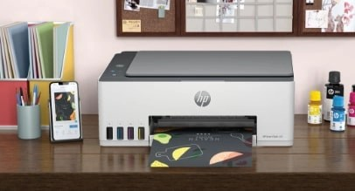

Table of Contents
Section: 1 4
1. Introduction 4
2. Preface 4
3. Process Overview 6
4. Product Overview 6
4.1. Dune Products 7
4.2. Difference between Workflow UI & Hybrid UI & Pro-select 7
4.3. Assets for Pro-Select, Hybrid, & Workflow UI 8
4.4. Difference between Enterprise and Non-Enterprise 10
4.5. Difference between EWS & Control Panel 11
3.5.1 EWS (Embedded Web Server) 11
3.5.2. Control Panel (on the device) 11
3.5.3. Difference between EWS and CP 12
5. Design and String Reviewer Interaction 13
6. Mail request 13
Section:2 15
6. Requirement Start Process 15
6.1. JIRA Dashboard Login 15
6.2. JIRA Start Process 17
6.3. JIRA Checkpoints: Status, Story points, Comments, products, fix version, sprint 18
6.3.1. Status 18
6.3.2. Story Points 19
6.3.3. Comments 19
6.3.4. Products 20
6.3.5. Fix Version 21
6.3.6. Sprint 22
6.4. Attributes: Epic, Story, Sub Tasks, Spike 22
6.4.1. Epic 22
6.4.2. Story 23
6.4.3. Bug 23
6.4.4. Spike 24
6.5. Sub Tasks 25
6.5.1 Sub-Task Execution 25
6.5.2 Sub-Task Types and Reviews 25
6.6. Guidelines 27
Section: 3 27
7. Workflow Review Process 27
7.1. Figma Review 27
7.2. String Review Spreadsheet 28
7.3. IA 29
7.4. Design Approval 30
7.5. Guidelines 30
Section: 4 30
8. Strings 30
8.1. Rosetta & Codex 30
8.2. String ID naming rules 31
8.3. Search A String ID or English 32
8.4. Creating/Updating String ID 34
8.4.1. When to create a string ID 34
8.4.2. When to revise a string ID 34
8.4.3. When to add a String Value 34
8.4.4. Multi-value string 35
8.5. Parts of String ID 36
8.5.1. String ID 36
8.5.2. English 36
8.5.3. Business Unit 37
8.5.4. Internal Comments 38
8.5.5. Translator Notes 39
8.5.6. Sizing 39
8.5.7. History 40
8.5.8. Foreign Languages 41
8.5.9. Function Sets 41
8.5.10. String by Product 43
8.5.11. Fn set 44
8.5.12. Others sections 44
8.6. OEM 44
8.7. Special Characters 44
8.8. Event codes and SR bits 44
8.9. Animations 44
8.10. Guidelines 44
Section: 5 44
9. Requirement Closure Process 44
9.1. When to close the requirement? 44
9.2. Additional Information About JIRA Before Closure: Story Points, sprint, Resolution 44
9.3. Checklist 44
9.4. JIRA Closure Mail 44
10. Dune Overall Guidelines 44
11. How to work with Stories and Bugs 44
11.1. Simple Story (Ex: DUNE-256479 and Ex: DUNE-257541) 44
11.2. Critical Story (Ex: DUNE-241635) 46
11.3. Simple Bug (Ex: DUNE-220583) 46
11.4. Localization Bug (Ex: DUNE-197420) 47
11.5. EWS Story (Ex: DUNE-244337) 48
11.6. Animation Story (Ex: DUNE-255848) 48

Section: 1

Introduction
Strings Team – Empowering User-Printer Communication
At Strings Team, we don’t just write content—we bridge the gap between users and technology. Our mission is to transform complex printer interactions into seamless, intuitive experiences through clear, engaging, and purposeful communication.
What We Do
We design and deliver interactive, user-centric content that guides, informs, and supports users at every step of their printing journey.
- Understandable – We simplify technical language into clear, actionable messages.
- Interactive – We create content that responds to user needs in real time.
- Empowering – We help users feel confident and in control of their devices.
Our client
HP Inc. (HP) – A global leader in printing innovation.
Our Product Focus
- Home Printing Solutions – Making everyday printing effortless for families and individuals.
- Graphic Business Solutions – Supporting professionals with precision and performance.
- Office Printing Solutions – Enhancing productivity in dynamic work environments.
Our Impact
We don’t just write, we enhance user satisfaction, reduce support calls and elevate brand experience through every word we craft.

Preface
Strings Team plays a role in managing the UI text content/ EWS content and Design review across various products. Create and manage String IDs and event code.

Dune
- Dune is the HP printer program names that includes both SFP (Single-functional printer) and MFP (Multi-functional printer) in DUNE products.
- There are three different UI (User Interface) styles in the HP printers:
- Workflow UI
- Hybrid UI
- Pro-select
Style/UI
- Spice - must be enabled for Dune Printers
Business Unit
- OPS
- GSB
- HPS
- The DUNE products will adopt the OPS, HPS, and GSB UI style.
JIRA
- Jira is a versatile project management and issue tracking software developed by Atlassian. Initially launched as a bug tracking tool.
The core concept includes:
  - Projects: Containers for issues, representing different teams, products, or initiatives.
  - Issues: Individual pieces of work, such as tasks, bugs, or user stories.
  - Workflows: Defined sequences of steps that issues follow from creation to completion.
  - Boards: Visual representations (Scrum) of work in progress, aiding in tracking and management.
  - Sprints: Time-boxed periods in which specific work must be completed and made ready for review.
Codex
- Codex is internal CMS (Control Management System) tool where string writer will create String IDs.
- String writer can create String IDs, from the Strings options in the Codex tool.
- The String IDs, requirement will receive from the UX designer in the form of Figma document.

Process Overview
- The System Engineer or Program Team initiates the process by creating an Epic for each feature and breaking it down into individual stories for relevant teams such as Design, Strings, and Graphics.
- The Strings Lead receives the requirement as a string-related story or bug on the JIRA dashboard and assigns it to a String Writer.
- The String Writer reviews the Epic, Design, and String stories to gather and understand the requirements.
- If there are any questions regarding String IDs, the String Writer consults with the Designer.
- The Designer then updates the design and English content, adding or modifying Wiki links or images in the Epic or Story as needed.
- Based on the updated design, the String Writer creates or updates the strings in DUNE Codex.
- The String Writer then:
  - Adds the String IDs and spreadsheet links in a JIRA comment,
  - Assigns the story to the String Approver, and
  - Adds a String Approval Request comment along with the current string status.
- The String Approver reviews all string ID content in the context of the functional screens in the design.
- Once approved, the strings are sent for integration every Wednesday.
- After all String IDs are approved, the Strings Team generates untranslated strings from DUNE Codex as “.xml” files (one per language) and sends them to the Localization Team on a scheduled basis (approximately every 3 weeks).
- Once the localized string IDs are received, they are imported into DUNE Codex, and a confirmation is sent to the Integration Team.

Product Overview
There are three types of products depending on the business unit.
- HPS = Home Printing Solutions
- OPS = Office Printing Solutions
- GSB = Graphics Solutions Business (Large Format Printers)

Common Product Specs
- Paper sizes: A3, A4, Single Roll, Multi-Roll
- Functionality:
  - MFP (Multi-Function Printer)
  - SFP (Single-Function Printer)
- Other attributes: Color/Mono, Scanner options, Display sizes

Dune Products
Dune is platform for modern printers. It covers
- Printer UI workflows.
- Workflows are delivered via Figma (a design tool).
- Contains latest implementation for all printer types: home, business, and large printers.
- Click Product Overview to see all the applicable DUNE products.
- The detailed information about all the Dune products is available in the product options in the Codex tool.

Difference between Workflow UI & Hybrid UI & Pro-select
Key Differences: Workflow UI, Hybrid UI, and Pro-Select UI.
WORKFLOW UI | HYBRID UI | PRO-SELECT
A Workflow UI is designed to facilitate and streamline the sequence of steps or processes (workflow) that users follow to complete tasks within an application. | A Hybrid UI combines elements from different types of user interfaces, such as combining web-based and native mobile interface components. | The term "Pro-select" doesn't have a widely recognized standard definition in UI/UX terminology. It might refer to a specific user interface design pattern or component within a particular software system or application.
It often includes elements like task lists, progress indicators, decision points, and actions users can take at each step of a process. | It may leverage web technologies (like HTML, CSS, JavaScript) alongside native mobile frameworks (like Swift for iOS or Android) to create unified user experience across different platforms. | It could denote a UI element or feature designed specifically for professional users (hence "pro"), possibly involving selection or choice functionality.
It aims to optimize efficiency, clarity, and ease of use by guiding users through complex procedures or workflows. | Hybrid UIs are often used to maximize code reusability and development speed while delivering a consistent user interface across multiple devices and platforms. | Without specific context or industry use, its exact meaning can vary and might be clarified within the specific software or system documentation.
 | Applicable products are different from Workflow UI. Applicable product is Zelus. | It will be in Round UI. Applicable product is Ulysses.
Interaction model: touchscreen | Interaction model: Touch and non-touchscreen, physical buttons for navigation, | Interaction model: non-touchscreen, physical dial for navigation
Color/Mono: Color | Color/Mono: Mono | Color/Mono: Mono
Sizes: XS, S, M, L, XL
Physical display sizes (inches): XS=2.4, 2.7, S=4.3, M=8, 10.1, L=16, XL=23 | Physical display size (inches): 2.2 | Physical display size (inches): 2.7
Sample products: Jupiter, Euthenia, Marconi, Beam, Namhae | Sample products: Zelus, | Sample product: Ulysses.

Assets for Pro-Select, Hybrid, & Workflow UI
Workflow UI | Proselect UI | Hybrid UI
Tools | Wi-Fi Direct | Tools
System Error | Web Services | Supplies
Supplies | USB Print | Status And Message Centre
Substrate Library | Tools | Settings
Status Centre | Templates | Quick Forms
Status | Status & Message Centre | Print RRTP
Settings on the Fly | Shortcuts | Printer Update
Settings | Settings | OOBE
Send | Scan | Media Handling
Scan | Quickset | Job Queue
Quiet Mode | Printer Update | Job Log
Quickset App | Print RRTP | Home Menu and Info
Quick Copy Widget | Preview | Global Help
Print USB | OOBE | Energy
Printer RRTP | Media Handling | Connectivity
Print Quick forms | Legacy Supplies | ANA
Print Photo, Passport | Job storage
Print Photo | Job Queue
Print From Network Folder | Job Log
Print From My Home Folder | Interaction Constraints
Preview | Home & Menu
Power Button | Global Help
Physical Actions | Fax
Paper | Energy
OOBE | Copy
License | Contacts
Jobs | Connectivity
Job Storage | ANA
Info
Home/Menu
Global Help
Firmware Update
Extensibility
Energy
Enable/Disable
CSAT
Copy/Print Settings
Copy
Contexual_Help
Contacts
Connectivity
Cloud Shortcuts
Calibration
ANA
All options
Adaptive UI: System events/Covers & Doors
Accessibility

Difference between Enterprise and Non-Enterprise
Enterprise refers to large organizations or businesses that require scalable, secure, and robust solutions—often with advanced features, support, and compliance.
Non-Enterprise typically means smaller businesses, startups, or individual users using standard or basic versions without enterprise-level customization or support.
Key Differences: Enterprise, and Non-Enterprise
Aspect | Enterprise | Non-Enterprise
Scope | Large-scale organizations | Small to medium-sized businesses or individuals
Size | Typically, large with extensive resources and staff | Smaller with limited resources and staff
Structure | Hierarchical with defined departments and roles | Less formal, often with fewer organizational layers
Focus | Comprehensive business operations | Specific market focus
Scale of Operations | National or international reach | Local or regional operations
Technology Use | Advanced and integrated systems | Basic or Standalone technologies
Budget | Significant budgets for IT, operations, etc. | Limited budgets, often allocated conservatively
Decision-Making | Formalized processes involving multiple stakeholders | Flexible, often driven by key decision-makers
Customer Base | B2B (Business-to-Business) focus | B2C (Business-to-Consumer) or smaller B2B segments
Regulations | Compliance with complex regulations and standards | Compliance with basic regulations
Risk Tolerance | Moderate to high due to extensive resources | Lower due to limited resources and size
Innovation | Emphasis on innovation and adapting to market trends | Innovation driven by specific needs

Difference between EWS & Control Panel
The EWS (Embedded Web Server) and the Control Panel are two different interfaces used to interact with and manage printers or multifunction devices (like those from HP). Here's a breakdown of their differences:

3.5.1 EWS (Embedded Web Server)
What it is:
- A web-based interface built into the printer's firmware.
- Accessible through a browser using the printer's IP address (e.g., http://192.168.1.10).
Key Features:
- View and change printer settings remotely.
- Monitor status (e.g., toner levels, paper jams, usage reports).
- Configure network settings, security, email profiles, etc.
- Often provides more advanced configuration options than the physical panel.
- Can be accessed by IT admins or users with the right credentials.
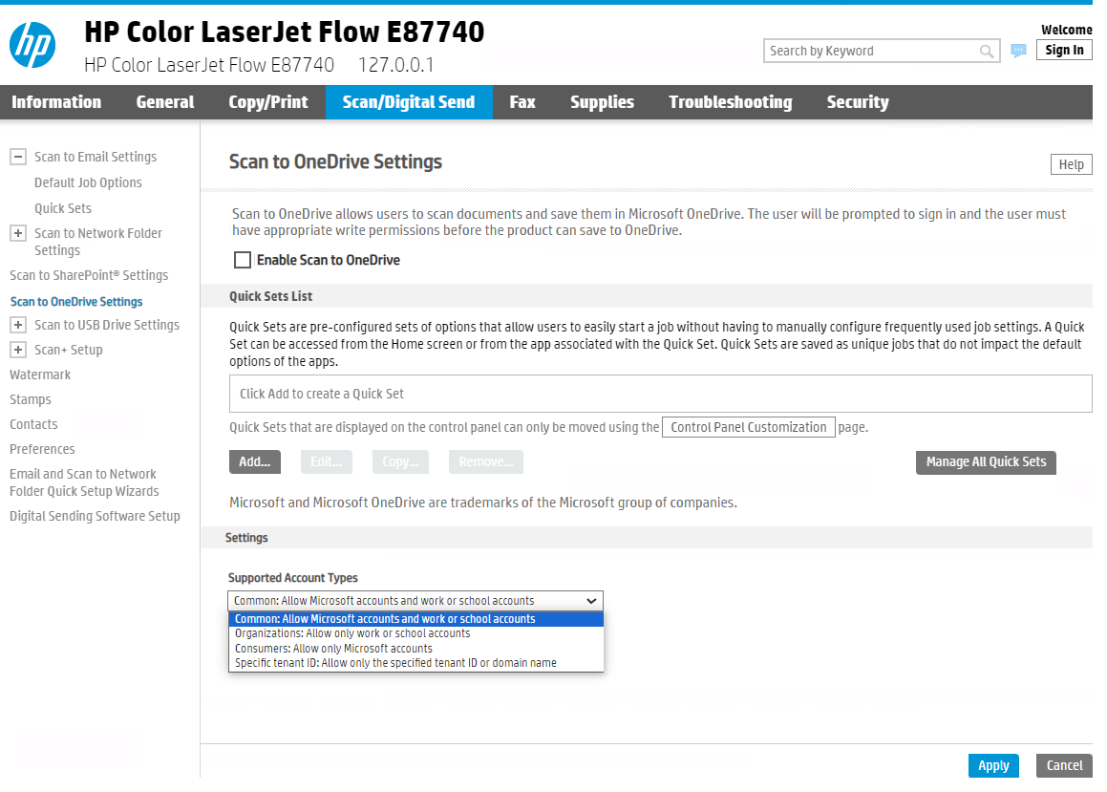

3.5.2. Control Panel (on the device)
What it is:
- The physical interface on the printer itself (buttons + screen or touchscreen).
Key Features:
- Direct access to basic and sometimes advanced functions.
- Print, copy, scan, fax operations.
- Local configuration like Wi-Fi setup, tray settings, etc.
- Useful for quick troubleshooting and local operation.

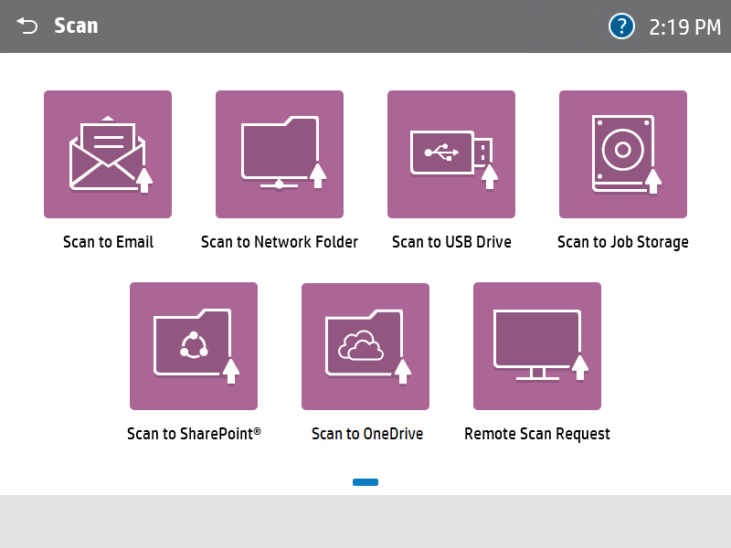

3.5.3. Difference between EWS and CP
Refer to the table below for a detailed comparison between EWS (Embedded Web Server) and the Control Panel.
Features | Embedded Web Server (EWS) | Control Panel
Access Method | Accessed through a web browser (e.g., Chrome, Firefox) by entering the printer's IP address or hostname. | Accessed directly from the physical interface of the printer or device, usually via a touchscreen or physical buttons.
Functionality | Provides a web-based interface for comprehensive device management, configuration, and maintenance. | Provides basic to intermediate device management options and settings adjustment directly on the device.
Features | Typically offers advanced settings and administrative controls, including network settings, firmware updates, security settings, and diagnostics. | Allows users to perform tasks such as print, copy, scan and fax (if applicable), and accessing basic settings like paper tray selection, quality settings, and print job management.
Remote Access | It can be accessed remotely from any device connected to the same network or, in some cases, over the internet if configured securely. | Typically used for immediate access and control of the device itself, suitable for quick adjustments and basic operations without the need for external devices.
Key difference | EWS is accessed via a web browser on a computer or mobile device | It is displaying panel of printer.
 | EWS offers more comprehensive administrative and maintenance functions | Control Panel focuses on operational tasks and basic settings adjustment.
 | EWS provides a graphical web interface, often with more detailed information and options | Control Panel's interface is typically more simplified and task oriented.

Note: 1. Sizing is not required while creating strings for EWS. if the content is available on the wiki link, we should create the strings using that content.
2. For EWS no spreadsheet is maintained; information is provided via screenshots and tabular format in Jira.
3. In EWS, we will provide a single string for each paragraph—based on discussions with the designer—rather than two separate strings.

Design and String Reviewer Interaction
Once the Design is ready and uploaded to the Epic story, the string writer will review it and interact with the designer via JIRA comments or email to gather the following information:

- Confirmation of the applicable products.
- Clarification on String content, Design information, Description, and any Screenshot or Images.
- If it is a new feature or need to create any new String ID, request a one-line description and Screen/ Images.
- Inform to Designer, if any mistakes found in the mock up or screenshots within the Story, Epic or Bug.

Mail request
These are ad-hoc requests typically initiated by Developers or Firmware (FW) teams via email and may sometimes relate to Stories or Bugs in Jira. This workflow outlines how to properly handle and document these types of requests.

Step 1: Check the Email for a Jira Reference
- Look for a Jira Story or Bug number mentioned in the email.
  - If present: Go to the corresponding Jira item and add comments summarizing the request.
  - If not present: Note down the request separately and flag it for tracking if needed.

Step 2: Identify Urgency
- Assess the urgency or priority of the request:
  - Is this a blocker or part of a scheduled release?
  - Confirm with the requester if unclear.

Step 3: Verify Asset and Version
- Confirm the following details from the email:
  - Asset name (e.g., UI screen, template, module)
  - Version number (to ensure the right file/context is being updated)
  - Request clarification if any detail is missing.

Step 4: Confirm Required Information
- Ensure that all necessary input is available:
  - Description of the change
  - Screenshots or references (if applicable)
  - Target location in the UI

Step 5: Implement the Request
- Make the required changes using:
  - The Review Spreadsheet (for text/content tracking)
  - Codex (for managing UI strings or code-based updates)

Step 6: Update Jira (if applicable)
- If a Jira story/bug exists:
  - Add a comment indicating that the change has been implemented.
  - Note the source of the request (e.g., Request received via email from [Name/Team] on [Date].

Step 7: Respond to the Email
- Always reply to the original email to confirm:
  - That the request has been received, working and completed.
  - Any clarifications required
  - Timeline for completion (if applicable)

When to send a mail request:
- When there is a confirmation required regarding the applicable product.
- When there is a query related to a description, story or screenshot.
- When animations or images are not updated in the Figma design.
- When additional design changes are needed.

Section:2

Requirement Start Process

JIRA Dashboard Login
To access the JIRA dashboard:
- Open Your Browser
Launch a compatible web browser (e.g., Chrome or Edge).
- Go to the JIRA URL
Enter the JIRA site address in the browser’s address bar.
https://hp-jira.external.hp.com/secure/Dashboard.jspa
Enter Credentials
Username/Email: Enter company email address or JIRA username.
Password: Enter the system password.
NOTE: If Single Sign-On (SSO) is enabled, you may be redirected to a Google login page—just follow the prompts.
- Complete Authentication
If Multi-Factor Authentication (MFA) is enabled, enter the verification code sent to your phone or app or email.
- Access the Dashboard
Once logged in, you’ll be taken to your default JIRA Dashboard. From here, you can view tickets, manage boards, or navigate to different projects.
How to access project dashboard:
- Open the JIRA Site
Enter the following URL in your browser’s address bar:
https://hp-jira.external.hp.com/secure/Dashboard.jspa
- Navigate to Manage Dashboards
Click on the Dashboard dropdown in the top navigation bar and select Manage Dashboards.
- Search for the Project Dashboard
Under the Manage Dashboards section, click on the Search option (under the Favourites tab).
- Enter Search Details
Provide the project dashboard name and the owner’s name, then click the Search button.
- Pin the Dashboard to Favourites
Once the desired project dashboard appears in the results, select it and pin it to your Favourites for easy future access.
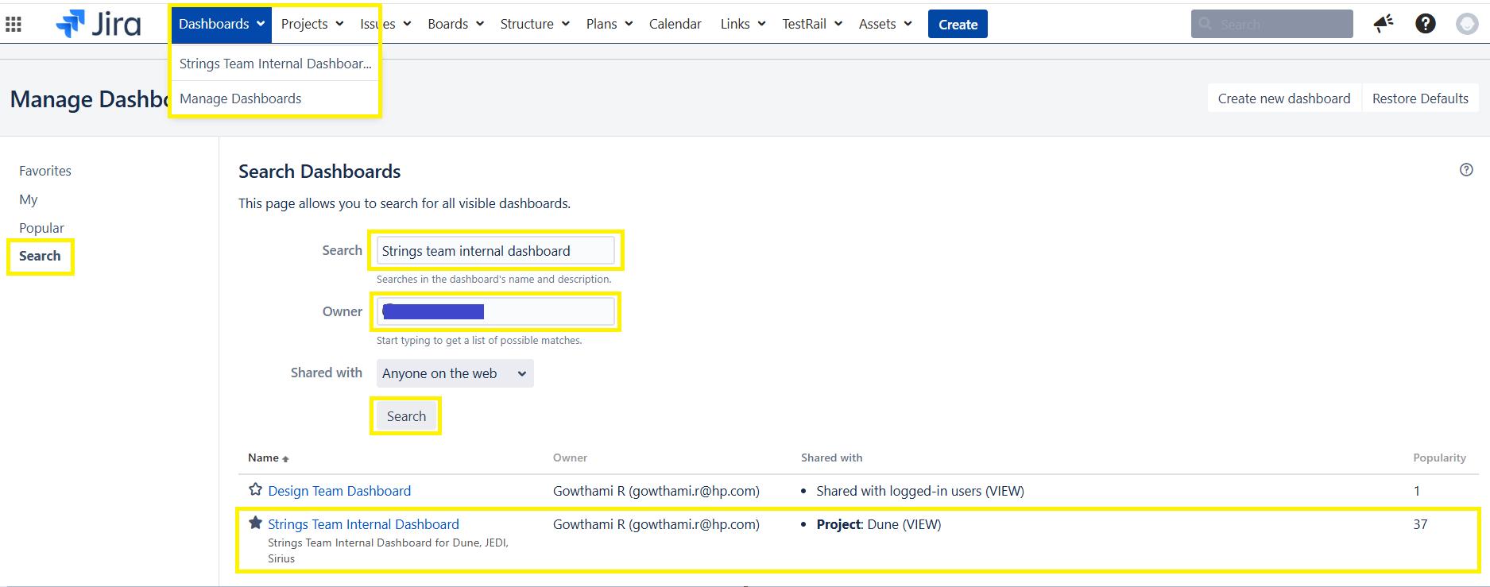
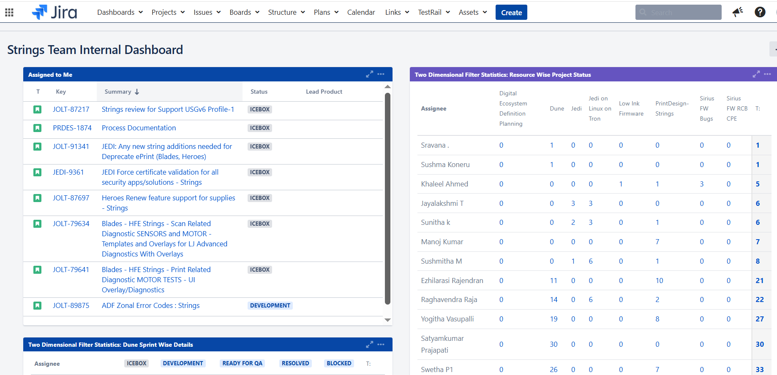

JIRA Start Process
- When a JIRA story is assigned to a string writer, they should verify the following details:
- Assign Name: As soon as we receive the Jira Story/Bug need to check the name of the string writer.
- Type: Check whether it is bug, story, spike etc. and then need to start work according to that.
- Applicable Products: These will be listed in the story when it’s created (e.g., Sunspot, Beam, etc.). Confirm with the designer and reporter to make sure the listed products are correct. In few cases the lead product also need to be checked which syncs with applicable product.
- Story Points:
- Story points estimate task effort based on an 8-hour workday, not calendar time.
- 2 (1 day effort) [not calendar time…]
- 4 (2-3 days effort)
- 6 (4-7 days effort)
- 8 (8-10 days effort)
- Acceptance Criteria: Review the design and capture the string ID in Codex.
- Priority: Need to check the priority of bug/story as “High, Medium, None” etc. and need to work as per the
- Sprint: Fortnight period during which a specific set of Stories, typically from the product backlog, are planned to be completed. Sprint is represented as - Printfw 23.09a (9Aug – 22Aug).
- Fix Version: Fix Version refers to the planned release version in which a story, bug, or task is expected to be completed and deployed.
- Comments: Check the latest comments and start the Jira process.
- Watchers: Need to add the required people in watchers list by searching the names and adding them so that they can parallel get notify about the Jira status or information.
- Title Description: Determine whether the item is a Story or a Bug for CP/EWS classification, then initiate the workflow according to the Jira issue type.

JIRA Checkpoints: Status, Story points, Comments, products, fix version, sprint

Status
JIRA status shows the current progress of an issue, helping to track the workflow and identify bottlenecks.
- ICEBOX:
- When the design or required information has not yet been received from the Designer or Reporter.
- When the task is not prioritized (i.e., the fix version and sprint is not set in JIRA).
In some cases, a Story in Jira may arrive already in the Icebox status.

- Ready for Development:
  - When the design is updated in the string story and the designer has added a comment in JIRA or sent an email, the string writer will move the status to Ready for Development, review the document, and provide necessary comments to the designer.
  - If the String Writer is occupied with another high-priority task and does not currently have bandwidth, they may still move the story to Ready for Development to indicate the Design is ready but work on strings will be picked up once available.

- Development:
  - Once the designer has updated the design file and shared the file to the string writer, the string writer shall update the task status to 'Development' and begin implementation.

- Ready for QA:
- When the string writer has captured all string content and created any new strings as required by the design, the story’s status should be changed to ‘Ready for QA’ and it should be assigned to the string approver, with a comment added.
- Add the comment including string spreadsheet link (for UI workflows) with:
  - String ID
  - English Content
  - Applicable screen/DFD
  - Where it's used (Context)
  - Status
- Blocked:
- The issue cannot proceed due to a dependency or unresolved problem.
- It may be blocked from designer end or firmware team. In this cases also the status will be blocked.
- Resolved: Resolved is intended to be used when string approval is done from the approver and then moving the story to the resolved state
- Closed: Once all the strings are integrated into the latest FW version the story/bug will be closed by respective DUNE string writer.

Story Points
A numeric value estimating the effort or complexity of a task. Used in Agile for sprint planning and velocity tracking.

- Story Points are based on an 8-hour workday of effort. For example, if a task requires 24 hours of effort, it should be estimated as 2 story points (2 x 8).

- Please note that story points measure effort, not duration. So, if a task spans 2 weeks but only requires 8 hours of actual work, it would be estimated as 1 story point.

- Story point values should typically not exceed 10 if in case the story is exceeded more than 10 days then the story as to be cloned to another story as phase 2 under the same epic. As sprints are 2 weeks long (i.e., 10 working days). Preferred values follow a standard scale such as 1, 2, 4, or 8.
- 2 (1 day effort) [not calendar time…]
- 4 (2-3 days effort)
- 6 (4-7 days effort)
- 8 (8-10 days effort)

Comments

The purpose of adding comments in JIRA includes:

Comments in Jira are used to facilitate communication, track progress, and maintain a record of discussions related to an issue. They allow teams to collaborate effectively by providing a dedicated space for updates, questions, clarifications, and feedback on specific issues.
Clarification & Resolution:
Comments can be used to ask clarifying questions, provide additional information, and ultimately, help resolve the issue.
- @Addressing: Comments allow users to @(address) specific team members, notifying them of the comment and ensuring they are aware of relevant discussions.
- Communication & Collaboration: Comments provide a centralized platform for team members to communicate, ask questions, and provide feedback on the issue.
- Progress Tracking: Comments are used to record the evolution of an issue, including status updates, actions taken, and decisions made.

Examples:
- For Icebox:

The design is not ready. The string story will be addressed in the upcoming design story sprint.
"<Design story number>: ........., <Designer>: ........... "

- For Ready for Development:

@Requestor: I have received the latest design, but I am currently occupied with a high-priority task. Once that is completed, I will begin reviewing the design and provide the necessary review comments.

- For Development:

@Requestor: The ETA for the received design is DD/MM /YYYY.

- For Ready for QA:

@String Approver: @approver, Review and approve the strings required for the story.

Products
- Lead Product: Is family of products. Example: Flowers
- Applicable Product: List of products belonging to a family. Example: Enterprise, Flowers, Lotus, LFP, Pro, Euthenia, etc…

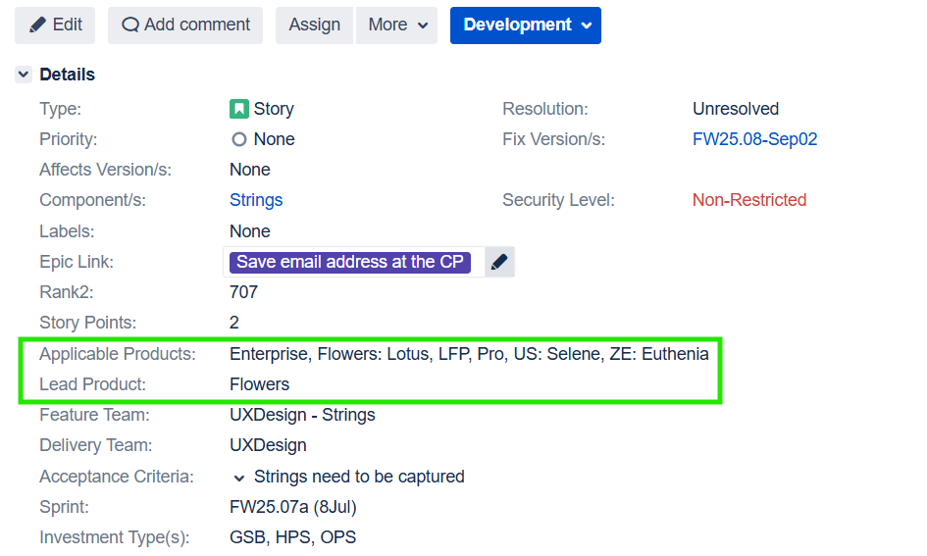

Fix Version
In Jira, the 'Fix Version' field specifies the release version in which the issue within the epic is must be resolved. This helps in tracking and managing the release process, allowing teams to plan, monitor, and report on the work associated with different versions.
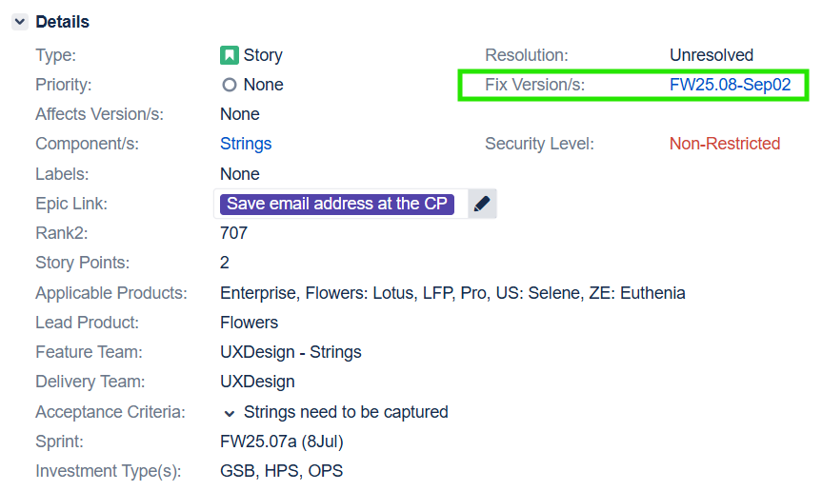

Sprint
- A sprint is a time-boxed iteration, usually 2 weeks (i.e., 10 working days), during which a specific set of tasks or stories are completed.
- In JIRA, the Sprint field indicates which sprint an issue is assigned to on the Agile board.

Importance of Sprint:

- Organizes work into manageable cycles.
- Enables planning, tracking, and reporting using Agile metrics like burn-down charts and velocity.
- Helps teams stay focused on a clear set of priorities.

Attributes: Epic, Story, Sub Tasks, Spike

Epic
- In Agile methodologies, an epic is a large body of work that can be broken down into smaller, more manageable tasks called user stories. It represents a significant feature, functionality, or goal that is too large to be completed within a single sprint or iteration.
- It helps track progress, plan work, and organize features across multiple sprints.

Common Fields in a Jira EPIC
Here are the typical fields you’ll find when creating or viewing an EPIC in Jira:
Field Name | Description
EPIC Name | A short, unique name used to identify the EPIC on boards and reports.
Summary | A brief title or headline for the EPIC.
Description | A detailed explanation of the EPIC’s purpose, goals, and scope.
Issue Type | Set to EPIC to distinguish it from stories, tasks, or bugs.
Status | Tracks the current state (e.g., To Do, In Progress, Done).
Priority | Indicates the importance (e.g., High, Medium, Low).
Assignee | The person responsible for overseeing the EPIC.
Reporter | The person who created the EPIC.
Labels | Tags to help categorize or filter EPICs.
Start Date | When work on the EPIC is expected to begin.
Due Date | When the EPIC is expected to be completed.
Linked Issues | Other issues (stories, tasks, bugs) that are related to this EPIC.
Components | Optional field to group EPICs by product areas or teams.
Custom Fields | Jira admins can add custom fields like OKRs, business value, etc.

Story
Stories, also called “user stories,” are short requirements or requests written from the perspective of an end user.
Purposes of a JIRA Story.
- Each story is assigned to a specific team member (e.g., string writer, developer, designer, tester) with clearly defined responsibilities.
- Tracks end-to-end work, including design review, string creation, validation, Codex entry, and localization readiness.
- Facilitates communication between designers, developers, and string writers through JIRA comments or emails.
- Enhances transparency and reporting, as stories contribute to dashboards, sprint planning, and overall progress tracking in JIRA.

Common Fields in a Jira Story
Field Name | Description
Summary | A short title describing the story.
Description | A detailed explanation of the user’s need, often using the user story format.
Issue Type | Set to Story to distinguish it from EPICs, tasks, or bugs.
Acceptance Criteria | Conditions that must be met for the story to be considered complete.
Status | Tracks the current state (e.g., Icebox, Development, Ready for QA, closed, resolved, Blocked).
Epic link | An Epic is a large body of work, which is broken down into multiple smaller tickets (stories, bugs, tasks) that collectively deliver a big feature or initiative.
Priority | Indicates the importance (e.g., High, Medium, Low).
Assignee | The team member is responsible for completing the story.
Reporter | The person who created the story.
Story Points | An estimate of the effort required (used in Agile planning).
Sub Tasks | Sub tasks need to be created for all stories.
Sprint | The sprint in which the story is scheduled.
Labels | Tags to help categorize or filter stories.
Linked Issues | Related issues like tasks, bugs, or the parent EPIC.
Components | Optional field to group stories by product areas or teams.

Bug
Definition: A Bug is an issue that describes an error, flaw, or fault in the software that causes it to produce incorrect or unexpected results.
Purpose: To track, prioritize, and resolve defects in the system to improve software quality.
Common Fields in a Jira Bug
Field Name | Description
Summary | A short title describing the bug.
Description | A detailed explanation of the issue, including steps to reproduce it.
Issue Type | Set to Bug to distinguish it from stories, tasks, or EPICs.
Steps to Reproduce | A list of actions that consistently trigger the bug.
Expected Result | What should have happened.
Actual Result | What actually happened.
Severity | Indicates the impact (e.g., Critical, Major, Minor).
Priority | Indicates how urgently the bug should be fixed.
Status | Tracks the current state (e.g., Open, In Progress, Resolved, Closed).
Assignee | The person responsible for fixing the bug.
Reporter | The person who reported the bug.
Environment | Information about the system where the bug occurred (e.g., browser, OS).
Attachments | Screenshots, logs, or other files that help illustrate the bug.
Linked Issues | Related issues like stories or tasks.

A Bug in JIRA is used to report a defect or issue identified in the product during development, testing, or post-release. Bugs typically relate to issues found in UI strings, functionality, design mismatches, or localization errors. Usually linked to the original Story or Epic where the bug occurred.
Description: Detailed explanation of the bug including
- What is the issue?
- Where is it occurring? (screen/module)
- Steps to reproduce the bug
- Expected vs actual results
- Screenshots or attachments (if applicable)

Spike
Definition: A SPIKE is a time-boxed research task used to gain knowledge or answer a question that helps the team make better decisions.
Purpose: To explore technical approaches, evaluate tools, understand requirements, or reduce risk before starting development.
Common Fields in a Jira SPIKE
Field Name | Description
Summary | A short title describing the research goal.
Description | A detailed explanation of what needs to be investigated and why.
Issue Type | Set to Spike (if configured in Jira) or use Task/Story with a label.
Acceptance Criteria | What questions must be answered or what outcomes are expected.
Timebox | A fixed amount of time allocated for the research (e.g., 1–2 days).
Assignee | The person responsible for conducting the research.
Linked Issues | Related stories or tasks that depend on the outcome of the spike.
Labels | Often tagged with spike for easy filtering.

During implementation of the Feature if the team comes across any critical requirement to be handled this comes back as a spike and needs to be completed on High priority.

Sub Tasks

6.5.1 Sub-Task Execution
Definition: A Task is a standalone piece of work that contributes to a project but may not directly represent a user-facing feature.
Use Case: Tasks are often used for things like setting up infrastructure, writing documentation, fixing configuration issues, or performing research.
Common Fields in a Jira Task
Field Name | Description
Summary | A short title describing the task.
Description | A detailed explanation of what needs to be done.
Issue Type | Set to Task to distinguish it from stories, bugs, or EPICs.
Status | Tracks the current state (e.g., In Progress, Blocked, Closed).
Priority | Indicates the importance (e.g., High, Medium, Low).
Assignee | The person responsible for completing the task.
Reporter | The person who created the task.
Due Date | When the task should be completed.
Labels | Tags to help categorize or filter tasks.
Linked Issues | Related issues like stories, bugs, or EPICs.
Components | Optional field to group tasks by product areas or teams.
Story Points (optional) | Sometimes used to estimate effort, though more common in stories

- Update Sub-Task Status
- Mark as Open, In Progress, Closed, or Blocked appropriately.
- Comment on Sub-Task Progress
- Add comments when starting and finishing each sub-task.
After all sub-tasks are completed:
      - Comment on the main story
      - Prepare Checklist of the story/Bug
      - Send Closure mail
      - CC relevant stakeholders(Approver and manager).

6.5.2 Sub-Task Types and Reviews
1. Legacy Product Review
- The Legacy review process involves verifying the feature described in a user story against the corresponding implementation in the Legacy product, specifically the Jedi Opus suite.
- Feature details are primarily extracted from the story’s title and description. In some cases, additional context or visual references, such as screenshots of JEDI screens, are available within the associated EPIC.
- Using this information, the writer searches for Function screens under the Function Management option in JEDI Rosetta.
- From the available function screens, only those associated with Opus 8.0 (workflow) and Web Server (EWS) are selected. The String writer captures the corresponding string IDs, English content, and screen name content for analysis.
- The objective of this review is to compare and identify the impact over DUNE workflow with that of the Legacy product, ensuring consistency and completeness.
- After completing the spreadsheet review, the writer should upload the same sheet to the Legacy Review subtask.
- If there are contents present in JEDI Rosetta then add the comments and also can close the subtask.
- Closed the Subtask.
2. Design Review
- In this phase writer clarifies the queries (If any) with designer.
- It is mandatory to include comments, Figma link, Azure link, or any design link, and email conversation attachments. (Designer, Design lead or Design Architect.)
- In some stories, Design Review and Internal Review within the team are combined as Design Review and Queries.
- Closed the Subtask.
3. Spreadsheet Review
- The DUNE content captured in the spreadsheet are updated as per workflow.
- The comments are updated in the comments section for the designer and notes for writer.
- Closed the Subtask.
Note: EWS there is no spreadsheet required.
4. String Update
- Codex update is done for modification and new creations.
- Capture and update the string content related to the story.
- For All stories, the updated and modified string are added in tabular form along with screen names and status of string id.
- Closed the Subtask.
5. String Approval/G-Drive Approval
- By adding all sub tasks comments at a time in last subtasks and providing the G-Drive links or SharePoint link for approval.
- Assign the subtask to the approver name without closing the subtask.

Workflow Review Process

7.1. Figma Review

Once the design is shared and uploaded to the story, the string writer must ensure that a Figma link has been provided by the designer. If the Figma link is available, follow the steps below:

Access the Design

Click on the Figma link to open the design file.

Verify Version History

Check the latest version history to ensure that the design and string stories align correctly with the corresponding JIRA ticket number.

Proceed with String Review

Continue with the string review process as outlined in the earlier section.
    - Capture content along with string id.
By checking the design contents, they need to captured in spreadsheet along with latest version updated and where used along with status and if needed designer comments.

String Review Spreadsheet
How to update Review a string spec sheet
Please keep the design document open alongside the review spreadsheet. Make the following updates in the review spreadsheet:
      - Update the screen name, string ID, and English content to the latest version. Ensure that all fields are completed in the Workflow UI section.
Note: - The screen display name should be in title case, with the initial letter capitalized, and words separated by underscore (_). Review each design document screen and incorporate relevant information into your review comments. Provide suggestions to the designer if needed.
- Determine whether strings were pre-existing or newly generated.
- Add comments related to content, screen names, etc., in the "Review comments (String Team)" section for the designers to review and update accordingly. Include design feedback within this section as well.
- After the spreadsheet update it should be sent for approval by adding it in relevant subtasks.
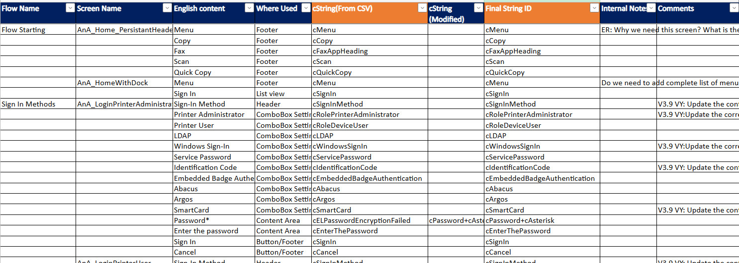

IA
What is IA
Information Architecture (IA) is the practice of organizing and structuring features involved in product development.
Path IA:
Click MUI Architecture - Published - Google Drive(CP IA) Dune EWS Architecture - Published - Google Drive(EWS IA) to access all details related to the IA documentation.

- We engage with the IA document as requested by designers, dependent on project requirements and design needs.
- Ensure the latest release and content availability in IA (Information Architecture) align with Assets in Internal Audit Version History.
- If design is unavailable, IA is used as reference for String creation with related applicable products.

Design Approval
Internal Design Review: Once the design is completed, the team conducts an internal review to verify design system adherence and check for potential patent-related issues.
Stakeholder Review and Approval: After internal review, the design is shared with stakeholders (e.g., Randy and the story creator) for feedback and final approval before the story is officially closed.

Section: 4

Strings
A string is a sequence of characters used to represent text. Strings can include letters, numbers, symbols, and even spaces. A string value will be displayed on a control panel or webpage.
- As a string writers, we play a key role in creating and modifying the strings used in control panel or webpage of the HP printers.
- Codex and Rosetta are web-based app supporting various websites to manage the contents of various platforms like Sirius, InkStem , Laserstem, Jedi/Jolt, Dune and Ares.

Rosetta & Codex
- Rosetta is a website that support the content management for JEDI/Jolt platform.
- Codex is a website that support the content management for DUNE/Ares platform.
- String writers use Rosetta/Codex to create and modify content required for control panel or webpage of the HP printers. This content is presented to end users as help messages, instructions, and error messages etc. 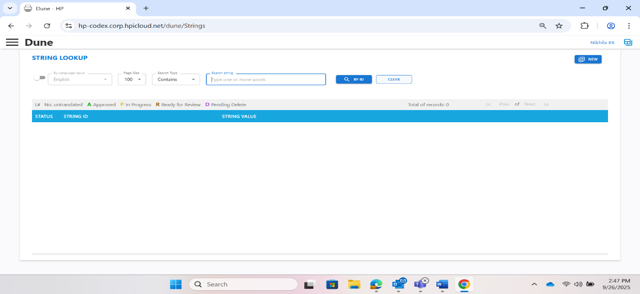
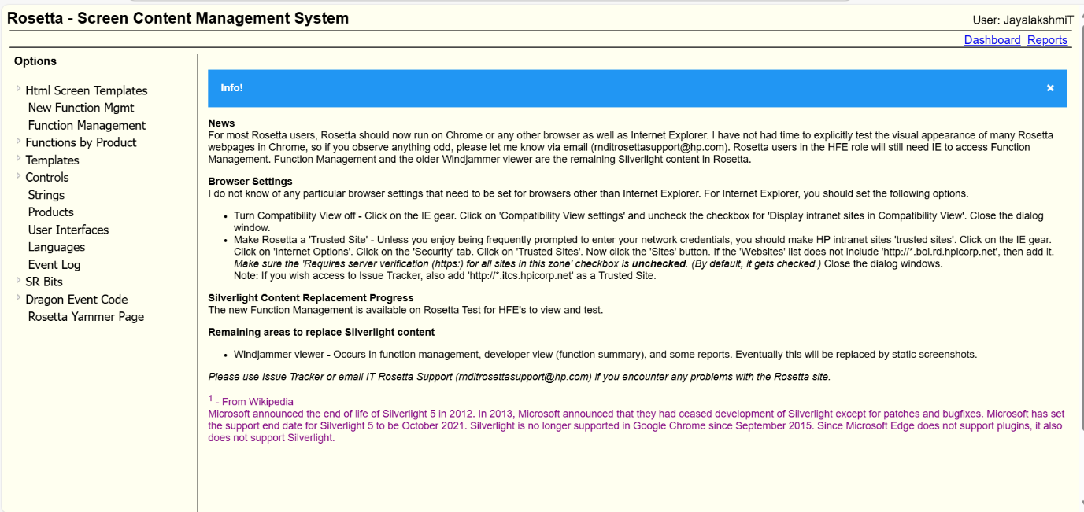

String ID naming rules
      - String ID name starts with small ‘c’.
- Correct: cOkButton
- Incorrect: OkButton

      - String ID name should co-relate with the content.
Correct:
- Content- Scan to Network Folder Setup
- String ID - cScanToNetworkFolderSetup.
Incorrect:
- Content - Scan to Network Folder Setup
- String ID - cScanToEmail.
      - Not more than 4 meaningful words. No space and special characters should be used in string id.
- Correct: cFolderQuickSets
- Incorrect: cScan ToFolder&SharePoint
      - Words must be in Camel case.
- Correct: cScanDefaultFolder
- Incorrect: cScandefaultfolder
Note: Camel case has words with first letter capitalized and written without spaces.
      - No two string IDs will have same name. String IDs are unique.
For Example: cScan and cScanLabel – with same content but string ID name is unique.
Note: Same content can have multiple string IDs as per the usage of content – Heading, Description, Buttons etc.

Search A String ID or English
String Option is the most frequently used option in Codex. It is used for the following processes: creating and modify String IDs.
To search for a string ID, we have two methods: finding by the string ID itself or by the English value. Additionally, the string writer can utilize the 'Search type' dropdown menu to execute specific searches like Contains, Exact match, starts with, or ends with.
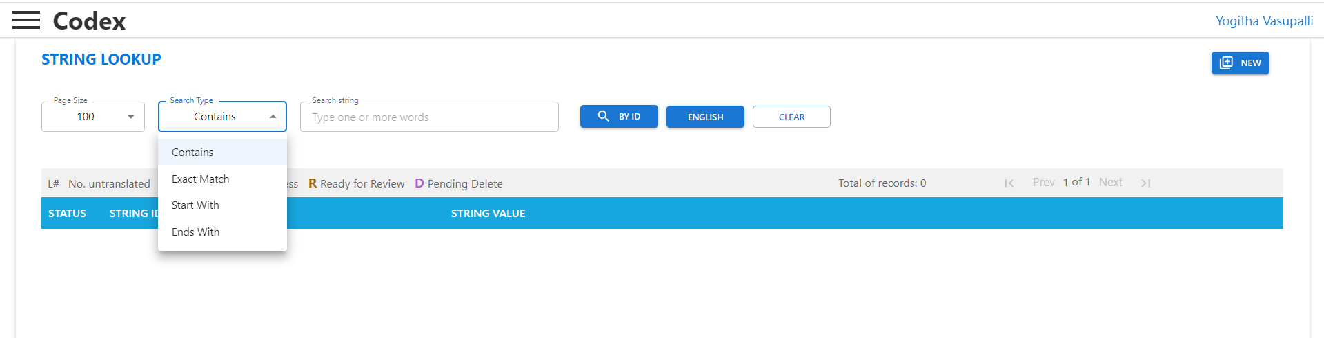
Search string text box:
Using this text box, user can enter any String ID and click on BY ID button to search and find the String ID.
If the String ID exists, String ID will be listed after the search. If the String ID doesn’t exist, Message appears – String not found
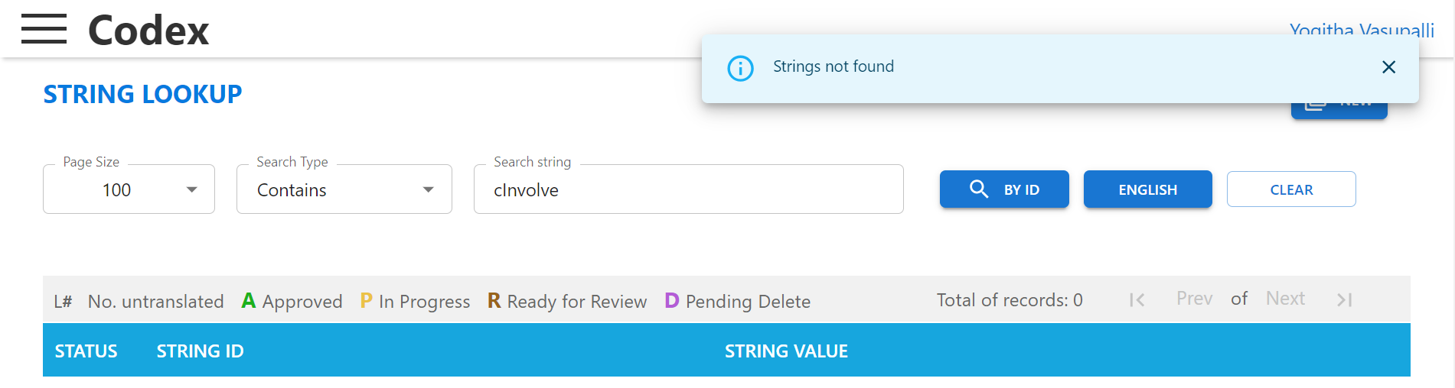
Note: In Rosetta, along with this message, “New String” option will be available to create the entered string ID. In Codex, we must click on  to create the string ID.
Search Type:
Contains a list of options a user can use to search for their required String ID or English content.

List of Options:
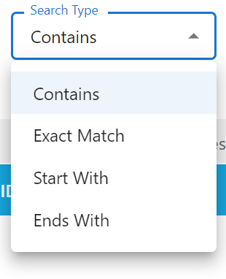
Contains: Searches for the availability of entered text in the String ID name or in English content (depends on text box).
Exact Match: Searches for the String ID name or English content with exact text that is entered in text box.
Starts With: Searches for the String ID name or English content that Starts with text entered in text box.
Ends With: Searches for the String ID name or English content that Ends with text entered in text box.
In Codex we have the following additional options:
Any Word: Searches for the String ID or English content with any of the word from the text entered in the text box.
All Words: Searches for the String ID or English content with all the words from the text entered in the text box.
New Button: 
Button allows string writers to generate new string IDs. When the button is clicked, a text box will appear, allowing the writer to enter the string ID name that needs to be created.
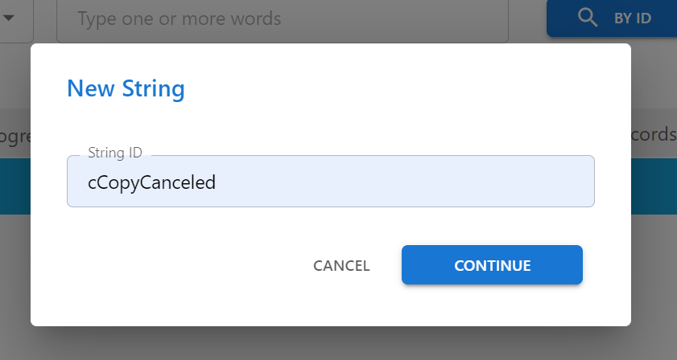

Creating/Updating String ID
On the String Creation screen, we can either create a new String ID or update an existing one, depending on the product applicability.

When to create a string ID
As string writers, we generally recommend reusing existing strings whenever possible especially when they convey the same meaning, even if there are slight differences in wording. This helps avoid unnecessary duplication of strings with similar meaning content and contributes to more efficient string management.
Additionally, reusing strings significantly reduces translation costs and simplifies localization efforts.
However, if no existing string adequately meets the requirement, we proceed with creating a new, dedicated string.
A new String ID should be created in the following scenarios:
- When content is not available in Codex, as per the latest design document.
- When there is a mismatch between required content and available content in Codex.
For Example:
- Existing String ID and content: cServerAddress – Server address
- Created new String ID (Title case for Header): cAddressForServer - Server Address

When to revise a string ID
Revision of string ID is required when existing contents have the following errors.
- English content is incorrect – Grammar or spelling errors.
- Updated design – Content is modified.
- Incorrect Function set updated, or content is now required for additional products which requires Function set update.
- To update correct sizing values.
- To update correct translations.

When to add a String Value
This is English content that will appear on the Control Panel or Webpage of the product function specified by the string ID, also referred to as the string value.
Add a string value in the following scenarios:
- When the required English content is not available in Codex, as per the latest design.
- When there is a mismatch between the required content and the existing content in Codex.
- For example:
Existing String ID and content: cServerAddress – Server address
New String ID created (with title case for header): cAddressForServer – Server Address

Multi-value string
A string ID can have one or more English value/String value. These string IDs are called Multi-valued String IDs.
Usage:
Multi-value string ids are used in the following scenarios:
- Difference in materials used - Paper & Substrate
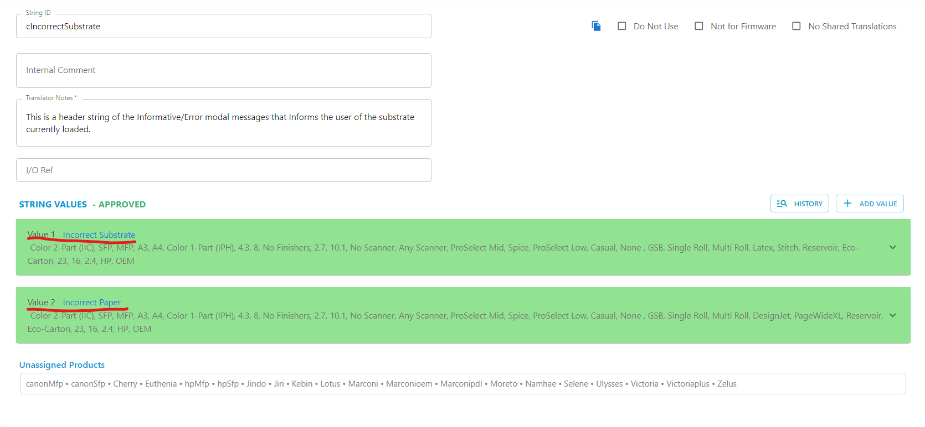

- Difference in user interaction - Touch & Select
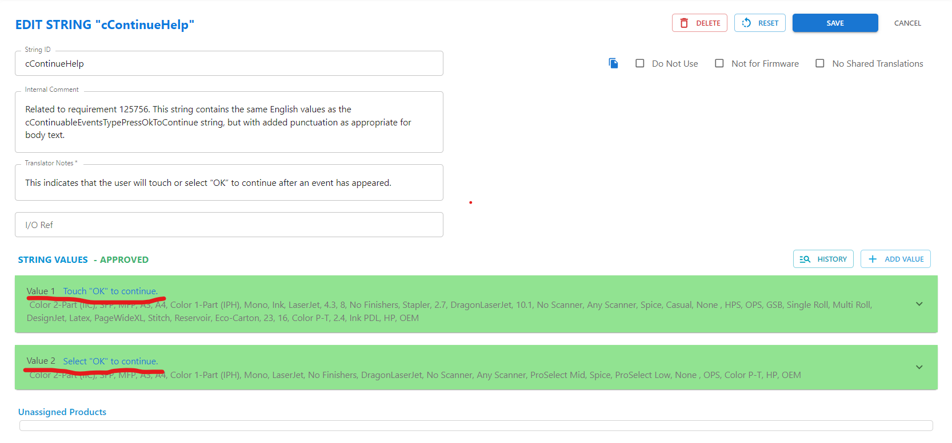
Rules:
- Resolved Product list for Multiple values within the string ID should be unique.
- Each value must be individually approved and translated.
- In case of few products like (Ulysses, Zelus and Namhae) “select “word will be taken but where as other dune products will use “Touch” in these cases we will created multi value string.

Parts of String ID

String ID
A string ID typically begins with the prefix c, followed by a camelCase name using letters or numeric or alphanumeric characters. Do not use symbols, special characters, or spaces.
Example: cInolve


English
This is the content that appears on the user interface. It is also referred to as the string's “Value.”
Note:
- Ensure the English content does not have line breaks or extra empty space in the end.
Example:
Parameter string ids:
- When we have a dynamic value, we create or provide a new parameter string ID to handle it.
- Parameter string IDs are used in situations where part of the text content can change at runtime.
Example: Case 1: Job Name
- Since the status is not constant, we define a parameter string ID like cJobNameParam, with the content:" Job Name: {0}”
- Here, {0} is a placeholder, and at runtime, a dynamic value (like "Scan", "Copy", etc.) will be passed into it.
- The actual job status value is provided by the firmware team.
- This approach allows the string to act as a dynamic string identifier, making the text more personalized, reusable, and easier to localize.
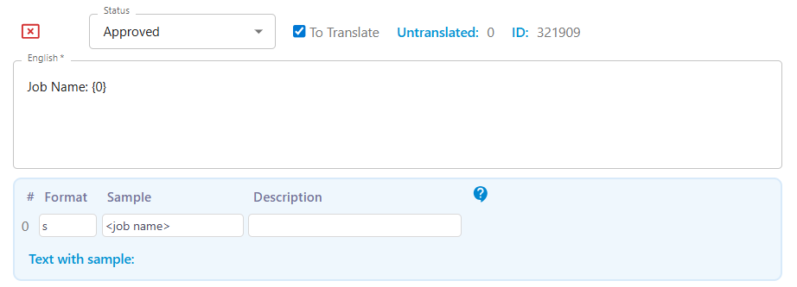
Case 2: Event code
- In this case also we will be creating a parameter string id and in sample we will pass the values.
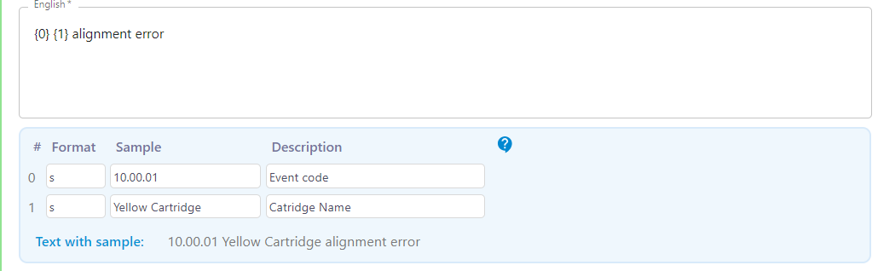
Case 3: Time
- In case of dynamic fax printing times a parameter string id can be used/created.

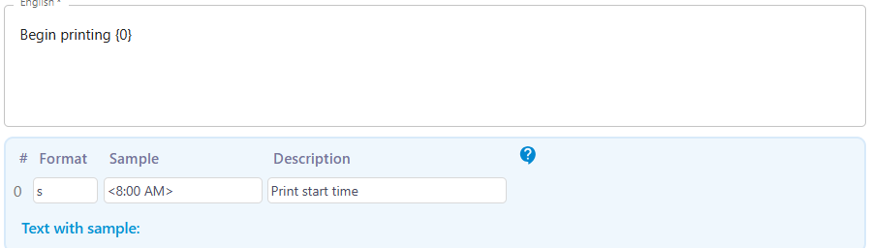

Case 4: Numbers
- In case of dynamic numbers also parameter string id is used.

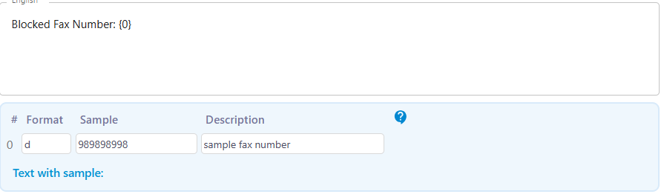
In different types of cases, we will be passing different format:
- s-String Use snn for max of nn characters
- d-Integer Digits. dn for n digits.
- f-Float. Numbers that can have a decimal point
- e- Enumeration. Enumerations are used for sizes, types, trays, and supplies.
- X- Hexadecimal number where the letters A-F are upper case. This is the format for event codes

Names | English Content | String ID
Asterisk | * | cAsterisk
Two Asterisks | ** | cTwoAsterisks
Three Asterisks | *** | cFootNoteThreeAsterisks
Dagger | † | cFootNoteDagger
Double Daggers | ‡ | cFootNoteDoubleDagger
Two Daggers | †† | cFootNoteTwoDagger
Two Double Daggers | ‡‡ | cFootNoteTwoDoubleDagger
Section | § | cSectionSign
Two Sections | §§ | cFootNoteTwoSectionSigns
Three Dots | … | cStringEllipsis
Asterisk with Value | {0}* | cStringAsterisk
Colon | : | cStringColon
Colon with Strings | {0}: {1} | cStringColonString
Exclamation | ! | cStringExclamatory
Value | {0} | cString
Ellipsis | {0}...... | cStringEllipsis
Status Value | {0} | {1} | {2} | cStringBar
Job Events | {0} | {1} | {2} | {3} | cStringBarFour
Bullet with Value | cStringBullet | * {0}

Business Unit
We are mostly focused on OPS, HPS, and GSB products.
OPS (Office Printing Solutions)
OPS generic function set:
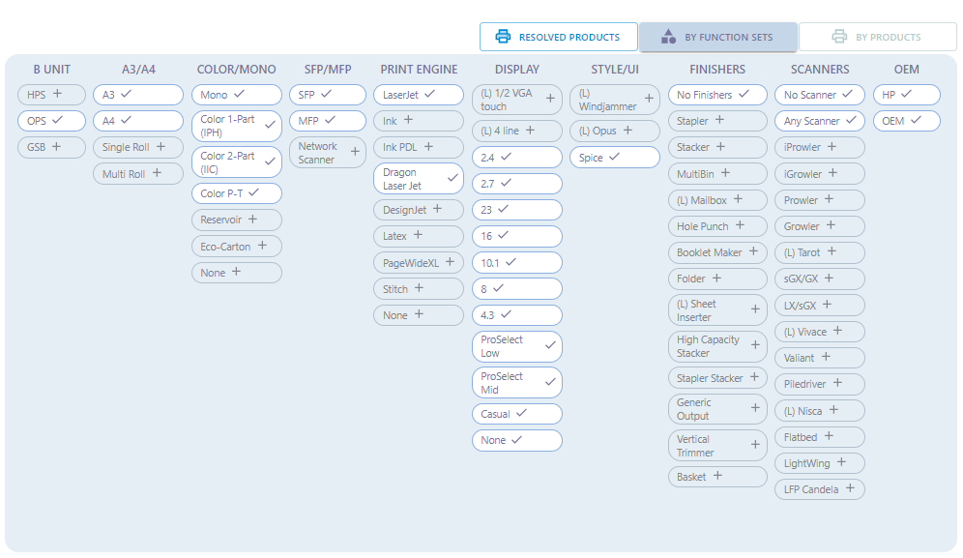
HPS (Home Printing Solutions)
Generic function set:
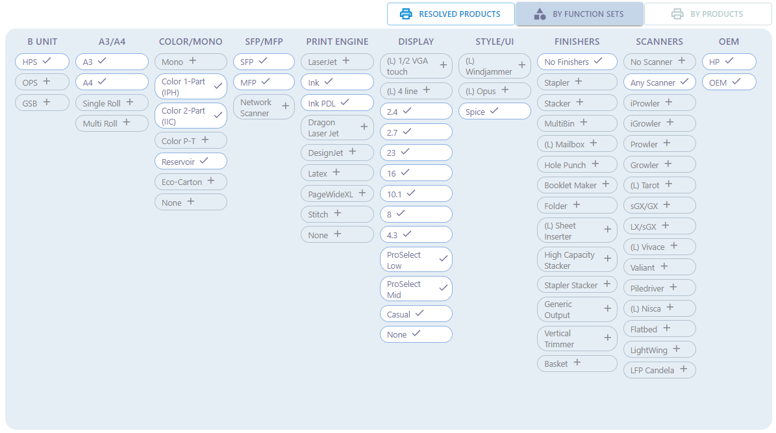

GSB (Graphic Solution Business)
GSB generic function set:
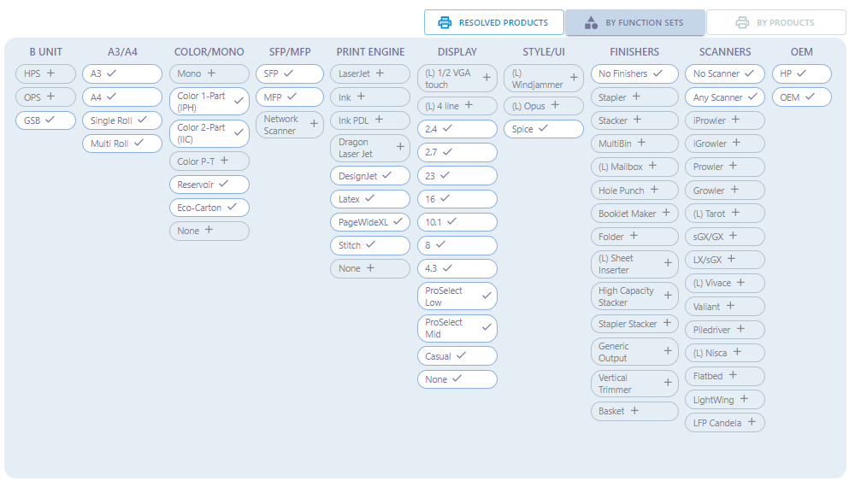

Internal Comments
1. Internal Comments are notes shared among string writers and approvers. They provide additional information about the String ID that is not visible to translators or users or firmware.
2. Internal comments are added only for specific string IDs like SMS string (I/O ref info added as comments) and Animation strings (Product name and asset added as comments).
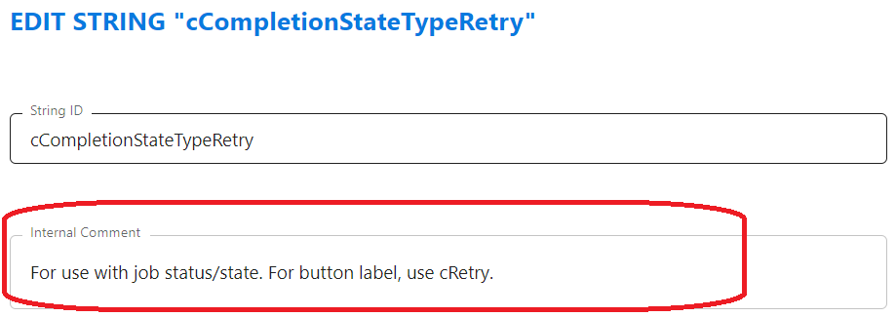

Translator Notes
Translator notes are short context information written by string creators to guide translators in accurately localizing Figma strings. These notes are used to provide information on the English value contained in the string ID. This info helps the translators to translate the content more accurately.
Why we give translator notes?
Translators do not have access to design documents. So, the translator notes give a picture and help the translators to understand the content, its location and usage. Thus, translating the content more accurately.
Guidelines for Writing Translator Notes
DO:
- Explain the meaning of the string, not just repeat the text.
- Clarify compound terms and modifiers.
- Provide examples when parameters are used.
- Customize explanations according to the design context and printer complexity.
Does:
- Excessive punctuation, or unclear styling
- Incomplete parameter explanations
Example: Standard UI Strings
String ID | English Content | Translator Note
cAuthStatusFailed | Authentication failed | This message appears when a user attempts to sign in but is unsuccessful.

Sizing
The Sizing option allows string writers to define the size of the string’s value as it will appear on the control panel. Sizing should be updated according to the latest DUNE sizing sheet.
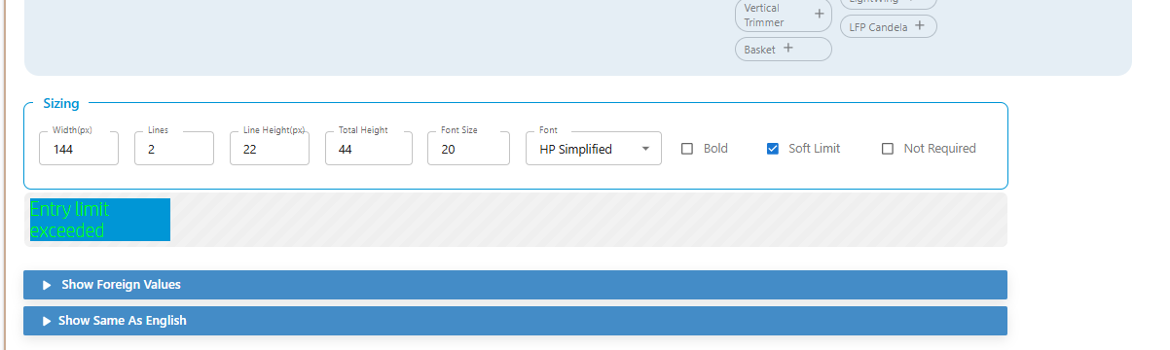
How get Sizing details from DUNE sizing sheet
- Verify the exact string holder description using reference images.
- In exceptional cases, if the string content does not fit within the field on the Strings page in Codex, consult with the Designers or String Reviewer.
- Content should ideally fit within the text box. However, if the "soft limit" option is selected, it's acceptable if the text slightly overflows the box.
- No sizing is required for: EWS & Event Log
- Refer this link Sizing Template.docx for sizing .

History
Creation details and any changes made to the string ID are documented in the history comments.
History must include the following information:
- Brief description of the changes made/ Creation details.
- Screen Name – Including the name of Workflow UI/ Pro-select/Hybrid UI (if the string ID is created/updated for CP)
- Story/ BUG number
- In case of String IDs created based on IA source – comment should be updated with asset name and IA version.
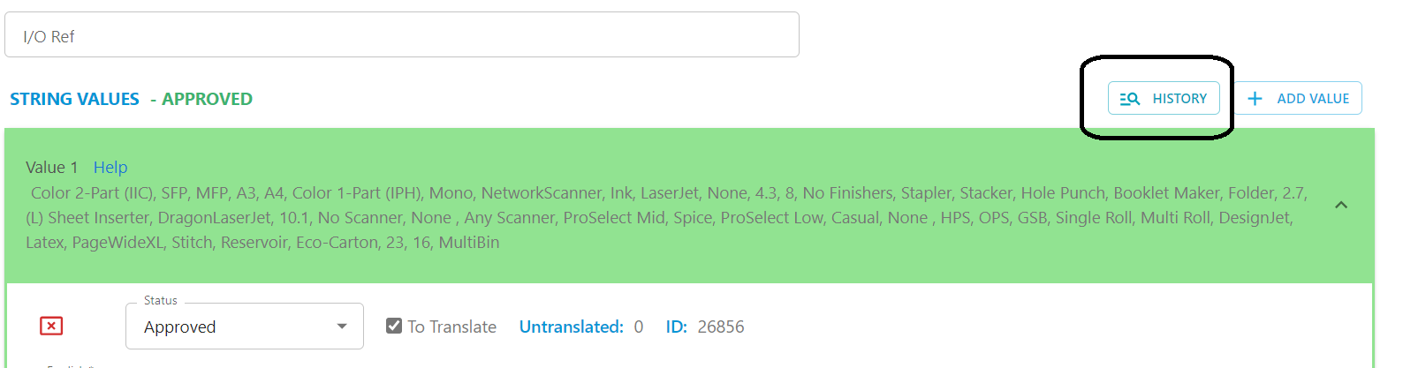
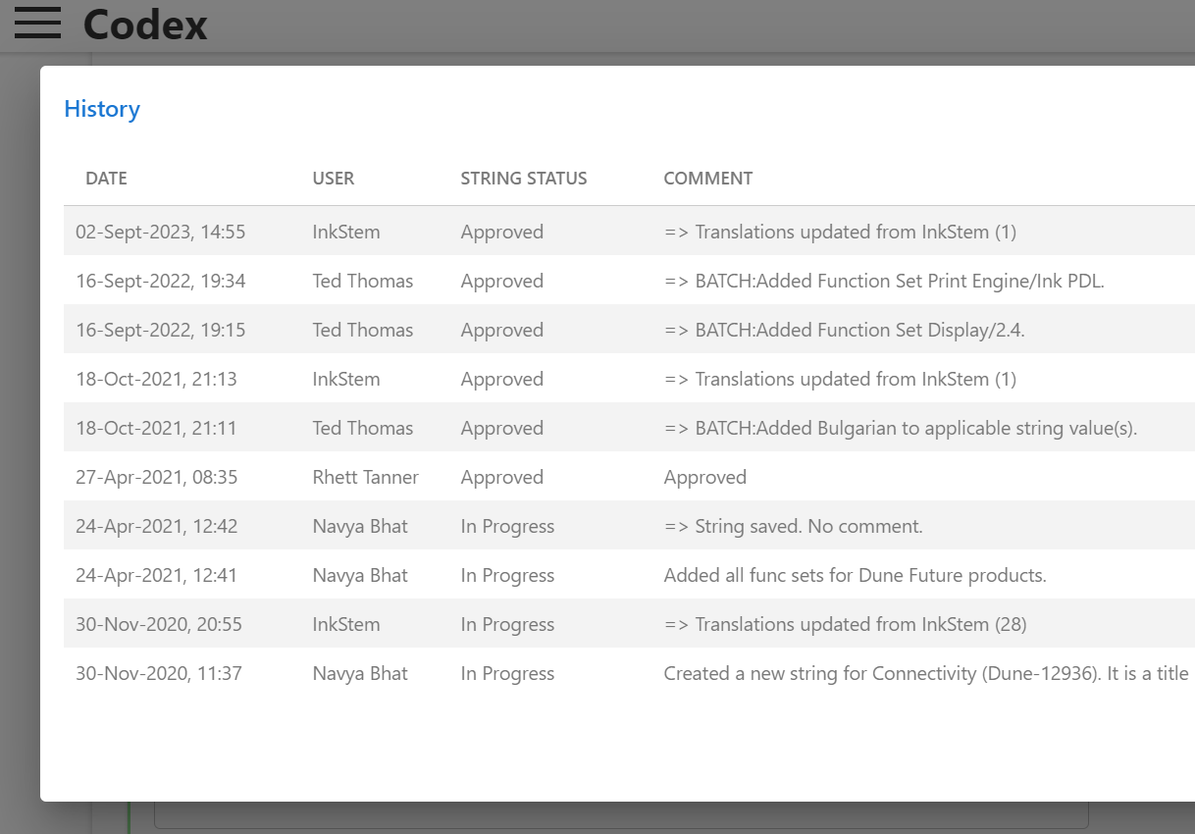

Foreign Languages
It is translator helps convert English content into the localization language, making the string value information easier to understand.
All values within a string ID will be translated into below multiple foreign languages.
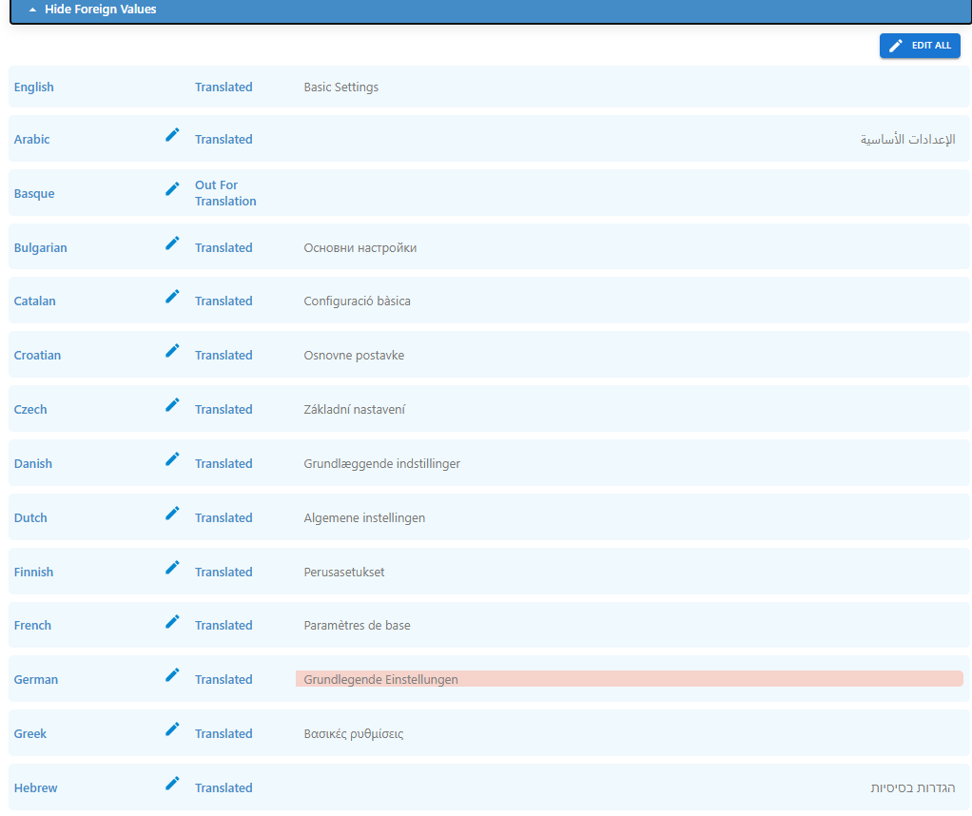

Function Sets
We choose the "By Function Set" option if the requirement is based on specific function sets.
The Function Set list provides a group of checkboxes that can be selected to allocate functionality and assign products to a String ID.
Dune provides a 'Products' tab where you can view all applicable function sets for each product. This section helps identify which function set are supported by which products.
By reviewing this information, you can accurately select the checkbox based on the specific requirements, ensuring that only the required products and function sets are included.
Example:
- Function sets selected for OPS – Pro-Select – which gives Cherry, Ulysses, and Zelus.
- Hence this value will be enabled only on these products.
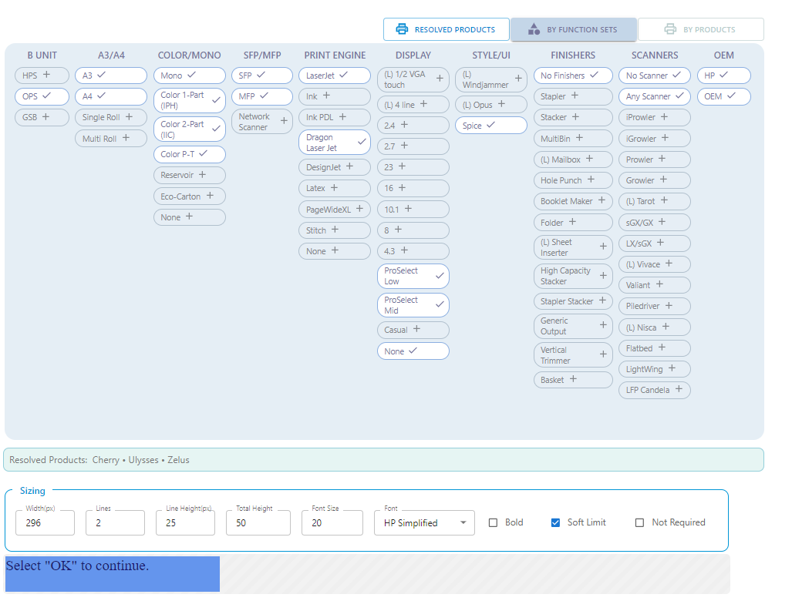
- Function sets are organized into the sub-lists listed below:
Business Unit – Includes the following:
- HPS (Home Printing Solutions)
Generic function set:

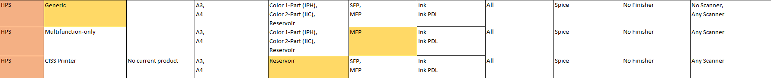
- OPS (Office Printing Solutions)
OPS generic function set: 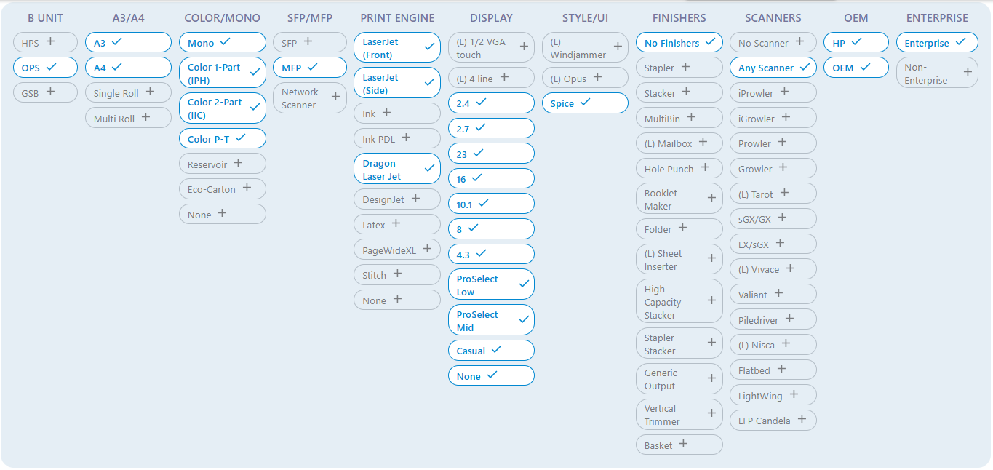

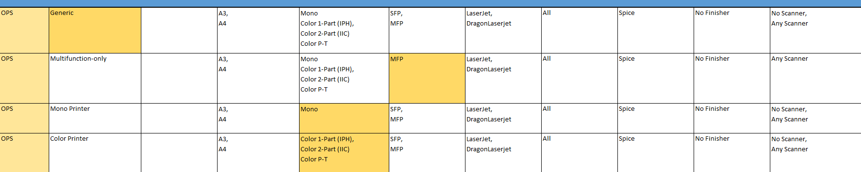
- GSB (Graphic Solution Business)
GSB generic function set:
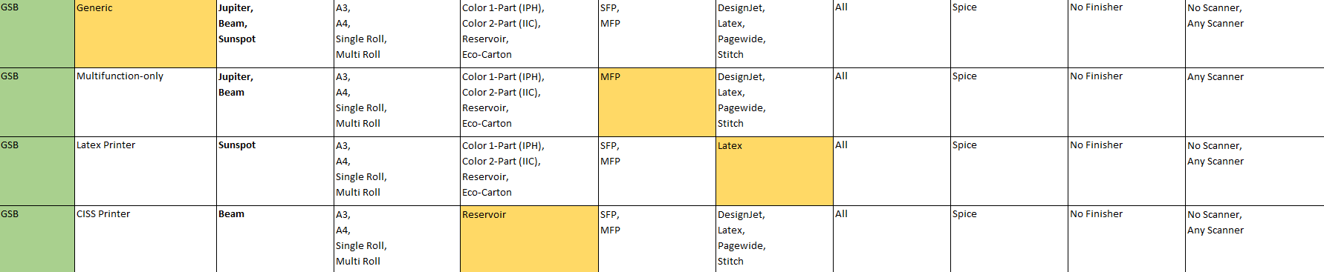

String by Product
We use the "By Product" option when the requirement involves a few specific products that may or may not share the same function sets.
In such cases, if we use "By Function Set" it could unintentionally include other products that meet the same functional criteria but are not required for the string. This potentially causes an error. To avoid this, we select the "By Product" option to explicitly choose only the required products.

For EWS, please use Dune EWS Architecture Master - Google Sheets to check product applicability.
For CP, please use MUI Architecture - Release 27.7 - 15 Apr 2025 1.xlsx to check product applicability.

Others sections

OEM
- HP – Enabled when the string IDs are used only on HP printers and are not applicable to non-HP company printers.
- OEM – Used when the string IDs are also applicable to non-HP companies.
We use the following OEM string IDs as parameters to enable OEM-specific behaviour in any string ID:
- cOEMBlankCompanyName: For an OEM customer, this string is replaced with a blank string
Example: "{cOEMBlankCompanyName} FutureSmart" will appear as "FutureSmart" for OEM customers, and "HP FutureSmart" for HP.

cOEMCompanyName: If the company name is "HP", this parameter is replaced with "HP". If the company name is not "HP", it is replaced with the non-HP company name.

Special Characters
To include special characters in the content, we just need to add the name of the special character at the end of the string IDs. There's no need to add the special characters directly in the English content.
String IDs are available for special characters like Colon (:), Ellipsis (...), Asterisk (*) etc which are frequently used along with other string values.
- Search with “cString” in Codex for special characters:
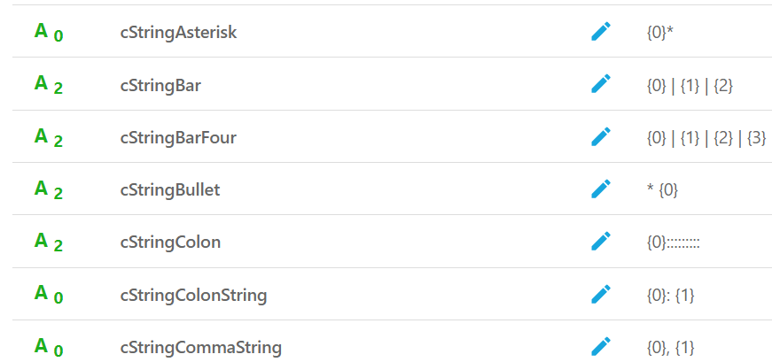
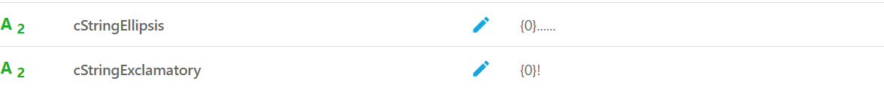

Event codes and SR bits
An Event Log is a combination of an Event Code and a String ID. It is used to display the following types of events that occur in a printer:
- Warning
- Information
- Error
- None
Log has two parts: –
String ID: String ID that is linked to an Event code and contains the message corresponding to a particular event code.
Event Code: Event codes are numerical or alphanumeric identifiers used to classify and report specific events or errors that occur within the printer. Each event code corresponds to a particular issue or condition, such as a paper jam, low toner, connectivity problems, or maintenance requirements. When a problem occurs, the printer's firmware can generate an event code to help identify the issue, which can then be communicated to the user or a service technician for troubleshooting and resolution.
String ID creation process for Event code is same as any other string ID. String ID information which is required for Event log will be provided in the story in Event Code Template.
Example:
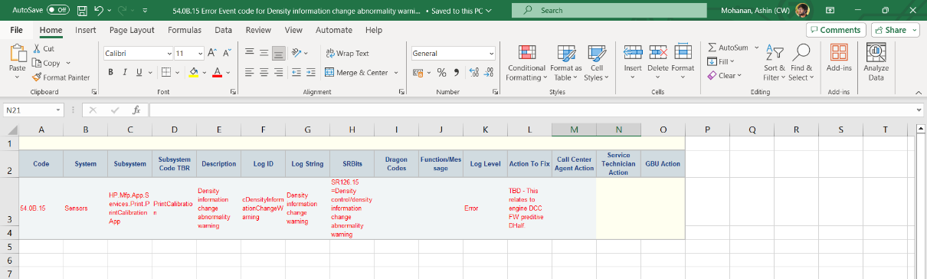
How to create an” EVENT CODE”
- Go to “Event Code” options and Click on the "Event Code Lookup" to search/add an event code.
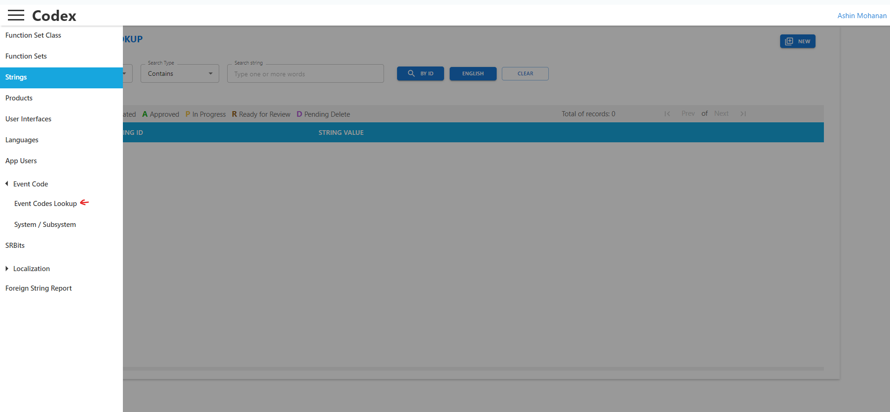
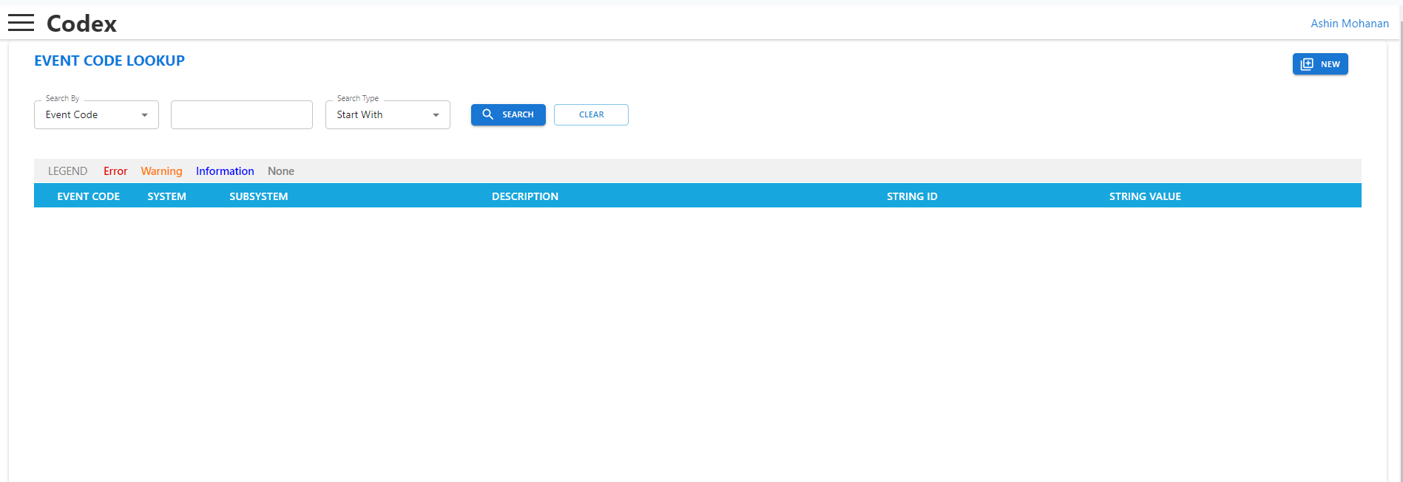
- Create a new event code if the required Event code is not available in the Codex database.
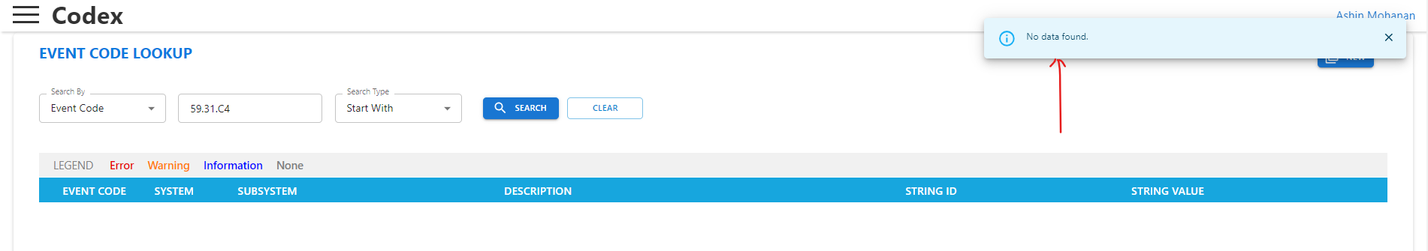

1. To create new event code, click on New button.
2. Type the required event code in the format: XX.YY. ZZ . Click on “Continue” to proceed.
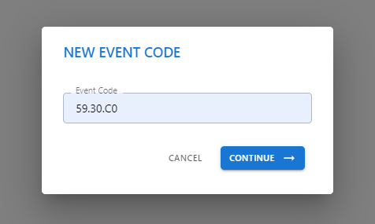

3. An Event code requires the following details to be added:
- Severity
- System
- Subsystem
- String ID
- String Value
- Event Code Description
- Function Sets
- Product Exclusion
- SR bits
- Actions
- User Action
- Call Center Agent Action
- Service Technician Action
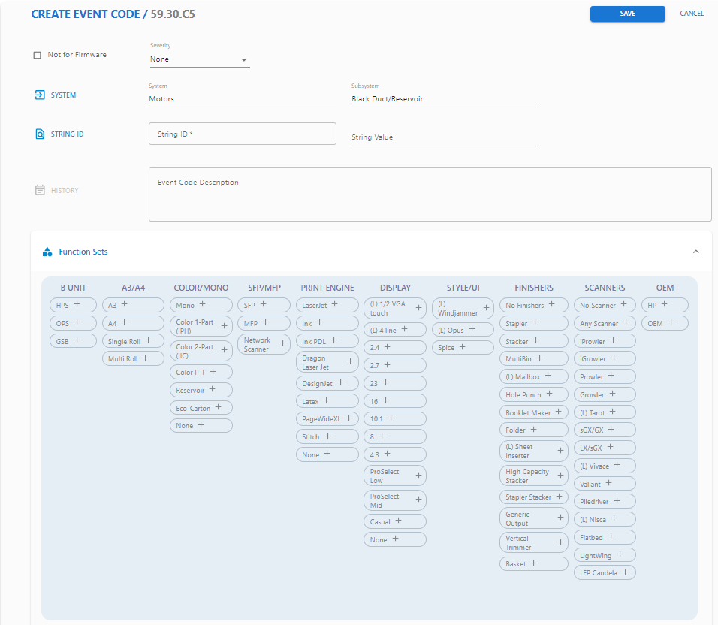
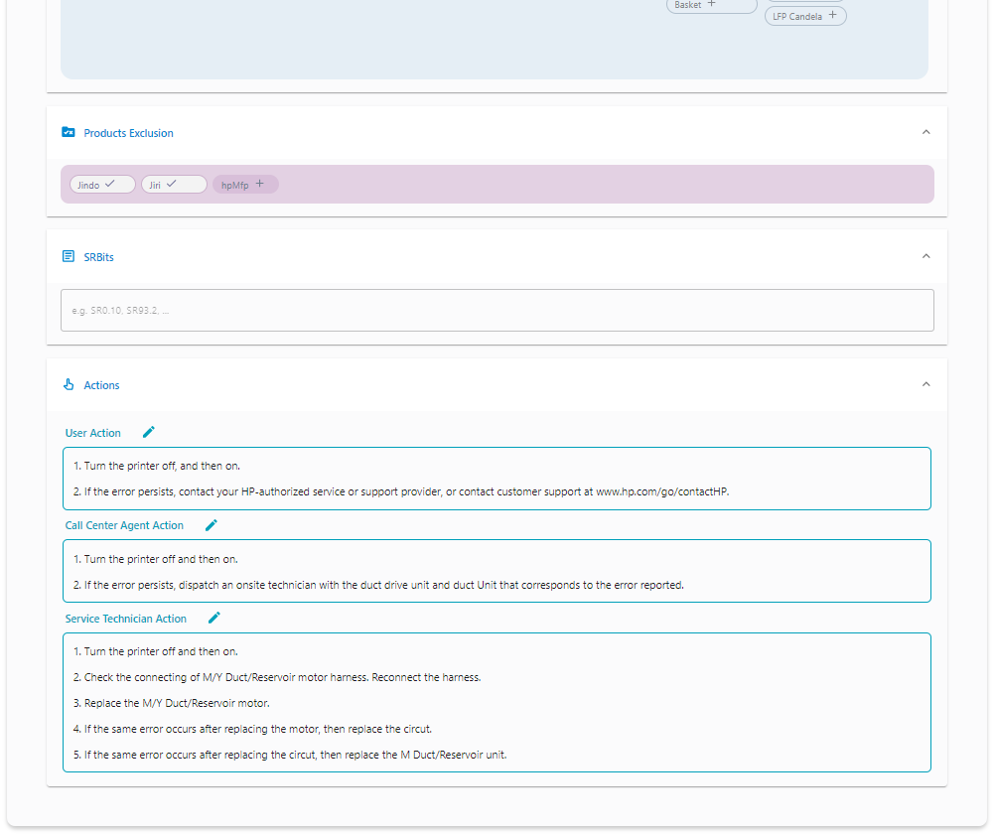

Under Severity, writer can select the type of log. There are four types of logs:
    - None – Default value when code is initially created.
    - Warning – For creating Event code for Warning messages.
    - Information – For creating Event code which displays Information related to printer on the Control Panel.
    - Error – For creating Event code for Error messages that appear on the printer screen.
    - Each log type is used for different purposes and information related to the type of the log that is required to be created will be mentioned in Jira story/bug.
    - System and Sub-System: This is generated automatically based on the values given in the XX and YY of the Event code.
    - If the System and Sub-system is unavailable, writer can create it using “System/Subsystem” option under “Event Code”.
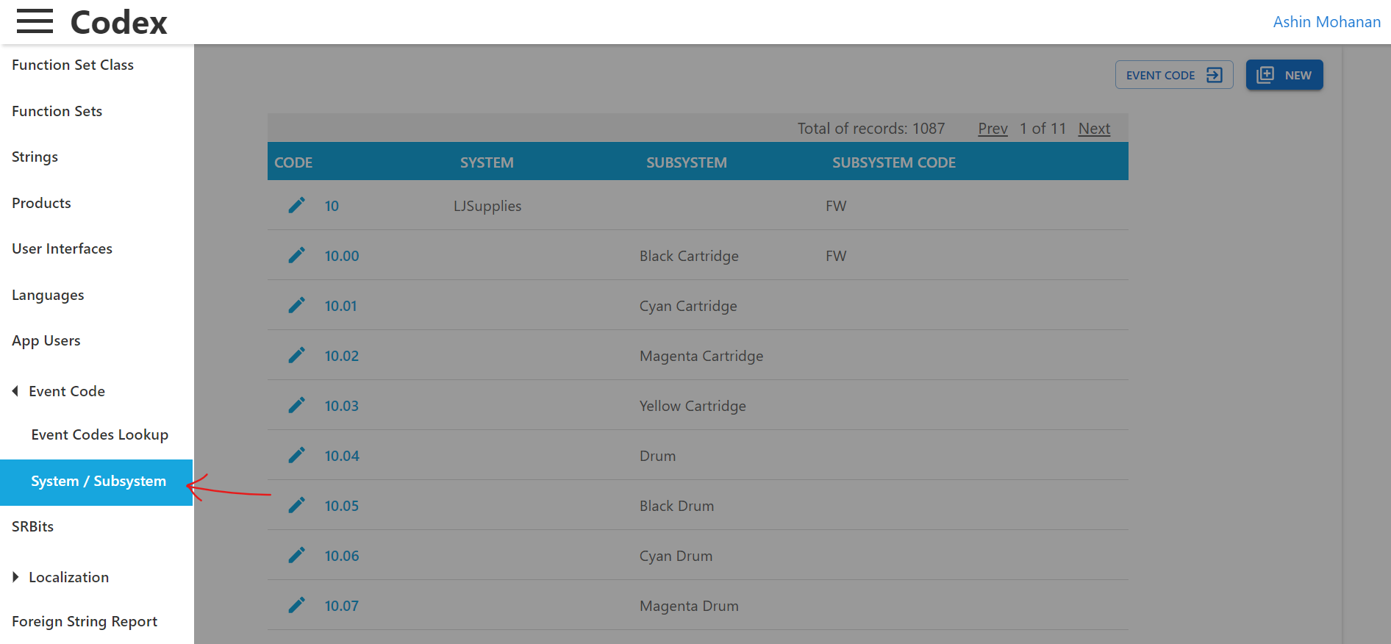

String ID and String value:
A String ID must be linked to an Event code. Details related to the content and string ID will be given in Event Code template (provided with the JIRA story)
In the scenario where content and String ID are not available, String ID must be created before linking it with the event code.
How to link string ID:
- Upon clicking on String ID text box, a screen for searching the required string ID will be displayed.
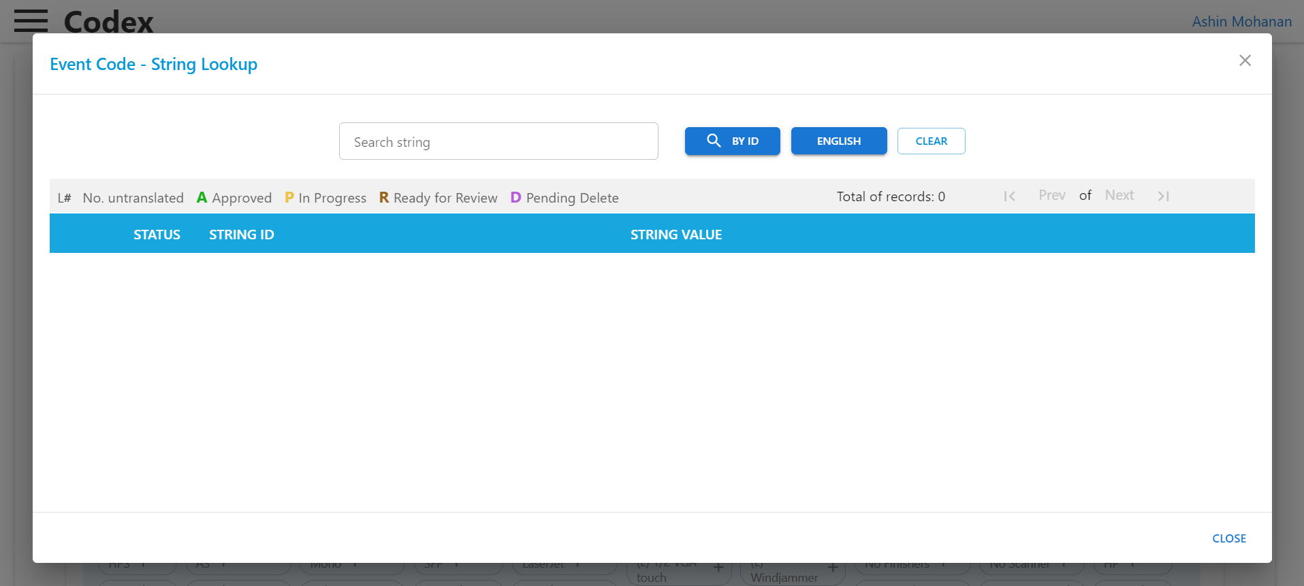
- Type the required string ID or Content and search by clicking on either BY ID or English Button.
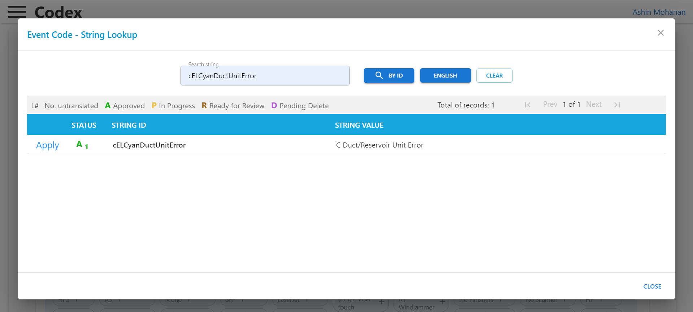
- Click “Apply” button next to the string ID name to link that string ID to the code. After applying string value from the ID gets added into the Event code details.
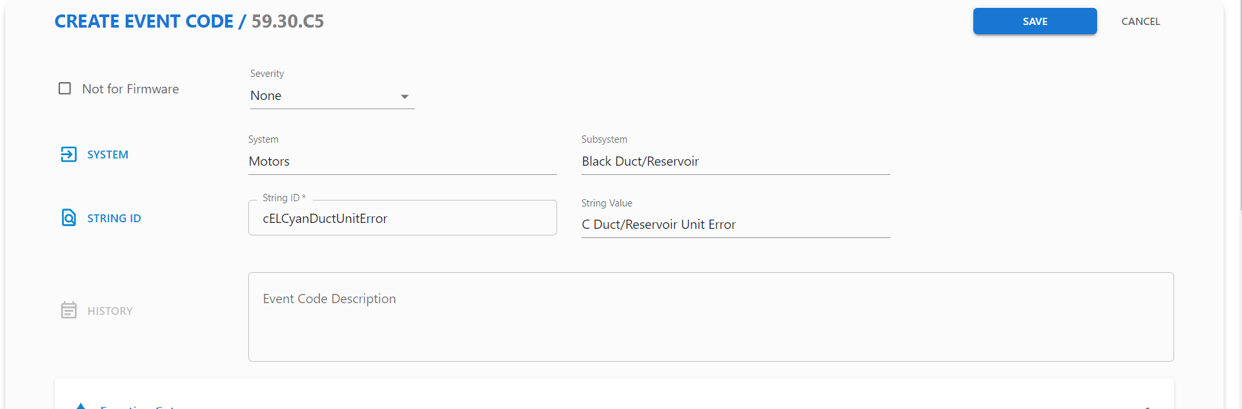

- Description: Add the description as per the template. Description provides general information on the event code.
- Function Sets: Event code like String ID, have function sets to add applicable products. But for Event code the function set enabled are very product specific. Function sets are not added in a Generic way.
- Product Exclusion: This option is used to exclude products. By using this option, we can enable the Event code to very specific product from the list of products added by function sets.
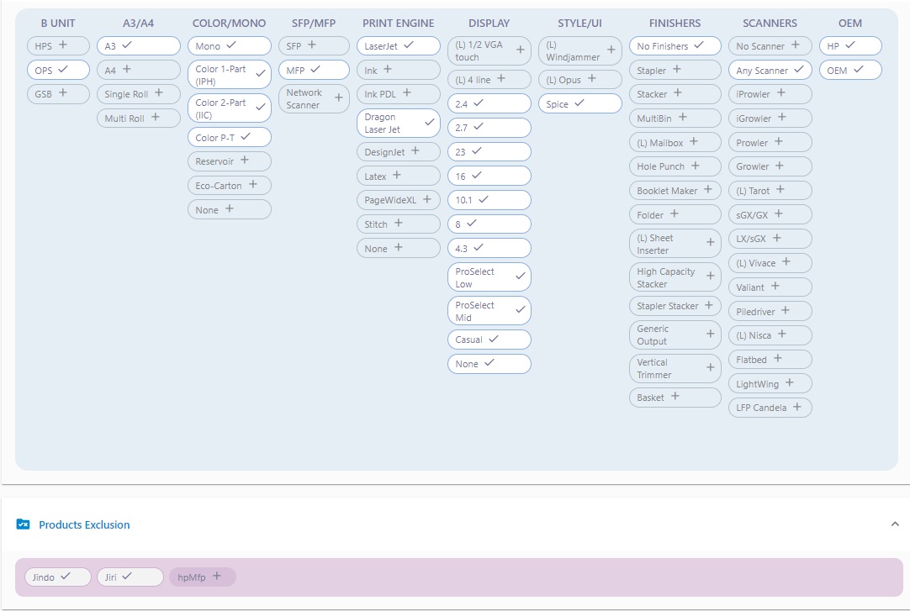

SR bits: In printers, the SR bits refer to status register bits that indicate various conditions of the printer, such as whether it's ready to print, if there's a paper jam, if ink levels are low, or if there's any other issue affecting printing operations. These bits are used by the printer's firmware to manage and report on the printer's current state.
Dragon Codes: When a problem occurs, the printer may display a corresponding Code along with any relevant information on its control panel, LCD screen, or through software interfaces. Users or service technicians can then reference these codes to diagnose the issue and take appropriate action. Dragon Codes accompanied by troubleshooting guides provided by the printer manufacturer, helping users to understand the nature of the problem and offering steps to resolve it. This can streamline the troubleshooting process and facilitate quicker resolution of printer issues.

Actions:
These are actions which are required to performed when there is occurrence of the Event code
- User Action – For users to perform
- Call Center Agent Action – For the call center agents to provide solution
- Service Technician Action – For service technician to perform
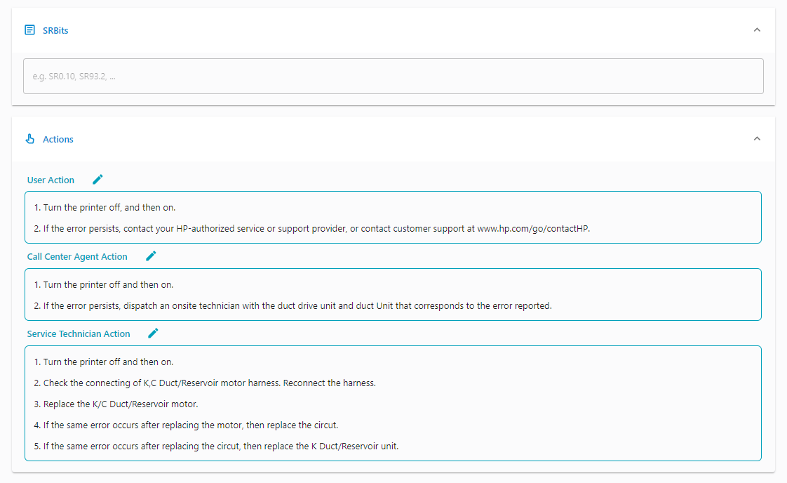
- Check the product applicable for the event code and check those function set.
- The name of the product will appear in “Product Exclusions”. By selecting the checkboxes, will exclude the corresponding Product.
- Click save.
- Actions to be added after saving the Even Code.

Here is a wiki page that goes into detail about the different formats and how to add the mapping and descriptions:
https://rndwiki.inc.hpicorp.net/confluence/display/Dune/7.5.1+%28annex%29+External+codes+and+localized+messages+for+System+Events
We can support any of these formats in the .csv files we get from Codex/Codex (Codex only supports XX.YY. ZZ, but if Codex/Codex adds more formats, we’ll be able to handle it with no problem and with no changes to Localization Framework). The only limitation is that the characters in the event code, besides the ‘.’ and ‘-‘separators must be hex numbers, so 0-9 and A-F, which all of the current formats follow.

Animations
Animation refers to the moving visuals or graphics displayed on the printer's screen. These animations are designed to help users understand the printer’s status, guide them through setup steps, or provide instructions for tasks such as replacing ink or clearing a paper jam.



randiblackdrumcartridge1.gif

Why Are Animations Used in Printers?
- To help with setup and use:
Animations provide step-by-step instructions to help users perform tasks such as adding paper, changing ink, or connecting the printer to Wi-Fi.
- To display printer activity:
Printers use moving icons or bars to show what they are doing, such as printing, warming up, or waiting to start.
- To make problem-solving easier:
When something goes wrong, such as a paper jam or low ink, animations indicate the issue and provide instructions on how to fix it, helping users resolve the problem quickly.
- To make instructions clearer:
Pictures and animations are often easier to follow than written steps, especially for new users or people who speak different languages.

HOW TO CREATE ANIMATION STRINGS
- A story/Bug will be assigned by the reporter.
- Once the story is assigned, check for the requirement in Jira.
- Writer can go to G-Drive link to access “Animation spreadsheet”.
There are 4 spreadsheets based on the appliable products, which are:
- Beam
- Sunspot
- Jupiter
- Pixiu – Combination of Beam, Jupiter and Sunspot
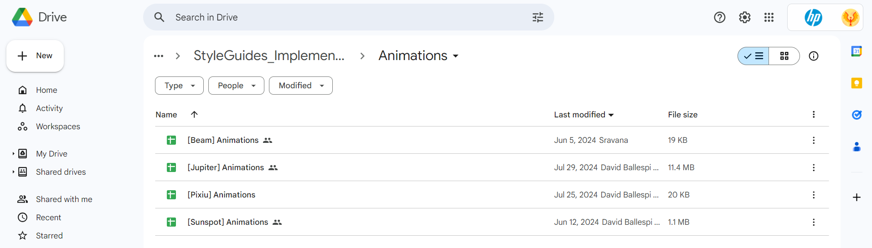
- Once confirmed about the English content and then start updating the strings in spreadsheet.
- Update the spreadsheet if the strings are existing or newly created.

Section: 5

Requirement Closure Process

When will close the requirement?
A requirement can be considered ready for closure when the following conditions are met:
Final Design link Received
- No open queries remain with the designer.
- String writer has completed creating and updating string IDs in Codex.
String and Function Mapping Completed
- All relevant design is mapped to string IDs and functions.
- String IDs are correctly sized as per guidelines.
- String IDs are accompanied by detailed translator notes.
- All string IDs are mapped to the correct functions and UI screens.
- Function screens, exceptions, triggers, and event codes are thoroughly updated.
- Event codes are updated accordingly.
Validation Against Design
- Figma links, Wiki links, and Azure links are consistent with the final Design.
Language & Style Compliance
- All string content follows HP style guidelines for grammar, punctuation, and formatting.
JIRA Updates
- Sprint, Story Points and Comments are correctly updated in the story/bug.
- Final design link is attached in both the story and the epic.

Additional Information About JIRA Before Closure: Story Points, sprint, Resolution
Story Points
- Story point values should typically not exceed 10 if in case the story is exceeded more than 10 days then the story as to be cloned to another story as phase 2 under the same epic. As sprints are 2 weeks long (i.e., 10 working days). Preferred values follow a standard scale such as 1, 2, 4, or 8.
- 2 (1 day effort) [not calendar time…]
- 4 (2-3 days effort)
- 6 (4-7 days effort)
- 8 (8-10 days effort)
Sprint Point
Assign the story or bug to the correct Sprint in which the work was performed or completed. This ensures accurate sprint tracking, velocity measurement, and reporting in JIRA dashboards.
In JIRA, the Sprint field indicates the specific sprint or time-boxed iteration that an issue (such as a Story, Bug, or Task) is assigned to on the Agile board.
This helps teams to:
- Maintain focus on clearly defined priorities
- Improve sprint planning and execution
- Generate accurate reports and dashboards
Make sure to update the Sprint field before closing the story or bug to reflect the actual sprint in which it was completed.
Resolution
Select the appropriate resolution status based on the outcome of the story or bug, such as:
- Fixed: Database Change
The string issue was resolved specifically through a database-level fix or by making necessary changes in Codex.
- Duplicate:
The bug is a duplicate of an existing issue already tracked in JIRA.
- Not a Defect: As Designed
The behaviour reported is intended and matches as per the design—not a defect.
- Won’t do:
A bug/story is raised stating a string is missing/but upon review/the string is not applicable to the listed product. In such cases, close the story/bug with the resolution “Won’t Do” and add a JIRA comment clarifying the reason.
- Done/Closed: When the story or bug is fully completed as expected. The Jira will be closed by Integration team.

Checklist
The Requirement Closure Process Checklist ensures that all conditions related to a JIRA story, bug, or task are fully addressed before marking it as complete. It helps maintain quality, consistency, and traceability across the project lifecycle.
The purpose of Checklist is to confirm that a JIRA item has met all functional, design, and localization requirements before closure.
SharePoint link: Strings Team - Review Checklist - All Documents (sharepoint.com)

Review Checklist
Attached is the Review checklist: - Checklist_Dune_Template.xlsx (DO NOT EDIT THIS SHEET)

JIRA Closure Mail
A JIRA Closure Mail is a formal communication sent for approval after a JIRA ticket (Story, Bug, Task, etc.) has been marked as "Ready for QA."
Closure Mail Format:
Hi (Approver Name),
Completed the string work and sent the RFR strings(if new strings created) and existing strings for the approver and file to the designer.
Updated the comments in Jira and attached the required files in the given checklist path.
Bug/Story No: DUNE-248970
Design story: Provide No (If present)
Jira Summary: Inconsistent behavior observed between Jolt and Dune devices when submitting a print job from the Reports page.
Resolution note: Reviewed the design and updated the toast message in the spreadsheet
Checklist SharePoint Path: Provide link (If present)
Legacy product review spreadsheet SharePoint path: Provide link (If present)
Design link Figma Link: Provide link (If present)

Dune Overall Guidelines
- Complete the legacy review or spreadsheet and add a comment in JIRA.
- Close all related subtasks before proceeding with main requirement closure.
- Send the JIRA closure email to relevant stakeholders in the specified format.
- Use standard story points (1, 2, 4, 6, 8) and clone stories exceeding 10 days.
- Assign the correct sprint to reflect when the work was completed.
- Set an appropriate resolution (e.g., Fixed, Duplicate, Won’t Do, etc.).
- Refer to the Strings Review Checklist and ensure all quality checks are done.
- Verify all JIRA fields (Story Points, Sprint, Resolution) are filled before closure.
- Include SharePoint and spreadsheet links in the closure mail for traceability.
- Document all work and decisions clearly in JIRA comments and closure mail.

Stories, Bugs & Spike Workaround
The Strings Team is responsible for managing all text elements used in the user interface, EWS (embedded web server) messages, and design components. Our key tasks include:

Creating and maintaining String IDs based on the product, event codes, and screen flow.

Ensuring that the text content aligns with the design. If discrepancies are found, we coordinate with the designer to update the design with the correct English content.

Different types of stories and bugs
- Simple Story -DUNE-256479, DUNE-257541
- Critical Story -DUNE-241635
- Bug -DUNE-220583
- Localization Bug -DUNE-197420
- EWS Story -DUNE-244337
- Animation -DUNE-255848

(Steps involved - Jira, Epic, Design Story, Spreadsheet, Design, Codex)

Simple Story: DUNE-256479

Title
[String] Add missing string

Objective
To address the missing string content for the "Private Jobs" feature and implement cTotalParaValues support on the Jupiter platform.

Step-by-Step Process

JIRA Check

Access Jira
- Log in using your HP credentials.
- Navigate to the Jira Dashboard and check for any stories or bugs assigned to the Writers (@) queue.

Story Assignment
- DUNE-256479 was assigned to the Writers queue by the Dune Strings Lead/Approver (@Ezhil).
- The story was initiated by Abhiprae Chowdhury from the FW team, addressing missing content.

Initial Story Details
The story was created with the following key information, which is essential for understanding and resolving the issue:

- Key: DUNE-256479
- Status: Icebox
- Title: [String] Add missing string
- Type: Story
- Priority: None
- Fix Version/s: FW25.06-Jun24
- Component/s: Strings
- Epic Link: Locked Job Implementation in Job Storage
- Rank2: 564
- Applicable Products: Ballparks, Blades, Coasters, Enterprise, GS2, Inventors, Islands: Jeju, Jindo, Namhae, LFP, Mountains: Halla, Jiri, Pro
- Lead Product: Ballparks
- Acceptance Criteria: Provide string ID for "Private Jobs"
- Description: Add the missing string for "Private Jobs" and enable cTotalParaValues for Jupiter
- Assignee: Satyamkumar Prajapati
- Reporter: Abhiprae Chowdhury

Story Updates
    - Initially, no story points were defined.
    - After reviewing the design story and estimating the workload, the story was updated with 2 story points.
    - The current sprint was updated to FW25.07a (8 Jul), as the task involves only two string updates.

Product Impact
    - This story affects multiple products, including:
Ballparks, Blades, Coasters, Enterprise, GS2, Inventors, Islands (Jeju, Jindo, Namhae), LFP, Mountains (Halla, Jiri), and Pro. Inclusion for Private Jobs
cTotalParaValues this only for LFP-Jupiter.

Legacy Review
- The content was initially reviewed to determine if it belonged to any legacy products, specifically JEDI.
- It was confirmed that the content did not match any of the legacy products.
- A detailed check was conducted in JEDI Function Management and the strings repository to identify any existing string content.
- No applicable or matching string content was found.
- A comment was added stating: “The content and the string are not available in the legacy product JEDI.”
- The legacy review for the story was then closed, and the comments were updated accordingly.

Design Review and Queries

    - While reviewing the Epic, it was identified that this story is a continuation of DUNE-244530, which belongs to the same Epic and serves as a foundational reference for the current work.
    - The design implementation story is linked to DUNE-232552, with Designer (@Balakrishnan Shanmugamoorthi).
    - The Phase 1 design story was completed and documented in the review spreadsheet.
    - Relevant design and documentation links:
Design Link: https://www.figma.com/design/rDUIQJkVlr9amzjwS7iuY4/branch/Vj7e6JFNkS1Qq1UomAkepc/WS---Job-Storage?review-number=5&t=YbW9e2lw3euknMkG-0

Review Spreadsheet Update

- All updates were documented in the review spreadsheet located in the IPS SharePoint: Workflow_UI_JobStorage_V2.1.xlsx.
- The version history was updated with the relevant details
- Details are “Spreadsheet Review Version number, Workflow Name n Version, Status, Screen names, Comments related for story or bug or string works.
- Main Spreadsheet updated for the screens with strings: for the story related screens (Screen name)
Screen Name | English content | Strings
JobStorage_Folder_ThumbnailView | Private Jobs | cStoredPrivateJobs
 | Total: <value> | cTotalParaValues
JobStorage_Folder_ThumbnailView_PrintJobSelected | Private Jobs | cStoredPrivateJobs
 | Total: <value> | cTotalParaValues
JobStorage_Folder_ThumbnailView_ScanJobSelected | Private Jobs | cStoredPrivateJobs
 | Total: <value> | cTotalParaValues
JobStorage_Folder_ThumbnailView_MultipleScanJobSelected | Private Jobs | cStoredPrivateJobs
 | Total: <value> | cTotalParaValues
JobStorage_Folder_ThumbnailView_MultiplePrintScanJobs_Selected | Private Jobs | cStoredPrivateJobs
 | Total: <value> | cTotalParaValues
JobStorage_Folder_ThumbnailView_Unlocked | Private Jobs | cStoredPrivateJobs
 | Total: <value> | cTotalParaValues

    - The main sheet was updated to reflect the screens associated with the new strings.
    - The subtask for updating the review spreadsheet was closed with the comment:
    - “Review spreadsheet update completed. Review comments are added in the review spreadsheet. Added the review spreadsheet path below:”
    - Spreadsheet Path: IPS SharePoint > Workflow_UI_JobStorage_V2.1.xlsx
    - The approval subtask, titled "String Approval / G Drive Approval", along with the main story, was assigned to the Dune Strings Lead/Approver (@Ezhil) with the following comment:
“The strings cStoredPrivateJobs and cTotalParaValues are applicable for Enterprise and Jupiter.
As per discussion with the designer, the strings have been created and captured.”
String ID | Content | Status
cStoredPrivateJobs | Private Jobs | RFR
cTotalParaValues | Total: {0} | RFR
Spreadsheet link: Workflow_UI_JobStorage_V2.1.xlsx
Ezhilarasi Rajendran (Approver name) can you please approve the strings.”

String Update
- The string cTotalParaValues was updated to ensure compatibility with the Jupiter platform.
- Additionally, the “Private Jobs” string was created using the generic string sets associated with OPS/GSB.
- Closed the subtask (String Update) buy adding the comments “Design review and queries is completed. Analyzed design workflow and captured Dune string, no further clarification is needed.”

Add String Creation for Private Jobs
- Login to Codex “Dune - HP”
- Enter the English content Search strings and click on Enter.
- The string ID “Private Jobs” was not found in Codex, new string ID need to be created as “cStoredPrivateJobs”. (Used cStoredPrivateJobs as cPrivateJobs string ID already existed with the English content "Private Jobs ({0})" Hence created the string ID with "cStoredPrivateJobs".)
- Translator notes need to be updated as per English content: “This title describes the private jobs selected by the user.”
- This string uses OPS and GSB
  - OPS generic function sets –
  - Business Unit - OPS
  - A3/A4 - A3, A4
  - COLOR/MONO - Mono, Color 1-Part (IPH), Color 2-Part (IIC), Color P-T
  - SFP/MFP - SFP, MFP
  - PRINT ENGINE - LaserJet, Dragon Laser Jet
  - DISPLAY - 2.4, 2.7, 23, 16, 10.1, 8, 4.3, ProSelect Low, ProSelect Mid, Casual, None
  - STYLE/UI - Spice
  - FINISHERS - No Finishers
  - SCANNERS - No Scanners, Any Scanners
  - OEM - HP, OEM
  - ENTERPRISE - Enterprise, Non-Enterprise.

  - GSB generic function sets –
  - Business Unit - GSB
  - PRODUCTS - Jupiter, Beam, Sunspot
  - A3/A4 - A3, A4, Single Roll, Multi Roll
  - COLOR/MONO - Color 1-Part (IPH), Color 2-Part (IIC), Reservoir, Eco-Carton
  - SFP/MFP - SFP, MFP
  - PRINT ENGINE - DesignJet, Latex, Pagewide, Stitch
  - DISPLAY - 2.4, 2.7, 23, 16, 10.1, 8, 4.3, ProSelect Low, ProSelect Mid, Casual, None
  - STYLE/UI - Spice
  - FINISHERS - No Finishers
  - SCANNERS - No Scanners, Any Scanners
  - OEM - HP, OEM
  - ENTERPRISE - Enterprise, Non-Enterprise.
- Sizing need to be given as per the “DUNE_NAME_AND SIZING” sheet Settings Row sizing configured as 296 - 3 - 26 - 22 and Soft Limit set to “Y”.
- Updated the comments in Codex as “Created the string for the screen: JobStorage_Folder_ThumbnailView_PrintJobSelected asset: Workflow_UI_JobStorage_V2.1”
- Change the status from In Progress to Ready for Review and update the comments accordingly.

- Reviewed the second-string ID ‘cTotalParaValues’. The string was already approved but requires Jupiter product. Updated the status to ‘Ready for review’ and rechecked Translator notes and selected the relevant Jupiter products-
  - GSB Function Sets: Business Unit – GSB
  - A3/A4 – Multi Roll
  - Color/Mono: Eco-Carton
  - SFP/MFP: MFP
  - Print Engine: DesignJet
  - Display: 16
  - Style/UI: Spice
  - Finishers: No Finishers
  - Scanners: Any Scanners
  - OEM: HP
  - Enterprise: Non-Enterprise
- Updated the comments in Codex as “As per the request received from FW selected Jupiter products for the string ID for the story "DUNE-244530" for Job Storage V2.1 asset”
- Refer to the process documents “Dune All in One sheet” for products and Function sets and “Dune_Naming_and_Sizing”.
- Please refer to Process document.
Add Comment for Subtasks
- If contents are not available in Rosetta then
- A comment was added stating: “The content and the string are not available in the legacy product JEDI.”

String Approval / G Drive Approval
- Upon review, Dune Strings Lead/Approver (@Ezhil) verified all key attributes of the story, including status, type, priority, Epic link, story points, and other checkpoints—ensuring they matched the validations initially performed by the writer.
- Also confirmed that the steps followed by String Writer (@Satyam) were accurate, including Design analysis, Review spreadsheet updates, Codex string creation and updates
- The string was approved in Codex, with the history comment:
“Approved DUNE-256479 screen: JobStorage_Folder_ThumbnailView_PrintJobSelected for the asset: Workflow_UI_JobStorage_V2.1.”
- The approval subtask was closed, and the main story was marked as Resolved.
- The story was then reassigned to String Writer (@Satyam) with the approver comment:
“String IDs will be available in the integration cycle of the week 25/6/2025 to 28/6/2025.”

JIRA Closure
- The final integration was handled by the IT Support team (@Manoj), who generated the weekly .CSV file required for string deployment.
- String Writer (@Satyam) validated that the newly created strings were successfully integrated.
- The story was then closed with the following comment:
“Strings are integrated in the branches 25.02, 24.02, 24.12, and 24s.”

2. Simple Story: DUNE-257541

2.1. Title
Strings- Add ellipsis in job states process

2.2. Objective
To add the Ellipsis to the strings update for the content across the listed screens in workflow_UI_Jobs_V4.9.

2.3. Step-by-Step Process

2.3.1. Jira Check

2.3.1.1. Access Jira
- Log in using your HP credentials.
- Navigate to the Jira Dashboard and check for any stories or bugs assigned to the Writers (@) queue.

2.3.1.2. Story Assignment
- DUNE-257541 was assigned to the Writers queue by the Dune Strings Lead/Approver (@Ezhil).
- The story was initiated by Abhiprae Chowdhury from the FW team, addressing missing content.

2.3.1.3. Initial Story Details
The story was created with the following key information, which is essential for understanding and resolving the issue:
- Key: DUNE-257541
- Status: Icebox
- Title: Strings- Add ellipsis in job states process
- Type: Story
- Priority: None
- Fix Version/s: FW25.07a (8Jul)
- Component/s: Strings
- Epic Link: JobSoln design changes
- Applicable Products: .N/A
- Lead Product: There won’t be any lead product as we need to add only ellipsis in job states process
- Acceptance Criteria: Strings
- Description: strings update
- Assignee: Yogitha Vasupalli
- Reporter: Abhiprae Chowdhury

2.3.1.4. Story Updates
- Initially, no story points were defined.
- After reviewing the design story and estimating the workload, the story was updated with 2 Story points.
- The current sprint was updated to FW25.07a (8Jul), as the task involves only ellipsis in job states process.

2.3.2. Legacy Review
- The content was initially reviewed to determine if it belonged to any legacy products, specifically JEDI.
- It was confirmed that the content did not match any of the legacy products.
- A detailed check was conducted in JEDI Function Management and the strings repository to identify any existing string content.
- No applicable or matching string content was found.
- A comment was added stating: “The content and the string are not available in the legacy product JEDI.”
- The legacy review for the story was then closed, and the comments were updated accordingly.

2.3.2. Design Review and Queries
    - The design implementation story is linked to DUNE-134964, with Designer (@SHREYA KUDACHI).
    - Relevant design and documentation links:
Design Link: https://www.figma.com/design/Mv6K4Y8bRKrOr0i6Ppcqvb/branch/RZ7C5IMHGKwpw4tI7fbrZe/WS---Jobs?m=auto&node-id=0-1&t=ww7H6sndeO4BcxyS-1
- Following the confirmation, the Design Review and Queries subtask was closed with the comment:
“As per the discussion with Shreya, design review and queries completed. Analysed design workflow to capture the strings.”

. Review Spreadsheet Update
- All updates were documented in the review spreadsheet located in the SharePoint: workflow_UI_Jobs_V4.9.
- The version history was updated with the relevant screen names and the comments as “Updated as per DUNE-257541-Strings- Add ellipsis in job states process”
- The story related screens (Screen name)
(Please refer to the string table)
    - The main sheet was updated to reflect the screens associated with the new strings.
    - The subtask for updating the review spreadsheet was closed with the comment: “Review spreadsheet update completed. Review comments are added in the review spreadsheet. Added the review spreadsheet path below:”
    - Spreadsheet Path: IPS SharePoint > Workflow_UI_Jobs_V4.9.xlsx
    - The approval subtask, titled "String Approval / G Drive Approval," along with the main story, was assigned to the Dune Strings Lead/Approver (@Ezhil) with the following comments: Sent for approval since all strings are approved and only an ellipsis was added.
    - As per discussion with the designer, the strings have been captured with ellipsis for the below contents-
Screen name | English content | String ID
Jobs_JobQueueByState_SuperSet | Dialing… | cDialingMessage+cStringEllipsis
 | Sending… | cSending+cStringEllipsis
 | Incoming call… | cIncomingCall+cStringEllipsis
 | Connecting… | cConnecting+cStringEllipsis
 | Receiving fax… | cReceivingFax+cStringEllipsis
 | Scanning… | cScanning+cStringEllipsis
Jobs_InProgress_PreparingToPrint | Preparing to print… | cPreparingToPrintProgress+cStringEllipsis
Jobs_InProgress_Printing | Printing… | cPermissionPrintingApp+cStringEllipsis
Jobs_InProgress_Drying | Drying… | cJobStateTypeDrying+cStringEllipsis
Jobs_InProgress_Curing | Curing… | cCuring+cStringEllipsis
Jobs_InProgress_Folding | Folding… | cJobStateTypeFolding+cStingEllipsis
Jobs_InProgress_Interrupting | Interrupting… | cJobStateTypeInterrupting+cStringEllipsis
Jobs_InProgress_Canceling | Canceling... | cJobStateTypeCanceling+cStringEllipsis
Jobs_AllJobs_Canceling | Canceling... | cJobStateTypeCanceling+cStringEllipsis
Jobs_Upcoming_Processing | Processing… | cJobStateTypeProcessing+cStringEllipsis
Jobs_Upcoming_Receiving | Receiving… | cReceiving+cStringEllipsis
Jobs_Upcoming_Canceling | Canceling... | cJobStateTypeCanceling+cStringEllipsis
Jobs_Queue_Pausing | Pausing… | cJobStateTypePausing+cStringEllipsis
Jobs_Queue_Resuming | Resuming… | cJobStateTypeResuming+cStringEllipsis
Jobs_Queue_Resumed | Preparing to print… | cPreparingToPrintProgress+cStringEllipsis
Figma link: https://www.figma.com/design/Mv6K4Y8bRKrOr0i6Ppcqvb/branch/RZ7C5IMHGKwpw4tI7fbrZe/WS---Jobs?m=auto&node-id=0-1&t=ww7H6sndeO4BcxyS-1
IPS GED Singapore - Jobs App - All Documents

2.3.4. String Update
- Following the clarification, the strings and the English content updated as –
(Please refer the previous string table)
- Closed the subtask (String Update) buy adding the comments “Design review and queries is completed. Analyzed design workflow and captured Dune string, no further clarification is needed.”

2.3.5. String Approval / G Drive Approval
- Upon review, Dune Strings Lead/Approver (@Ezhil) verified all key attributes of the story, including status, type, priority, Epic link, story points, and other checkpoints ensuring they matched the validations initially performed by the writer.
- Also confirmed that the steps followed by String Writer (@Yogitha) were accurate, including Design analysis, Review spreadsheet updates, Codex approved strings
- The approval subtask was closed, and the main story was marked as Resolved.
- The story was then reassigned to String Writer (@Yogitha) with the approver comment:
“The strings are already approved and available in .csv file (18/6/2025).”

2.3.6. Jira Closure
- The final integration was handled by the IT Support team (@Manoj), who generated the weekly .CSV file required for string deployment.
- String Writer (@Yogitha) validated that the newly created strings were successfully integrated.
- The story was then closed with the following comment:
“The string story is now closed and integrated into the latest branches 24s, 24.02 , 24.12 and 25.02”

3. Critical Story: DUNE-241635

3.1. Title
Strings- (Connectivity OOBE) - OOBE on 8"/10" Enterprise (SR)

3.2. Objective
To add the screens for the Strings- (Connectivity OOBE) - OOBE on 8"/10" Enterprise (SR)

3.3. Step-By-Step Process

3.3.2. Legacy Review
- The content was initially reviewed to determine if it belonged to any legacy products, specifically JEDI.
- It was confirmed that the content did not match any of the legacy products.
- A detailed check was conducted in JEDI Function Management and the strings repository to identify any existing string content.
- No applicable or matching string content was found.
- A comment was added stating: “The content and the string are not available in the legacy product JEDI.”
- The legacy review for the story was then closed, and the comments were updated.;

3.3.3. Design Review and Queries
    - The design implementation story is linked to DUNE-241632, with Designer (@Mayur Chaudhari).
    - Relevant design and documentation links:
      - Design Link: WS-Connectivity-V7.1
      - Spreadsheet: IPS GED Singapore - OOBE Connectivity - All Documents
      - Screens Covered
Disclaimer: For Beta Release, XL-M screen experience will be same as S-XS screens.Please refer S-XS screens for the same.
Enterprise OOBE Flow: This page has been created, and the following screens have been added under it
- OOBE_ConnectionMethod_Duplicate:
- ENTOOBEConnectivity_EthernetCableNotDetected:
- ENTOOBEConnectivity_WiFiAlreadyConfigured:
- ENTOOBEConnectivity_WiFiAlreadyConnected
- ENTOOBEGeneric_StatusBusy_Duplicate
- ENTOOBEConnectivity_StatusSearchingForWirelessRouters
- ENTOOBEConnectivity_EthernetCableAttached
- ENTOOBEConnectivity_WiFiSearchError
- ENTOOBEConnectivity_OOBESelectNetworkName
- ENTOOBEConnectivity_EnterNetworkName
- ENTOOBEConnectivity_ChooseEncryption
- ENTOOBEConnectivity_SupportedAuthenticationNotDetected
- ENTOOBEConnectivity_EnterpriseEncryptionError
- ENTOOBEConnectivity_AdHocError
- ENTOOBEConnectivity_StatusTryingToConnect
- ENTOOBEConnectivity_ConnectionError
- ENTOOBEConnectivity_IncorrectPassword
- ENTOOBEConnectivity_EnterWPA/WEPPassword
- ENTOOBEConnectivity_Emptypassword
- ENTOOBEConnectivity_NetworkSummary
- ENTOOBEConnectivity_ManualProxySettings
- ENTOOBEConnectivity_OOBEProxyUpdated
- ENTOOBE_Connectivity_IPSettingsMethodChanging
- ENTOOBEConnectivity_OOBEManualIPSettings
- ENTOOBEConnectivity_ManualIPSettingsConstrained
- ENTOOBEConnectivity_StatusRetaining
- ENTOOBEConnectivity_Retained
- ENTOOBEConnectivity_StatusRestoring
- ENTOOBEConnectivity_Restored
Connectivity - Enterprise OOBE DFDs: DFD page has been created and below mentioned DFD’s are included in this page.
- OOBE_Connectivity_DFD
- ENTOOBE_Connectivity_OOBEProxySettings_DFD
- ConnectivityOOBE_WirelessEthernetConflictManagement_DFD
- ENT OOBE Connectivity_OOBE_IP_DFD
- OOBE Connectivity Wireless Setup Wizard (WSW) DFD
- ENTOOBE Connectivity WEP / WPA DFD
- ENT OOBE Connectivity WSW Connect DFD
- Restore/Retain Settings
The below path consists of Add ellipsis in job states process for the screens and the content. All the strings are approved and RFR strings.
Workflow_UI_Connectivity_V7.1.xlsx
- Based on the above reference, the current story required review and created the strings.
- To confirm the string requirements, Designer (@Mayur) arranged a call to share content updates with the string writer (@Yogitha).
- During the call, it was confirmed that asset review for OOBE Enterprise as well as few screens were added to the screen.
- Following the confirmation, the Design Review and Queries subtask was closed with the comment:
“As per the discussion with Mayur, design review and queries completed. Analysed design workflow to capture the strings.”

3.3.4. Review Spreadsheet Update
- All updates were documented in the review spreadsheet located in the SharePoint: IPS GED Singapore - OOBE Connectivity - All Documents.
- The version history was updated with the relevant screen names and the comments as “Update based on DUNE-241635”
- The story related screens (Screen name)
(Please refer to the Path)
    - The main sheet was updated to reflect the screens associated with the new strings.
    - The subtask for updating the review spreadsheet was closed with the comment: “Review spreadsheet update completed. Review comments are added in the review spreadsheet. Added the review spreadsheet path below:”
    - Spreadsheet Path: IPS SharePoint > IPS GED Singapore - OOBE Connectivity - All Documents
    - The approval subtask, titled "String Approval / G Drive Approval," along with the main story, was assigned to the Dune Strings Lead/Approver (@Ezhil) with the following comments: Sent for approval since all strings are approved and only an ellipsis was added.

3.3.5. String Update
- Following the clarification, the strings and the English content updated as –
(Please refer the IPS Path for the Screens)
- Closed the subtask (String Update) buy adding the comments “Design review and queries is completed. Analyzed design workflow and captured Dune string, no further clarification is needed.”

3.3.6. String Approval / G Drive Approval
- Upon review, Dune Strings Lead/Approver (@Ezhil) verified all key attributes of the story, including status, type, priority, Epic link, story points, and other checkpoints ensuring they matched the validations initially performed by the writer.
- Also confirmed that the steps followed by String Writer (@Yogitha) were accurate, including Design analysis, Review spreadsheet updates, Codex approved strings
- The approval subtask was closed, and the main story was marked as Resolved.
- The story was then reassigned to String Writer (@Yogitha) with the approver comment:
“The strings required will be available in the integration cycle of the week 25/6/2025 to 28/6/2025.”

3.3.7. Jira Closure
- The final integration was handled by the IT Support team (@Manoj), who generated the weekly .CSV file required for string deployment.
- String Writer (@Yogitha) validated that the newly created strings were successfully integrated.
- The story was then closed with the following comment:
“The string story is now closed and integrated into the latest branches 24s, 24.02 , 24.12 and 25.02”

Bug -DUNE-220583

4.1. Title
1.Image is Missing in implementation
2.Value is Missing below the progress bar in implementation
3.Footer is Empty in both Design and implementation.

4.2. Objective
1.Image is Missing in implementation
2.Value is Missing below the progress bar in implementation
3.Footer is Empty in both Design and implementation.
Time Stamp:02:07
Path:Home>Tools>Service >Service Resets
References:Service
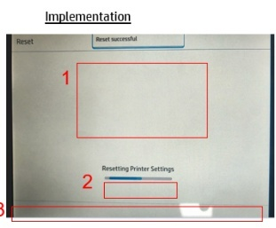
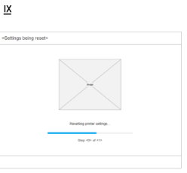

4.3. Step-by-Step Process

4.3.1. Jira Check

4.3.1.1. Access Jira
- Log in using your HP credentials.
- Navigate to the Jira Dashboard and check for any stories or bugs assigned to the Writers (@) queue.

4.3.1.2. BUG Assignment
- DUNE- 220583 was assigned to the Writers queue by the Dune Strings Lead/Approver (@Ezhil).
- The BUG was initiated by Revathi Sankarasubbaraj from the FW team, addressing missing content.

4.3.1.3. Initial BUG Details
The BUG was created with the following key information, which is essential for understanding and resolving the issue:
- Key: DUNE-220583
- Status: Icebox
- Title:
1.Image is Missing in implementation
2.Value is Missing below the progress bar in implementation
3.Footer is Empty in both Design and implementation.
- Type: BUG
- Priority: None
- Fix Version/s: Initially the sprint was FW25.04b (29Apr), later changed to FW25.05a (13May), finally got the design and the update for FW25.06a (10Jun)
- Component/s: Design: Workstreams, UI
- Applicable Products: GS2, Inventors
- Description:
1.Image is Missing in implementation
2.Value is Missing below the progress bar in implementation
3.Footer is Empty in both Design and implementation.
Time Stamp: 02:07
Path:Home>Tools>Service >Service Resets
References:Service



- Assignee: Yogitha Vasupalli
- Reporter: Revathi Sankarasubbaraj

4.3.1.4. BUG Updates
- BUG story points not required.
- The current sprint was updated to FW25.06a (10Jun)

4.3.2. Firmware team Request
- The firmware team requested a string ID for the English text: "Step <0> of <1>", and to add it for CanonMFP products.
- While testing, a PI failure occurred for the string ID: cStepValueOfValueProgress.
- Based on the request, CanonMFP was added for the Maintenance_ResettingPrinterSetting: Maintenance_V4.8
- The string was sent for approval and later approved for OPS inclusion, as part of the bug
- The BUG was then reassigned to String Writer (@Yogitha) with the approver comment:
“The String ID is not yet present trunk. Please move it back, once the String ID is integrated.”

4.3.4. Jira Closure
- The final integration was handled by the IT Support team (@Manoj), who generated the weekly .CSV file required for string deployment.
- String Writer (@Yogitha) validated that the newly created strings were successfully integrated.
- The BUG was then closed with the following comment: “The string story is now closed and integrated into the latest branches 24s, 24.02 , 24.12 and 25.02”

5. Localization BUG: DUNE-197420

5.1. Title
The translation for 'Sunday' is wrong on Schedule Print On/Off screen.

5.2. Objective
      - Change the language to Chinese on FP.
      - Go to Settings>General>Energy>Schedule Printer On/Off>Days> Every Sunday>Next>Done
      - Check the Days.
  - Actual Resul: '太阳' shows on screen.
  - Expect Result: '周日' should be shown on screen.
  - Additional Info: This issue also occurs on BR4 FW 6.24.0.899
  - Configuration:
  - Printer: Beam MFP
  - FW: 6.25.0.730

5.3. Step-By-Step Process

5.3.1. JIRA Check

5.3.1.1. Access Jira
- Log in using your HP credentials.
- Navigate to the Jira Dashboard and check for any stories or bugs assigned to the Writers (@) queue.

5.3.1.2. BUG Assignment
- DUNE-197420 was assigned to the Writers queue by the Dune Strings Lead/Approver (@Ezhil).
- The story was initiated by Sophia Deng from the FW team, addressing missing content.

5.3.1.3. Initial BUG Details
The BUG was created with the following key information, which is essential for understanding and resolving the issue:

Key: DUNE-197420
Status: Icebox
Title: The translation for 'Sunday' is wrong on Schedule Print On/Off screen.
Type: BUG
Priority: Medium
Component/s: Strings
Applicable Products: Beam.CISS, Beam.MFP, Beam.SFP
Description:
Change the language to Chinese on FP.
Go to Settings>General>Energy>Schedule Printer On/Off>Days> Every Sunday>Next>Done
Check the Days.
Actual Resul: '太阳' shows on screen.
Expect Result: '周日' should be shown on screen.
Additional Info: This issue also occurs on BR4 FW 6.24.0.899
Configuration:
Printer: Beam MFP
FW: 6.25.0.730
Assignee: Ezhilarasi Rajendran
Reporter: Sophia Deng

5.3.1.4. Story Points
- BUG story points not required.

5.3.2. Firmware team Request
  - Issue Observed
  - The screen shows ‘太阳’ (which means "sun") instead of the correct word for Sunday
  - Expected Translation
  - It should show ‘周日’ or ‘星期天’ (all valid terms for Sunday in Chinese)
  - This issue still occurs on Beam SFP with FW 6.24.1.3.
  - Requested the integrator to review, since the localization was updated based on Juan’s suggestion as ‘周日’ or ‘星期天’.

5.3.3. Jira Closure
The BUG was closed as the issue can't reproduce on Pixiu Premium MFP with FW 6.27.0.143 and 6.25.1.9, with the reference image.
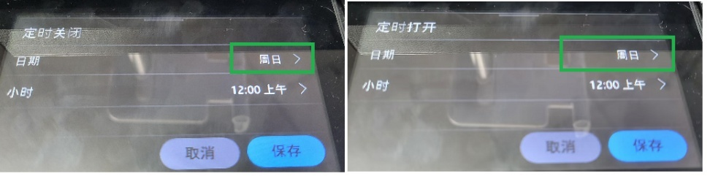

6. EWS Story – DUNE-244337

6.1. Title
EWs String-Configure Fax Notifications by Email

6.2. Objective
String configuration for Fax notifications by email.

6.3. Step-By-Step Process

6.3.1. Jira Check

6.3.1.1. Access Jira
- Log in using your HP credentials.
- Navigate to the Jira Dashboard and check for any stories or bugs assigned to the Writers (@) queue.

6.3.1.2. Story Assignment
- DUNE- 244337 was assigned to the Writers queue by the Dune Strings Lead/Approver (@Ezhil).
- The story was initiated by Sowdeshwari M. from the FW team, addressing missing content.

6.3.1.3. Initial Story Details
The story was created with the following key information, which is essential for understanding and resolving the issue:
- Key: DUNE-244337
- Status: Icebox
- Title: EWs String-Configure Fax Notifications by Email
- Type: Story
- Priority: None
- Fix Version/s: FW25.06b (24Jun)
- Component/s: Strings
- Epic Link: Configure Fax Notifications by Email
- Applicable Products: Ballparks, Enterprise, GS2, Home, Inventors, Islands: Jindo, Pro
- Lead Product: Ballparks
- Acceptance Criteria: Scope
  - What should be tested? What should NOT be explicitly tested?)
  - ...
Risk areas
  - What functional area or features are more likely to be inadvertently impacted by this work. What is the plan to minimize this?
  - ...
External requirements
  - Are there any external requirements needed in place before the epic and its test can be implemented? (CDM, hardware, …)
  - ...
Test strategy
  - Unit testing is mandatory unless it cannot be done. Covered in each story. If can't do, explain why.
  - ...
  - What types of tests need to be developed to qualify the epic?
  - Integration tests:
  - Automated System tests:
  - Manual tests:
  - Exploratory:
  - Non-functional testing. (Performance, reliability, security, …):
  - Where do these tests need to be executed? (Simulator, HW, …)
  - ...
  - What is the severity of these test cases? How often do they get executed? What is the severity of a failure? (S1, S2, S3)
  - ...
Test case list
  - Write tables for each of the aspects that need to be tested. Preferable to use the Given…When…Then notation. (See: https://cucumber.io/docs/gherkin/reference/)

- Description: Strings update
- Assignee: Yogitha Vasupalli
- Reporter: Sowdeshwari M .

6.3.1.4. Story Updates
- Initially, no story points were defined.
- After reviewing the design story and estimating the workload, the story was updated with 2 Story points.
- The current sprint was updated to FW25.06b (24Jun), as the task involves only ellipsis in job states process.

6.3.2. Legacy Review
- The content was initially reviewed to determine if it belonged to any legacy products, specifically JEDI.
- It was confirmed that the content did not match any of the legacy products.
- A detailed check was conducted in JEDI Function Management and the strings repository to identify any existing string content.
- No applicable or matching string content was found. A comment was added stating: “The content and the string are not available in the legacy product JEDI.”
- The legacy review for the story was then closed, and the comments were updated accordingly.

6.3.3. Design Review and Queries
The design implementation story is linked to DUNE-244334, with Designer (@Vegesna Sarath Chandra Varma).
Relevant design and documentation links:
Design Link: https://rndwiki.inc.hpicorp.net/confluence/pages/viewpage.action?pageId=1447038499
Screens Covered
Notification Enterprise (DUNE-244334) for Fax received Settings
Below table consists of Approved and RFR strings.

String ID | English content | String Status
cMethodToDeliverNotif | Method Used to Deliver Notification | Approved
cEmail | Email | Approved
cPrintApp | Print | Approved
cNotificationEmailAddress | Notification Email Address | Approved
cUserEditable | User Editable | Approved
cIncludeThumbnail | Include Thumbnail | Approved
cIncludeThumbnailNote | Include a thumbnail of the first scanned page in the notification. | Approved
cNotiticationSettingsNote | Note: The email address associated with a user's account is used for job notification when a user signs in at the product. If not signed in, the user must enter an email address before notification is sent. The product must also be set up to use an SMTP server for sending email jobs. | Approved
cInvalidEmailAddress | The format of the email address is invalid. | Approved
cMissingInputValue | Missing input value | Approved
CEmailServerRequired | Email Server Required | RFR
CEmailServerNotification | An outgoing email server is required for sending job notification by email. Set an outgoing email server (SMTP) on the {0}Email Servers{1} page. | RFR
cFaxRxSettings | Fax Receive Settings | Approved
cFaxSettings | Fax Settings | Approved
cFaxAppHeading | Fax | Approved
cFaxReceiveDisabled | Fax Receive Disabled | Approved
cToEnableFaxReceive | To enable Fax Receive, decide which receive method will be used, and then go to the corresponding tab and configure the required settings. After you have configured the settings, return here and turn on "Fax Receive". | Approved
cCommonJobSettings | Common Job Settings | Approved
cIPFax | IP Fax | Approved
cAnalogFax | Analog Fax | Approved
cLanFax | LAN Fax | Approved
cUsageItemInternetFax | Internet Fax | Approved
cFaxReceive | Fax Receive | Approved
cFaxReceiveMethod | Fax Receive Method | Approved
cNotification | Notification | Approved
cConditionToNotify | Condition on Which to Notify | Approved
cDoNotNotify | Do not notify | Approved
cDefaultJobOptions | Default Job Options | Approved
cSides | Sides | Approved
c1Sided | 1-Sided | Approved
cOutputBinTitle | Output Bin | Approved
cPaperTray | Paper Tray | Approved
cAutomaticallySelect | Automatically Select | Approved
cFitToPage | Fit to Page | Approved
cStampReceivedFaxes | Stamp Received Faxes | Approved
cMemoryLock | Fax Printing | Approved
cFaxPrintingSchedule | Fax Printing Schedule | Approved
cAlwaysPrint | Always Print | Approved
cBlockedFaxNumbers | Blocked Fax Numbers | Approved
cFaxNumToBlockInstructions | To stop receiving faxes from a certain fax number, enter the number and then transfer it to the list of Blocked Fax Numbers. | Approved
cNewFaxNumber | New Fax Number | Approved
cStampReceivedFaxesNote | The stamp prints the date, time, phone number, and page number on each incoming page. | Approved
cAdd | Add | Approved
cCancel | Cancel | Approved
cApply | Apply | Approved
cThisJobLabel | Notify when job completes | Approved
cOnErrorLabel | Notify only if job fails | Approved
cEnableDisable | Enable/Disable | Approved
cNotifyIfJobUnsuccessful | Notify only if job is unsuccessful | Approved
cInvalidEmailAddress | The format of the email address is invalid. | Approved
cSuccessfullyOperation | The operation was completed successfully. | Approved
cOperationFailed | The operation has failed. | Approved
cCorrectErrors | Please correct the errors below and try again. | Approved
cLocationGeneral | Location | Approved
cHeaderNameCompany | Header Name/Company Name | Approved
cFaxNumber | Fax Number | Approved
cContentOrientation2SidedFormat | 2-Sided Format | Approved
cContentOrientationBookBook | Book-Style | Approved
cListEmpty | This list is empty. | Approved
cExampleEmailDomain | (Example: hp.com) | Approved

6.3.4. Review Spreadsheet Update
As it is EWS story there is no spreadsheet update.
by adding comments this subtask will be closed.

6.3.5. String Update
- Following the clarification, the strings and the English content updated
- Closed the subtask (String Update) buy adding the comments “Design review and queries is completed. Analyzed design workflow and captured Dune string, no further clarification is needed.”

6.3.6. String Approval / G Drive Approval
- Upon review, Dune Strings Lead/Approver (@Ezhil) verified all key attributes of the story, including status, type, priority, Epic link, story points, and other checkpoints ensuring they matched the validations initially performed by the writer.
- Also confirmed that the steps followed by String Writer (@Yogitha) were accurate, including Design analysis, Review spreadsheet updates, Codex approved strings
- The approval subtask was closed, and the main story was marked as Resolved.
- The story was then reassigned to String Writer (@Yogitha) with the approver comment:
“the week 25/6/2025 to 28/6/2025. The other strings are already available in 11/6/2025 .csv file”

6.3.7. Jira Closure
- The final integration was handled by the IT Support team (@Manoj), who generated the weekly .CSV file required for string deployment.
- String Writer (@Yogitha) validated that the newly created strings were successfully integrated.
- The story was then closed with the following comment:
“The string story is now closed and integrated into the latest branches 24s, 24.02 , 24.12 and 25.02”

Animation Story: DUNE-255848

Title
[Strings] [Altair] Ink collector foams Animations

Objective
It is required to create new strings for Altair Ink collector foams for the following animations.

Step-By-Step Process

Jira Check

Access Jira
  - Log in using your HP credentials.
  - Navigate to the Jira Dashboard and check for any stories or bugs assigned to the Writers (@) queue.

Story Assignment
  - DUNE- 255848 was assigned to the Writers queue by the Dune Strings Lead/Approver (@Ezhil).
  - The story was initiated by Ferran Olivera Corpas from the FW team, addressing missing content.

Initial Story Details
The story was created with the following key information, which is essential for understanding and resolving the issue:
- Key: DUNE-255848
- Status: Icebox
- Title: [Strings] [Altair] Ink collector foams Animations
- Type: Story
- Priority: None
- Fix Version/s: Initially the sprint was FW25.06b (24Jun) then we got the design by FW25.07a (8Jul)
- Component/s: UI, UX
- Epic Link: Add removable printzone steps in media load workflow
- Applicable Products: Altair
- Lead Product: Altair
- Acceptance Criteria: TBD
- Description: It is required to create new strings for Altair Ink collector foams for the following animations.
  - Ink collector foams installation
  - Ink collector foams uninstallation
Refer to the spec in: https://docs.google.com/spreadsheets/d/1UPwoHOeYHPr6YXpquZ2IniZJoNQNKzLvoYvruX0Fspo/edit?gid=2035877972#gid=2035877972
if you have any doubt, do not hesitate to contact me.
- Assignee: Yogitha Vasupalli
- Reporter: Ferran Olivera Corpas

7.3.1.4. Story Updates
- Initially, no story points were defined.
- After reviewing the design story and estimating the workload, the story was updated with 2 Story points.
- The current sprint was updated to FW25.07a (8Jul), as the task involves only ellipsis in job states process.

Legacy Review
- The content was initially reviewed to determine if it belonged to any legacy products, specifically JEDI.
- It was confirmed that the content did not match any of the legacy products.
- A detailed check was conducted in JEDI Function Management and the strings repository to identify any existing string content.
- No applicable or matching string content was found.
- A comment was added stating: “The content and the string are not available in the legacy product JEDI.”
- The legacy review for the story was then closed, and the comments were updated accordingly.

Design Review and Queries
Relevant design and documentation links:
Design Link: https://www.figma.com/design/nu747HPrVVKBxwcq3VFIn9/Animations-Exploration?node-id=47-50&t=mLUemZO3fVkNHSbN-1

- Animation contents and the strings need to confirm with Rhett Allen
- Created the strings for the Animation design
- Requested the designer to update the English content to be corrected in both the design and the Animation path.
• Following the confirmation, the Design Review and Queries subtask was closed with the comment:
“As per the discussion with Shreya, design review and queries completed. Analysed design workflow to capture the strings.”

Review Spreadsheet Update
    - All updates were documented in the review spreadsheet located in the SharePoint: [Altair] Animations - Google Sheets
- The story related screens (Screen name)
(Please refer to the string table)
    - The main sheet was updated to reflect the screens associated with the new strings.
    - The subtask for updating the review spreadsheet was closed with the comment: “Review spreadsheet update completed. Review comments are added in the review spreadsheet. Added the review spreadsheet path below:”
    - Spreadsheet Path: [Altair] Animations - Google Sheets
    - The approval subtask, titled "String Approval / G Drive Approval," along with the main story, was assigned to the Dune Strings Lead/Approver (@Ezhil) with the following comments: Sent for approval since all strings are approved and only an ellipsis was added.
    - As per discussion with the designer, the strings have been captured for the below contents-
String ID | Status | English content | Comments
cUnlockPrintZone | RFR | Lift up the lever to unlock the print zone. | Update thee content as "Lift up the lever to unlock the print zone."
cPullPlatenModule | RFR | Push down and then pull each platen module to remove it. | Update the content as "Push down and then pull each platen module to remove it."
cRemovePlatenModules | RFR | Repeat the process to remove each of the platen modules. | Update the content as "Repeat the process to remove each of the platen modules."
cInkCollectorModule | RFR | Install each ink collector module by pushing down and back until it snaps into place. | Update the content as "Install each ink collector module by pushing down and back until it snaps into place."
cInstallInkCollector | RFR | Repeat the process to install each of the ink collector modules.
cLockPrintZone | RFR | Push down the lever to lock the print zone. | Update the content as "Push down the lever to lock the print zone."
cPushDownModule | RFR | Push down and then pull each ink collector module to remove it. | Update the content as "Push down and then pull each ink collector module to remove it."
cRemoveInkCollector | RFR | Repeat the process to remove each of the ink collector modules. | Update the content as "Repeat the process to remove each of the ink collector modules."
cOnePlatenModule | RFR | One platen module has a window that is used by the sensor. Make sure it is placed in the correct position. | Update the content as "One platen module has a window that is used by the sensor. Make sure it is placed in the correct position."
Figma link: https://www.figma.com/design/nu747HPrVVKBxwcq3VFIn9/Animations-Exploration?node-id=47-50&t=mLUemZO3fVkNHSbN-1

Strings Update
- Following the clarification, the strings and the English content updated as –
(Please refer the previous string table)
- Closed the subtask (String Update) buy adding the comments “Design review and queries is completed. Analyzed design workflow and captured Dune string, no further clarification is needed.”

String Approval / G Drive Approval
- Upon review, Dune Strings Lead/Approver (@Ezhil) verified all key attributes of the story, including status, type, priority, Epic link, story points, and other checkpoints ensuring they matched the validations initially performed by the writer.
- Also confirmed that the steps followed by String Writer (@Yogitha) were accurate, including Design analysis, Review spreadsheet updates, Codex approved strings
- The approval subtask was closed, and the main story was marked as Resolved.
- Once the new strings are approved and available in CSV file then the story can be closed by adding the integration.
- The story was then reassigned to String Writer (@Yogitha) with the approver comment:
“Strings will be available in the integration cycle of the week 25/6/2025 to 28/6/2025.”

Jira Closure
- The final integration was handled by the IT Support team (@Manoj), who generated the weekly .CSV file required for string deployment.
- String Writer (@Yogitha) validated that the newly created strings were successfully integrated.
- The story was then closed with the following comment:
- “The string story is now closed and integrated into the latest branches 24s, 24.02 , 24.12 and 25.02”星期天’.
Bug Closure
- The bug was closed after verification on Pixiu Premium MFP devices running firmware versions 6.27.0.143 and 6.25.1.9, where the issue could not be reproduced.

Additional Notes/Key Points
Sl.no | Type | Summary | Description | Resource | Date
1 | JIRA Status | Confirm design, update JIRA status, and ensure assets are complete | Review linked Epic and Design Story. Confirm design availability and scope with designer/reporter. Use JIRA comments/email. Move story to Icebox if design is missing, or to Ready for Development if ready. Update status to Development when work starts. Mark Ready for Review after strings are added. Ensure Story Points and Sprint fields are filled. Review strings for accuracy. Add Figma/Wiki links and attach final spreadsheet. | General Update | NA
2 | Design Status | Extract, format, and review strings from Figma; update spreadsheet and JIRA. | String team will receive the design link from designers. Confirm Figma link is available. Check version history before extracting content. Update spreadsheet with English strings. Include both Approved and RFR strings in JIRA. Check Codex for existing strings with applicable products. Format screen names in title case. Review UI sizing across devices. Add feedback in Review Comments section if the content is not matching with the design. Confirm updates in Design Approval subtask. | General Update | NA
3 | String Status | String ID and Localization | 1. Dune uses Spice UI and Codex tools to manage string IDs that start with a lowercase ‘c’ and follow camelCase format. These strings are reviewed, approved, and translated into multiple languages, then tracked in weekly CSV files. Codex also manages product info, event codes, and function screens, with updates recorded through comments and history. Multi-value string IDs are used when there are differences in contents with same meaning (like paper vs. substrate) or user interactions (such as touch vs. select). Each value must be unique, approved, and translated separately. String IDs can also include parameters like {0}, {1}, which are known as Parameter String IDs. Verify OEM details whenever "HP" appears in the English content, and get final approval from the Firmware team if a specific string value is needed.  2. According to Spike story DUNE-269551, new strings are needed for the "maximum fax numbers reached" message across products like Ballparks, Blades, Coasters, Enterprise, GS2, Home, Inventors, and Pro. For Enterprise, the limit is 210 fax numbers; for HomePro, it's 100. A single string with two values will be created. one linked to OPS functions, and the other to both HPS and OPS functions with the required products assigned as per design.  3. The content "Select" is restricted to use only with Ulysses, Zelus, and Namhae. It should not be applied to any other products or platforms. Always verify usage before applying.  4. The term "Touch" is applicable across all Dune products. It can be used in string content related to any Dune model. No restrictions apply for usage within this product line.  5. Replace the term "Wireless" with "Wi-Fi" in all string content. This ensures consistency across product messaging. Always use "Wi-Fi" when referring to wireless connectivity.  6. Use "and" instead of "&" while creating the strings. The "&" symbol is allowed only in legal content.  7. Use a separate string for buttons. Other sections can reuse the same string depending on the case. This helps maintain clarity and consistency.  8. Use "best" instead of "better" while creating the strings. For example, say “best print quality” or “best possible print quality.” This helps maintain clear messaging. |  | NA
4 | Update | Print Engine Function Set Change | In the Dune system, the "Print Engine" function set group has been updated. Previously, OPS products used either "LaserJet" (for Canon) or "Dragon LaserJet" (for HPPK). To better support string requirements for paper loading, orientation, and rotation, "LaserJet" has now been split into two: "LaserJet (Front)" the original LaserJet and "LaserJet (Side)" a newly introduced variant. For all non-media-related strings, both "LaserJet (Front)" and "LaserJet (Side)" should be selected. This configuration has already been applied to existing strings in Codex. | Codex  Rhett | 09/16/2025
5 | Legacy Review | Review spreadsheet and confirm in JIRA. | Update the legacy spreadsheet and reviewing all the string IDs, translations, and related information is updated correctly and complete. Check for any missing information, outdated entries, or inconsistencies, and make necessary corrections. Once the review is completed, go to JIRA story and add a comment that the legacy review has been completed. Update the comments if there are any changes required in English contents, attach the updated spreadsheet for reference and any Email confirmation. | General | NA
6 | Subtask Closure | Close subtasks before main story closure | Subtasks help break down the work needed to complete a string story and are only created for stories, not bugs. Each subtask should be updated with its status, and comments must be added when starting and finishing the task. Once all subtasks are closed, update the main story with comments, attach emails, and include all involved team members who ever is required for the story. Legacy and design reviews, string updates, and approvals follow specific steps to ensure accuracy, and proper validation before the story is marked to Ready for QA. | General | NA
7 | Closure Email | Confirm approvals and files before QA submission. | Before closing a Jira story, make sure all necessary approvals and documents are collected. Complete the string review and send all "Ready for Review" (RFR) and approved strings for validation. Update comments in the Jira story and all related subtasks, and attach the required files in their correct locations. Include references such as the design story number (e.g., DUNE-164730), string story number (e.g., DUNE-168302), and Jira summary. Add a resolution note explaining the action taken, such as creating new strings in Codex based on design requirements. Also, provide links to the strings review checklist on SharePoint, the legacy product review spreadsheet (if available), the G-Drive spreadsheet path, and the workflow folder path. Makes sure everything is ready and approved before sending the story to QA. | General | NA
8 | Story Points | Story points estimate work effort. | Story points are used to estimate how much effort the story will take, based on an 8-hour workday (not calendar days). For example, a task needing 24 hours of work would be marked as 2 story points. If a task takes more than 10 days of effort, it should be split into a second story under the same epic. Common values are 2, 4, 6, or 8, and they help with sprint planning and tracking progress. | General | NA
9 | Sprint Assignment | Update sprint based on design status. | A sprint is a two-week cycle where teams complete planned tasks for the stories. In JIRA, it's important to assign each story or bug to the correct sprint to track progress accurately. will upadte the comments if the deisgn is not ready or the story assigned to the string writer "The design story is not yet ready and will be handled in the upcoming design sprint." Once the string writer receive the design from the designer or FW, OR from Developer the string writer will check teh sprint date and update the sprint date. | General | NA
10 | Resolution Field | Set proper resolution status | When closing a Jira story or bug, include a resolution note that explains what actions were taken by the string writer. Mention if the design was reviewed and confirmed with the designer or firmware team. Specify whether new strings were created, exisitng string or any chages in Codex, and confirm that the spreadsheet was updated with all relevant string IDs and status. Note if a legacy review was done and whether any features were added. Include details about workflow screen verification, Figma or Wiki links added, and email approvals received. Mention the final resolution status, such as Fixed, Duplicate, Won’t Do, or Done. | General | NA
11 | Quality Checklist | Checklist ensures accuracy. | The checklist thorough self-review and structured documentation across stages, from verifying JIRA assignments and updating workflow spreadsheets to ensuring string accuracy and translation notes. It highlights the importance of matching content with design, maintaining consistency in screen names, headers, and body formatting, and adhering to codex standards. Special attention is given to string validation, OEM guidelines, and behavior table updates, ensuring clarity and usability across static and dynamic content. Final steps include string approval, mail communication with designers and approvers, and closure procedures in JIRA. | General | NA
12 | Field Verification | Verify JIRA fields | Story points estimate effort based on an 8-hour workday, using values like 2, 4, 6, or 8, and tasks exceeding 10 days should be split into a second story. Each story or bug must be assigned to the correct sprint for accurate tracking, and comments should be added if the design isn't ready. Upon receiving the design, the string writer updates the sprint date accordingly. When closing a Jira item, include a resolution note detailing design confirmation, string updates, spreadsheet status, and final resolution type. | General | NA
13 | Link Inclusion | Epic to integration: strings approved. | The Reporter starts by creating an Epic and dividing it into stories for Design, Strings. The Strings Lead assigns the string-related story to a String Writer, who reviews the Epic and design to gather requirements and consults with the Designer if needed. Based on the updated design, the String Writer updates strings in DUNE Codex, adds details in JIRA, and requests approval. Once approved, strings are integrated, localized, and tracked through spreadsheets and SharePoint paths, with final confirmation sent to the Integration Team. | General | NA
14 | Documentation | EWS strings reviewed and sending for approval. | Designers will share the Wiki link for EWS stories, which we’ll review to update the English content. All String IDs and corresponding text will be captured in the table. If any corrections are needed, we’ll request the designers to update both the String table and the design. Once the designer updates the correction, the file will be sent for approval. | General | NA
15 | Segmentation | HP print : HPS, OPS, GSB. | HPS stands for Home Printing Solutions, OPS refers to Office Printing Solutions, and GSB represents Graphic Solutions Business. These acronyms categorize HP’s key printing segments based on user needs and environments. | General | NA
16 | Labeling | Design update | In design, "button" should be one word. In some cases, it can be split into two words, but never more than that. Always follow this rule for consistency. Ex - Learn More, All Options, …. | General | NA
17 | Terminology | Content Update | Region should be replaced with “Location” | General | NA
18 | Paragraphing | CP stories allow paragraphs; EWS doesn’t. | Paragraphs are not allowed in EWS stories. They can be used in CP stories, depending on the designer and design content. Each paragraph must have a different string ID. | General | NA
19 | Structuring | Bullet needs separate string. | Create a separate string for bullet content. Other text can be created as usual. This keeps formatting clear and organized. | General | NA
20 | ToastTone | Toast: no period, "!" for success. | Toast messages should not end with a period. Keep the tone clear. Avoid punctuation at the end unless its necessary.  Successful toast messages should end with an exclamation mark "!". This adds a positive, energetic tone. Use it only for success confirmations. | General | NA
21 | Progressive | Ellipses for ongoing toast. | Some successful toast messages may end with ellipses. This applies to actions like searching, sorting, or filtering. It indicates an ongoing process. | General | NA
22 | Unpolished | Use “please” only in essential toast cases. | Avoid using “please” in toast messages. Reserve it for limited cases like “Please wait” or “Please try again.” Keep the tone direct and minimal. | General | NA
23 | Unhyphenated | “Multipage” only. | Use “multipage” without a hyphen. The content should appear as one word. Avoid “multi-page” in all cases. | General | NA
24 | Rebranded | Workpath replaces JetAdvantage. | HP JetAdvantage Link has been renamed. The new name is HP Workpath. Use “HP Workpath” in all references going forward. | General | NA
25 | Capitalized | Capitalize “S” in 1-Sided. | Use “1-Sided” with a capital “S”. Avoid using “1-sided” with a lowercase “s” or hyphen. Stick to the correct format for consistency. | General | NA
26 | Parameterized | cStrings—two each. | Use cStringColon, cStringEllipsis, and cStringExclamatory for “:”, “…”, and “!”. Provide two string variants to FW for each. Stick to these constants for punctuation. | General | NA
27 | Consistent | Same name, same content—no duplicates. | Screen names must match their content. If two screens share the same name, their content must be identical. Avoid naming different screens the same. | General | NA
28 | Redundant | Skip header if body is clear. | If the body content is clear on its own, a header isn’t needed. Avoid adding headers when the message is already self-explanatory. Keep it minimal. | General | NA
29 | Differentiated | Header: Shutdown. Button: Shut Down. | Use “Shutdown” for headers to keep it simple. Use “Shut Down” for buttons to match action phrasing. Maintain this format consistently. | General | NA
30 | Unbroken | Dune: no breaks, except SMS. | Don’t use line breaks in Dune. The only exception is for SMS strings. Keep all other content as per the flow. | General | NA
31 | Segmented | OPS: “Supplies”; GSB/HPS: others. | Only OPS LaserJet products use the term “Supplies.” GSB and HPS use “Cartridge,” “Ink,” or “Printhead” instead. Keep the content update with product type. | General | NA
32 | Preserved | No brand translation. | Don’t translate branded features. Keep brand terms exactly as they are. | General | NA
33 | Declarative | No questions in headers. | Avoid using question marks in headers. Write headers as clear statements. This keeps the content easy to read and presise. | General | NA
34 | Restricted | Strings locked—Rhett approves edits. | Leave SMS, Animation, and Media Size/Type strings unchanged. These must not be edited. Keep them exactly as it provided. Before taking any action we need to get the confirmation from Rhett. | General | NA
35 | Casing | Use lowercase “x” in 802.1x. | Use “802.1x” with a lowercase “x”. The version with a capital “X” is incorrect. Always follow the correct content. | General | NA
36 | Simplify | Use “Document Feeder”—no ADF. | Follow the HP Style Guide: use “Document Feeder” instead of “Automatic Document Feeder (ADF).” Drop the abbreviation and keep it simple. | General | NA
37 | Spacing | Use “Web Scan” with a space. | The correct format is “Web Scan”. Don’t use “Webscan” or “WebScan.” Always keep the space between Web and Scan. | General | NA
38 | Expendable | IMC absorbs air, becomes disposal cartridge. | Disposal Ink Cartridge: The printhead (PH) can't handle air, and white ink requires recirculation through both White and IMC cartridges. To clear air from the recirculation tube, we use a working IMC cartridge. Once it absorbs the air and fills with ink, it becomes a "disposal ink cartridge" no longer usable for printing. | General | NA
39 | Storage | Use “Reservoir” for tanks, not cartridges. | Use “Reservoir” only when referring to ink or toner storage, like tanks or general containers. If you're specifically talking about cartridges, don’t use “Reservoir.” Keep the terms distinct. | General | NA
40 | Rollability | Rolls: Jupiter (multi), Beam/Sunspot (single). | Jupiter, Beam, and Sunspot are Workflow UI products which support roll Media, while enterprise laser, Marconi, and Moreto do not support. Jupiter supports multiple rolls; Beam and Sunspot support only one roll each. Roll compatibility is limited to select models. | General | NA
41 | Source | Choose “Printer” or “Device” based on connection direction. | Use “Printer” when another item is connecting to it. Use “Device” when the printer initiates the connection, like to an iPhone. Choose based on who’s doing the connecting. for example, in cWiFiDirectFailedConnection. | General | NA
42 | Modeling | OPS–LaserJet, HPS–Ink, GSB–DesignJet, scan/general–None. | Select “LaserJet” and “DragonLaserJet” for OPS, and “Ink” for HPS.  For GSB, choose “DesignJet,” “Latex,” “PageWideXL,” or “Stitch.”  Use “None” for scan and general features. | General | NA
43 | Cartridging | IPH uses Black + Tricolor cartridges; Novelli (Sirius) was the latest. | IPH = integrated printhead  IIC = individual ink cartridge  IPH printers use two cartridges: one Black and one Tricolor. Novelli in Sirius was our most recent IPH model. This setup differs from individual ink cartridge systems. | General | NA
44 | DefaultExcept | Select all by default; skip “(L)” items. | For Display settings, select all items by default. Skip any items marked with “(L)”. These are exceptions to the general rule. | General | NA
45 | SpiceOnly | Select “Spice”; skip “(L)” items. | Style/UI: Ensure “Spice” is selected. Items marked “(L)” aren’t processed by firmware during integration and may complicate the “Resolve Products” feature if chosen. | General | NA
46 | MediaScope | Media support differs by unit. | Media types and sizes vary by business unit. Not every unit or product supports the same options. Compatibility depends on the specific business context. | General | NA
47 | ScopeCheck | Use broadly; don’t limit by product. | Strings in Jira stories may target specific products, but don’t limit function sets to just those. Check if the string applies more broadly before finalizing. | General | NA
48 | PrintOrg | HP printers: HPS, OPS, GSB. | HP printers are produced by different business units.  HPS handles small-format home and SOHO ink printers,  OPS makes LaserJet models,  GSB focuses on large-format ink printers. | General | NA
49 | PrintTone | Color/Mono defines print type. | Color/Mono refers to the printing technology used. It indicates whether the printer uses color or monochrome mechanisms. This helps define the print output type. | General | NA
50 | PanelType | Display = control panel type. | Display refers to the printer’s control panel. It includes both the size and type of interface used. This helps define how users interact with the device. | General | NA
51 | PostOps | Finishers = output add-ons. | Finishers are external devices that work with the printer. They handle output tasks like stapling, stacking, or folding. The printer’s supported finishers define its post-print capabilities. | General | NA
52 | MetaMap | Function sets = string metadata. | Function sets are metadata linked to each string. To represent a product accurately, select at least one function set from every category. This ensures complete coverage. | General | NA
53 | HeatFlag | Caution = Sunspot-only (one is Latex). | “Caution” strings apply only to Sunspot printers, since others lack heating modules. The final caution might suit Jupiter, but for now, restrict it to Latex. This ensures safe and relevant usage. | General | NA
54 | TrackUnit | Length = GSB-only metric. | Length tracking applies only to GSB products, where it’s used to monitor the printed substrate in feet or meters. OPS and HPS printers don’t use this method; if they did, they’d measure in mm, cm, or inches. Instead, HPS/OPS track usage via “A4/Letter Equivalent” pages, calculated from toner or ink consumption based on the printer’s default paper setting. | General | NA
55 | No Abbreviation | Bluetooth Low Energy ≠ BLE. | Bluetooth brand guidelines prohibit abbreviating “Bluetooth Low Energy” as “BLE.” The full term must always be used to maintain brand consistency. This ensures proper representation across materials. | General | NA
56 | Plot Scope | Plots = GSB only. | Use “Plots” only for GSB products, exclude HPS and OPS. For those, the correct term is “Reports.” See string ID cCheckAlignmentStatusPlot for reference. | General | NA
57 | Title Lock | Note = ReportName | Translator notes should clarify that strings like “Printhead Status Plot” and “Alignment Status Plot” are report titles. Translations must preserve this naming to reflect their official status. | General | NA
58 | Parameter Note | Note = ParamHint | Include brief explanations of parameter strings in the Translator Notes, since translators may not have access to the “parameter description” section. This helps avoid localization issues. Example: string ID “cTakeUpReelTensionModeValue.” | General | NA
59 | No Localize | Exclude = Large HPS + Pro-select | Larger-size HPS products are excluded from translation. GSB Pro-select is also not selected for translation. These items fall outside the current localization scope. | General | NA
60 | Latex Only | WhiteInk = Sunspot-only | Strings related to white ink, white printheads, IMC, and auxiliary printhead are exclusive to Sunspot and the HP Latex white ink system. If Beam or Jupiter products reference these, it's a development issue—not a string or Rosetta error. Non-Latex functions must not be applied to these strings. | General | NA
61 | GSB Languages | GSB translation languages = 15 preset locales. | For GSB strings, the following foreign languages are applicable for translation. Use this list when handling any translation-related queries: Catalan, German, Spanish, French, Italian, Japanese, Korean, Portuguese, Russian, Simplified Chinese, Traditional Chinese, Polish, Swedish, and Dutch. | General | NA
62 | Service Skip | Service menu strings = No Localize per Nate report. | Strings in the Service menu for HPS and GSB printers do not require localization. This is based on the Nate report. These strings are excluded from translation. | General | NA
63 | Proselect Logic | Proselect = multi-value; headers = 15-char max. | 1. Create multi-value strings with Proselect sizing, excluding Footer buttons and Body strings.  2. For Common strings, generate one version without Proselect (all combinations) and another exclusively for Proselect.  3. In Hybrid UI flows, Headers and List items are fixed and may act as headers in the next menu. Limit string length to 15 characters, suggest alternatives if exceeded. | General | NA
64 | Scan Configuration | GSB = feeder; HPS/OPS = glass+feeder optional. | Media types vary by scan method. Flatbed scanners can scan any media. GSB printers use only a document feeder, which they refer to as a scanner. HPS and OPS printers differentiate: a document feeder is labeled as such, and while all feeders include scanner glass, not all scanner glass setups include feeders, those are upscale features. Eddington and Kebin models have A3-size scanner glass and A4-size document feeders. | General | NA
65 | Dual Toast | Toast = dual-use; full stop ensures cross-device fit. | On concurrent devices, the toast string also serves as a body string on non-concurrent ones. To support both uses, a two-sentence toast string can end with a full stop. This ensures consistency across device types. | General | NA
66 | PDL Driver | PDL = HPS print driver. | In HPS context, PDL refers to the Printer Driver. It defines how print data is processed and sent to the printer. This term is used for driver-related documentation. | General | NA
67 | SOHO Print | SOHO = MMK home printer. | SOHO stands for Small Office Home Office. It refers to compact home printers designed for small-scale use. MMK is one such small-format printer in this category. | General | NA
68 | SMB Hybrid | SMB = hybrid HPS/OPS printers for small offices. | SMB stands for Small and Micro Business. It combines elements from both OPS and HPS printer categories. These devices are designed for small office environments. | General | NA
69 | Format Type | LFP/SFP = printer types by media size. | LFP stands for Large Format Printer, typically used for wide media outputs. In design terminology, SFP refers to Small Format Printer, suited for standard-sized prints. These terms help distinguish printer capabilities by media size. | General | NA
70 | String Rules | Rosetta string = reset, restrict, review, sync. | * If a string originally marked for GSB is updated to include OPS or HPS BU, reset its translation status to "Untranslated" for all languages.  * Selecting SFP means no scanner should be chosen, and vice versa.  * Selecting MFP requires a scanner to be selected, and vice versa.  * Avoid using single quotes (‘ ’) in button labels or highlighted content.  * The ellipsis (…) is not a special character—it’s three periods. Confirm this when reviewing strings.  * Ensure all display sizes are selected for every string.  * Before removing any string or product from Rosetta, coordinate with developers. Send an email for any changes—content, function set, product, or status—and follow up to get the PR details. | General | NA
71 | Task Type | Concurrent = multitask freely; non-concurrent = wait to switch. | Concurrent mode supports both foreground and background processes, allowing navigation to the background screen anytime. Non-concurrent mode runs a single process, and navigation is only possible after closing the current screen. This defines how multitasking behaves across modes. | General | NA
72 | Align Mode | OPS = Right ID; GSB = Alignment ID. | The string ID cMediaOutputIdRight is specific to OPS usage. For GSB, use string IDs that end with "RightAlignment" or "LeftAlignment" based on the required direction. This ensures proper alignment tagging across systems. | General | NA
73 | Head less | Color-1pt IPH = no print head content. | For the function set "color-1pt IPH," print heads should not be included in the content. This ensures the configuration stays accurate and compliant. Always exclude print head references for this set. | General | NA
74 | Fax Scope | Fax = apply to all supported products per Iqbal. | Fax applies to all products that support fax functionality. This guideline was confirmed by Iqbal. Ensure compliance across relevant product lines. | General | NA
75 | Code Flex | Dune = flexible hex event codes. | Dune supports three event code formats, XX.YY.ZZ, WW.XX.YY.ZZ, and XXXX-YYYY-ZZZZ, to meet BU-specific needs. All formats are compatible with Rosetta/Codex CSVs, though Rosetta currently supports only XX.YY.ZZ. Codes must use hex characters (0–9, A–F), excluding separators, and no changes are needed in the Localization Framework to support new formats. Full details are in the Dune wiki. | General | NA
76 | Cartridge Type | Cartridge = all but CISS. | Mono and color printers use cartridges, differing only in count, mono uses one, color uses four or more. CISS (tank) printers like Pixiu don’t support cartridges at all. All products support cartridges except CISS models. Use the singular value only for OPS mono printers; the plural applies across all businesses. | General | NA
77 | Ellipsify | Ellipses required on processing screens. | Ellipses (…) must be included on all processing screens. This indicates ongoing activity or wait time. Always use three periods, not a special character. | General | NA
78 | PenRegion | PenSupply = Service label. | The label "Pen Supply Region" is listed in the Service menu. It’s part of the interface text shown during service operations. Ensure it's correctly localized and placed. | General | NA
79 | Size Bound | String sizing = update only within Dune limits. | Update string sizing only if it fits within the existing limits defined in Dune. Do not exceed the preset sizing constraints. Adjustments must stay within allowed bounds. | General | NA
80 | No Gap | No symbol spaces. | Symbols must appear without spaces between them. For example, write <10% without any gaps. This ensures correct formatting and display. | General | NA
81 | Dash Lock | Em dash = no spaces on either side. | An em dash should appear without spaces on either side. It connects words or phrases directly. Always avoid adding gaps before or after the dash. | General | NA
82 | Slash Tight | Slash formatting = no spaces (e.g., on/off). | Do not add spaces before or after a slash. Keep it tight, like “on/off” or “yes/no”. This ensures correct formatting and consistency. | General | NA
83 | Capitalize Rule | Capitalize Internet & Home. | Use capital letters for the words "Internet" and "Home". These terms must always be capitalized in UI and documentation. This ensures consistency and brand compliance. | General | NA
84 | No Translate | “HP Smart” = no translation across languages. | Do not translate the term “HP Smart”. It must remain in English across all languages. This preserves brand identity and consistency. | General | NA
85 | Quote Tag | Button names = use quotes, no “button” label. | Enclose button names in double quotes when used in body text. Do not include the word “button” alongside them. This keeps the formatting clean and consistent. | General | NA
86 | Template Fit | Follow workflow template for sizing updates. | Refer to the template section in the workflow prototype when updating sizing. This ensures alignment with predefined layout standards. Always base adjustments on the template guidance. | General | NA
87 | XS First | Prefer XS sizing unless larger is essential. | Use XS sizing whenever possible. It’s the preferred option for consistency and layout efficiency. Stick to XS unless a larger size is absolutely necessary. | General | NA
88 | Laser Only | Clean Belt = Laser only, exclude HPS/GSB. | The Clean Belt feature is designed specifically for Laser printers. Do not apply it to HPS or GSB models. This ensures proper functionality and avoids misuse. | General | NA
89 | Registration Scope | Image Registration = Laser only, exclude HPS/GSB. | The Image Registration feature is meant only for Laser printers. Do not use it with HPS or GSB models. This ensures correct application and prevents compatibility issues. | General | NA
90 | No Caps | Use “On”/“Off” with proper casing; avoid all-caps. | Avoid using all-caps “ON” and “OFF” in string content. Use “On” and “Off” with appropriate casing based on context. This ensures clarity and aligns with style guidelines. | General | NA
91 | Auto Ellipsis | Ellipsis auto-replaced in Office. | Microsoft Office programs often auto-correct three dots ("...") into a single ellipsis character ("…"). This happens automatically during typing. Be mindful of this when formatting content. | General | NA
92 | No Size | No sizing for EWS/media/report. | You don’t need to apply sizing to EWS strings, media size or type strings, and Internal Report strings. These categories are exempt from sizing rules. Keep them as-is for consistency. | General | NA
93 | Media Set | Substrate = Sunspot; Paper = Beam or Jupiter. | Use “Sunspot” for Substrate. For Paper, choose either “Beam” or “Jupiter.” These are the designated options for each category. | General | NA
94 | Context Role | Avoid “the user”; prefer context-based roles. | Do not refer to people as “the user.” Use more natural or role-specific terms based on context. This improves clarity and tone. | General | NA
95 | translations Check | Keep one; check translations before delete. | Choose one string to keep and mark the rest as “Pending Delete.” Before finalizing, confirm that all translations are identical. This helps avoid accidental loss of valid variants. | General | NA
96 | Secure Link | Dune EWS links must use “https” only. | Dune EWS links must always use “https.” This ensures secure access to web pages. Avoid using “http” in any link. | General | NA
97 | Page Label | Use “Number of pages: {0}” — not “<n> pages.” | Use “Number of pages: {0}” instead of “<n> pages.” This format is clearer and preferred for consistency. Avoid placeholder styles like angle brackets. | General | NA
98 | Input Style | Use “Enter Password: ” instead. | Update the string from “Enter password” to “Enter Password: ”. Capitalize “Password” and add a colon for clarity and consistency. This aligns with preferred formatting standards. | General | NA
99 | Help ID | No Help IDs in Dune. | Help IDs are currently not available in Dune. Avoid adding or referencing them for now. | General | NA
100 | No Prefix | Drop “EL” prefix. | Event log strings don’t need the “EL” prefix. Skip it to keep formatting clean and consistent. This applies to all event log entries. | General | NA
101 | SMS Flex | Colon + multiline allowed. | SMS strings can end with a colon. They may also span multiple lines if needed. This format is acceptable. | General | NA
102 | Group Select | HPS/OPS: A3+A4; GSB: All. | Select both “A3” and “A4” for HPS and OPS. For GSB, choose every available option. Apply selections as per group type. | General | NA
103 | CartridgeBlock | Skip “Mono” and “Reservoir” if “Cartridges” appear. | Avoid selecting “Mono” when the string includes “Cartridges” in plural. Also, skip “Reservoir” if “Cartridges” are mentioned. These options don’t apply in such cases. | General | NA
104 | Scan None | Network scanners: set Color/Mono to “None”. | When configuring network scanners, choose “None” in the Color/Mono section. This setting applies specifically to network scanner profiles. Avoid selecting color or mono options. | General | NA
105 | Scanner Include | Include “Network Scanner” for scan and general features. | When configuring scan or general features, include “Network Scanner” in the selection. This applies across both categories. Make sure it's checked. | General | NA
106 | Ink Balancer | IMC prevents White ink from solidifying. | IMC stands for Ink Mix Container. It’s the secondary cartridge used to keep White ink functional, since White ink can solidify. Ink is transferred between the White cartridge and IMC to prevent clogging. | General | NA
107 | Laser Solo | Namhae: print-only, laser-only. | Namhae is a color laser single-function printer (SFP) that supports only printing. It doesn’t offer multifunction features like fax, scan, or copy. It also excludes ink-based components, working solely with laser parts like toner, fusers, and drums. | General | NA
108 | Print Pure | Namhae: laser-only, print-only device. | Namhae is a color laser single-function printer, built solely for printing. It doesn’t support multifunction tasks like faxing, scanning, or copying. It also uses only laser components, no ink cartridges or printheads. | General | NA
109 | EWS Only | Hyperlink only in EWS. | Add hyperlink parameters ({0} and {1}) only for strings used in EWS. Do not apply them to strings shown in other areas like the control panel UI or Reports. Keep this formatting exclusive to EWS content. | General | NA
110 | Waste Bin | Collects waste: toner for laser, ink for inkjet. | The Toner Collection Unit stores waste material from printing. In laser printers, it gathers excess toner. In ink printers, it collects stray ink droplets during calibration and other operations. | General | NA
111 | Lock Hold | Don’t edit approved strings, only update products, sizing, or comments. | If a string is already translated and approved, leave its content unchanged. You may add products or update sizing with a comment, but don’t alter the string itself. Translations are already finalized. | General | NA
112 | Mono Block | Mono: OPS-only, laser-only. | "Mono” should not be used when:  1- The Business Unit function is set to “GSB” or “HPS” (only “OPS” supports Mono).  2- The technology is ink-based.  3- The string references colors—except gray or black, which apply to Mono; colors like cyan, magenta, or yellow do not.  4- The printer has only one cartridge.  5- The string mentions “tanks” or CISS/CTSS systems, which are currently ink-only in Dune. | General | NA
113 | Finish Block | Use “No Finishers” to maintain Dune firmware compatibility. | Select only “No Finishers” during setup. Dune firmware does not currently support finishers in integration. This ensures compatibility. | General | NA
114 | Scan Rule | Scanner: Only “No” or “Any.” | Always choose either “No Scanner” or “Any Scanner.” For MFP-only features, select only “Any Scanner.” Avoid using “No Scanner” in those cases. | General | NA
115 | SMS Spec | SMS: Don’t touch. Product-tied. | Avoid modifying SMS strings. These messages are tied to specific products and require precise function set selections. Changing them can disrupt intended behavior. | General | NA
116 | Media Type | A3/A4 define standard media sizes for device compatibility. | A3 and A4 refer to standard media sizes. They help differentiate supported paper types. These sizes guide compatibility across devices. | General | NA
117 | Functional Type | Printer types: SFP (print), MFP (multi), Scanner (scan-only). | Printers are classified by function. SFPs handle printing only, while MFPs support print, copy, scan, and fax. Network Scanners are scan-only devices. | General | NA
118 | Media Type | Print engine defines core output tech and media support. | The print engine is the core technology behind the printing process. It determines how the system produces printed output. Different engines support different capabilities and media types. | General | NA
119 | Panel Set | Style/UI: Control panel design. | Style/UI refers to the visual and interactive design of the control panel. It defines how users experience layout, icons, and navigation. This design language shapes usability and brand consistency. | General | NA
120 | Scan Configuration | Scanners define device-specific compatibility and scan capabilities. | Scanners refer to the models or types compatible with the printer. Each printer supports specific scanner configurations. This determines scanning functionality and integration. | General | NA
121 | Function Set | 9 printer feature categories. | Function sets are grouped into nine key categories. These include business unit, media size, color support, device type, print technology, display, UI style, finishing options, and scanner type. Each category defines a specific aspect of printer capability. | General | NA
122 | Tray Align | GSB feed types mirror OPS/HPS trays. | Single-sheet and multi-sheet feeding apply only to GSB devices. In OPS, single-sheet feeding is considered manual feed, typically done via Tray 1. Some high-end GSB models use cassette-style trays like OPS and HPS, which explains why GSB function sets include A3 and A4 media. | General | NA
123 | Print Tech None | “Color/Mono” and “Print Engine” define print capability, “None” means no printing function. | The “Color/Mono” category defines how print material is applied to the page. “Print Engine” refers to the core printing mechanism. If “Color/Mono” is set to “None,” the device lacks any print medium, no ink, toner, or cartridges, meaning it doesn’t print. If “Print Engine” is “None,” the product has no printing capability at all and isn’t a printer. | General | NA
124 | Printless | “Color/Mono” and “Print Engine”: “None” means no printing tech. | The “Color/Mono” category refers to how the printer applies ink or toner to paper. If it’s marked “None,” the device doesn’t print at all. it has no ink, toner, or print mechanism. “Print Engine” indicates whether the product includes any printing technology; if set to “None,” it’s not a printer. | General | NA
125 | Mismatch | Use CDM only for true Letter size (8.5x11); 8x10 is photo, not Letter. | Use a CDM value that matches the true Letter size: 8.5x11 inches. The 8x10 inch size is for photo paper and not related to Letter. Avoid mixing them. | General | NA
126 | Semi Assist | Victoria supports semi-auto alignment only, not full auto-alignment. | Victoria doesn’t support auto-alignment. However, it does support semi-auto alignment. Use semi-auto mode for alignment tasks. | General | NA
127 | Scheduled | Pending deletion, Rhett and Sravan. | Deletion is pending and assigned to Rhett and Sravan. They will take care of it. | General | NA
128 | Clarification | WHs, acronyms, translation, check all. | Translator Note: Ensure all WH questions are answered. Expand any acronyms. Indicate if translation is needed. | General | NA
129 | Mapping | Media strings must match product specs, Rosetta isn’t the issue. | Media strings (types and sizes) aren’t universally compatible across all Dune-supported products. Each business unit or product line supports specific media, and Rosetta reflects this through fixed function sets that cannot be altered. Therefore, any issues with the media strings below stem from development, not Rosetta or the strings themselves. Developers must consult the correct media specs before applying these strings to a product. | General | NA
130 | Unsupported | ID Card Copy isn’t supported on GSB, flatbed-only feature, not a Rosetta issue. | ID Card Copy isn’t supported on GSB or large-format printers, as it requires a flatbed scanner. GSB devices use sheet-feed scanners similar to OPS/HPS feeders. If Beam or Jupiter attempt to use these strings, it’s a development issue, not a Rosetta or string error. GSB function sets won’t be applied to these strings. | General | NA
131 | Retained | Minor English, only fixes should reset status to “Translated.” | Sushma and Gowthami should let the team know that minor English edits, like spelling fixes, which don’t impact other languages, should reset the translation status to “Translated.” | General | NA
132 | Differentiation | GSB supports “Plot” and “Report”; HPS/OPS only “Report”, requires separate string ID. | Reports labeled as "plots" are exclusive to GSB products. GSB supports both "Plot" and "Report," while HPS/OPS only support "Report." A new string ID must be created to reflect this distinction. | General | NA
133 | Coupled | Latex and Stitch are substrate-linked SFPs, “white” content maps to Stitch. | Stitch printers use substrate, and any content mentioning "white" is associated with Stitch. Latex and Stitch are linked by their shared use of substrate, selecting one implies selecting the other. Both are categorized as SFPs. | General | NA
134 | Restricted | Don’t approve JEDI strings or Dune designs without bindings. | Strings in JEDI and design updates in Dune must not be approved without proper bindings. Bindings are a required prerequisite for validation. | General | NA
135 | Excluded | Latex/Stitch: exclude from GSB-MFP. | For GSB-MFP, Latex and Stitch should not be included in the function set since they are SFPs without scanners. Their substrate use is primarily fabric-based. | General | NA
136 | Manual | GSB: no glass, manual A4 feed. | GSB devices don’t have scanner glass and require manual feeding. They include an A4-sized glass surface. | General | NA
137 | Present-only | Present tense only; future is rare. | Use present tense for all sentences. Future tense is allowed only in exceptional cases. | General | NA
138 | Finalized | Multi-sentence toasts require termination. | If a toast message contains more than one sentence, termination is appropriate. This ensures clarity and consistency. | General | NA
139 | Notified | SMS in firmware handles legal notifications. | Firmware includes SMS (Status Message Service), which is used for legal notifications. SMS ensures required messages are delivered in compliance contexts. | General | NA
140 | Fullform | Always use full forms for media size and type. | Always use long forms for media size and type. Avoid abbreviations to maintain clarity and consistency. | General | NA
141 | Enterprise-only. | Full Calibration applies only to Enterprise A4, not Mono products. | Full Calibration applies only to Enterprise A4 products. It is not supported for Mono products. This distinction ensures correct usage across product types. | General | NA
142 | Separated | Use “to” instead of hyphen for ranges. | Use "to" instead of a hyphen when writing ranges. For example, write "0 to 5" not "0-5". This improves clarity and consistency. | General | NA
143 | Prefixed | Place unit before range for clarity. | Place the unit before the range. For example, write "Minutes (0 to 5)" instead of "(0 to 5) Minutes". This keeps formatting consistent and clear. | General | NA
144 | Hyphen-capitalize | Capitalize both parts of hyphenated terms if each would be capitalized alone. | Use "Multi-Feed Detection" with capitalized words. In hyphenated terms, capitalize each part if it wouldn’t be lowercase without the hyphen. This keeps formatting consistent. | General | NA
145 | Enabled | Cherry-Proselect runs Hybrid UI with workflow 2.4. | Cherry-Proselect uses a Hybrid UI. It supports version 2.4 of the workflow. This setup ensures compatibility and streamlined performance. | General | NA
146 | Filtered | Send localization for HPS only, not GSB. | Localization for the Service menu will be sent for HPS. It will not be sent for GSB. This ensures targeted delivery. | General | NA
147 | Version History | Include Version History in all review spreadsheets. | Add a Version History sheet to every review spreadsheet. This applies to both Enterprise and Non-Enterprise formats. It ensures consistent tracking across all files. | General | NA
148 | Attributes | Include workflow metadata fields for tracking. | Include key details such as Workflow Version Number, Writer and Approver Names, and Status. Also add Received Date, Completed Date, and a brief Description. This ensures clear tracking and accountability. | General | NA
149 | Aligned | Update strings prioer to DUNE for smooth integration. | Update all strings before the DUNE drop. This ensures strings are ready for integration. Timely updates keep the workflow on track. | General | NA
150 | Aligned | Confirm workflow release with Designer prior sprint. | Check with the Designer before the sprint for the latest workflow release. This keeps updates timely and ensures alignment. Regular follow-ups help maintain accuracy. | General | NA
151 | Synchronized | Keep all review sheets version-aligned, even for single-story updates. | Ensure all review spreadsheets reflect the latest workflow, guided by the version history. This applies even when updating a single story. Consistency across files is key. | General | NA
152 | Approved | PRDES done, IA approved, strings created. | Finish all PRDES stories and share IA updates per asset or sheet with the approver. Once Benny and Randy approve the content in IA, create strings for the specific story, bug, or PRDES. The approver will then validate the final strings. | General | NA
153 | Captured | Log adhoc tasks in JIRA with linked strings and design context. | Track all adhoc tasks or email requests in JIRA. Request your lead to create a strings story for each item. Share the relevant Design story or Epic details for context. | General | NA
154 | Flagged | Approval strings in JIRA comments. | List all strings needing approval in the JIRA comments. Include full details for each item. This ensures clarity and smooth review for the approver. | General | NA
155 | Pending | Use "In Progress" for strings pending final content. | Avoid creating strings before the English Content is confirmed. If needed, create the string and mark it as "In Progress" until the content is finalized. This indicates it's under review and can be updated once approved. | General | NA
156 | Content first | Content-first update, not design | Update the product based on the final content and what is already in Rosetta. Don’t rely only on the design or IA plans. Content comes first. | General | NA
157 | Update | Design updates. | After finishing string updates, update the string IDs in Jira comments and content in the story. Tag the designer to update the correct content in the design. This keeps everything clear. | General | NA
158 | Reuse | Recommend existing content without changes. | Refer to the existing content and recommend it as is. No need to create or suggest new content. Stick with what's already available. | General | NA
159 | Track | Update reports daily and keep sheets formatted. | Update the status report every day and make sure all sheets are current. Keep the formatting consistent and clean. This helps maintain clarity across the team. | General | NA
160 | Bookmark | Bookmark all required pages for quick access. | Save all the pages you need by bookmarking them. This makes it easy to find and access them later. Don’t miss any important ones. | General | NA
161 | Clarify | Check with approvers if you have any questions. | If you have any questions, reach out to your approvers. They can help clarify things. Always confirm with them when unsure. | General | NA
162 | Refresh | Reset translation status after edits. | Whenever existing content is changed, set the translation status to Untranslated. This ensures the updates are flagged for retranslation. Always reset the status after any modification. | General | NA
163 | Mandatory | Checklist required for all stories. | Every story must include a checklist. This applies to both Writers and Approvers. It's a required step before moving forward. | General | NA
164 | Naming | Filename format: Story_Writer_Approver. | Each file name should follow this format: StoryNumber_WriterName_ApproverName. This helps ensure consistency and easy identification. Always use underscores to separate the elements. | General | NA
165 | Validation | Review spreadsheet naming accuracy. | Make sure the sheet name, column names, and spreadsheet name are correctly updated in the review file. This ensures clarity and avoids confusion during review. Always double-check for accuracy. | General | NA
166 | Naming accuracy | Ensure correct naming across sheet, columns, and spreadsheet. | Update the sheet name, column names, and spreadsheet title accurately in the review file. This ensures clarity and avoids errors during review. Always verify these details before submission. | General | NA
167 | Semi-auto | Don’t upload review spreadsheets to the WIP folder. | Victoria doesn’t support auto-alignment. However, it does support semi-auto alignment. Use semi-auto mode for alignment tasks. | General | NA
168 | Sync | Share updates and log them in notes. | Share any new updates with the team promptly. Make sure to reflect the changes in the notes section. Keeping both communication and documentation up to date is essential. | General | NA
169 | Handoff | Assign string changes to firmware and keep the item open. | If any string changes occur, assign the story or bug to the firmware team for code updates. Do not close the item until the update is complete. This ensures proper tracking and implementation. | General | NA
170 | Clarity | Use correct grammar and spelling in Jira comments. | Add comments in Jira with correct grammar and spelling. Review your text before posting to ensure clarity. Clear, error-free comments improve team communication. | General | NA
171 | Polish | Use error-free grammar and spelling in Jira comments. | Write Jira comments with correct grammar and spelling. Review before posting to avoid mistakes. Clear comments help maintain professional and effective communication. | General | NA
172 | Closure | Resolve after fix and recheck. | Move the design story to “Resolved” only after sharing the WIP file with Strings, getting it reviewed, and fixing all comments. Once fixed, the designer must notify the Strings team, via email or message, for a final check. This ensures all feedback is properly addressed | General | NA
173 | Post-release | Close design story post final release. | Close the design story only after the final release is completed. This ensures all design work is finalized and delivered. Waiting until release avoids premature closure. | General | NA
174 | Disclosure | String review status must be shared. | For each story, the design team must inform the Strings team whether string review is needed. This decision should also be shared with Alok and Sushma through Jira. It helps ensure proper creation or modification of the Strings story. | General | NA
175 | Completion | Resolve after review; close when strings are in final CSV. | Move the Strings story to “Resolved” after the WIP file and spreadsheet are reviewed by the approver. Close the story only when the updated CSV file includes the final strings. This ensures all review and delivery steps are complete. | General | NA
176 | Exception | Only Tools and OOBE have separate specs; others use standard workflow. | Only the Tools and OOBE assets have separate Design specs and Strings sheets for Enterprise. All other assets follow the existing workflow UI. This keeps the process consistent across most assets. | General | NA
177 | Fallback | Add clear notes to guide translators. | Victoria doesn’t support auto-alignment. However, it does support semi-auto alignment. Use semi-auto mode for alignment tasks. | General | NA
178 | Title | Title case | You can reuse the String ID created for a list item, checkbox, or radio button. It’s valid to share the same ID for that string. This helps maintain consistency across similar UI elements. | General | NA
179 | List Item (Side panel, value) | Sentence case | Use title case for headings with fewer than four words. Apply sentence case when the heading has more than four words. This keeps formatting consistent and readable. | General | NA
180 | Check box | Sentence case | Use a checkbox to apply sentence case to key points. If a point has fewer than four words, use title case. For longer points, switch to sentence case. | General | NA
181 | Radio button | Sentence case | Use a radio button to control sentence casing for key points:  Select Title Case if the point has fewer than four words.  Select Sentence case if it has four or more words. | General | NA
182 | Sub-text | Sentence case | Message content using sentence case for key points must end with a period. | General | NA
183 | Message | Sentence case | Message content using sentence case for key points must end with a period. | General | NA
184 | Error Message | Sentence case | Error messages using sentence case for key points typically don’t end with a period. This keeps the tone direct and consistent with UI standards. Use punctuation only when clarity demands it. | General | NA
185 | Warning Message | Sentence case | Error messages using sentence case for key points typically don’t end with a period. This keeps the tone direct and consistent with UI standards. Use punctuation only when clarity demands it. | General | NA
186 | Status Message | Sentence case | Warning messages using sentence case for key points typically don’t include a period. This keeps the tone neutral and aligned with UI standards. Use punctuation only when clarity requires it. | General | NA
187 | Toast Message | Sentence case | Status messages using sentence case for key points typically don’t end with a period. This keeps the tone clean and consistent with UI standards. Add punctuation only if clarity requires it. | General | NA
188 | Button | Title case | Use title case for button text and keep it short—ideally no more than two words. The string ID assigned to the button cannot be reused elsewhere. This ensures clarity and proper string mapping. | General | NA
189 | Event code strings | Sentence case | Event code strings using sentence case for key points typically don’t include a period. This keeps the format clean and consistent. Add punctuation only if clarity requires it. | General | NA
190 | Toggle string | Sentence case | Toggle strings using sentence case for key points should be short, ideally no more than two words. This keeps the UI clean and scannable. Stick to concise phrasing for clarity. | General | NA
191 | Information Notification | Sentence case | Information notifications should use sentence case for key points. This keeps the tone clear and consistent. Apply standard capitalization rules for readability. | General | NA
192 | Warning Notification | Title case | Use title case for warning notification key points. However, if the content is a complete sentence, switch to sentence case. This ensures clarity and follows standard formatting rules. | General | NA
193 | Error Message Notification | Title case | Use title case for error message notification key points. If the message is a full sentence, switch to sentence case. This keeps formatting clear and consistent. | General | NA

Annexures
Annexure 1: Rosetta.
- Rosetta is a web-based screen content management system used to create, read, update, and delete content for HP printers control panel UI.
- String writers use Rosetta to create and modify content required for control panel or webpage of the HP printers. This content is presented to end users as help messages, instructions, and error messages etc.

Rosetta Options:
In Rosetta, we primarily use the following options: Function Management, Strings, Products, Event Logs, SR Bits, Reports.
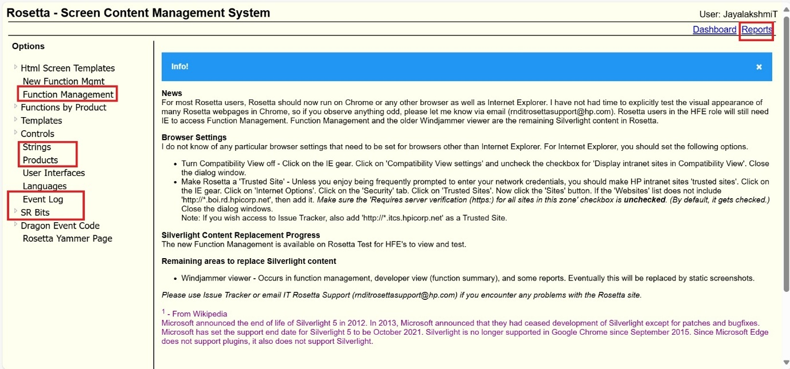

- Strings – Used to create, read, update, and delete string IDs.
- Event Code – Used to create event codes.
- Function Management – Enables searching, reading, creating, updating, and deleting function screen details. It also allows assigning applicable products to a function screen. String IDs, Help IDs, Event Logs, and Triggers can be added to the function screen using this option.
- Products – The Products option in Rosetta helps identify the function sets for all JEDI/JOLT products. It includes details such as colour type, display size, SFP/MFP, print engine, style/UI, finishers, and scanner providing a comprehensive overview of product capabilities.
By cross verifying this information, we can select the appropriate function sets and add products, accordingly, based on the required function sets for the string IDs. This is particularly useful when assigning applicable products to a string by function sets.
The list below shows the available function sets for each product.
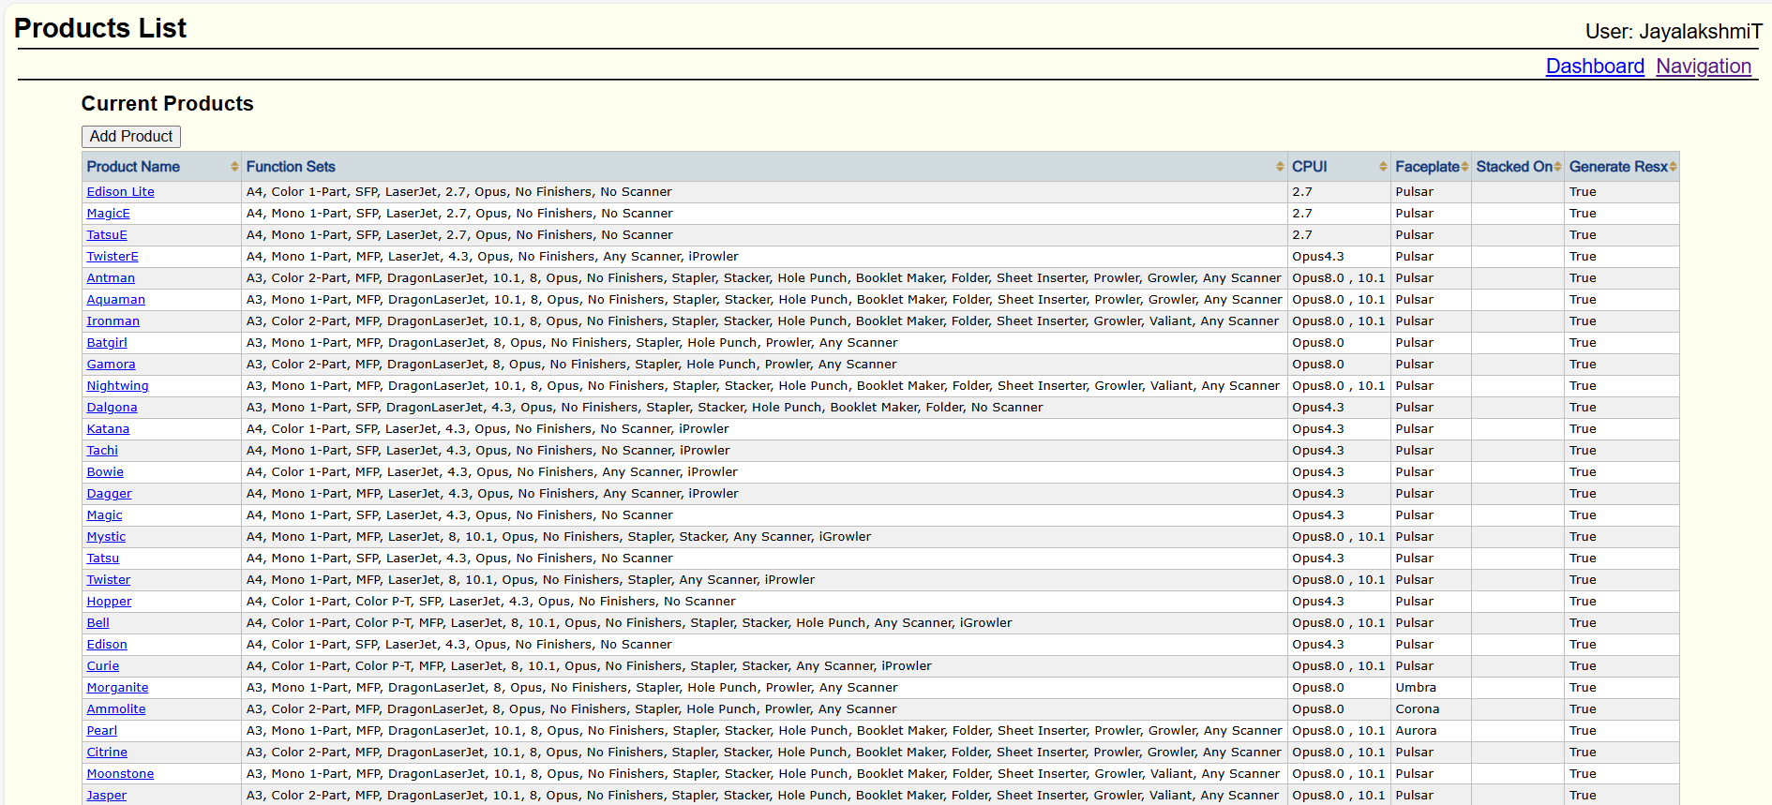
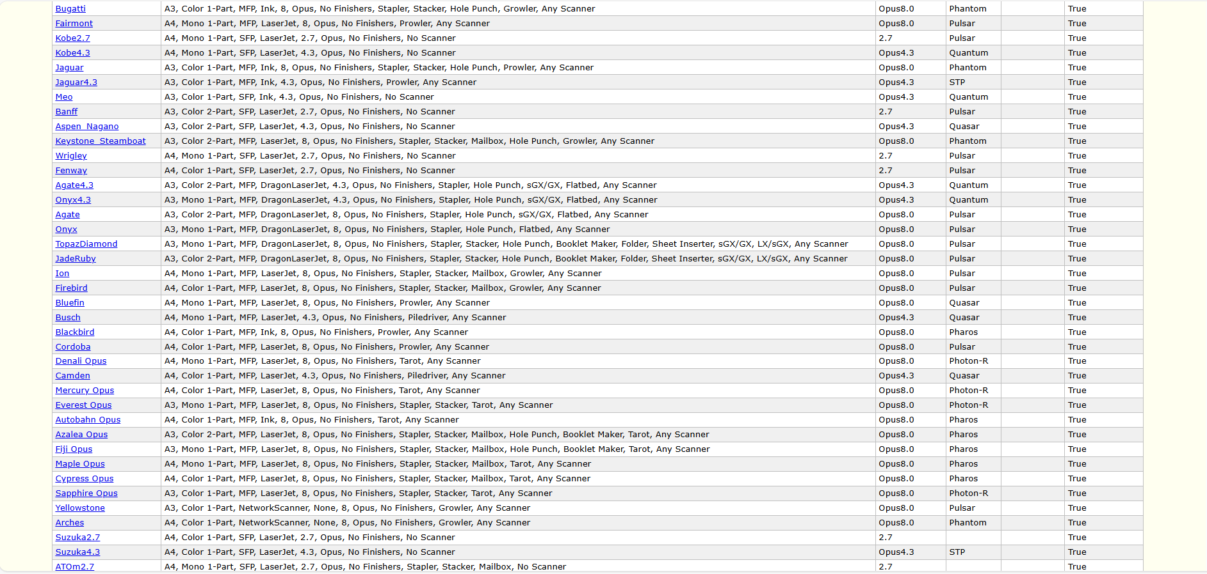
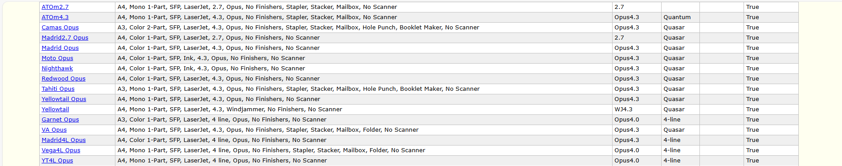

SR Bits:
- We typically receive SR bits from the event code template provided by the designer. We then add these SR bits to their corresponding event codes.
- If a document specifies that SR bits should add as a trigger for a particular function, we configure them as trigger using 'Edit Others' option in function management.

Reports:
The strings team utilizes the following options under reports:
- Binding Strings to Products: After running this option, any product added to the strings in Function Management will also be added to the single value strings on the Strings page. ( if the string is in “By product”)

- Animations and Images: Under this section, the string team uses two options:
1. Animations Per Product Metrics: Displays the count of animations assigned per product in Function Management. This option generates a report detailing:
    - How many animations are present in the Rosetta file for each product
    - In how many places the animations are used in Function Management
    - A list of animations that are missing from the Rosetta file
2. Animation:
The report displays a list of animations used across different products. When we Click on the Function link button, it shows the Function Title where the specific animation is applied.

- File Generation: Here reporter primarily use two options:
  - Generate Resx Files: After running this option, a Help Category JSON file for each selected product in generated and saved in the CSV product folder. These files are then sent to the integration team for implementation.
  - Schedule Rosetta Task: The Integration Team is responsible for generating RESX files, but only for JEDI and Ballpark products this does not apply to JOLT products. These RESX files are used specifically for integration. Once the files are generated, the Strings Team check them. If any language files are not supported for a product, the Strings Team removes those files using the File Delete Tool, based on the information provided by the Integration Team.
- Help: Under the "Help" section, strings team use the following options:
  - Import WUH files: This option is used to import translations provided by the localization team.
  - Approve WUH: After importing, we use 'Approve WUH' to approve the imported translations.
Annexure 2: Reports in Rosetta
Animations Per Product Metrics:
- Navigate to: Reports → Animations and Images → Animations Per Product Metrics
This report provides:
- The count of animation files assigned per product in the function management.
- A list of missing animation files per product.
- Details of GIF animation files currently used in Rosetta.
- Clickable links on animation entries that redirect to the respective Function Screen where the animation is used.

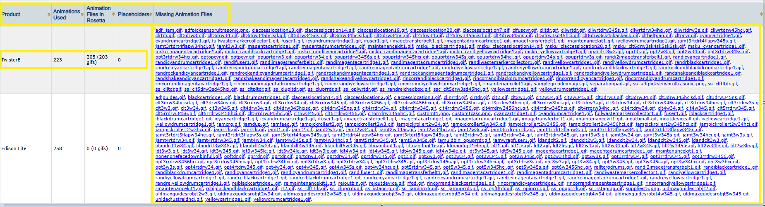

Animations Products:
- Navigate to: Reports → Animations and Images → Animation Products
- The report displays a list of animations used across different products.
- Clicking on the Function link button shows the Function Title where the specific animation is applied.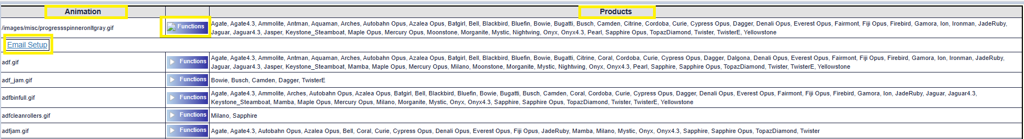

Bind Strings To Products:
- Navigate to: Reports → String Maintenance → Bind Strings to Products
- Select the required products and click the Run button.
- This report binds the products assigned in the Function screen to single-value strings in JEDI that vary by product.
- This ensures the correct string value is displayed based on the product selected in the Function screen.
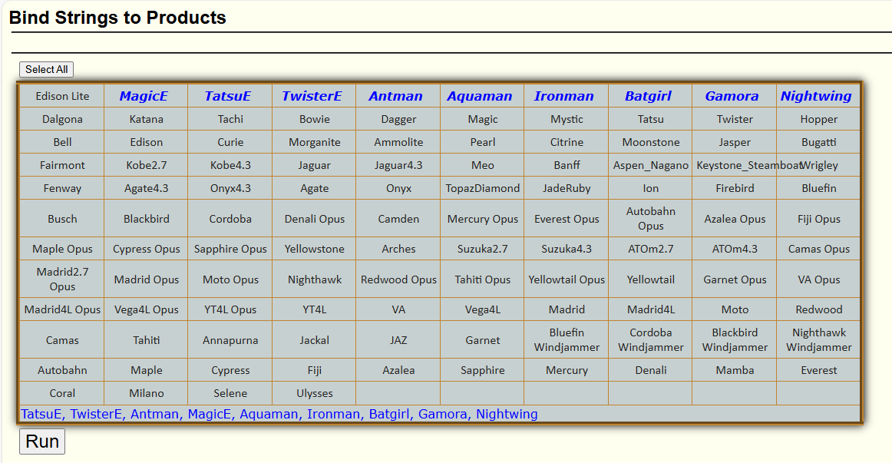

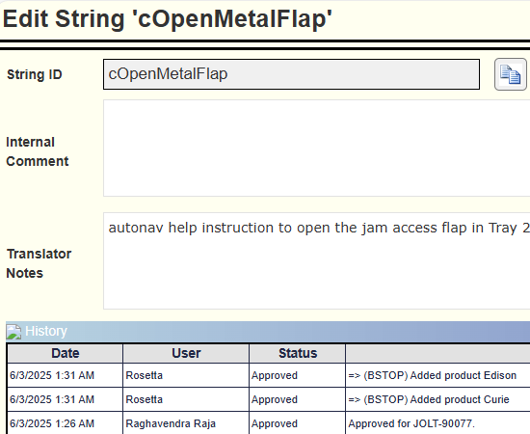

Generate Resx Files:
- Navigate to: Reports → File Generation → Generate Resx Files
- Select all JOLT products except Ballparks, which are not included in the CSV output file.
- Click the Generate button. The tool will generate files and store them in the server folder based on their date.
- In the generated folder, extract only the Help Category JSON file for each selected product and rename each file using the format:productname.Helpcategory (e.g., ammolite.Helpcategory).
- Move the renamed files to the respective product folder to generate the CSV output file.
- Once done, forward the final files path to the Integration Team for implementation.
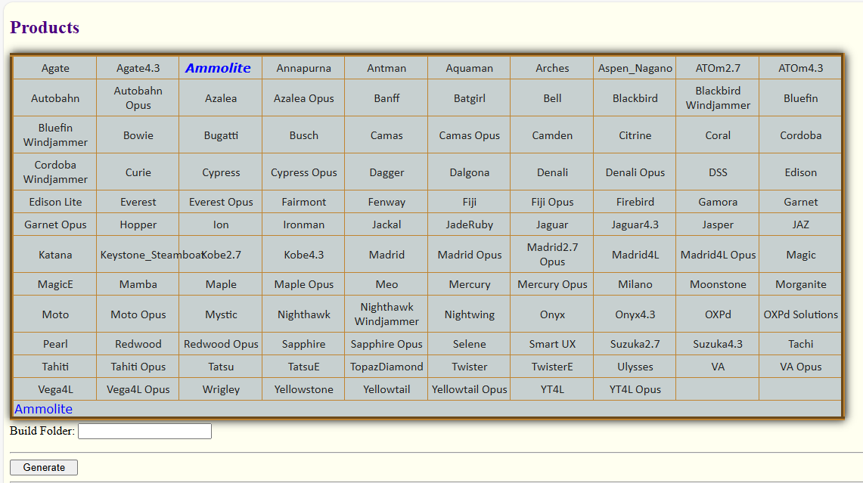

Schedule Rosetta Task:
- Navigate to: Reports → File Generation → Schedule Rosetta Task
- The Integration team will generate RESX file for only JEDI and Ballpark products (Not applicable for JOLT products).
- These RESX files are used for integration purposes.
- After generation, the String Team uses the File Delete Tool to:
- Remove unsupported language files across all products
- Ensures that languages not supported by JEDI are excluded
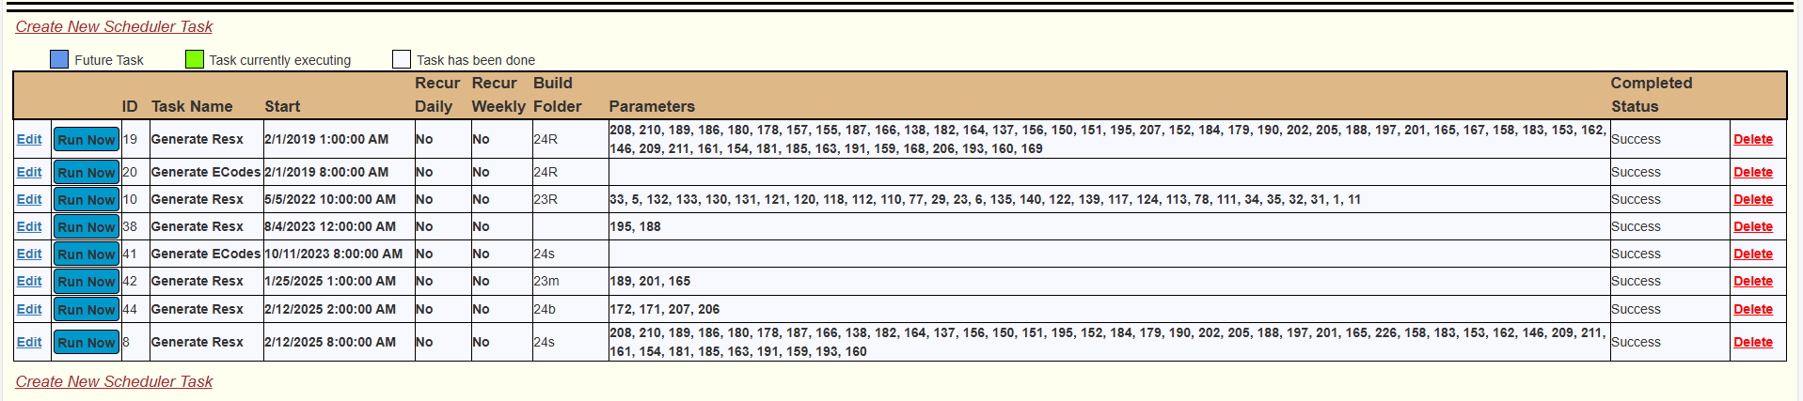

Annexure 3: String Approval
- The Strings Approver will review the finalized strings for grammar, UI constraints, and functional fit.
- If String IDs do not follow JEDI guidelines, move the story back to the String Writer with comments.
- If the String Writer adds additional products to a String ID, confirm and clarify with them as needed.
- Review the UXD document to ensure string IDs and function links are correctly updated.
- Validate that all Rosetta Notes / Translator Notes and contextual information (e.g., sizing, binding) are complete and clear
- Confirm that JIRA fields such as Story Point, Sprint, and Story Status are appropriately updated.
- Add closure comments in JIRA and tag additional reviewers if any further action is pending.
- Approve the string IDs by marking them as “Approved” and transitioning the story to the next team (Integration, Localization, etc.).
- Once all strings are approved, the story will be transitioned to the Integration team to update the firmware (FW) codes, based on the latest FW version.
- Every month, the approved String IDs are shared with the Localization team to initiate translation requests across 33 supported languages.
- The JEDI String Approver is responsible for approving the string IDs created by the String Writer.
- Before approving, the Approver will verify that all strings are updated with translator notes, sizing, function binding, product information, and that they comply with JEDI guidelines.
- Once approved, the strings are handed over to the Integration Team to update the firmware (FW) code based on the latest FW version.
- Every month, the approved string IDs are shared with the Localization Team to initiate translation requests across the 33 supported languages.

Annexure 4: Simulator
JEDI/JOLT Simulator
- Title:
Step-by-Step Guide for Setting Up and Using the Jedi/Jolt Simulator and Emulator GUI
- Introduction:
This comprehensive guide walks users through the process of setting up and accessing the Jedi/Jolt Simulator and its Emulator GUI. It begins with the necessary prerequisites, including how to request access to the Dev Box via Jira under the FW Infra team (BFWINFRA), and provides reference ticket details and approval instructions. Once access is granted, the guide explains how to connect to the simulator machine using Remote Desktop Connection, ensuring a smooth and efficient setup experience.
- Prerequisites
  - Users who require access to the Dev Box must raise a support ticket in Jira under the FW Infra team (BFWINFRA).
  - Reference ticket: BFWINFRA-34293.
  - Access will be granted only after the ticket is approved (Add approver as:
Gowthami R, gowthami.r@hp.com) and processed by the infra team.
- Accessing the Remote Desktop
Use Remote Desktop Connection to access the simulator machine.
- Go to Start → Run.
- Type mstsc and press Enter or click OK
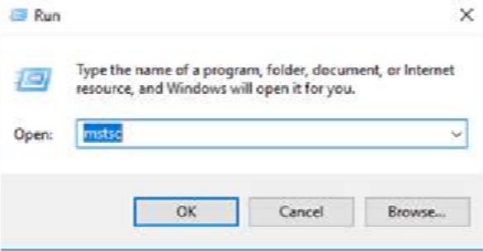
- In the dialog box, enter the computer IP address: IP 15.77.20.168
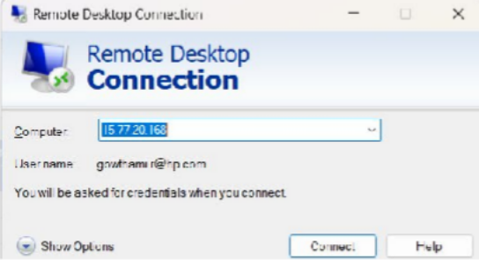
- Click Connect.
- Sign in using your NT password.

- Launching the Simulator
- Open Windows/File Explorer.
- Navigate to: D:\git\joltfw\System
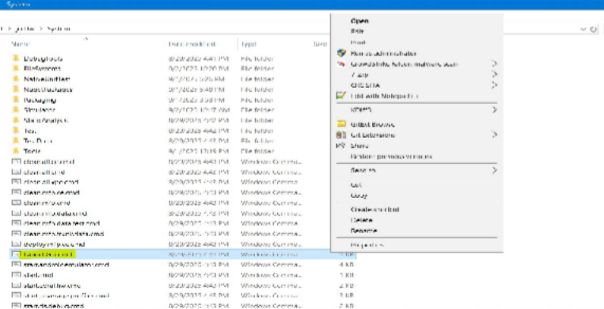
  - Right-click on LaunchGui.cmd and select Run as administrator.
- The Simulator Launch Window will appear.
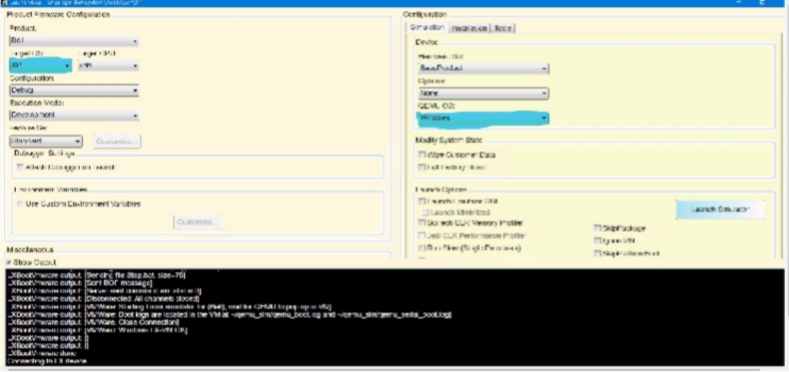
- Select the correct environment for your product:
  - XP for Jedi printers.
  - LX for Jolt products.
  - If you select XP, choose Windows in the QEMU OS settings.
  - If you select LX, choose Linux in the QEMU OS settings.

- Click Launch Simulator.
  - It may take a minute or two to load.
- Once launched, the Control Panel Window will appear.

  - You can now interact with the control panel.
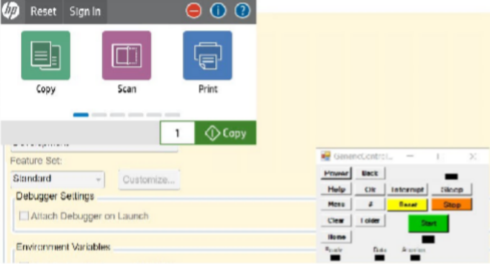

- Shutting Down the Simulator
When you are done:
- Go back to the Launch Window.
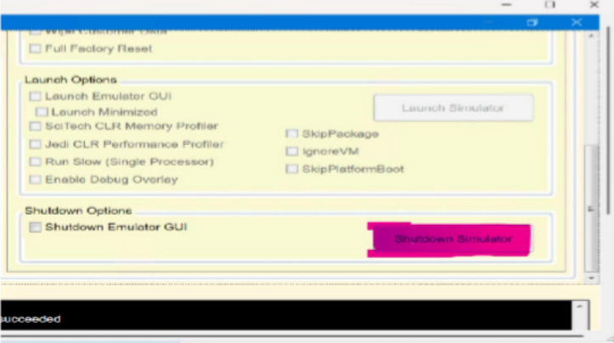
- Click Shutdown Simulator.
- Wait for the shutdown process to complete.
- Close all windows.
- Log off the development box by selecting Disconnect from the power options.

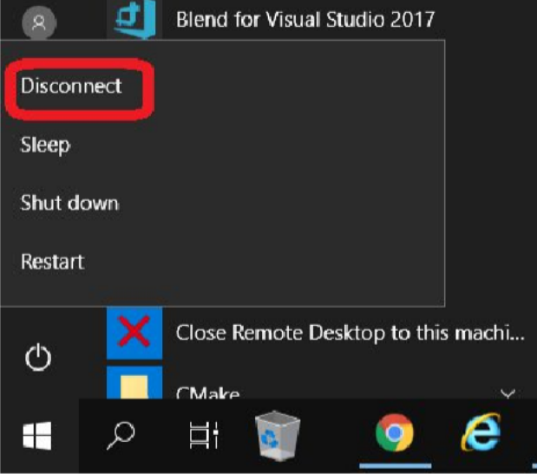

  - ⚠ Caution: Avoid shutting down the development machine.

- Using the Emulator GUI
The Emulator GUI allows simulation of actions such as paper jams, door operations, media loading, USB attachment, and more.
- Launch the Simulator (if not already running).

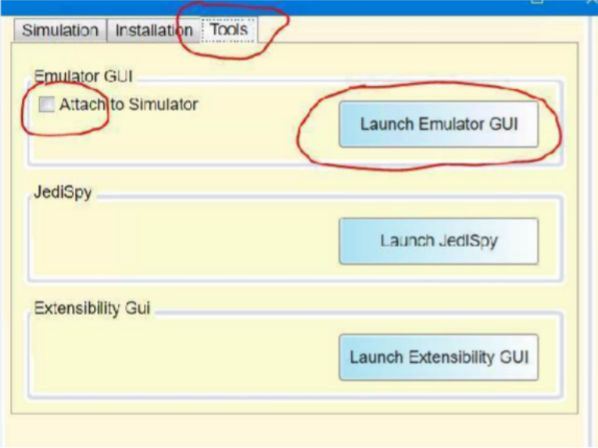
- Navigate to the Tools tab.
- Ensure Attach to Simulator is unchecked.
- Click Launch Emulator GUI.
- In the Emulator GUI Setup Window, click Find Running Simulator.
  - It should detect the active simulator.
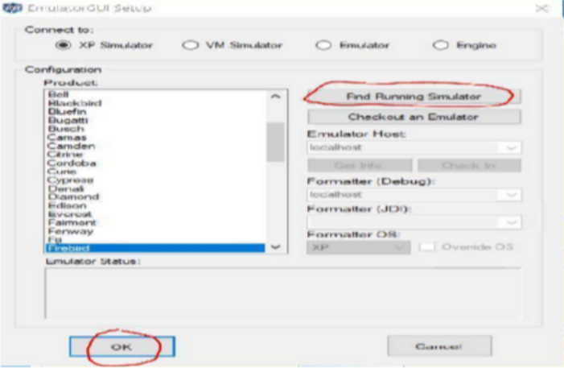
- Click OK.
- The Emulator GUI will launch.

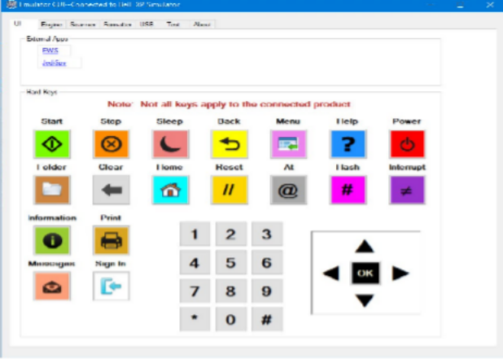

- Accessing the Embedded Web Server (EWS)
To access the EWS:
- Option 1:
1. Open a browser and go to: http://localhost:4242
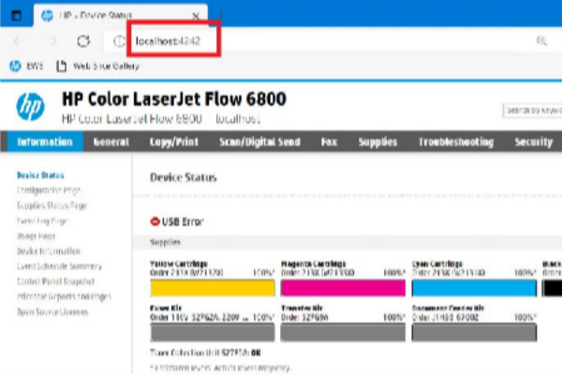
- Option 2:
    - Go to the Emulator GUI window.
    - Navigate to the UI tab.
    - Click EWS.

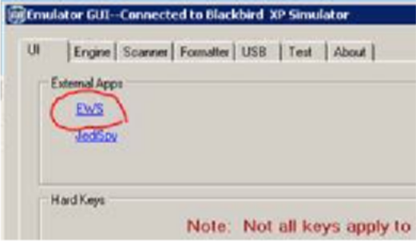
- Managing Service PIN and Admin Password
If you don’t know the service PIN for the product:
- Go to the Security tab in the EWS.

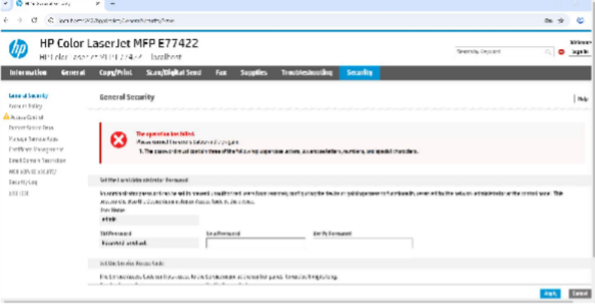

- Set a custom Service PIN (Note: This PIN can also be used as the Admin password to log in to the printer.)
  - The password must comply with standard complexity requirements, including at least three of the following: uppercase letters, lowercase letters, numbers, and special characters.
- Suppressing USB Errors
The simulator may boot with a USB error by default. To suppress it:
- Go to Environment Variables → Customize.
- Set: suppressUSBerror = True
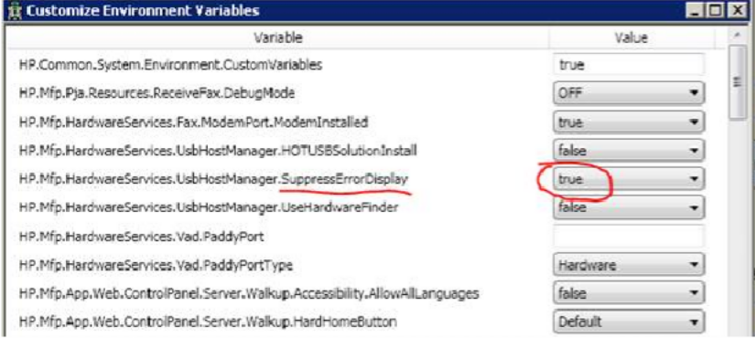

- Accessing Simulator Output
Simulator output (such as print reports or copies) is saved in: D:\git\jedifw2\System\Simulator\Output
Tip: Create a desktop shortcut to this folder for quick access
- Checking Firmware Datecode
- Open the EWS.
- Navigate to: Information → Configuration Page → Firmware Datecod
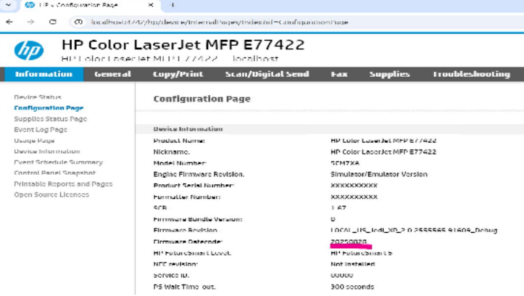

- Simulator Limitations
The simulator has the following limitations:
  - Networking:
- Most networking settings and features are not available, as they rely on the JetDirect Inside (JDI) card and firmware.
  - Web Services:
- Web service-related features are not supported.
  - Time and Latency:
- The simulator runs faster than real hardware; timing and latency tests should be performed on a physical device.
  - Finishing Options:
- Finishing features (like stapling or sorting) should be tested on real hardware.
  - Physical Hardware:
- Any functionality that requires interaction with physical components is not available in the simulator.

- Dev Box Users (As of September 2025)

Below is the list of users who currently have access to the Dev Box:

User Account | Role
AUTH\DasBandh | User
AUTH\kumarnan | User
AUTH\MohananA | User
AUTH\P3Pr334 | User
AUTH\ReddPras | User
AUTH\rgo | User
AUTH\subrammu | User




