Hi guys this is our mini project.

FACE MASK DETECTION.

**DON'T DO ANY THING BEFORE READING THIS. BECAUSE YOU HAVE KNOW ALL THE THINGS AND PROCEDURE BEFORE RUNNING THE CODE.**

First make sure that python must be installed and added to the environment variables. If you are not aware of adding to envir0nment variables

please go through the link below.

<https://youtu.be/Y2q_b4ugPWk>

next type the below command in the command promt.

pip install -r req.txt

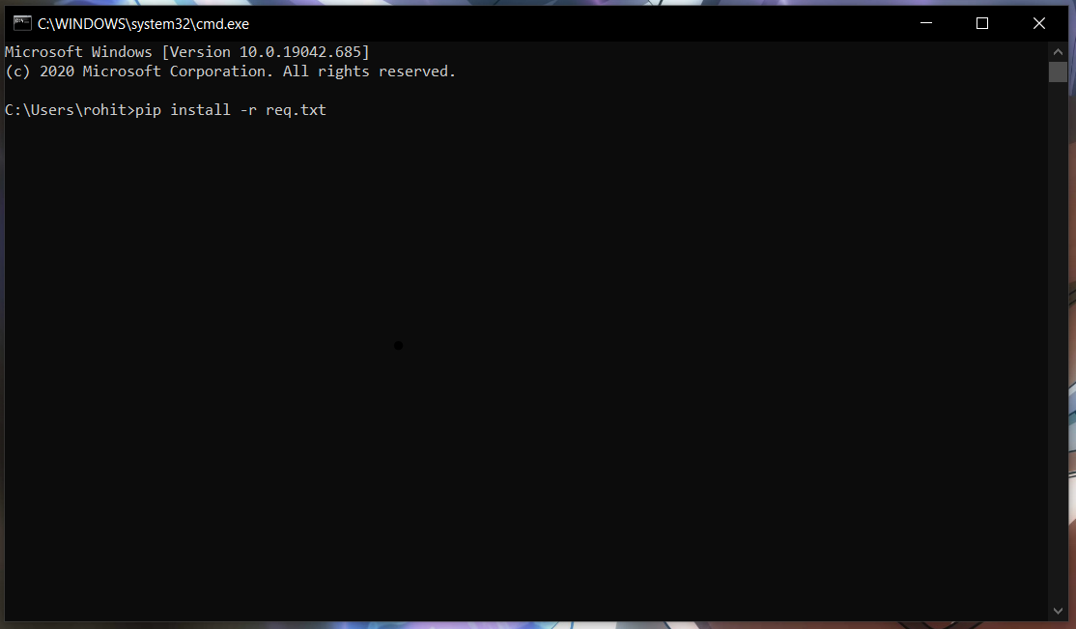

it will automatically install all the required modules.

Literally it wasn't made by me. But I used some resources from you tube and google. At the last there is a u tube link from where I have taken the base code. I had changed many things. In that video the model detects only through the web cam. But I added the image and video.

hope u will understand the things. Try to understand the code by using the video from you tube.

I have given the data set for model. As i have already trained the model. It was saved as mask_detectro_1.model. You need not to train

again. If u want to train you have to add the path of data set in train_mask_detector.py file. There some points you have to notice

* PLEASE DONT TRAIN THE MODEL IN OUR COLLAGE LAPTOP. IT WILL HANG. TRY TO DO IT IN BETTER LAPTOP
* YOU HAVE CHANGE THE PATH OR IT WILL GIVE ERROR
* MAKE SURE THAT YOU HAVE INSTALL ALL THE REQUIRED MODULES
* CHANGE THE OUTPUT MODEL NAME AND PLOT NAME
* IF YOU ARE TO TRAIN IT WILL TAKE MORE AND 40 MIN FOR MY CASE IT TOOK 45 MIN
* I PREFER NOT TO TRAIN. I HAVE ALREADY SET THE PATH FOR MODEL SO THERE WILL BE NO PROBLEM.

For starting the program you have to run the detect_mask_all.py and choose the option.

If you run the program it will gives u like this.

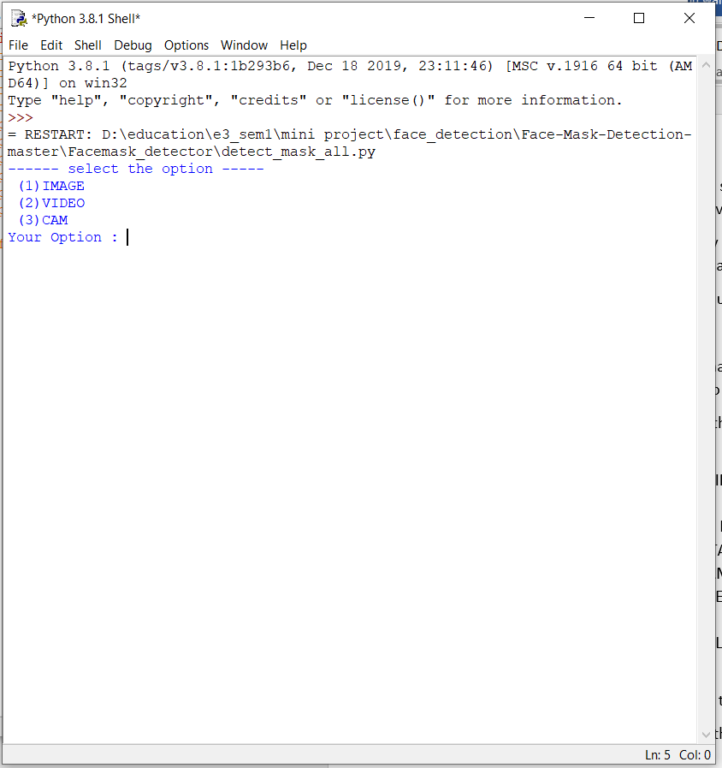

Initially choose option 3 only. Because you have to set the path for image and video. If you are able to set the path you can try the other options.

For out put it will take some time as it has to load the model first and then it will print the option. Please be patience.

**NOTE: PLEASE FOLLOW ALL THE THINGS AND TRY RUNNING THE CODE AND IF U HAVE AND ERROR IMMEDIATELY MESSAGE ME WITH SCREEN SHOT OR CALL ME, I WILL TRY TO RESOLVE IT. AS I FACED A LOT FOR MODULE ERRORS AND CODE ERRORS.**

**-----------------ERRORS MAKE US TO LEARN NEW THINGS--------------------**

**Video link:** [**https://youtu.be/Ax6P93r32KU**](https://youtu.be/Ax6P93r32KU)

You can use the above link to understand the code and other things.

After completing this we must gather and discuss the other thing

Don’t worry if u don’t have the laptop but please see the video as a initial reference.