**Shoulder muscle recruitment of small amplitude motor units during the delay period encodes a reach movement plan which is sensitive to task context**

(Figures)

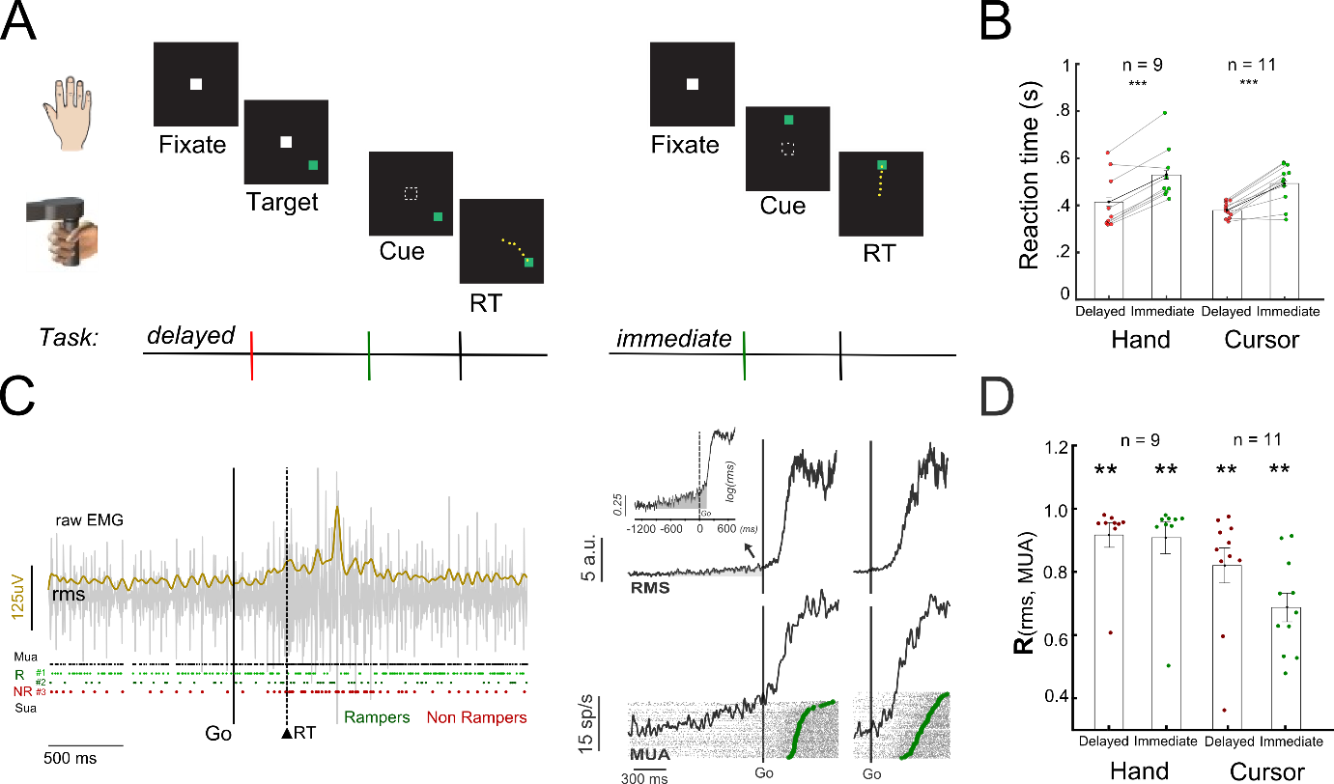

**Fig 1: Task and methods.**

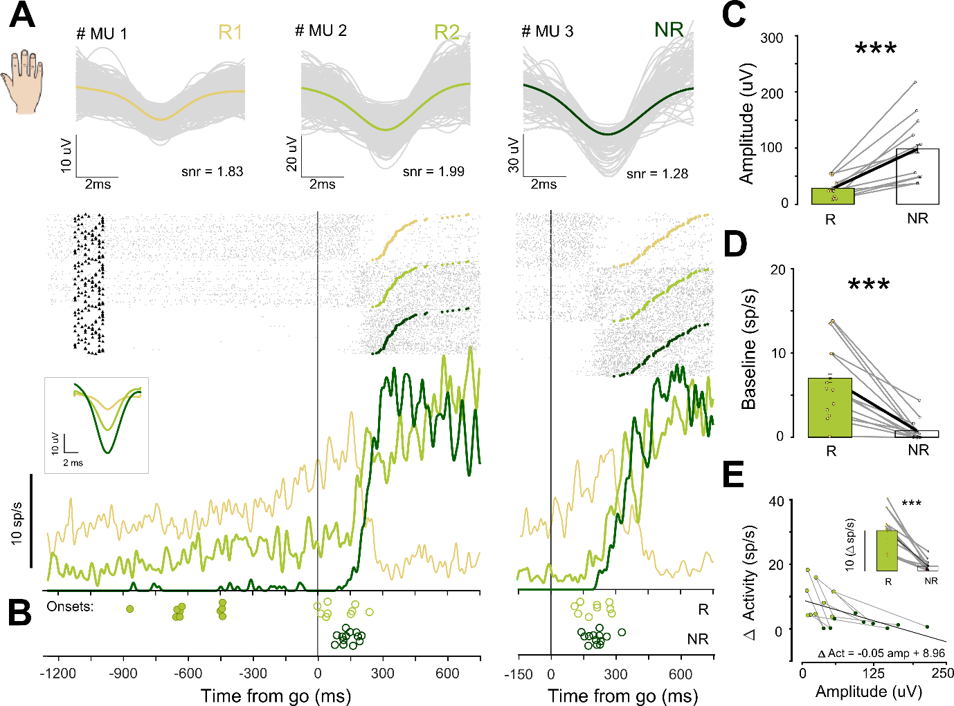

**Fig 2: Recruitment of motor units based on amplitude size and baseline activity**

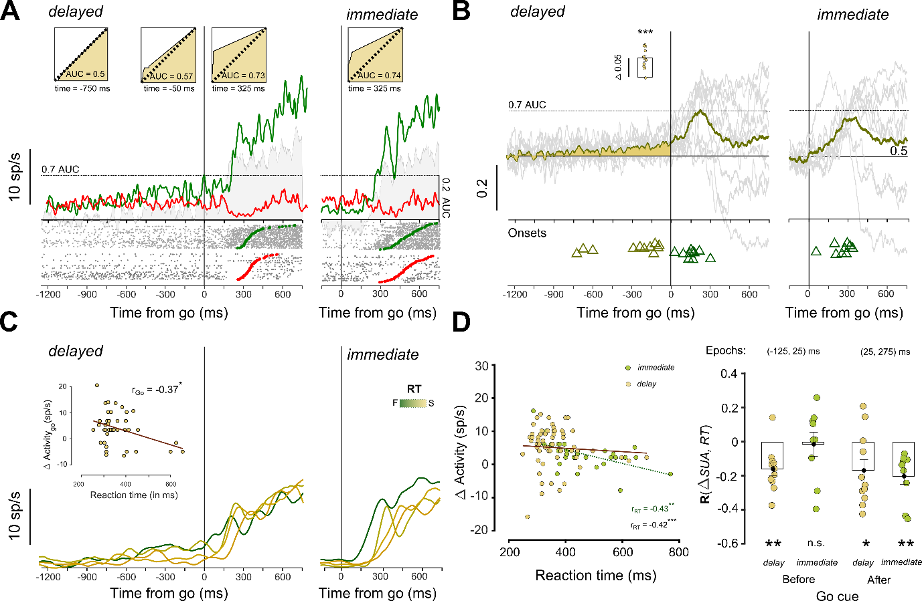

**Fig 3: Rampers showing spatially selective response and temporal correlation for upcoming hand movements during the delay period and reaction time.**

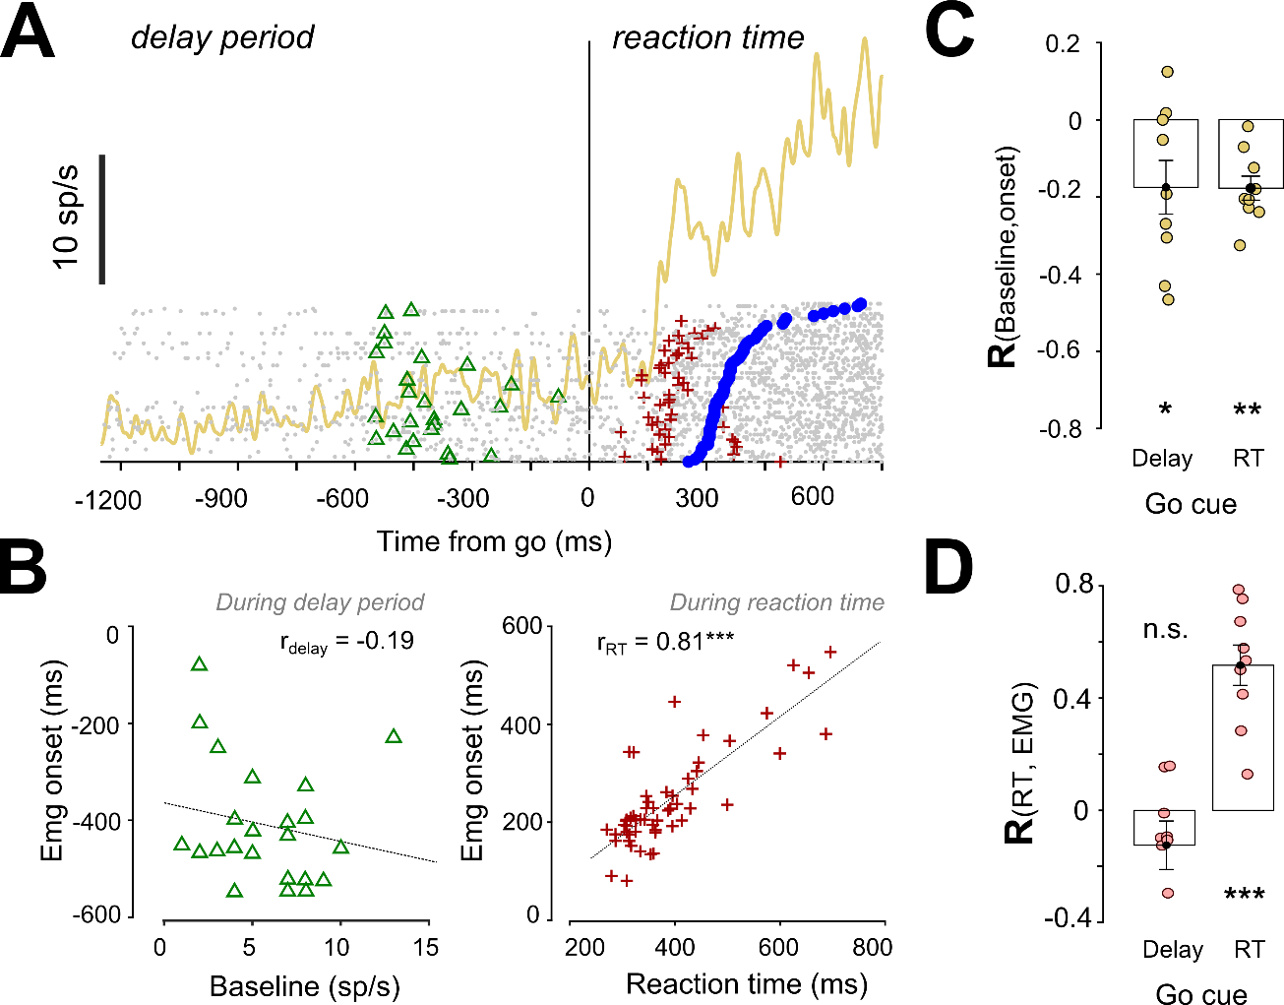

**Fig 4: Single trials onsets for rampers during the delay period and reaction time period.**

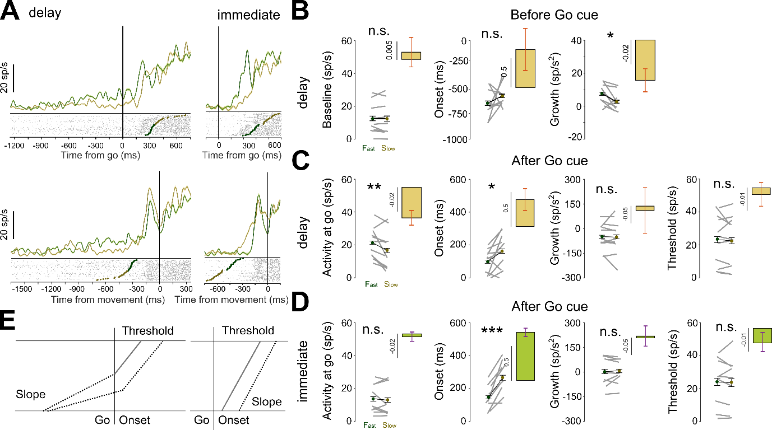

**Fig 5: Ramping activity can be described as an accumulator model.**

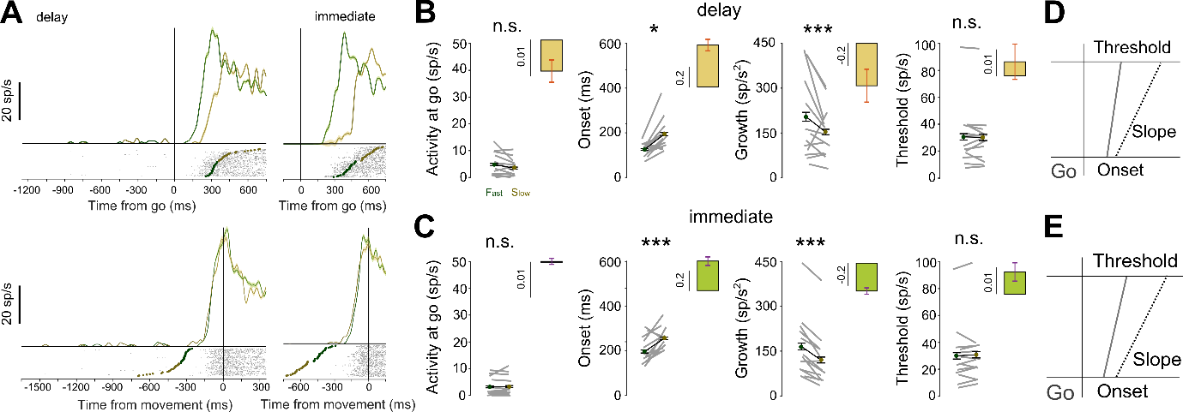

**Fig 6: Non-ramping activity can be described as an accumulator model.**

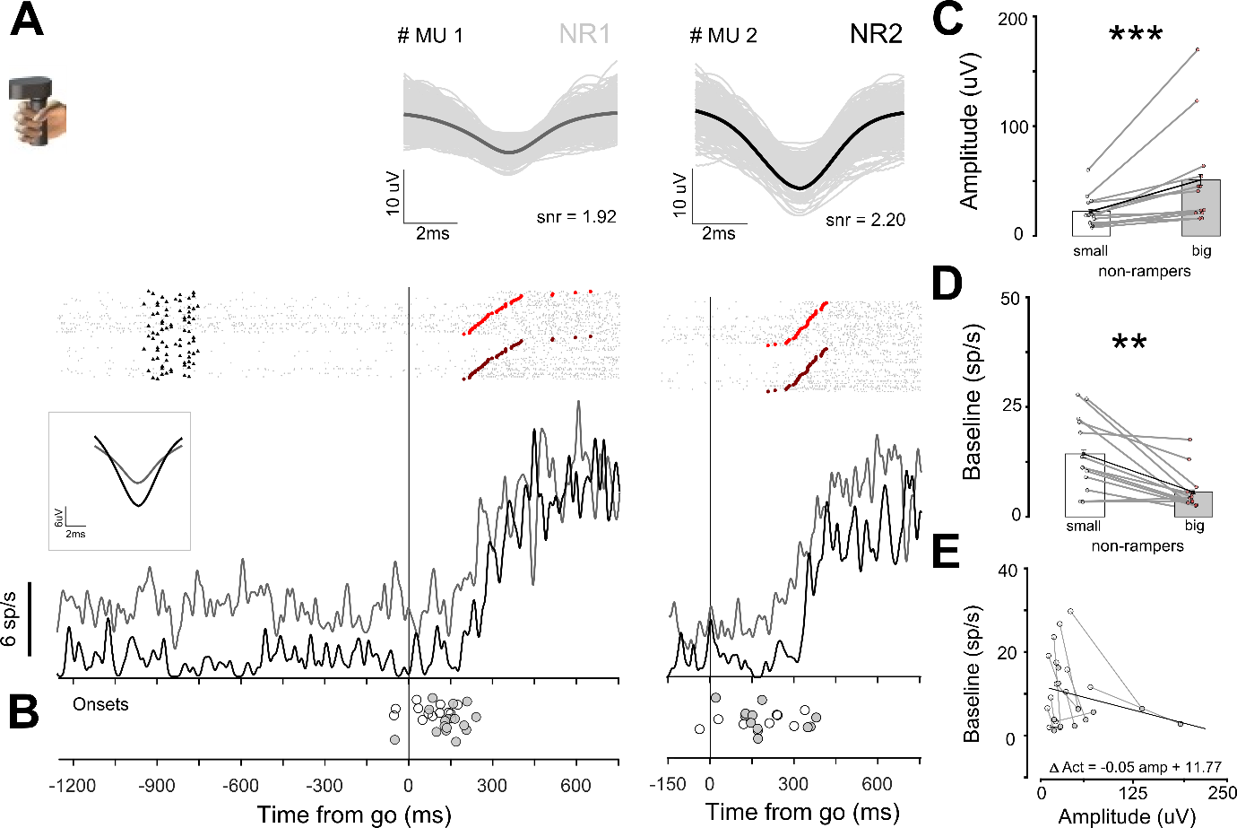

**Fig 7: Recruitment of motor units based on amplitude size and baseline activity in the isometric cursor task.**

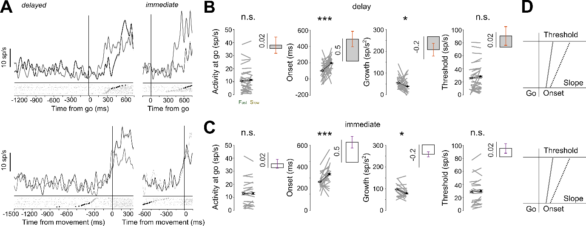

**Fig 8: Isometric force driven initiation of cursor movements**