**Shoulder muscle recruitment during the delay period encodes a reach movement plan which is sensitive to task context**

(Supplementary figures and legends)

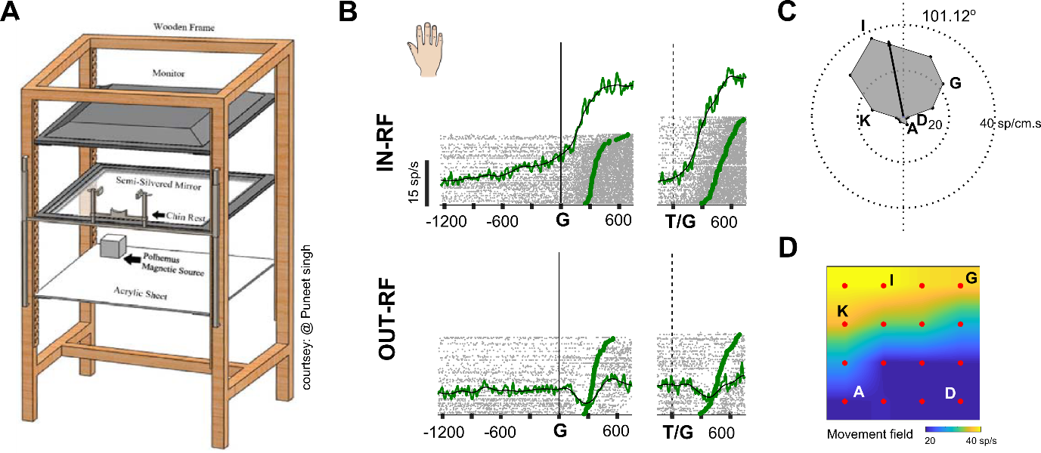

**S1: Reach movement experimental setup and response fields of muscle activity**

A) Schematic representation showing the experimental setup for hand movements. B) Top panel: Response of deltoid (shoulder) muscles when the target was located in the movement field for delayed (left panel) and immediate movements (right panel). Bottom panel: Response of deltoid (shoulder) muscles when target was located away from the movement field. C) A polar plot showing the preferred movement direction. D) A The movement field generated from target and movements arranged in a rectangular grid. Muscle activity is colour coded with yellow indicating high activity and blue indicating lower activity.

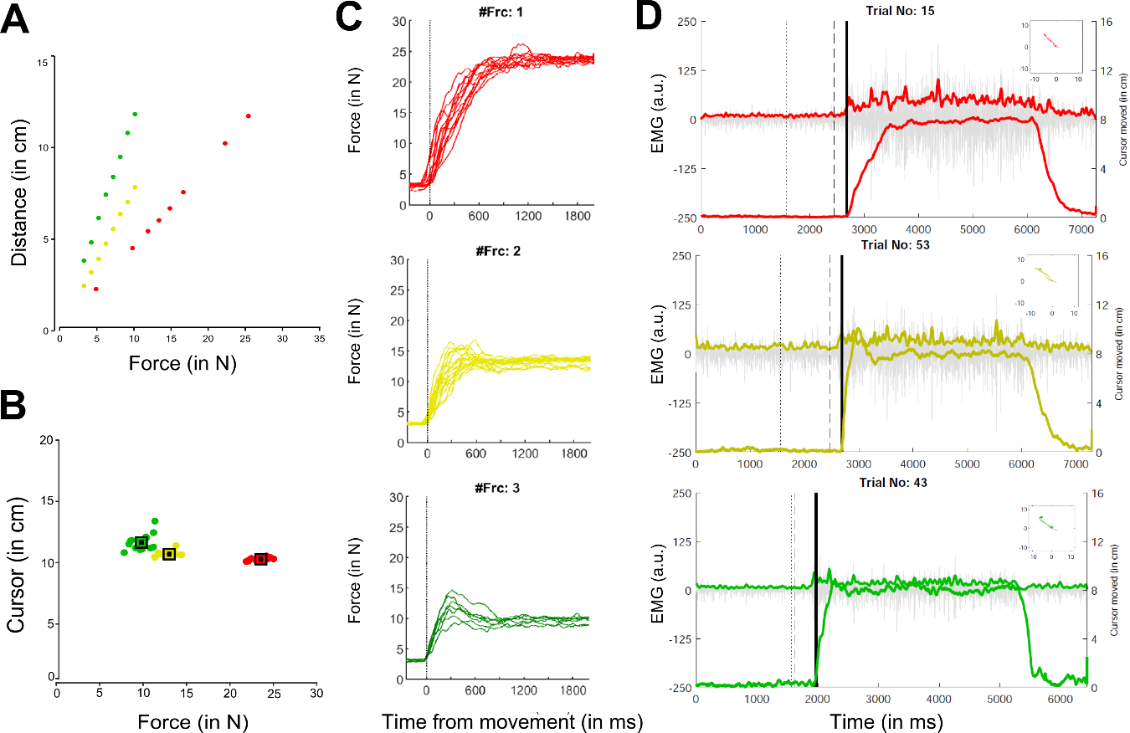

**S2: Isometric cursor movements and EMG activity at different force levels.**

A) Scatter plot showing distance moved by cursor on the screen as a function of different force levels applied on the manipulandum of the robotic arm. B) The distance moved by the cursor from the centre of the fixation spot at the end of each trial for each force condition. C) Top panel (red), middle panel (yellow) and bottom panel (green) showing example trials as a function of time, aligned on movement onset for each force level, respectively. D) Root mean square (rms) response variation in strength of the EMG signal for each example trial as a function of different force levels (red, yellow and green).

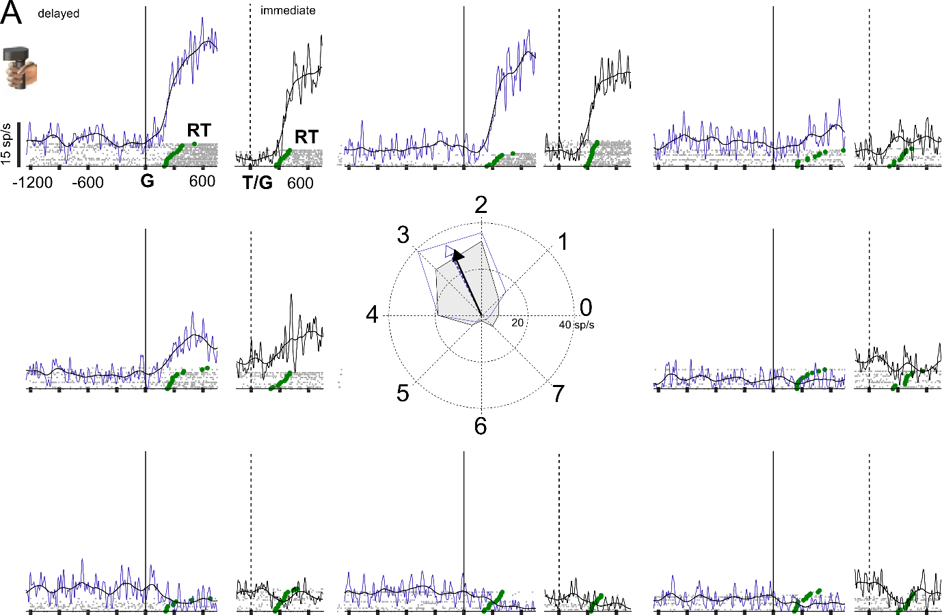

**S3: Spatially tuned response field for cursor-based movements**

A) EMG responses for delayed (blue) and immediate (black) movements, aligned on the go cue, for eight different target locations, for a representative session recorded from the shoulder muscles during isometric cursor movements. Each grey marker represents a spike. Each spike train represents the response on a single trial which were sorted based on reaction time (green markers). Solid line for the delayed (blue) and immediate task (black) represents the trend seen in the muscle activity for the example session.

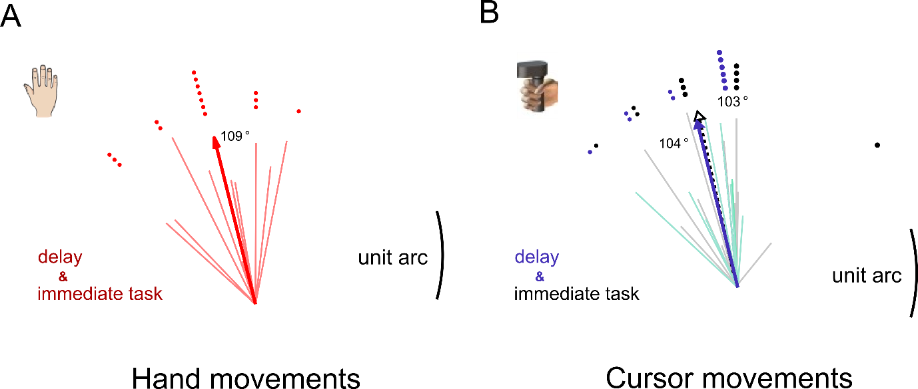

**S4: Preferred movement directions of the anterior deltoid muscle during hand and cursor movements.**

A) The polar plot shows the preferred direction and amplitude of the movement field for the population (thick line) and each session (thin lines) that was recorded prior to delayed and immediate hand movements. The dots demarcate the frequency of occurrence. B) The polar plot shows the preferred direction of the movement field for the population (thick and dashed line) and each session (thin lines) for immediate (grey) and delayed (blue) cursor movements, respectively. The dots demarcate the frequency of occurrence.