**ONLINE MOVIE TICKET BOOKING SYSTEM**

Project report in partial fulfillment of the requirement of Software Engineering Lab

In

COMPUTER SCIENCE & ENGINEERING DEPT.

Submitted By

Aditi Tibrewal Department of Computer Science,

University Roll No. 12018009019341 UEM, Kolkata

Section: B, Class Roll No.: 4

Akash Mondal Department of Computer Science,

University Roll No. 12018009019600 UEM, Kolkata

Section: B, Class Roll No.: 6

Aishee De Sarkar Department of Computer Science,

University Roll No. 12018009019133 UEM, Kolkata

Section: 5, Class Roll No.: 5





UNIVERSITY OF ENGINEERING & MANAGEMENT, KOLKATA

University Area, Plot No. III – B/5, New Town, Action Area – III, Kolkata – 700 156

Table of Contents

Table of Contents ii

Revision History ii

1. Introduction 1

1.1 Purpose 1

1.2 Document Conventions 1

1.3 Intended Audience and Reading Suggestions 1

1.4 Project Scope 1

1.5 References 1

2. Overall Description 2

2.1 Product Perspective 2

2.2 Product Features 2

2.3 User Classes and Characteristics 2

2.4 Operating Environment 2

2.5 Design and Implementation Constraints 2

2.6 User Documentation 2

2.7 Assumptions and Dependencies 3

3. System Features 3

3.1 System Feature 1 3

3.2 System Feature 2 (and so on) 4

4. External Interface Requirements 4

4.1 Hardware Interfaces 4

4.2 Software Interfaces 4

4.3 Communications Interfaces 4

5. Other Nonfunctional Requirements 5

5.1 Performance Requirements 5

5.2 Safety Requirements 5

5.3 Security Requirements 5

5.4 Software Quality Attributes 5

6. Other Requirements 5

Appendix A: Glossary 5

Appendix B: Analysis Models 6

Appendix C: Issues List 6

7. Design Documents

8. Screen Shots of the developed system

9. Future Scope

10. Bibliography

## Purpose

• The main purpose of our online ticket booking system is to provide another way for the customer to buy cinema ticket. It is an automatic system.

• This system is basically aimed to provide the customer the complete information of the movie, according to which the customer can book the tickets and the refund facility provides more flexibility to the system.

• The goals of our system are:

1 To provide a anytime anyplace service for the customer

2 To minimize the number of staff at the ticket box

3 To promote the film on the internet

4 To increase the profit

## Document Conventions

Heading: Font Size: 18

Font Style: Bold

Font : Times New Roman

Sub Heading: Font Size: 14

Font Style: Bold

Font: Times New Roman

Content: Font Size: 11

Font: Times New Roman, Arial

## Intended Audience and Reading Suggestions

This document is intended for the users and developers. We suggest that the readers read the documents to understand very clearly the information including the goal of the system, the advantages and how does the system work.

## Project Scope

The project objective is to book cinema tickets in online. The Ticket Booking System is an Internet based application that can be accessed throughout the Net and can be accessed by anyone who has a net connection. User is required to login to the system and needs a credit card for booking the tickets. Tickets can be collected at the counter and Watching movies with family and friends in theatres is one of the best medium of entertainment after having a hectic schedule. But all this excitement vanishes after standing in hours in long queues to get tickets booked. The website provides complete information regarding currently running movies on all the screens with details of show timings, available seats. Ticket reservations are done using credit card and can be cancelled if needed. Our online tickets reservation system is one of the best opportunities for those who cannot afford enough time to get their tickets reserved standing in long queues. People can book tickets online at any time of day or night.

## References

* Class notes
* Stackoverflow.com
* W3schools.com

## Product Features

**User Registration and Login Screen**

User registration and login screen are the basic features of the ticket booking platform.

**Details Of The Movie:**

Once the user selects the movie, he is navigated to another page that gives details about the movie such as its synopsis, trailers, featured interviews or news, information about the cast and crew, runtime and reviews & ratings.

**Seat Allocation:**

The number of seats to be booked, the location of seats and tire of the seat from the seat layout. You can also put a limit on the number of seats per purchase.

**Payment Gateway:**

Once the user selects the seats the next step is to make the purchase. It is essential to make sure the experience is convenient and safe — and for this reason, you need to consider the following factors .

* Security.
* Provide different  payment methods
* Selecting the right payment gateway

## User Classes and Characteristics

<Identify the various user classes that you anticipate will use this product. User classes may be differentiated based on frequency of use, subset of product functions used, technical expertise, security or privilege levels, educational level, or experience. Describe the pertinent characteristics of each user class. Certain requirements may pertain only to certain user classes. Distinguish the favored user classes from those who are less important to satisfy.>

## Operating Environment

* **Frontend, UI**: HTML5/CSS3
* **Backend**: PHP
* **Server**: Xampp
* **Database**: PHP Myadmin

***Platform Windows platform like***: 2000 professional, XP & Vista

# Design and Implementation Constraints

* The online movie ticket booking system shall be web based system that can run onto different browsers such as Internet explorer, Mozilla Firefox, Google chrome, Safari etc.
* The system shall be developed using Html, CSS, Bootstrap, Php.
* The system shall run using MySQL database server.

## User Documentation

In order to provide assistance to the user, the online ticket booking system provides a **contact us** page where the user can put their queries.

## Assumptions and Dependencies

We are assuming that the user has basic knowledge how to book tickets online.

**System Design**

The design of the system is the most critical factor affecting the quality of the software; it has major impact on the later phases, particularly testing and maintenance. The output of this phase is the design document. This document is similar to blueprint or plan for the solution

The design activity is often divided into two phases: -

System design:

* Aims to identify the modules that should be in the system, the specifications of these modules and how they interact with each other to produce the desired results.
* At the end of system design all the major data structures, file formats and the major modules in the system and their specifications are decided

Physical Design (Database Design)

* A database may be thought of as a set of related files. Related files mean that record of one file may be associated with the records in another file.
* The conventional file based systems emphasized that the application and files were built around it. The database environment emphasizes the data independently of the applications that use the data.

# System Features

* Sign up page
* Log in page
* Home page
* About page
* Contact page
* Booking page

# External Interface Requirements

## Hardware Interfaces

Intel Pentium and Celeron class processor

**Processor Speed** – 1.2 GHz or above

**RAM** - 512 MB

* HDD - 40 GB
* Monitor-14”SVGA
* Printer –Laser Printer
* Mouse- Normal
* Keyboard- Normal

## Software Interfaces

***Front-end Tool:*** - HTML5/CSS3

* User friendly
* Low Cost Solution
* GUI feature
* Better designing aspects

***Back-end Tool:*** - PHP/JAVASCRIPT

* Security
* Portability
* Quality

**Platform Windows platform like**: 2000 professional, XP & Vista

## Communications Interfaces

The required communication interfaces are

* TCP/IP
* HTTP

# Other Nonfunctional Requirements

## Performance Requirements

**Reliability** : The system will consistently perform its intended function.

For eg: The important information must be validated.

**Integrity** : Only System Administrator has rights to access the database, not every user can access all the information. Each user will be having rights to access the modules

## Security Requirements

**System login**:

For user to login it requires the valid login and password before granting further access.

**Data encryption**: The online reservation system encrypts all information before writing it into the database.

**Maximum login attempts:** This system allows the maximum of three consecutive attempts.

**Transaction recordings**: This system shall keep a record of all failure login attempts with user login, terminal login and time.

## Safety Requirements

The user system should have an active internet connection. If in case user lost its connection the website is designed in such a way that it preserves of all the data and prevent any data loss.

## Software Quality Attributes

The system is designed in such a way that the user cannot view the internal details such as the information provided in login and signup databases

# Other Requirements

It requires a large database.

Appendix A: Analysis Models

Class Diagram

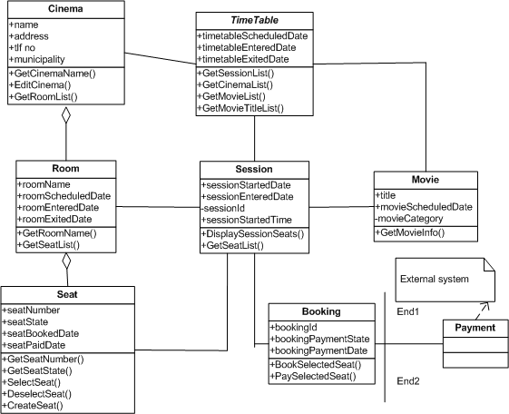

Activity Diagram

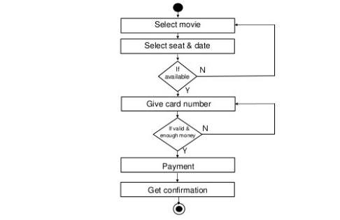

Sequence Diagram

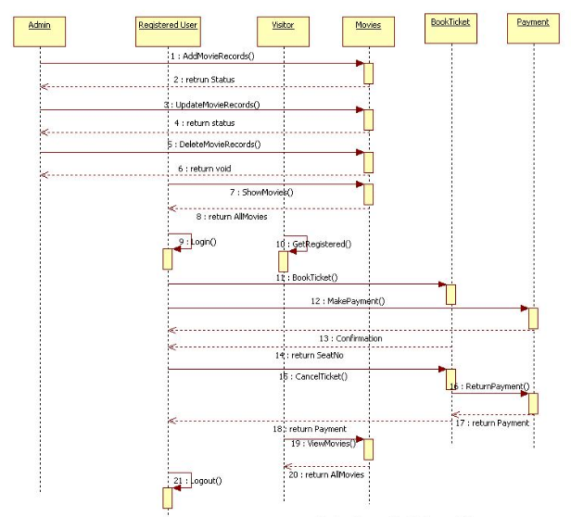

Appendix B: Implementation

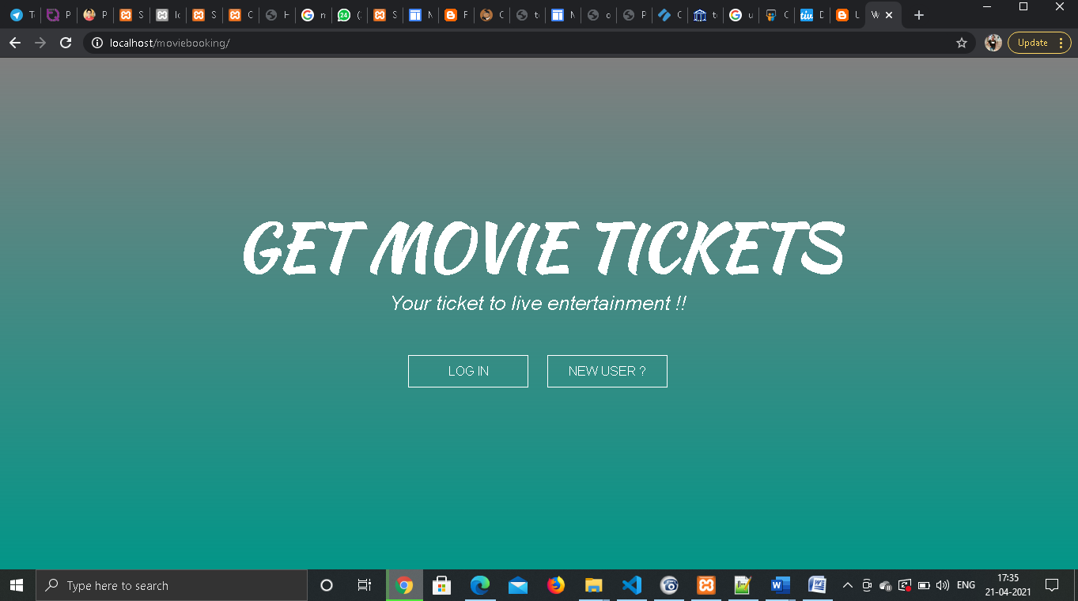

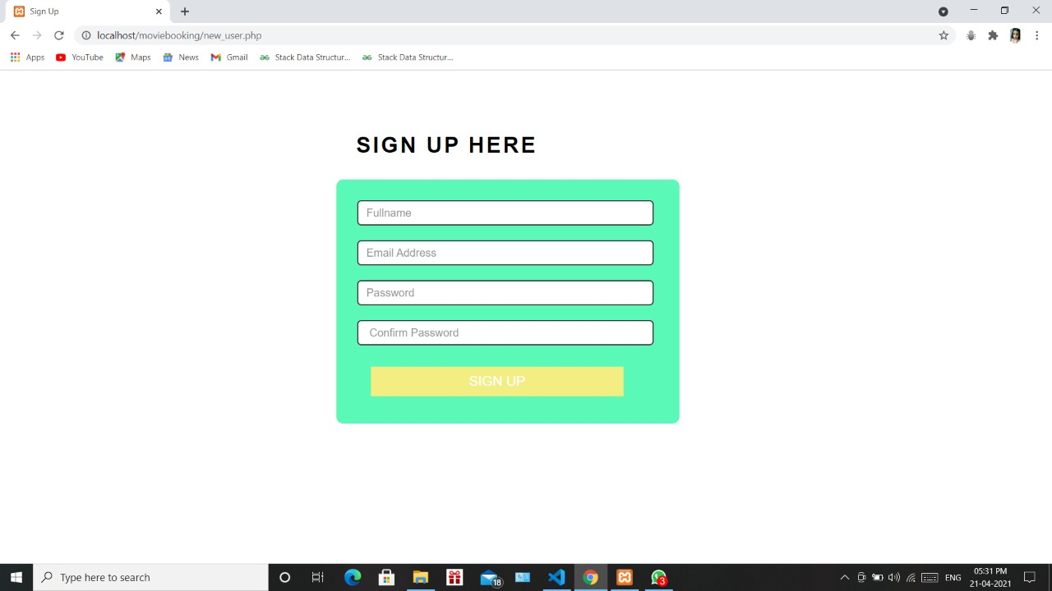

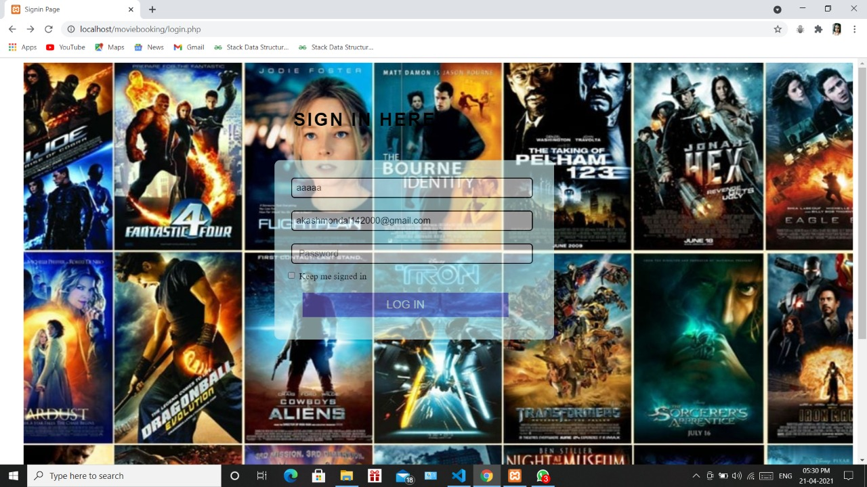

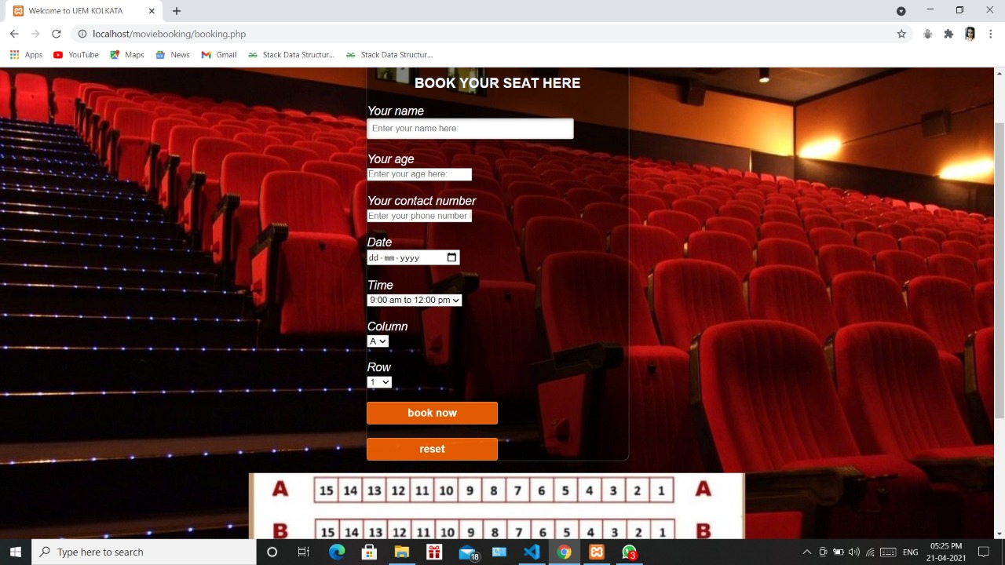

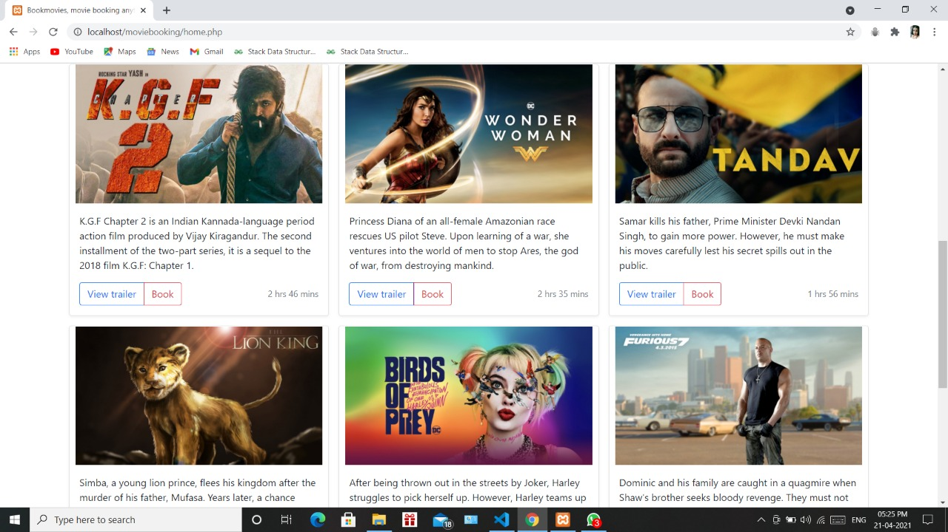

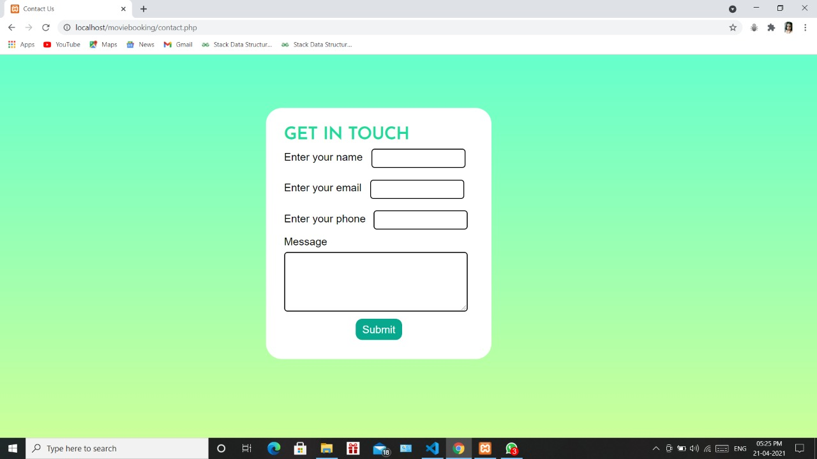

THANK YOU!!