Hallucination Detection in Large Language Model Outputs Using Claim-Level Evidence Retrieval and Natural Language Inference
P Satya Sreejay  School of Computer Science Engineering  and Information Systems  Vellore Institute of Technology  Vellore, India | Rishu Raveendran  School of Computer Science Engineering  and Information Systems  Vellore Institute of Technology  Vellore, India | Sreehari K  School of Computer Science Engineering  and Information Systems  Vellore Institute of Technology  Vellore, India

Abstract—Large language models (LLMs) often state false information fluently, and their own confidence cannot be used to judge whether a statement is correct. This paper presents a hallucination detection system that verifies an LLM’s answer claim by claim against external evidence instead of trusting the generator. The answer is split into sentence-level claims with spaCy, evidence passages are retrieved from Wikipedia and ranked by lexical overlap, and a separate natural language inference (NLI) cross-encoder labels each claim as Supported, Contradicted or Insufficient Evidence. Retrieval and model failures receive their own labels rather than a guessed verdict, and a Streamlit dashboard shows every claim with its evidence, scores and verdict. On 2,950 held-out FEVER development pairs, the pretrained DeBERTa-v3-base NLI verifier reaches 80.2% accuracy and a macro F1-score of 0.797, and 80.9% and 0.807 with thresholds tuned on validation data. On the RAGTruth corpus of real LLM hallucinations, its strict sentence-level precision of 12.6% is about 3.6 times the 3.5% base rate, but its F1-score is only 0.16, because most RAGTruth hallucinations are unsupported additions rather than contradictions.
Index Terms—large language models, hallucination detection, fact verification, natural language inference, evidence retrieval, DeBERTa, FEVER, RAGTruth.
I. Introduction
Large language models produce text that is likely given their training, not text that has been checked. When they state something false, the output is just as fluent and confident as when it is correct, a behaviour known as hallucination [1]. Because confidence and correctness are not linked, the model’s own output is an unreliable judge of itself.
Existing detectors take two broad approaches. Uncertainty-based methods measure how consistent a model is with itself, for example by sampling several answers and checking whether they agree [2], [3]. Evidence-based methods instead break a response into short factual statements and check each one against an external knowledge source [4], [5]. This work follows the second approach and treats hallucination detection as a fact-verification task [6]: the answer is split into checkable claims, independent evidence is retrieved for each claim, and a classifier trained for textual entailment decides whether the evidence supports, contradicts or does not settle the claim.
The contributions of this paper are:
• a modular pipeline in which the answer generator and the verifier are separate models, so the verifier sees only the claim and the evidence;
• an explicit labelling policy in which missing evidence is never treated as falsity and retrieval or model failures are reported rather than hidden;
• an evaluation of pretrained DeBERTa-v3 NLI verifiers on FEVER and on RAGTruth, a corpus of real LLM hallucinations.
II. Proposed System
Fig. 1 shows the runtime pipeline. The system has two halves that never share state. The generation half wraps any LLM behind one interface, and the verification half performs claim extraction, evidence retrieval and NLI classification. Each stage is a separate Python module with its own tests, so any stage can be replaced or evaluated on its own.
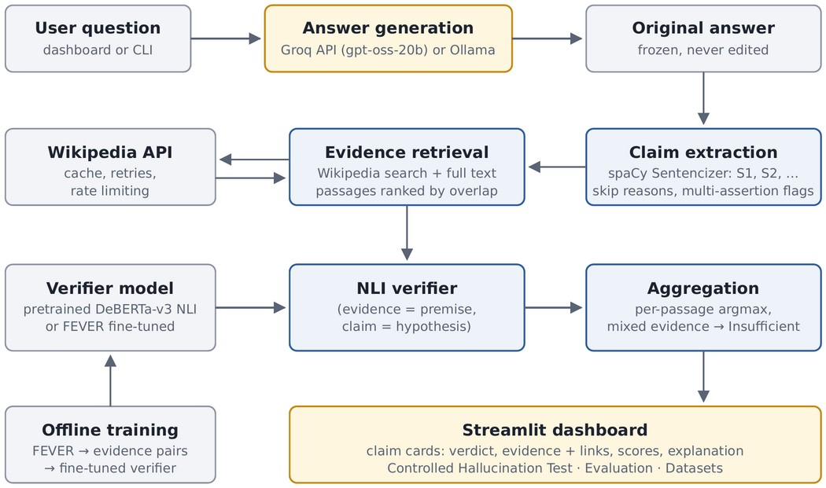
Fig. 1. Runtime pipeline. Blue: verification system; amber: generation and presentation; grey: inputs, data and offline training.
A. Answer Generation
By default, answers are generated by the open-weight gpt-oss-20b model through the Groq API. Other OpenAI-compatible providers and local Ollama models can be selected through a configuration setting. Errors such as an invalid key, rate limiting, timeouts or malformed replies are reported explicitly, and no answer is silently substituted. The original answer is frozen and never edited, and each answer records the provider and model that produced it.
B. Claim Extraction
The rule-based spaCy Sentencizer splits the answer into sentences, each with an identifier and its exact character span. Questions, greetings, opinions, advice and fragments shorter than four words are shown but not verified, with the reason given. A sentence is not always a single fact, so sentences with signs of several assertions, such as semicolons, coordinated or relative clauses, parentheses or two or more numbers, are flagged and verified as a whole; they are Supported only if everything in them is supported. Optionally, an LLM can decompose a sentence into atomic sub-claims, in the spirit of FActScore [4], and sub-claims that cannot be traced back to the answer are discarded.
C. Evidence Retrieval
The subject of the answer is first identified as the top Wikipedia search result for the question, or for the first claim when an answer is pasted in. For each claim, the MediaWiki search API returns the top matching Wikipedia pages, with a keyword fallback; a claim that does not name the subject, such as “It was designated a UNESCO World Heritage Site in 1983”, is searched together with it. The subject only steers retrieval and is never shown to the verifier. The full plain text of each article is fetched, cut into passages and ranked by BM25-style lexical overlap with the claim, and the top three passages are kept. Passages from pages whose titles share no content word with the claim or the subject are discarded, so that an article about a different entity cannot decide the verdict. Timeouts, retries with backoff, request spacing and a disk cache keep retrieval polite and repeatable. Retrieved text is treated as untrusted data and is never followed as instructions.
D. NLI Verification and Aggregation
Each (passage, claim) pair is classified by an NLI cross-encoder based on DeBERTa-v3 [7], with the passage as the premise and the claim as the hypothesis. The page title is prefixed to the passage so that pronouns can be resolved. Table I shows how NLI classes map to FEVER classes and to the labels shown to the user.
TABLE I
Mapping of Verifier Outputs to Claim Labels
NLI / FEVER class | Claim label | Meaning
Entailment / SUPPORTS | Supported | Evidence states the claim
Contradiction / REFUTES | Contradicted | Evidence is incompatible
Neutral / NOT ENOUGH INFO | Insufficient Evidence | Evidence does not settle it

For each passage, the highest-scoring class is taken; minimum-score thresholds are disabled unless they have been tuned on validation data. Across passages, if some passages support a claim and others contradict it, the claim is labelled Insufficient Evidence and marked as mixed evidence. Otherwise Supported takes precedence over Contradicted, which takes precedence over Insufficient Evidence. If no evidence is found, the claim is labelled Insufficient Evidence, never Contradicted, and network or model failures are labelled Retrieval Failure or Verification Error. Scores are presented as uncalibrated model scores, not as probabilities of truth.
E. Dashboard
A Streamlit dashboard shows the unmodified answer and a card for every claim with its verdict, retrieved passages with titles and links, per-passage scores and an explanation. Further tabs report service status, run the dataset evaluations and provide a controlled hallucination test, in which a copy of the answer receives one known-false claim and both versions are verified side by side.
III. Datasets and Experimental Setup
A. FEVER
FEVER [6] contains claims written from Wikipedia, each labelled SUPPORTS, REFUTES or NOT ENOUGH INFO, with evidence given as sentences from a 2017 Wikipedia dump. The training file contains 145,449 claims and the official development file 19,998 claims. Claims were converted into (evidence text, claim, label) pairs. A validation slice was held out from the training data, grouped by claim text so that identical claims never cross the split, and was used only for model selection and threshold tuning. The official development file was used only for final evaluation, after removing two claims that also appear in the training data. Class-balanced, seeded subsets were used so that runs fit a CPU budget (Table II). NOT ENOUGH INFO claims have no annotated evidence, so their evidence sentences were sampled from the page whose title best matches the claim.
TABLE II
Prepared FEVER Evidence–Claim Pairs
Split | Pairs | SUP. | REF. | NEI
Train | 8,888 | 2,972 | 2,977 | 2,939
Validation | 2,959 | 995 | 993 | 971
Dev (test) | 2,950 | 988 | 989 | 973

B. RAGTruth
RAGTruth [8] contains 17,790 responses from six LLMs to question answering, summarisation and data-to-text prompts, with annotated character spans that conflict with, or are not supported by, the source document. It was used only for evaluation and never mixed with FEVER. The test split was restricted to the question-answering and summarisation tasks. Each response was split with the same Sentencizer, and a sentence was labelled hallucinated if any counted span overlapped it. The evidence for each sentence was the response’s own source document rather than Wikipedia. Under the strict rule, a sentence is predicted as hallucinated if it is labelled Contradicted; under the lenient rule, if it is labelled anything other than Supported.
C. Models
Two pretrained NLI cross-encoders were evaluated as downloaded, without fine-tuning: nli-deberta-v3-base and nli-deberta-v3-xsmall. A random seed of 13 was used for all sampling, and seeds, sample sizes, model names and settings were recorded with every result.
IV. Results and Discussion
A. Verification Accuracy on FEVER
Table III reports the DeBERTa-v3-base verifier given gold evidence. On the validation split, with thresholds tuned on that split (support ≥ 0.8, contradiction ≥ 0.9), it reaches 81.1% accuracy. On the held-out development split, using the plain argmax rule, it reaches 80.2% accuracy and a macro F1-score of 0.797; applying the thresholds tuned on validation raises this to 80.9% and 0.807, a small gain that carries over to unseen data. The validation and held-out results are close, so the performance is not an artefact of tuning on the validation data. About a third of the pairs are NOT ENOUGH INFO with nearest-page evidence, which may make that class easier than in real use.
TABLE III
DeBERTa-v3-base NLI Verifier on FEVER
Split | Rule | n | Acc. | Macro F1
Validation | Tuned thresholds | 2,959 | 81.1% | 0.808
Dev (held out) | Argmax | 2,950 | 80.2% | 0.797
Dev (held out) | Tuned thresholds | 2,950 | 80.9% | 0.807

B. Detecting Real Hallucinations on RAGTruth
Both verifiers were run on the same 300 test responses, giving 1,665 sentences, of which 59 (3.5%) were hallucinated; 48 of the 300 responses (16%) contained a hallucination. Sentences skipped by the extractor (167) were excluded. Table IV and Fig. 2 report precision, recall and F1-score for the hallucinated class. Overall accuracy is not reported because labelling every sentence as clean would already score 96.5%.
TABLE IV
Hallucination Detection on RAGTruth (300 Responses)
Level / rule | Model | P | R | F1 | Flags
Sentence, strict | xsmall | 0.090 | 0.288 | 0.138 | 188
 | base | 0.126 | 0.220 | 0.160 | 103
Sentence, lenient | xsmall | 0.055 | 0.949 | 0.104 | 1,023
 | base | 0.062 | 0.966 | 0.116 | 921
Response, strict | xsmall | 0.208 | 0.521 | 0.298 | 120
 | base | 0.247 | 0.438 | 0.316 | 85
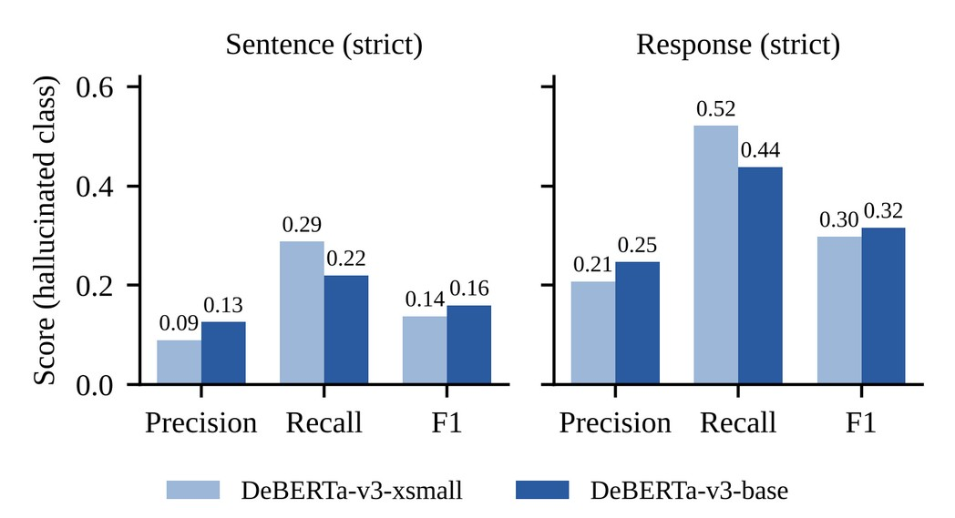
Fig. 2. Precision, recall and F1-score for the hallucinated class on RAGTruth under the strict rule, at sentence and response level.
Under the strict rule, the base model’s sentence-level precision of 12.6% is about 3.6 times the 3.5% base rate, so the verifier carries real signal, but most of its flags are still false alarms. The base model is more cautious than the xsmall model, raising 103 rather than 188 flags and 90 rather than 171 false alarms, while catching slightly fewer hallucinations (13 versus 17). With only 59 positives, this difference is within noise, and the two models are best described as comparable. The lenient rule detects almost every hallucination only by flagging more than half of all sentences, so it is not a usable detector.
The task is hard for a pretrained NLI model because most RAGTruth hallucinations are baseless information, that is, content absent from the source, rather than direct contradictions, and an NLI model classifies such content as neutral. Source documents are also long and are seen in chunks. These scores are not comparable to published RAGTruth baselines, which are span-level; converting spans to sentence labels marks a whole sentence as hallucinated even when only a short span is wrong.
C. Limitations
Sentences are not atomic facts; multi-assertion sentences are flagged rather than split unless LLM decomposition is enabled. Lexical retrieval can still return the wrong passage; pages about other subjects are discarded, but a related page can yield Insufficient Evidence or, occasionally, a spurious Contradicted verdict. NLI models can also misread equivalent wording: in one test answer, “on the south bank of the Yamuna” was labelled Contradicted by evidence stating “the right bank”, which at Agra is the same side. NLI models read at most 512 tokens per pair and their scores are not calibrated probabilities. Supported means consistent with the retrieved Wikipedia text, which may itself be wrong or outdated and differs from FEVER’s 2017 dump. Finally, CPU-sized subsets were used instead of the full datasets.
V. Conclusion and Future Work
This paper presented a hallucination detection system that checks an LLM’s answer claim by claim against retrieved evidence, using a verifier that is separate from the generator and an explicit policy that never treats missing evidence as falsity. A pretrained DeBERTa-v3-base NLI verifier reached 80.9% accuracy on held-out FEVER claims with gold evidence, using thresholds tuned on validation data. On real LLM hallucinations in RAGTruth it carried a clear signal above the base rate but remained a weak detector, mainly because unsupported additions look neutral rather than contradictory to an NLI model.
Future work will fine-tune the verifier on FEVER and compare it with the pretrained baseline on the same held-out split, evaluate the fine-tuned model on RAGTruth, run the controlled hallucination test on reviewed false claims, and add dense retrieval and calibrated scores.
Acknowledgment
The authors thank their guide, Suganya A, School of Computer Science Engineering and Information Systems, Vellore Institute of Technology, for her guidance on this work.
References
[1] L. Huang et al., “A survey on hallucination in large language models: Principles, taxonomy, challenges, and open questions,” ACM Trans. Inf. Syst., vol. 43, no. 2, 2025, doi: 10.1145/3703155.
[2] S. Farquhar, J. Kossen, L. Kuhn, and Y. Gal, “Detecting hallucinations in large language models using semantic entropy,” Nature, vol. 630, pp. 625–630, 2024, doi: 10.1038/s41586-024-07421-0.
[3] P. Manakul, A. Liusie, and M. Gales, “SelfCheckGPT: Zero-resource black-box hallucination detection for generative large language models,” in Proc. 2023 Conf. Empirical Methods in Natural Language Processing (EMNLP), Singapore, 2023, pp. 9004–9017, doi: 10.18653/v1/2023.emnlp-main.557.
[4] S. Min et al., “FActScore: Fine-grained atomic evaluation of factual precision in long form text generation,” in Proc. 2023 Conf. Empirical Methods in Natural Language Processing (EMNLP), Singapore, 2023, pp. 12076–12100, doi: 10.18653/v1/2023.emnlp-main.741.
[5] J. Wei et al., “Long-form factuality in large language models,” in Advances in Neural Information Processing Systems (NeurIPS), 2024, doi: 10.52202/079017-2567.
[6] J. Thorne, A. Vlachos, C. Christodoulopoulos, and A. Mittal, “FEVER: A large-scale dataset for fact extraction and VERification,” in Proc. 2018 Conf. North American Chapter of the Association for Computational Linguistics: Human Language Technologies (NAACL-HLT), New Orleans, LA, USA, 2018, pp. 809–819, doi: 10.18653/v1/N18-1074.
[7] P. He, J. Gao, and W. Chen, “DeBERTaV3: Improving DeBERTa using ELECTRA-style pre-training with gradient-disentangled embedding sharing,” in Proc. Int. Conf. Learning Representations (ICLR), 2023.
[8] C. Niu et al., “RAGTruth: A hallucination corpus for developing trustworthy retrieval-augmented language models,” in Proc. 62nd Annu. Meeting Assoc. Computational Linguistics (ACL), Bangkok, Thailand, 2024, pp. 10862–10878, doi: 10.18653/v1/2024.acl-long.585.

