**Phase-3 final project**

Satya Computer IP address - 3.89.194.229

Steps to complete this project:

1. From LMS Portal, AWS was launched.
2. Several steps were taken to create an instance. At 6th step, a new rule was added.
3. The connection could be established either from command prompt where .pem file (this is the key pair file) is stored or online in the browser. I chose to connect in the browser.
4. Then I installed Java, Maven, Git. Screenshots are provided below with the commands.
5. Then a Git repo was cloned and I navigated to the rest-assured-tutorial directory.
6. After navigating, Spring boot was run. Screenshots are provided below.
7. Once the application started in the Tomcat server, I manually tested the steps in postman and developed a code in Eclipse IDE with assertions. This case passed. The test steps included Get All Employees, Create Employee, Update Employee, Delete Employee and Get Deleted Employee.
8. The project was pushed to Github. The URL is

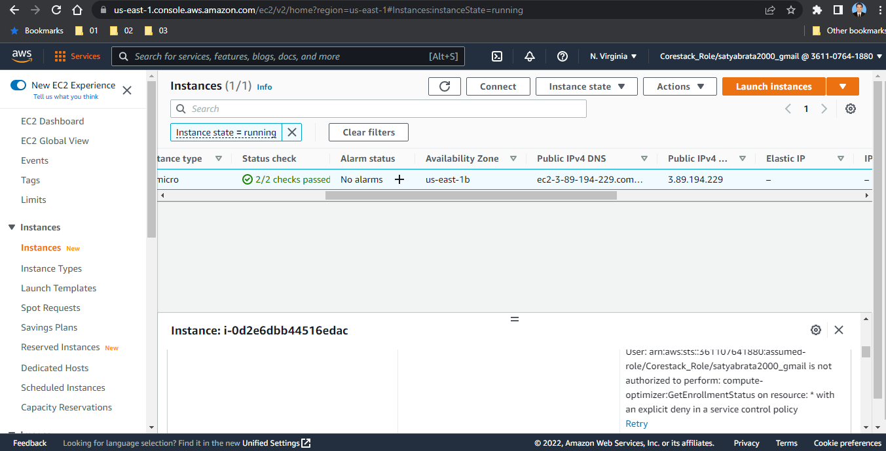

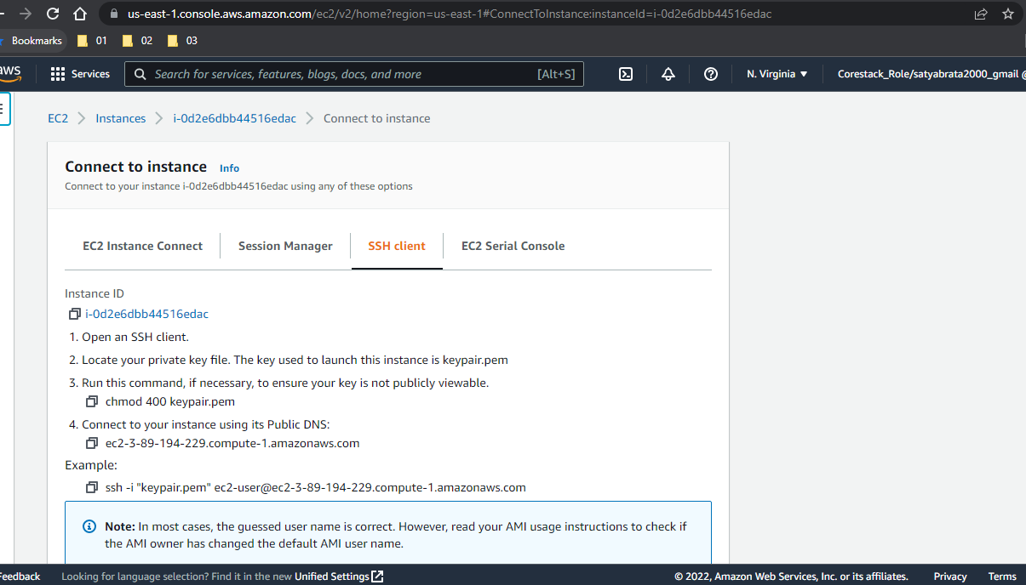

sudo yum update

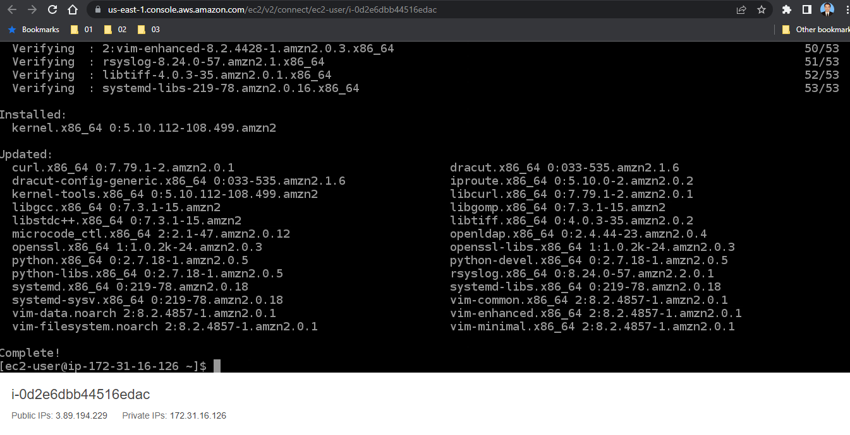

sudo yum install java-1.8.0 -y

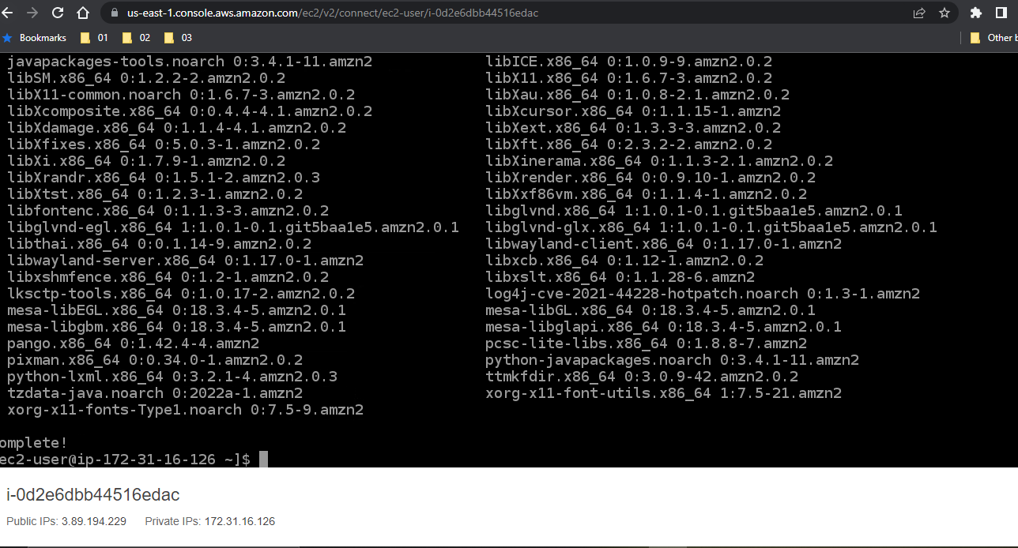

sudo yum install maven -y

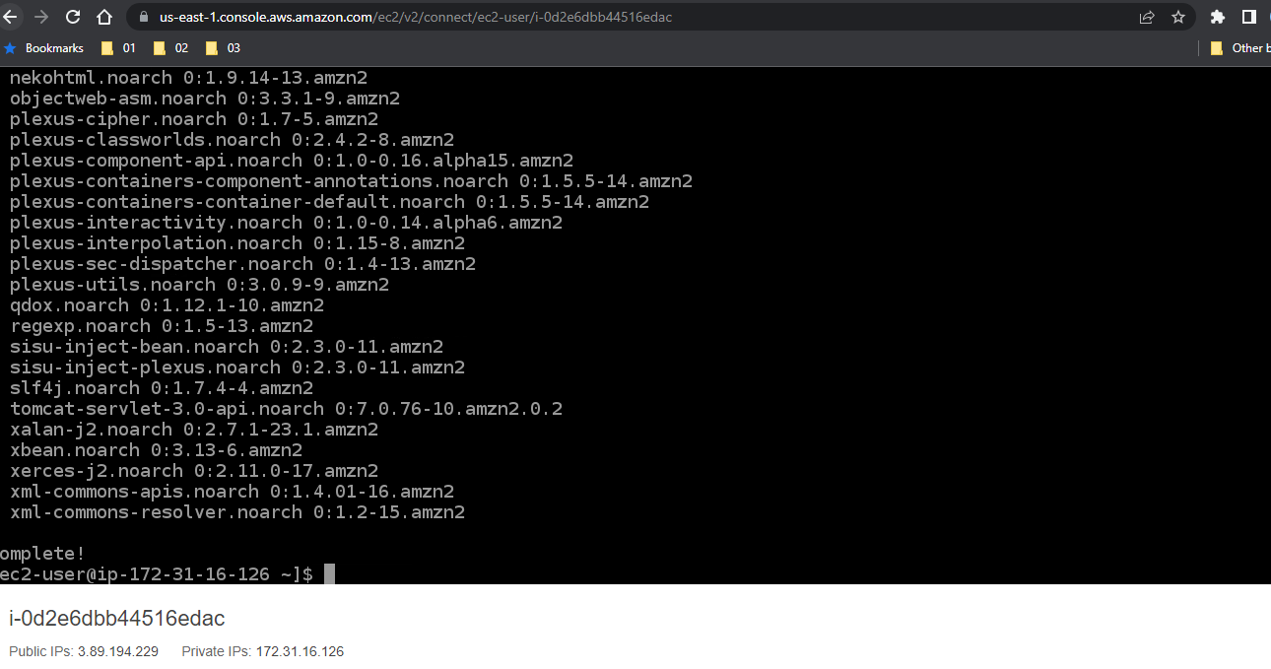

sudo yum install git -y

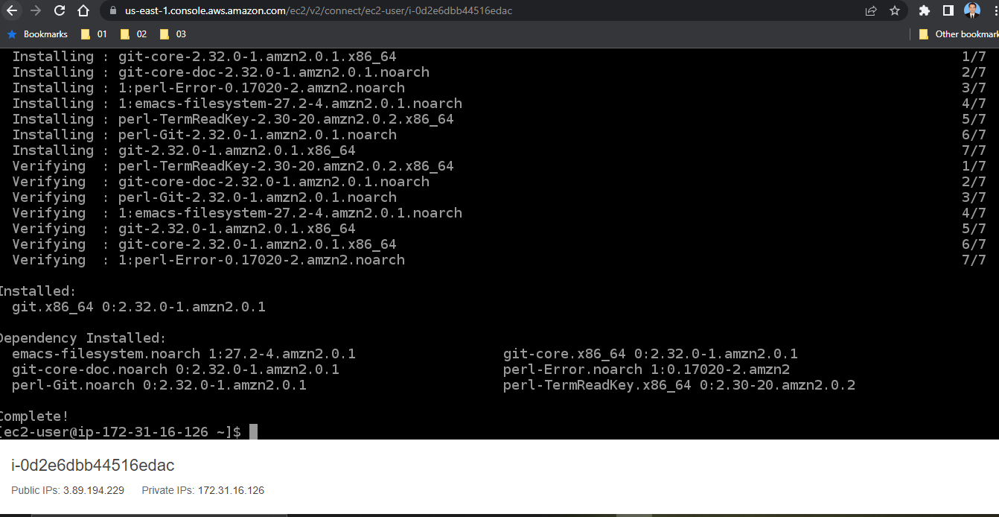

git clone <https://github.com/onlyfullstack/rest-assured-tutorial.git>

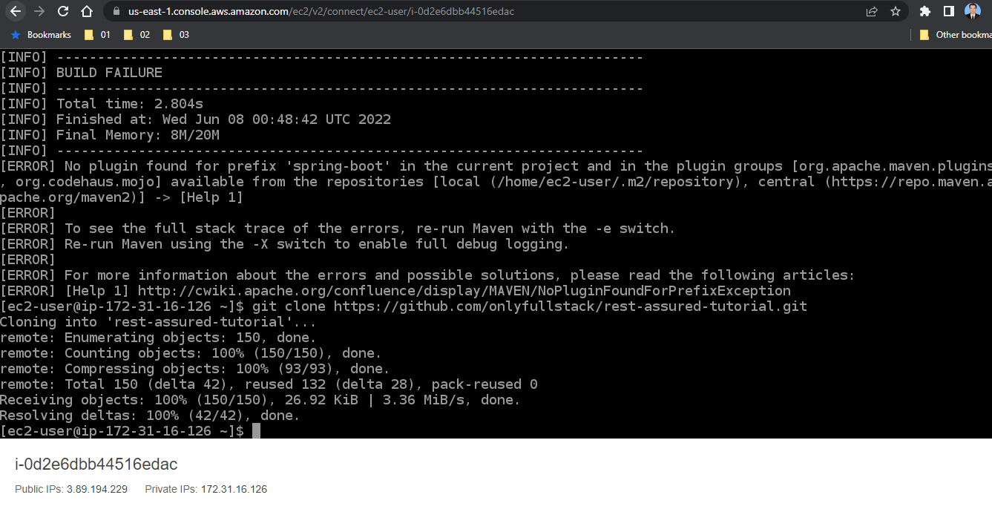

cd rest-assured-tutorial/

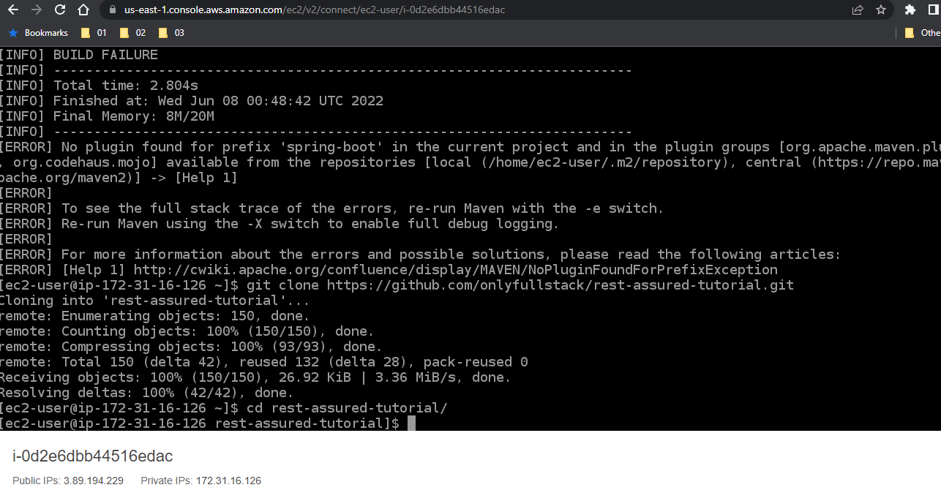

mvn spring-boot:run

