

Setup Windows Performance Counters

May 17, 2024

This document contains unpublished confidential and proprietary information of Odessa Technologies, Inc. No disclosure or use of any of these materials may be made without the express written consent of Odessa. ©1998-2020 Odessa Technologies, Inc. All Rights Reserved.



## Document revision history.

|  |  |  |  |
| --- | --- | --- | --- |
| Date | Description | Version | Author |
| 25 March 2024 | Document Created | 1.0 | Naga Katrapati |
|  |  |  |  |
|  |  |  |  |
|  |  |  |  |

Introduction:

The Document lists out steps to create a user defined data collector set, add relevant performance counters for Disk, CPU, Memory, SQL Server Databases and schedule the data collector set.

1. Open Windows Performance Monitor.

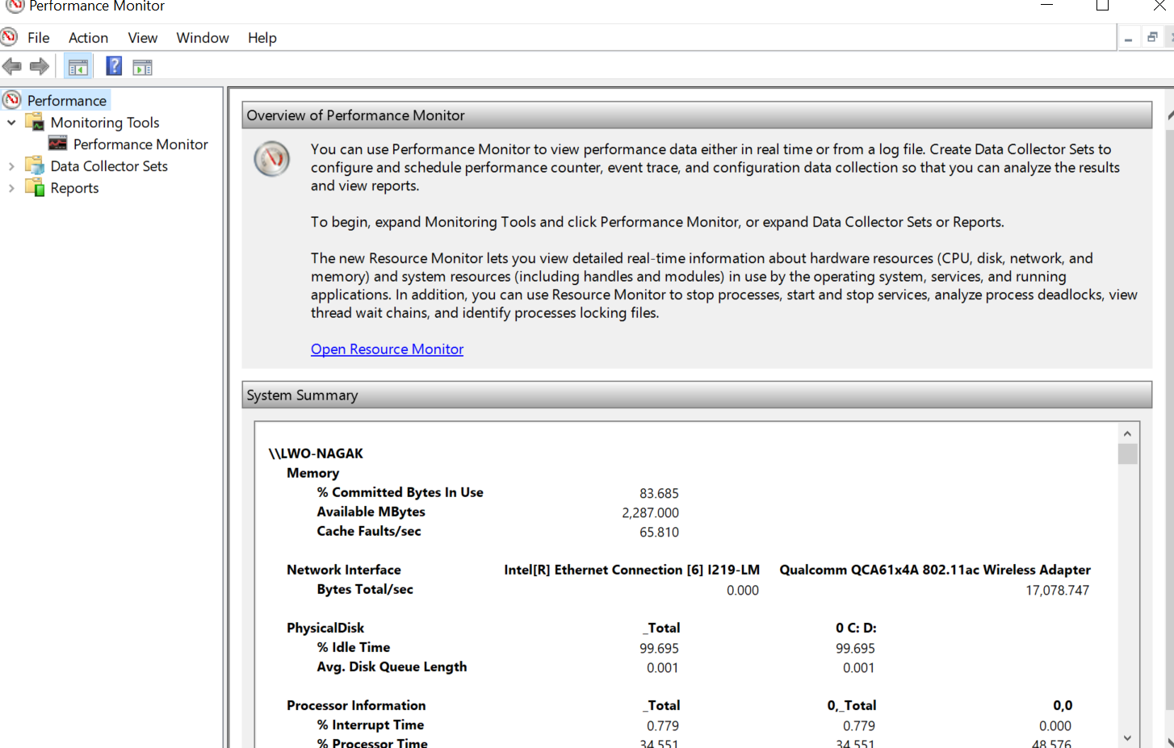

1. Navigate to User Defined data collector sets, right click and open new data collector set. Select “Create manually” option in the next window.

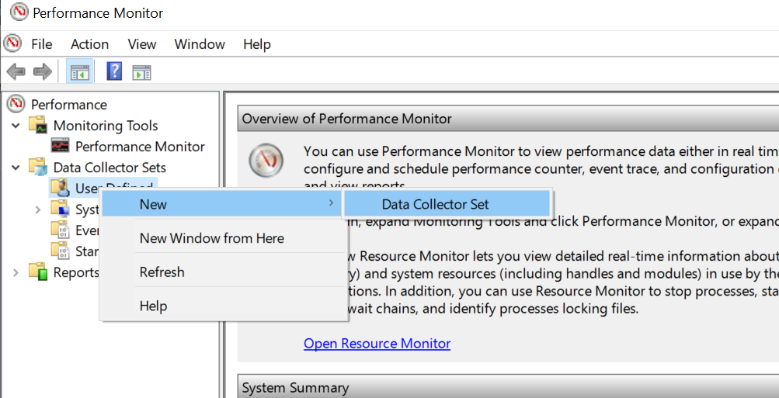

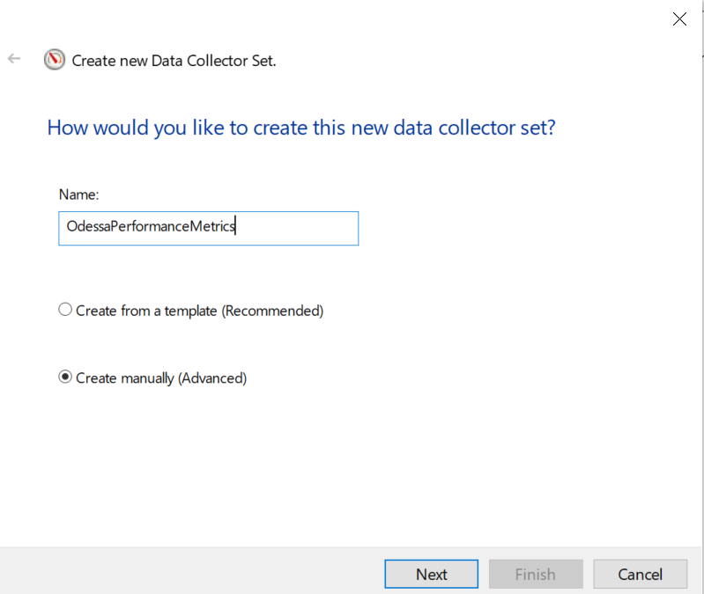

1. Select “Performance counter” option

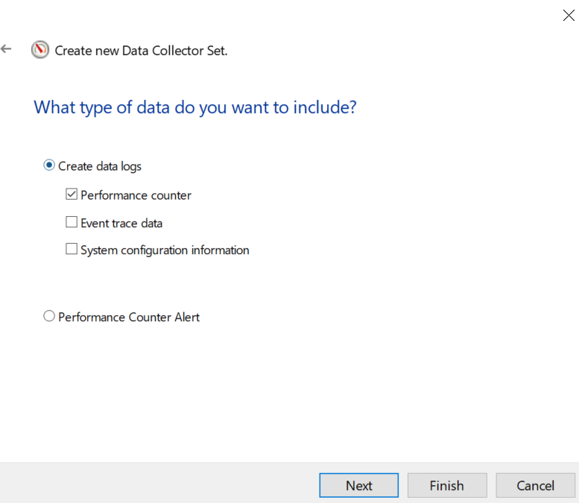

1. Click on “Add” button and select the counters as listed below:  
   (Attached PerformanceCounters.txt file has the list of counters that needs to be added)

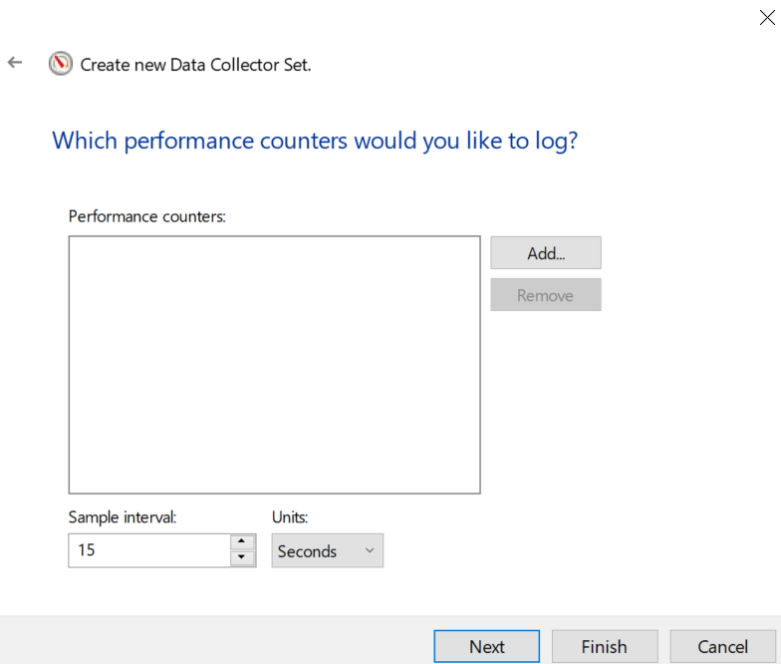

1. Add each of the counters as listed in the “PerformanceCounters.txt” file



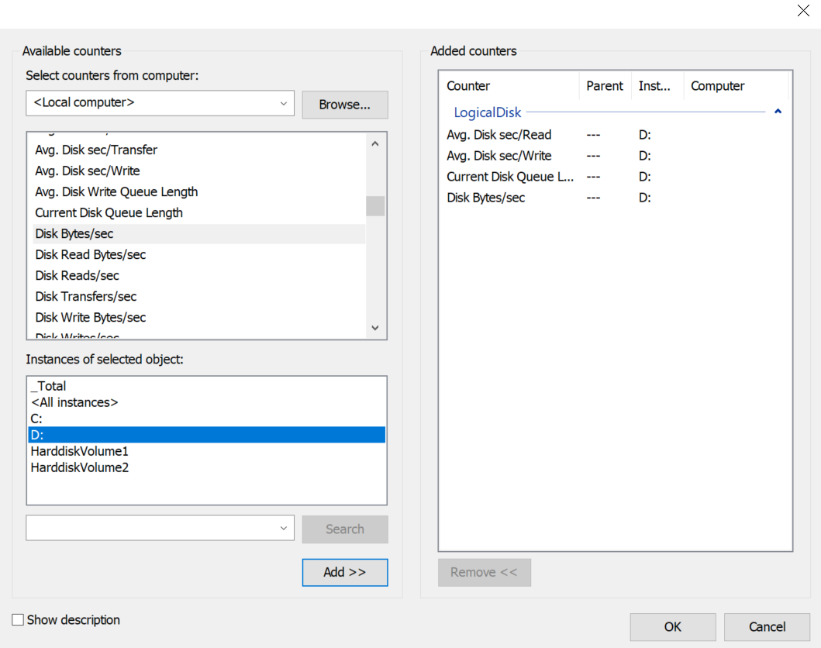

1. After adding all the counters as listed above, proceed to next window. Select “Save and close” option.

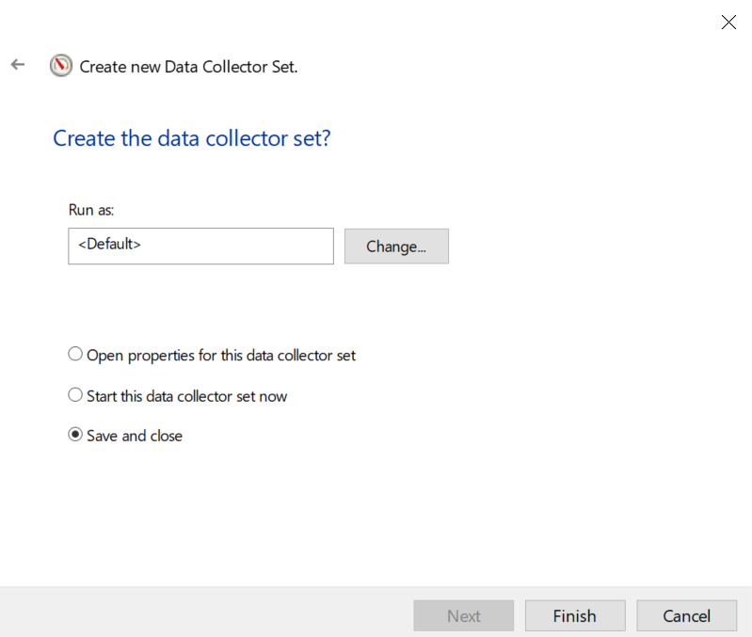

**To Schedule User defined Data Collector Set**:

1. Navigate to User Defined and Right click on the newly created data collector set (PerformanceMetrics). Click on the schedule, add new schedule and stop condition.

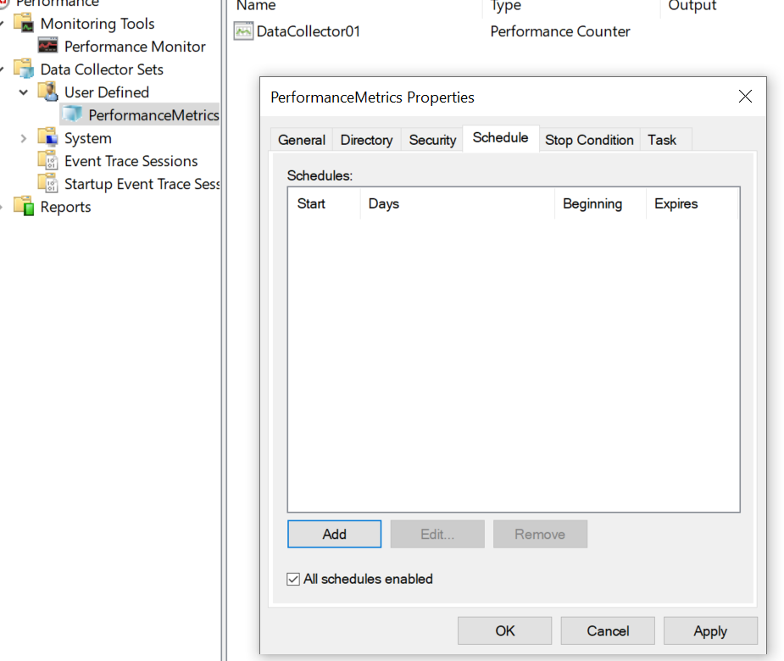

1. Navigate to ReportsàUser DefinedàPerformanceMetrics. Right click and select properties.

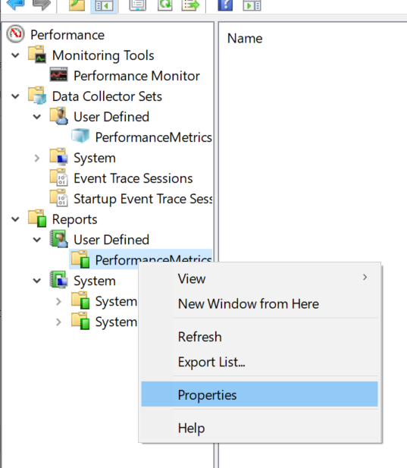

1. In Data Manager tab, enable the two settings as shown in the screenshot below

(Apply policy before data collection starts & Enable data management and report generation)

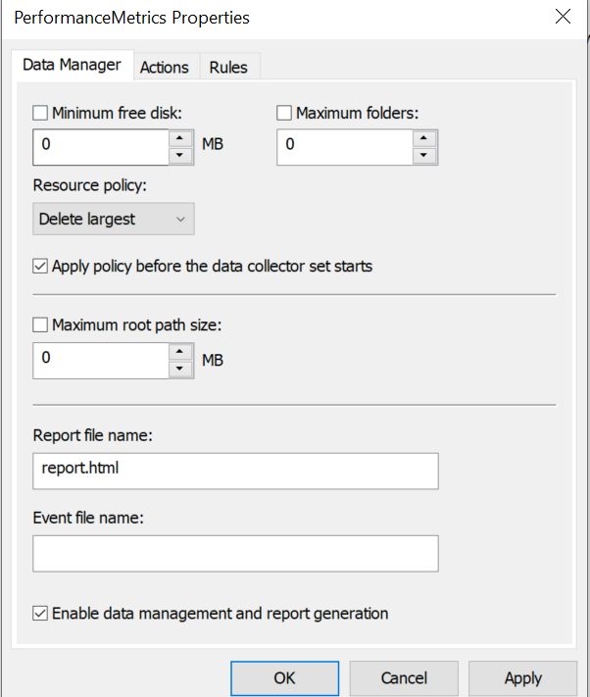

1. Select the Actions tab and provide Age for retention of reports (7 days or less). Also enable the options as shown below (Delete data files, cab files and report).

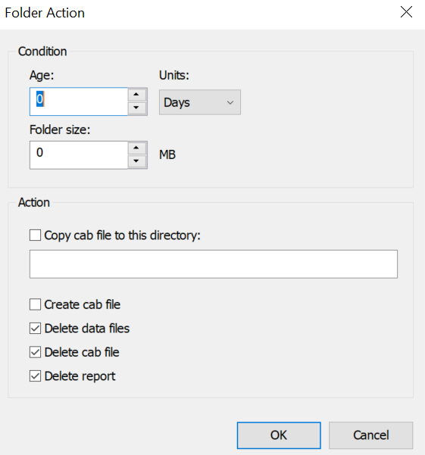

Please schedule the Performance Monitor during business hours. The space usage by the Performance monitor report in our environment (for 7 days) is around 3 MB. The report will get created in   
C:\PerfLogs\Admin\PerformanceMetrics\