Q1) write a program for arithmetic operators

Code:

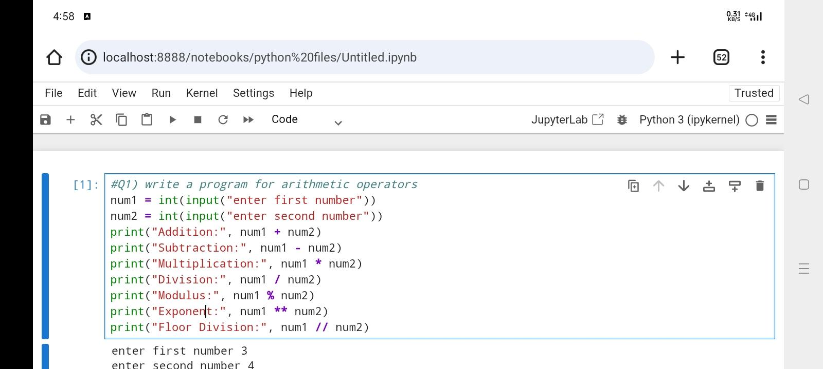

Output:

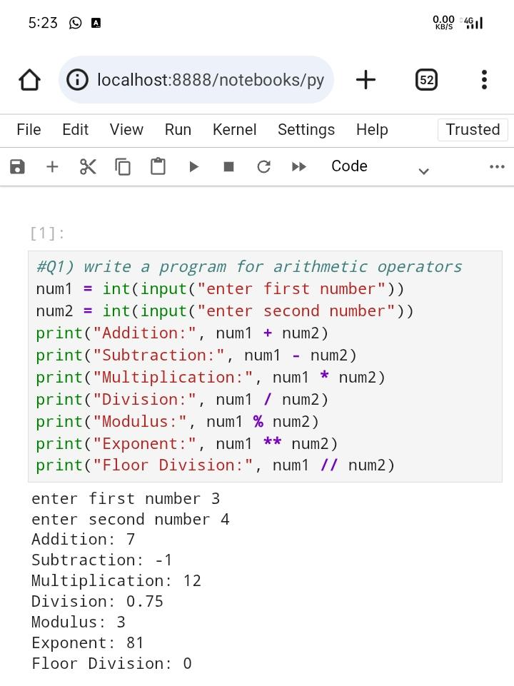

Q2) write a program for assignment operators

Code:

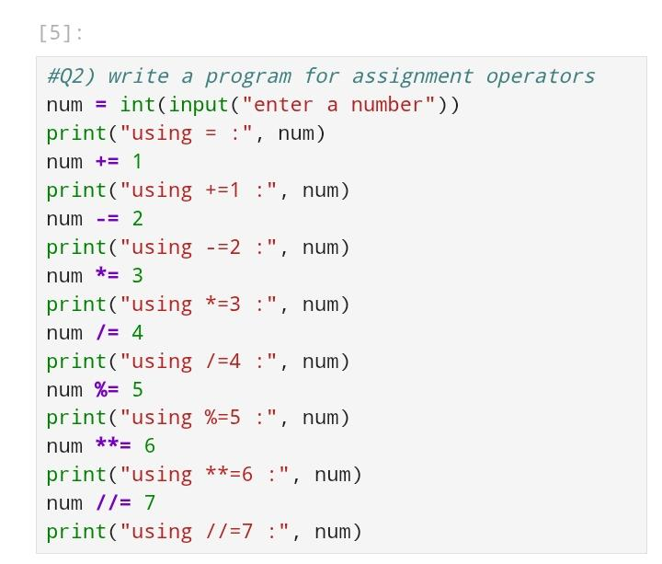

Output:

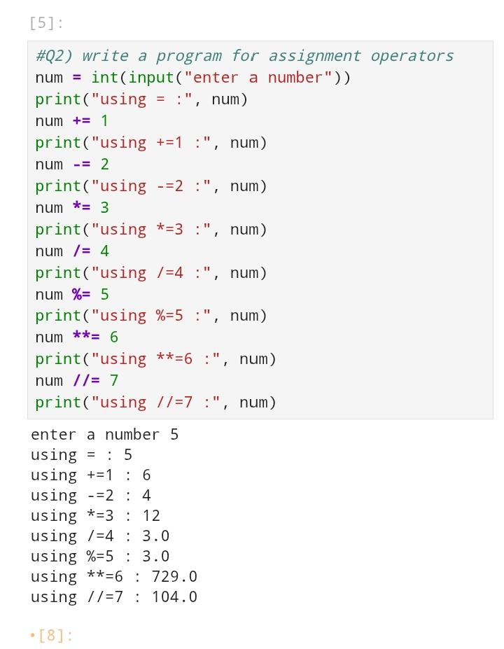

Q3) write a program for assignment operators

Code:

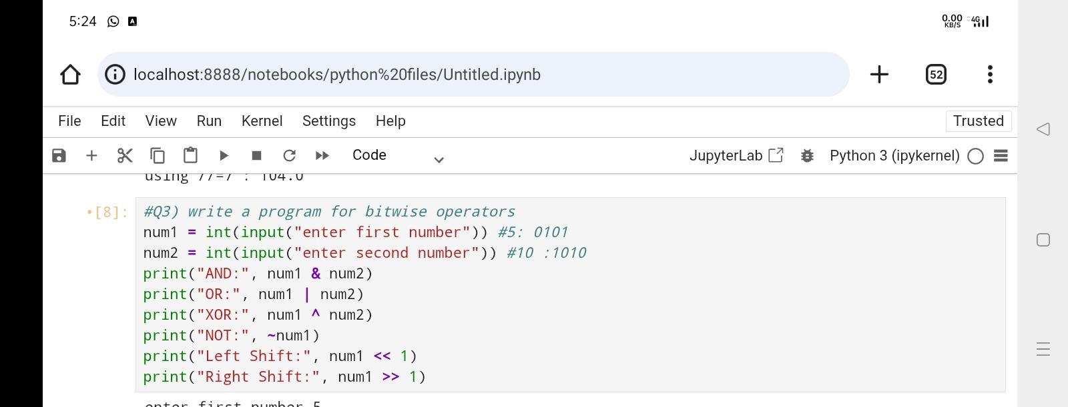

Output:

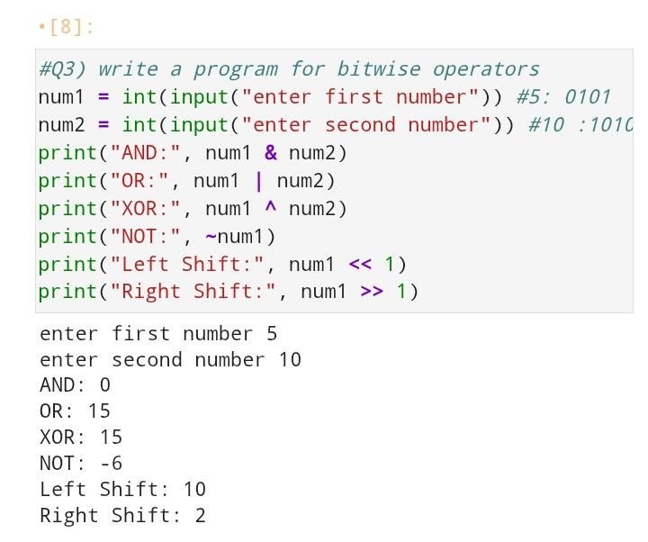

Q4) write a program to calculate greatest of three number

Code:

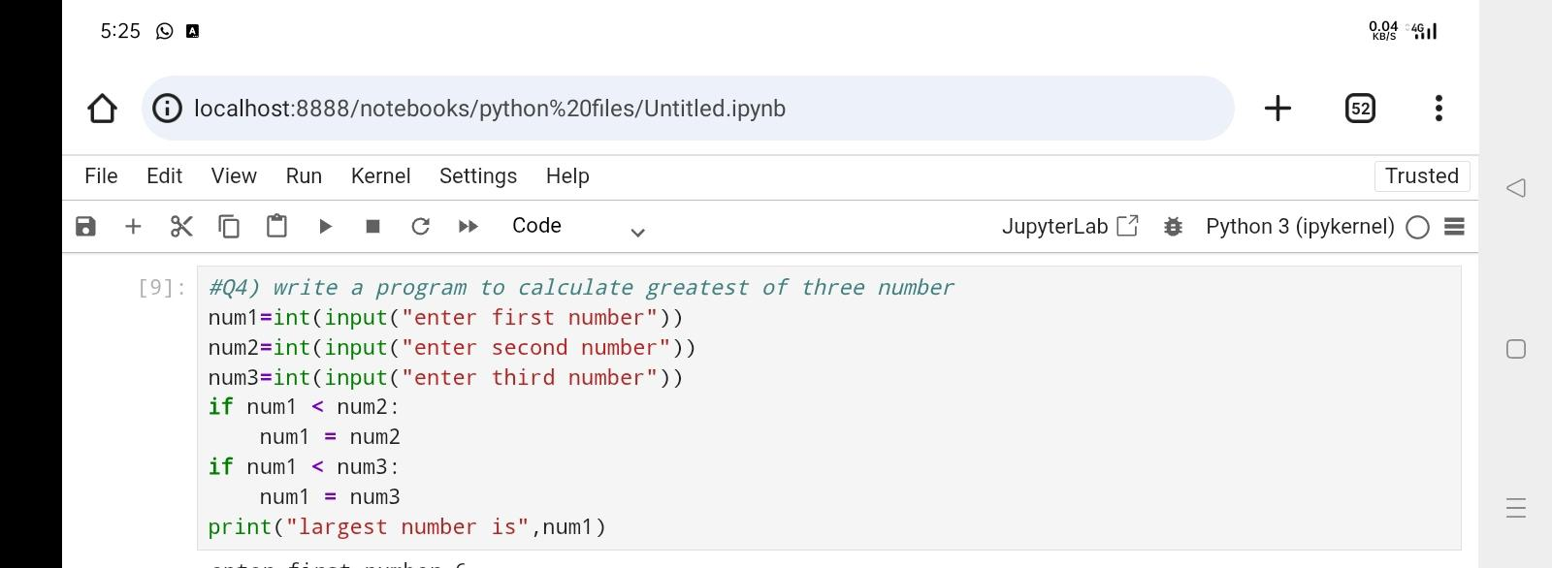

Output:

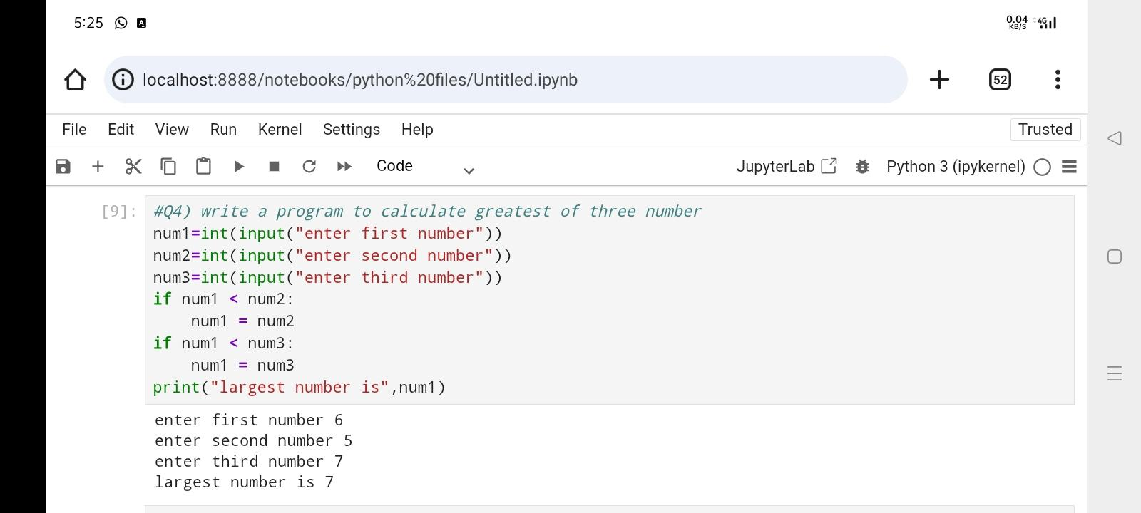

Q5) write a program to calculate the area of circle

Code:

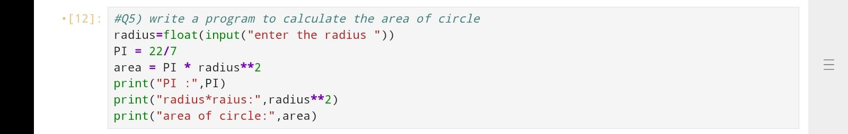

Output:

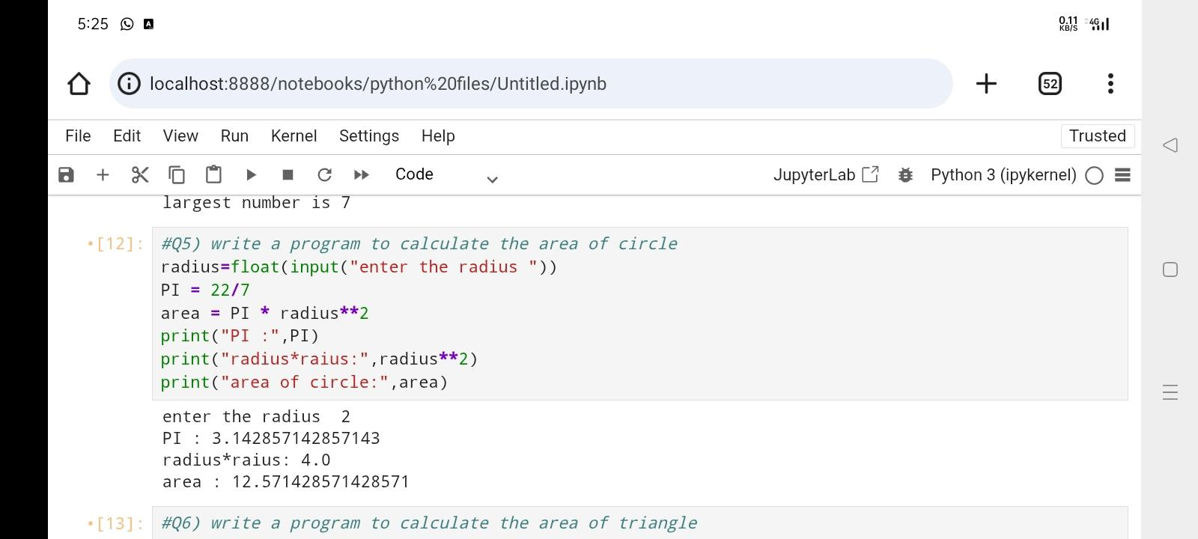

Q6) write a program to calculate the area of triangle

Code:

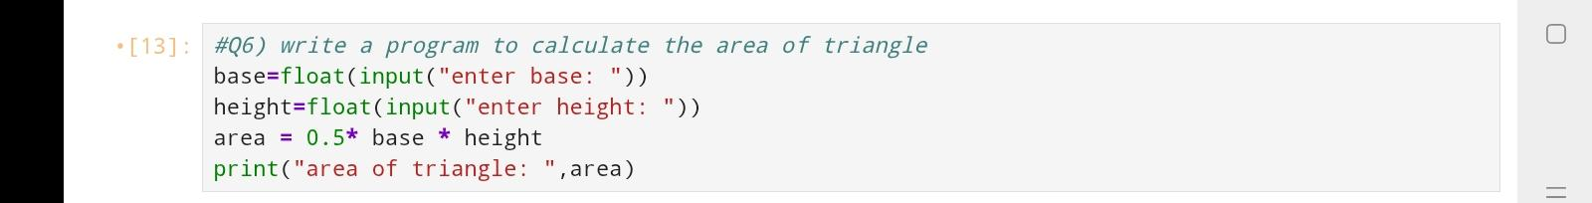

Output:

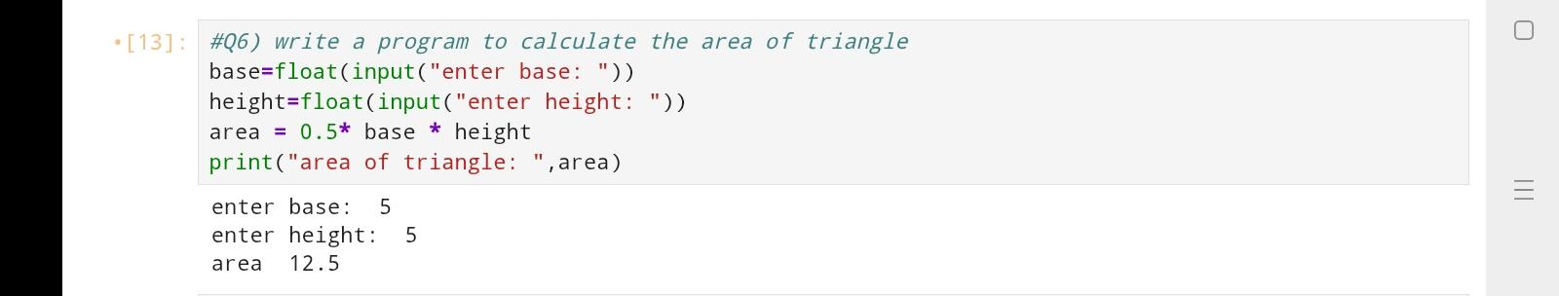

Q7) write a program to calculate the area of rectangle

Code:

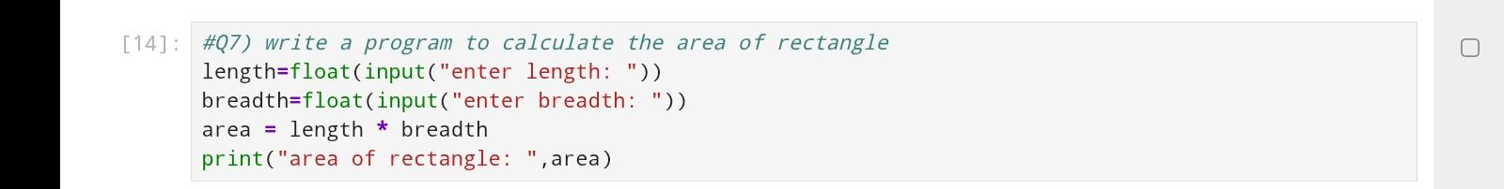

Output:

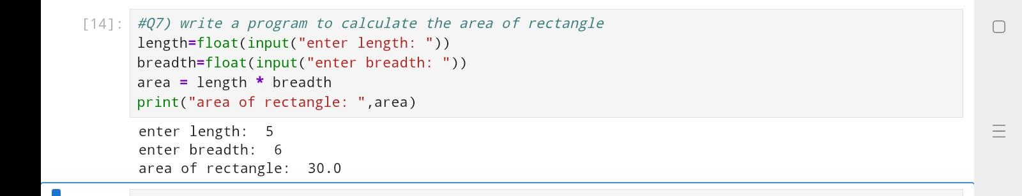

Q8) write a program to calculate the area of square

Code:

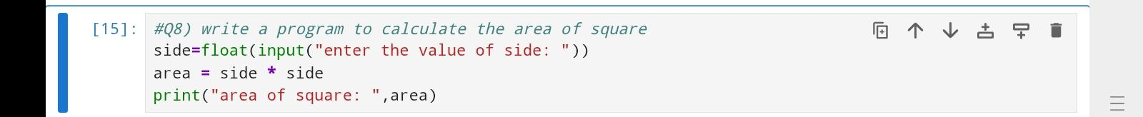

Output:

