Game Design Document

Fill up the Following document

1. Write the title of your project.

**ALPHACHAMP**

1. What is the goal of the game?

To collect the letters for the word given.

1. Write a brief story of your game?

Pikachu has started learning “alphabets”; and he/she has encountered a problem that a group of monsters come and take away all the words from his/her book, and scatters each and every letter of the words. Now he/she has got the challenge to rescue the words from the creepy monsters, and be a real hero of words. He/She has to jump over buildings, dodge the monsters and help only the correct letters out.

Draw your imagination of this game. What does this game look like?

* Draw the game either on your computer or on paper,
* Add images of scenes of the game to show each of the playing and non-playing characters at least once.

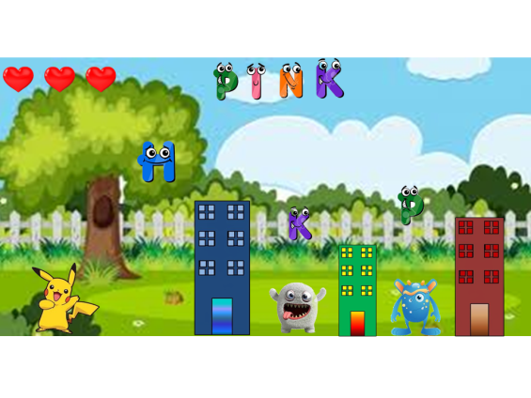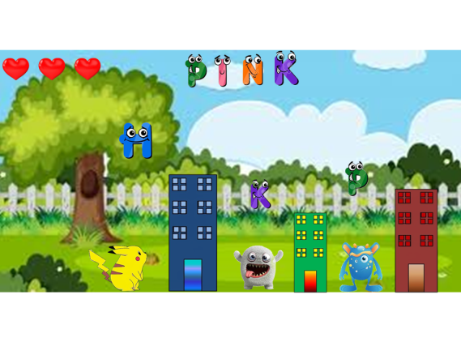

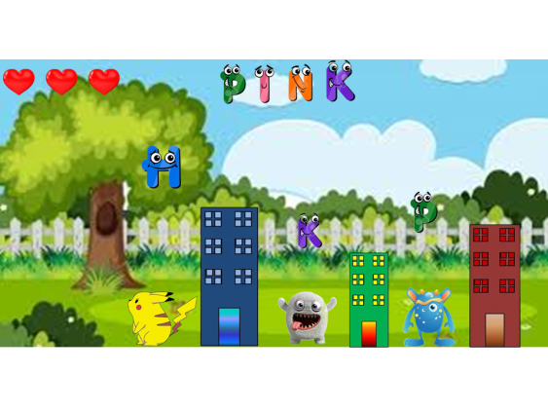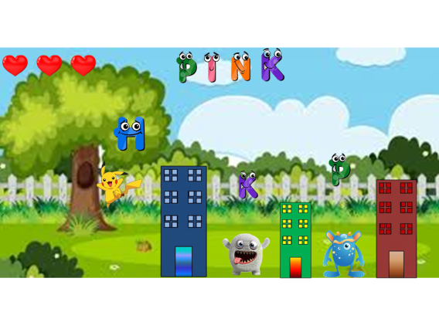  
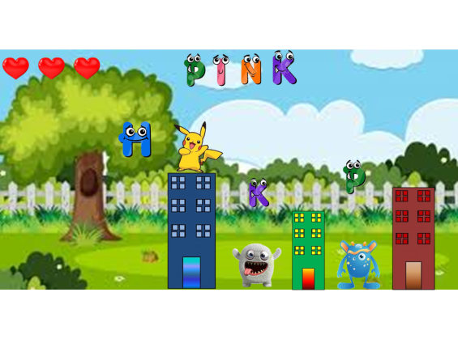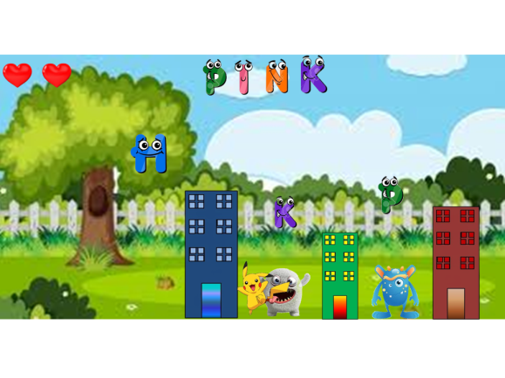

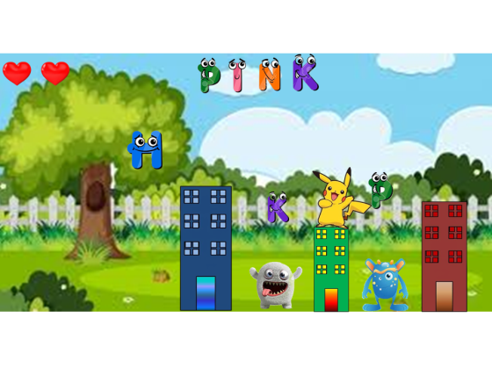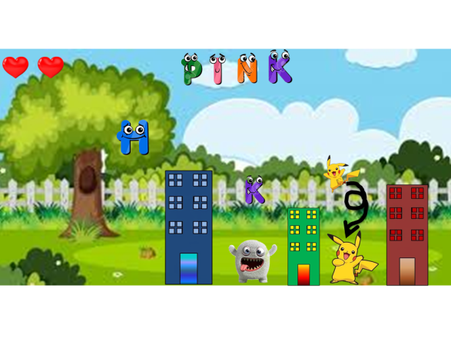4. Which are the playing characters of this game?

* Playing characters are the ones which respond to the user based on the input from the user
* Cars, monkeys, dinos, wizards etc, are the playing characters in the game.

|  |  |  |
| --- | --- | --- |
| Number | Character Name | What can this character do? |
| 1 | Pikachu | Jump over buildings, dodge the monsters, rescue the letters. |

1. Which are the Non Playing Characters of this game?

* Non Playing characters are the ones which don't have an action or a behaviour when the user interacts with the game.
* Hurdles, stones, bananas, coins, etc are non playing characters in the game.

|  |  |  |
| --- | --- | --- |
| Number | Character Name | What can this character do? |
| 1 | Book-Monsters | Prevent Pikachu from rescuing the letters. |
| 2 | Buildings | Help Pikachu by giving him a platform to stand. |
| 3 | Letters | The main things which Pikachu is going to rescue. |

How do you plan to make your game engaging?

The game is engaging because the player also gets attractive and cute feedbacks on completing an action, and especially for kids it will help them in pronouncing the letters and also the spelling of words.

An effect of balance is also given as Pikachu can also kill the monsters and the monsters can also kill Pikachu and many other features are there.

Rules and Regulations:

* + - 1. Pikachu is going to move with the left and right arrow keys.
      2. Space bar is used for Pikachu to jump.
      3. He has to jump over the monsters for killing them.
      4. If the monsters touch Pikachu from the sides then Pikachu loses his life.
      5. Pikachu is having only 3 lives.
      6. Pikachu can only pickup 3 wrong letters.
      7. A well-defined scoring system is present.
      8. When Pikachu is standing over the buildings he is safe from the monster’s attack.
      9. Pronunciation of the letters will be given when Pikachu touches any letter either right or wrong.
      10. Sounds will come at different times, like after completing half words and after ending, and also a smooth and faint music will run in the background forever.
      11. Correct letters will come in the order of the placement of them in the word given.
      12. The collection of words will be increased each month.