EMPLOYMENT AGREEMENT

*This agreement lays down the terms of employment, agreed upon by the employer and employee. Whether stated explicitly in the agreement or not, both the employee and the employer have the duty of mutual confidence and trust, and to make only lawful and reasonable demands on each other.*

This EMPLOYMENT AGREEMENT (Hereinafter, the “Agreement”) is entered into on this 23rd day of September, 2024.

## BY AND BETWEEN

BAtalks, a private limited company incorporated under the Companies Act, 2013, having its registered office at Madhapur (hereinafter referred to as the “Company” or “Employer”, which expression shall, unless repugnant to the meaning or context hereof, be deemed to include all permitted successors and assigns)

## AND

**Pedasingu Abhi Priya,** son/daughter/wife of **Venkata Rama Raju,** aged **21** years and residing at 4-307, Vuyyari vari Meraka, Pragathi Nagar, Sakhinetipalli , East Godavari, Andhra Pradesh – 533251. (hereinafter referred to as the "Employee", which expression shall, unless repugnant to the meaning or context hereof, be deemed to include all permitted successors and assigns).

**WHEREAS,** the parties hereto desire to enter into this Agreement to define and set forth the terms and conditions of the employment of the Employee by the Company;

**NOW, THEREFORE,** in consideration of the mutual covenants and agreements set forth below, it is hereby covenanted and agreed by the Company and the Employee as follows:

# Interpretation

In this agreement the following terms shall have the following meanings:

|  |  |
| --- | --- |
| a) **“Confidential Information”** | any trade secret or other information which is confidential or commercially sensitive and which is not in the public domain (other than through the wrongful disclosure by the Employee) and which belongs to any Group Company (whether stored or recorded in documentary or electronic form) and which (without limitation) relates to the business methods, management systems, marketing plans, strategic plans, finances, new or maturing business opportunities, marketing activities, processes, inventions, designs or similar of any Group Company, or to which any Group Company owes a duty of confidentiality to any third party and including in particular [*insert specific named items of Confidential Information*]; |
| **b) “The Employment”** | the employment of the Employee by the Company in accordance with the terms of this agreement; |
| **c) “Group Company”** | the Company, any company of which it is a Subsidiary (being a holding company of the Company) and any Subsidiaries of the Company or any holding company, from time to time; |
| **d) “Subsidiary”** | a company as defined in section 2(87) of the Companies Act 2013; |
| **e) “Termination Date”** | the date on which the Employment ceases. |

# Position

1. Upon execution of this Agreement, the employee would be posted as the **Junior Resource** in the Company.
2. During the term period of this Agreement, the Company may change the employee's above mentioned post (or position) or location based on the Company's production, operation or working requirements or according to the employee's working capacities and performance, including but not limited to adjustments made to the employee's job description or work place, promotion, work transfer at the same level, and demotion, etc., or adjustments made to the employee's responsibilities without any change to employee's post (or position).

# Term and Probation Period

1. **Probationary Period**: The initial six (6) months of employment will be considered a

probationary period. During this time, the Employee’s performance and overall suitability for the role will be evaluated.

1. **Non-Termination Policy**: **The Company will not terminate the Employee's employment within the first six (6) months**, except under the following circumstances:
   * If the Employee’s performance is determined to be exceptionally poor.
   * If the Employee fails to comply with any conditions outlined in this Agreement.
2. **Immediate Termination**: In the event that termination is deemed necessary due to the reasons stated above, the Employee will be given a period of two (2) days to provide an explanation. If the explanation is found to be unsatisfactory, the termination will proceed immediately thereafter.

# Performance of Duties

The Employee agrees that during the Employment Period, he/she shall devote his/her full business time to the business affairs of the Company and shall perform the duties assigned to him/her faithfully and efficiently, and shall endeavor, to the best of his/her abilities to achieve the goals and adhere to the parameters set by the Company.

* + - The Employee shall be responsible for the duties as disclosed in the Annexure-A as mentioned at the end of the document.

# Compensation

Subject to the following provisions of this Agreement, during the Employment Period, the Employee shall be compensated for his services as follows:

* 1. The Employee shall receive an annual salary, payable in monthly or more frequent installments, as per the convenience of the Employer, an amount of Rs 15000/- per month, subject to such increases from time to time, as determined by the Employer. Such payments shall be subject to such normal statutory deductions by the Employer.
  2. During the term of this Agreement, the Employee's salary shall be paid by means of bank transfer, cheque, or any other method convenient to the Employer, and consented to by the Employee.
  3. 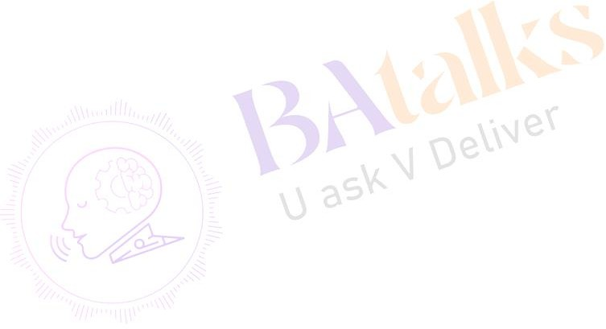All reasonable expenses arising out of employment shall be reimbursed assuming that the same have been authorized prior to being incurred and with the provision of appropriate receipts.

# Obligations of the Employee

* 1. Upon execution of agreement, the Employee shall not engage in any sort of theft, fraud, misrepresentation or any other illegal act neither in the employment space nor outside the premise of employment. If he/she shall do so, the Company shall not be liable for such an act done at his own risk.
  2. The Employee further promises to never engage in any theft of the Employer’s property or

attempt to defraud the Employer in any manner.

* 1. The Employee shall always ensure that his/her conduct is in accordance with all the rules, regulations and policies of the Company as notified from time to time.
  2. The Employee shall not take up part-time or full-time employment or consultation with any other party or be involved in any other business during the term of his/her employment with the Company.
  3. The Employee shall always ensure that his/her conduct is in accordance with all the rules, regulations and policies of the Company as notified from time to time, including but not limited to Leave Policy and Sexual Harassment Policy.
  4. The Employer hereby prohibits the Employee from engaging in any sexual harassment and the Employee promises to refrain from any form of sexual harassment during the course of employment in and around the premise of employment. If the Employee violates this term in

the agreement, he shall be fully responsible for his/her actions and the Employer shall not be held responsible for any illegal acts committed at the discretion of the Employee.

* 1. The Employee shall keep the Company promptly informed of all material matters which come to the Employee attention relating to or affecting the business of the company or any matters concerning the provision of Services hereunder by the Employee.
  2. The Employee agrees and acknowledges that:
  3. This agreement shall constitute the primary contract between Company and Employee, notwithstanding any subsequent or prior agreements entered into by Employee with other entities, whether such agreements are made prior to, during, or subsequent to the term of this agreement. Employee agrees that his/her commitments and obligations to Company as outlined in this agreement shall take precedence over any conflicting terms in other agreements.

# Leave Policy

* 1. The Employee is entitled to “12” days of paid casual leaves in a year and “12” days of sick leave. In addition, the Employee will be entitled to “10” public holidays mentioned under the Leave Policy of the Employer.
  2. The Employee may not carry forward or encash any holiday to the next holiday year.
  3. In the event that the Employee is absent from work due to sickness or injury, he/she will follow the Leave Policy and inform the designated person as soon as possible and will provide regular updates as to his/her recovery and as far as practicable will inform the designated person of the Employer of his/her expected date of return to work.
  4. If the Employee is absent from work due to sickness or injury for more than three consecutive days he/she must submit to the Employer a self-certification form. If such absence lasts for more than seven consecutive days the Employee must obtain a medical certificate from his/her doctor and submit it to the employer.
  5. For any period of absence due to sickness or injury the Employee will be paid statutory sick pay only, provided that he satisfies the relevant requirements. The Employee’s qualifying days for statutory sick pay purposes are Monday to Friday.

# Assignment

* 1. The Employee acknowledges that any work including without limitation inventions, designs, ideas, concepts, drawings, working notes, artistic works that the Employee may individually

or jointly conceive or develop during the term of Employment are “works made for hire” and to the fullest extent permitted by law, Employee shall assign, and does hereby assign, to the Employer all of Employee's right, title and interest in and to all Intellectual Property improved, developed, discovered or written in such works.

* 1. Employee shall, upon request of the Employer, execute, acknowledge, deliver and file any and all documents necessary or useful to vest in the Employer all of Employee's right, title and interest in and to all such matters.

# Competing Businesses

During the Term of this Agreement and for a period of one (1) year after the termination of this Agreement, the Employee agrees not to engage in any employment, consulting, or other activity involving BAtalks company’s nature of business that competes with the business, proposed business or business interests of the Employer, without the Employer’s prior written consent.

# Confidentiality and Non-Disparagement Clause

* 1. The Employee acknowledges that, in the course of performing and fulfilling his/her duties hereunder, he/she may have access to and be entrusted with confidential information concerning the present and contemplated financial status and activities of the Employer, the disclosure of any of which confidential information to the competitors of the Employer would be highly detrimental to the interests of the Employer.
  2. The Employee further acknowledges and agrees that the right to maintain the confidentiality of trade secrets, source code, website information, business plans or client information or other confidential or proprietary information, for the purpose of enabling the other party such information constitutes a proprietary right which the Employer is entitled to protect.
  3. Accordingly, the Employee covenants and agrees with the Employer that he/she will not, under any circumstance during/after the continuance of this agreement, disclose any such confidential information to any person, firm or corporation, nor shall he/she use the same, except as required in the normal course of his engagement hereunder, and even after the termination of employment, he/she shall not disclose or make use of the same or cause any of confidential information to be disclosed in any manner.
  4. The Employer owns any intellectual property created by the Employee during the course of the employment, or in relation to a certain field, and he shall thereon have all the necessary

rights to retain it. After termination of employment, Employee shall not impose any rights on the intellectual property created. Any source code, software or other intellectual property developed, including but not limited to website design that was created by the employee, during the course of employment under this Agreement, shall belong to the Employer.

* 1. Employee acknowledges that all material and information supplied by Employer which has or will come into Employee's possession or knowledge of Employee in connection with its performance hereunder is to be considered Employer’s confidential and proprietary information ("Confidential Information"). By way of illustration, but not as a limitation, Confidential Information includes software, trade secrets, processes, data, know-how, program codes, documentation, flowcharts, algorithms, marketing plans, forecasts, published financial statements, budgets, licenses, prices, costs, and employee and customer lists or/and will become familiar with the confidential information of Employer, its customers, licensees, employees, and investors, affiliated companies, including without limitation, method of doing business, financial information, personnel information, leads, loan programs, incentive programs, advertising programs, referral sources, marketing strategies, source code, Software strategies, investor lists, and other information of confidential nature which must remain confidential for continuing success of Employer. Contractors' undertaking and obligations under this Section will not apply, however to any Confidential Information which:

1. is or becomes known to the public through no action on Employee's part, or
2. is disclosed to third Parties by the Employer without restriction on such third Parties, or
3. is approved for release by written authorization of the Employer.
   1. Employee acknowledges that Confidential Information is the sole property of Company. The Employee agrees that disclosure of such information to, or use by, third Parties, either during or after this Agreement, will cause Company, irreparable damage. Employee agrees to use all best efforts to hold Confidential Information in the strictest confidence, not to make use of it other than for the performance of the software development.
   2. The Employee agrees not to engage in any activity, directly or indirectly, that misrepresents or defames the Company, its reputation, operations, or any of its employees. Any form of disparagement, whether verbal, written, or through digital platforms, that harms or could potentially harm the Company, will be grounds for immediate termination of employment. If such behavior comes to the notice of the Company, it reserves the right to terminate the Employee's employment without prior notice or further explanation.
   3. The Employee acknowledges that Employer's purpose in pursuing the development of the Software is to gain a significant competitive advantage over competitors operating without such Software and such advantage will be jeopardized if such competitors learn of Employer's negotiations with the Employee or the performance by the Employee of its obligations hereunder. Additionally, the Employee acknowledges that the Employer's Confidential Information is a valuable, special, and unique asset of the Employer's business and as such the following covenants protect a legitimate interest and do not solely serve to limit the Employee's future competition. Accordingly, the Employee agrees to keep such negotiations and performance of its obligations hereunder strictly confidential and not to disclose any information to any third party or entity without the prior written permission of the Employer.

# Remedies

If at any time the Employee violates to a material extent any of the covenants or agreements set forth in paragraphs 6 and 9, the Company shall have the right to terminate all of its obligations to make further payments under this Agreement. The Employee acknowledges that the Company would be irreparably injured by a violation of paragraph 6 or 9 and agrees that the Company shall be entitled to an injunction restraining the Employee from any actual or threatened breach of paragraph 6 or 9 or to any other appropriate equitable remedy without any bond or other security being required.

# Amendment and Termination

* 1. In case the Employer terminates the employment without just cause, in which case the Employer shall provide the Employee with advance notice of termination or compensation in lieu of notice equal to “1” month(s).
  2. The Employee may terminate his/her employment at any time by providing the Employer

with at least “1” month(s) advance notice of his/her intention to resign.

* 1. The Employee may terminate on the last day of the month in which the date of the Employee’s death occurs; or the date on which the Company gives notice to the Employee if such termination is for Cause or Disability.
  2. For purposes of this Agreement, "Cause" means the Employee's gross misconduct resulting in material damage to the Company, willful insubordination or disobedience, theft, fraud or dishonesty, willful damage or loss of Employer’s property, bribery and habitual lateness or absence, or any other willful and material breach of this Agreement.

# Restrictive Covenant

Following the termination of employment of the Employee by the Employer, with or without cause, or the voluntary withdrawal by the Employee from the Employer, the Employee shall, for a period of three years following the said termination or voluntary withdrawal, refrain from either directly or indirectly soliciting or attempting to solicit the business of any client or customer of the Employer for his own benefit or that of any third person or organization, and shall refrain from either directly or indirectly attempting to obtain the withdrawal from the employment by the Employer of any other Employee of the Employer having regard to the same geographic and temporal restrictions. The Employee shall not directly or indirectly divulge any financial information relating to the Employer or any of its affiliates or clients to any person whatsoever.

# Notices

* 1. Any notice required to be given hereunder shall be deemed to have been properly given if delivered personally or sent by pre-paid registered mail as follows:
     + To the Employee: abhipriya0432@gmail.com
     + To the Employer: contact@batalks.com
  2. And if sent by registered mail shall be deemed to have been received on the 4th business day of uninterrupted postal service following the date of mailing. Either party may change its address for notice at any time, by giving notice in writing to the other party pursuant to the provisions of this agreement.

# Non-Assignment

The interests of the Employee under this Agreement are not subject to the claims of his creditors and may not be voluntarily or involuntarily assigned, alienated or encumbered.

# Successors

This agreement shall be assigned by the Employer to any successor employer and be binding upon the successor employer. The Employer shall ensure that the successor employer shall continue the provisions of this agreement as if it were the original party of the first part.

# Indemnification

The Employee shall indemnify the employer against any and all expenses, including amounts paid upon judgments, counsel fees, environmental penalties and fines, and amounts paid in settlement (before or after suit is commenced), incurred by the employer in connection with his/her defense or settlement of any claim, action, suit or proceeding in which he/she is made a party or which may be asserted against his/her by reason of his/her employment or the performance of duties in this Agreement. Such indemnification shall be in addition to any other rights to which those indemnified may be entitled under any law, by-law, agreement, or otherwise.

# Modification

Any modification of this Agreement or additional obligation assumed by either party in connection with this Agreement shall be binding only if evidenced in writing signed by each party or an authorized representative of each party.

# Severability

Each paragraph of this agreement shall be and remain separate from and independent of and severable from all and any other paragraphs herein except where otherwise indicated by the context of the agreement. The decision or declaration that one or more of the paragraphs are null and void shall have no effect on the remaining paragraphs of this agreement.

# Paragraph headings

The titles to the paragraphs of this Agreement are solely for the convenience of the parties and shall not be used to explain, modify, simplify, or aid in the interpretation of the provisions of this Agreement.

# Applicable Law and Jurisdiction

This Agreement shall be governed by and construed in accordance with the laws of India. Each party hereby irrevocably submits to the exclusive jurisdiction of the courts of Andhra Pradesh, Telangana, for the adjudication of any dispute hereunder or in connection herewith.

# Counterparts

The Agreement may be executed in two or more counterparts, any one of which shall be deemed the original without reference to the others.

**IN WITNESS WHEREOF**, the Employee has hereunto set his hand, and the Company has caused these presents to be executed in its name and on its behalf, all as of the day and year first above written.

## ANNEXURE-A

**Statement of work**

The Employee agrees to:

1. Collaborate with the Company to gather comprehensive requirements and specifications for the software(s) project.
2. Develop a detailed project plan and resources required for successful execution.
3. The Employee will be responsible for acquiring, setting up, and configuring the necessary server infrastructure to support the development and deployment of the project.
4. Prepare the software(s) for deployment, ensuring compatibility and seamless integration with the designated server environment.
5. Develop the software(s) code in accordance with the project(s) specifications provided by the Company.
6. Develop and implement the required codebase as per the specifications provided by the Company.
7. Ensure the code adheres to coding standards, is well-documented, and is optimized for performance and scalability.
8. Thoroughly debug and test the developed code to ensure functionality and efficiency.
9. Deploy the developed software(s) onto the designated server infrastructure, ensuring seamless integration and functionality.
10. Conduct necessary performance tests to verify system stability post-deployment.
11. Provide ongoing maintenance, including bug fixes, updates, and optimizations post- deployment.
12. Provide documentation detailing the deployment process for future reference.
13. Implement updates, patches, and enhancements as required by the Company or identified through regular maintenance checks.
14. Monitor system performance, security, and functionality to ensure optimal operation.
15. 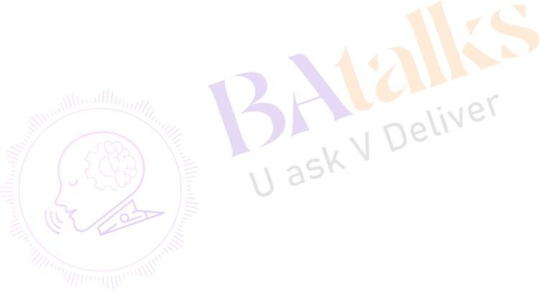Provide user guides or manuals as necessary to assist end-users in utilizing the software effectively.
16. Maintain open communication channels with the Company to provide regular updates on project(s) progress, issues, and resolutions.
17. Prepare and deliver reports outlining milestones achieved, challenges faced, and future plans.
18. Conduct training sessions or provide documentation to enable the Company’s team to effectively use and maintain the software(s).

## (Employee) (The Employer)

Represented By: BAtalks PVT LTD Designation: Founder & C.E.O