WTPR5
Problem Statement
Implement the sample program demonstrating the use of Servlet

Folder structure
D:\apache-tomcat-9.0.85\webapps\STUDENTAPP\
├── index.html ← HTML form for student registration
├── success.jsp ← Simple confirmation page
└── WEB-INF/
├── web.xml ← Servlet configuration
└── classes/
| └── com/
| └── example/
| └── StudentServlet.class ← Compiled servlet file
└── lib/
└── mysql-connector-j-8.0.33.jar ← JDBC driver for MySQL

web.xml Configuration File
<web-app xmlns="http://java.sun.com/xml/ns/javaee" version="3.0">
<servlet>
<servlet-name>StudentServlet</servlet-name>
<servlet-class>com.example.StudentServlet</servlet-class>
</servlet>
<servlet-mapping>
<servlet-name>StudentServlet</servlet-name>
<url-pattern>/register</url-pattern>
</servlet-mapping>
</web-app>

MySQL Database (Table Structure)
CREATE TABLE students (
id INT AUTO_INCREMENT PRIMARY KEY,
name VARCHAR(100),
email VARCHAR(100),
course VARCHAR(100)
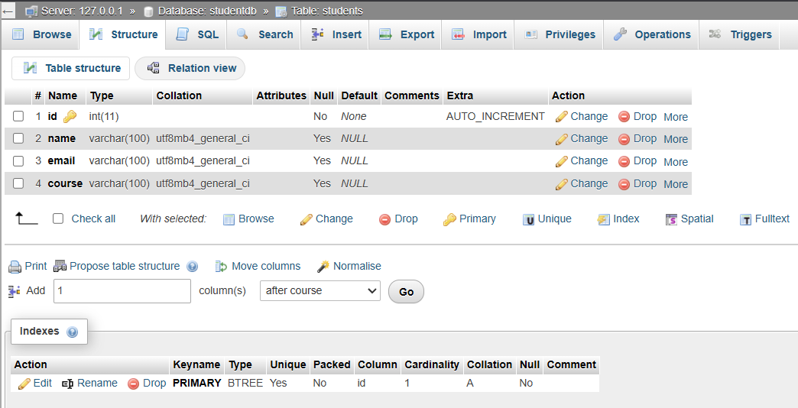
);

HTML Form Submission (Form Page) index.html
<!DOCTYPE html>
<html>
<head>
<title>Student Registration</title>
<link rel="stylesheet" type="text/css" href="style.css">
</head>
<body>
<div class="form-container">
<h2>Student Registration Form</h2>
<form action="register" method="post">
<label>Name:</label>
<input type="text" name="name" required>
<label>Email:</label>
<input type="email" name="email" required>
<label>Course:</label>
<input type="text" name="course" required>
<input type="submit" value="Register">
</form>
</div>
</body>
</html>
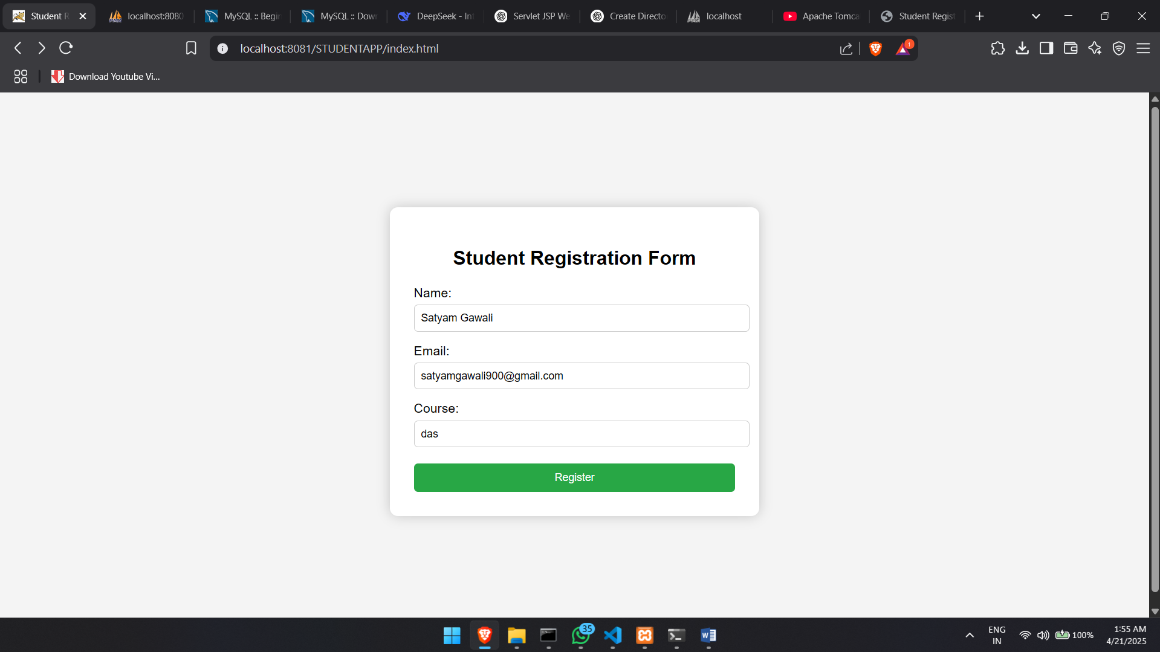
Style.css
body {  font-family: Arial, sans-serif;  background: #f4f4f4;  display: flex;  justify-content: center;  align-items: center;  height: 100vh;  }  .form-container {  background: white;  padding: 30px;  border-radius: 10px;  box-shadow: 0 0 15px rgba(0,0,0,0.2);  width: 400px;  }  h2 {  text-align: center;  }  label {  display: block;  margin-top: 15px;  } | input[type="text"],  input[type="email"] {  width: 100%;  padding: 8px;  margin-top: 5px;  border: 1px solid #ccc;  border-radius: 5px;  }  input[type="submit"] {  margin-top: 20px;  width: 100%;  padding: 10px;  background: #28a745;  color: white;  border: none;  border-radius: 5px;  cursor: pointer;  }
StudentServlet.class
package com.example;
import java.io.IOException;
import java.sql.Connection;
import java.sql.DriverManager;
import java.sql.PreparedStatement;
import javax.servlet.ServletException;
import javax.servlet.annotation.WebServlet;
import javax.servlet.http.HttpServlet;
import javax.servlet.http.HttpServletRequest;
import javax.servlet.http.HttpServletResponse;
@WebServlet({"/register"})
public class StudentServlet extends HttpServlet {
public StudentServlet() {
}
protected void doPost(HttpServletRequest var1, HttpServletResponse var2) throws ServletException, IOException {
String var3 = var1.getParameter("name");
String var4 = var1.getParameter("email");
try {
Class.forName("com.mysql.cj.jdbc.Driver");
Connection var5 = DriverManager.getConnection("jdbc:mysql://localhost:3306/studentdb", "root", "");
String var6 = "INSERT INTO students (name, email) VALUES (?, ?)";
PreparedStatement var7 = var5.prepareStatement(var6);
var7.setString(1, var3);
var7.setString(2, var4);
var7.executeUpdate();
var5.close();
var2.sendRedirect("success.jsp");
} catch (Exception var8) {
var8.printStackTrace();
var2.getWriter().println("Database Error: " + var8.getMessage());
}
}
}
Database Connection (Success or Error Message) success.jsp
<%@ page language="java" contentType="text/html; charset=UTF-8" %>
<!DOCTYPE html>
<html>
<head>
<title>Success</title>
</head>
<body>
<h2>🎉 Registration Successful!</h2>
<p>Thank you for registering.</p>
</body>
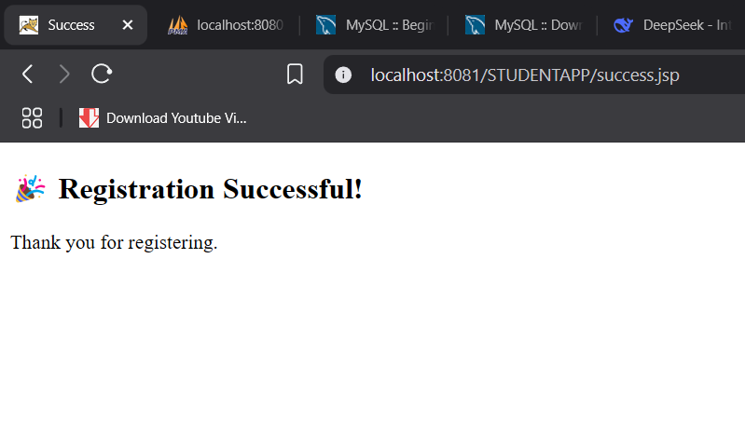
</html>

