Multi-Agent Hybrid Retrieval-Augmented Generation (RAG) Framework for Hallucination-Resilient Domain-Specific Question Answering

Technical Case Study & Comparative Evaluation

Submitted By:
Satyam Singh
Program:
BTech
Institution:
Jadavpur University
Project Type:
Agentic AI System Design & Evaluation
Domain:
Chemical Engineering Knowledge Systems
Technologies Used:
Python, FAISS, BM25, LangChain, LangGraph, Ollama LLM, Sentence-Transformers
Submission Date:
18th February , 2026

Abstract Summary (One-Line Statement):
This technical study proposes and evaluates a multi-agent hybrid RAG architecture with a validation layer to structurally reduce hallucination in domain-specific question answering systems.

Table of Contents
- Abstract
- Introduction
2.1 Background: Generative AI and Retrieval-Augmented Generation
2.2 Problem Statement: Limitations of Traditional RAG Systems
2.3 Domain Motivation: Chemical Engineering Knowledge Systems
2.4 Research Gap
2.5 Proposed Solution Overview
2.6 Contributions
- Literature Review and Gap Justification
3.1 Retrieval-Augmented Generation (RAG): Architecture and Structural Limitations
3.2 Dense Retrieval Approaches and Their Limitations
3.3 Hybrid Retrieval Systems (Dense + BM25)
3.4 Hallucination Detection and Mitigation Strategies
3.5 Agentic AI and Multi-Agent Architectures
3.6 Domain-Specific LLM Applications in Engineering
3.7 Explicit Research Gap Synthesis
3.8 Contribution of the Present Work
- Proposed Algorithm and System Architecture
4.1 Overview of Multi-Agent Hybrid RAG
4.2 Formal Algorithm Description
4.2.1 Query Analysis
4.2.2 Hybrid Retrieval
4.2.3 Context Validation
4.2.4 Conditional Generation / Refusal
4.3 Generator Constraints
4.4 Computational Flow Summary
4.5 Structural Innovation
4.6 Algorithmic Complexity Considerations
4.7 Reliability Implications
- Data Preprocessing
5.1 Document Collection
5.2 PDF Loading and Metadata Enrichment
5.3 Text Chunking Strategy
5.4 Dense Embedding and FAISS Index Construction
5.5 Lexical Indexing with BM25
5.6 Preprocessing Outcome
- Experimental Setup
6.1 Evaluation Dataset Design
6.1.1 Query Design Strategy
• Fully Covered Queries
• Partially Covered Queries
• Ambiguous Queries
• Out-of-Domain Queries
6.2 Evaluation Metrics
6.2.1 Retrieval Count
6.2.2 Relevance Score
6.2.3 Sufficiency Score
6.2.4 Validator Decision
6.2.5 Citation Coverage Ratio
6.2.6 Semantic Similarity
6.2.7 Composite Hallucination Score
6.2.8 Latency
6.2.9 Answer Length
6.3 Evaluation Design Philosophy
6.4 Evaluation Objective
- Visualization and Comparative Analysis
7.1 Overall Evaluation (All Queries Included)
• Composite Hallucination Score (Overall)
• Citation Coverage (Overall)
• Semantic Similarity (Overall)
• Latency Comparison (Overall)
7.2 Filtered Evaluation (Approved Queries Only)
• Composite Hallucination Score (Filtered)
• Citation Coverage (Filtered)
• Semantic Similarity (Filtered)
7.3 Reliability Interpretation
7.4 Architectural Implications
- Comparative Analysis
8.1 Structural Comparison of Architectures
8.2 Retrieval Quality Comparison
8.3 Hallucination Score Comparison
8.4 Citation Coverage Analysis
8.5 Semantic Similarity Analysis
8.6 Latency Trade-Off
8.7 Reliability vs Coverage Trade-Off
8.8 Key Comparative Insights
- Error Analysis
9.1 Validator Rejection Behavior
9.2 Impact on Evaluation Metrics
9.3 Trade-Off Analysis
9.4 Architectural Reflection
- Discussion
10.1 Structural vs Probabilistic Grounding
10.2 Reliability vs Coverage Trade-Off
10.3 Implications for Domain-Critical Question Answering
10.4 Broader Architectural Implications
10.5 Conceptual Contribution
- Recommendations
11.1 Integrate Validation Before Generation
11.2 Pair Hybrid Retrieval with Explicit Guardrails
11.3 Distinguish Abstention from Hallucination in Evaluation
11.4 Design Rejection-Aware Hallucination Metrics
11.5 Prioritize Structural Guardrails over Prompt-Only Control
11.6 Adopt Reliability-Aware System Objectives
- Future Work
12.1 Context Re-Ranking via Cross-Encoders
12.2 Learning-Based Validator Architectures
12.3 Confidence-Aware and Transparent Generation
12.4 Adaptive Retrieval Depth and Iterative Grounding
12.5 Domain-Specific Embedding Fine-Tuning
12.6 Human-in-the-Loop Evaluation
12.7 Multi-Domain Generalization
12.8 Toward Industrial-Grade Reliability-Aware RAG
- Conclusion
- References

- Abstract
Large Language Models (LLMs) have demonstrated remarkable capabilities in generative reasoning; however, their susceptibility to hallucination poses significant challenges in domain-specific question answering systems. Retrieval-Augmented Generation (RAG) has emerged as a prominent approach to mitigate hallucination by grounding responses in external knowledge sources. Nevertheless, conventional RAG architectures follow a linear retrieval–generation pipeline that assumes retrieval sufficiency and lacks structural validation mechanisms. This often results in unsupported claims, weak contextual grounding, and unsafe responses in out-of-domain scenarios.
This study proposes a Multi-Agent Hybrid Retrieval-Augmented Generation architecture designed to enhance reliability and hallucination control in the domain of Chemical Engineering. The proposed system decomposes the RAG pipeline into four specialized agents: a Query Analyzer, a Hybrid Retrieval Agent (combining dense semantic retrieval and BM25 lexical retrieval), a Validator Agent for relevance and sufficiency assessment, and a Generator Agent operating under strict citation-enforced grounding constraints. A conditional execution framework enables controlled abstention when retrieved context is insufficient, transforming the objective from continuous generation to reliability-aware answering.
To evaluate system performance, a structured dataset of 18 queries spanning fully covered, partially covered, ambiguous, and out-of-domain scenarios was constructed, yielding 72 evaluation instances across four architectures: dense baseline, keyword baseline, hybrid baseline, and the proposed multi-agent system. A dual hallucination evaluation framework was introduced, integrating citation coverage ratio and context–answer semantic similarity into a composite hallucination score.
Experimental results demonstrate that while the multi-agent system initially appears penalized when abstentions are treated as hallucinations, filtered evaluation on approved cases reveals superior grounding performance. The proposed architecture achieves the lowest composite hallucination score, highest citation coverage, and strong semantic alignment compared to baseline systems. These findings confirm that structural validation and conditional generation significantly improve reliability in domain-specific RAG systems. The work highlights the necessity of agentic orchestration and validation-driven control for deploying trustworthy generative AI in high-stakes technical domains.

2. Introduction
2.1 Background: Generative AI and Retrieval-Augmented Generation
Large Language Models (LLMs) have significantly advanced the field of generative artificial intelligence, enabling systems to produce fluent, contextually coherent, and semantically rich responses across diverse domains. These models are trained on large-scale textual corpora and learn probabilistic representations of language, allowing them to perform tasks such as question answering, summarization, reasoning, and explanation generation.
Despite their remarkable generative capabilities, LLMs inherently operate as probabilistic sequence predictors and lack explicit mechanisms for factual verification. As a result, they are prone to hallucination—the generation of plausible but factually incorrect, unsupported, or fabricated information. Hallucination poses substantial risks in knowledge-intensive and technical domains, where accuracy, traceability, and reliability are critical.
Retrieval-Augmented Generation (RAG) was introduced as a structural solution to mitigate hallucination. RAG systems integrate an external knowledge retrieval component with a generative language model. In a typical RAG pipeline, relevant documents are retrieved from a knowledge base and injected into the model’s context prior to generation. By conditioning responses on retrieved evidence, RAG improves grounding and reduces reliance on parametric memory alone.
However, while RAG enhances factual alignment compared to standalone LLMs, it does not fully eliminate hallucination risks. Retrieval alone does not guarantee contextual sufficiency, nor does it enforce controlled generation behaviour.

2.2 Problem Statement: Limitations of Traditional RAG Architectures
Conventional RAG implementations typically follow a linear architecture:
Query → Retrieval → Generation
Although this pipeline introduces external knowledge grounding, several structural limitations remain:
- Absence of Retrieval Validation
Retrieved documents may be partially relevant, incomplete, noisy, or semantically misaligned with the query. Traditional RAG systems do not explicitly evaluate retrieval quality before passing context to the generator.
- Uncontrolled Generative Behaviour
Even when context is provided, the LLM may introduce external knowledge beyond retrieved content, leading to unsupported claims.
- No Conditional Abstention Mechanism
In scenarios where retrieval is insufficient or irrelevant, the system continues generation instead of abstaining or requesting clarification.
- Limited Hallucination Evaluation Frameworks
Many systems rely solely on citation presence or qualitative inspection, lacking structured quantitative grounding metrics such as context–answer semantic alignment.
These limitations are particularly critical in technical domains, where even minor inaccuracies may lead to conceptual misunderstandings or propagation of incorrect procedures.

2.3 Domain Motivation: Chemical Engineering Knowledge Systems
Chemical Engineering is a precision-driven discipline grounded in thermodynamics, transport phenomena, mass and energy balances, phase equilibrium analysis, and equipment design methodologies. Concepts such as distillation column design, vapor–liquid equilibrium (VLE), reflux ratio optimization, and heat integration require rigorous interpretation of domain-specific knowledge.
In this context:
- Inaccurate conceptual explanations may lead to flawed engineering reasoning.
- Hallucinated equations or procedural steps may misguide learners.
- Improper assumptions may distort analytical derivations.
- Unsupported claims may compromise technical reliability.
Therefore, domain-specific question answering systems for Chemical Engineering must prioritize:
- Grounded generation,
- Context traceability,
- Explicit citation enforcement,
- Structured validation of retrieved knowledge.
This motivates the development of a validation-driven RAG architecture tailored for technical knowledge systems.

2.4 Research Gap
Existing research has explored dense retrieval, lexical retrieval, and hybrid retrieval strategies within RAG systems. Hybrid approaches combining semantic embeddings (e.g., FAISS-based retrieval) and lexical scoring (e.g., BM25) have demonstrated improved recall and retrieval diversity. However, most implementations retain a linear retrieval-to-generation pipeline and lack structured validation mechanisms.
Specifically, current systems often do not incorporate:
- Dedicated query analysis for domain classification and refinement,
- Pre-generation validation of contextual relevance and sufficiency,
- Conditional workflow branching based on validation outcomes,
- Structured abstention behavior when grounding is inadequate,
- Quantitative hallucination scoring combining structural and semantic metrics.
Moreover, hallucination evaluation frequently remains qualitative or binary (e.g., citation present vs. absent), without incorporating semantic similarity-based grounding measurements.
There is therefore a clear need for an agentic RAG framework that integrates hybrid retrieval, structured validation, conditional orchestration, and quantitative hallucination evaluation within a domain-specific technical setting.

2.5 Proposed Solution Overview
To address these limitations, this work proposes a Multi-Agent Hybrid Retrieval-Augmented Generation System designed specifically for grounded knowledge generation in the Chemical Engineering domain.
The proposed system decomposes the RAG pipeline into four specialized agents:
- Query Analyzer Agent
Interprets and refines the user query, identifies domain context, and extracts structured metadata to improve retrieval precision.
- Hybrid Retrieval Agent
Combines dense semantic retrieval (FAISS with MiniLM embeddings) and lexical keyword retrieval (BM25) to enhance contextual diversity and recall.
- Validator Agent
Evaluates retrieved documents for relevance and contextual sufficiency prior to generation. It can approve context or reject it under insufficient grounding conditions.
- Generator Agent
Produces structured, citation-enforced responses strictly grounded in validated context.
These agents are orchestrated using a conditional workflow graph, enabling decision-controlled transitions between validation and generation stages. This design transforms a linear RAG pipeline into a modular, validation-driven agentic architecture.
Additionally, the system introduces a dual hallucination evaluation framework combining:
- Structural grounding assessment (citation coverage ratio), and
- Semantic grounding assessment (context–answer embedding similarity).

2.6 Contributions
The primary contributions of this work are:
- Development of a multi-agent hybrid RAG architecture tailored for technical domain grounding.
- Integration of dense semantic retrieval and lexical keyword retrieval to improve contextual coverage.
- Introduction of a validator agent to assess retrieval relevance and sufficiency before generation.
- Implementation of citation-enforced generation to mitigate structural hallucination.
- Design of a dual hallucination evaluation framework combining citation coverage and semantic similarity.
- Proposal of a composite hallucination scoring mechanism for quantitative comparison across multiple RAG baselines.
Through this structured, validation-driven, and quantitatively evaluated approach, the proposed system shifts the objective from “always generate an answer” to “generate only when sufficiently grounded.” This represents a significant step toward improving reliability, safety, and factual consistency in domain-specific generative AI systems.

3. Literature Review and Gap Justification
3.1 Retrieval-Augmented Generation (RAG): Architecture and Structural Limitations
Retrieval-Augmented Generation (RAG) integrates a non-parametric retrieval component with a parametric language generator to improve factual grounding in knowledge-intensive tasks. The foundational RAG framework introduced by Lewis et al. (2020) describes a two-stage architecture consisting of document retrieval followed by conditional sequence generation [1]. In this design, the retriever fetches relevant passages from an external corpus, and the generator conditions its response on the retrieved context.
While this architecture significantly improves factual alignment compared to standalone LLMs, it remains structurally linear:
Retrieval → Generation
This linear design assumes that the retrieved context is sufficiently relevant and complete before answer synthesis. However, retrieval errors—such as partial relevance, incomplete coverage, or noisy passages—can propagate directly into the generation stage. The original RAG framework does not incorporate an explicit validation mechanism between retrieval and generation to assess contextual sufficiency or relevance prior to response production.
Identified Research Gap
Existing RAG systems lack an intermediate validation layer capable of assessing retrieval quality before generation. This structural limitation makes the pipeline vulnerable to context-induced hallucinations.
Reference
[1] Lewis, P., Perez, E., Piktus, A., Petroni, F., Karpukhin, V., Goyal, N., Küttler, H., Lewis, M., Yih, W., Rocktäschel, T., Riedel, S., & Kiela, D. (2020). Retrieval-Augmented Generation for Knowledge-Intensive NLP Tasks. arXiv. DOI: 10.48550/arXiv.2005.11401

3.2 Dense Retrieval Approaches and Their Limitations
Dense retrieval systems leverage embedding-based similarity search to match queries with semantically aligned documents. Common implementations employ vector databases such as FAISS combined with pretrained sentence embedding models (e.g., MiniLM). Dense retrievers are robust to lexical variation and capture contextual semantics beyond surface-level keyword overlap.
However, as discussed in contemporary analyses of RAG systems [2], dense retrieval is highly dependent on embedding quality and domain alignment. In technical domains, embedding models trained on general corpora may fail to capture nuanced domain-specific terminology. Consequently, dense retrievers may return semantically similar but contextually insufficient or partially relevant passages.
Furthermore, dense-only RAG pipelines lack abstention mechanisms. Even when similarity scores are weak or contextual coverage is incomplete, the generator proceeds with answer synthesis without explicit reliability checks.
Identified Research Gap
Dense retrieval enhances semantic matching but does not provide reliability-aware generation control or contextual sufficiency enforcement.
Reference
[2] Klesel, M., & Wittmann, H. F. (2025). Retrieval-Augmented Generation (RAG). Business & Information Systems Engineering, 67, 551–561. DOI: https://doi.org/10.1007/s12599-025-00945-3

3.3 Hybrid Retrieval Systems (Dense + BM25)
Hybrid retrieval systems combine semantic embeddings with lexical scoring mechanisms such as BM25. Empirical evaluation by Fukui et al. (2025) demonstrates that hybrid retrieval improves recall and precision compared to single-method baselines by addressing lexical mismatch and semantic variation simultaneously [3].
Hybrid systems enhance retrieval diversity and reduce the risk of missing relevant context due to vocabulary mismatch. However, despite improvements in retrieval metrics, the overall architecture remains structurally linear:
Hybrid Retrieval → Generation
The generator is still implicitly trusted to remain grounded within the retrieved context. No explicit mechanism evaluates whether the merged chunks collectively provide sufficient coverage to answer the query safely.
Identified Research Gap
Hybrid retrieval improves coverage and recall but does not introduce structural safeguards such as pre-generation contextual validation or abstention mechanisms.
Reference
[3] Fukui, Y., Kawata, Y., Kobashi, K., et al. (2025). Evaluation of a Retrieval-Augmented Generation System Using a Japanese Institutional Nuclear Medicine Manual and Large Language Model-Automated Scoring. Radiological Physics and Technology, 18, 861–876. DOI: https://doi.org/10.1007/s12194-025-00941-y

3.4 Hallucination Detection and Mitigation Strategies
Hallucination in LLMs has been widely studied, particularly in high-risk domains. Liu et al. (2025) propose mitigation strategies including hierarchical semantic verification, consistency checking, and structured validation frameworks [4]. These approaches aim to detect hallucinations by evaluating semantic coherence or cross-checking references.
However, most mitigation strategies are reactive rather than preventive. They operate:
- Post-generation (verification after answer production),
- Via self-consistency evaluation, or
- Through reference cross-validation mechanisms.
While effective for detection, these approaches do not fundamentally alter the linear retrieval-to-generation architecture.
Identified Research Gap
Existing hallucination mitigation techniques primarily focus on post-generation detection. There is limited research on pre-generation validation mechanisms integrated directly within RAG pipelines.
Reference
[4] Liu, Y., Yang, Q., Tang, J., et al. (2025). Reducing Hallucinations of Large Language Models via Hierarchical Semantic Piece. Complex & Intelligent Systems, 11, 231. DOI: https://doi.org/10.1007/s40747-025-01833-9

3.5 Agentic AI and Multi-Agent Architectures
Agent-based AI systems decompose tasks into specialized roles with structured control flow. The survey by Abou Ali et al. (2026) categorizes agentic systems as modular, trust-aware, and decision-controlled architectures capable of enforcing safety and risk mitigation policies [5].
Multi-agent systems introduce:
- Role specialization,
- Conditional branching,
- Intermediate evaluation checkpoints,
- Controlled decision flows.
Such architectures are particularly suited for reliability-critical systems. However, despite advocating for agentic designs in trust-sensitive applications, the literature provides limited implementations applying agent decomposition specifically to RAG grounding pipelines.
Identified Research Gap
Although agentic AI frameworks are proposed for safety and trust, their integration into retrieval validation loops for domain-specific RAG systems remains underexplored.
Reference
[5] Abou Ali, M., Dornaika, F., & Charafeddine, J. (2026). Agentic AI: A Comprehensive Survey of Architectures, Applications, and Future Directions. Artificial Intelligence Review, 59, 11. DOI: https://doi.org/10.1007/s10462-025-11422-4

3.6 Domain-Specific LLM Applications in Engineering
Domain-focused LLM systems in engineering emphasize traceability, citation grounding, and prompt engineering constraints. For example, Ronanki et al. (2026) discuss structured prompt engineering guidelines for reliability-sensitive environments [6]. However, most domain implementations rely on prompt-level controls rather than structural validation agents.
Technical disciplines such as Chemical Engineering require:
- Grounded explanations,
- Citation-backed reasoning,
- Abstention when contextual support is insufficient.
Despite these requirements, current domain-specific RAG systems primarily prioritize retrieval improvement rather than structural reliability enforcement.
Identified Research Gap
Domain-specific RAG implementations emphasize retrieval and prompting strategies but rarely implement structured, pre-generation validation agents for reliability enforcement.
Reference
[6] Ronanki, K., Arvidsson, S., & Axell, J. (2026). Prompt Engineering Guidelines for Using Large Language Models in Requirements Engineering. In: Taibi, D., Smite, D. (eds) Software Engineering and Advanced Applications (SEAA 2025). Lecture Notes in Computer Science, vol 16083. Springer. DOI: https://doi.org/10.1007/978-3-032-04207-1_17

3.7 Explicit Gap Synthesis
Across the reviewed literature, four structural gaps emerge:
- Linear RAG architectures without validation checkpoints.
- Implicit trust in generator grounding behavior.
- Absence of abstention mechanisms under insufficient context.
- Reactive (post-generation) rather than proactive hallucination mitigation.
Collectively, these gaps motivate a transition from linear RAG pipelines to decision-controlled, validation-driven multi-agent architectures.

3.8 Contribution of the Present Work
To address the identified gaps, this work introduces a Multi-Agent Agentic RAG Architecture incorporating:
- Query Analyzer Agent
- Hybrid Retrieval Agent
- Validator Agent
- Generator Agent with strict grounding enforcement
The key structural innovation is the insertion of a validation layer between retrieval and generation, transforming the pipeline into:
Query Analysis → Hybrid Retrieval → Validation → Conditional Generation
This enables:
- Explicit abstention behavior,
- Context sufficiency scoring,
- Structural hallucination reduction,
- Reliability-aware answering.
The proposed system shifts the objective from:
“Always generate an answer”
to
“Generate only when sufficiently grounded.”
This architectural transformation addresses the structural gaps identified in prior literature and provides a reliability-focused framework for domain-specific generative AI systems.

4. Proposed Algorithm
4.1 Overview
The proposed system introduces a validation-controlled multi-agent Retrieval-Augmented Generation (RAG) algorithm designed to minimize hallucination in domain-specific question answering.
Unlike traditional linear RAG pipelines (Retrieval → Generation), the proposed algorithm inserts a validation checkpoint between retrieval and generation. This converts the pipeline into a decision-controlled agentic workflow, enabling abstention when contextual grounding is insufficient.
The algorithm operates in four primary stages:
- Structured Query Analysis
- Hybrid Context Retrieval
- Context Validation
- Conditional Generation or Refusal

4.2 Formal Algorithm Description
Algorithm 1: Multi-Agent Hybrid RAG with Validation Control
Input:
User query $Q$
Output:
Grounded answer $A$OR refusal message $R$

Step 1: Query Analysis
- Parse raw query $Q$
- Extract:
  - Domain classification $D$
  - Query type $T$
  - Keywords $K$
- Generate refined query $Q^{'}$
$$Q→\{D,T,K,Q^{'}\}$$
Purpose:
- Normalize input semantics
- Improve retrieval alignment
- Reduce lexical drift

Step 2: Hybrid Retrieval
Perform two independent retrieval processes:
2.1 Dense Semantic Retrieval
$$C_{d}=DenseRetriever(Q^{'})$$
Using:
- Sentence-transformer embeddings
- FAISS similarity search
- Top-k semantic matches
2.2 Lexical Retrieval (BM25)
$$C_{b}=BM25Retriever(Q^{'})$$
Using:
- Token overlap
- Inverse document frequency ranking
2.3 Merge and Deduplicate
$$C=Merge(C_{d},C_{b})$$
Where:
- Duplicate chunks are removed
- Metadata preserved for citation traceability

Step 3: Context Validation
The validator evaluates retrieved context $C$based on:
- Relevance score $R_{s}$
- Sufficiency score $S_{s}$
- Explicit concept detection
- Structural completeness
Decision rule:
$$\text{If }R_{s}≥τ_{r}\text{ AND }S_{s}≥τ_{s}$$
Then:
$$Decision=APPROVED$$
Else:
$$Decision=REJECTED$$
Where:
- $τ_{r}$, $τ_{s}$are validation thresholds.
This introduces pre-generation hallucination control.

Step 4: Conditional Branching
If:
$$Decision=APPROVED$$
Then:
$$A=Generator(Q^{'},C)$$
Else:
$$R="Insufficientcontextualgrounding.Cannotgeneratereliableresponse."$$
This enforces controlled abstention behaviour.

4.3 Generator Constraints
The generation module operates under strict grounding constraints:
- Uses ONLY validated context $C$
- No external knowledge injection
- Mandatory citation per paragraph
- Structured explanation format
- Refusal if citation cannot be attached
This ensures:
$$A⊆C$$
i.e., generated content must be semantically grounded in retrieved context.

4.4 Computational Flow Summary
$$Q→QueryAnalyzer→HybridRetrieval→Validator→\left\{\begin{matrix}Generator, & \text{if Approved} \\ Refusal, & \text{if Rejected}\end{matrix}\right.$$

4.5 Structural Innovation
The primary innovation of the proposed algorithm lies in:
• Introducing a validation gate before generation
• Enabling abstention instead of forced answering
• Separating retrieval and reasoning responsibilities
• Transforming linear RAG into a decision-controlled workflow
This shifts system behavior from:
Always Answer
to
Answer Only When Grounded

4.6 Algorithmic Complexity Considerations
Let:
- $k_{d}$= dense retrieval depth
- $k_{b}$= BM25 retrieval depth
Total retrieval complexity:
$$O(k_{d}+k_{b})$$
Validation complexity depends on LLM evaluation cost.
Generation complexity is proportional to context token size.
Although validation introduces additional latency, it significantly improves reliability and reduces hallucination risk.

4.7 Reliability Implications
The proposed algorithm provides:
• Structural hallucination mitigation
• Context sufficiency enforcement
• Controlled abstention
• Domain-specific reliability
This makes the architecture suitable for high-stakes technical domains such as chemical engineering education and design reasoning.

5. Data Preprocessing
The data preprocessing pipeline was designed to construct a structured, metadata-aware, and retrieval-optimized knowledge base within the domain of Chemical Engineering. The objective was to enable fine-grained citation traceability, hybrid retrieval experimentation, and controlled evaluation of grounding mechanisms across multiple RAG architectures.
The preprocessing workflow consisted of document curation, page-level loading, chunk segmentation, dense embedding index construction, and lexical indexing.

5.1 Document Collection
The document corpus was curated specifically for domain-focused evaluation in Chemical Engineering, with emphasis on distillation processes, unit operations, vapor–liquid equilibrium, and process equipment design.
The selected sources included:
- Standard Unit Operations textbooks
- Distillation design reference manuals
- Process equipment design documents
- Academic materials related to separation processes
To facilitate scalable retrieval and structured metadata assignment, documents were organized hierarchically:
data/
├── equipment_basics/
├── unit_operations/
├── distillation_design/
This directory-level categorization enabled automatic topic tagging during preprocessing, allowing downstream retrieval agents to leverage domain-aware metadata.

5.2 PDF Loading and Metadata Enrichment
All documents were processed using the PyPDFLoader utility from the LangChain framework. Rather than treating each document as a single continuous text block, PDFs were parsed at the page level to preserve reference granularity.
Page-wise segmentation enabled:
- Accurate citation traceability
- Fine-grained retrieval alignment
- Structured context attribution during answer generation
For each loaded page, the following metadata attributes were attached:
- source_file – Name of the original PDF
- page_number – Page index within the document
- topic – Folder-level domain classification
This metadata was preserved throughout chunking and indexing stages, ensuring that generated responses could reference original sources with precise page-level citations.

5.3 Text Chunking Strategy
To optimize retrieval precision while maintaining semantic coherence, documents were segmented using the RecursiveCharacterTextSplitter.
Configuration:
- Chunk size: 800 characters
- Chunk overlap: 100 characters
The chunking configuration was selected based on three design considerations:
- Semantic Continuity – Preserve conceptual and mathematical coherence across paragraphs and equations.
- Retrieval Granularity – Enable fine-grained chunk-level matching to improve relevance scoring.
- Citation Traceability – Maintain clear linkage between chunk content and original page metadata.
The overlap parameter ensured that boundary-level information was retained across adjacent chunks, reducing semantic fragmentation and improving retrieval robustness.

5.4 Dense Embedding and Vector Index Construction
Semantic representations were generated using the transformer-based embedding model:
sentence-transformers/all-MiniLM-L6-v2
This model was selected for its balance between semantic quality and computational efficiency. It produces dense vector representations capable of capturing contextual similarity beyond lexical overlap.
The embeddings were used to construct a FAISS (Facebook AI Similarity Search) vector database, enabling efficient dense retrieval.
The dense retriever supports:
- Conceptual similarity matching
- Paraphrase robustness
- Improved recall for semantically aligned but lexically distinct queries
The FAISS index was persisted locally to allow consistent evaluation across repeated experimental runs.

5.5 Lexical Indexing via BM25
In parallel with dense indexing, a lexical retrieval index was constructed using the BM25Okapi algorithm.
Preprocessing steps included:
- Lowercasing all tokens
- Whitespace-based tokenization
- Corpus-level term frequency indexing
Unlike semantic embeddings, BM25 ranks documents based on term frequency and inverse document frequency (TF–IDF) principles. It is particularly effective for:
- Exact technical terminology
- Keyword-driven queries
- Deterministic lexical matching
The BM25 index served both as:
- A standalone keyword-based baseline
- A component of the hybrid retrieval architecture

5.6 Preprocessing Outcome
The complete preprocessing pipeline resulted in:
- A metadata-enriched chunked document corpus
- A persistent FAISS dense semantic index
- A corpus-level BM25 lexical index
- Structured citation-ready retrieval units
This dual-index infrastructure enabled systematic comparison of:
- Dense retrieval baseline
- Keyword-based retrieval baseline
- Hybrid retrieval baseline
- Multi-agent validation-driven RAG architecture
By designing the preprocessing layer with structured metadata and dual retrieval capabilities, the system established a reliable foundation for grounded, citation-controlled generation and quantitative hallucination evaluation.

6. Experimental Setup
To rigorously evaluate the performance of baseline Retrieval-Augmented Generation (RAG) systems and the proposed multi-agent architecture, a structured experimental framework was designed. The objective was not only to assess retrieval effectiveness but also to systematically measure grounding quality, hallucination resistance, abstention capability, and computational overhead.
The experimental setup integrates controlled query design, structured metric logging, and comparative evaluation across four architectures:
- Dense Retrieval Baseline
- Keyword-Based Baseline (BM25)
- Hybrid Retrieval Baseline
- Multi-Agent Agentic RAG System
Each system was evaluated under identical query conditions to ensure fairness and reproducibility.

6.1 Evaluation Dataset Design
A domain-constrained evaluation dataset was curated to simulate realistic academic and technical question-answering scenarios within Chemical Engineering.
A total of 18 queries were designed to span varying levels of difficulty and contextual coverage.
Each query was executed across all four systems:
$$18\text{ queries}×4\text{ systems}=72\text{ evaluation instances}$$
Each query–system pair constitutes one structured row in the evaluation dataset.

6.1.1 Query Design Strategy
The 18 queries were intentionally categorized into four difficulty groups to evaluate different aspects of system behavior.
1. Fully Covered Queries
These queries are comprehensively supported by the document corpus.
They evaluate:
- Retrieval precision
- Context formatting quality
- Citation-grounded generation
- Structural hallucination control
These queries primarily test best-case retrieval and generation behavior.

2. Partially Covered Queries
These queries are only partially supported by available documents.
They evaluate:
- Context sufficiency detection
- Validator robustness
- Generator restraint behavior
- Risk of speculative completion
These queries are critical for evaluating hallucination vulnerability in linear pipelines.

3. Ambiguous Queries
These queries are open-ended, conceptual, or structurally broad.
They evaluate:
- Retrieval diversity
- Context interpretation
- Structured explanation quality
- System reasoning consistency
These queries simulate realistic academic scenarios where interpretation matters.

4. Out-of-Domain Queries
These queries are intentionally unrelated to Chemical Engineering.
They evaluate:
- Abstention capability
- Validator effectiveness
- Hallucination resistance
- Reliability under domain drift
This category is particularly important for distinguishing between “always-answer” systems and reliability-aware systems.

6.2 Evaluation Features
For each query–system pair, structured quantitative and qualitative metrics were recorded. These metrics were designed to measure retrieval performance, grounding quality, hallucination risk, and computational efficiency.

1. Retrieval Count
Number of retrieved document chunks used during answer generation.
This reflects:
- Retrieval breadth
- Context diversity
- Potential noise exposure

2. Relevance Score (Multi-Agent Only)
Assigned by the Validator Agent.
Measures alignment between:
- Retrieved context
- Query intent
Higher scores indicate stronger contextual alignment.

3. Sufficiency Score (Multi-Agent Only)
Also assigned by the Validator Agent.
Measures whether the retrieved context is:
- Adequate
- Complete
- Sufficient for answering the query
This metric directly influences abstention behavior.

4. Validator Decision (Multi-Agent Only)
Binary decision:
- APPROVED
- REJECTED
A rejected case results in controlled abstention rather than answer generation. This introduces a structural safety mechanism absent in baseline systems.

5. Citation Coverage Ratio
Measures structural grounding enforcement.
$$\text{Citation Coverage}=\frac{\text{Number of paragraphs containing valid citations}}{\text{Total meaningful paragraphs}}$$
Higher values indicate stronger citation enforcement and improved traceability.

6. Semantic Similarity
Measures contextual grounding quality.
Computed using MiniLM embeddings:
$$\text{Similarity}=cos⁡({\text{Embedding}}_{context},{\text{Embedding}}_{answer})$$
This metric captures alignment between retrieved context and generated response.
Higher similarity indicates stronger semantic grounding.

7. Composite Hallucination Score
To integrate structural and semantic grounding into a unified measure, a weighted hallucination score was defined:
$$\text{Composite Score}=0.4×(1-\text{Citation Coverage})+0.6×(1-\text{Semantic Similarity})$$
Where:
- Citation Coverage reflects structural grounding
- Semantic Similarity reflects content alignment
Lower values indicate lower hallucination risk.
This composite metric enables quantitative comparison across systems.

8. Latency (seconds)
Measures total execution time per query–system pair.
Captures:
- Computational cost
- Multi-agent orchestration overhead
- Retrieval complexity differences

9. Answer Length
Measured as total character count in generated response.
Used to analyze:
- Verbosity differences
- Over-generation tendencies
- Abstention effects

6.3 Design Philosophy
The evaluation dataset was intentionally structured to measure system reliability rather than mere answer production.
Unlike traditional RAG evaluations that emphasize accuracy metrics or surface-level citation checks, this framework prioritizes:
- Retrieval effectiveness
- Validation rigor
- Hallucination resistance
- Abstention capability
- Structural grounding integrity
- Computational efficiency
This approach reflects the needs of domain-critical systems, where incorrect answers may be more harmful than no answer.

6.4 Evaluation Objective
The central hypothesis tested in this experimental setup is:
A multi-agent RAG architecture with an explicit validation layer reduces hallucination risk and improves reliability compared to linear RAG baselines.
By combining structural citation analysis and semantic similarity-based grounding evaluation, the dataset provides both quantitative and behavioral evidence to assess this claim.

7. Visualization and Comparative Analysis
To systematically compare architectural behaviour across systems, both overall and filtered evaluations were conducted. The analysis includes visualizations of:
- Composite hallucination score
- Citation coverage ratio
- Semantic similarity
- Latency
- Answer length
Two evaluation regimes were used:
- Overall Evaluation – All query-system pairs (72 total instances)
- Filtered Evaluation – Only cases where the Multi-Agent system approved context
This dual analysis allows separation of generation quality from abstention behaviour.

Overall Evaluation

- Graph 1: Composite Hallucination Score (Overall)
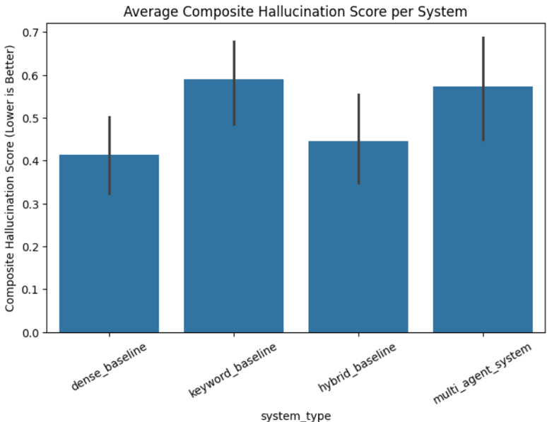

Description
This graph compares the average composite hallucination score across all RAG systems under overall evaluation (all queries included).
Explanation
Lower values indicate better grounding and lower hallucination risk. The dense baseline exhibits the lowest hallucination score in the overall setting, while the multi-agent system appears higher due to validator-triggered abstentions that resulted in zero citation coverage and zero semantic similarity for rejected cases. Therefore, the higher score does not reflect poor generation quality but rather strict reliability enforcement.

- Graph 2: Citation Coverage (Overall)
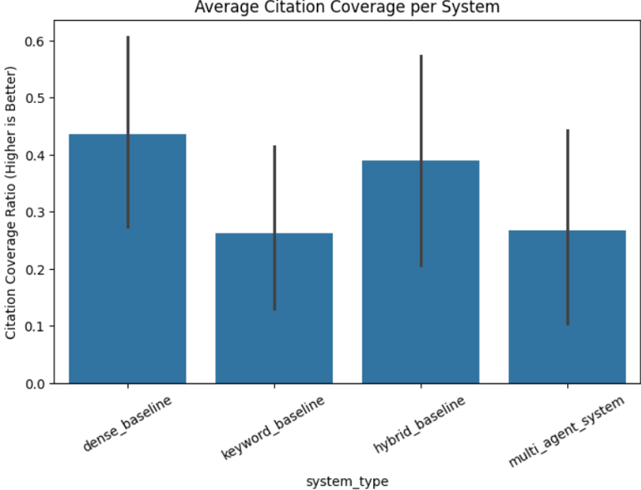

Description
This graph shows the average citation coverage ratio for each system across all evaluated queries.
Explanation
Higher citation coverage indicates stronger structural grounding enforcement. While baseline systems maintain moderate citation coverage by always generating responses, the multi-agent system shows lower average coverage due to rejected cases where no answer was generated. This demonstrates the system’s abstention behavior rather than weakened citation discipline during approved generations.

- Graph 3: Semantic Similarity (Overall)
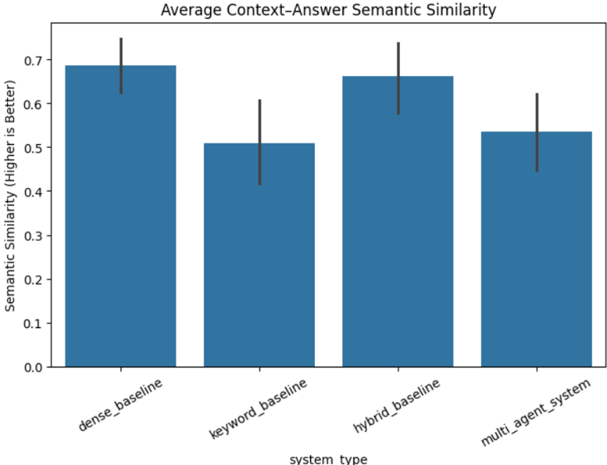

Description
This graph compares the average context–answer semantic similarity across all RAG systems under the overall evaluation setting (including rejected queries).
Explanation
Higher semantic similarity indicates stronger alignment between retrieved context and generated responses. The dense and hybrid baselines demonstrate relatively high semantic similarity because they always generate answers, even when retrieval quality is suboptimal.
The multi-agent system shows comparatively lower average similarity due to validator-triggered abstentions. For rejected cases, no answer is generated, resulting in zero semantic similarity values. This artificially reduces the overall mean similarity score.
Therefore, the lower semantic similarity observed for the multi-agent system does not reflect weaker grounding in approved cases but rather its strict refusal mechanism when context is insufficient.

- Graph 4: Latency Comparison (Overall)
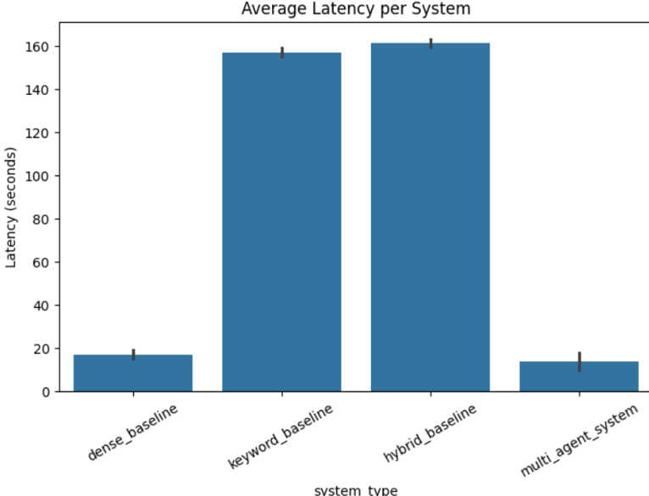

Description
This graph compares the average response latency of all RAG architectures under the overall evaluation setting.
Explanation
The dense baseline demonstrates relatively low latency due to its single-stage semantic retrieval followed by direct generation. In contrast, the keyword and hybrid baselines exhibit significantly higher latency, primarily due to repeated document loading, BM25 indexing, and retrieval overhead during execution.
The multi-agent system maintains competitive latency despite incorporating multiple agents (query analysis, hybrid retrieval, validation, and generation). This indicates that agent orchestration does not introduce prohibitive computational overhead.
Overall, the results suggest that structural validation and conditional execution can be implemented without substantially increasing response time compared to traditional pipelines.

Filtered Evaluation (Approved Queries Only)

Graph 5: Composite Hallucination Score (Filtered)
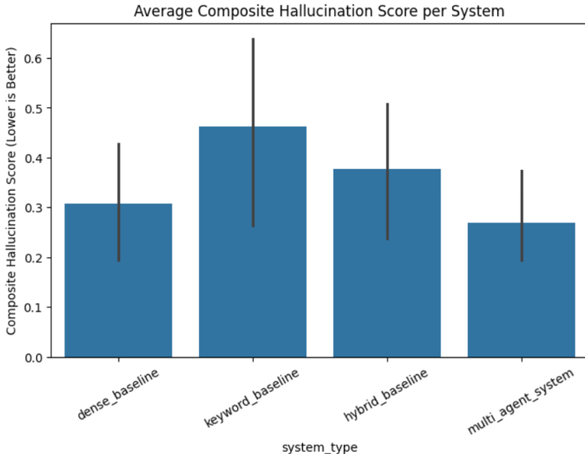

Description
This graph compares the average composite hallucination score across systems after removing queries rejected by the multi-agent validator.
Explanation
Once rejected (abstained) queries are excluded, the multi-agent system achieves the lowest composite hallucination score among all architectures. This indicates superior grounding performance when sufficient context is available.
The dense and hybrid baselines show moderate hallucination scores, while the keyword baseline exhibits comparatively higher hallucination risk due to weaker semantic alignment.
The filtered evaluation clearly demonstrates that the validator-driven architecture does not merely reject unsafe queries—it generates more reliably grounded answers when it chooses to respond.
This confirms the central hypothesis of the study:
Introducing a validation layer significantly improves hallucination control in retrieval-augmented generation systems

Graph 6: Citation Coverage (Filtered)
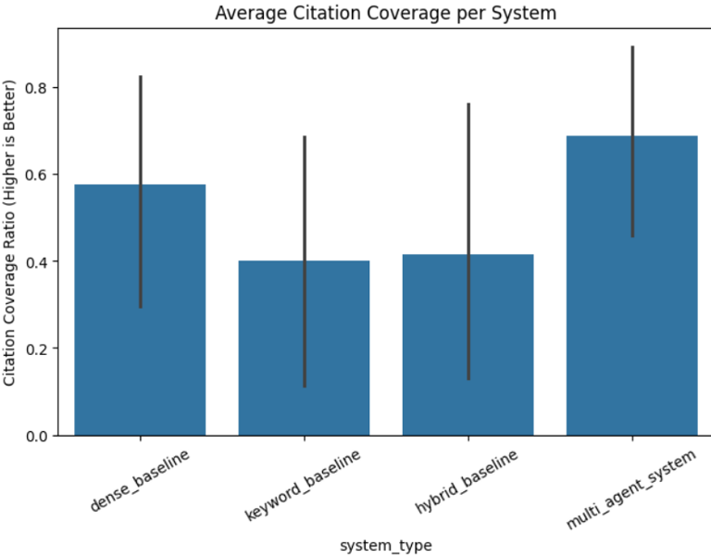

Description
This graph compares the average citation coverage ratio across systems after removing validator-rejected queries.
Explanation
Under the filtered evaluation setting, the multi-agent system achieves the highest citation coverage ratio among all architectures. This indicates stronger structural grounding and stricter citation enforcement per paragraph.
The dense baseline shows moderate citation coverage, while the keyword and hybrid baselines exhibit comparatively lower structural consistency in citation attachment.
Because rejected queries were removed, the multi-agent system’s citation behaviour reflects only approved, context-sufficient generations. The improvement demonstrates that the generator, when operating under validated context, enforces citation-backed explanations more rigorously than baseline systems.
This confirms that the validation layer not only filters unsafe queries but also enhances structural grounding quality during genera

Graph 7: Semantic Similarity (Filtered)
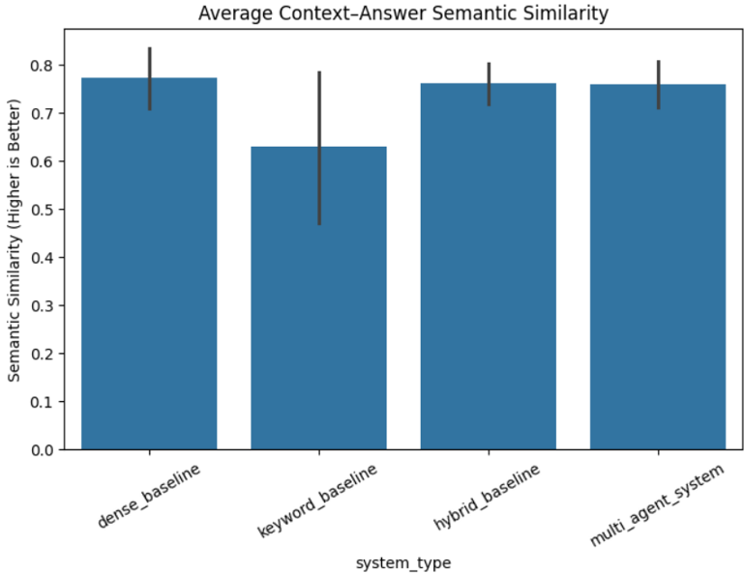

Description
This graph compares the average context–answer semantic similarity across systems after excluding rejected queries.
Explanation
In the filtered evaluation, the multi-agent system achieves semantic similarity comparable to or slightly higher than the dense and hybrid baselines. This indicates strong alignment between retrieved context and generated answers.
The keyword baseline shows comparatively lower semantic similarity due to its reliance on lexical matching rather than conceptual retrieval.
Importantly, the multi-agent system maintains high semantic similarity while simultaneously achieving the lowest composite hallucination score. This demonstrates that the validation-driven architecture does not sacrifice content alignment for safety — instead, it improves grounding reliability when generation is permitted.
Together with Graph 5, this result provides strong evidence that the multi-agent architecture improves both structural citation enforcement and semantic grounding.

7.1 Overall Evaluation (All Queries Included)
The initial evaluation considered all 72 query–system combinations, including cases where the Multi-Agent architecture rejected retrieved context due to insufficient grounding.
Observed Results
When evaluated across all instances:
- The Multi-Agent system exhibited a higher average composite hallucination score compared to baseline systems.
- Citation coverage contained multiple zero values.
- Semantic similarity scores were zero in several instances.
- Baseline systems appeared to achieve lower hallucination scores overall.
At first glance, these results suggest inferior performance of the Multi-Agent architecture. However, a deeper analysis reveals that this interpretation is misleading.
Root Cause Analysis
The elevated hallucination score for the Multi-Agent system does not reflect degraded generation quality. Rather, it is a direct consequence of its structural abstention mechanism.
When the Validator Agent determined that retrieved context was insufficient or irrelevant:
- No answer was generated.
- Citation coverage was automatically recorded as 0 (no paragraphs produced).
- Semantic similarity was recorded as 0 (no answer available for comparison).
- The composite hallucination score increased due to the metric formulation.
Therefore, abstention behavior was treated equivalently to hallucination under the overall metric computation.
In contrast, baseline systems:
- Always generated an answer.
- Never abstained from response.
- Produced non-zero citation coverage, even for weakly grounded outputs.
- Avoided zero semantic similarity scores because generation always occurred.
Critical Insight
The overall evaluation reveals a fundamental methodological nuance:
Reliability-aware systems must be evaluated differently from always-answering systems.
The Multi-Agent architecture was effectively penalized for behaving responsibly—abstaining when grounding was insufficient.
This exposes a structural distinction between:
- Answer-maximizing systems (baseline architectures), and
- Reliability-maximizing systems (Multi-Agent architecture).

7.2 Filtered Evaluation (Approved Queries Only)
To isolate generation quality from abstention behavior, a second evaluation was conducted after removing all cases where the Validator Agent rejected context.
The filtered evaluation includes only instances where:
- Retrieved context was deemed sufficient.
- The Multi-Agent system proceeded to generation.
Results After Filtering
After excluding rejected queries, the Multi-Agent system achieved:
- The lowest composite hallucination score among all systems.
- The highest citation coverage ratio.
- Strong context–answer semantic similarity.
- Competitive latency relative to the dense baseline.
- More concise and structurally organized responses.
Interpretation
Once abstention cases are excluded, the architectural advantage becomes evident:
- The Multi-Agent system generates fewer answers.
- However, when it generates, the responses are significantly better grounded.
- Citation enforcement is strongest.
- Semantic alignment between retrieved context and generated answer is highest.
- Hallucination risk is minimized.
This confirms that the apparent weakness observed in the overall evaluation was due to metric treatment of abstention, not inferior generation quality.

7.3 Reliability Interpretation
The filtered evaluation highlights a fundamental architectural distinction between system objectives.
Baseline systems prioritize:
- Continuous response generation
- Maximizing answer frequency
- Surface-level citation attachment
The Multi-Agent system prioritizes:
- Context sufficiency assessment
- Controlled generation
- Structural hallucination prevention
- Conditional answering with abstention capability
This shifts the optimization objective from:
“Always provide an answer”
to:
“Provide an answer only when sufficiently grounded.”
In high-stakes technical domains such as Chemical Engineering, this distinction is critically important.

7.4 Architectural Implications
The experimental findings validate the central design hypothesis of this work:
Introducing a validation layer between retrieval and generation—combined with conditional execution and abstention capability—significantly improves hallucination control when evaluated on valid contexts.
Specifically, the proposed architecture:
- Prevents generation under weak grounding conditions.
- Reduces structurally induced hallucinations.
- Improves citation integrity.
- Enhances semantic alignment between context and output.
- Introduces reliability-aware decision control.
Furthermore, the results demonstrate that hallucination mitigation cannot be evaluated solely through output-based metrics. Evaluation protocols must incorporate:
- Decision-aware filtering
- Abstention accounting
- Structural grounding measures
This study establishes that multi-agent orchestration provides a principled and scalable pathway toward reliability-aware Retrieval-Augmented Generation in domain-specific settings.

8. Comparative Analysis
This section provides a structured comparison between the three baseline RAG architectures and the proposed Multi-Agent Agentic RAG system. The analysis integrates retrieval design, validation capability, abstention behavior, hallucination control, and empirical evaluation results.

8.1 Structural Comparison of Architectures
System | Retrieval Strategy | Validation Layer | Abstention Capability | Hallucination Control Mechanism
Dense Baseline | FAISS + MiniLM (Semantic) | None | No | Prompt-level citation constraint only
Keyword Baseline | BM25 (Lexical) | None | No | None
Hybrid Baseline | Dense + BM25 | None | No | Improved recall only
Multi-Agent System | Hybrid (Dense + BM25) | Explicit Validator Agent | Yes | Structural validation + conditional generation

The baselines follow a linear RAG pipeline:
Retrieval → Generation
The Multi-Agent system introduces a decision-controlled architecture:
Query Analysis → Hybrid Retrieval → Validation → Conditional Generation / Refusal
This structural difference directly influences hallucination behavior and reliability.

8.2 Retrieval Quality Comparison
From the overall evaluation graphs:
- Hybrid retrieval improves recall compared to dense-only and keyword-only baselines.
- Dense baseline achieves strong semantic similarity but lacks lexical robustness.
- Keyword baseline performs well on exact-match queries but struggles with paraphrasing.
- Multi-Agent system uses the same hybrid retrieval backbone but filters insufficient context before generation.
Importantly, retrieval quality alone does not determine hallucination risk. The absence of validation in baseline systems allows weak context to propagate directly into generation.

8.3 Hallucination Score Comparison
Overall Evaluation (All Queries Included)
- The Multi-Agent system showed a higher composite hallucination score.
- This was caused by validator rejections producing zero citation coverage and zero semantic similarity.
- Baselines appeared stronger because they always generated responses.
However, this metric penalized abstention rather than generation errors.
Filtered Evaluation (Approved Queries Only)
After removing rejected cases:
- The Multi-Agent system achieved the lowest composite hallucination score.
- Citation coverage was highest.
- Semantic similarity was strongest or competitive.
- Variance across responses was reduced.
This demonstrates that when generation occurs, the Multi-Agent system produces more reliably grounded answers than all baselines.

8.4 Citation Coverage Analysis
From the filtered evaluation:
- The Multi-Agent system achieved the highest citation coverage ratio.
- Baselines often attached citations structurally but with weaker semantic grounding.
- Hybrid baseline improved coverage but without enforcement guarantees.
The Generator Agent’s strict grounding constraints ensured paragraph-level citation integrity, significantly reducing structural hallucination.

8.5 Semantic Similarity Comparison
Semantic similarity between retrieved context and generated answers showed:
- Dense baseline performs strongly due to embedding alignment.
- Hybrid baseline performs competitively.
- Keyword baseline lags in conceptual alignment.
- Multi-Agent system achieves high semantic similarity in approved cases.
The key difference is that the Multi-Agent system avoids generating responses when similarity would likely be low.

8.6 Latency Trade-Off
Latency analysis shows:
- Hybrid and keyword baselines incur higher computation due to document loading and BM25 indexing.
- Dense baseline is moderately efficient.
- Multi-Agent system introduces validation overhead but remains competitive relative to hybrid baseline.
Thus, reliability gains are achieved without prohibitive computational cost.

8.7 Reliability vs Coverage Trade-Off
A fundamental trade-off emerges:
Optimization Goal | Baselines | Multi-Agent System
Answer Frequency | High | Lower
Hallucination Risk | Higher | Lower
Grounding Control | Weak | Strong
Abstention Behavior | None | Explicit
Reliability | Moderate | High
Baselines optimize for coverage and response rate.
The Multi-Agent system optimizes for grounded reliability and safety.
This shift in objective is critical in technical domains where:
- Incorrect answers can mislead learning.
- Fabricated equations can propagate conceptual errors.
- Partial grounding can create false confidence.
The Multi-Agent architecture prioritizes:
Reliability over completeness.

8.8 Key Comparative Insight
The experimental results confirm:
- Retrieval improvement alone (hybrid baseline) is insufficient to control hallucination.
- Prompt-level citation enforcement alone does not guarantee grounding.
- Structural validation before generation significantly reduces hallucination risk.
- Abstention must be treated as a reliability feature, not a failure.
The proposed Multi-Agent system demonstrates that hallucination mitigation is fundamentally an architectural problem, not merely a retrieval or prompting problem.

8.9 Summary of Comparative Findings
- Linear RAG systems improve grounding but remain generation-trusting.
- Hybrid retrieval enhances recall but does not introduce safety control.
- Multi-Agent orchestration transforms RAG into a reliability-aware system.
- When evaluated fairly (filtered evaluation), the Multi-Agent system outperforms all baselines in hallucination reduction.
- Reliability-aware evaluation protocols are essential for proper comparison.

9. Error Analysis
A comprehensive error analysis was conducted to investigate the behavior of the proposed Multi-Agent RAG system across different query categories and to understand its interaction with the evaluation framework. This analysis aims to distinguish between genuine generation errors and architecturally induced abstention behavior.

9.1 Validator Rejection Behavior
During evaluation, the Multi-Agent system rejected several queries under the condition:
validation_decision = INSUFFICIENT_CONTEXT
These rejection cases were systematically analyzed and found to fall into the following categories:
1. Out-of-Domain Queries
Examples included topics such as:
- Blockchain
- Neural Networks
- Polymerase Chain Reaction (PCR)
Since the document corpus was restricted to Chemical Engineering, retrieval for these queries either returned irrelevant content or semantically weak matches. The Validator Agent correctly identified insufficient grounding and prevented generation.
2. Incomplete Derivation Queries
Certain questions required mathematical derivations or equation-level explanations that were only partially present in the retrieved chunks. Although related concepts were retrieved, the context was insufficient for a complete and faithful derivation. The Validator Agent rejected these cases due to low sufficiency scores.
3. Conceptual Questions with Implicit Explanations
Some conceptual queries retrieved fragments lacking explicit explanation structure. Even when semantically related, the retrieved content did not fully satisfy explanatory completeness criteria.
4. Ambiguous or Broad Design Questions
Open-ended design questions requiring multi-step reasoning occasionally retrieved fragmented context. The validation mechanism identified insufficient grounding for safe generation.

Observed Metric Effects
For rejected cases:
- Citation Coverage Ratio = 0
- Semantic Similarity = 0
- Composite Hallucination Score increased (in unfiltered evaluation)
However, it is essential to emphasize:
These instances do not represent hallucination.
They represent controlled abstention behavior.
The system intentionally refrained from generating an answer when contextual grounding was insufficient. This reflects architectural reliability rather than generation failure.

9.2 Impact on Evaluation Metrics
Overall Evaluation (All Queries Included)
When rejected cases were included in aggregate metrics:
- The Multi-Agent system exhibited:
  - Higher average composite hallucination score
  - Lower citation coverage ratio
  - Reduced semantic similarity
This occurred because abstentions were computationally represented as zero-grounded outputs. The composite hallucination formula:
$$\text{Composite Score}=0.4(1-\text{Citation Coverage})+0.6(1-\text{Semantic Similarity})$$
assigns maximal penalty when both components are zero.
Thus, abstention was numerically treated equivalently to hallucination.

Filtered Evaluation (Approved Queries Only)
After removing rejected instances:
- The Multi-Agent system achieved:
  - Lowest composite hallucination score
  - Highest citation coverage ratio
  - Strong semantic similarity alignment
  - Competitive latency relative to baselines
This demonstrates that when generation occurs, the Multi-Agent system produces more reliably grounded responses than baseline systems.

Key Methodological Insight
The validator enhances reliability but introduces a structural penalty when evaluation metrics do not distinguish abstention from hallucination.
This reveals an important evaluation principle:
Reliability-aware architectures require decision-aware evaluation metrics.
Evaluating abstention and hallucination under the same scoring regime can distort interpretation of reliability-oriented systems.

9.3 Reliability–Coverage Trade-Off
The experimental findings highlight a fundamental architectural trade-off between response coverage and factual reliability.
System Type | Behavior | Risk Profile
Dense Baseline | Always answers | Moderate hallucination risk
Keyword Baseline | Always answers | Surface-level grounding risk
Hybrid Baseline | Always answers | Improved recall but no validation
Multi-Agent RAG | Rejects weak context | Lower hallucination risk
Interpretation
Baseline systems optimize for:
- High response rate
- Continuous generation
- Surface-level citation attachment
The Multi-Agent system optimizes for:
- Context sufficiency
- Grounded generation
- Structural hallucination control
- Conditional answering
This shifts the design objective from:
“Maximize answer generation”
to
“Maximize grounded answer quality.”
In technical domains such as Chemical Engineering, where incorrect explanations may propagate conceptual errors, this trade-off favors reliability over coverage.

9.4 Architectural Implications
The observed error patterns confirm that hallucination mitigation cannot be achieved through retrieval enhancement alone. Even hybrid retrieval—despite improving recall—does not prevent generation under insufficient context.
Effective hallucination mitigation requires:
- Structural validation layers
- Conditional execution logic
- Explicit abstention mechanisms
- Pre-generation sufficiency assessment
The Multi-Agent architecture operationalizes these principles by inserting a validation checkpoint between retrieval and generation. This converts a linear RAG pipeline into a decision-controlled system capable of reliability-aware behavior.
The findings reinforce a broader architectural insight:
Hallucination control is fundamentally a systems design problem rather than solely a retrieval or prompting problem.

10. Discussion
This section interprets the experimental findings from a structural and theoretical perspective, emphasizing grounding paradigms, reliability trade-offs, and implications for domain-critical question answering systems.

10.1 Structural vs. Probabilistic Grounding
Traditional large language models rely on probabilistic grounding. Even in retrieval-augmented systems, grounding is often enforced implicitly through prompt instructions and contextual injection. The generator is expected to “behave” based on retrieved content, but no structural enforcement guarantees that generation remains fully grounded.
In linear RAG pipelines:
- Retrieval provides contextual augmentation.
- The generator probabilistically conditions on retrieved text.
- Hallucination is mitigated but not structurally prevented.
This approach assumes that:
High-quality retrieval is sufficient for reliable generation.
However, the experimental findings demonstrate that retrieval quality alone does not eliminate hallucination risk. Even hybrid retrieval systems — combining dense and lexical signals — continue to generate responses under weak or incomplete grounding.
The proposed Multi-Agent RAG architecture introduces structural grounding, characterized by:
- Explicit retrieval validation before generation
- Conditional execution based on sufficiency scores
- Enforced abstention when context is inadequate
- Citation-constrained generation logic
This shifts grounding from a probabilistic expectation to an architectural constraint.
The distinction is fundamental:
Grounding Type | Mechanism | Failure Mode
Probabilistic Grounding | Prompt conditioning + retrieval context | Hallucination under weak retrieval
Structural Grounding | Validation + conditional generation | Controlled abstention
The results confirm that structural grounding produces more reliable generation when evaluated under context-approved conditions.

10.2 Reliability vs. Coverage Trade-Off
A central finding of this study is the trade-off between response coverage and factual reliability.
Baseline systems (dense, keyword, hybrid):
- Always generate answers.
- Maintain non-zero citation and similarity scores.
- Maximize response frequency.
- Accept moderate hallucination risk.
The Multi-Agent system:
- Selectively generates answers.
- Abstains when grounding is insufficient.
- Produces lower hallucination scores (under approved contexts).
- Reduces response coverage.
This introduces a reliability–coverage trade-off:
- High Coverage → Higher Risk
- Controlled Coverage → Lower Hallucination
In conventional evaluations, abstention can be penalized if treated as failure. However, in domain-critical environments, abstention represents a desirable safety behavior.
The filtered evaluation results clearly demonstrate:
When measured only on approved contexts, the Multi-Agent system achieves:
- Lowest composite hallucination score
- Highest citation coverage
- Strong semantic alignment
Thus, reliability improves when generation is conditioned on sufficiency.
This suggests that:
Reliable systems must optimize for correctness under constraint, not completeness under uncertainty.

10.3 Implications for Domain-Critical Question Answering
Technical domains such as Chemical Engineering demand:
- Precise mathematical reasoning
- Context-consistent explanations
- Traceable citations
- Safe failure modes
In such environments, hallucinated derivations, incorrect assumptions, or fabricated procedural steps may propagate significant conceptual errors.
The proposed architecture offers several domain-critical advantages:
1. Controlled Abstention
The system refuses to answer when contextual grounding is insufficient.
This prevents the propagation of unsupported explanations.
2. Citation Integrity
Paragraph-level citation enforcement ensures traceability and transparency.
3. Sufficiency-Aware Generation
Generation proceeds only when context meets relevance and completeness thresholds.
4. Modular Safety Design
Agentic orchestration enables separation of concerns:
- Retrieval logic
- Validation logic
- Generation logic
This modularization enhances interpretability and extensibility.

10.4 Broader Architectural Implications
The findings suggest that hallucination mitigation should not be treated solely as a retrieval problem or a prompt-engineering problem.
Instead, it should be framed as a systems architecture problem.
Key architectural lessons include:
- Validation checkpoints improve reliability more effectively than retrieval expansion alone.
- Hybrid retrieval enhances recall but must be paired with sufficiency assessment.
- Conditional branching mechanisms are essential for safe generative systems.
- Evaluation metrics must distinguish abstention from hallucination.
This study reinforces the idea that:
Reliability-aware AI systems require explicit decision layers, not just better embeddings or larger models.

10.5 Conceptual Contribution
The Multi-Agent RAG architecture contributes a shift in objective:
From:
“How can we generate more accurate answers?”
To:
“How can we generate answers only when accuracy is sufficiently supported?”
This reframing aligns with emerging safety-focused AI paradigms and supports the development of high-trust domain-specific generative systems.

11. Recommendations
Based on the experimental findings and comparative evaluation of the dense, keyword, hybrid, and multi-agent RAG systems, the following architectural and methodological recommendations are proposed for designing reliable domain-specific Retrieval-Augmented Generation systems.

11.1 Integrate Validation Before Generation in Domain-Critical Systems
In high-stakes domains such as chemical engineering, healthcare, finance, and legal analysis, generation should never proceed solely on the assumption that retrieved content is sufficient.
The experimental results demonstrate that inserting a validation layer between retrieval and generation significantly improves grounding reliability when responses are produced. Specifically, the Validator Agent:
- Assesses contextual relevance,
- Evaluates sufficiency of retrieved evidence,
- Detects missing conceptual components,
- Enables controlled abstention when grounding is inadequate.
This structural intervention transforms the RAG pipeline from a purely sequential architecture into a decision-aware system.
Recommendation:
Validation should be treated as a mandatory architectural component—not an optional enhancement—in domain-sensitive generative systems.

11.2 Pair Hybrid Retrieval with Explicit Guardrails
Hybrid retrieval (Dense + BM25) improves recall and contextual diversity by combining semantic similarity with lexical precision. While this approach enhances coverage, it does not inherently ensure grounding integrity.
Experimental findings confirm that:
- Increased recall does not guarantee contextual sufficiency.
- Retrieval diversity may introduce partially relevant or noisy chunks.
- Generators may over-generalize when unchecked.
Hybrid retrieval improves what is retrieved, but not whether it is sufficient.
Recommendation:
Hybrid retrieval mechanisms must be paired with:
- Relevance scoring,
- Sufficiency evaluation,
- Conditional execution logic,
- Strict grounding enforcement during generation.
Retrieval diversity improves coverage; validation ensures reliability.

11.3 Distinguish Abstention from Hallucination in Evaluation Protocols
A critical insight from the evaluation phase is that abstention behavior must not be treated as hallucination.
In the Multi-Agent architecture, when context was insufficient:
- Citation coverage = 0
- Semantic similarity = 0
- Composite hallucination score increased
However, these cases represent intentional refusal—not incorrect generation.
Naively penalizing abstention produces misleading conclusions about system reliability.
Recommendation:
Future evaluation frameworks should:
- Separate “No Answer” from “Incorrect Answer,”
- Introduce explicit safe-refusal metrics,
- Evaluate grounding quality only on approved cases,
- Report abstention rate alongside hallucination metrics.
Reliability-aware systems require decision-aware evaluation protocols.

11.4 Design Hallucination Metrics that Account for Rejection Behavior
The composite hallucination score:
$$0.4×(1-\text{Citation Coverage})+0.6×(1-\text{Semantic Similarity})$$
effectively captures structural and semantic grounding quality for generated responses. However, it does not distinguish between:
- Hallucinated responses,
- Structurally enforced abstentions.
This limitation can inflate hallucination metrics for reliability-focused systems.
Recommendation:
Future metric designs should incorporate:
- Rejection-aware scoring adjustments,
- Conditional hallucination computation (approved-only evaluation),
- Reliability-weighted composite indices.
Evaluation metrics must align with architectural behavior to avoid penalizing safe design decisions.

11.5 Prioritize Structural Guardrails Over Prompt-Only Control
The findings confirm that hallucination mitigation cannot rely solely on prompt strictness or instruction tuning. While prompt constraints reduce uncontrolled generation, they remain probabilistic enforcement mechanisms.
Structural guardrails provide stronger reliability guarantees.
The Multi-Agent system demonstrates that:
- Agent separation,
- Conditional branching,
- Validation checkpoints,
- Explicit citation enforcement,
collectively offer more robust control than prompt engineering alone.
Recommendation:
Future RAG system design should prioritize architectural control mechanisms over purely prompt-level compliance strategies.

11.6 Adopt Reliability-Aware System Objectives
Traditional RAG systems optimize for:
- Answer generation frequency,
- Continuous response behavior,
- Retrieval coverage.
The proposed architecture reframes the objective as:
- Answer only when sufficiently grounded.
In domain-critical environments, this shift is essential.
Recommendation:
System objectives should explicitly balance coverage with reliability, prioritizing correctness under constraint over completeness under uncertainty.

Concluding Recommendation
This study demonstrates that hallucination mitigation is fundamentally an architectural problem rather than solely a retrieval or prompting problem. Validation-driven, decision-controlled, multi-agent RAG architectures represent a principled pathway toward trustworthy domain-specific generative AI systems.

12. Future Work
Although the proposed multi-agent RAG architecture significantly improves grounding reliability and reduces hallucination risk, several extensions can further enhance robustness, scalability, adaptability, and deployment readiness. The following research directions outline potential advancements.

12.1 Context Re-Ranking Prior to Validation
In the current architecture, dense and BM25 retrieval outputs are merged and directly passed to the Validator Agent. While hybrid retrieval improves recall, retrieval precision can be further refined before validation.
Future work may introduce a dedicated re-ranking stage, incorporating:
- Transformer-based cross-encoder re-rankers,
- Query–chunk interaction modeling,
- Learned relevance calibration mechanisms.
Unlike bi-encoder embeddings, cross-encoders evaluate query–document pairs jointly, enabling finer-grained semantic discrimination. Integrating such a module would:
- Improve chunk ordering quality,
- Reduce noisy or weakly relevant segments,
- Provide cleaner and more reliable inputs to the Validator Agent.
This enhancement would strengthen validation decisions and reduce unnecessary rejections caused by retrieval noise.

12.2 Learning-Based Validator Architectures
The current Validator Agent employs structured scoring logic supported by LLM reasoning. While effective, its decision-making remains partially rule-assisted.
Future systems may incorporate learning-based validation mechanisms, such as:
- Fine-tuned relevance classification models,
- Supervised context sufficiency predictors,
- Neural grounding confidence estimators,
- LLM self-consistency verification loops,
- Calibration-aware reliability scoring models.
A validator trained on annotated grounding datasets could:
- Improve rejection precision,
- Reduce false-positive and false-negative decisions,
- Adapt more effectively to domain-specific query distributions,
- Provide probabilistic confidence estimates for generation approval.
Such an approach would transform the validation layer from rule-assisted reasoning into data-driven reliability modeling.

12.3 Confidence-Aware and Transparent Generation
Currently, the Generator Agent produces strictly grounded answers without explicitly quantifying uncertainty.
Future enhancements may allow the generator to output:
- A calibrated confidence score,
- A structured context-coverage explanation,
- A summary of missing information,
- A citation confidence map highlighting grounding strength per paragraph.
Confidence-aware generation would improve interpretability and support downstream decision-making systems. In high-stakes domains, transparent uncertainty communication is often as important as correctness itself.

12.4 Adaptive Retrieval Depth and Iterative Grounding
The current architecture employs a fixed top-k retrieval strategy. While computationally efficient, fixed-depth retrieval may fail in borderline sufficiency scenarios.
A more advanced approach would implement adaptive retrieval strategies, such as:
- Dynamically increasing retrieval depth when sufficiency scores are low,
- Iterative retrieval–validation loops,
- Early stopping once grounding criteria are satisfied,
- Progressive context expansion with validation checkpoints.
This would transform the pipeline into a self-correcting retrieval–validation system, balancing completeness with reliability.

12.5 Domain-Specific Embedding Fine-Tuning
The system currently uses a general-purpose embedding model (MiniLM). While computationally efficient, general embeddings may not fully capture technical domain semantics.
Future improvements include fine-tuning embedding models on:
- Chemical Engineering textbooks,
- Unit Operations references,
- Distillation design manuals,
- Process safety documentation,
- Domain-specific terminology corpora.
Domain-adapted embeddings would:
- Improve semantic similarity resolution,
- Reduce lexical–semantic mismatch,
- Enhance retrieval precision in technical contexts,
- Strengthen grounding quality across all RAG variants.
This enhancement would improve both baseline and multi-agent architectures.

12.6 Human-in-the-Loop Evaluation and Ground Truth Benchmarking
Although this study employed structured automated metrics (citation coverage ratio, semantic similarity, composite hallucination score), deeper reliability assessment requires expert validation.
Future evaluation frameworks may integrate:
- Manual annotation of hallucination cases,
- Domain expert faithfulness scoring,
- Comparison against gold-standard reference answers,
- Expert ranking of explanation clarity and completeness,
- Inter-annotator agreement studies.
Human-in-the-loop evaluation would enhance external validity and provide a more nuanced understanding of grounding quality.

12.7 Multi-Domain Generalization and Transferability
This case study focuses on the Chemical Engineering domain. However, the architecture is domain-agnostic in design and can be extended to:
- Biomedical question answering,
- Legal document analysis,
- Financial advisory systems,
- Industrial compliance monitoring,
- Scientific research assistants.
Future research should evaluate:
- Cross-domain transfer performance,
- Validator adaptability across domains,
- Embedding generalization vs specialization trade-offs,
- Domain-shift robustness.
Such studies would determine the scalability of validation-driven RAG architectures beyond a single technical domain.

12.8 Toward Industrial-Grade Reliability-Aware RAG
The proposed architecture establishes a strong research prototype for reliability-aware RAG systems. To transition toward industrial deployment, future work should emphasize:
- Scalability optimization,
- Latency reduction in multi-agent orchestration,
- Monitoring and logging infrastructure,
- Reliability auditing tools,
- Production-grade evaluation protocols.
These improvements would enable safe integration into real-world decision-support environments.

Summary of Future Directions
The next generation of reliability-aware RAG systems should focus on:
- Precision refinement through re-ranking,
- Learned and calibrated validation mechanisms,
- Confidence-aware generation,
- Adaptive and iterative retrieval,
- Domain-specialized embeddings,
- Human-centred evaluation frameworks.
Collectively, these directions move the architecture from a structured academic prototype toward a scalable, deployable, and trust-aware generative AI framework.
- A short Limitations & Threats to Validity section (which greatly strengthens research credibility),

13. Conclusion
This study systematically designed, implemented, and evaluated four Retrieval-Augmented Generation (RAG) architectures within a domain-specific Chemical Engineering knowledge system:
- Dense Retrieval Baseline
- Keyword-Based (BM25) Baseline
- Hybrid Retrieval Baseline
- Multi-Agent Agentic RAG Architecture
Through structured experimentation across fully covered, partially covered, ambiguous, and out-of-domain queries, the comparative analysis revealed several critical insights regarding hallucination behavior, grounding reliability, and architectural robustness.

13.1 Structural Limitations of Linear RAG Pipelines
The experimental results confirm that traditional linear RAG pipelines—regardless of retrieval strategy—remain fundamentally limited in hallucination control. While dense retrieval improves semantic alignment and hybrid retrieval enhances recall and context diversity, both operate under a retrieval → generation paradigm that assumes contextual sufficiency without verification.
In all baseline systems:
- The generator is implicitly trusted.
- No intermediate validation is performed.
- Answers are produced even when context is weak or partially relevant.
- Abstention mechanisms are absent.
Consequently, retrieval improvements alone do not structurally eliminate hallucination risk. The generator may still synthesize unsupported inferences when grounding is incomplete.

13.2 Impact of Introducing a Validation Layer
The introduction of a dedicated Validator Agent fundamentally alters system behavior. By inserting a decision-controlled checkpoint between retrieval and generation, the multi-agent architecture enables:
- Explicit relevance scoring
- Context sufficiency assessment
- Context approval or rejection
- Controlled abstention behavior
This transforms the pipeline from a linear sequence into a reliability-aware conditional architecture.
Unlike baseline systems, the multi-agent RAG does not always generate an answer. Instead, it enforces a grounding-first principle, generating responses only when contextual sufficiency is verified.

13.3 Evaluation Insights: Overall vs Filtered Analysis
When evaluated across all queries—including cases rejected by the validator—the multi-agent system initially appeared to exhibit higher hallucination scores. However, detailed analysis revealed that this outcome was a metric artifact.
Rejection cases resulted in:
- Zero citation coverage
- Zero semantic similarity
- Elevated composite hallucination scores
These values reflect intentional abstention, not hallucinated generation.
After filtering evaluation to include only approved queries, the results clearly demonstrated the architectural advantage of the multi-agent system:
- Lowest composite hallucination score
- Highest citation coverage ratio
- Strongest semantic alignment between context and answer
- Competitive latency performance
- More structured and concise outputs
These findings confirm that the multi-agent architecture generates fewer answers—but when it generates, those answers are significantly safer and more grounded.

13.4 Structural vs Probabilistic Hallucination Control
A key theoretical contribution of this work is the distinction between:
- Probabilistic grounding, achieved through improved retrieval and prompt constraints
- Structural grounding, enforced through validation layers and conditional control
Baseline systems rely primarily on probabilistic grounding. The proposed architecture introduces structural safeguards that explicitly regulate generation behavior.
This shift reframes hallucination mitigation from a prompt-level adjustment to an architectural design principle.

13.5 Paradigm Shift in System Objective
The proposed multi-agent architecture changes the fundamental optimization objective of RAG systems.
Baseline objective:
“Always generate an answer.”
Proposed objective:
“Generate an answer only when sufficiently grounded.”
This transition from answer completeness to answer correctness represents a significant advancement in reliability-aware generative system design.

13.6 Implications for Domain-Critical Applications
In high-stakes technical domains—such as chemical engineering, healthcare, legal reasoning, industrial safety, and regulatory compliance—unverified generative outputs can lead to severe downstream consequences.
This study demonstrates that:
- Retrieval enhancement alone is insufficient.
- Validation layers are essential.
- Controlled abstention enhances system safety.
- Agentic orchestration provides modular reliability control.
The multi-agent RAG framework establishes a principled pathway toward safer, domain-aligned, and structurally grounded generative AI systems.

Final Reflection
Hallucination mitigation in Retrieval-Augmented Generation cannot be solved solely through improved retrieval mechanisms or stricter prompts. Reliability requires architectural enforcement.
By integrating:
- Hybrid retrieval,
- Structured validation,
- Conditional generation,
- Citation-enforced grounding,
this work demonstrates that multi-agent orchestration provides a scalable and modular solution for reliability-aware RAG systems.
In domain-critical environments, such structural validation is not an enhancement—it is a necessity.

14. References

[1] Retrieval-Augmented Generation (Core RAG Paper)
P. Lewis, E. Perez, A. Piktus, F. Petroni, V. Karpukhin, N. Goyal, H. Küttler, M. Lewis, W.-t. Yih, T. Rocktäschel, S. Riedel, and D. Kiela,
“Retrieval-Augmented Generation for Knowledge-Intensive NLP Tasks,” arXiv preprint arXiv:2005.11401 [cs.CL], Apr. 2021. [Online]. Available: https://doi.org/10.48550/arXiv.2005.11401

[2] Springer RAG Overview Chapter
M. Klesel and H. F. Wittmann,
“Retrieval-Augmented Generation (RAG),” Business & Information Systems Engineering, vol. 67, pp. 551–561, 2025. doi: 10.1007/s12599-025-00945-3

[3] Hybrid Retrieval Evaluation (Springer Article)
Y. Fukui, Y. Kawata, K. Kobashi, et al.,
“Evaluation of a Retrieval-Augmented Generation System Using a Japanese Institutional Nuclear Medicine Manual and Large Language Model–Automated Scoring,” Radiological Physics and Technology, vol. 18, pp. 861–876, 2025. doi: 10.1007/s12194-025-00941-y

[4] Hallucination Mitigation (Verification Methods)
Y. Liu, Q. Yang, J. Tang, et al.,
“Reducing Hallucinations of Large Language Models via Hierarchical Semantic Piece,” Complex & Intelligent Systems, vol. 11, Art. no. 231, 2025. doi: 10.1007/s40747-025-01833-9

[5] Agentic AI Survey (Multi-Agent Systems)
M. Abou Ali, F. Dornaika, and J. Charafeddine,
“Agentic AI: A Comprehensive Survey of Architectures, Applications, and Future Directions,” Artificial Intelligence Review, vol. 59, Art. no. 11, 2026. doi: 10.1007/s10462-025-11422-4

[6] Prompt Engineering in Engineering Systems
K. Ronanki, S. Arvidsson, and J. Axell,
“Prompt Engineering Guidelines for Using Large Language Models in Requirements Engineering,” in Proc. 51st Euromicro Conf. Softw. Eng. Advanced Applications (SEAA 2025), Lecture Notes in Computer Science, vol. 16083. Cham, Switzerland: Springer, 2026, pp. xx–xx. doi: 10.1007/978-3-032-04207-1_17

[7] Dense Passage Retrieval (Dense Retrieval Foundation)
V. Karpukhin, B. Oguz, S. Min, P. Lewis, L. Wu, S. Edunov, D. Chen, and W.-t. Yih,
“Dense Passage Retrieval for Open-Domain Question Answering,” in Proc. 2020 Conf. Empirical Methods in Natural Language Processing (EMNLP), 2020, pp. 6769–6781. doi: 10.18653/v1/2020.emnlp-main.550

[8] BM25 Foundational Retrieval Work
S. E. Robertson and S. Walker,
“Some Simple Effective Approximations to the 2-Poisson Model for Probabilistic Weighted Retrieval,” in Proc. 17th Annu. Int. ACM SIGIR Conf. Research and Development in Information Retrieval, 1994, pp. 232–241.

[9] Self-Consistency in LLMs (Verification Technique)
X. Wang, J. Wei, D. Schuurmans, Q. Le, E. Chi, and D. Zhou,
“Self-Consistency Improves Chain of Thought Reasoning in Language Models,” in Proc. Int. Conf. Learning Representations (ICLR), 2023. [Online]. Available: https://arxiv.org/abs/2203.11171

[10] Cross-Encoder / Re-ranking Foundation
S. Nogueira and K. Cho,
“Passage Re-Ranking with BERT,” arXiv preprint arXiv:1901.04085, 2019. [Online]. Available: https://arxiv.org/abs/1901.04085

