Name: - Satyam Kumar Roll no.: -B19BB060

**Assignment – 2 (Signal and System)**

In this assignment we are doing image processing. In which we compare multiple images and for that we are using different techniques.

Firstly, an image of 1920×1080 samples is given. And we want to transmit it through a channel C but the constraint is that it only allows 960×540. So, we need to do down-sampling of this image.

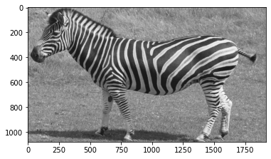

Fig: - This is our original image with dimension 1920×1080.

* There are different methods of down-sampling but here for the first task we are just choosing alternate pixel and this will help in the reduction of sample by a factor of 2.

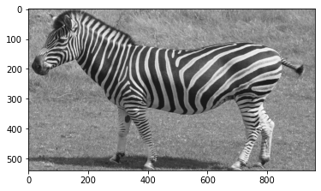

Fig: - This is down-sampled image with dimension 960×540

* Now after receiving the image through the channel we want to up-sample this image i.e., increase the number of samples by a factor of 2. And for this I’m using **linear interpolation** method by using inbuilt library of **OpenCV.** Image interpolation works in two directions, and tries to achieve a best approximation of a pixel’s colour and intensity based on the values at surrounding pixels.
* Now in **Task 1**, we need to compare our original image and this up-sampled image. So, for that we just subtract the matrix value of original image and up-sampled image. And then I just visualise this difference.

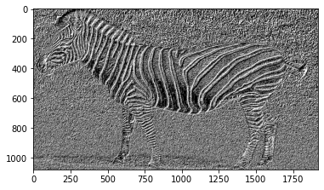

Fig: - Difference between original image and up-sampled image (by using interpolation)

* Now in Task 2, we need to first use a moving average filter of size 3×3 (also called a low pass filter) for our original image. A low pass filter is the basis for most smoothing methods. An image is smoothed by decreasing the disparity between pixel values by averaging nearby pixels. 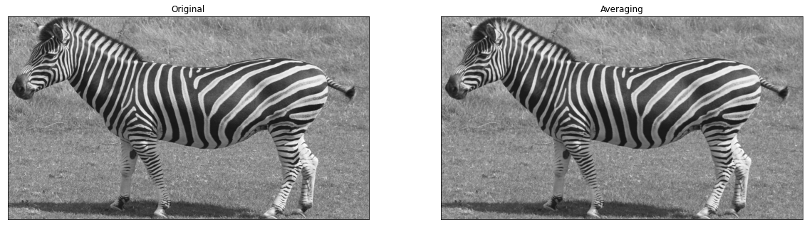

Fig: - As we observe both images closely, it is observed that the edges are not so sharp in case of Averaging as we are using Low pass filter here.

* Now we down-sampled the Averaging image (fm) by a factor of 2 by just dropping alternate pixels. And name them as g.

* Now up-sampled this image (g) again by using linear interpolation. And name them as gu.

* Our last objective is to compare original image i.e., f with up-sampled image i.e., gu. And for this just take a difference of f and gu matrix, and observe the image.

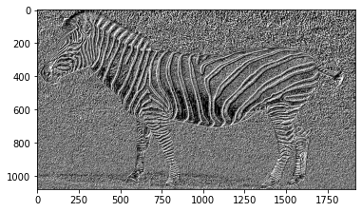

Fig: - Difference between original image and up-sampled image (in case of moving average)

**Conclusion: -**

* Image of task 1 is visually closer to original image (Similarity of image in Task 1 is 87.5% and in Task 2 is 83.6%).
* In Task 2 we are using Low pass filter and it makes image blurry because it does not detect edges.
* Edge is basically high frequency signal because there is sudden jump in intensity which can be detected by High pass filter but not by low pass filter.

For codes, I’m attaching a file from there you will get all codes.