**EXERCISE 3-DML Commands – INSERT, SELECT, UPDATE, DELETE**

**Q2**

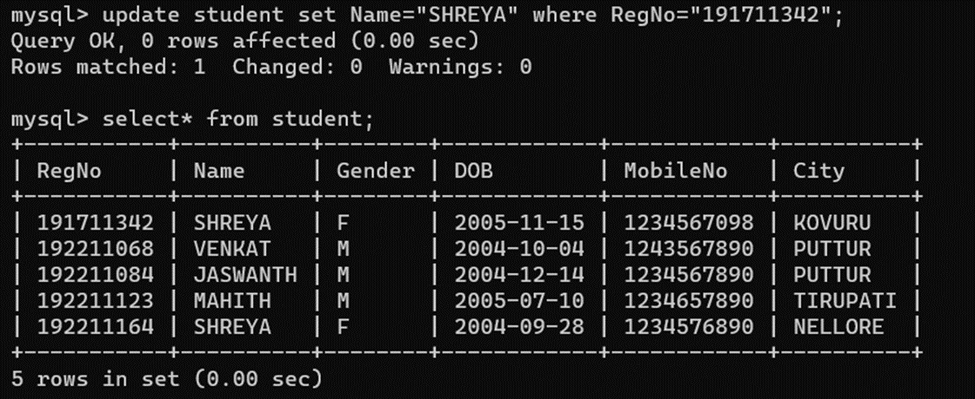

Q3

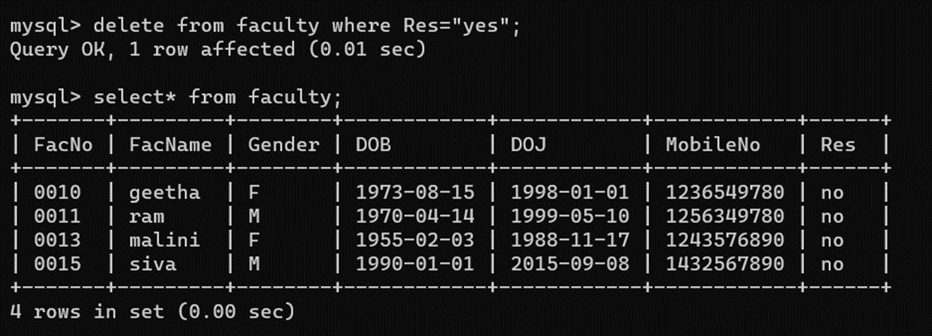

Q4

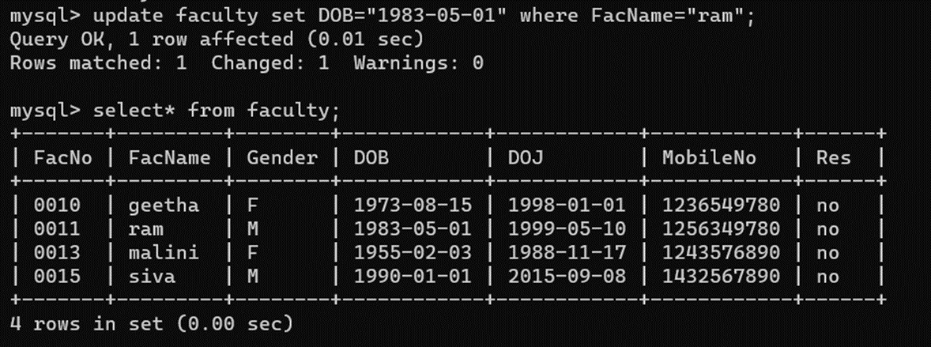

Q5

