**EXERCISE 5**

**SELECT with various clause – BETWEEN, IN, Aggregate function**

Q1

AGGREGATE

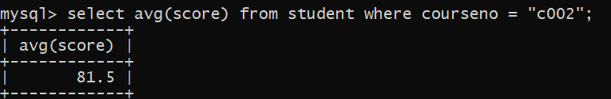

Q2

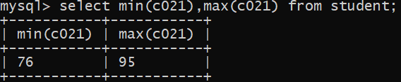

Q3

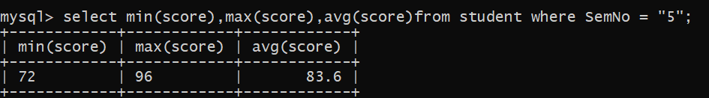

Q4

