FROM ubuntu:20.04

This line specifies that the base image for this Dockerfile is the official Ubuntu 20.04 image.

RUN apt-get update && apt-get install -y python3 python3-pip

This line runs the apt-get command to update the package lists for upgrades and new package installations. It then installs Python 3 and pip (Python's package installer) without asking for user confirmation.

RUN pip install flask

This line runs the pip command to install Flask.

COPY app.py /opt/

This line copies the app.py file from the current directory on the host machine to the /opt/ directory inside the Docker container.

ENTRYPOINT FLASK_APP=/opt/app.py flask run --host=0.0.0.0 --port=8080

This line sets the FLASK_APP environment variable to /opt/app.py and then runs the flask command with the run subcommand to start the Flask application. The –host option is set to 0.0.0.0 to allow the application to be accessible from outside the Docker container, and the –port option is set to 8080 to specify the port number that the application will listen on.

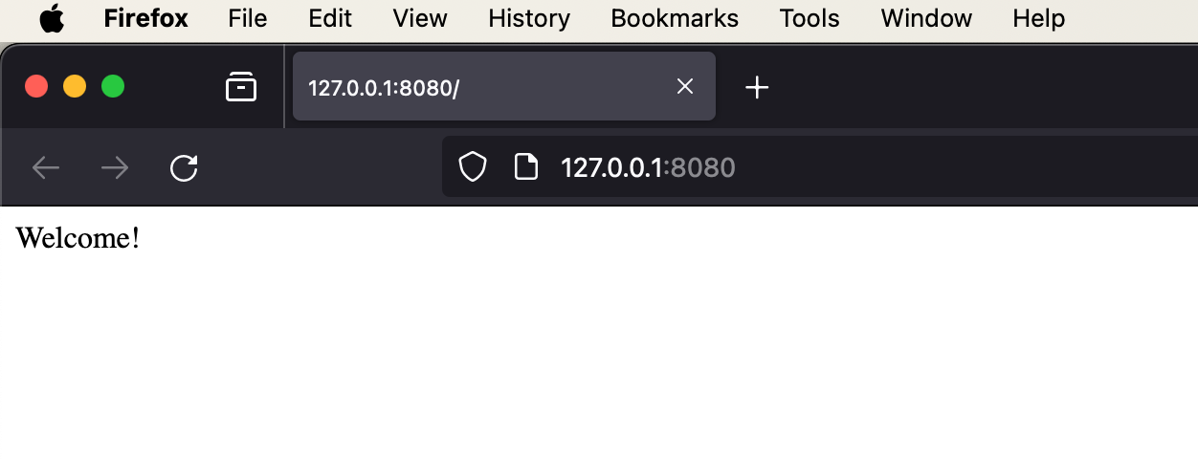

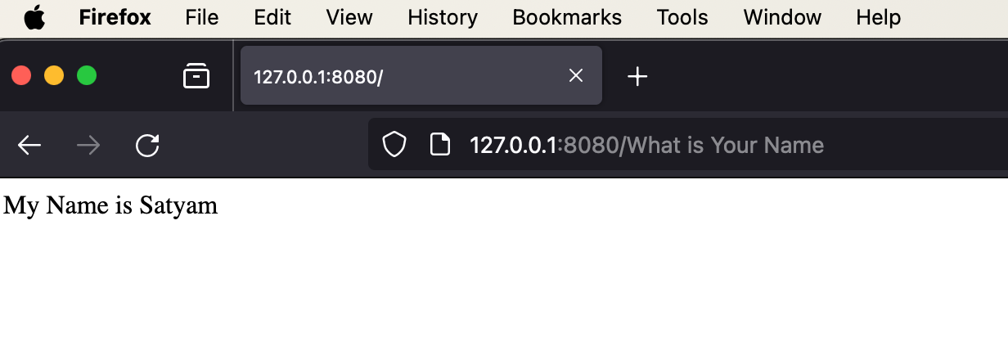

DockerHub Link : <https://hub.docker.com/repository/docker/satyam196/flask_app_test>