**AUTOMATE TRIGGER WITH TESTING**

*#created by: - Satyam Markam*

*#Date: -16-06-2023*

*#language: SQL, Python*

**Table Details:**

**1.SQL query table**

* Test case SQL queries are stored in a table.
* The procedure utilizes this table to generate the test output.

**2. Test template**

* The table has a fixed number of columns and rows, serving as a template.
* A procedure will fill the table with output specific to the current date.
* Python will then utilize this table to trigger the tableau subscription.

**3. history table**

* Store daily test results.
* Perform monthly analysis using the stored data.

**1. SQL query table**

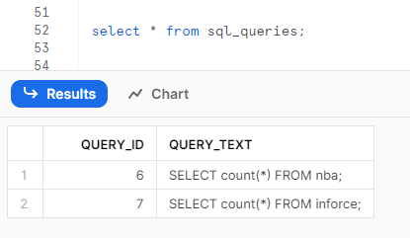

**2. Test template**

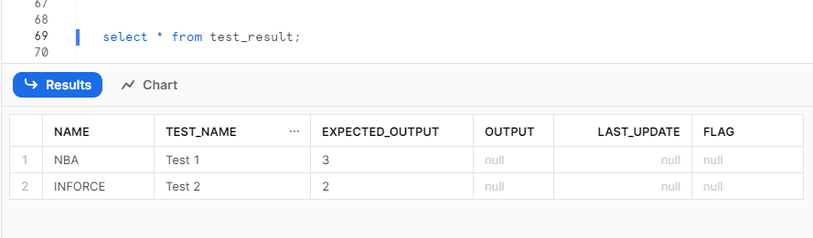

**3 history table**

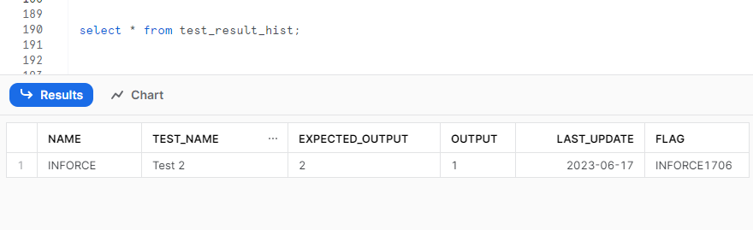

**Flow:**

Python

SNOWFLAKE

**Steps:**

1. Load completion triggers the procedure.
2. The procedure updates the template with current date testing result.
3. Python validates and sends confirmation emails to users.

**Python Flow:**

**Load completed.**

CHECK SNOWFALKE TEST TEMPLATE

**TEST TEMPLETE UPDATE**

PYTHON TRIGGER

TEST FAILED

Send mail.

TEST PASS

Trigger tableau

Send mail.