MISCELLANEOUS ASSIGNMENT
Comparison of Iterative Binary Search vs Recursive Binary Search

Date: 08.08.2025
Name: Satyam kumar Singh
Roll No.: 3254
Branch: Comp-A
Batch: S-3

CODE(using recursion):
import time

def binary_search_recursive(arr, target, low, high, step=1):
if low > high:
print(f"{target} not found in array.")
return -1

print(f"Step {step}: Searching in {arr[low:high+1]}")
mid = (low + high) // 2

if arr[mid] == target:
print(f"Found {target} at index {mid}")
return mid
elif arr[mid] < target:
return binary_search_recursive(arr, target, mid + 1, high, step + 1)
else:
return binary_search_recursive(arr, target, low, mid - 1, step + 1)

arr_input = input("Enter sorted array elements (space-separated): ")
arr = list(map(int, arr_input.strip().split()))

target = int(input("Enter the target value to search: "))

print("\n=== Recursive Binary Search ===")
start_time = time.time()

binary_search_recursive(arr, target, 0, len(arr) - 1)

end_time = time.time()
elapsed_time = end_time - start_time

print(f"\nTime taken: {elapsed_time:.6f} seconds")

code(using iteration):
import time
def binary_search_iterative(arr, target):
low = 0
high = len(arr) - 1
step = 1
while low <= high:
print(f"Step {step}: Searching in {arr[low:high+1]}")
mid = (low + high) // 2
if arr[mid] == target:
print(f"Found {target} at index {mid}")
return mid
elif arr[mid] < target:
low = mid + 1
else:
high = mid - 1
step += 1
print(f"{target} not found in array.")
return -1
arr_input = input("Enter sorted array elements (space-separated): ")arr = list(map(int, arr_input.strip().split()))
target = int(input("Enter the target value to search: "))
print("\n=== Iterative Binary Search ===")
start_time = time.time()

binary_search_iterative(arr, target)

end_time = time.time()
elapsed_time = end_time - start_time

print(f"\nTime taken: {elapsed_time:.6f} seconds")

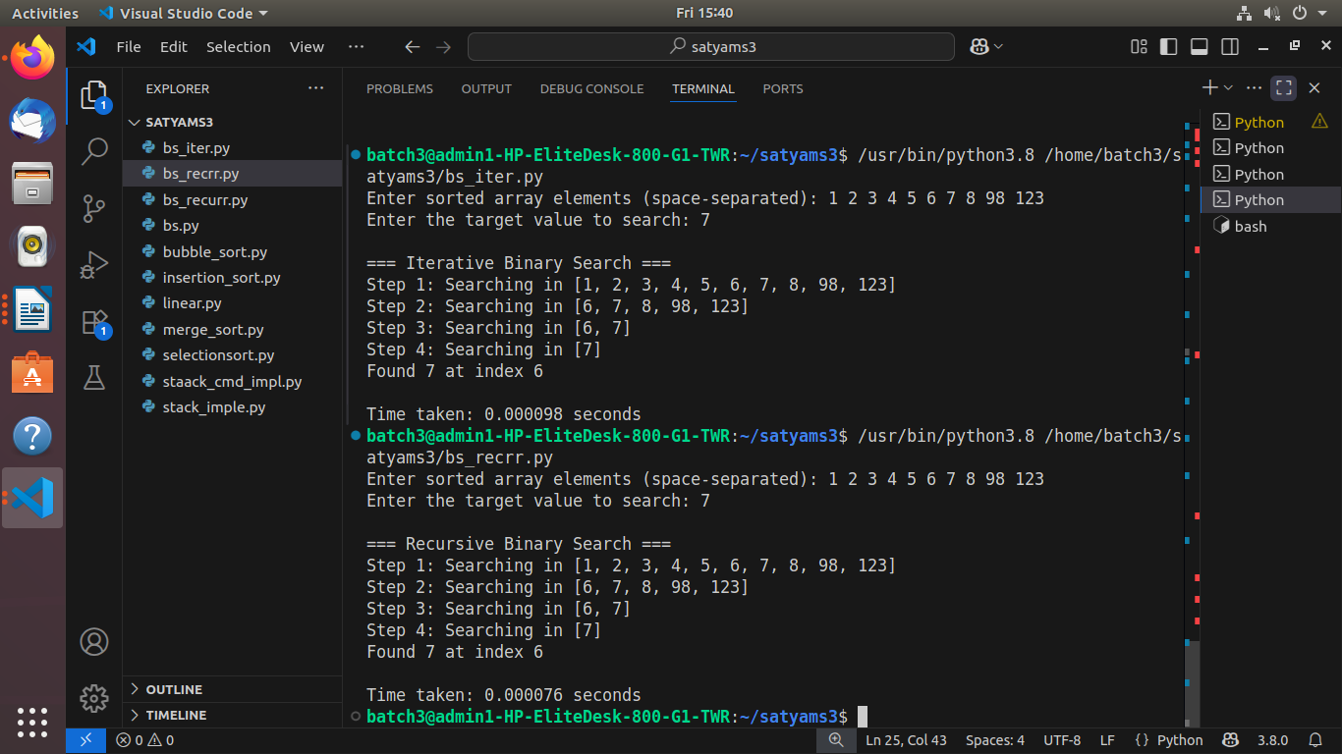
#screenshot(output)

Algorithm | Array Size | Key | Execution Time
Iterative Binary Search | 10 | 1 | 0.000057
Iterative Binary Search | 10 | 123 | 0.000078
Iterative Binary Search | 10 | 98 | 0.000095
Iterative Binary Search | 100 | 1 | 0.000032
Iterative Binary Search | 100 | 100 | 0.000067
Iterative Binary Search | 100 | 88 | 0.00043
Iterative Binary Search | 1000 | 1 | 0.000052
Iterative Binary Search | 1000 | 1000 | 0.000232
Iterative Binary Search | 1000 | 965 | 0.000023
Iterative Binary Search | 10000 | 1 | 0.000678
Iterative Binary Search | 10000 | 10000 | 0.000232
Iterative Binary Search | 10000 | 8564 | 0.000017

Recursive Binary Search | 10 | 1 | 0.000092
Recursive Binary Search | 10 | 123 | 0.000109
Recursive Binary Search | 10 | 98 | 0.000092
Recursive Binary Search | 100 | 1 | 0.00042
Recursive Binary Search | 100 | 45 | 0.00037
Recursive Binary Search | 100 | 237 | 0.000123
Recursive Binary Search | 1000 | 1 | 0.00237
Recursive Binary Search | 1000 | 65 | 0.0003475
Recursive Binary Search | 1000 | 546 | 0.0004346
Recursive Binary Search | 10000 | 1 | 0.006832
Recursive Binary Search | 10000 | 10000 | 0.000576
Recursive Binary Search | 10000 | 8650 | 0.696

