**Data-Driven Consumer Insights**

A Deep Dive into E-Commerce Sales and Behavior Trends

horizontal line

**Role:** Business Analyst Intern  
**Name:** Satyam Kumar

As a consultant for major consumer brands, I have analyzed their Amazon performance data to identify opportunities, patterns, and challenges in online sales performance. Using SQL and analytical tools, I’ve addressed key business questions, derived insights, and flagged critical issues.  
  
**Please find the** [**SQL solution file**](https://drive.google.com/file/d/1L0ZvMxEEFftY4qf9SGrBVVQ8kz8xC--I/view?usp=sharing) **for all the questions here (contains all the SQL solutions)**

**Please find the** [**Excel solution file**](https://docs.google.com/spreadsheets/d/14Rgmq1Ht1gEA4SdrrLcpLOupstsrDeQh/edit?usp=sharing&ouid=111704656152914448501&rtpof=true&sd=true) **for all the questions here (contains all the tables/charts/graphs)**

## Question 1: Most Expensive SKU (on average)

[**SQL solution file**](https://drive.google.com/file/d/1L0ZvMxEEFftY4qf9SGrBVVQ8kz8xC--I/view?usp=sharing)

[**Excel solution file**](https://docs.google.com/spreadsheets/d/14Rgmq1Ht1gEA4SdrrLcpLOupstsrDeQh/edit?usp=sharing&ouid=111704656152914448501&rtpof=true&sd=true)

**Approach:**

* Aggregated total revenue and units sold per SKU
* Computed Average Selling Price (ASP) = Revenue / Units

**Result:**

* **SKU Name:** C03CBL[721
* **Average Price:** ₹1147.79
* **Total Revenue:** ₹575,044.59
* **Total Units Sold:** 501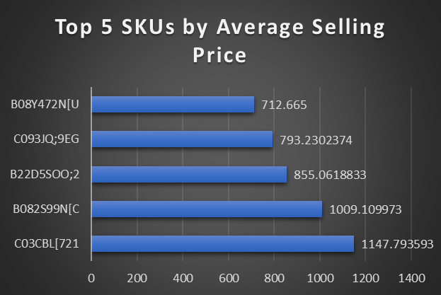

## Question 2: Percentage of SKUs with Revenue

% of SKUs that have generated some revenue in this time period:

[**SQL solution file**](https://drive.google.com/file/d/1L0ZvMxEEFftY4qf9SGrBVVQ8kz8xC--I/view?usp=sharing)

[**Excel solution file**](https://docs.google.com/spreadsheets/d/14Rgmq1Ht1gEA4SdrrLcpLOupstsrDeQh/edit?usp=sharing&ouid=111704656152914448501&rtpof=true&sd=true)

**Approach:**

* Counted distinct SKUs with revenue > 0 or revenue <0
* Compared against total SKUs

**Result:**

* **Total SKUs:** 465
* **SKUs with Revenue:** 365
* **Percentage:** **78.49%**

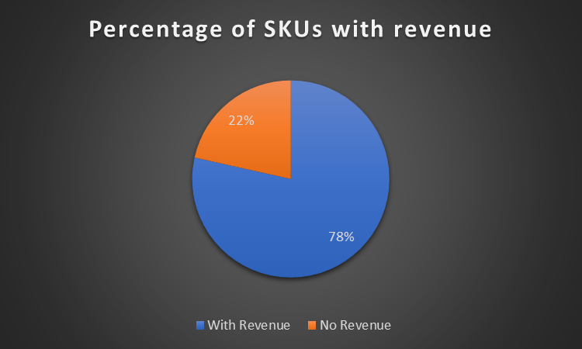

### SKUs That Stopped Selling After July

* Identified SKUs with sales before July 31, but zero sales afterward
* **Number of such SKUs:** 19
* **Sample SKUs:** B012GU7SOL, B116DUQLEB, B20EKD5JF4, B225I326ET, C019:8WTE8, C01JPONNVK, C035O8\UJC, C076JT7:XY, C09;:9PR57, C13EHKRAS4, C1964PSQ[N, D02DR5SY3I, D03O20QQDE, D07;D:4VGR, D187XMSWL3, D1883SDB64, D22TZCQYWC, D26XH5B4OM, D28EGTXVWH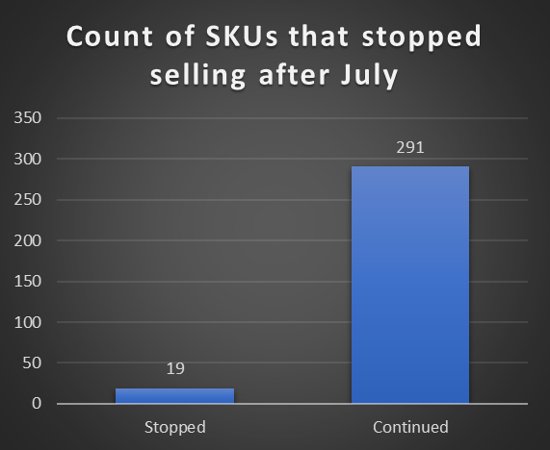

## Question 3: Sale Event Dates

Somewhere in this timeframe, there was a Sale Event. To identify those dates:

[**SQL solution file**](https://drive.google.com/file/d/1L0ZvMxEEFftY4qf9SGrBVVQ8kz8xC--I/view?usp=sharing)

[**Excel solution file**](https://docs.google.com/spreadsheets/d/14Rgmq1Ht1gEA4SdrrLcpLOupstsrDeQh/edit?usp=sharing&ouid=111704656152914448501&rtpof=true&sd=true)

**Approach:**

* Plotted daily revenue trends (sum of ordered_revenue vs Feed_date)
* Identified spikes significantly above average

**Sale Period Identified:**

**July 15 – 16, 2019**

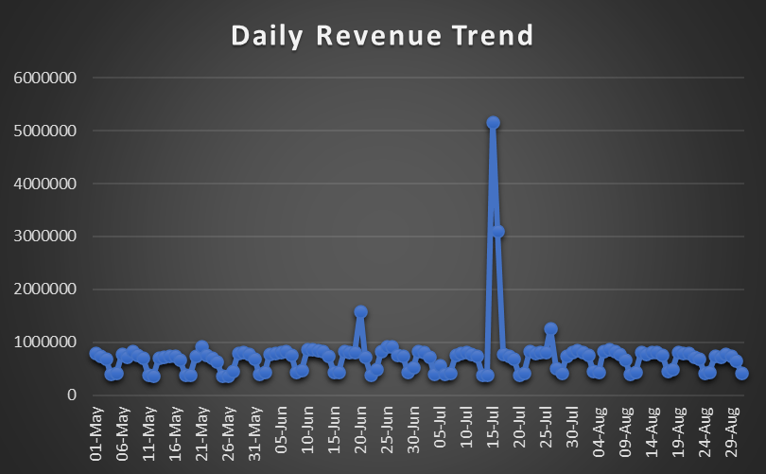

*Sharp revenue spike suggests a sale*

## Question 4: Post-Sale Cannibalization

[**SQL solution file**](https://drive.google.com/file/d/1L0ZvMxEEFftY4qf9SGrBVVQ8kz8xC--I/view?usp=sharing)

[**Excel solution file**](https://docs.google.com/spreadsheets/d/14Rgmq1Ht1gEA4SdrrLcpLOupstsrDeQh/edit?usp=sharing&ouid=111704656152914448501&rtpof=true&sd=true)

**Approach:**

* Compared sales before vs after sale event
* Used paired t-test for statistical validation

**Key Insight:**

* Avg Revenue for Pre-Sale: 1880
* Avg Revenue During Sale: 12371.59 (up by 558.05%)
* Avg Revenue for Post-Sale: 2035 (up by 8.24%)  
  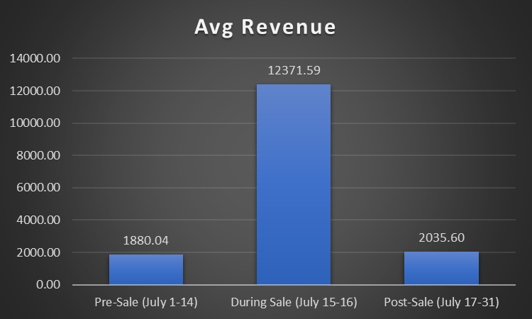

***Post-sale revenue is 8.24% higher than pre-sale levels, suggesting no cannibalization***

**Possible Reasons:**

* Limited Sale Duration (2 days) prevented over-purchasing.
* Potential New Customers: Sale may have attracted new buyers who returned

## Question 5: Slowest-Growing Subcategories

[**SQL solution file**](https://drive.google.com/file/d/1L0ZvMxEEFftY4qf9SGrBVVQ8kz8xC--I/view?usp=sharing)

[**Excel solution file**](https://docs.google.com/spreadsheets/d/14Rgmq1Ht1gEA4SdrrLcpLOupstsrDeQh/edit?usp=sharing&ouid=111704656152914448501&rtpof=true&sd=true)

**Approach:**

* To analyze growth, we need to divide the dataset into 2 timeframes:
  + Early period (before July 1)
  + Late Period (July 1 and after)
* Calculated Growth Rate for each subcategory and its corresponding category.
* Computed MoM growth by subcategory and category

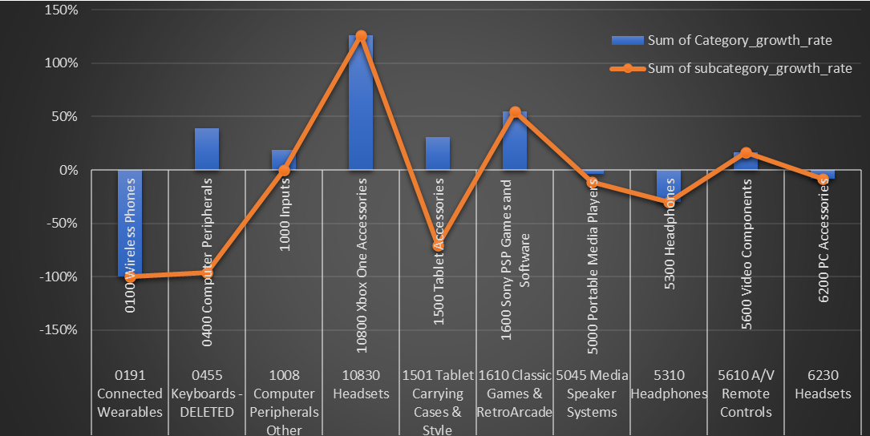

**Findings:**

|  |  |  |  |
| --- | --- | --- | --- |
| **Category** | **Category_growth_rate** | **Sub_category** | **subcategory_growth_rate** |
| **0100 Wireless Phones** | **-100%** | **0191 Connected Wearables** | **-100%** |
| **0400 Computer Peripherals** | **39%** | **0455 Keyboards - DELETED** | **-96%** |
| **1000 Inputs** | **19%** | **1008 Computer Peripherals Other** | **0%** |
| **10800 Xbox One Accessories** | **126%** | **10830 Headsets** | **126%** |
| **1500 Tablet Accessories** | **31%** | **1501 Tablet Carrying Cases & Style** | **-71%** |
| **1600 Sony PSP Games and Software** | **55%** | **1610 Classic Games & RetroArcade** | **55%** |
| **5000 Portable Media Players** | **-4%** | **5045 Media Speaker Systems** | **-11%** |
| **5300 Headphones** | **-30%** | **5310 Headphones** | **-30%** |
| **5600 Video Components** | **17%** | **5610 A/V Remote Controls** | **17%** |
| **6200 PC Accessories** | **-8%** | **6230 Headsets** | **-8%** |

**Most Concerning Sub-Category:** 0455 Keyboards - DELETED

* It’s part of a rapidly expanding category, showing a growth of 39%, but it’s also faced a staggering decline of 96%. This points to a serious problem within this specific subcategory, which could be due to reasons like delisting, stocking issues, or quality concerns.
* The word **“DELETED”** hints that it may have been taken off the market or discontinued, so we need to confirm that.
* Next steps: look into the availability of the SKU, check its search performance, and see if there’s a replacement product that has been introduced.

**Additional Subcategories to Monitor:**

* 1501 Tablet Carrying Cases & Style: Also declined sharply (-71%) in a +31% category.

## Question 6: Data Anomalies

[**SQL solution file**](https://drive.google.com/file/d/1L0ZvMxEEFftY4qf9SGrBVVQ8kz8xC--I/view?usp=sharing)

[**Excel solution file**](https://docs.google.com/spreadsheets/d/14Rgmq1Ht1gEA4SdrrLcpLOupstsrDeQh/edit?usp=sharing&ouid=111704656152914448501&rtpof=true&sd=true)

**Issues Detected:**

**For Sales_Data:**

* Null values in column REP_OOS.

**Assumption:** no out-of-stock views for the SKUs.

**Imputation:** filled with ‘0’ in all the blank cells in the column.

* Negative values for Ordered_Units and Ordered_Revenue.

**Assumption:** May represent returns/cancellation. Hence, no imputation

* Identified rows where Ordered_Revenue > 0 and Ordered_Units = 0 in Sales_data. This creates inconsistencies in ASP and conversion metrics.

**Assumption:** Subscription-based or service revenue rather than physical product sales. Hence, no imputation

**For Glance_Views:**

* Negative values in the Units column.

**Assumption:** Returns or Cancellations. Hence, no imputation

## Question 7: Conversion vs Average Selling Price for a particular SKU C120[H:8NV

[**SQL solution file**](https://drive.google.com/file/d/1L0ZvMxEEFftY4qf9SGrBVVQ8kz8xC--I/view?usp=sharing)

[**Excel solution file**](https://docs.google.com/spreadsheets/d/14Rgmq1Ht1gEA4SdrrLcpLOupstsrDeQh/edit?usp=sharing&ouid=111704656152914448501&rtpof=true&sd=true)

**Approach:**

* Filtered the data for SKU C120[H:8NV] from both Sales and Glance Views tables.
* Calculated Unit Conversion as Ordered Units / Views for each date.
* Calculated Average Selling Price (ASP) as Ordered Revenue / Ordered Units.
* Observed that ASP remained nearly constant, making it difficult to determine any correlation with Unit Conversion.

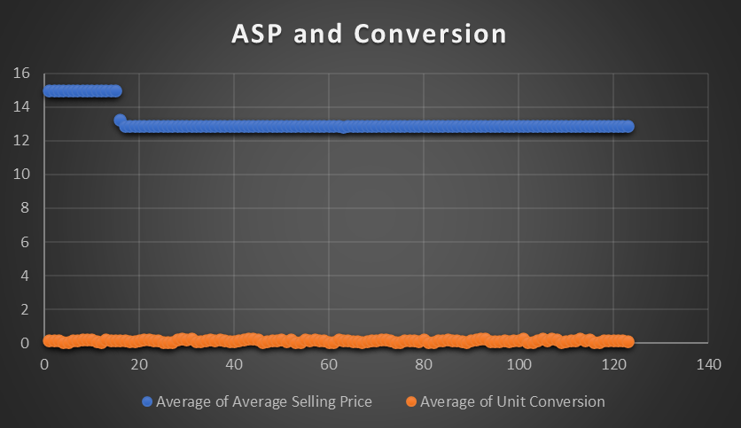

* The Average Selling Price (ASP) remains almost constant throughout the time period (hovering around 13–15).
* Unit Conversion shows some fluctuations, but since ASP did not change, those variations cannot be attributed to pricing.
* This makes it impossible to determine any causal relationship between Unit Conversion and ASP for this SKU from this dataset alone.

**Findings:**

The Average Selling Price for SKU C120[H:8NV] has stayed pretty steady throughout the specified period. Since there hasn’t been much fluctuation in pricing, we can’t really figure out if there’s any connection between the Average Selling Price and Unit Conversion. To conduct a meaningful statistical analysis, we’d need more data on the same.

**Thank You**

**Contact: satyamkumar262000@gmail.com**