VINAYAKA MISSIONS UNIVERSITY
AARUPADAI VEEDU INSTITUTE OF TECHNOLOGY,PAIYANOOR.

DEPARTMENT OF COMPUTER SCIENCE & ENGINEERING & IT

WEBTECHNOLOGY

QUESTION BANK
UNIT – I

PART – A
1.Define internet
Answer: Network is an interconnection of systems to share data and information. Internet is networks of networks or collection of heterogeneous networks.

2. What is the use of IP addresses and ports?
Answer:
IP address
An Internet Protocol address (IP address) is a numerical label assigned to each device (e.g., computer, printer) participating in a computer network that uses the Internet Protocol for communication.

PORTS
A port is identified for each address and protocol by a 16-bit number, commonly known as the port number.

3. Write short notes on SMTP status code.
Answer:

It is three digit code that indicates the status of the response. The status code are classified with respect to their functionality into five groups.
- 1xx-informational
- 2xx-success
- 3xx-redirectional
- 4xx-client error
- 5xx-server error

4. Define firewall.
Answer: The hardware and software that sits between the Internet and the local network, checking all the data that comes and goes out is called ―firewalls. The security is provided using SSL(SecureSocket Layer) in internet.

5. Define proxy servers
Answer: Proxy servers are related to firewalls prevents hosts on a network from making direct connections to the outside world; a proxy server can act as a go-between. Thus a machine that is prevented from connecting to the external network by a firewall would make a request for a web page from the local proxy server instead of requesting the web page directly from the remote web server.

6. List down the types of Request Method in HTTP protocol?
Answer:
There are the types of Request Method in HTTP protocol
GET
PUT
HEAD
POST
DELETE
7. What is the use of MIME?
Answer:
It is used to send non ASCII data through email which transforms non ASCII data at the sender side to NBT ASCII data and delivers to the client MTA to be sent through the internet, so the message at the receiving site is transformed back to the original data.

8. Define URL & URN.
Answer:
URL – Uniform Resource Locaters is a pointer to a particular resource on the Internet at a
particular location.
URN– Uniform Resource Name is a name for a particular resource but without reference to a
particular location.

9. What is meant by relative URL?
Answer: URLs that are not complete but inherit pieces from their parent are called relative URL.
In contrast, a completely specified URL is called an absolute URL address.

10. List out few Environment Variables in CGI
Answer:
HTTP_COOKIE--The visitor's cookie, if one is set.
HTTP_HOST--The hostname of your server.
HTTP_REFERER--The URL of the page that called your script.
REMOTE_HOST--The hostname of the visitor (if your server has reverse-name-lookups on; otherwise this is the IP address again).

11. What is a domain & mention different type of domains?
Answer: Domain is a place where information is available.

DOMAIN NAME EXTENSION

.edu – Servers that provide Educational services
.gov – About the government of a country.
.mil – Servers that provide military information.
.org – Provide information about the organizations in the world.
.com – Servers providing commercial services on the Internet.

12.Mention the types of header in HTTP protocol.
Answer:There are the types of header in HTTP protocol
General Header
Response Header
Entity Header

13.What are the components of http URL?
Answer:The components are host, an optional port, path, filename, section and query string.

14.Define URL encoding.
Answer:URL encoding involves replacing all unsafe and nonprintable characters with a percent sign (%)followed by two hexadecimal digits corresponding to the character's ASCII value.

15.List the goals of SGML.
Answer:
- To manage the flow of millions of pages.
- For structuring information exchange
- For modeling inter-document linkages
- For managing information flows between departments and weapons systems

16. What are the sequences of steps for each http request from a client to the server?
Answer:
- Server process is created to establish TCP connection.
- HTTP client initiates a TCP connection with the HTTP server.
- HTTP server accepts the connection.
- HTTP client sends a request.
- The server processes the request and sends the response back to the client.
- The server closes the TCP connection.
- The client receives the response containing information and processed data.

17. List the MIME content types.
Answer:
1. Text
2. Multipart
3. Message
4. Image
5. Audio
6. Video
7. Model
8. Application

18. Mention any four commands of POP3 protocol in transaction state.
Answer:
There are four commands of POP3 protocol in transaction state:-
1.STAT Command
2.LIST Command
3.RETR Command
4.DELE Command

19. What are the issues of next generation IP?
Answer:
- The issues to be considered in IP next generation are:-
- Addresses Space Growth
- Support large Global networks
- A clear way of transition from the existing IP to new IP next generation

20. What are the advantages of IMAP protocol?
Answer:
- IMAP is more powerful and more complex.
- Prior downloading of email header.
- A user can create a hierarchy of mail boxes in a folder for email storage.
- A user can create, delete or rename mail boxes on the mail server.

PART – B
- Briefly explain about SGML and its importance.
Answer:
SGML is a system for defining markup languages. Authors mark up their documents by representing structural, presentational, and semantic information alongside content. HTML is one example of a markup language. Here is an example of an HTML document:
<HTML>
<HEAD>
<TITLE>My first HTML document</TITLE>
</HEAD>
<BODY>
<P>Hello world!
</BODY>
</HTML>
An HTML document is divided into a head section (here, between <HEAD> and </HEAD>) and a body (here, between <BODY> and </BODY>).

SGML constructs used in HTML

The following sections introduce SGML constructs that are used in HTML:-
1 Elements:
An SGML declares element types that represent structures or desired behavior. HTML includes element types that represent paragraphs, hypertext links, lists, tables, images,etc. Each element type declaration generally describes three parts: a start tag, content, and an end tag.
For example, the start and end tags of the UL element type delimits the items in a list:
<UL>
<LI><P>...list item 1...
<LI><P>...list item 2...
</UL>

2 Attributes:

Elements may have associated properties, called attributes, which may have values (by default, or set by authors or scripts). Attribute/value pairs appear before the final ">" of an element's start tag.
In this example, the id attribute is set for an H1 element:
<H1 id="section1">
This is an identified heading thanks to the id attribute
</H1>

3 Character references:

Character references are numeric or symbolic names for characters that may be included in an HTML document. They are useful for referring to rarely used characters.
Some common examples include:
- "&lt;" represents the < sign.
- "&gt;" represents the > sign.
- "&quot;" represents the " mark.
- "&#229;" (in decimal) represents the letter "a" with a small circle above it.
- "&#1048;" (in decimal) represents the Cyrillic capital letter "I".
- "&#x6C34;" (in hexadecimal) represents the Chinese character for water.

4 Comments
HTML comments have the following syntax:
<!-- this is a comment -->
<!-- and so is this one, which occupies more than one line -->

Goals of SGML.
• To manage the flow of millions of pages.
• For structuring information exchange
• For modeling inter-document linkages Powered By www.technoscriptz.com
• For managing information flows between departments and weapons systems

2. Narrate the History of Internet and World Wide Web.
Answer:

A Very Brief History of the Internet
Late 1960's to early 1970's Dept. of Defense Advanced Research Projects Agency (ARPA) ¨ ARPANET served as basis for early networking research as well as a central backbone during the development of the Internet. ¨ TCP/IP evolved as the standard networking protocol for exchanging data between computers on the network.

Mid-To-Late 1970's Basic services were developed that make up the Internet: - Remote connectivity - File Transfer - Electronic mail

1979-80 Usenet systems for newsgroups

1982 Internet gopher

1991 Public introduction to World Wide Web (mostly text based) - In the early 1990s, the developers at CERN spread word of the Web's capabilities to scientific audiences worldwide. - By September 1993, the share of Web traffic traversing the NSFNET Internet backbone reached 75 gigabytes per month or one percent. By July 1994 it was one terabyte per month.

1994 Prior to this time the WWW was not used for commercial business purposes - The Internet is one-third research and education network - Commercial communications begin to take over the majority of Internet traffic

History of the Web
Tim Berners-Lee invented the World Wide Web in 1989, about 20 years after the first connection was established over what is today known as the Internet. Tim documented what was to become the World Wide Web with the submission of a proposal to his management at CERN, in late 1989 , This proposal specified a set of technologies that would make the Internet truly accessible and useful to people. Believe it or not, Tim’s initial proposal was not immediately accepted. However, Tim persevered. By October of 1990, he had specified the three fundamental technologies that remain the foundation of today’s Web (and which you may have seen appear on parts of your Web browser):
- HTML: HyperText Markup Language. The publishing format for the Web, including the ability to format documents and link to other documents and resources.
- URI: Uniform Resource Identifier. A kind of “address” that is unique to each resource on the Web.
- HTTP: Hypertext Transfer Protocol. Allows for the retrieval of linked resources from across the Web.

3. Elucidate MIME.
Answer:
MIME (Multi-Purpose Internet Mail Extensions) is an extension of the original Internet e-mail protocol that lets people use the protocol to exchange different kinds of data files on the Internet: audio, video, images, application programs, and other kinds, as well as the ASCII text handled in the original protocol

Use of MIME:
- MIME is a way to encode different kinds of data, such as sound and text, to be transmitted over a 7-bit ASCII connection.
- It also lets the recipient know what kind of data has been sent, so that it can be displayed properly.
- MIME was originally designed to facilitate multimedia email and to provide an encoding that could get binary data past the most train –damaged mail transfer programs.
- MIME is an open standard for sending multipart, multimedia data through Internet email.
- MIME was originally intended for email, it has become a widely used technique to describe a file’s contents

MIME Headers:

MIME-Version is a required header indicating that this message is to use the rules of MIME. "MIME-Version: 1.0" is the only currently defined MIME-Version header allowed.
Content-Type headers are used to specify the media type and subtype of data in the body of a message and to fully specify the native representation of such data. This header embodies much of the power of MIME.
Content-Transfer-Encoding headers can have two different meanings. If the value is "base64" or "quoted-printable", then the header indicates the encoding used for this body part. If the value is "7bit", "8bit", or "binary", then the header indicates that there is no encoding and that this value indicates only the type of content this body part contains.
Content-ID headers are world-unique values that identify body parts, individually or as groups. They are necessary at times to distinguish body parts and allow cross-referencing between body parts.
Content-Description headers are optional it define the body is image, audio, or video.

List of predefined MIME content types.
1. Text
2. Multipart
3. Message
4. Image
5. Audio
6. Video
7. Model
8. Application

4. Explain about CGI.
Answer:
Common Gateway Interface (CGI) is a standard method used to generate dynamic content on Web pages and Web applications. CGI, when implemented on a Web server, provides an interface between the Web server and programs that generate the Web content. These programs are known as CGI scripts or simply CGIs; they are usually written in a scripting language, but can be written in any programming language.

Typical steps in CGI script execution:
1. Read input from the HTML form.
2. Process user’s input, as appropriate.
3. Send HTTP response containing HTML back to the user.

5. Explain in detail about Internet Standards.
Answer:
In computer network engineering, an Internet Standard (abbreviated as "STD") is a normative specification of a technology or methodology applicable to the Internet. Internet Standards are created and published by the Internet Engineering Task Force (IETF).

Standardization process
Becoming a standard is a two step process within the IETF called Proposed Standards and Internet Standards. If an RFC is part of a proposal that is on the Standard Track, then at the first stage, the standard is proposed and subsequently organizations decide whether to implement this Proposed Standard

Proposed Standard

A Proposed Standard (PS) is generally stable, has resolved known design choices, is believed to be well-understood, has received significant community review, and appears to enjoy enough community interest to be considered valuable.

Internet Standard
An Internet Standard ensures that hardware and software produced by different vendors can work together. Having a standard makes it much easier to develop software and hardware that link different networks because software and hardware can be developed one layer at a time. Normally, the standards used in data communication are called protocols.
The goals of the Internet Standards Process are:
1. Technical excellence;
2. Prior implementation and testing;
3. Clear, concise, and easily understood documentation;
4. Openness and fairness; and
5. Timeliness.

6. Explain in detail about POP3 architecture.

Answer:

POP3 (Post Office Protocol 3) is the most recent version of a standard protocol for receiving e-mail. POP3 is a client/server protocol in which e-mail is received and held for you by your Internet server. Periodically, you (or your client e-mail receiver) check your mail-box on the server and download any mail, probably using POP3

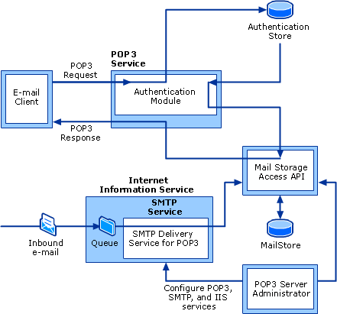

POP3 architecture
The POP3 service is the interface between e-mail clients and the mail store. POP3 listens on TCP port 110 for connections from e-mail clients, authenticates the client, and manages the connection with the client.
The authentication store is the repository of user information needed to authenticate the user. The store can be the Active Directory database, the local SAM database, or the encrypted password file for the user. The authentication module accesses the authentication store to verify the credentials submitted by the client to the POP3 service.
The Mail Storage Access API is the common interface to the mail store for all processes. The POP3 service, the SMTP delivery service for POP3, and the POP3 Server Administrator use the API to access the mail store.
The mail store uses the file system for storage. The mail store is typically located on the same server as the POP3 service, but it should be located on a different local or network volume than the operating system to avoid potential disk space problems. For large mail stores, the mail store can be placed on a Network Attached Storage (NAS) device and accessed by one or more servers running the POP3 service. Even though the mail store is contained in the file system, it is accessed by using the Mail Storage Access API.
The SMTP delivery service for POP3 is the component that transfers e-mail from the SMTP service to the user mailboxes. The delivery service is notified by the SMTP service when new e-mail arrives. New e-mail is delivered to the mail store by means of the Mail Storage Access API.
The POP3 Server Administrator is the interface used by the tools to configure the server, domains, and mailboxes. The server administrator accesses the mail store by means of the Mail Storage Access API to create or modify domains and mailboxes. Modifications to the service itself are made through calls to the administration interface within the POP3 service.

7.Briefly explain the operational scenario of SMTP protocol in detail.
Answer:
FIRST SCENARIO:
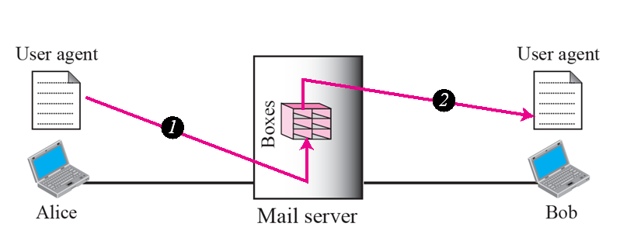
- When the sender and the receiver of an e-mail are on the same mail server,we need only two user agents.
SECOND SCENARIO:
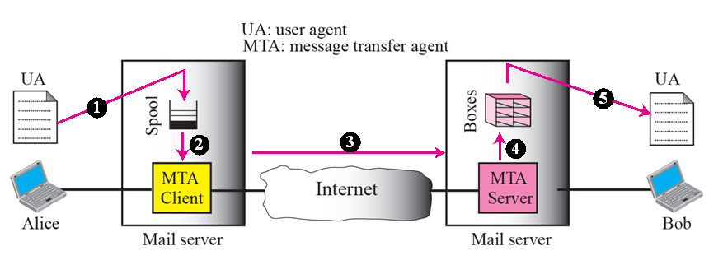
- When the sender and the receiver of an e-mail are on different mail servers,we need two UAs and a pair of MTAs (client and server).

THIRD SCENARIO:
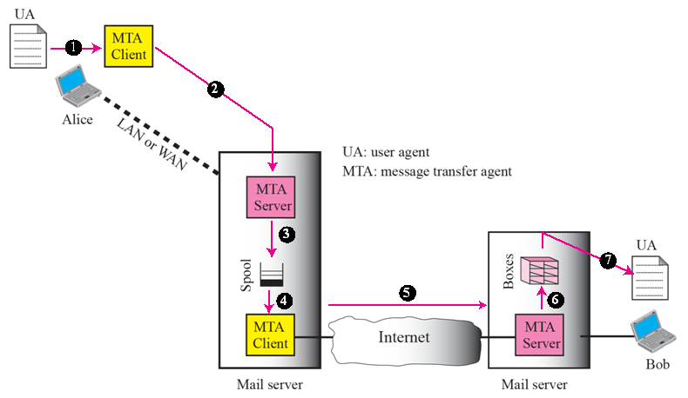
- When the sender is connected to the mail server via a LAN or a WAN, we need two UAs and two pairs of MTAs
(client and server).
FOURTH SCENARIO:
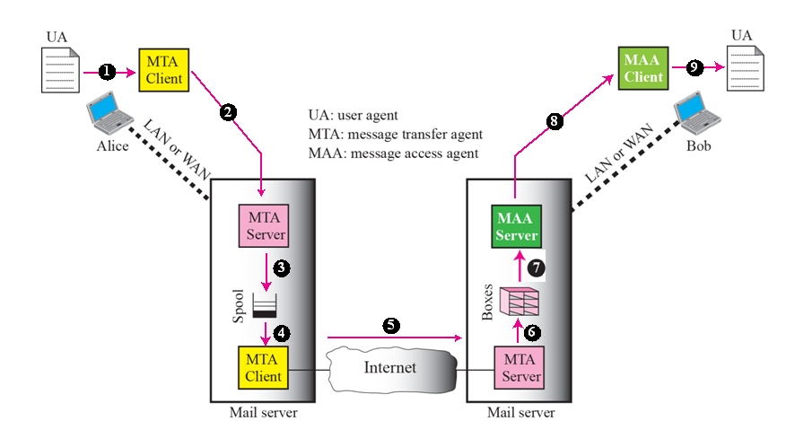
Push versus pull
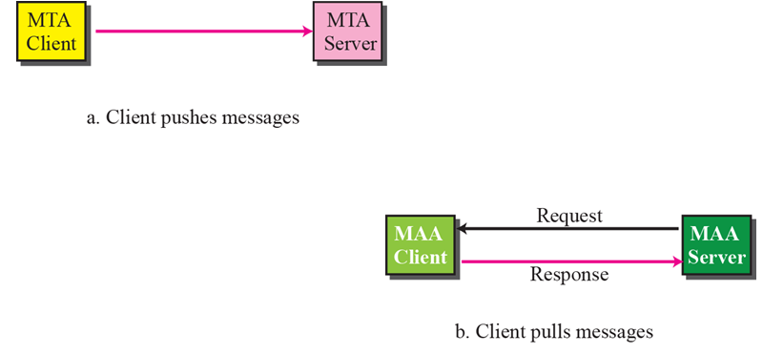

- When both sender and receiver are connected to the mail server via a LAN or a WAN, we need two UAs, two pairs of MTAs (client and server), and a pair of MAAs (client and server). This is the most common situation today.
COMMANDS AND RESPONSE:

SMTP uses commands and responses to transfer messages between an MTA client and an MTA server.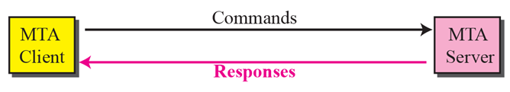

COMMANDS:
Commands are sent from the client to the server. The format of the command is:
Keyword: argument(s)
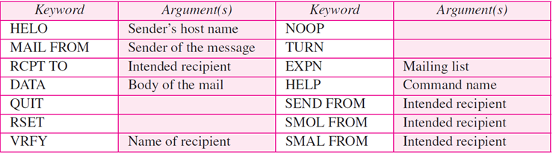
- HELO- used by client to identify itself.
- HELO: challenger.atc.fhda.edu
- MAIL FROM-used by client to identify sender of message
MAIL FROM: forouzan@challenger.atc.fhda.edu
- RCPT TO-used by client to identify the intended recipient of the message
RCPT TO: betsy@mcgraw-hill.com
- DATA-used to send the actual message
- VRFY-used to verify the address of the recipient
VRFY: betsy@mcgraw-hill.com
- EXPN-it asks the receiving host to expand the mailing list
EXPN: x y z
- SEND FROM-specifies that the mail is to be delivered to the terminal of the recipient &not the mail box
SEND FROM: forouzan@fhda.atc.edu
- SMOL FROM-specifies the mail is to be delivered to the terminal & the mail box of the recipient
SMOL FROM: forouzan@fhda.atc.edu
- SMAL FROM- specifies the mail is to be delivered to the terminal & the mail box of the recipient
SMAL FROM: forouzan@fhda.atc.edu
RESPONSE:
Responses are sent from the server to the client. It is a three digit code that may be followed by additional textual information.
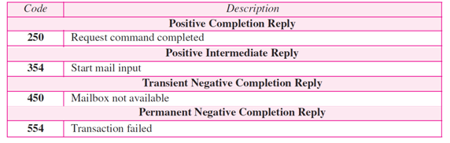
CONNECTION ESTABLISHMENT:
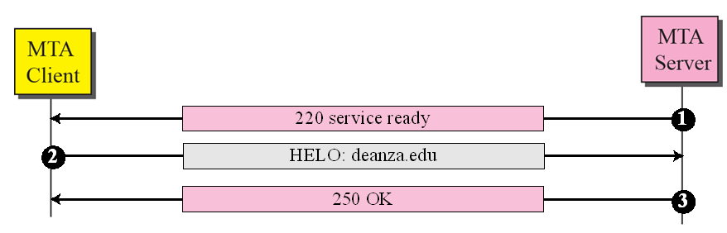
MESSAGE TRANSFER:
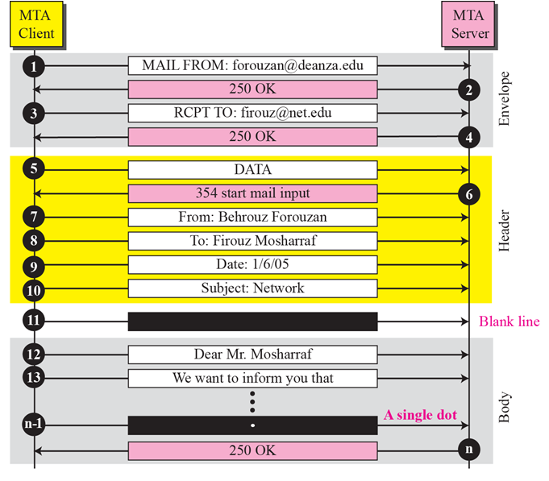
CONNECTION TERMINATION
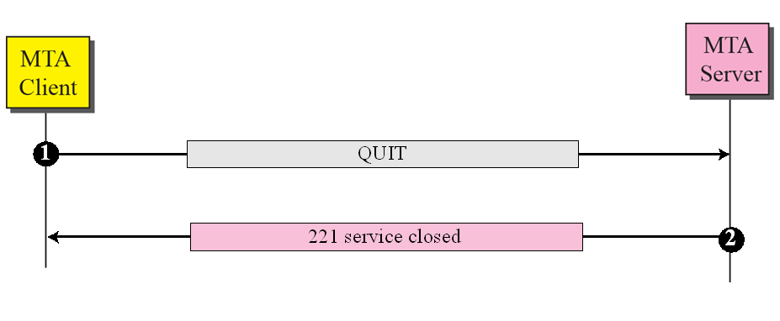

8.Write short notes on i) IMAP ii) States of POP3 protocol
Answer:
1.IMAP
IMAP stands for Internet Message Access Protocol. It is a method that allows you to access electronic mail or mesages that are kept on a mail server. In other words, email stored on an IMAP server can be read and responded to from a desktop computer at home, a workstation at the office, or a laptop computer while you are traveling, and you do not need to transfer these messages back and forth between computers. This protocol works best when a user is reliant upon multiple computers in multiple locations.
The following are the IMAP states:-
1.Not Authenticated State:
2.Authenticated State
3.Selected State
4.Logout State
2.States of POP3 Protocol
A POP session between a client and a server has three states:-
1.Authorization State:- The POP3 session is now in the AUTHORIZATION state. The client must now identify and authenticate itself to the POP3 server. Two possible mechanisms for doing this are described in this document, the USER and PASS command combination and the APOP command.
2.Transaction State:- Once the client has successfully identified itself to the POP3 server and the POP3 server has locked and opened the appropriate maildrop, the POP3 session is now in the TRANSACTION state.Here, the client is allowed to perform mailbox operation(view/retrieve/delete/………..mails).
3.Update State:- When the client issues the QUIT command from the TRANSACTION state, the POP3 session enters the UPDATE state.Here, the server deletes messages marked for deletion ,session is closed and TCP connection is terminated.

9.With an example explain about HTTP Messages.
Answer:
HTTP messages are passed in a format similar to that used by the Internet mail [RFC5322] and the Multipurpose Internet Mail Extensions (MIME) .These messages include requests from client to server and responses from server to client which will have the following format:
HTTP-message = Request | Response

Response Messages:- It response to the request message, a response message is sent by a server to the client .It consists of the following part:
A Status Line
A Header
An Empty Line
An Optional Body

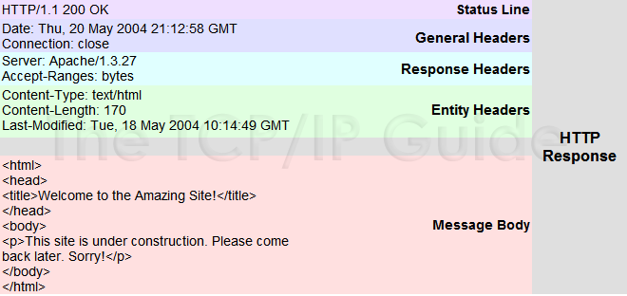

Request Messages:-A request message is sent by a web client to the web server. It consist of the following parts:
A request line
A header
A empty line
A optional body
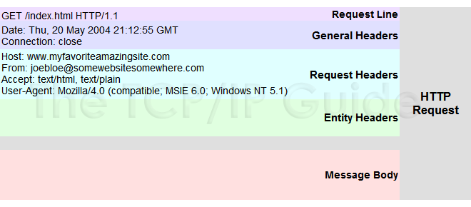

10.Explain about request type method in HTTP protocol
Answer: There are Request Type methods:
GET:
The GET method is used to retrieve information from the given server using a given URI. Requests using GET should only retrieve data and should have no other effect on the data.

HEAD:
Same as GET, but transfers the status line and header section only.

POST:
A POST request is used to send data to the server, for example, customer information, file upload, etc. using HTML forms.

PUT:
Replaces all current representations of the target resource with the uploaded content.

DELETE: Removes all current representations of the target resource given by a URI.

CONNECT:
Establishes a tunnel to the server identified by a given URI.

OPTIONS:
Describes the communication options for the target resource.

TRACE:
Performs a message loop-back test along the path to the target resource.

PATCH:
This is similar to the PUT method except that it specifies a list of differences that must be applied on the existing file.

LINK:
This is used to create a link or links from one document to another.

UNLINK:
It is used to remove a link or links created by the LINK method.

COPY:
The HTTP protocol may be used to copy a file from one location to another.

MOVE:
It is similar to the COPY method except that it delete the source file.

UNIT – II
PART – A

- Define DHTML.
The combination of HTML plus JavaScript and the DOM is referred to as
Dynamic HTML (DHTML), and an HTML document that contains scripting is
called a dynamic document.

- What is HTML?
Hypertext is ordinary text that has been designed with extra features
such as formatting, images, multimedia and links to other documents. Markup
is the process of taking ordinary text and adding extra symbols. Each of the
symbols used for markup in HTML is a command that tells a browser how to
display the text. HTML is the technical term for the format used to create
normal web pages.

- What is the difference between HTML and DHTML?

S.NO | HTML | DHTML
1 | It is used to create dynamic web  Page | It is used to create dynamic web page
2 | It consists of simple HTML tags | It consists of HTML tags+Cascading Style Sheets+Javascript
3 | It does not allow to alter the text and graphics on the web page unless web page get changed. | Can alter the text and graphics of the web page and need not have to change the entire web page
4 | Creation of web page is simplest but less interactive. | Creation of DHTML is complex but more interactive.

- State the difference between JavaScript and java.

S.NO | JAVASCRIPT | JAVA
1 | JavaScript is a scripting language | Java is a programming language.
2 | JavaScript is not a object oriented programming language.Its object model is far different than a typical object oriented programming language such as C++ or Java | Java is an object oriented programming language.
3 | In JavaScript variables need not be declared before their use.checking the compatibility of type can be done dynamically. | Java is strongly typed language and the type checking is done at compile time.
4 | In JavaScript the objects are dynamic, that means we can change the total data members and method of an object during execution. | Objects in java are static, that means the number of data members and method are fixed at compile time.

- Write the uses of JavaScript.
- Javascript can be embedded in XHTML.
- It can be used to detect the visitor‘s browsers and can load the page accordingly.
- It can be used to create cookies
- Javascript are used to validate the data on the web page before submitting it to the server.
- Mention the advantages of JavaScript.
- Use sending data continuously File storage
- Massively parallel computing
- Smart forms – includes various controls like text box, radio button, text area control etc.
- Peer-to-Peer Interaction – used in various client/server models.
- Games – Combine the ability to easily include networking in your programs with java‘s powerful graphics and you have the recipe for truly awesome multiplayer games.
- Chat – Used in various chat applications.
- Whiteboards – Java programs are not limited to sending text and data across the network.
- A number of programmers have developed whiteboard software that allows users in
- diverse locations to draw on their computers

- Write the syntax of <table>
<TABLE>
<TR>…</TR><!—Row1_
<TR>…</TR><!—Row2_
…
<TR>…</TR><!—Rowm_
</TABLE>

- Write a JavaScript program to create confirm dialog box.
Confirm is used to confirm a user about certain action, and decide between two choices depending on what the user chooses.
<script type="text/javascript">
var x=window.confirm("Are you sure you are ok?")
if (x)
window.alert("Good!")
else
window.alert("Too bad")
</script>

- What does data binding mean?
Data binding is DHTML feature that lets you easily bind individual elements in your document todata from another source such as database or comma delimited text file.

- Mention the various <form> elements.
Various elements or controls can be created in FORM using <INPUT> tag. They are
1. Label
2. Text box
3. Text Area
4. Radio button
5. Check box
6. List box
7. Command button
8. Scroll bars

- What is the use of frames in html give the syntax of frames?
Frames are used to have a systematic representation of data on the web page. But sometimes we want these frames to be interactive. By making the frames interactive we can use the data entered in one frame in another frame.
Syntax of Frame:
<frameset cols=”200,*”>
<frame src=”D:\DHTML_Examles\frame1.html” name=”First” />
<frame src=” ” name=”Second” />
</frameset>

- Write the syntax to change the color of background and text in HTML?
Include the element "bgcolor" with a color code in your body tag:
<BODY BGCOLOR="#ffffff" TEXT="#000000" LINK="#cc0000"
VLINK="#000066" ALINK="#ffff00">

- What are the necessities of using HTML forms?
- Gathering user information
- Conducting Surveys
- Interactive services

- Mention the types of scripting languages.
JavaScript is a Scripting language (web site development environment)created by Netscape.
Hence JavaScript works best with the Netscape suite of Client and Serverproducts.
JavaScript is the native scripting language of Netscape Navigator.
VBScript is the native Scripting language of HTML.

- Mention the various java script object models.
- Math Object
- String Object
- Date Object
- Boolean and Number Object
- Document Object
- Window Object

- List the various dialog boxes in java script.
alert()
prompt()
confirm()

- How scripting language is different from html?
- HTML is used for simple web page design
- HTML with FORM is used for both form design and Reading input values from user.
- Scripting Language is used for Validating the given input values weather it is correct or not, if the input value is incorrect, the user can pass an error message to the user.
- Using form concept various controls like Text box, Radio Button, Command Button, Text Area control and List box can be created.

- Define function in java script.
Function is a part of a program or in other words function is a module in java program which can be called or invoked any number of times from the main program.
Function can be called any number of times but it can accept any input values or parameters, however it can return only one output at a time.

- Define CSS.
- CSS are powerful mechanism for adding styles (e.g. Fonts, Colors, Spacing) to web documents.
- They enforce standards and uniformity throughout a web site andprovide numerous attributes to create dynamic effects.
- The advantage of a style sheet includes the ability to make global changes to all documents from a single location. Style sheets are said to cascade when they combine to specify the appearance of a page.
- The style assignment process is accomplished with the <STYLE>…</STYLE> tags.

- Mention the types of style sheets.
- Embedded or Internal Style sheet
- External or Linked Style sheet
- Inline style sheet

PART – B

- Explain the frames, forms and table tags of HTML with suitable examples.
Frames :
Frames are used to have a systematic representation of data on the web page. But sometimes we want these frames to be interactive. By making the frames interactive we can use the data entered in one frame in another frame.
<html>
<head>
<title> Frame Object Demo </title>
</head>
<frameset cols=”200,*”>
<frame src=”D:\DHTML_Examles\frame1.html” name=”First” />
<frame src=” ” name=”Second” />
</frameset>
</html>
Forms:
HTML Forms are used to select different kinds of user input. HTML forms are used
to pass data to a server. A form can contain input elements like text fields, checkboxes, radiobuttons,submit buttons and more. A form can also contain select lists, textarea, fieldset,legend, and label elements.The<form> tag is used to create an HTML form.
HTML Input Element:
The most important form element is the input element. The input element is
used to select user information.An input element can vary in many ways, depending on the type attribute. An input element can be of type text field, checkbox, password, radio button, submit button, and more.The most used input types are described below.
Text Fields:
<input type="text" /> defines a one-line input field that a user can enter text into:
<form>
First name: <input type="text" name="firstname" /><br />
Last name: <input type="text" name="lastname" />
</form>
Password Field:
<input type="password" /> defines a password field:
<form>
Password: <input type="password" name="pwd" />
</form>
Radio Buttons:
<input type="radio" /> defines a radio button. Radio buttons let a user select only one of a limited number of choices:
<form>
<input type="radio" name="sex" value="male" /> Male<br />
<input type="radio" name="sex" value="female" /> Female
</form>
Checkboxes:
<input type="checkbox" /> defines a checkbox. Checkboxes let a user select one or more
options of a limited number of choices.
<form>
<input type="checkbox" name="vehicle" value="Bike" /> I have a bike<br />
<input type="checkbox" name="vehicle" value="Car" /> I have a car
</form>
Submit Button:
<input type="submit" /> defines a submit button.A submit button is used to send form data to a server. The data is sent to the page specified in the form's action attribute. The file defined in the action attribute usually does something with the received input:
<form name="input" action="html_form_action.asp" method="get">
Username: <input type="text" name="user" />
<input type="submit" value="Submit" />
</form

TABLE:
The <table> tag defines an HTML table.
An HTML table consists of the <table> element and one or more <tr>, <th>, and <td>elements.
The <tr> element defines a table row, the <th> element defines a table header, and the <td> element defines a table cell.
A more complex HTML table may also include <caption>, <col>, <colgroup>, <thead>, <tfoot>, and <tbody> elements.
A simple HTML table, containing two columns and two rows:
<table>
<tr>
<th>Month</th>
<th>Savings</th>
</tr>
<tr>
<td>January</td>
<td>$100</td>
</tr>
</table>

- Highlight the features of the following objects in java script String, Date, and Math.
String:
String is a collection of characters. In javascript using string object many useful string related functionalities can be exposed off. Some commonly used methods of string object are concatenating two strings, converting the string to upper case or lower case, finding the substring of a given string and so on. Here is a list of some methods of string.
Method | Meaning
concat(str) | This method concatenates the two strings
CharAt(index_val) | This method returns the character specified by value index_val
substring(begin,end) | This method returns the substring specified by begin and end character
toLowerCase() | This function is used to convert all the Uppercase letters to lower case.
toUpperCase() | This function is used to convert all the Lowercase letters to Upper case.
valueOf() | This method returns the value of the string.
Date:
This object is used for obtaining the date and time. This date and time value is based on computers local time (system’s time) or it can be based on GMT(Greenwich MeanTime). GMT is also known as Universal Coordinated Time. This is basically a world time standard.
Commonly used methods are
Method | Meaning
getTime() | It returns the number of milliseconds.
getDate() | Returns the current date based on computers local time.
getUTCDate() | Returns the current date obtained from UTC .
getUTCDay() | Returns the current day based on UTC .
getHours() | Returns the Hour value ranging from 0 to 23 based on local time.
getUTCHours() | Return the Hour value ranging from 0 to 23. Based on UTC TimeZone.
getMinutes() | Return the Minute value ranging from 0 to 59. Based on Local Time.
getSeconds() | Return the Second value ranging from 0 to 59. Based on Local Time.
setDate(value) | This function helps to set the desired date using local timing or UTC timing zone.

Math:
For Performing the mathematical computation there are some useful methods available from math object for example If you want to findout minimum of two numbers then we can write document.write(math.min(4,5,7,8)
The above statement will result in 4.5.
Some commonly used math objects are
Method | Meaning
Sqrt(num) | This method finds the square root of num.
abs(num) | Returns absolute value of num
ceil(num) | Returns the ceil value of num.Ex:ceil(10.3)will return 11
floor(num) | Returns the floor value of num.Ex:floor(10.3)will return 10
log(num) | Returns the natural logarithm value of num.Ex:log(7.9) will return 2
pow(a,b) | This method will compute the ab.Ex:pow(2,5) will return 32.
min(a,b) | Return minimum value of a and b.
max(a,b) | Return maximum value of a and b.
Sin(num) | Returns the sine of num
cos(num) | Returns the cosine of num.
tan(num) | Return the tangent of num.
exp(num) | Returns the exponential value.

- Explain about JavaScript built-in objects with method description.

JavaScript sports a number of built-in objects that extend the flexibility of the language. These objects are Date, Math, String, Array, and Object. Several of these objects are "borrowed" from the Java language specification, but JavaScript's implementation of them is different. If you're familiar with Java, you'll want to carefully examine JavaScript's built-in object types to avoid any confusion.
The JavaScript object model is a simple one. The bulk of these objects deal with window content -- documents, links, forms, and so forth. In addition to window-content objects, JavaScript supports a small handful of "built-in" objects. These built-in objects are available regardless of window content and operate independently of whatever page your browser has loaded.

The built-in objects are Date, Math, String, Array, and Object. Each is used in a unique and not-quite-consistent way. Furthermore, newer versions of JavaScript (as found in Netscape "Atlas," currently in beta) implement several of these objects in a different manner than in Netscape 2.0. In this column we will address these built-in objects and how to use them. And we'll make note of the quirks you'll encounter as you apply these objects to your JavaScript pages.

Understanding the string object
Of all JavaScript's objects, the String object is the most commonly used. In the Netscape 2.0 JavaScript implementation, new string objects are created implicitly using a variable assignment. For example,
var myString = "This is a string";
creates a string, with the specified text, called myString. In Netscape 2.0, there is no actual object called string, and attempting to instantiate a new String object using the new statement results in an error, as String (or string) is not a defined keyword. In the Atlas version of Netscape, however, String is a bona fide object, and the String keyword can be used to create new strings. The following two approaches are allowed in Atlas, but not in Netscape 2.0.
var myString = new String();
myString = "This is a string";
and
var myString = new String ("This is a string");
String objects have one property: length. The length property returns the length of the string and uses the syntaxstring.length, where string is the name of the string variable. Both of the following display
alert ("This is a string".length)
and
var myString = "This is a string";
alert (myString.length);

While there may be just one string property, JavaScript supports a large number of methods that can be used with strings. These methods can be roughly divided into two broad camps: string management and text format.
String management methods include substring, indexOf, lastIndexOf, andtoLowerCase. These are used to return or change the content of the string in some way. For instance, the substring method returns a specified portion of a string. The indexOf method determines the location of a character or group of characters in a string. And the toLowerCase method converts the string to lower case. (As you can imagine, there's also a toUpperCase method.)
Text format methods are used to format text in a document in some special way, and are provided as alternatives to using HTML tags for the same purpose. These methods include big, small, sup, sub, anchor, link, and blink.
String methods can be used directly on strings, or on variables that contain strings. Methods always use open and closed parentheses, even if the method doesn't use parameters. For instance, to convert text to upper case, you'd use one of the following:
var tempVar = "this text is now upper case".toUpperCase();
or
var myString = "this text is now upper case";
var tempVar = myString.toUpperCase();
In Netscape 2.0 there is only one String object, and all strings are created from it. Conversely, strings are first-class objects in Atlas, and each new string is a treated as a separate object. The single-object behavior of strings in Netscape 2.0 can cause some subtle side effects. Take the short script segment that follows. Two strings are created: string1 and string2. A new property (called extra) is assigned to string1. Yet the alert message shows that the property also now belongs to string2.
<SCRIPT>
string1 = "this is string 1"
string2 = "this is string 2"
string1.extra = "new property"
alert (string2.extra)
</SCRIPT>
Technically speaking, strings are "immutable" in JavaScript. That is, the content of the string is static, and cannot be changed. In Netscape 2.0, JavaScript is capable of modifying a string only by creating a new location in memory for it. Because of this, a script that modifies a string many times is prone to memory errors. Each time the string is altered, JavaScript creates a new location in memory for the new version. New strings are created before garbage collection takes place to destroy the old string. Eventually, JavaScript uses all of its available memory, and an "out of memory" error occurs.
A classic example of this problem can be seen in the popular JavaScript "message scrollers," where a message scrolls in the status bar or a text box. For each pass, the scroller redefines the string variable that is displayed. Memory is eventually depleted because JavaScript creates new instances of the string with each pass. For example, the following script will eventually (sooner on some platforms, such as Windows 3.1) cause an "out of memory" error:
<SCRIPT>
var count = 0;
var text = "This is a test of a JavaScript scroller. ";
scroll();
function scroll () {
var myString = text.substring (count, text.length) + text.substring (0, count)
window.status = myString
if (count < text.length)
count ++;
else
count = 0;
setTimeout ("scroll()", 333);
// 333ms is the minimum delay for Netscape 2.0
}
</SCRIPT>
A simple rewrite avoids the problem of creating new blocks of memory. Delete the myString variable assignment, and parse the text directly to the status bar, using window.status.
window.status = text.substring (count, text.length) + text.substring (0, Count)
(While the above approach avoids JavaScript's string-object replication problem, memory leaks still occur because of the use of the setTimeout method. Over many iterations -- typically several thousand or more -- setTimeout will consume all available memory, and eventually JavaScript will display an "out of memory" message.)
For your reference, here are the methods and properties used with JavaScript's string object:

String Properties
length | The length of a string

String Methods
anchor | Creates a named anchor (hypertext target)
big | Sets text to big
blink | Sets text to blinking
bold | Sets text to bold
charAt | Returns the character at a specified position
fixed | Sets text in fixed-pitch font
fontcolor | Sets the font color
fontsize | Sets font size
indexOf | Returns the first occurrence of character x starting from position y
italics | Sets text to italics
lastIndexOf | Returns the last occurrence of character x starting from position y
link | Creates a hyperlink
small | Sets text to small
strike | Sets text to strikeout
sub | Sets text to subscript
substring | Returns a portion of a string
sup | Sets text to superscript
toLowerString | Converts a string to lowercase
toUpperString | Converts a string to uppercase

Using JavaScript as a scientific calculator
JavaScript's Math object provides advanced arithmetic and trigonometric functions, expanding on JavaScript's basic arithmetic operators (plus, minus, multiply, divide). The Math object in JavaScript is borrowed from Java. In fact, the implementation of the Math object in JavaScript closely parallels the Math class in Java, except that the JavaScript Math object offers fewer methods.
JavaScript's Math object properties are treated as constants. In fact, the property names are in all upper-case, following the usual convention of capitalizing variable constants. These properties return often-used values, includingpi and the square root of 2. The Math methods are used in mathematical and trigonometric calculations. Handy Math-object methods include ceil, floor, pow, exp (exponent), max, min, round, and random. (Random is only available when using the X Window platform, however.)
The Math object is static, so you don't need to create a new Math object in order to use it. To access the properties and method of the Math object, you merely specify the Math object, along with the method or property you wish. For example, to return the value of pi, you use:
var pi = Math.PI;
Similarly, to use a math method you provide the name of the method, along with the parameters you wish to use. For example, to round the value of pi, you'd use:
var pi = Math.PI;
var pieAreRound = Math.round(pi); // displays 3
Note that you must specify the Math object by name for each Math method/property you wish to use. JavaScript does not recognize the keywords PI and round all by themselves. Exception: you may use the with statement to associate the names of methods and properties with the Math object. This technique is a handy space-saver when you must use several Math properties and methods. The previous example can be written as
with (Math) {
var pi = PI;
var pieAreRound = round(pi);
alert (pieAreRound)
}
For your reference, here are the properties and methods supported by JavaScript's Math object.

Math Properties
E | Euler's constant
LN2 | The natural logarithm of 2
LN10 | The natural logarithm of 10
LOG2E | The base 2 logarithm of e
LOG10E | The base 10 logarithm of e
PI | The numeric equivalent of PI: 3.14 etc.
SQRT1_2 | The square root of one-half
SQRT2 | The square root of 2

Math Methods
abs | Returns the absolute value of a number
acos | Returns the arc cosine of a number
asin | Returns the arc sine of a number
atan | Returns the arc tangent of a number
ceil | Returns the least integer greater than or equal to a number
cos | Returns the cosine of a number
exp | Returns e (Euler's constant) to the power of a number
floor | Returns the greatest integer less than or equal to its argument
log | Returns the natural logarithm (base e) of a number
max | Returns the greater of two values
min | Returns the lesser of two values
pow | Returns the value of a number times a specified power
random | Returns a random number (X-platforms only)
round | Returns a number rounded to the nearest whole value
sin | Returns the sine of a number
sqrt | Returns the square root of a number
tan | Returns the tangent of a number

Asking JavaScript for a date
Also borrowed by Java is the Date object, which can be used in JavaScript to determine the current time and date. A popular JavaScript application of the Date object is displaying a digital clock in a text box. The script uses the Date object to update the clock once every second. You also use the Date object to perform date math. For example, your script might determine the number of days between now and a certain future date. You can use this to display a "countdown," such as the number of days left of your company's big sale.
JavaScript treats the Date object like a constructor class. To use Date you must create a new Date object; you can then apply the various Date methods to get and set dates. (The Date object has no properties.) If you're familiar with the Date class in Java, you'll find the properties of the JavaScript Date object largely the same. The most commonly used methods are the get methods, which obtain the time and date of the value in the Date object. These methods are:
- getHours() - Returns the hour
- getMinutes() - Returns the minutes
- getSeconds() - Returns the seconds
- getYear() - Returns the year ("96" is 1996)
- getMonth() - Returns the month ("0" is January)
- getDate() - Returns the day of the month
- getDay() - Returns the day of the week ("0" is Sunday)
(JavaScript's Date object also provides for setting the time and date of the Date object, but these are seldom used.)
Constructing a new Date object can take several forms. To return an object containing the current date and time, you use the Date object without parameters. In the following, date_obj is a new object, containing the value of the current date and time, as set by the computer's system clock.
var date_obj = new Date();
Alternatively, you can specify a given date and time as part of the date constructor. Either of these methods is allowed -- both set the new date object to January 1, 1997, at midnight local time.
var date_obj = new Date ("January 1 1997 00:00:00")
and
var date_obj = new Date (97, 0, 1, 12, 0, 0)
To use a Date method, append the method to the date object you previously created. For example, to return the current year, use:
var now = new Date();
var yearNow = now.getYear();
For your reference, here are the methods supported by JavaScript's Date object.

Date Methods
getDate | Returns the day of month of a specified date
getDay | Returns the day of week of a specified date
getHours | Returns the hour of a specified date
getMinutes | Returns the minutes of a specified date
getMonth | Returns the month of a specified date
getSeconds | Returns the seconds of a specified date
getTime | Returns the number of seconds between January 1, 1970 and specified date
getTimeZoneoffset | Returns the time zone offset in minutes for the current loca le
getYear | Returns the year of specified date
parse | Returns the number of milliseconds in a data since January 1, 1970, 00:00:00
setDate | Sets the date
setHours | Sets the hours of a specified date
setMinutes | Sets the minutes of a specified date
setMonth | Sets the month of a specified date
setSeconds | Sets the seconds of a specified date
setTime | Sets the time of a specified date
setYear | Sets the year of a specified date
toGMTString | Converts a date to a string using GMT conventions
toLocaleString | Converts a date to a string using locale conventions
toString | Converts the value of a Date object or current location object to a string
UTC | Converts a comma-delimited date to the number of seconds since Jan 1, 1970 < /TD>

Creating arrays and objects
JavaScript supports two (currently) undocumented object constructors: Array and Object. Both do a similar job, but are used in different situations. In JavaScript, an array is really just an object, using numbers or associative names for the array elements. You can create new arrays and objects with either constructor, but for readability, you'll probably want to use the constructor that is most closely associated with your application. Use Array when creating an array; use Object when creating an object.
Let's tackle the Array constructor first.
In JavaScript you can create an array explicitly using your own constructor function. Here is a n example of a basic array constructor.
function makeArray(numElements) {
this.length = numElements
for (count = 1; count <= numElements; count++)
this[count] = 0;
return (this);
}
To define a new array, you call the makeArray function using the new statement. The following example creates an array with three elements, and fills them with data.
var myArray = new makeArray(3);
myArray[1] = "item 1";
myArray[2] = "item 2";
myArray[3] = "item 3";
Actually, JavaScript doesn't much care how you make your arrays. Though you can define the number of elements in the array, the makeArray function uses this value only to pre-load an initial value in the first three elements. (Element 0 contains the length of the array; element[0] is synonymous with the length property.) You can add additional elements at any time, even after the array has been created.
The Array object in JavaScript does the same work as the makeArray constructor function. You can use it to create a new array, then provide the data for each element in the usual manner. In Netscape 2.0, the Array object ignores any "length" or number of elements value you pass to it, so if you need to store the number of elements in the array, you must do so explicitly.
var myArray = new Array();
myArray[0] = 3;
myArray[1] = "item 1";
myArray[2] = "item 2";
myArray[3] = "item 3";
When the array is created, JavaScript merely creates an object for it, but doesn't fill any of the elements with an initial value. JavaScript returns null when you access an element of an array that has not been expressly defined. In the example above myArray[4] returns null, since element[4] is not defined.
In Atlas, the Array object accepts a length parameter, so you don't need to set the length separately. Merely pass the number of elements as a parameter of the Array()constructor; you may then refer to the length using the construct array_name.length. You can remove array elements by defining them with null, but the length property remains constant. You can, however, manually change the length property at any time yourself, simply by defining a new value forarray_name.length. As in Netscape 2.0, undefined array elements contain a null value.
Object is a generic object constructor, and is borrowed from Java. However, JavaScript's Object is a much simplified version of the Java Object class. In Java, Object is used as a superclass, but in JavaScript, Object is used as a simplified means of creating new objects without providing an object constructor function. In JavaScript, an object constructor function is called with the new statement, and the function defines any properties or methods of the object. In the following simplified example, the calling statement instantiates a new object named myObject. ThemakeObject function creates the object, defining one property ("name") to it.
myObject = new makeObject ("my object");

function makeObject(name) {
this.name = name;
return (this);
}
The Object constructor saves you the trouble of making a constructor function, and is handy when you don't need or want to define methods and properties of the object when it is created, or when you want to define just one two properties. These following two lines replicate the example above:
myObject = new Object();
myObject.name = "my object";
You might use the Object constructor as a quick means to create an object. One such example is a , color database, which uses JavaScript as a miniature database. The database can consist of just one or two objects; separate properties of the objects contain the individual data items.
The following script uses JavaScript to built a small database lookup application. The Object constructor creates two objects: an index object and a data object. The index object is really an array with 10 elements; each element contains the name of a Netscape-supported color. The data object mirrors the sequence of the color names, and includes the equivalent hexadecimal value for that color -- the color aliceblue is f0f8ff, for example, and blanchedalmond is ffebcd. Note that the same database can be constructed using Array.
<HTML><HEAD>
<TITLE>Color Database</TITLE>
<SCRIPT LANGUAGE="JavaScript">
Idx = new Object();
Data = new Object();

Idx[0]=10
Idx[1]="aliceblue"
Idx[2]="antiquewhite"
Idx[3]="aqua"
Idx[4]="aquamarine"
Idx[5]="azure"
Idx[6]="beige"
Idx[7]="bisque"
Idx[8]="black"
Idx[9]="blanchedalmond"
Idx[10]="blue"

Data[1]="f0f8ff"
Data[2]="faebd7"
Data[3]="00ffff"
Data[4]="7fffd4"
Data[5]="f0ffff"
Data[6]="f5f5dc"
Data[7]="ffe4c4"
Data[8]="000000"
Data[9]="ffebcd"
Data[10]="0000ff"

function checkDatabase() {
var Found = false;
var Item = document.testform.color.value.toLowerCase();
for (Count = 1; Count <= Idx[0]; Count++) {
if (Item == Idx[Count]) {
Found = true;
alert ("The hex triplet for '" + Item + "' is #" +
Data[Count]);
break;
}
}
if (! Found)
alert ("Sorry, the color '" + Item +"' is not listed in the database.");

}
</SCRIPT>
<FORM NAME="testform" onSubmit="checkDatabase()">
Specify a color name, then click the "Find" button to see its hex triplet: <BR>
<INPUT TYPE="text" NAME="color" Value="" onClick=0> <P>
<INPUT TYPE="button" NAME="button" Value="Find" onClick="checkDatabase()">
</FORM>
</BODY></HTML>
JavaScript's associative arrays can come in handy when creating databases. Associative array names are synonymous with the object's property names. With this feature you can simplify the color database script by defining a single object -- named Idx -- for the colors. Then use the names of the colors as the property names, defined as Idx["colorname"]. Each property is assigned the equivalent hexadecimal color value. For example, the property Idx["aliceblue"] -- which is the functional equivalent to the syntax Idx.aliceblue -- is assigned the hex value f0f8ff.
In the revised color database example, the user types a color name, which doubles as a property name for the Idx object. An if expression determines whether the Idx object contains a property with that name. If the return value is "<undefined>" then no such property exists, and therefore the color is not listed in the database. If the value is something else, it is assumed to be the hex value of the specified color, and that value is displayed in an alert box.
<HTML>
<HEAD>
<TITLE>Another Color Database</TITLE>
<SCRIPT LANGUAGE="JavaScript">
Idx = new Object();
Idx["aliceblue"] = "f0f8ff"
Idx["antiquewhite"] ="faebd7"
Idx["aqua"] ="00ffff"
Idx["aquamarine"] ="7fffd4"
Idx["azure"] ="f0ffff"
Idx["beige"] ="f5f5dc"
Idx["bisque"] ="ffe4c4"
Idx["black"] ="000000"
Idx["blanchedalmond"] ="ffebcd"
Idx["blue"] ="0000ff"

function checkDatabase() {
var Item = document.testform.color.value.toLowerCase();
if ("" + Idx[Item] == "<undefined>")
alert ("Sorry, the color '" + Item +"' is not listed in the database.");

else
alert (Idx[Item])
}
</SCRIPT>
<FORM NAME="testform" onSubmit="checkDatabase()">
Specify a color name, then click the "Find" button to see its hex triplet: <BR>
<INPUT TYPE="text" NAME="color" Value="" onClick=0> <P>
<INPUT TYPE="button" NAME="button" Value="Find" onClick="checkDatabase()">
</FORM>
</BODY></HTML>

- Write a JavaScript program to validate a form.

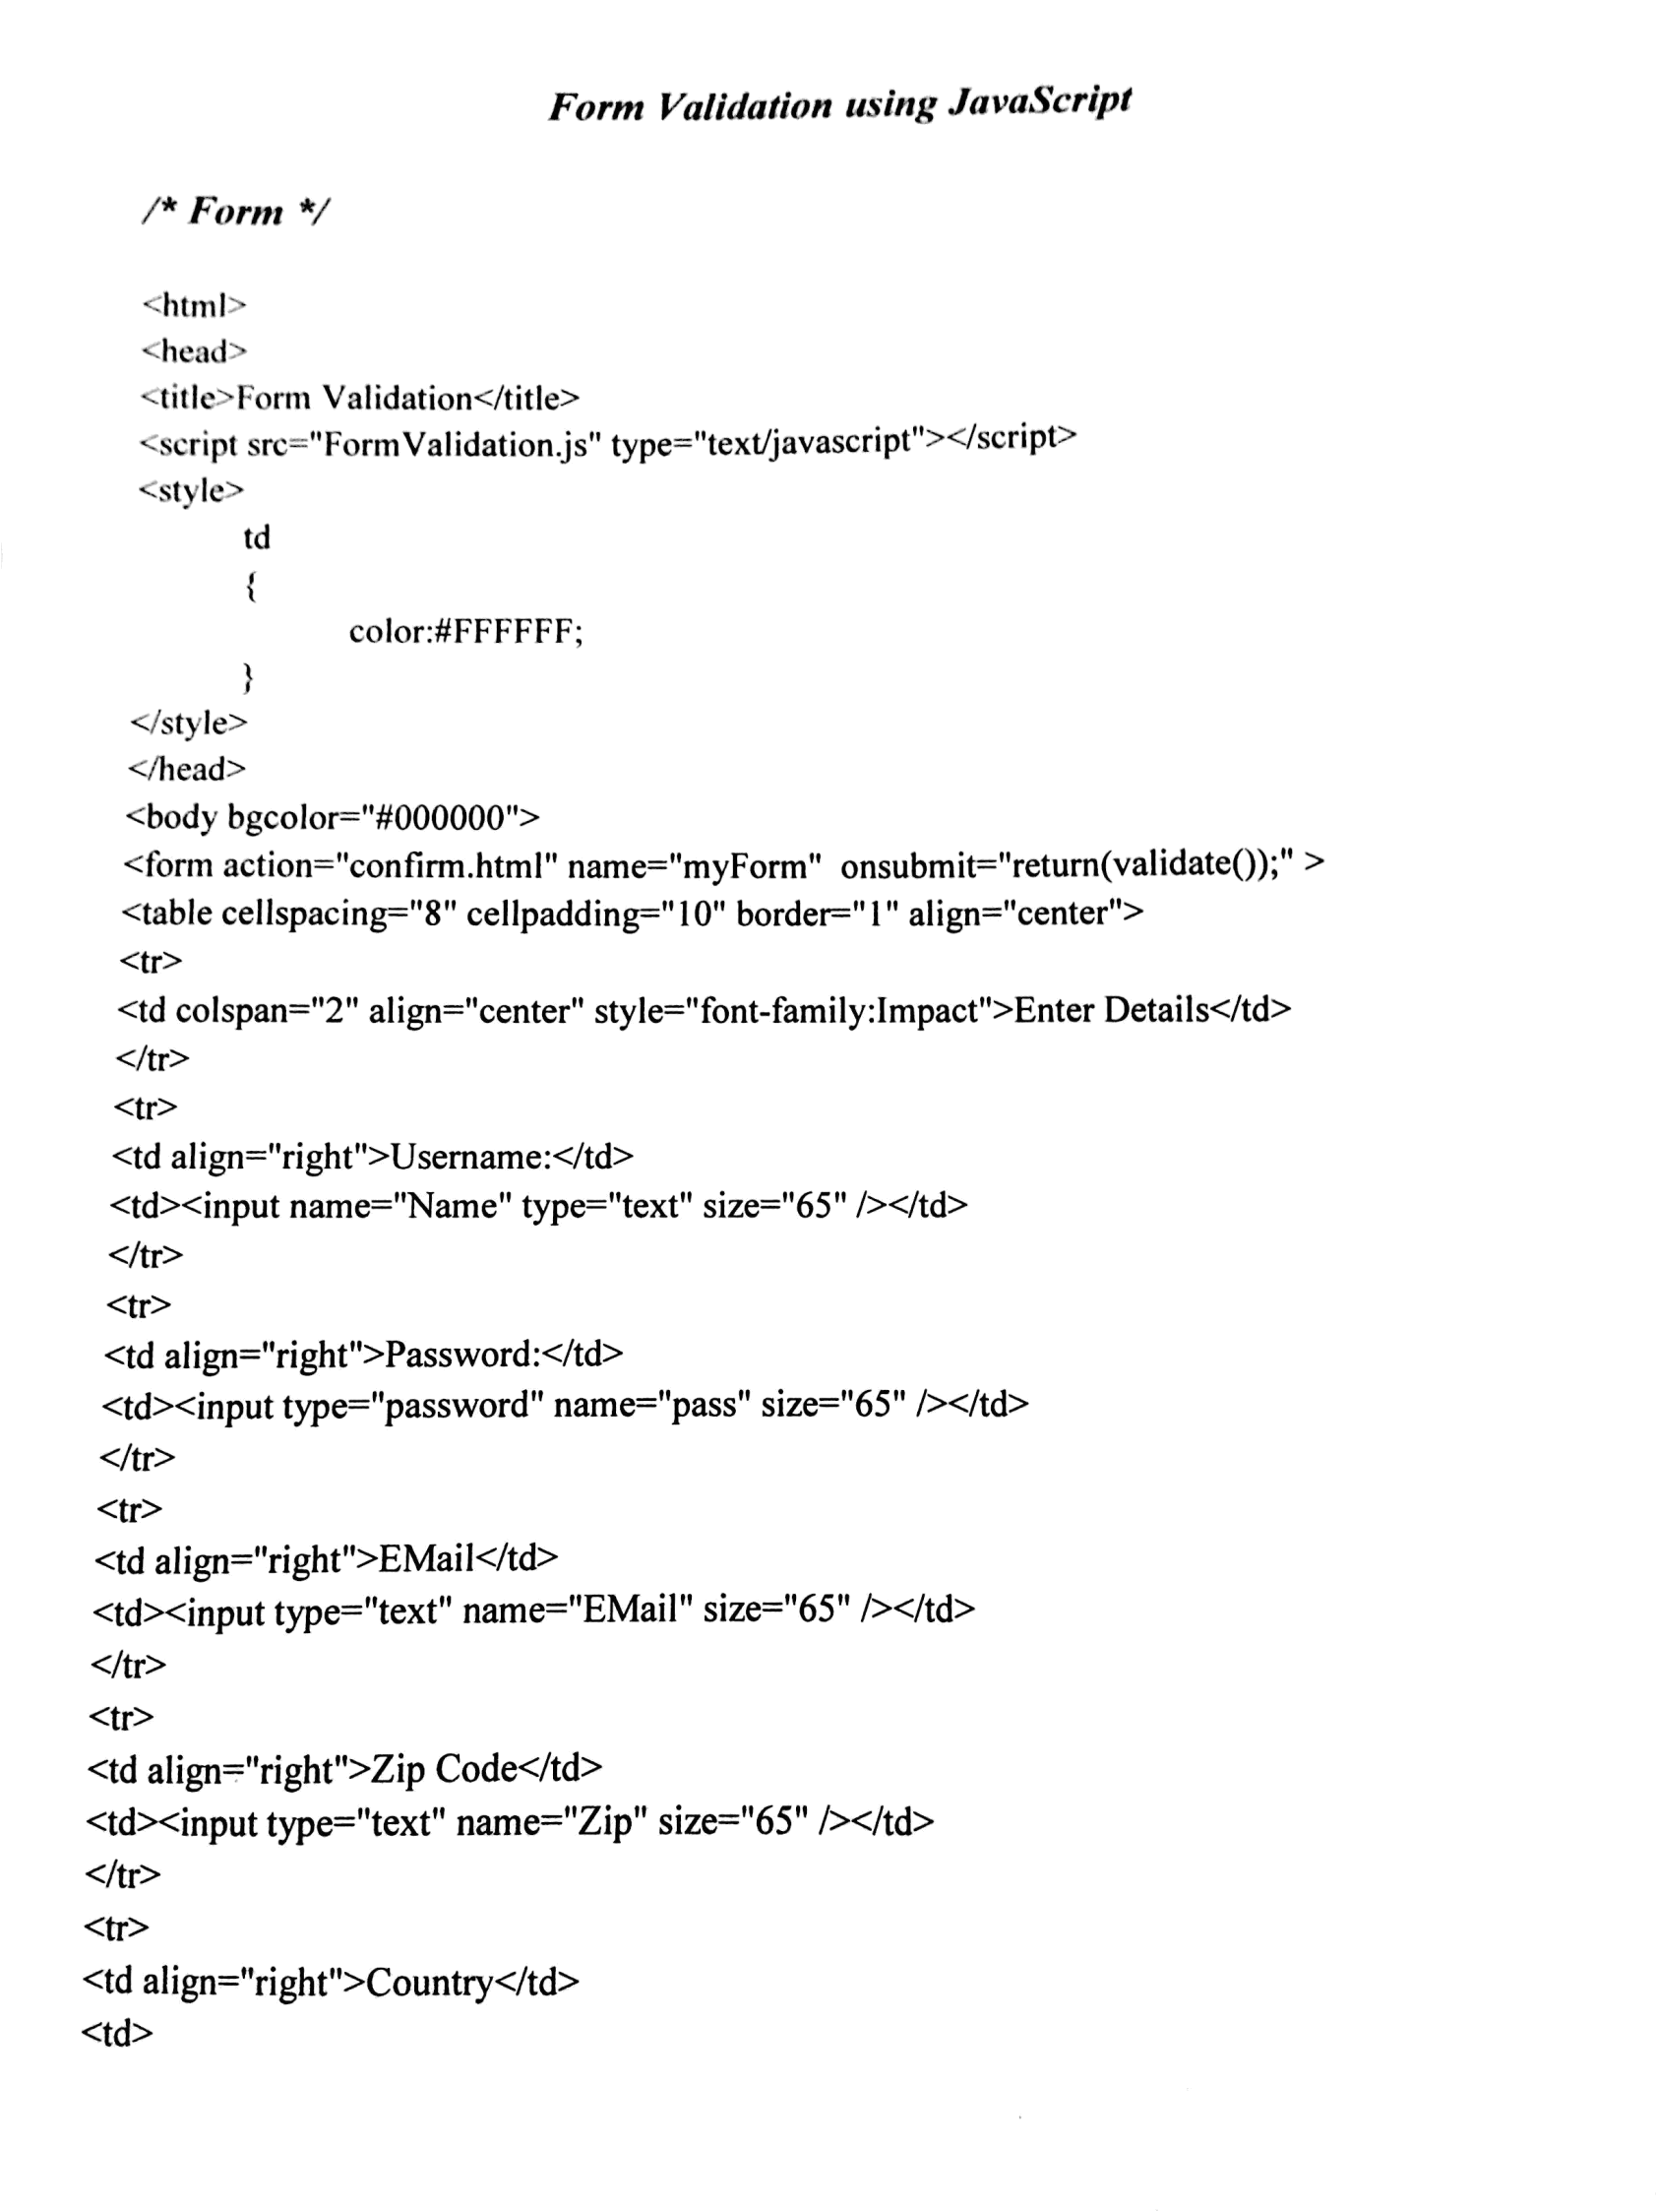
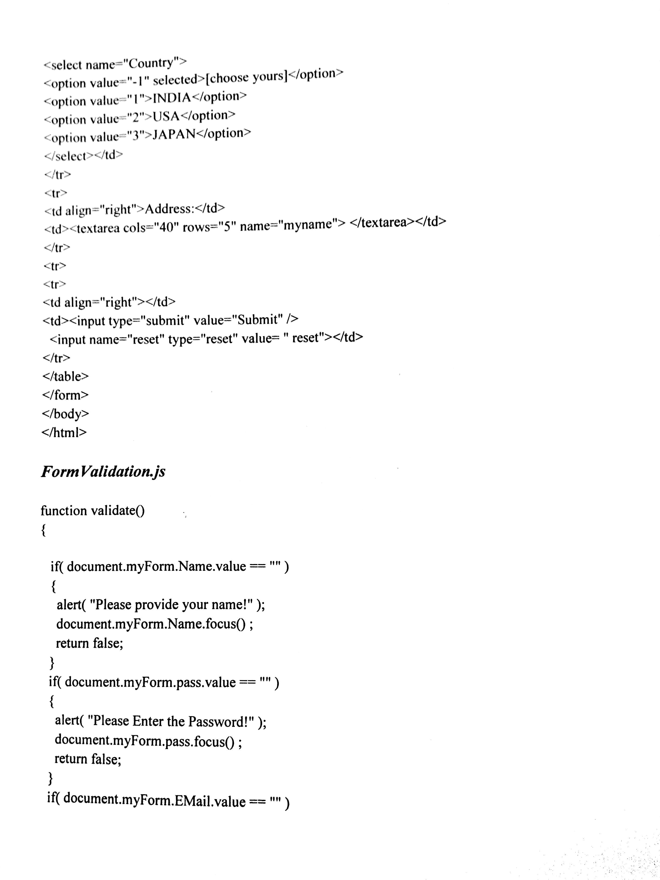
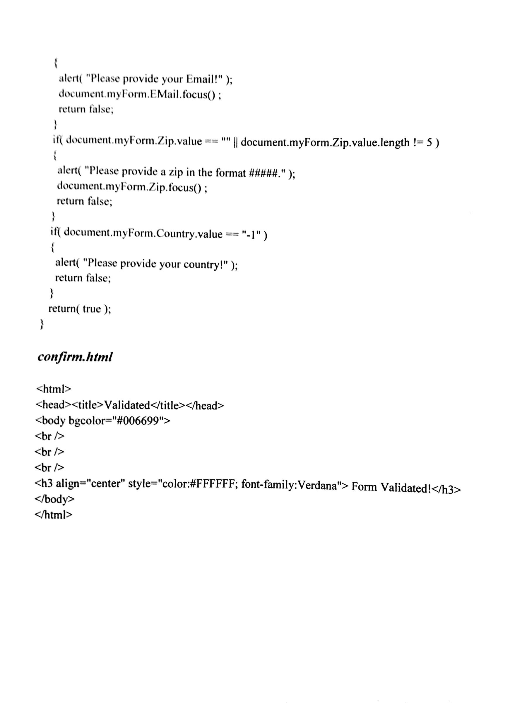
- Write a DHTML program to apply Flip filters on text and Chroma filters for images.
Flip Filters: flipv and fliph
flipv and fliph filters mirror text or images vertically and horizontally, respectively
Example program
<?xml version=”1.0”?>
<! DOCTYPE html PUBLIC “-//w3c//DTD XHTML 1.0 Transitional//EN”
http://www.w3.org/TR/xhtml1/DTD/xhtml1-transitional.dtd>
<html xmlns=http://www.w3.org/1999/xhtml>
<head>
<title>Chroma Filter</title>
<script type=”text/css”>
body { background-color: #CCFFCC}
table { font-size : 3em;
font-family :Arial, sans serif;
background-color: #FFCCCC;
border-style: ridge;
border-collapse: collapse }
td { border-style: grove;
padding: 1ex }
</style>
</head>
<body>
<table>
<tr>
<td style=”filter:flipvfliph”>Text</td>
<td style=”filter:flipv”>Text </td>
</tr>
</table>
</body>
</html>

Chroma Filter
- chroma filter applies transparency effects dynamically
  - Without using a graphics editor to hard-code transparency into the image
- onchange
  - Fires when the value of a form changes

Example program
<?xml version=”1.0”?>
<! DOCTYPE html PUBLIC “-//w3c//DTD XHTML 1.0 Transitional//EN”
http://www.w3.org/TR/xhtml1/DTD/xhtml1-transitional.dtd>
<html xmlns=http://www.w3.org/1999/xhtml>
<head>
<title>Chroma Filter</title>
<script type=”text/javascript”>
<!—
function changecolor(theColor)
{
if (thecolor ){
chromaImg.filters(“chroma” ).color= theColor;
chromaImg.filters(“chroma” ).enabled= true;
}
else
chromaImg.filters(“chroma” ).enabled= false;
}
</script>
</head>
<body>
<h1> Chroma Filter </h1>
<img id =”chromaImg” src=”trans.gif” style=”position: absolute; filter:chroma” alt =”Transparent Image” />
<form action = “ “>
<select onchange=”changecolor(this.value)”>
<option value= “ “>None</option>
<option value= “#00FFFF “>Cyan</option>
<option value= “ #FFFF00“>Yellow</option>
<option value= “#FF00FF “>Magenta</option>
<option value=”#000000” selected=”selected”>Black</option>
</select>
</form>
</body>
</html>

- With an example explain about JavaScript statements.
The if() statement

Code like this:

if (something is the case) {
more JavaScript commands
}
is used when you want to execute some code only if a specific condition is met.

if ()

For instance, suppose you read out the annual income of a user from a form and put it in the variable income. Now if the income is over $100,000, you want to inform the user of some special benefit for people with large incomes. Then the code becomes:

var income = [read out from form]

if (income > 100000) {
alert('We can offer you a special benefit.');
(more code)
}
The code is very simple: you take income and compare it to 100000. If it's larger, so if the condition (income > 100000) is met, the code between the curly brackets {} is executed. If the condition is not met, nothing happens.

See the Boolean logic page for a description of how conditions like this one work.

else if ()

Now suppose you also want to see if the user has a house of his own. If he does but still has an income less than $100,000 you want to inform him of some other interesting possibilities.

If you want to check for ownhouse only if income is not larger than $100,000 you have to use this code:

var income = [read out from form]
varownhouse = [read out from form, value is 'Yes' or 'No']

if (income > 100000) {
alert('We can offer you a special benefit.');
(more code)
}
else if (ownhouse == 'Yes') {
alert('We still have some offers');
(more code)
}

if - else if

With if - else if you can define various conditions that are checked one after another until the script finds a true condition. Then the block below the true condition is executed. After one block is executed the script ignores any subesquent else if's.

In this case the script first checks if income is larger than 100000. If it isn't, it then checks (else if) if the user owns a house.

So in an if-else if constructions there are four possibilities:

Only the first condition is met: the first block of code is executed
Only the second condition is met: the second block of code is executed
Both conditions are met: only the first block of code is executed.
Neither condition is met: nothing happens
Of course you can use as many else ifs as necessary.

else

Now suppose that you want to say sorry to those people who have an income less than $100,000 and have no house. You can add the following code below the last else if:

else {
alert ('sorry');
(more code)
}
This else means: in all other cases. If none of the above conditions are met, this block of code is executed.

Comparision of values

Usually in an if statement you want to compare two strings or numbers. You do this as follows:

Larger than: if (income > 100000)
Smaller than: if (income < 100000)
Larger than or equal to: if (income >= 100000)
Smaller than or equal to: if (income <= 100000)
Equal to: if (income == 100000) (note the double equation mark: ==)
Not equal to: if (income != 100000)
If you want to compare strings, be sure to always write the string between single quotes, like:

if (ownhouse == 'Yes') {
alert('We still have some offers');
(more code)
}
If you leave out the quotes, JavaScript thinks that you want to compare the value of the variable ownhouse with the value of the variable Yes.

if (ownhouse == Yes) {
alert('We still have some offers');
(more code)
}
If you haven't declared a variable Yes strange errors can creep up.

Seeing if objects exist

You can also see if an object exists:

if (document.images) {
do something with document.images
}
If the object document.images exists, the condition becomes true and the block of code is executed.

The Object detection page explains why you should do this.

The for () statement

This block of code

for (vari=0;i<5;i++) {
alert('i = ' + i);
}
is a for loop that gives alerts with the numbers 0,1,2,3 and 4. Try it to see what it does.

As you can see, the alert gives the value of i and this value goes from 0 to 4. This is caused by the for statement:

for (vari=0;i<5;i++)
This means: the variable i starts at 0 (vari=0;), the for loop goes on as long as i is less than 5 (i<5) and i is increased by one each time the loop is done again (i++).

In practice, that means that the code between the curly brackets {} is executed with i=0, then with i=1 etc. until i=4. When it increases i to 5, the code sees that the condition i<5 is no longer met and it stops the loop.

So the for statement is used to execute the same code a couple of times with each time a different value of i. You will use this statement mainly if you want to go through an array and do the same thing with each of the elements.

By saying vari you declare a new, local variable for this for loop only. Sometimes it's very important to declare it as such because the program can get confused if you use the variable i more than once. By explicitly declaring it you confine it to this for loop only, as soon as it's done the variable is removed from the program memory. This avoids all potential confusion.

You can also put an if inside a for, like:

for (vari=0;i<5;i++) {
if (thearray[i] == 'Yes') {
(do something)
}
}
Now the code takes all elements from the array thearray and for each one checks if the value is Yes. If it is, the innermost block of code is executed.

Of course, you can also go from 4 to 0 backwards:

for (vari=4;i>=0;i--)
or from 0 to 10 in steps of 2

for (vari=0;i<11;i+=2)
or anything else that's necessary.

A related statement is for (vari in object). This does the same, except that you go through all the properties of an object. This statement is explained on the associative arrays page.

- (a)Write a program using CSS to display the background image repeatedly.

<head>
<title>Background Image</title>
<style type=”text/css”>
body{background-image:url(victorialfalls.jpg);
background-repeat:repeat; }
p
{
font-family:Arial;
font-size:20px;
}
</style>
</head>
<body>
<center>
<h2>Wonder of the World</h2>
</center>
<p>
The Victorial falls is one of the greatest waterfall in the world.
The Victoria falls can be seen 25-40 miles away.
This falls was named after queen Victoria.
</p>
</body>
</html>

(b) Describe about object model and collections.

    - Object Model:
-Allows Web authors to control the presentation of their pages
-Gives them access to all the elements on their pages

Object | Description
Objects:
Window | Represents the browser window and provides access to the document object contained in the window. If the window contains frames a separate window object is created automatically for each frame, to provide access to the document rendered in the frame. Frames are considered to be subwindows in the browser.
document | Represents the XHTML document rendered in a window. The document object provides access to every element in the XHTML document and allows dynamic modification of the XHTML document.
Body | Provides access to the body element of an XHTML document.
history | Keeps track of the sites visited by the browser user. The object provides a script programmer with the ability to move forward and backward through the visited sites, but for security reasons does not allow the actual site URLs to be manipulated.
navigator | Contains information about the Web browser, such as the name of the browser, the version of the browser, the operating system on which the browser is running and other information that can help a script writer customize the user’s browsing experience.
location | Contains the URL of the rendered document. When this object is set to a new URL, the browser immediately switches (navigates) to the new location.
Event | Can be used in an event handler to obtain information about the event that occurred (e.g., the mouse x-y coordinates during a mouse event).
Screen | Contains information about the computer screen for the computer on which the browser is running. Information such as the width and height of the screen in pixels can be used to determine the size at which elements should be rendered in a Web page.

    - Collections:
-Arrays of related objects on a page all the XHTML elements in a document
Children.Specific element contains that element’s child elements

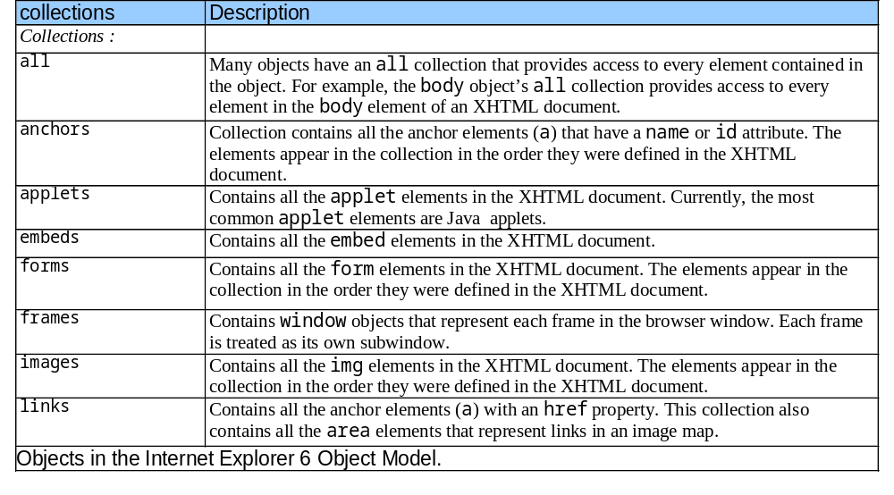

- Describe in detail about ActiveX Control of web page.

An ActiveX control is an object that supports a customizable, programmatic interface. Using the methods, events, and properties exposed by a control, Web authors can automate their HTML pages. Examples of ActiveX Controls include text boxes, command buttons, audio players, video players, stock tickers, and so on.

ActiveX Control is basically an object which can be placed on the webpage in order to increase the user’s interaction.

Basically there are five different ActiveX objects such as:
- Sequencer control
- Path control
- Media player
- Sprite control and
- Structured Graphics control

You can develop ActiveX Controls using Microsoft Visual Basic, Microsoft Visual C++, and Java.
Because ActiveX Controls are complex, Microsoft offers some tools that help a C++ developer create an ActiveX control. The following table describes these tools.

Tool | Description | Ships with
Microsoft Foundation Classes (MFC) | A set of C++ classes that support Component Object Model (COM), OLE, and ActiveX (among other things). MFC provides the simplest means of creating ActiveX Controls. | Visual C++ version 4.2 or later. (MFC ships with earlier versions of Visual C++; however, these versions do not support ActiveX.)
Microsoft ActiveX Template Library | A set of C++ templates designed to create small and fast COM objects. | Active Template Library (ATL) 2.1 ships with Visual C++ version 5.0. (ATL 2.0 is a Web release that relies on the Visual C++ 4.2 IDE.)

DHTML Program to write a simple application in which three objects:oval,rectangle,round rectangle are loaded on the web page:
<html>
<head>
<title>Introduction to ActiveX controls</title>
</head>
<body>
<object id=”my_obj
Classid=”CLSID:369303C2-D7AC-11DO-89D5-00A0C90833E6”
style=”position:absolute;top:0;left:0;width:500;height:500”>
<param name=”Line0001” value=”setFillColor(255,0,0)”>
<param name=”Line0002” value=”Oval(-120,-50,200,100,45)”>
<param name=”Line0003” value=”setFillColor(0,255,0)”>
<param name=”Line0004” value=”Rect(-150,-190,200,100,0)”>
<param name=”Line0005” value=”setFillColor(0,0,255)”>
<param name=”Line0006” value=”RoundRect(50,-100,100,100,50,60,0)”>
</object>
</body>
</html>
In the above program:
Following are the steps that can be applied while handling the object of SGC:
- Any ActiveX object is denoted within <object>tag.In SGC you can create various objects and move them anywhere on your web page.In order to refer these objects it is a must to have some id to these objects.
- Then we must specify the classid.It is basically a reference to an ActiveX control. This will help to load our object with the ActiveX control.By CLSID the identity code of SGC will be given as-
classid=”CLSID:369303C2-D7AC-11D0-89D5-00A0C90833E6
- The style is used to define the canvas for the graphical objects.
- The paramis a sub-attribute of attribute object. The syntax of param is
<param name=”LineXXXX value=”method()”
- Note that the LineXXXX must appear sequentially otherwise the desired object will not appear on the webpage. And method() is for specifying the method for corresponding objects. In above program,first of all we have used method setFillColor(R,G,B).Then we have used the method Oval() for display of oval shape. In the similar manner,we have written code for displaying Rect() and RoundRect().
Thus we get the following output:

OUTPUT

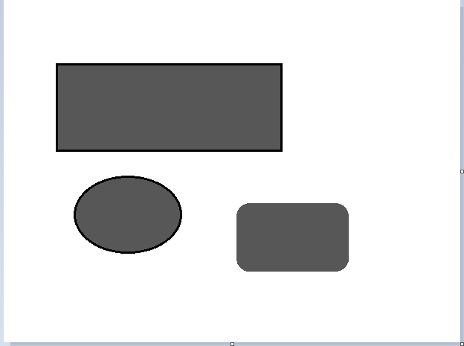

- Explain about the various types of cascading style sheet with examples.

There are three ways of cascading style sheet:
- External style sheet
- Internal style sheet
- Inline style

    - External style sheet

An external style sheet is ideal when the style is applied to many pages. With an external style sheet, you can change the look of an entire Web site by changing just one file.

Each page must include a link to the style sheet with the <link> tag. The <link> tag goes inside the head section:

<head>
<link rel="stylesheet" type="text/css" href="mystyle.css">
</head>
An external style sheet can be written in any text editor. The file should not contain any html tags. The style sheet file must be saved with a .css extension. An example of a style sheet file called "myStyle.css", is shown below:

body {
background-color: lightblue;
}
h1 {
color: navy;
margin-left: 20px;
}

    - Internal style sheet

An internal style sheet should be used when a single document has a unique style. You define internal styles in the head section of an HTML page, inside the <style> tag, like this:

Example

<head>
<style>
body {
background-color: linen;
}
h1 {
color: maroon;
margin-left: 40px;
}
</style>
</head>

    - Inline style

An inline style loses many of the advantages of a style sheet (by mixing content with presentation). Use this method sparingly!

To use inline styles, add the style attribute to the relevant tag. The style attribute can contain any CSS property. The example shows how to change the color and the left margin of a h1 element:

Example

<h1 style="color:blue;margin-left:30px;">This is a heading.</h1>

    - Multiple Style Sheets
If some properties have been set for the same selector in different style sheets, the values will be inherited from the more specific style sheet.

For example, assume that an external style sheet has the following properties for the <h1> element:

h1 {
color: navy;
margin-left: 20px;
}

then, assume that an internal style sheet also has the following property for the <h1> element:

h1 {
color: orange;
}

If the page with the internal style sheet also links to the external style sheet the properties for the <h1> element will be:

color: orange;
margin-left: 20px;

Multiple Styles Will Cascade into One
Styles can be specified:
- inside an HTML element
- inside the <head> section of an HTML page
- in an external CSS file
Tip: Even multiple external style sheets can be referenced inside a single HTML document.
Cascading order
What style will be used when there is more than one style specified for an HTML element?
Generally speaking we can say that all the styles will "cascade" into a new "virtual" style sheet by the following rules, where number four has the highest priority:
- Browser default
- External style sheet
- Internal style sheet (in the head section)
- Inline style (inside an HTML element)

10. (a)Write short notes on Event Model.

In DHTML,the event model is used to respond the user interaction and make the changes accordingly.thus we can create the interactive,dynamic and more user friendly web pages.various events can be mouse clicks,mousemovement,key strokes and so on.
Few commonly used events are:
- onclick Event and onload Event:
In the following program we have created an object ‘msg’ for triggering the onclick event for the text.We have also created one button and on clicking this button the alter box will display the message as “You have clicked button”.similarly we can click the text and get the message “You have clicked the text” on the web page.
Example Program:
<html>
<head>
<title> Event Demo of OnClick event </title>
<script ype = “text/javaScript” for=”msg” event=”onclick”>
Alert(“You have clicked the text”);
</script>
</head>
<body>
<center>
<p id=”msg”><b>You can click this text</b></p>
<input type=”button” value=”Click” onclick=”alert(‘You have clicked button’)”/>
</center>
</body>
</html>
ii) onerror Event
iii) Mouse Related Event

(b)Write notes on filters and transitions.
Filters:
i)Flip filter
ii)Blur filter
iii)Wavy filter
iv)Mask filter
v)Image filter
Transitions
- blendTrans
ii) revealTrans

UNIT – III
PART – A

- What is meant by relational database?
A relational database is a collection of data items organized as a set of formally-described tables from which data can be accessed or reassembled in many different ways without having to reorganize the database tables. The relational database was invented by E. F. Codd at IBM in 1970.

- Define DTD.
A DTD is a set of rules that specifies how to use XML markup. It contains specifications for each element, including what the element's attributes are, what values the attributes can take on and what elements can be contained in others.

- Differentiate between ASP and JSP.
S.NO | ASP | JSP
1 | Its stand for Active server pages.it is Microsoft product.It is a server side scripting language. | Its stand for Java server pages.It is a sun systems product.It is a server side scripting language.
2 | It execute only on windows platform. | It execute on windows,Linux Mac OS platform.
3 | It does not allow customized tags. | It allow customized tag.
4 | It is a vendor specific product.The ASP code executes on the PWS or IIS server which need to be purchased | It execute on Tomcat container which is a open source product of Apache group. Hence we need not have to purchase Tomcat web server.
5 | For writing ASP one must know VB script or Javascript. | For writing the JSP one must know Java.
6 | ASP code is interpreted. | JSP code is complied at run time.JSP runs faster than ASP when few changes are there in JSP code.

- Define ASP.
Active Server Pages (ASP) is a server-side scripting technology that can be used to create dynamic and interactive web applications.

- What are the ASP objects?
1. Application - It manages your web application.
2. Session - It manages and tracks individual user sessions.
3. Server - It controls behavior of your web server
4. Response - It transmits information from the web server to web browser
5. Request -It retrieves information from the browser for processing at the server.

- What is global.asa file?
The global.asa file is a Active Server Application file you can track and
manage the application and session events, variables and objects. When you
start the application the server will load the global.asa file into memory.

- Define response object and list its methods.
The response object transmits information from the web server to browser. Methods are:
1.Write
2.BinaryWrite
3.Redirect
4.AppendToLog
5.AddHeader
6.Clear
7.Flush

- What is XML?
Extensible markup language. It offer a standard, flexible and inherently extensible
data format, XML significantly reduces the burden of deploying the man technologies needed to ensure the success of Web services.

- What is the use of XML namespace?
- XML allows document authors to create custom elements.
- This extensibility can result in naming collisions (i.e. different elements that have the same name) among elements in an XML document.
- An XML namespace is a collection of element and attribute names. Each namespace has a unique name that provides a means for document authors to unambiguously refer to elements with the same name (i.e. prevent collisions).

- Differentiate between HTML & XML.
S.NO | HTML | XML
1 | HTML was designed to display data with focus on how data looks | XML was designed to be a software and hardware independent tool used to transport and store data, with focus on what data is.
2 | HTML is a markup language itself | XML provides a framework for defining markup languages.
3 | .HTML is a presentation language | XML is neither a programming language nor a presentation language.
4 | HTML is case insensitive | XML is case sensitive.
5 | HTML is used for designing a web-page to be rendered on the client side | XML is used basically to transport data between the application and the database.
6 | HTML has itown predefined tags | XML flexible is that custom tags can be defined and the tags are invented by the author of the XML document.
7 | HTML is not strict if the user does not use the closing tags | XML makes it mandatory for the user the close each tag that has been used.
8 | HTML does not preserve white space. | XML preserve white space
9 | HTML is about displaying data,hencestatic | XML is about carrying information,hencedynamic.

- List out the usage of DOM.
It is used to load, access, delete and changing the XML document.

- What are the common mechanisms used for session tracking?
User authorization
Hidden fields
URL rewriting
Cookies
Session tracking API

- What are the two ways for maintaining session?
Two ways to implement session tracking
- Hidden files in forms
- URL Rewritting

- What do you mean by DTD in XML?
- DTD means Document Type Definition.
- DTD file is similar to CSS file, because DTD also contains only styles.
- DTD contains various styles which are to be applied in XML document.
- Like .CSS file .DTD file also should be linked with XML program.
- Styles in XML program should be save with .xsl (Xml Style Sheet Language) extension.

- What are the XML rules for distinguishing between the content of a document and the XML markup element?
- The start of XML markup elements is identified by either the less than symbol (<) or the ampersand (&) character
- Three other characters, the greater than symbol (>), the apostrophe or single quote (‗) and the double quotation marks (―) are used by XML for markup.
- To use these special characters as content within your document, you must use the corresponding general XML entity.
- What is metadata?
Literally data about data. XML element and attribute names are considered metadata in that they may be used to describe the data contained in a document. Metadata isn‘t needed but it certainly helps.
- What is the use of file system objects in ASP?
The File System Object in ASP is used to access the file system on a server.

- What are the various methods for file system objects in ASP?
BuildPath
CopyFile
CreateFolder
CreateTextFile
DeleteFile
DeleteFolder
FileExists
FolderExists
GetdriveName
GetFile
OpenTextFile

- What are name spaces in XML?
In general, a namespace uniquely identifies a set of names so that there is no ambiguity when objects having different origins but the same names are mixed together. Using the Extensible Markup Language (XML), an XML namespace is a collection of element type and attribute names. These element types and attribute names are uniquely identified by the name of the unique XML namespace of which they are a part. In an XML document, any element type or attribute name can thus have a two-part name consisting of the name of its namespace and then its local (functional) name.

- List out the various Objects in ADO.
Connection
Command
Recordset
Field

PART – B

- What is DOM? Draw the detailed DOM objects structure. Explain its usage.

The Document Object Model (DOM) is a programming interface for HTML, XML and SVG documents. It provides a structured representation of the document (a tree) and it defines a way that the structure can be accessed from programs so that they can change the document structure, style and content.
The DOM is a programming API for documents. It is based on an object structure that closely resembles the structure of the documents it models.

For instance, consider this table, taken from an HTML document:

<TABLE>
<TBODY>
<TR>
<TD>Shady Grove</TD>
<TD>Aeolian</TD>
</TR>
<TR>
<TD>Over the River, Charlie</TD>
<TD>Dorian</TD>
</TR>
</TBODY>
</TABLE>

A graphical representation of the DOM of the example table is:

<TABLE>

<ROWS>

<TR>
<TR>

<TD>
<TD>
<TD>
<TD>

Doran
Over the River,
Charlie
Aeolian
Shady Grove

Fig: DOM Representation of example table

In the DOM, documents have a logical structure which is very much like a tree; to be more precise, which is like a "forest" or "grove", which can contain more than one tree.
Each document contains zero or one doctype nodes, one root element node, and zero or more comments or processing instructions; the root element serves as the root of the element tree for the document.
However, the DOM does not specify that documents must be implemented as a tree or a grove, nor does it specify how the relationships among objects be implemented.
The DOM is a logical model that may be implemented in any convenient manner. In this specification, we use the term structure model to describe the tree-like representation of a document. We also use the term "tree" when referring to the arrangement of those information items which can be reached by using "tree-walking" methods; (this does not include attributes).
One important property of DOM structure models is structural isomorphism: if any two Document Object Model implementations are used to create a representation of the same document, they will create the same structure model, in accordance with the XML Information Set [Infoset].

USAGE:
- It is used to load, access, delete and changing the XML document
- Programmers can build documents, navigate their structures, add, modify and delete elements and contents.
- It can be used in a wide variety of environments and applications.

- Explain the working of Active Server Pages.

Working of Active Server Pages (ASP) :
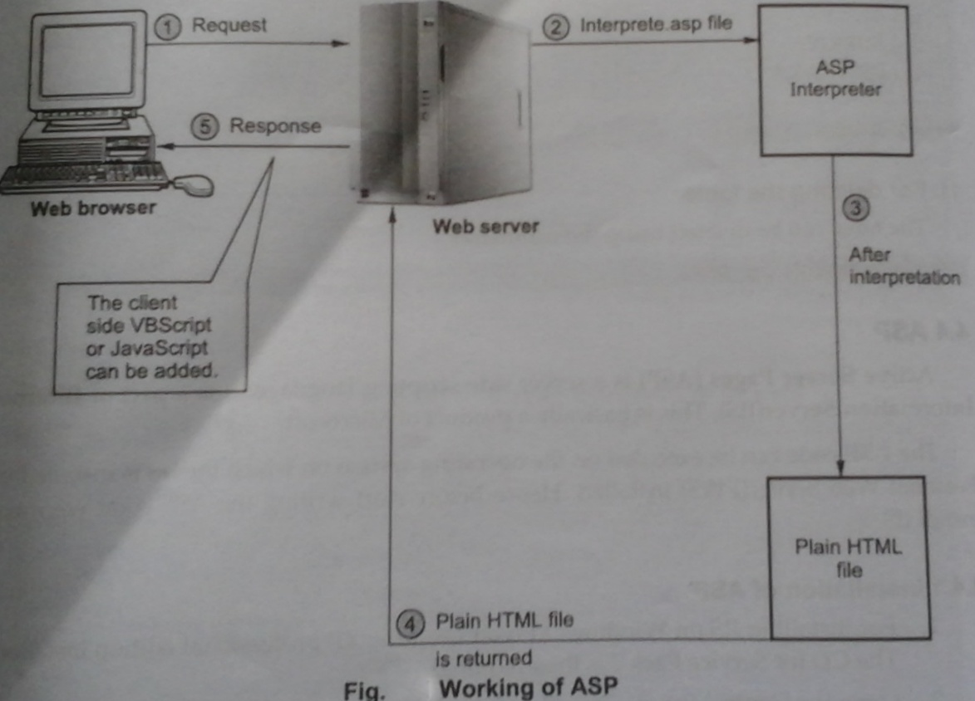

STEP 1:
User submits the request for a webpage(.asp page) using the web browser.This request is submitted to the web Server.
STEP 2:
The source of this API file is in ASCII format .The extension .asp of this request tells the web server that it is an ASP file.Hence the web server sends it to ASP interpreter in order to interpret it.
STEP 3:
The interpreter reads the code line by line,executes it and converts it to HTML form. Thus as an output a plain HTML file gets created.
STEP 4:
This plain HTML file is returned to the web server.
STEP 5:
The web server returns this HTML file to the user on his web browser as a response. The client side VBScript and JavaScript can be included in this file.

When the ASP code is requested then it is loaded from the memory for the first time. Later on, when there is a demand for the same ASP code then it is served by the thread of hat process. No separate process needs to be created each time for serving each request. This increases the efficiency of request processing.
This method of executing the request from the memory for the first time is done using Dynamic Linking Library.

- Explain the various building blocks and types of DTD.

The Document Type Definition is used to define the basic building block of any XML document. Various building blocks of XML are:

Building Block | Explanation
Elements | Main nodes and main building block
Attributes | Extra information about element
Entity | Special character in XML
PCDATA | Parsed character data
CDATA | Character data
  - XML Elements:
In HTML and XML,Elements are main building blocks.
Consider the following XML documents:
<Book pages=“100”>
<name>Learn XML</name>
<author>Pritesh</author>
<type>Scripting</type>
</Book>

In the above example XML elements are:
Element | Name of Element
Root element | Book
Child element | Name,author,type

  - XML Attributes
XML attributes provides some kind of extra information about XMLelement.attributes are kind of names and value pair which provides some information of element.
Consider the following example-
<Book pages=“100” type=”script”>
<name>Learn XML</name>
<author>Pritesh</author>
</Book>

Now in this example-
<Book pages=”100” type=”script”>
Name | Element/Attribute | Attribute value
book | Element | -
Pages | Attribute | 100
type | attribute | Script

  - XML Entities
We know that XML tags are written inside the pair of <and>.
So problem occurs if we put these characters as textual data inside the XML.
Thus some characters that are having special meaning in XML documents are called as entities.XML provides list of following entities-

Entity Reference | Character
&lt; | <
&gt; | >
&amp; | &
&quot; | “
&apos; | ‘

  - PCDATA/CDATA:

PCDATA | CDATA
PCDATA means parsed character data | CDATA means character data
Generally used for elements | Generally used for attributes
PCDATA is text that will be parsed by a parser | CDATA is text that will not be parsed by a parser.
Tags inside the text will be treated as markup and entities will be expanded | Tags inside the text will NOT be treated as markup and entities will not be expanded

TYPES OF DTD:
      - Internal DTD
Consider the following document
XML Document[DTDDemo1.xml]
<?xml version=”1.0” encoding=”UTF-8”?>
<!DOCTYPE student[
<!ELEMENT student(name,address,std,marks)>
<!ELEMENT name(#PCDATA)>
<!ELEMENT address(#PCDATA)>
<!ELEMENTstd(#PCDATA)>
<!ELEMENT marks(#PCDATA)>
]>
<student>
<name>Anand</name>
<address>Pune</address>
<std>Second</std>
<marks>70 percent</marks>
</student>

      - External DTD
In this type, an external DTD file is created and its name must be specified in the corresponding XML file.
Following XML document illustrates the use of external DTD:

STEP 1: Creation of DTD file[student.dtd]

Open some suitable text editor or notepad. Type the following code into it.
<ELEMENT student (name address std and marks)>
<ELEMENT name (#PCDATA) >
<ELEMENT add (#PCDATA)>
<ELEMENT std (#PCDATA)>
<ELEMENT marks (#PCDATA)>

Now save the file as student.dtd

Step 2: Creation of XML document

XML Document[DTD Demo.xml]

Now create a xml document as follows

<?xml version =’1.0’?>
<!DOCTYPE student SYSTEM ‘student.dtd’>
<student>
<name>Anand</name>
<address>Pune</address>
<std>second<std>
<marks>70 percent </marks>
</student>

Step 3: using the web browser open the xml document
<student>
<name> Anand</name>
<address>Pune</address>
<std>Second</std>
<marks>70 percent</marks>
</student>

- Describe the various types of objects supported by ASP.
Objects are six built in objects that are supported by ASp.
These objects provide certain functionalities that can be directly used in the web pages.
In the ASP code we have to simply use the properties ,methods and events that are belonging
to this objects. These built in objects are:-
1. Application
2. Session
3. Request
4. Response
5. Error
6. Server

Let us understand how to use this object in the ASP code.
      - Application Object:
Application is used to store and access any variables from any page.The application object consist of collection of methods and events.those are :
Collection | Contents | Whatever item are enlisted on the script will be display.
Collection | Static object | Contain all objects that appear with <object> tag.
Method | Comments remove | Remove item from the content from collection.
Method | Comments remove all() | Remove all the items from the content collection.
Method | Lock | Other user can not modify the variable at the same time if this method is associated with the object variable.
Method | Unlock | Other user can modify the variable at the same time if this method is associated with the object variable.
Event | Application on End | This events takes place at the end of application.
Event | Application On Start | This events takes place at the before starting new session.

Following example makes use of collection contents using which all the items on the web page can be displayed on the web browser-
ASP code [ObjectApp.asp]<% Application(“name”)=”Monika” Application(“city”)=”Pune”
Application(“work”)=”Graphics Designer”
Application(“complexation”)=”fair”
For each I in Application.Contents
Response.Write(i&”is”&Application.Contents(i)&”<br/>”)
Next
%>

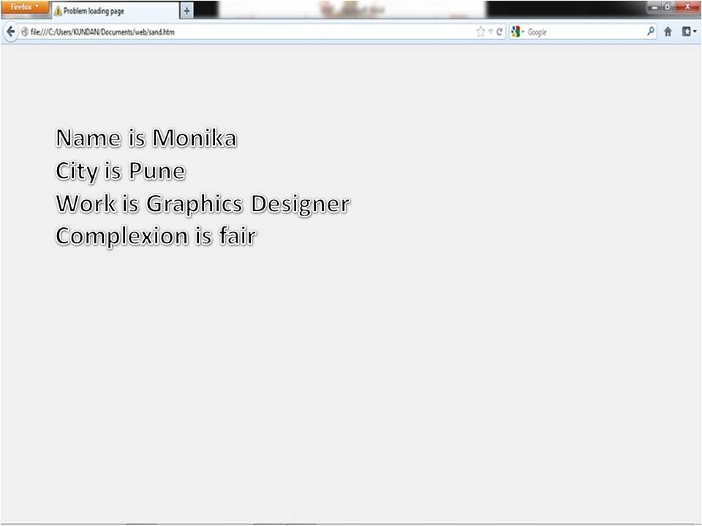
Following examples make use of the methods Lock and Unlock

Asp Code [ObjectProgLock.asp]
<%
Application Lock
Application(“visit_count”)=Application(“visit count”)+1
Application.Unlock
%>
<h2>
Welcome user!!!<br/>
You are visiting this page for <%=Application(“visit_Count”)%>times
</h2>

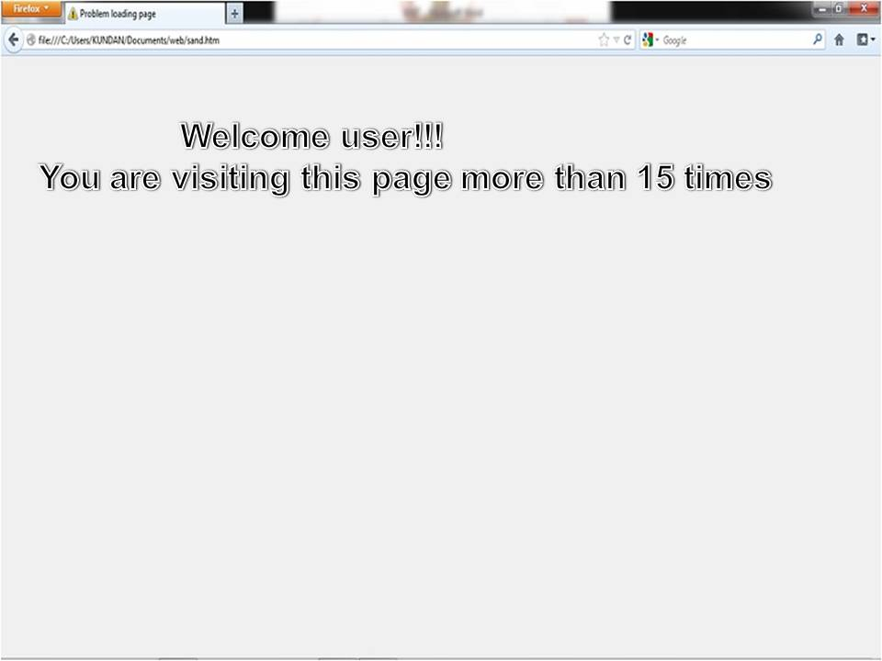

- Session:
The session object is automatically created every time whe user access the browser. This object is intended to the store information about the user.Various collections, methods properties and events used for the session are
Collection | Contents | What ever items are enlisted on the script to the current session will be displayed
Collection | Static objects | Contains all the object that appears with <object> tag.
Method | Contents Remove | Removes items from the contents collection
Method | Contents RemoveAll() | Removes all the items from the contents collection
Method | Abandon | It destroys the user sessions
Property | Code Page | While displaying the dynamic contents the character set is specified using the property
Property | Session ID | It returns the session ID generator for each user
Property | Timeout | Sets the timeout period for the session object in application
Event | Session onEnd | The event that takes place in the end of the session
Event | Session onStart | The event that takes place before starting new session

ASP Code[ObjectProgSession.asp
<%
Dim My_ID
My_ID = Session. SessionID
Response.Write(“The session ID is:”My_ID)
%>
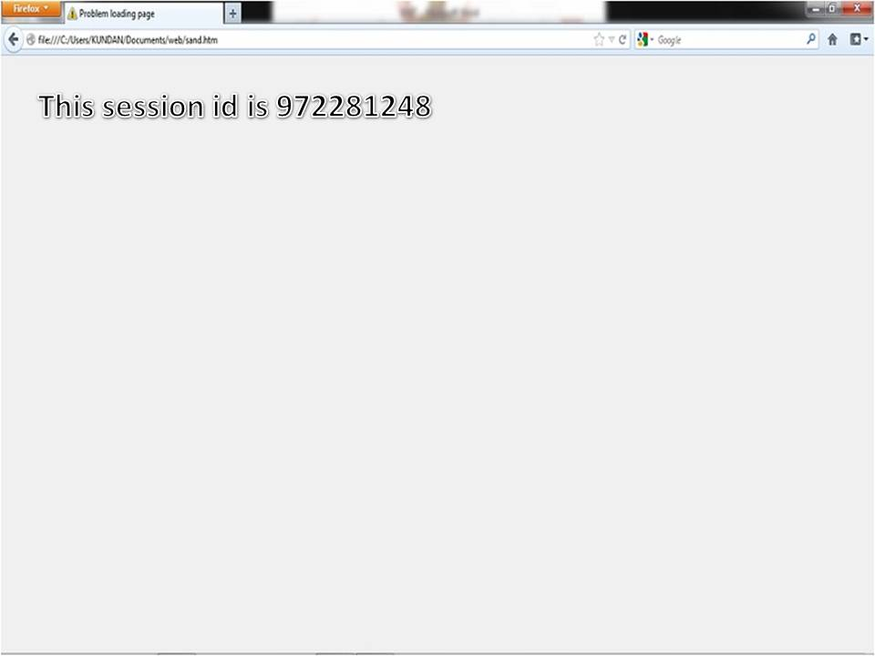
- Request
Therequest object makes available all the values that are passed from browser to the ever uring HTTP request. Following are Collections,Properties and Methods
Collection | Cookies | Contains all the cookies which is present in the HTTP request
Collection | Form | Contains all the form values that the form uses
Collection | QueryString | Contain all the form variables value in HTTP query string
Collection | Server variables | Contain all the server variable values
Method | TotalBytes | Returns he total no of bytes that the client sent in request
Property | BinaryRead | Retrives the data sent to the server from the client

Example : Following is an example in which the collection Server Variable of the request object is used.

ObjectProgRequest.asp

<html>
<body>
<h3>Following are server variables…</h3>
<%
For each i in requestServerVariables response.write(i&”<br/>”)
Next
%>
</body>
</html>
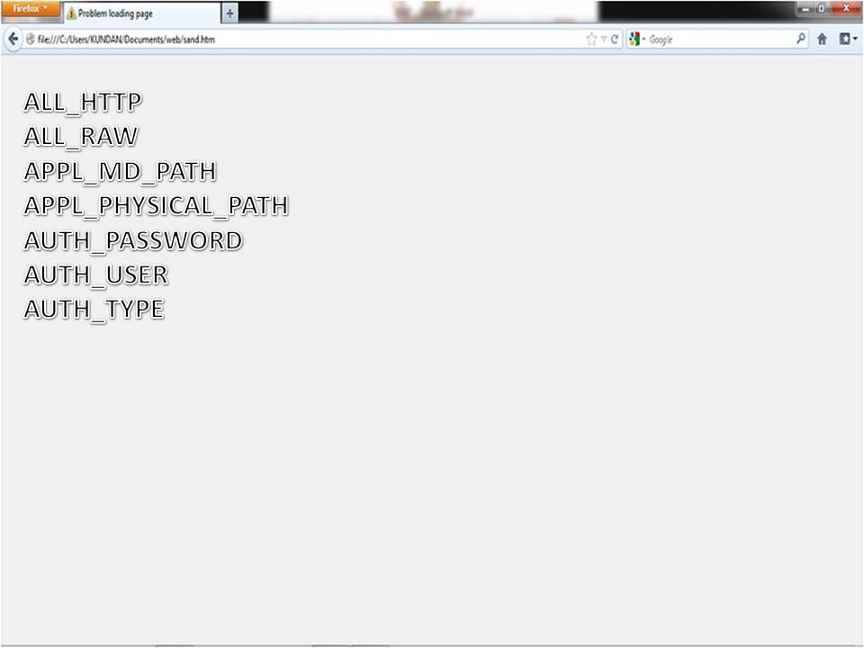

We can display specific information about the user using the request object for getting the name of the server we can write following code

ASP CODE
<html>
<body>
<h3> Server name is: </h3>
<%
Response.write(Request.ServerVariables(“server_name”))
%>
</body
</html>

- RESPONSE
The response object is used to send the output back to the client it includes the cookies ,http variables which is stored in clients browser.
Collection | cookies | Sets the cookie value
Property | Buffer | It indicatess the page output is buffered or not
Property | Charset | The name of the character set is appeared in the response object
Property | ContentType | This string specifies the HTTP content type for response
Property | CacheControl | This string specifies whether the output should be cached or not
Property | Expires | This is the integer which specifies the expiry time for the web page
Method | AddHeader | Adds the new HTTP header to the response
Method | AppendToLog | This method add some string at the end of the web server lo entry
Method | Clear | It clears the HTML buffered output
Method | Flush | It sends the buffered output immediately ro rhe client
Method | Write | This method is used to write the desired content which can then be displayed on the web page

3.

Example: Following are two ASP codes.The first ASP code sets the cookies and second ASP code retrives it.
SetCookie.asp

<html>
<body>
<%
Creating Cookie
Response Cookies(‘looks’)=”beautiful”
%>
<p>The cookie is set</p>
</body>
</html>

GetCookies.asp

<%
Dim val
Val=Request.Cookies(“looks”)
Response.write(“Monika looks”&val)
%>

Now open the two web browser windows first of all execute the asp code for SetCookies and then in another window execute the ASP code for GetCookies . The output can be

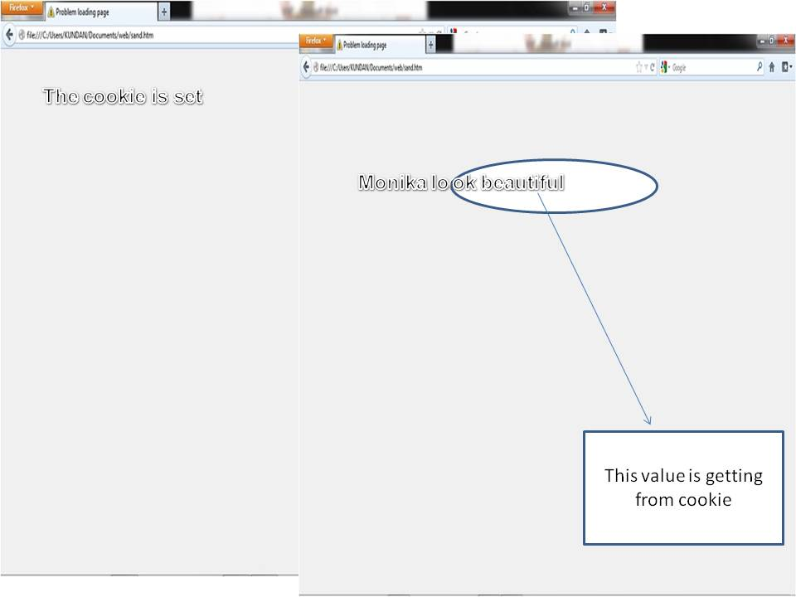

EXAMPLE: Following ASP code make use of the method URLEncode

ASP Code[ServerObj.asp]
<%
Dim obj
Obj = Server.URLEncode(“http://www.google.co.in”)
Response.write(obj)
%>

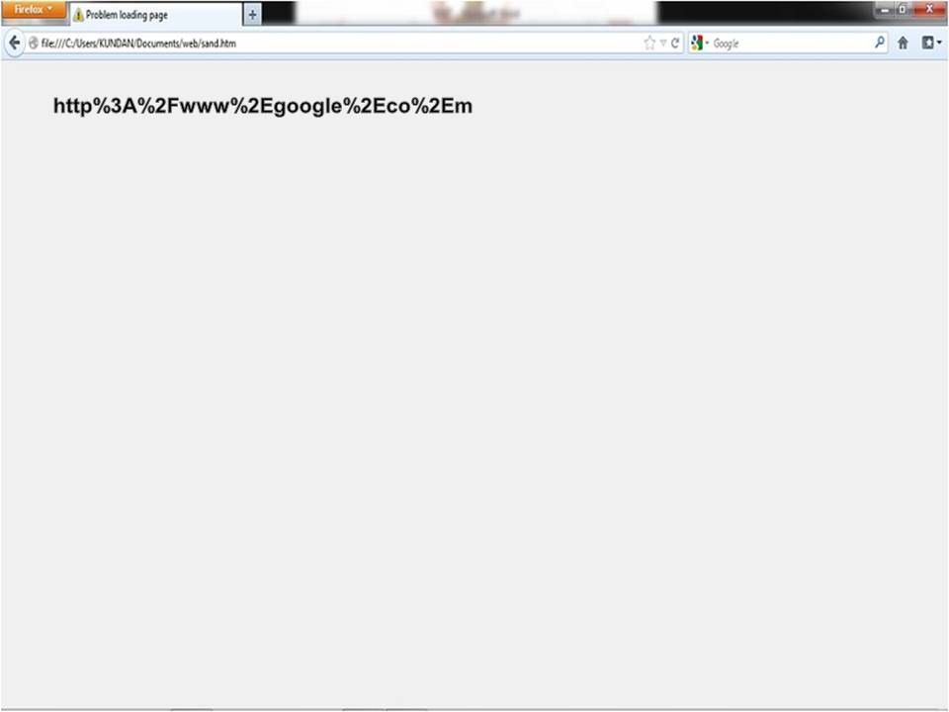

- How to develop an application using ASP? Explain in detail.

ASP codes must be saved and executes systematically. Following are the steps that execute the same-

      - Open up My Computer, click on the C drive and select the folder Inetpub. Select the wwwroot folder.
      - Now create a directory by giving some appropriate name and store your ASP code in it.
      - For instance we have created a folder named hello and then opened notepad application for writing the ASP code. We have saved it by the name test.asp. that means the location of my first ASP code is C:\Inetpub\wwwroot\hello\test.asp
      - The code is as follows: ASP Code[test.asp]
<%@ LANGUAGE=Jscript %>
<html>
<body>
<%
Response.write(“<h1>Hello ASP</h1>
%>
</body>
</html>

      - Now open the web browser and execute it by typing the URL http://localhost/hello/test.asp in the address bar.t The ouput will be as follows:
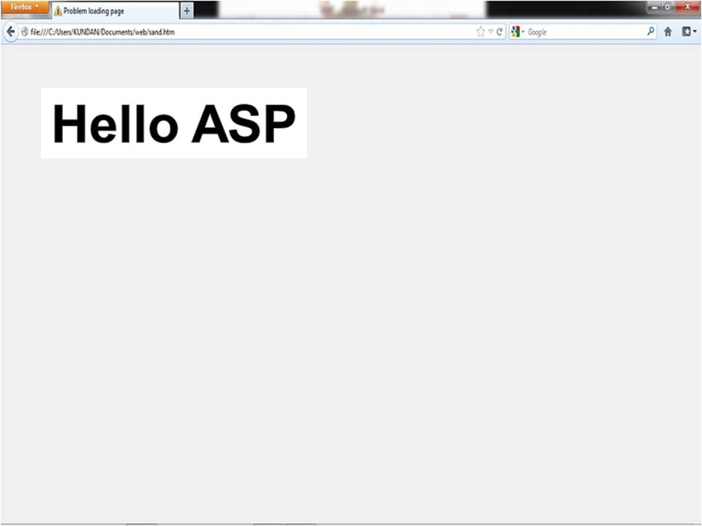

EXPLANATION:
The ASP code can be embedded with HTML tags. There are two methods of writing ASP code- one by using VBScript another by JavaScript.By default ASP supports VBScripting. But if we want to use JavaScript then we must specify it.

The ASP code must be embedded within <% and %> . The Response.Write method is used to display the message on the web page.

Let us another example which displays current date:

ASP Code[DisplayDate.asp]:

<html>
<body>
<%
Dim str
str=Date();
Response.Write(“Today’s date is:”&str)
%>
</body>
</html>

Output:
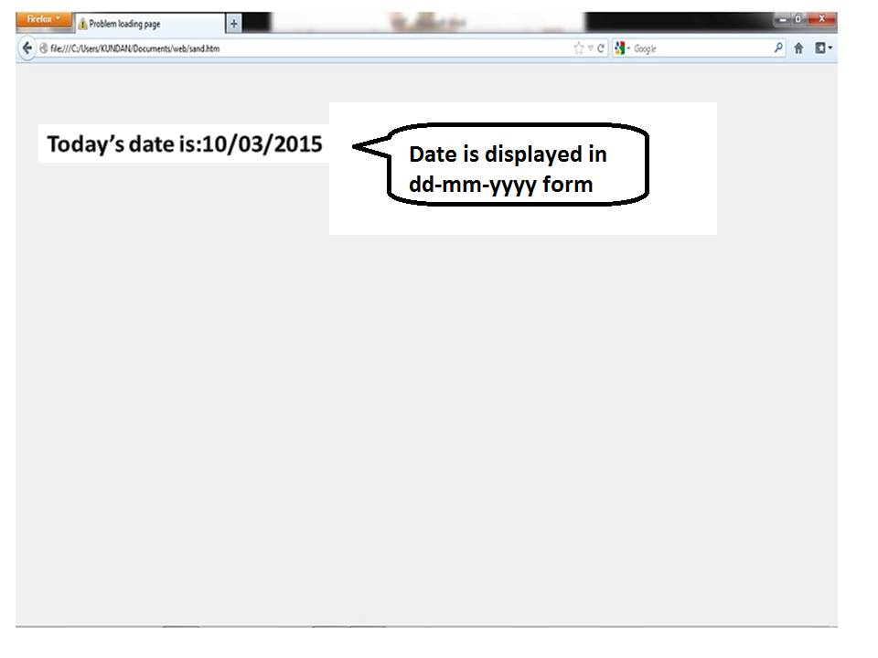

- Explain the Structural Query Language statements with examples.

SQL statements, are used to communicate with the database to perform specific tasks, work, functions and queries with data.Commonly used statements are grouped into the following categories:
Data Query Language (DQL)
- SELECT - Used to retrieve certain records from one or more tables.
Syntax of SQL SELECT Statement:
SELECT column_list FROM table-name
[WHERE Clause]
[GROUP BY clause]
[HAVING clause]
[ORDER BY clause];

Data Manipulation Language (DML)
- INSERT - Used to create a record.
We can insert data to a table in two ways,
- Inserting the data directly to a table.

Syntax for SQL INSERT is:

INSERT INTO TABLE_NAME

[ (col1, col2, col3,...colN)]

VALUES (value1, value2, value3,...valueN);
2)Inserting data to a table through a select statement.

Syntax for SQL INSERT is:
INSERT INTO table_name
[(column1, column2, ... columnN)]
SELECT column1, column2, ...columnN
FROM table_name [WHERE condition];

- UPDATE - Used to change certain records.
The Syntax for SQL UPDATE Command is:
UPDATE table_name
SET column_name1 = value1,
column_name2 = value2, ...
[WHERE condition]
- DELETE - Used to delete certain records.
Syntax of a SQL DELETE Statement:
DELETE FROM table_name [WHERE condition];
- SQL TRUNCATE Statement: The SQL TRUNCATE command is used to delete all the rows from the table and free the space containing the table.
Syntax to TRUNCATE a table:
TRUNCATE TABLE table_name;

Data Definition Language (DDL)
- CREATE - Used to create a new table, a view of a table, or other object in database.
The Syntax for the CREATE TABLE Statement is:
CREATE TABLE table_name
(column_name1 datatype,
column_name2 datatype,
...column_nameNdatatype
);
- ALTER - Used to modify an existing database object, such as a table.
The ALTER command is used to perform the following functions.
1) Add, drop, modify table columns
2) Add and drop constraints
3) Enable and Disable constraints

Syntax to add a column

ALTER TABLE table_name ADD column_namedatatype;

Syntax to drop a column

ALTER TABLE table_name DROP column_name;
- DROP - Used to delete an entire table, a view of a table or other object in the database.
Syntax to drop a sql table structure:
DROP TABLE table_name;

Data Control Language (DCL)
- GRANT - Used to give a privilege to someone.
SQL GRANT Command
SQL GRANT is a command used to provide access or privileges on the database objects to the users.
The Syntax for the GRANT command is:
GRANT privilege_name
ON object_name
TO {user_name |PUBLIC |role_name}
[WITH GRANT OPTION];
- REVOKE - Used to take back privileges granted to someone.
SQL REVOKE Command:
The REVOKE command removes user access rights or privileges to the database objects.
The Syntax for the REVOKE command is:
REVOKE privilege_name
ON object_name
FROM {user_name |PUBLIC |role_name}

- Narrate Structuring of data in XML with example.

XML:

- XML stands for extensible Markup Language.
- Contains various tags. But tags are not predefined.
- The user can create their own tags.
- XML is designed for transport or to store the data.

Structuring of data:

- In XML we can create our own tags.
- XML allows the programmer to create markup for virtually any type of information.
- Example Program which can be written using notepad
<Person>
<Person-Info>
<Name>Raj< /Name>
<City>Chennai</City>
</ Person-Info>
<Hobby>
<first>reading</ first>
<second>singing</ second>
</Hobby>
</Person>

OUTPUT:

-<Person>
-<Person-Info>
<Name>Raj< /Name>
<City>Chennai</City>
</ Person-Info>
-<Hobby>
<first>reading</ first>
<second>singing</ second>
</Hobby>
</Person>

Rules that must be followed while writing XML:

      - XML is a case sensitive.
For example
<Hobby>reading</Hobby> - Correct
<hobby> reading</Hobby> - Wrong
      - Start tag must have matching end tag.
For example
<staring>XML- Correct
<Simple> implement</ Simple>- Wrong
      - The elements in XML must be properly nested.
For example
<one><two>Hai! <\two><\one>- Correct
<one><two>Hai! <\ one><\two> - Wrong

Elements :
- In XML the basic entity is element.The elements are used for defining the tags.
- The elements typically consist of opening and closing tag.
For example
<Element name>hello<\Element name>
Example Program: (XML Document)
<Person>
<Person-Info>
<Name>Raj< /Name>
<City>Chennai</City>
</ Person-Info>
<Hobby>
<first>reading</ first>
<second>singing</ second>
</Hobby>
</Person>
Description for the above program is
<Person> is a root element
<Person-Info> is a container element

<Name>Raj< /Name>
<City>Chennai</City> child element

If the above program is display in web browser
- We get the + and –signs appearing before the tags.
- - element indicate that the child elements of the corresponding elements are displayed.
- + element indicates the child element are hidden.

Attributes:
- An empty tag can be putting a /(forward slash) before closing the bracket.
For example:<Student/>
- A space or a tab character is not allowed in the element name or in attribute name.
For example:
<Per son> < ----------------------- a space is introduced here
<Person-Info>
<Name>Raj< /Name>
<City>Chennai</City>
</ Person-Info>
</Per son>
- The attributes must be enclosed within double quotes or a single quote.
For example:
<Person flag=”true”>
<name>sarath</name>
<grade>B</grade>
</Person>
- ”<” and “>” are used for enclosing the tags.
  - &lt; for less than
  - &gt; for greater than
  - &apos; for apostrophe
  - &amp; for ampersand
  - &quot; for double quotes
For example:
<Person flag=”true”>
<name>sarath</name>
<grade>sarath &apos;s grade is B</grade>
</Person>

OUTPUT:
-<Person flag=”true”>
<name>sarath</name>
<grade>sarath’s grade is B</grade>
</Person>
Comments in XML:
<!--
--> comment line statement

For example:
<hello>
<!--
<body>my life</body>
-->
</hello>

- Explain about Active-X Components.

- An ActiveX component is a unit of executable code, such as an .exe, .dll, or .ocx file, that follows the ActiveX specification for providing objects. ActiveX technology allows programmers to assemble these reusable software components into applications and services.
- You can buy ActiveX components that provide generic services, such as numerical analysis or user interface elements. You can create components that encapsulate your own business transactions, and combine these with generic components. Reusing tested, standardized code in this fashion is called component software development.
- Component software development using ActiveX technology should not be confused with object-oriented programming (OOP). OOP is a way to build object-based software components; ActiveX is a technology that allows you to combine object-based components created using many different tools. To put it another way, OOP is concerned with creating objects, while ActiveX is concerned with making objects work together.
- For example, you can use an OOP tool such as Microsoft Visual C++® to construct a set of useful objects. These objects can be used and further extended by other C++ developers. If you package your objects in an ActiveX component, however, they can be used and further extended with any programming tool that supports ActiveX technology.

Features of Visual Basic ActiveX Components
- With Visual Basic you can create components ranging from code libraries to Automation-enabled applications. You can create and distribute ActiveX control packages, with full licensing capability, or Internet applications with ActiveX documents that can display themselves in Internet browsers. With the Enterprise Edition of Visual Basic, you can run code components — such as business rule servers — on remote computers.
Figure 1.1 shows a Visual Basic application that uses several components, all of them built with Visual Basic.
Figure 1.1 Visual Basic application using components

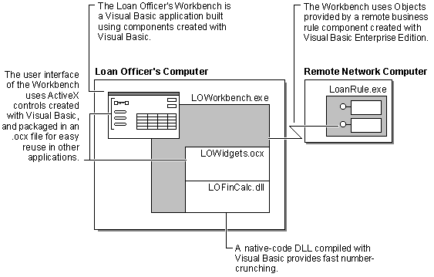
- Visual Basic ActiveX components are Internet- and intranet-enabled. Figure 1.2 shows a business analyst viewing a form on his desktop computer at the home office, while a sales representative views the same information through a Web page, using a Visual Basic ActiveX document.

Figure 1.2 Visual Basic activates the Internet
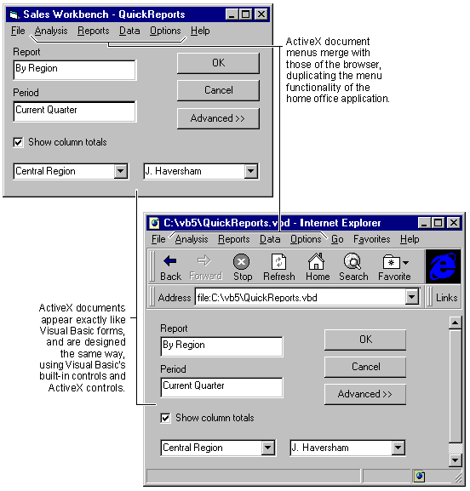

Which Type of Component Should be Build?
With all the different types of ActiveX components to choose from, how do you decide which type of component is best for a given situation? It may help to think of them in terms of functionality:
- If you need an invisible component that provides a service, you’ll want to build a code component — either an ActiveX Exe or an ActiveX DLL.
  - If you need a component that can run in the same process with your application, you’ll want an ActiveX DLL. An example of this would be a component that performs complex calculations.
  - If you need a component that can serve multiple applications and can run on a remote computer, you’ll want an ActiveX Exe. For example, a business rules server that enforces tax rules would best be implemented as an ActiveX Exe.
- If you need a visible component that can be dropped into an application at design time, you’ll want to build an ActiveX control. An example of this might be a phone number control that properly formats and validates phone numbers; such a control would undoubtedly be useful in many applications.
- If you need a visible component that can take over an application window at run time, choose an ActiveX document. The above example shows a sales application that can be viewed in a Web browser, duplicating the functionality of a desktop application.
No matter which type of ActiveX component you choose to build, Visual Basic makes reusability a reality.

Features for Building Components
The following are some of the features Visual Basic provides for creating software components.
- Components can provide several types of objects, as described in the related topics "ActiveX Controls," "ActiveX Documents," "Code Components," and "Applications that Provide Objects."
- Objects provided by components can raise events. You can handle these events in a host process or in another application — with the Enterprise Edition, such an application can even be running on a remote computer.
- Components can be data-aware, binding directly to any source of data without the need for a data control. You can also create an ActiveX component that acts as a data source to which other objects can bind. For example, you could create your own data control (similar to the ADO Data control or the Remote Data control), but instead of binding via ADO or RDO you could bind to a flat file or a proprietary binary data format.
- Friend functions allow the objects provided by a component to communicate with each other internally, without exposing that communication to applications that use those objects.
- The Implements keyword lets you add standard interfaces to your objects. These common interfaces enable polymorphic behavior for objects provided by a component, or for objects provided by many different components.
- You can use enumerations to provide named constants for all component types.
- You can choose a default property or method for each class of object your component provides.
- You can allow users of your component to access the properties and methods of a global object without explicitly creating an instance of the object.

- Write short notes on vocabularies and its type in XML.

i)Mathematical Markup Language(MathML) (4 Marks)
ii)Wireless Markup Language(WML) (4 Marks)
iii)Product Data Markup Language(PDML) (4 Marks)
iv)Chemical Markup Language(CML) (4 Marks)

- Write an ASP code to access a table and records from a student database to obtain the result of a student.
The following code will allow you to display the contents of a database table in an HTML table. The HTML table is built dynamically as the records are pulled out of the database. Minimal changes are necessary if you copy and paste this code - basically just change the DSN, table and field names. Note this example has an inner table for formatting purposes, but it is not necessary.
<%@ Language="VBScript%">
<html>
<head>
<title>Display all Records</title>
</head>
<body>
<%
strSQL = "Select * from TableName;" 'create SQL string (where clauses etc
'should be added according to what you would like displayed)
SET DbObj = Server.CreateObject("ADODB.Connection") 'set up the
'ADO connection
DbObj.Open "DSN=DSNName","username","password" 'open the connection to
'the database, using DSN - set up the DSN in your control panel

SET oRs = DbObj.Execute(strSQL) 'Execute the SQL statement
%>
<center>
<%
DO WHILE NOT oRs.EOF
on error resume next
%>
<table border="1" width="100%" bordercolor="#00FFFF">
<tr>
<td width="35%">
<table border="0" width="96%">
<tr>
<td width="100%"><font color="#000080" size="4">
Display field description here: <% = oRs.Fields("FieldName") %></td>
</tr>
</table>
</td>
<font color="#000080" size="4">
<td width="65%"> <% = oRs.Fields("FieldName") %></td></font>
</tr>
</table>
<% oRs.MoveNext %>
<% Loop %> 'Go to the next record if not end of file
</center>
<% DbObj.Close 'Close the database connection
SET DbObj = Nothing 'Clean up after yourself
%>
</body>
</html>

UNIT- IV
PART - A

- Write a note on Internet Information Server (IIS).
Microsoft's Web server that runs on Windows NT platforms, In fact, IIS comes bundled with Windows NT 4.0. Because IIS is tightly integrated with the operating system, it is relatively easy to administer.

- What do you mean by JDBC?
JDBC is a part of the Java Development Kit which defines an application-programming interface that enables java programs to execute SQL statements and retrieve results from database. JDBC stands for Java Database Connectivity, which is a standard Java API for database-independent connectivity between the Java programming language and a wide range of databases.

- State the different types of JDBC Statements?
Types of statements are:
- Statement (regular SQL statement)
- PreparedStatement (more efficient than statement due to pre-compilation of SQL)
- CallableStatement (to call stored procedures on the database)

- Write short notes on Hidden Fields.
Hidden fields are not displayed by the browser and userscan never interact with them. However, users can see the field by viewing the source code. Scripts, like other fields, can access them. One of the important application is session tracking where information is sent back and forth between the server and the browser.

- How do you create a connection object?
There are 3 overloaded DriverManager.getConnection() methods to create a connection object:
- getConnection(String url, String user, String password):Using a database URL with a username and password.
- getConnection(String url):Using only a database URL.
- getConnection(String url, Properties prop):Using a database URL and a Properties object.

- What are the basic steps to create a JDBC application?
Following are the basic steps to create a JDBC application:
- Import packages containing the JDBC classes needed for database programming.
- Register the JDBC driver, so that you can open a communications channel with the database.
- Open a connection using the DriverManager.getConnection () method.
- Execute a query using an object of type Statement.
- Extract data from result set using the appropriate ResultSet.getXXX () method.
- Clean up the environment by closing all database resources relying on the JVM's garbage collection.

- List the disadvantages of using cookies.
- Some browser doesn‘t support cookies
- Cookies can be disabled on user browsers
- Cookies are transmitted for each HTTP request/response causing overhead on bandwidth

- What is the need for tracking session?
When there is a series of continuous request and response from a same client to a server, the server cannot identify from which client it is getting requests, because HTTP is a stateless protocol. When there is a need to maintain the conversational state, session tracking is needed.
For example, in a shopping cart application a client keeps on adding items into his cart using multiple requests. When every request is made, the server should identify in which client’s cart the item is to be added. So in this scenario, there is a certain need for session tracking.

- What are the ways to maintain session?
Cookies
User authentication
URL Rewriting
Http Session

- Define Cookies.
Cookies are the bit of information sent by the web server to a browser that can be read back from that browser later.

- List the advantages of using cookies.
- The user can configure cookies to expire when the browser session ends (session cookies) or they can exist for a specified length of time on the client’s computer (persistent cookies).
- Cookies do not require any server resources since they are stored on the client
- Cookies are easy to implement

- List down the ways how ODBC differs from JDBC?
ODBC is for Microsoft and JDBC is for java applications.
ODBC can't be directly used with Java because it uses a C interface.
ODBC makes use of pointers which have been removed totally from java.
ODBC mixes simple and advanced features together and has complex options for simple queries, But JDBC is designed to keep things simple while allowing advanced capabilities when required.
ODBC requires manual installation of the ODBC driver manager and driver on all client machines. JDBC drivers are written in java and JDBC code is automatically installable, secure and portable on all platforms.
JDBC API is a natural Java Interface and is built on ODBC. JDBC retains some of the basic feature of ODBC

- Define ODBC
ODBC is a standard for accessing different database systems. There are interfaces for Visual Basic, Visual C++, SQL and the ODBC driver pack contains drivers for the Access, Paradox, dBase, Text, Excel and Btrieve databases.

- List down the types of drivers available in JDBC.
- Type 1: JDBC-ODBC Bridge driver (Bridge)
- Type 2: Native-API/partly Java driver (Native)
- Type 3: All Java/Net-protocol driver (Middleware)
- Type 4: All Java/Native-protocol driver (Pure)

- What are the three parts of multi tier architecture?
Presentation tier
Logic or business tier
Data tier

- What is web server? Give some examples.
Web server is a program responsible for accepting HTTP request from clients and serving HTTP response along with optional data.
Eg: Java web server, Tomcat, Microsoft Internet Information Services

- Difference between HTTP get and post methods
Get | Post
It is idempotent | It is nonidempotent
Data embedded with url | Data embedded with message body of HTTP
Size limitation of 2000 characters | No size limitation
This is not a secured way since it is visible | It is a secured way
If a page is refreshed, it would not prompt before the request is resubmitted | If a page is refreshed, it would prompt before the request is resubmitted

- What are the different methods used for session tracking?
Cookies
SSLsessions
URL- rewriting

- Draw the JDBC two-tier and three-tier architecture.
Two tier…

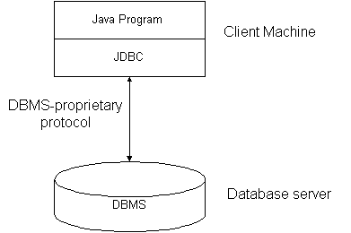
Three tier…
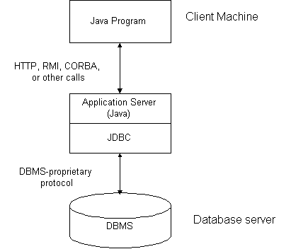

- Write short notes on Session API.

The portion of the Servlet API devoted to session tracking, should be supported in any web server that supports servlets. The session API is the javax.servlet.http.HttpSession interface which is used in JSP technology that provides a higher level approach for session tracking.

PART-B
- Explain about JDBC connectivity
- JDBC is java database connectivity. JDBC helps us to connect to a database and execute SQL statements against a database. JDBC api provides set of interfaces and there are different implementations respective to different databases.
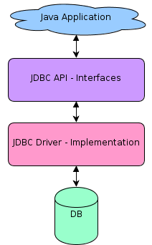
Using JDBC in our application can be segregated into three major steps as below,
- Obtaining a database connection.
- Execute queries against the connected database and receive results.
- Process the received results.
- Explain any five important methods of Cookie class. Write a Java Program to demonstrate session tracking through cookie.
Methods of cookie class are :-
- Equals - Overrides the Object.Equals method. (Overrides Object.Equals(Object).)
- GetHashCode - Overrides the Object.GetHashCode method. (Overrides Object.GetHashCode().)
- GetType - Gets the Type of the current instance. (Inherited from Object.)
- ToString - Overrides the Object.ToString method. (Overrides Object.ToString().)
Program to demonstrate session tracking through cookies:-
import java.io.*;
importjava.servlet.*;
importjava.servlet.http.*;
public class sessiontracking extends HTTPServlet
{
public void doGet(HttpServletRequestreq,HttpServletResponse res)throws servletException,IOException
{
res.getContentType("text/html");
PrintWriter out=res.getWriter();
HttpSession session=req.getSession();
String[] items=(String[]) session.getAttribute("cart.items");
out.println("<html><head><title>SessionTracker</title></head>");
out.printl("<body><li>Session Tracking Demo </li>");
out.println("U currently have the following items");
if(items==NULL){
out.println("none");
}
else{
out.println("<ul>");
for(int i=0;i<items.length;i++){
out.printl("<li>" +items[i]);
}out.println("</ul>")
}out.printl("<form action=\"/servlet/shoppingcart\" method=POST>");
out.printl("Would You like to");
out.printl("<input type=Submit value = \"add more items\">");
out.printl("<input type=Submit value=\"Check out\">");
out.printl("</form><body>");
out.printl("</html>");}

- Explain the prepared statement and callable statement in JDBC.
The PreparedStatement Objects:
- The PreparedStatement interface extends the Statement interface which gives the added functionality with a couple of advantages over a generic Statement object.
- This statement gives the flexibility of supplying arguments dynamically.
Creating PreparedStatement Object:
PreparedStatementpstmt=null;
try{
String SQL ="Update Employees SET age = ? WHERE id = ?";
pstmt=conn.prepareStatement(SQL); ... }
catch(SQLException e){ ... }
finally{ ... }
All parameters in JDBC are represented by the?symbol, which is known as the parameter marker. All of the Statement object's methods for interacting with the database like
- execute()
- executeQuery()
- executeUpdate() also work with the PreparedStatement object.
Closing PreparedStatementObeject:
A simple call to the close() method will close the Connection of the PreparedStatement object.
PreparedStatementpstmt=null;
try{
String SQL ="Update Employees SET age = ? WHERE id = ?";
pstmt=conn.prepareStatement(SQL); ...}
catch(SQLException e){ ...}finally{ pstmt.close(); }
The CallableStatement Objects:
Just as a Connection object creates the Statement and PreparedStatement objects, it also creates the CallableStatement object which would be used to execute a call to a database stored procedure.
Creating CallableStatement Object:
DELIMITER $$
DROP PROCEDURE IF EXISTS `EMP`.`getEmpName` $$
CREATE PROCEDURE `EMP`.`getEmpName`
(IN EMP_ID INT, OUT EMP_FIRST VARCHAR(255))
BEGIN
SELECT first INTO EMP_FIRST
FROM Employees
WHERE ID = EMP_ID;
END $$
DELIMITER ;
Three types of parameters exist: IN, OUT, and INOUT.
The PreparedStatement object only uses the IN parameter.
The CallableStatement object can use all three.
Here are the definitions of each:
Parameter Description
IN - A parameter whose value is unknown when the SQL statement is created.
OUT - A parameter whose value is supplied by the SQL statement it returns.
INOUT - A parameter that provides both input and output values.
The following code snippet shows how to employ the Connection.prepareCall() method to instantiate aCallableStatement object based on the preceding stored procedure:
CallableStatementcstmt=null;
try{
String SQL ="{call getEmpName (?, ?)}";
cstmt=conn.prepareCall(SQL); .. .}
catch(SQLException e){ ...}
finally{ ...}
Closing CallableStatementObeject:
The close() method close the Connection of the CallableStatement object
CallableStatementcstmt=null;
try{
String SQL ="{call getEmpName (?, ?)}";
cstmt=conn.prepareCall(SQL); ... }
catch(SQLException e){ ... }
finally{ cstmt.close(); }

- State the various JDBC drivers and explain its function.
JDBC drivers
- Type 1: JDBC-ODBC Bridge driver (Bridge)
- Type 2: Native-API/partly Java driver (Native)
- Type 3: All Java/Net-protocol driver (Middleware)
- Type 4: All Java/Native-protocol driver (Pure)
JDBC drivers function
- Sends JDBC API calls to a middle-tier net server that translates the calls into the DBMS-specific network protocol.
- The translated calls are then sent to a particular DBMS.
- Follows a three tier communication approach.
- Can interface to multiple databases - Not vendor specific.
- The JDBC Client driver written in java, communicates with a middleware-net-server using a database independent protocol, and then this net server translates this request into database commands for that database.
- What are the basic steps are followed to work with JDBC – ODBC connectivity.
The following basic steps are followed to work with JDBC..
- Loading a driver
try {
Class.forName("sun.jdbc.odbc.JdbcOdbcDriver");
}
catch(Exception e){
System.out.println("Exception is loading the driver."+e);
}

- Making a connection
try{
Connection connection = DriverManager.getConnection(connectionUrl,dbUserName,dbPassword");
}
catch( SQLException sqlEx ){
System.out.println( "Exception in getting a connection"+sqlEx);
}

- Executing an SQL statement
PreparedStatement pstmt = connection.prepareStatement("UPDATE EMPLOYEE SET name = ? WHERE empid = ?");
pstmt.setString(1, "XYZ");
pstmt.setInt(2, 10829);

- Give a brief overview of the JDBC process with simple application.
JDBC process with simple application
The basic process for a single data retrieval operation using JDBC would be as follows.
  - A JDBC driver would be loaded;
  - A database Connection object would be created from using the DriverManager (using the database driver loaded in the first step);
  - A Statement object would be created using the Connection object;
  - A SQL Select statement would be executed using the Statement object, and a ResultSetwould be returned;
  - The ResultSet would be used to step through (or iterate through) the rows returned and examine the data.
The following JDBC code sample demonstrates this sequence of calls.
JDBCSample.java
Import.java.sql.*;
public class JDBCSample {
public static void main( String args[]) {
String connectionURL = "jdbc:postgresql://localhost:5432/movies;user=java;password=samples";
// Change the connection string according to your db, ip, username and password
try {
// Load the Driver class.
Class.forName("org.postgresql.Driver");
// If you are using any other database then load the right driver here.
//Create the connection using the static getConnection method
Connection con = DriverManager.getConnection (connectionURL);
//Create a Statement class to execute the SQL statement
Statement stmt = con.createStatement();
//Execute the SQL statement and get the results in a Resultset
ResultSetrs = stmt.executeQuery("select moviename, releasedate from movies");
// Iterate through the ResultSet, displaying two values
// for each row using the getString method
while (rs.next())
System.out.println("Name= " + rs.getString("moviename") + " Date= " + rs.getString("releasedate"));
}
catch (SQLException e) {
e.printStackTrace();
}
catch (Exception e) {
e.printStackTrace();
}
finally { // Close the connection con.close(); }}}

- Write a servlet program to implement session tracking using HTTP session object
// Import required java libraries
import java.io.*;
importjavax.servlet.*;
importjavax.servlet.http.*;
importjava.util.*;
// ExtendHttpServlet class
publicclassSessionTrackextendsHttpServlet{
publicvoiddoGet(HttpServletRequest request,
HttpServletResponse response)
throwsServletException,IOException
{
// Create a session object if it is already not created.
HttpSession session =request.getSession(true);
// Get session creation time.
DatecreateTime=newDate(session.getCreationTime());
// Get last access time of this web page.
DatelastAccessTime=
newDate(session.getLastAccessedTime());
String title ="Welcome Back to my website";
IntegervisitCount=newInteger(0);
StringvisitCountKey=newString("visitCount");
StringuserIDKey=newString("userID");
StringuserID=newString("ABCD");
// Check if this is new comer on your web page.
if(session.isNew()){
title ="Welcome to my website";
session.setAttribute(userIDKey,userID);
}else{
visitCount=(Integer)session.getAttribute(visitCountKey);
visitCount=visitCount+1;
userID=(String)session.getAttribute(userIDKey);
}
session.setAttribute(visitCountKey,visitCount);
// Set response content type
response.setContentType("text/html");
PrintWriterout=response.getWriter();
StringdocType=
"<!doctype html public \"-//w3c//dtd html 4.0 "+
"transitional//en\">\n";
out.println(docType+
"<html>\n"+
"<head><title>"+ title +"</title></head>\n"+
"<body bgcolor=\"#f0f0f0\">\n"+
"<h1 align=\"center\">"+ title +"</h1>\n"+
"<h2 align=\"center\">Session Infomation</h2>\n"+
"<table border=\"1\" align=\"center\">\n"+
"<trbgcolor=\"#949494\">\n"+
" <th>Session info</th><th>value</th></tr>\n"+
"<tr>\n"+
" <td>id</td>\n"+
" <td>"+session.getId()+"</td></tr>\n"+
"<tr>\n"+
" <td>Creation Time</td>\n"+
" <td>"+createTime+
" </td></tr>\n"+
"<tr>\n"+
" <td>Time of Last Access</td>\n"+
" <td>"+lastAccessTime+
" </td></tr>\n"+
"<tr>\n"+
" <td>User ID</td>\n"+
" <td>"+userID+
" </td></tr>\n"+
"<tr>\n"+
" <td>Number of visits</td>\n"+
" <td>"+visitCount+"</td></tr>\n"+
"</table>\n"+
"</body></html>"); } }
- What are the various session tracking mechanisms? Explain with example.
- Cookies:
A webserver can assign a unique session ID as a cookie to each web client and for subsequent requests from the client they can be recognized using the received cookie.
ex., Cookie cookie = new Cookie(“userID”, “7456”);
res.addCookie(cookie);
- URL rewriting:
Extra data on the end of each URL that identifies the session, and the server can associate that session identifier with data it has stored about that session.
ex., http://url.com/file.htm;sessionid=12345, the session identifier is attached as sessionid=12345 which can be accessed at the web server to identify the client.
- HttpSession:
- servlet provides HttpSession Interface which provides a way to identify a user across more than one page request or visit to a Web site and to store information about that user.
- The servlet container uses this interface to create a session between an HTTP client and an HTTP server. The session persists for a specified time period, across more than one connection or page request from the user.
HttpSession session = request.getSession();
- Hidden form fields:
A web server can send a hidden HTML form field along with a unique session ID as follows:
<input type="hidden" name="sessionid" value="12345">

- Develop a simple student management system using JDBC- ODBC connectivity.
import java.sql.Connection;
import java.sql.DriverManager;
import java.sql.ResultSet;
import java.sql.SQLException;
import java.sql.Statement;
public class JDBCBasicExample {
private Connection connection = null;
private Statement statement = null;
private ResultSet resultSet = null;
public static void main() throws Exception {
try {
// using mysql driver - download and add in classpath
Class.forName("com.mysql.jdbc.Driver");
connection = DriverManager.getConnection("jdbc:mysql://localhost/studentdb?" + "user=dbregno && password=dbpassword");
statement = connection.createStatement();
resultSet = statement.executeQuery("select * from studentdb");
while (resultSet.next()) {
String studentname = resultSet.getString("name");
regno1=resultSet.getString("regno");
int regno=Integer.parseInt("regno1");
int empid = resultSet.getString("empid");
int empid=Integer.parseInt("empid");
String department = resultSet.getString("department");
String grade = resultSet.getString("grade");
Date dateofBirth = resultSet.getDate("dateofbirth");
System.out.println("Student Name: " + studentname);
System.out.println("Register no: " + regno);
System.out.println("Date of Birth: " + dateofBirth);
System.out.println("Department: " + department);
System.out.println("Grade: " + grade);} } catch(SqlException sqe) {
sql.printStacktrace(); }
finally { try {
resultSet.close();
statement.close();
connection.close();}catch(Exception e){ } } } }

- Describe about the two ways of maintaining the sessions:

Cookies
Cookies are the mostly used technology for session tracking. Cookie is a key value pair of information, sent by the server to the browser. This should be saved by the browser in its space in the client computer. Whenever the browser sends a request to that server it sends the cookie along with it. Then the server can identify the client using the cookie.
snippet to create a cookie:
Cookie cookie = new Cookie(“userID”, “7456”);
res.addCookie(cookie);
Session tracking is easy to implement and maintain using the cookies. Disadvantage is that, the users can opt to disable cookies using their browser preferences. In such case, the browser will not save the cookie at client computer and session tracking fails.
Rewriting URLs

Original URL: http://server:port/servlet/ServletName
Rewritten URL: http://server:port/servlet/ServletName?sessionid=7456
When a request is made, additional parameter is appended with the url. In general added additional parameter will be sessionid or sometimes the userid. It will suffice to track the session. This type of session tracking doesn’t need any special support from the browser.
Disadvantage is, implementing this type of session tracking is tedious. The need to keep track of the parameter as a chain link until the conversation completes and also should make sure that, the parameter doesn’t clash with other application parameters.

UNIT – V
PART - A
- Define Servlet
Servlet is a java program resides and executes on server that dynamically process requests and construct response.

- Give the difference between Servlet and Applet
Servlet | Applet
1.server side program  2.it runs on java enabled 3.web/application server  4. it doesn‘t use GUI | 1.client side program  2. It runs under any web 3.browser on client machine.  4. It uses GUI
- How servlet works?
The server checks if the servlet is requested for the first time.If yes, web container does the following tasks:
- Loads the servlet class.Instantiates the servlet class.
- Calls the init method passing the servletconfig objectelse
- Calls the service method passing request and response objects
- The web container calls the destroy method when it needs to remove the servlet such as at time of stopping server or undeploying the project.

- What are HTTP GET and POST request?
GET method is the most frequently used method in the WWW.It is specified when a client wants to retrieve (GET) a resource (document) from the server.
POST method is used when a client wants to send (POST) some information (possibly large) to the server. The actual information is included in the body part of the request message instead of appending it to the URL as done in the GET method.

- What is Multi Tier application?
- A multi-tier application is any application developed and distributed among more than one layer. It logically separates the different application-specific, operational layers.
- The number of layers varies by business and application requirements, but three-tier is the most commonly used architecture.
- Any application that depends on or uses a middleware application is known as a multi-tier application. A multi-tier application is also known as a multitier application or n-tier application.

- What are the advantages of JSP?
- JSP pages easily combine static templates, including HTML or XML fragments, with code that generates dynamic content.
- JSP pages are compiled dynamically into servlets when requested, so page authors can easily make updates to presentation code. JSP pages can also be precompiled if desired.
- JSP tags for invoking JavaBeans components manage these components completely, shielding the page author from the complexity of application logic.

- Compare JSP with Servlets.
JSP | Servlets
JSP run slower compared to Servlet as it takes compilation time to convert into Java Servlets | Servlets run faster compared to JSP
It’s easier to code in JSP than in Java Servlets | Servlet code is complicated compare to JSP
In MVC, jsp act as a view | In MVC, servlet act as a controller

- What is the use of Servlets?
Servlets may be used at different levels on a distributed framework. The following are some examples of servlet usage:
- To accept form input and generate HTML Web pages dynamically.
- As part of middle tiers in enterprise networks by connecting to SQL databases via JDBC.
- In conjunction with applets to provide a high degree of interactivity and dynamic Web content generation.
- For collaborative applications such as online conferencing.
- A community of servlets could act as active agents which share data with each other.
- Servlets could be used for balancing load among servers which mirror the same content.
- Protocol support is one of the most viable uses for servlets. For example, a file service can start with NFS and move on to as many protocols as desired; the transfer between the protocols would be made transparent by servlets. Servlets could be used for tunneling over HTTP to provide chat, newsgroup or other file server functions.

- Difference between servlets and CGI.
CGI | Servlets
CGI programs are platform dependent | servlets are platform independent
CGI programs run as separate processes on the computer | servlets run on the JVMCGI

- How JSP work?
When a client such as web browser sends a request to a web server for a jsp file using a URL, the web server identifies the .jsp file extension in the URL and figures out that the requested resource is a java server page. The web server hands over the request to a special servlet. This servlet checks whether the servlet corresponding to this jsp page exists or not.if the servlet does not exists, or exists but is older than the jsp page, it performs the following:
- Translates the jsp source code into the servlet source code.
- Compiles the servlet source code to generate a class file.
- Loads the class file and create an instance.
- Initializes the servlet instance by calling the jspint() method.
- Invokes the _jspservice() method,passing request and response objects.
If the servlet exists and is not older than the corresponding jsp page requested,it does the following:
- If the instance is already running,it simply forwards the request to this instance.
- Otherwise,it loads the class file,creates an instance ,initializes it,and forwards the request to this instance.
11. What is template text?
- Template text consists of static HTML/XML componenets which is used in the JSP page.
- A JSP page consists of two parts: HTML/XML markups and JSP constructs.

12. Write down the various attributes for the page directives in JSP.
- import
- session
- buffer
- autoFlush
- isThreadSafe
- info
- contentType
- errorPage and isErrorPage
13. Define Directives.
A JSP page may contain instructions to be used by the JSP container to indicate how this page is interpreted and executed.those instructions are called directives.Directives do not generate any output directly,but tell the jsp engine how to handle the jsppage.they are enclosed within the <%@ and %>tags.the commonly used directives are page,include, and taglib.

14. Define JSP.
Java Server Pages(JSP) is a server-side technology that enables web programmers to generate web pages dynamically in response to client requests.jsp is nothing but high level abstraction of java servlet technology. It allows us to directly embed pure java code in the html page.jsp pages runs under the supervision of an environment called web container.

15. List down the components of JSP.
- Directives
- Comments
- Expressions
- Scriplets
16. Mention the methods used to handle HTTP requests.
- GET
- HEAD
- POST
- PUT
- PATCH
- COPY
- MOVE
- DELETE
- LINK
- UNLINK
- OPTIONS
- CONNECT
- TRACE
17. What are the differences between Generic Servlet and Http Servlet?
Generic Servlet | Http Servlet
1. The GenericServlet class defines a generic protocol- independent servlet. | 1. The HTTPServlet class extends GenericServlet and provides a framework for handling HTTP requests.
2. Methods-init() and destroy() | 2. methods- doGet() and doPost()

18. List down the types of JSP Engine.
- Tomcat
- Java Web Server
- webLogic
- webSphere
19.Write short notes on Scriptlets.
Scriptlets are useful if you want to insert complex code which would otherwise be difficult using expressions. A scriptlet can contain any number of variables, class declarations, expressions, or other language statements.
Scriptlets have the following form:
<% scriptlets %>

20.What is the use of include directive?
Include Directive is used to insert the contents of a file in a JSP page, during the translation phase when the JSP page is compiled.
<%@ include file=”relativeURL” %>

Part-B

- Describe about servlet Architecture.
Servlet architecture includes:
- The central abstraction in the Servlet API is the Servlet interface.
- All servlets implement this interface, either directly or, more commonly, by extending a class that implements it such as HttpServlet.
The inheritance hierarchy looks as follows.

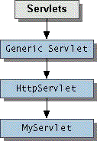

- Servlet architecture consists of two packages : javax.servlet and javax.servlet.http.
- The first package contains top-level interfaces and classes that are used and extended by all other servlets.
- The second package is provided for servlets that can handle HTTP requests.
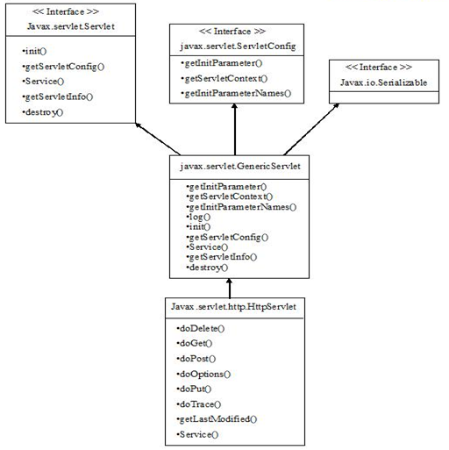

The top-level interface of the servlet architecture is javax.servlet.Servlet.It provides the basic functionalities of all the servlets that are created by implementing this interface directly or indirectly.

- Explain with necessary illustration the life cycle of servlet.

Servlets - Life Cycle

A servlet life cycle can be defined as the entire process from its creation till the destruction. The following are the paths followed by a servlet
- The servlet is initialized by calling the init () method.
- The servlet calls service() method to process a client's request.
- The servlet is terminated by calling the destroy() method.
- Finally, servlet is garbage collected by the garbage collector of the JVM.
Now let us discuss the life cycle methods in details.
The init() method :
The init method is designed to be called only once. It is called when the servlet is first created, and not called again for each user request. So, it is used for one-time initializations, just as with the init method of applets.When a user invokes a servlet, a single instance of each servlet gets created, with each user request resulting in a new thread that is handed off to doGet or doPost as appropriate. The init() method simply creates or loads some data that will be used throughout the life of the servlet.
The init method definition looks like this:
public void init() throws ServletException {
// Initialization code...
}

The service() method :
The service() method is the main method to perform the actual task. The servlet container (i.e. web server) calls the service() method to handle requests coming from the client( browsers) and to write the formatted response back to the client.Each time the server receives a request for a servlet, the server spawns a new thread and calls service. The service() method checks the HTTP request type (GET, POST, PUT, DELETE, etc.) and calls doGet, doPost, doPut, doDelete, etc. methods as appropriate.
Here is the signature of this method:
public void service(ServletRequest request,
ServletResponse response)
throws ServletException, IOException{
}
The service () method is called by the container and service method invokes doGe, doPost, doPut, doDelete, etc. methods as appropriate. So you have nothing to do with service() method but you override either doGet() or doPost() depending on what type of request you receive from the client.
The doGet() and doPost() are most frequently used methods with in each service request. Here are the signature of these two methods.

The doGet() Method
A GET request results from a normal request for a URL or from an HTML form that has no METHOD specified and it should be handled by doGet() method.
public void doGet(HttpServletRequest request,
HttpServletResponse response)
throws ServletException, IOException {
// Servlet code
}

The doPost() Method
A POST request results from an HTML form that specifically lists POST as the METHOD and it should be handled by doPost() method.
public void doPost(HttpServletRequest request, HttpServletResponse response)
throws ServletException, IOException {
// Servlet code
}

The destroy() method :
The destroy() method is called only once at the end of the life cycle of a servlet. This method gives your servlet a chance to close database connections, halt background threads, write cookie lists or hit counts to disk, and perform other such cleanup activities.
After the destroy() method is called, the servlet object is marked for garbage collection. The destroy method definition looks like this:
public void destroy() {
// Finalization code...
}

3. Write short notes on
a. Servlet interface
b. ServletConfig interface
c. ServletContext interf

- Servlet interface

Servlet Interface
- Servlet Interface
- Methods of Servlet interface

Servlet interface provides common behaviour to the entire servlets.Servlet interface needs to be implemented for creating any servlet (either directly or indirectly). It provides 3 life cycle methods that are used to initialize the servlet, to service the requests, and to destroy the servlet and 2 non-life cycle methods.

Methods of Servlet interface
There are 5 methods in Servlet interface.
- public void init(ServletConfigconfig)-- initializes the servlet. It is the life cycle method of servlet and invoked by the web container only once.
- public void service(ServletRequestrequest,ServletResponse response)-- provides response for the incoming request. It is invoked at each request by the web container.
- publicServletConfiggetServletConfig()--returns the object of ServletConfig.
- public String getServletInfo()--returns information about servlet such as writer, copyright, version etc.
- public void destroy()--is invoked only once and indicates that servlet is being destroyed.

ServletConfig Interface

An object of ServletConfig is created by the web container for each servlet. This object can be used to get configuration information from web.xml file.If the configuration information is modified from the web.xml file, we don't need to change the servlet. So it is easier to manage the web application if any specific content is modified from time to time.
Methods of ServletConfig interface
- public String getInitParameter(String name):Returns the parameter value for the specified parameter name.
- public Enumeration getInitParameterNames():Returns an enumeration of all the initialization parameter names.
- public String getServletName():Returns the name of the servlet.
- publicServletContextgetServletContext():Returns an object of ServletContext.

ServletContext Interface
An object of ServletContext is created by the web container at time of deploying the project. This object can be used to get configuration information from web.xml file. There is only one ServletContext object per web application.

Commonly used methods of ServletContext interface
- public String getInitParameter(String name):Returns the parameter value for the specified parameter name.
- public Enumeration getInitParameterNames():Returns the names of the context's initialization parameters.
- public void setAttribute(String name,Object object):sets the given object in the application scope.
- public Object getAttribute(String name):Returns the attribute for the specified name.
- public Enumeration getInitParameterNames():Returns the names of the context's initialization parameters as an Enumeration of String objects.
- public void removeAttribute(String name):Removes the attribute with the given name from the servlet context.

Servlet Example by implementing Servlet interface
import java.io.*;
import javax.servlet.*;
public class First implements Servlet{
ServletConfig config=null;
public void init(ServletConfig config){
this.config=config;
System.out.println("servlet is initialized"); }
public void service(ServletRequest req,ServletResponse res) throws IOException,ServletException{
res.setContentType("text/html");
PrintWriter out=res.getWriter();
out.print("<html><body>");
out.print("<b>hello simple servlet</b>");
out.print("</body></html>"); }
public void destroy(){System.out.println("servlet is destroyed");}
public ServletConfig getServletConfig(){return config;}
public String getServletInfo(){return "copyright 2007-1010";} }

5. Explain the life cycle of JSP.

JSP’s life cycle can be grouped into following phases.
- JSP Page Translation:
A java servlet file is generated from the JSP source file. This is the first step in its tedious multiple phase life cycle. In the translation phase, the container validates the syntactic correctness of the JSP pages and tag files. The container interprets the standard directives and actions, and the custom actions referencing tag libraries used in the page.
- JSP Page Compilation:
The generated java servlet file is compiled into a java servlet class.
- Class Loading:
The java servlet class that was compiled from the JSP source is loaded into the container.
- Execution phase:
In the execution phase the container manages one or more instances of this class in response to requests and other events.
The interface JspPage contains jspInit() and jspDestroy(). The JSP specification has provided a special interface HttpJspPage for JSP pages serving HTTP requests and this interface contains _jspService().
- Initialization:
jspInit() method is called immediately after the instance was created. It is called only once during JSP life cycle.
- jspService() execution:
This method is called for every request of this JSP during its life cycle. This is where it serves the purpose of creation. Oops! it has to pass through all the above steps to reach this phase. It passes the request and the response objects. _jspService() cannot be overridden.
- jspDestroy() execution:
This method is called when this JSP is destroyed. With this call the servlet serves its purpose and submits itself to heaven (garbage collection). This is the end of jsp life cycle.
jspInit(), _jspService() and jspDestroy() are called the life cycle methods of the JSP.
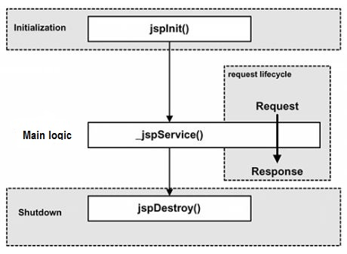

6. Give MVC architecture of JSP. Discuss advantage of this architecture.

Model View Controller or MVC as it is popularly called, is a software design pattern for developing web applications. A Model View Controller pattern is made up of the following three parts:

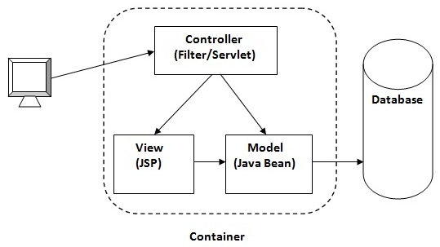
- Model - The lowest level of the pattern which is responsible for maintaining data.
- View - This is responsible for displaying all or a portion of the data to the user.
- Controller - Software Code that controls the interactions between the Model and View.

MVC is popular as it isolates the application logic from the user interface layer and supports separation of concerns. Here the Controller receives all requests for the application and then works with the Model to prepare any data needed by the View. The View then uses the data prepared by the Controller to generate a final presentable response. The MVC abstraction can be graphically represented as follows.

The model
The model is responsible for managing the data of the application. It responds to the request from the view and it also responds to instructions from the controller to update itself.

The view
A presentation of data in a particular format, triggered by a controller's decision to present the data. They are script based templating systems like JSP, ASP, PHP and very easy to integrate with AJAX technology.

The controller
The controller is responsible for responding to user input and perform interactions on the data model objects. The controller receives the input, it validates the input and then performs the business operation that modifies the state of the data model.
Implementing MVC with RequestDispatcher
- Define beans to represent the data:First step is define beans to represent the results that will be presented to the user.
- Use a servlet to handle requests: In most cases, the servlet reads request parameters.
- Populate the beans: The servlet invokes business logic, or data-access code to obtain the results. The results are placed in the beans that were defined in step 1
Implementing MVC with RequestDispatcher
- Store the bean in the request, session, or servlet context: The servlet calls setAttribute on the request, session, or servlet context objects to store a reference to the beans that represent the results of the request.
- Forward the request to a JSP page: The servlet determines which JSP page is appropriate to the situation and uses the forward method of RequestDispatcher to transfer control to that page.
- Extract the data from the beans: The JSP page accesses beans with jsp:useBean and a scope. The page then uses jsp:getProperty to output the bean properties
sendRedirect & RequestDispatcher
- sendRedirect requires the client to reconnect to the new resource, whereas the forward method of RequestDispatcher is handled completely on the server.
- sendRedirect results in a different final URL, whereas with forward, the URL of the original servlet is maintained.
- sendRedirect does not automatically preserve all of the request data; forward does.

7. Explain the benefits of MVC pattern.
1. Separation of concerns:
- The separation the three components, allows the re-use of the business logic across applications.
- Multiple User Interfaces can be developed without concerning the codebase
2. Developer specialization and focus:
- The developers of UI can focus exclusively on the UI screens without bogged down with business logic.
- The developer of Model / business can focus exclusively on the business logic implementations, modifications, updations without concerning the look and feel and it has nothing to with business logic.
3. Parallel development by separate teams:
- Business logic developers can build the classes, while the UI developers can involve in designing UI screens simultaneously, resulting the interdependency issues and time conservation.
- UI updations can be made without slowing down the business logic process
- Business logic rules changes are very less that needs the revision / updations of the UI.
4. Multiple view support
Due to the separation of the model from the view, the user interface can display multiple views of the same data at the same time.
5. Change Accommodation:
User interfaces tend to change more frequently than business rules. (different colors, fonts, screen layouts, and levels of support for new devices such as cell phones or PDAs) Because the model does not depend on the views, adding new types of views to the system generally does not affect the model. As a result, the scope of change is confined to the view.

- What do you meant by directive elements? Explain it with suitable example.

The jsp directives are messages that tell the web container how to translate a JSP page into the corresponding servlet.
There are three types of directives:
- page directive
- include directive
- taglib directive

Syntax of JSP Directive
<%@ directive attribute="value" %>
- JSP page directive
The page directive defines attributes that apply to an entire JSP page.

Syntax of JSP page directive
<%@ page attribute="value" %>

Attributes of JSP page directive
- import
- contentType
- extends
- info
- buffer
- language
- isELIgnored
- isThreadSafe
- autoFlush
- session
- pageEncoding
- errorPage
- isErrorPage
- import
The import attribute is used to import class,interface or all the members of a package.It is similar to import keyword in java class or interface.

Example of import attribute
- <html>
- <body>
- <%@ page import="java.util.Date" %>
- Today is: <%= new Date() %>
- </body>
- </html>
- contentType
The contentType attribute defines the MIME(Multipurpose Internet Mail Extension) type of the HTTP response.The default value is "text/html;charset=ISO-8859-1".

Example of contentType attribute
<html>
<body>
<%@ page contentType=application/msword %>
Today is: <%= new java.util.Date() %>
</body>
</html>
- extends
The extends attribute defines the parent class that will be inherited by the generated servlet.It is rarely used.
- info
This attribute simply sets the information of the JSP page which is retrieved later by using getServletInfo() method of Servlet interface.

Example of info attribute
<html>
<body>
<%@ page info="composed by Sonoo Jaiswal" %>
Today is: <%= new java.util.Date() %>
</body>
</html>
The web container will create a method getServletInfo() in the resulting servlet.For example:
public String getServletInfo() {
return "composed by Sonoo Jaiswal";
}
- buffer
The buffer attribute sets the buffer size in kilobytes to handle output generated by the JSP page.The default size of the buffer is 8Kb.

Example of buffer attribute
<html>
<body>
<%@ page buffer="16kb" %>
Today is: <%= new java.util.Date() %>
</body>
</html>
- language
The language attribute specifies the scripting language used in the JSP page. The default value is "java".
- isELIgnored
We can ignore the Expression Language (EL) in jsp by the isELIgnored attribute. By default its value is false i.e. Expression Language is enabled by default. We see Expression Language later.
<%@ page isELIgnored="true" %>//Now EL will be ignored

- isThreadSafe
Servlet and JSP both are multithreaded.If the user want to control this behaviour of JSP page, the user can use isThreadSafe attribute of page directive.The value of isThreadSafe value is true.If make it false, the web container will serialize the multiple requests, i.e. it will wait until the JSP finishes responding to a request before passing another request to it.If you make the value of isThreadSafe attribute like:
<%@ page isThreadSafe="false" %>
The web container in such a case, will generate the servlet as:
public class SimplePage_jsp extends HttpJspBase
implements SingleThreadModel{
.......
}
- errorPage
The errorPage attribute is used to define the error page, if exception occurs in the current page, it will be redirected to the error page.

Example of errorPage attribute
//index.jsp
<html>
<body>
<%@ page errorPage="myerrorpage.jsp" %>
<%= 100/0 %>
</body>
</html>
- isErrorPage
The isErrorPage attribute is used to declare that the current page is the error page.

Note: The exception object can only be used in the error page.

Example of isErrorPage attribute
//myerrorpage.jsp
<html>
<body>
<%@ page isErrorPage="true" %>
Sorry an exception occured!<br/>
The exception is: <%= exception %>
</body>
</html>
II. The include Directive:
The include directive is used to includes a file during the translation phase. This directive tells the container to merge the content of other external files with the current JSP during the translation phase.
Syntax:
<%@ include file="relative url" >
III. The taglib Directive:
The JavaServer Pages API allows to define custom JSP tags that look like HTML or XML tags and a tag library is a set of user-defined tags that implement custom behavior.

The taglib directive declares that your JSP page uses a set of custom tags, identifies the location of the library, and provides a means for identifying the custom tags in your JSP page.
Syntax:
<%@ taglib uri="uri" prefix="prefixOfTag" >

- Explain standard action elements.
- The <jsp:include> Action
This action lets you insert files into the page being generated. The syntax looks like this:
<jsp:include page="relative URL" flush="true" />
- The <jsp:useBean> Action
The useBean action is quite versatile. It first searches for an existing object utilizing the id and scope variables. If an object is not found, it then tries to create the specified object.
The simplest way to load a bean is as follows:
<jsp:useBean id="name" class="package.class" />
- The <jsp:setProperty> Action
The setProperty action sets the properties of a Bean. The Bean must have been previously defined before this action. There are two basic ways to use the setProperty action:
You can use jsp:setProperty after, but outside of, a jsp:useBean element, as below:
<jsp:useBean id="myName" ... />
...
<jsp:setProperty name="myName" property="someProperty" .../>
- The <jsp:getProperty> Action
The getProperty action is used to retrieve the value of a given property and converts it to a string, and finally inserts it into the output.
The getProperty action has only two attributes, both of which are required ans simple syntax is as follows:
<jsp:useBean id="myName" ... />
...
<jsp:getProperty name="myName" property="someProperty" .../>
- The <jsp:forward> Action
The forward action terminates the action of the current page and forwards the request to another resource such as a static page, another JSP page, or a Java Servlet.
The simple syntax of this action is as follows:
<jsp:forward page="Relative URL" />
- The <jsp:plugin> Action
The plugin action is used to insert Java components into a JSP page. It determines the type of browser and inserts the <object> or <embed> tags as needed.

Following is the typical syntax of using plugin action:

<jsp:plugin type="applet" codebase="dirname" code="MyApplet.class"
width="60" height="80">
<jsp:param name="fontcolor" value="red" />
<jsp:param name="background" value="black" />

<jsp:fallback>
Unable to initialize Java Plugin
</jsp:fallback>

</jsp:plugin>

- The <jsp:element> Action
- The <jsp:attribute> Action
- The <jsp:body> Action

The <jsp:element>, lt;jsp:attribute> and <jsp:body> actions are used to define XML elements dynamically. The word dynamically is important, because it means that the XML elements can be generated at request time rather than statically at compile time.

Following is a simple example to define XML elements dynamically:

<%@page language="java" contentType="text/html"%>
<html xmlns="http://www.w3c.org/1999/xhtml"
xmlns:jsp="http://java.sun.com/JSP/Page">

<head><title>Generate XML Element</title></head>
<body>
<jsp:element name="xmlElement">
<jsp:attribute name="xmlElementAttr">
Value for the attribute
</jsp:attribute>
<jsp:body>
Body for XML element
</jsp:body>
</jsp:element>
</body>
</html>

- The <jsp:text> Action
The <jsp:text> action can be used to write template text in JSP pages and documents. Following is the simple syntax for this action:
<jsp:text>Template data</jsp:text>

9. Describe about the types of scripting elements in JSP with example.

- Scriptlet
Scriptlets of the form <% code %> that are inserted into the servlet's service method, and
If you want to do something more complex than insert a simple expression, JSP scriptlets insert code into the service() method of the generated servlet.
Scriptlets have the following form:
<% Java Code %> Scriptlets have access to the same automatically defined variables as expressions
<%
String name = request.getParameter("name");
out.println("name: " + name);
%>
- Expression
Expressions of the form <%= expression %> that are evaluated and inserted into the output, A JSP expression is used to insert Java values directly into the output.
It has the following form:
<%= Java expression %>
The Java expression is evaluated, converted to a string, and inserted in the page
Current time: <%= new java.util.Date() %>
predefined variables that you can use
request, the HttpServletRequest;
response, the HttpServletResponse;
session, the HttpSession associated with the request (if any); and
out, the PrintWriter (a buffered version of type JspWriter) used to send output to the client.
Example :Your hostname: <%= request.getRemoteHost() %>

- Declaration
Declarations of the form <%! code %> that are inserted into the body of the servlet class, outside of any existing methods.
A JSP declaration define methods or fields that get inserted into the main body of the servlet class (outside of the service method processing the request). It has the following form:

<%! Java Code %>
or
<%!
public int getValue()
{
return 78;
}
%>
The method we can use in Expression also.
<%=getValue()%>

- Narrate the special methods used to handle HTTP requests.
- The HTTP GET request method is designed to retrieve information from the server.
- As part of a GET request, some data can be passed within the URI's query string, specifying for example search terms, date ranges, or other information that defines the query.
- As part of a POST request, an arbitrary amount of data of any type can be sent to the server in a request message body.
- A header field in the POST request usually indicates the message body's Internet media type.
The GET Method
Example
The query strings (name/value pairs) is sent in the URL of a GET request:
/test/demo_form.asp?name1=value1&name2=value2

GET requests do the following:

GET requests can be cached
GET requests remain in the browser history
GET requests can be bookmarked
GET requests should never be used when dealing with sensitive data
GET requests have length restrictions
GET requests should be used only to retrieve data

The POST Method
Example
The query strings (name/value pairs) is sent in the HTTP message body of a POST request:
POST /test/demo_form.asp HTTP/1.1
Host: readnote.com
name1=value1&name2=value2

POST requests do the following:

POST requests are never cached
POST requests do not remain in the browser history
POST requests cannot be bookmarked
POST requests have no restrictions on data length

