Psi-Bot

XLR8 2022-23

TEAM MEMBERS:

1. SATYAM GUPTA (LEADER)
2. MANAV AGRAWAL
3. NIVESH AGGARWAL
4. ADITYA SISODIYA

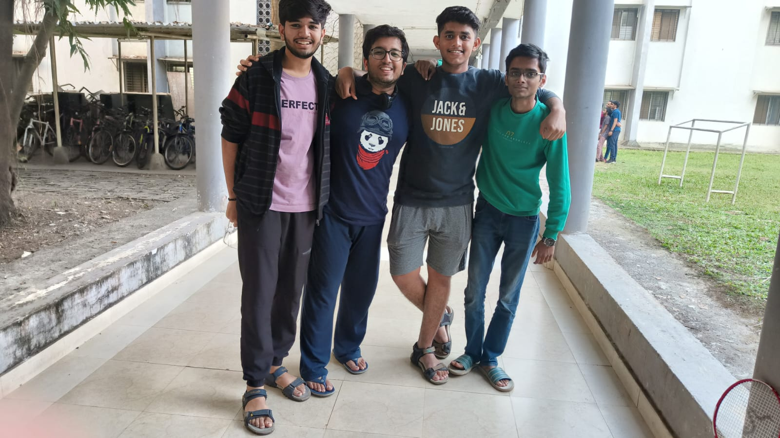MENTOR: ARCHIT GUPTA

THE TEAM WHICH MADE IT HAPPEN

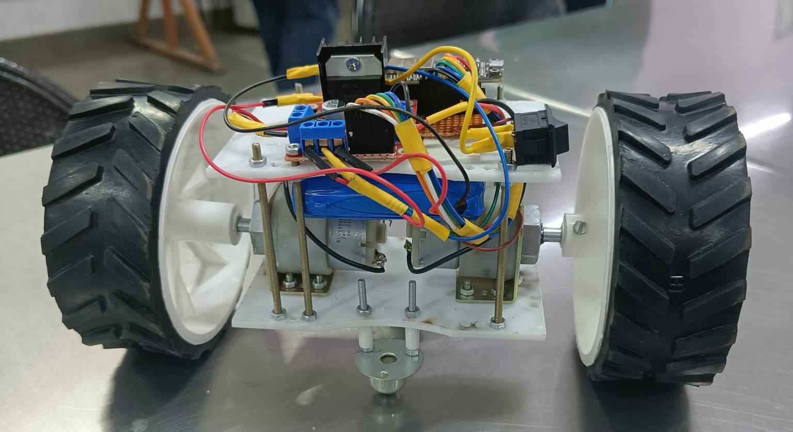**THE PSI-BOT VERSION 1.0**

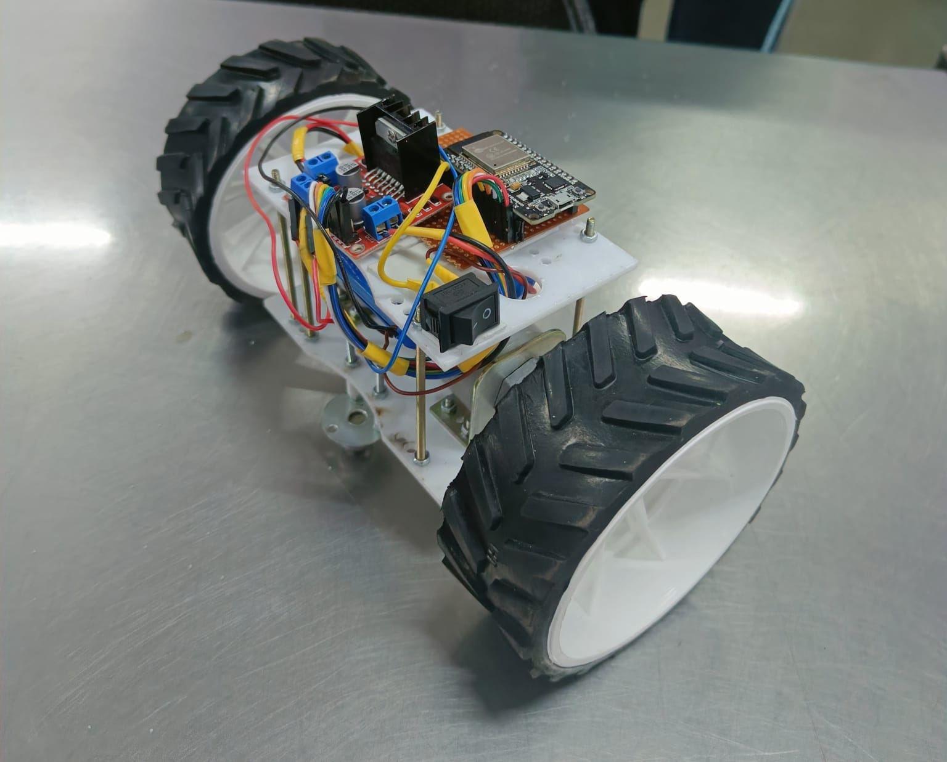

**PSI-BOT: THE DIFFERENT BOT**

**Motivation for Idea and XLR8 Journey**

OUR BOT IS UNIQUE IN THE SENSE THAT INSTEAD OF THE CONVENTIONAL RECTANGULAR CHASSIS AND 4-WHEELED BOT, OUR CHASSIS WAS MUCH SMALLER IN SIZE AND UNIQUE IN SHAPE (AS IS SEEN IN THE AUTOCAD MODEL AND PHOTOS OF THE BOT) AND WE USED TWO BIGGER 10X4 WHEELS AND TWO CASTOR WHEELS (AS IS SEEN IN TH PHOTOS OF THE BOT).

WE MADE THE BODY BY USING TWO IDENTICAL CHASSIS AND THEN WE ATTACHED ALL THE COMPONENTS (ESP32, MOTOR DRIVER, THE Li ION BATTERY, THE WIRES ETC) IN BETWEEN AND THEN WE ATTACHED TWO 10X4 TYRES IN THE SIDES OF THE 2CHASSIED BODY AND TO SUPPORT THE BOT FROM TOPPLING WE ATTACHED TWO SMALLER CASTOR WHEELS.

WE THOUGHT OF THIS BECAUSE WE INITIALLY WANTED TO MAKE A TWO WHEELED BOT ONLY, BUT WE LATER REALSIED TO SUPPORT THE BOT WE WOULD NEED TO ADD PID CONTROLLERS (OUT OF OUR PAY GRADE). THEREFORE, TO MAKE AN EXCEPTIONAL LOOKING MODEL WE DECIDED TO DO SO.

OVERALL, OUR XLR8 JOURNEY WAS VERY INFORMATIVE AND EXCITING THROUGOUT THE PERIOD. THE “GET CODIFIED”, “GET ELECTRIFIED”, “GET MECHANISED” SESSIONS WERE VERY ENTERTAINIG AND WE LEARNT HOW TO SOLDER, HOW TO WORK FOR LONG LATE NIGHTS, HOW TO FAIL RUTHLESSLY FOR LIKE A 1000 TIMES BEFORE FINALLY DECIDING HOW TO PROCEED AHEAD. OUR MENTOR HELPED US THROUGHOUT.

**RESOURCES USED**

WE MAINLY RELIED ON THE RESOURCES PROVIDED BY ERC. SOME ADDITIONAL COMPONENTS WERE BOUGHT BY US. WE USED FUSION 360 FOR AUTOCAD.

**MECHANICAL DESIGN**

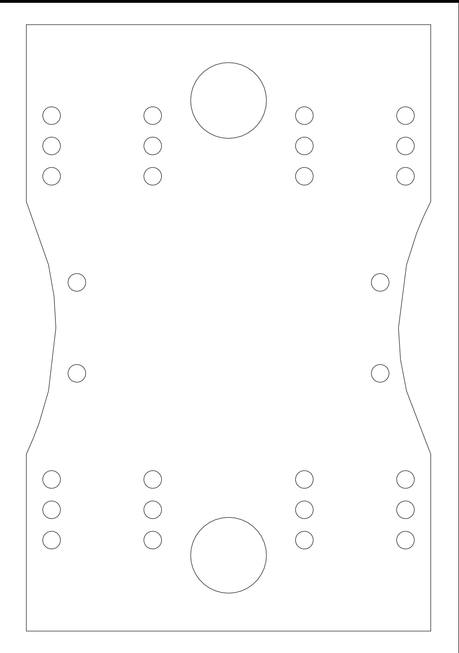

WE HAVE ALSO UPLOADED THE AUTOCAD FILE.

**ELECTRICAL CIRCUIT**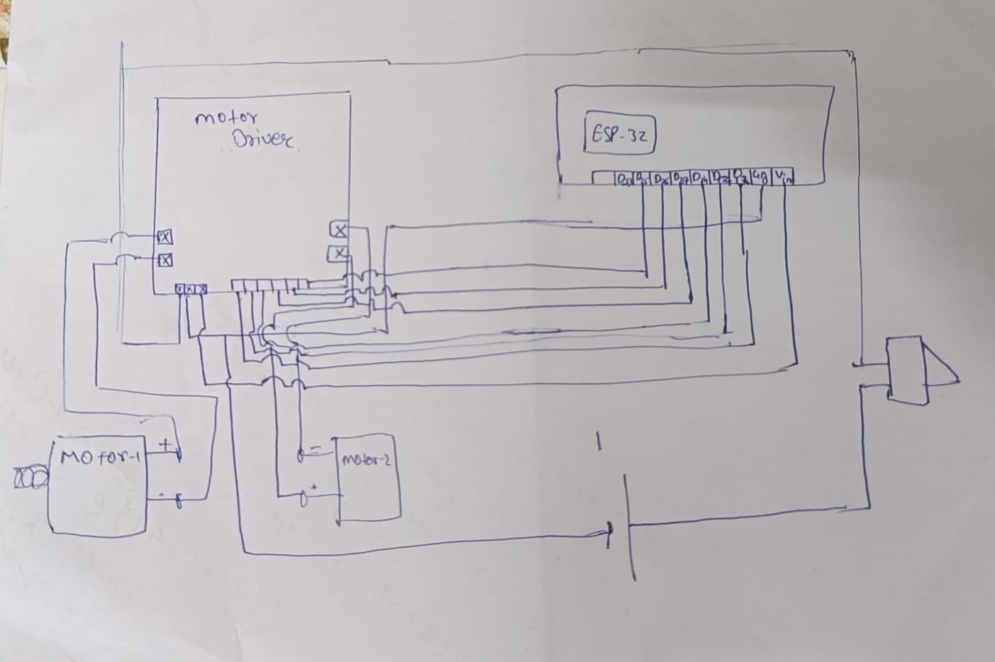

**CODE**

WE HAVE ATTACHED THE CODE FILE EXTERNALLY!