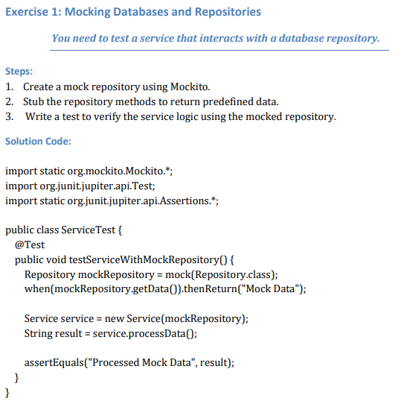

**Solution**

**Repository.java**

package com.mockito.advanced;

public interface Repository {

String getData();

}

**Service.java**

package com.mockito.advanced;

public class Service {

private final Repository repository;

public Service(Repository repository) {

this.repository = repository;

}

public String processData() {

return "Processed " + repository.getData();

}

}

**ServiceTest.java**

package com.mockito.advanced;

import org.junit.jupiter.api.Test;

import static org.mockito.Mockito.*;

import static org.junit.jupiter.api.Assertions.*;

public class ServiceTest {

@Test

public void testServiceWithMockRepository() {

Repository mockRepository = mock(Repository.class);

when(mockRepository.getData()).thenReturn("Mock Data");

Service service = new Service(mockRepository);

String result = service.processData();

assertEquals("Processed Mock Data", result);

}

}

**Output**

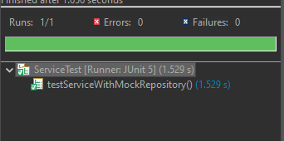

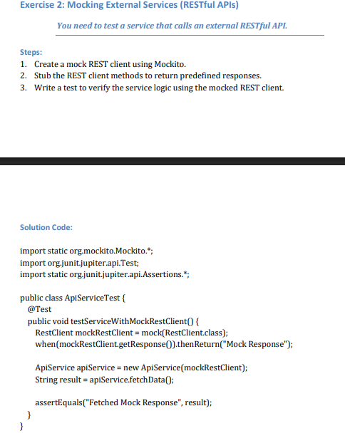

**Solution**

**RestClient.java**

package com.mockito.advanced;

public interface RestClient {

String getResponse();

}

**ApiService.java**

package com.mockito.advanced;

public class ApiService {

private final RestClient restClient;

public ApiService(RestClient restClient) {

this.restClient = restClient;

}

public String fetchData() {

return "Fetched " + restClient.getResponse();

}

}

**ApiServiceTest.java**

package com.mockito.advanced;

import org.junit.jupiter.api.Test;

import static org.mockito.Mockito.*;

import static org.junit.jupiter.api.Assertions.*;

public class ApiServiceTest {

@Test

public void testServiceWithMockRestClient() {

RestClient mockRestClient = mock(RestClient.class);

when(mockRestClient.getResponse()).thenReturn("Mock Response");

ApiService apiService = new ApiService(mockRestClient);

String result = apiService.fetchData();

assertEquals("Fetched Mock Response", result);

}

}

**Output**

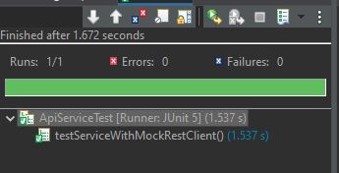

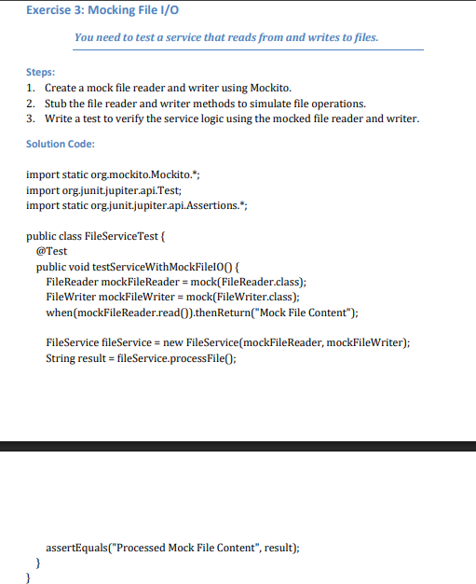

**Solution**

**FileReader.java**

package com.mockito.advanced;

public interface FileReader {

String read();

}

**FileWriter.java**

package com.mockito.advanced;

public interface FileWriter {

void write(String content);

}

**FileService.java**

package com.mockito.advanced;

public class FileService {

private final FileReader reader;

private final FileWriter writer;

public FileService(FileReader reader, FileWriter writer) {

this.reader = reader;

this.writer = writer;

}

public String processFile() {

String content = reader.read();

writer.write("Processed " + content);

return "Processed " + content;

}

}

**FileServiceTest.java**

package com.mockito.advanced;

import org.junit.jupiter.api.Test;

import static org.mockito.Mockito.*;

import static org.junit.jupiter.api.Assertions.*;

public class FileServiceTest {

@Test

public void testServiceWithMockFileIO() {

FileReader mockReader = mock(FileReader.class);

FileWriter mockWriter = mock(FileWriter.class);

when(mockReader.read()).thenReturn("Mock File Content");

FileService fileService = new FileService(mockReader, mockWriter);

String result = fileService.processFile();

assertEquals("Processed Mock File Content", result);

verify(mockWriter).write("Processed Mock File Content");

}

}

**Output**

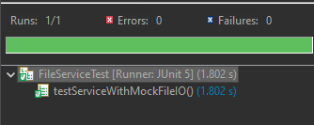

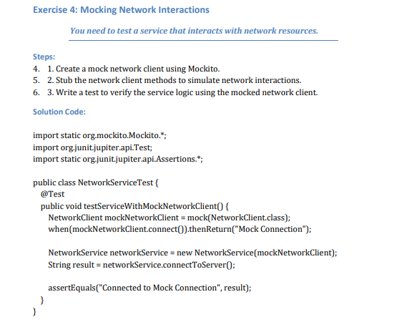

**Solution**

**NetworkClient.java**

package com.mockito.advanced;

public interface NetworkClient {

String connect();

}

**NetworkService.java**

package com.mockito.advanced;

public class NetworkService {

private final NetworkClient client;

public NetworkService(NetworkClient client) {

this.client = client;

}

public String connectToServer() {

return "Connected to " + client.connect();

}

}

**NetworkServiceTest.java**

package com.mockito.advanced;

import org.junit.jupiter.api.Test;

import static org.mockito.Mockito.*;

import static org.junit.jupiter.api.Assertions.*;

public class NetworkServiceTest {

@Test

public void testServiceWithMockNetworkClient() {

NetworkClient mockClient = mock(NetworkClient.class);

when(mockClient.connect()).thenReturn("Mock Connection");

NetworkService service = new NetworkService(mockClient);

String result = service.connectToServer();

assertEquals("Connected to Mock Connection", result);

}

}

**Output**

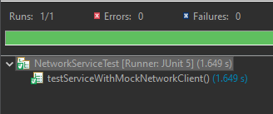

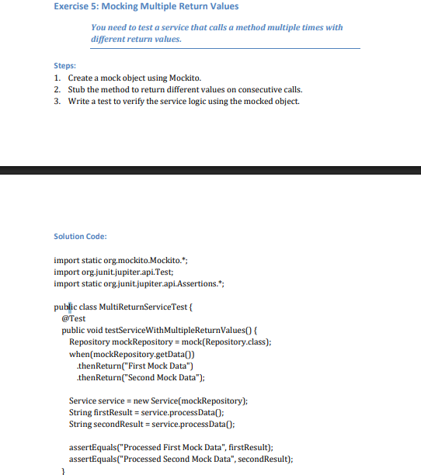

**Solution**

**MultiReturnServiceTest.java**

package com.mockito.advanced;

import org.junit.jupiter.api.Test;

import static org.mockito.Mockito.*;

import static org.junit.jupiter.api.Assertions.*;

public class MultiReturnServiceTest {

@Test

public void testServiceWithMultipleReturnValues() {

Repository mockRepository = mock(Repository.class);

when(mockRepository.getData())

.thenReturn("First Mock Data")

.thenReturn("Second Mock Data");

Service service = new Service(mockRepository);

String first = service.processData();

String second = service.processData();

assertEquals("Processed First Mock Data", first);

assertEquals("Processed Second Mock Data", second);

}

}

**Output**

