EDS PRACTICAL NO 4

Name : Satyam Bankar RollNo : 804

PRN No : 202201060039

#code:

#code to find best month for sale import pandas as pd df=pd.read_csv("grainsales.csv")

month=df.groupby("Months")["Sales"].sum().idxmax() earn=df.groupby("Months")["Sales"].sum().max() print("The best month for sale is :",month) print("Total earn in that month was",earn)

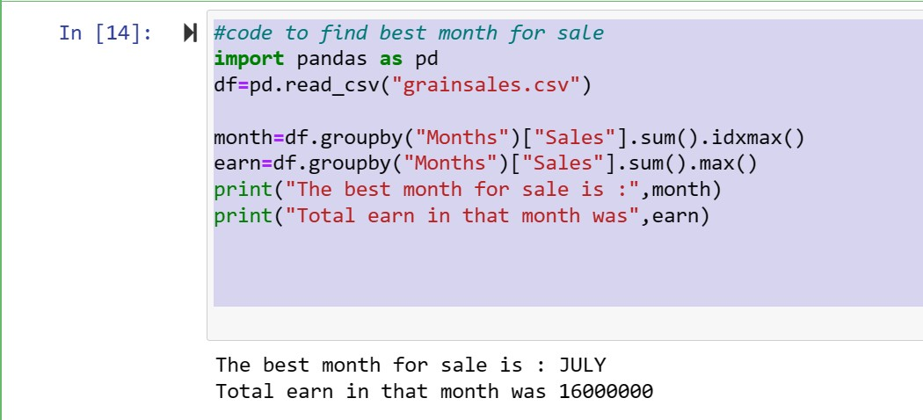

# #Question 2:

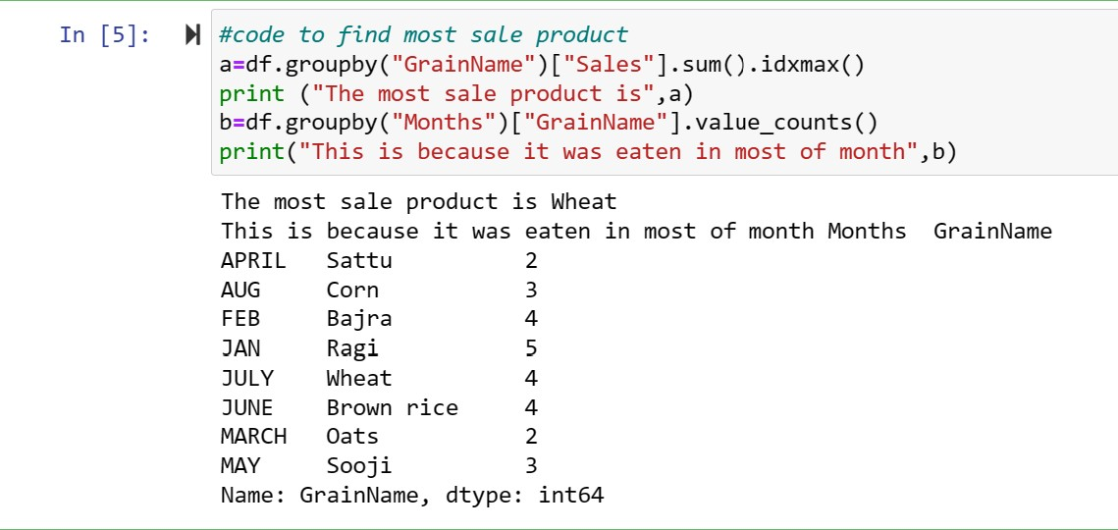

# Question 3:

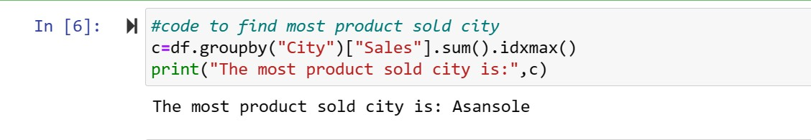

# # Question 4:

