**Practical: 08**

**Aim: Show a practical scenario of Key Distribution. Use the separate key-sharing server that shares the secret key created using the AES-256-bit algorithm and share the secret key using the RSA algorithm with 1024/2048-bit key size. The key-sharing server produces a new secret key for each new communication between two nodes.**

**CODE:**

import os

from cryptography.hazmat.primitives.asymmetric import rsa, padding

from cryptography.hazmat.primitives import hashes, serialization

from cryptography.hazmat.primitives.ciphers import Cipher, algorithms, modes

import base64

import time

class Node:

def __init__(self, name):

self.name = name

# Generate RSA key pair for this node

self.private_key = rsa.generate_private_key(

public_exponent=65537,

key_size=2048,

)

self.public_key = self.private_key.public_key()

self.session_keys = {} # Store session keys for different communications

def get_public_key_pem(self):

"""Return public key in PEM format"""

return self.public_key.public_bytes(

encoding=serialization.Encoding.PEM,

format=serialization.PublicFormat.SubjectPublicKeyInfo

)

def decrypt_session_key(self, encrypted_key):

"""Decrypt a session key that was encrypted with this node's public key"""

decrypted_key = self.private_key.decrypt(

encrypted_key,

padding.OAEP(

mgf=padding.MGF1(algorithm=hashes.SHA256()),

algorithm=hashes.SHA256(),

label=None

)

)

return decrypted_key

def encrypt_message(self, message, other_node_name):

"""Encrypt a message using the session key for communication with other_node"""

if other_node_name not in self.session_keys:

raise ValueError(f"No session key established with {other_node_name}")

session_key = self.session_keys[other_node_name]

# Generate a random IV

iv = os.urandom(16)

# Encrypt with AES-256 in CBC mode

encryptor = Cipher(

algorithms.AES(session_key),

modes.CBC(iv)

).encryptor()

# Pad the message to be a multiple of 16 bytes

padded_message = message + b' ' * (16 - len(message) % 16)

ciphertext = encryptor.update(padded_message) + encryptor.finalize()

# Return IV + ciphertext

return iv + ciphertext

def decrypt_message(self, encrypted_data, other_node_name):

"""Decrypt a message using the session key for communication with other_node"""

if other_node_name not in self.session_keys:

raise ValueError(f"No session key established with {other_node_name}")

session_key = self.session_keys[other_node_name]

# Extract IV (first 16 bytes)

iv = encrypted_data[:16]

ciphertext = encrypted_data[16:]

# Decrypt with AES-256 in CBC mode

decryptor = Cipher(

algorithms.AES(session_key),

modes.CBC(iv)

).decryptor()

plaintext = decryptor.update(ciphertext) + decryptor.finalize()

return plaintext.rstrip() # Remove padding

class KeySharingServer:

def __init__(self):

self.node_public_keys = {} # Store public keys of registered nodes

self.session_counter = 0

def register_node(self, node_name, public_key_pem):

"""Register a node's public key with the server"""

self.node_public_keys[node_name] = serialization.load_pem_public_key(public_key_pem)

print(f"Node {node_name} registered with the key server")

def create_secure_channel(self, node1_name, node2_name):

"""Generate a new AES-256 session key and distribute it to both nodes securely"""

if node1_name not in self.node_public_keys or node2_name not in self.node_public_keys:

raise ValueError("Both nodes must be registered with the key server")

# Generate a new AES-256 key

session_key = os.urandom(32) # 256 bits = 32 bytes

self.session_counter += 1

session_id = f"session_{self.session_counter}_{int(time.time())}"

# Encrypt the session key with each node's public key

encrypted_key_node1 = self.node_public_keys[node1_name].encrypt(

session_key,

padding.OAEP(

mgf=padding.MGF1(algorithm=hashes.SHA256()),

algorithm=hashes.SHA256(),

label=None

)

)

encrypted_key_node2 = self.node_public_keys[node2_name].encrypt(

session_key,

padding.OAEP(

mgf=padding.MGF1(algorithm=hashes.SHA256()),

algorithm=hashes.SHA256(),

label=None

)

)

print(f"New AES-256 session key generated for communication between {node1_name} and {node2_name}")

# Return the encrypted keys to be distributed to each node

return {

"session_id": session_id,

node1_name: encrypted_key_node1,

node2_name: encrypted_key_node2

}

# Simulation of the key distribution scenario

def simulate_key_distribution():

# Create a key sharing server

key_server = KeySharingServer()

# Create two nodes that want to communicate

node_a = Node("Node_A")

node_b = Node("Node_B")

# Register nodes with the key server

key_server.register_node(node_a.name, node_a.get_public_key_pem())

key_server.register_node(node_b.name, node_b.get_public_key_pem())

# Key server creates a secure channel by generating and distributing a session key

encrypted_keys = key_server.create_secure_channel(node_a.name, node_b.name)

# Nodes receive their encrypted session keys and decrypt them

node_a.session_keys[node_b.name] = node_a.decrypt_session_key(encrypted_keys[node_a.name])

node_b.session_keys[node_a.name] = node_b.decrypt_session_key(encrypted_keys[node_b.name])

print(f"Session established: {encrypted_keys['session_id']}")

# Now nodes can communicate securely using the shared session key

message = b"Hello, this is a secure message using our shared AES-256 key."

encrypted_message = node_a.encrypt_message(message, node_b.name)

print(f"\nNode A encrypts: {message.decode()}")

print(f"Encrypted data size: {len(encrypted_message)} bytes")

# Node B receives and decrypts the message

decrypted_message = node_b.decrypt_message(encrypted_message, node_a.name)

print(f"Node B decrypts: {decrypted_message.decode()}")

# For a new communication session, a new key is generated

print("\n--- Starting new communication session ---")

new_encrypted_keys = key_server.create_secure_channel(node_a.name, node_b.name)

# Nodes receive their new encrypted session keys and decrypt them

node_a.session_keys[node_b.name] = node_a.decrypt_session_key(new_encrypted_keys[node_a.name])

node_b.session_keys[node_a.name] = node_b.decrypt_session_key(new_encrypted_keys[node_b.name])

print(f"New session established: {new_encrypted_keys['session_id']}")

# Test with a different message

new_message = b"This message uses the newly generated session key."

new_encrypted_message = node_a.encrypt_message(new_message, node_b.name)

new_decrypted_message = node_b.decrypt_message(new_encrypted_message, node_a.name)

print(f"Node A encrypts: {new_message.decode()}")

print(f"Node B decrypts: {new_decrypted_message.decode()}")

if __name__ == "__main__":

simulate_key_distribution()

**OUTPUT:**

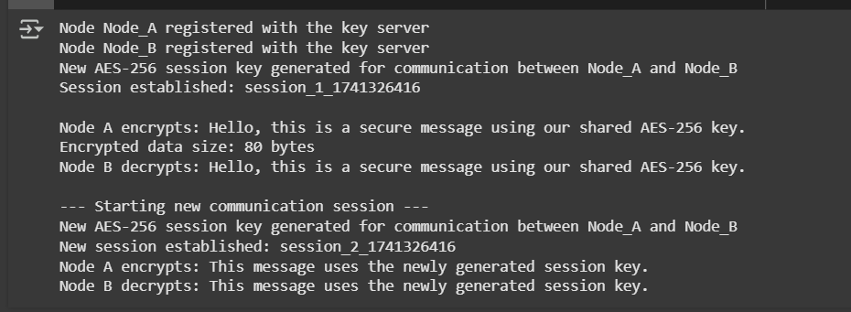

# **LATEST APPLICATIONS:**

• **Zero Trust Security Models** - Organizations use modern key distribution to validate every user and device before granting access, even those inside the network.

• **IoT Device Networks** - Smart home and industrial IoT systems use key distribution to securely connect numerous low-power devices.

• **Quantum Key Distribution (QKD)** - Using quantum properties to detect eavesdropping when sharing encryption keys between locations.

• **Blockchain Technology** - Cryptocurrencies and decentralized applications use sophisticated key distribution methods to secure transactions.

• **Multi-Cloud Security** - Enterprises use key distribution systems to maintain secure connections across different cloud environments.

**LEARNING OUTCOME:**

* Explain the difference between symmetric and asymmetric key distribution techniques
* Understand how trusted third parties facilitate secure key sharing
* Recognize the importance of key rotation and session-based encryption
* Identify potential vulnerabilities in key distribution systems