WeatherGPT
Explainable, Uncertainty-Aware Weather Intelligence Platform
Final-Year MSc (AI & ML) Capstone Project · Team of 3
Project Plan, Architecture & Team Work Split

This document reworks the original WeatherGPT proposal into a tighter, presentation-ready plan: a sharper pitch, a realistic 16-week scope, and a clean three-way work split so each teammate walks away with a distinct, provable contribution for their resume. Replace the [Name] placeholders below with your teammates' names, and swap the sample resume bullets for real numbers once you have them.

Executive Summary
WeatherGPT is a full-stack AI system that turns raw meteorological data into clear, trustworthy, personalized weather guidance. Instead of just reporting numbers, it fuses machine-learning forecasting, uncertainty quantification, anomaly detection, and explainable AI into a single risk-scoring engine — then lets users query that engine through a Retrieval-Augmented Generation (RAG) chatbot that answers in plain language, grounded in real forecast data rather than guesswork.
The platform ingests real-time and historical weather data from Open-Meteo (optionally NOAA GHCN), trains and compares multiple forecasting models (XGBoost, LSTM, ensembles), and produces calibrated probability forecasts instead of single-point guesses. A lightweight risk engine combines these forecasts with user context — travel plans, outdoor activities — to generate actionable advice, while a SHAP-based explainability layer shows exactly why the model made each call. Everything is delivered through a responsive web dashboard with a conversational interface, backed by a documented REST API, containerized deployment, and a CI/CD pipeline.
Built over a 16-week sprint by a three-person team, the project is scoped to demonstrate applied ML, LLM/RAG engineering, and full-stack delivery — the kind of end-to-end ownership that stands out in placements and interviews.

Why This Project Stands Out
Most student weather apps are a thin UI over a public API. WeatherGPT is designed to visibly demonstrate skills recruiters actually screen for:
- End-to-end forecasting: a genuine ML pipeline — data ingestion, feature engineering, model training, calibration — not just a call to a forecasting API.
- Uncertainty quantification: calibrated prediction intervals (quantile regression / ensembles), a skill most student projects skip entirely.
- Explainable AI: SHAP explanations wired into a live product and surfaced to an LLM, not left in a notebook.
- Applied RAG: a retrieval pipeline that grounds an LLM in structured + unstructured data and actively reduces hallucination.
- Full-stack delivery: FastAPI backend, React dashboard, Dockerized deployment, and a CI/CD pipeline.
- Clean individual ownership: each teammate owns a distinct layer end-to-end, so every contribution is separately provable in an interview.

A Note on Scope
The original brief pairs a full native mobile app with a web dashboard, admin console, route planner, and the entire ML/RAG stack — a lot for three people alongside coursework in 16 weeks. The recommendation below keeps the ambition but protects the AI substance, which is what the resume story actually rests on.
Recommendation
Build the web dashboard as the primary, fully responsive interface (usable on a phone browser out of the box) and treat a packaged native mobile app as a stretch goal. This avoids duplicating UI work across two platforms and keeps the team's time on the forecasting, uncertainty, anomaly-detection, explainability, and RAG components — the parts that differentiate this project.

How It Works (System Architecture)
Read top to bottom: raw weather data flows in, gets turned into forecasts and risk scores, and is exposed to the user both as charts and as a conversational assistant that only answers from real data.
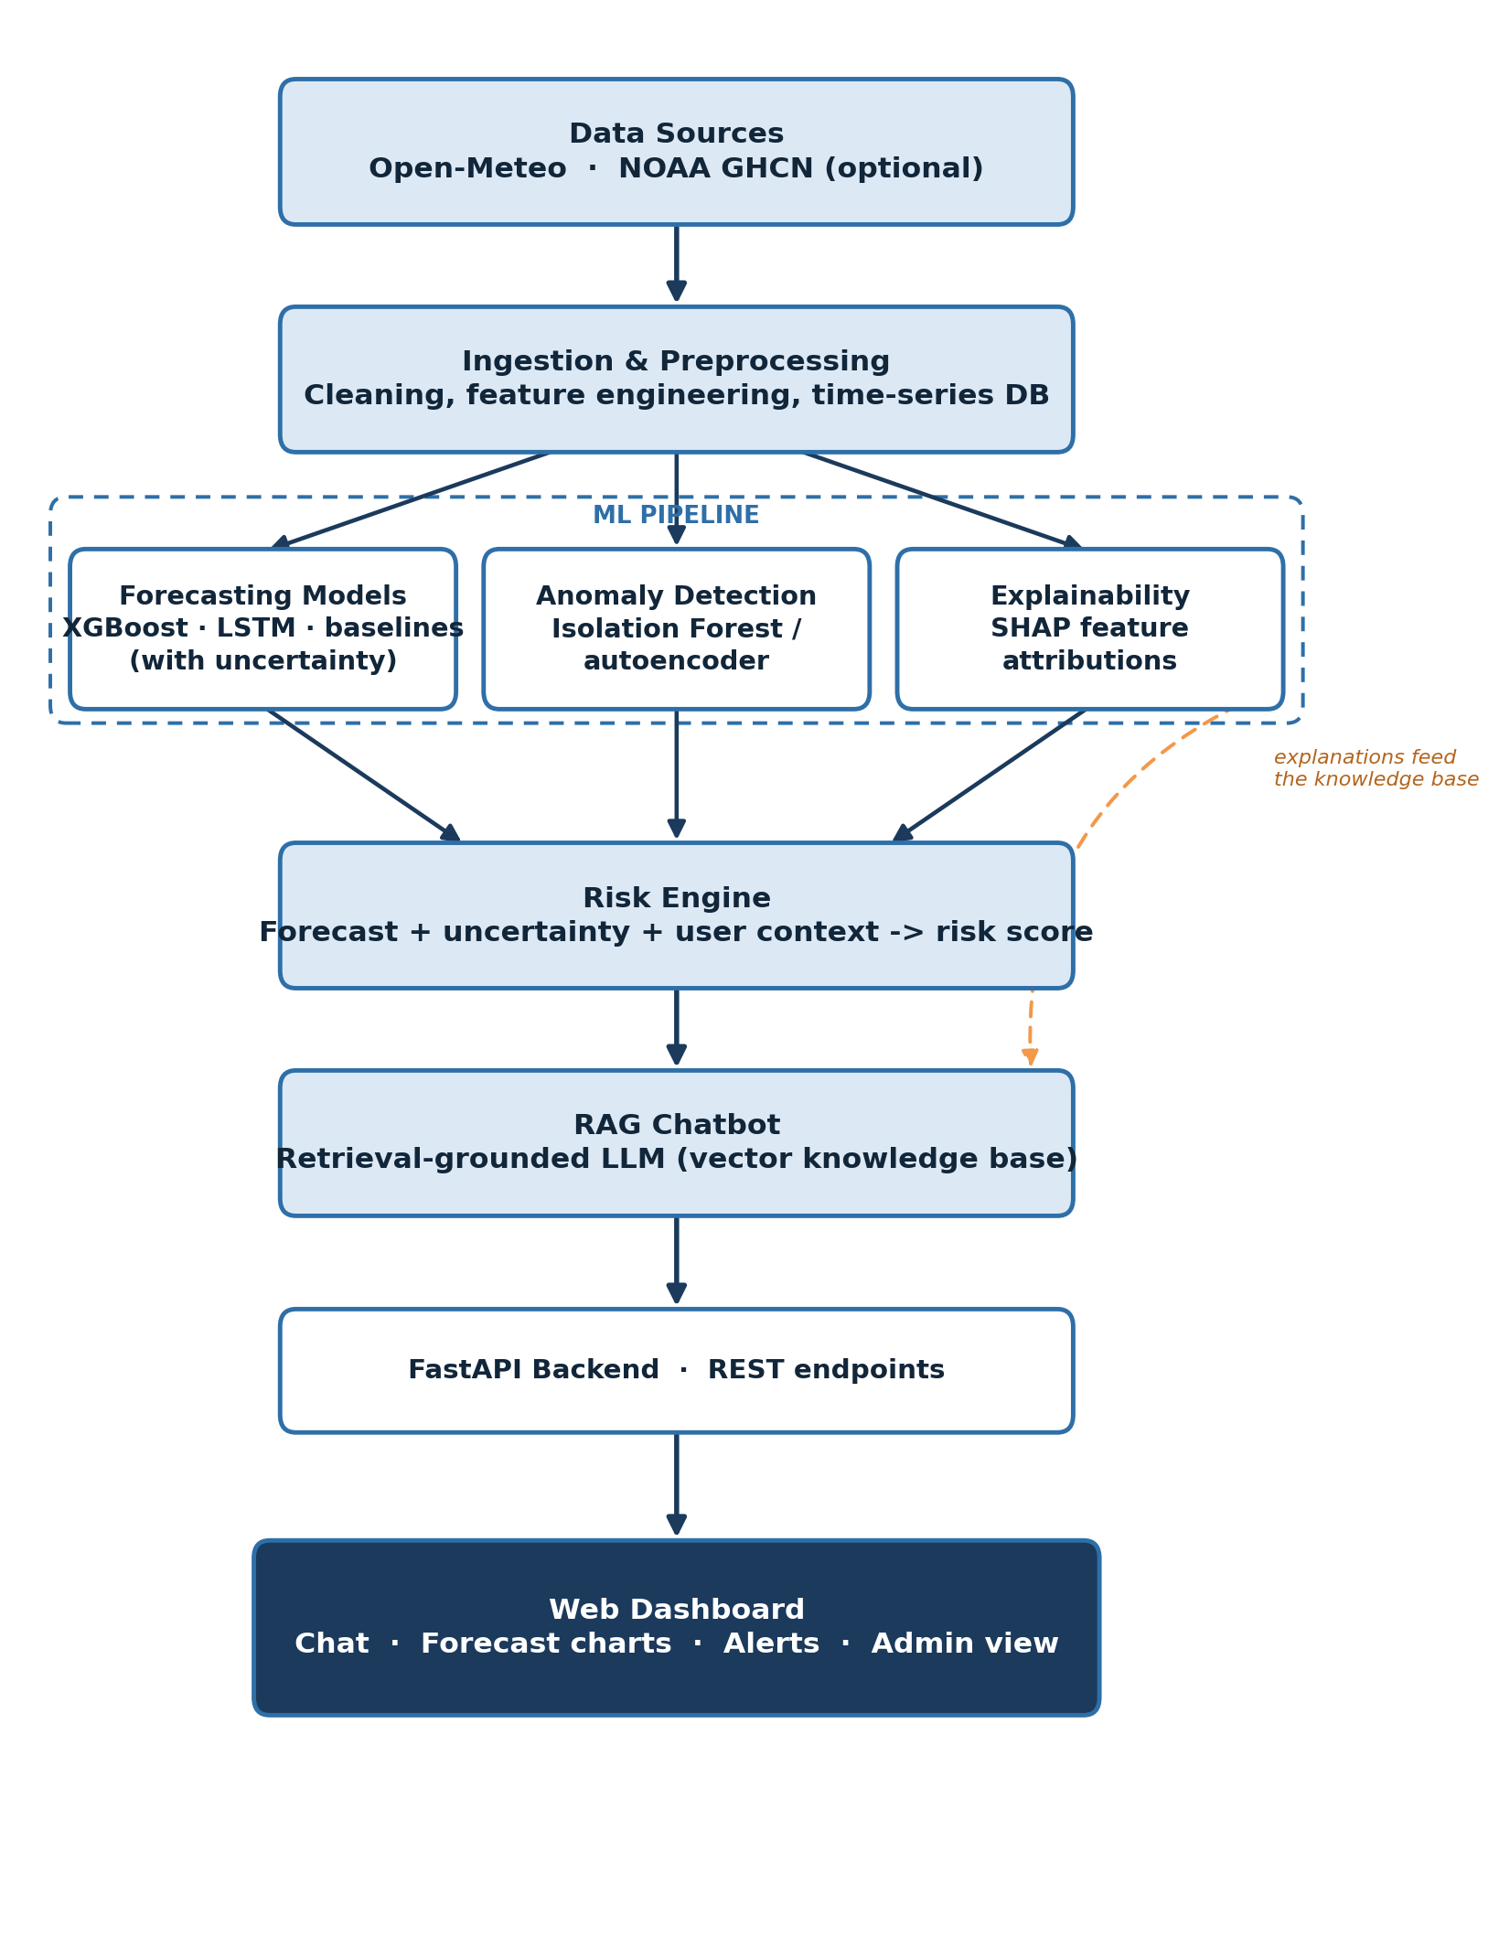
- 1. Data Sources — pulls live and historical weather data from Open-Meteo, optionally supplemented with NOAA GHCN station records.
- 2. Ingestion & Preprocessing — a scheduled job cleans the data, handles missing values, and engineers lag/rolling/time features into a time-series database.
- 3. ML Pipeline — baseline, XGBoost, and LSTM models predict temperature and precipitation with calibrated confidence intervals; an Isolation Forest flags abrupt pattern shifts; SHAP explains each prediction.
- 4. Risk Engine — combines forecasts, their uncertainty, and user context (location, activity) into a simple Low / Moderate / High risk score with a plain-language reason.
- 5. RAG Chatbot — retrieves the relevant forecast facts and explanations, then generates a grounded, natural-language answer instead of an unconstrained LLM guess.
- 6. API & Dashboard — a FastAPI backend exposes it all through documented REST endpoints, consumed by a React dashboard with chat, charts, alerts, and an admin view.

Core Features vs. Stretch Goals
Core features are what ships by Week 16 no matter what. Stretch goals are pulled in only if the team is ahead of schedule.

Core Features (MVP)
Feature | What It Does
Chat interface (RAG) | Multi-turn conversational Q&A grounded in live forecasts and explanations.
Forecast dashboard | Current conditions plus short-term forecast charts (temperature, precipitation) with confidence bands.
Risk alerts | Colour-coded risk banners (e.g. "High rain probability") driven by the risk engine.
Explainability panel | SHAP-based "why this forecast" view surfaced next to the chart and in chat answers.
Personalization | Saved locations, units, and activity types (e.g. commuting, running) that tailor risk messages.
Admin / data-ops view | Pipeline health, last-ingested timestamp, and model performance at a glance.

Stretch Goals (if ahead of schedule)
Feature | What It Does
Route-based analysis | Weather forecast at intervals along a multi-point travel route.
Native mobile app | Packaged mobile client, once the responsive web app is stable.
Historical explorer | Query and visualize past weather for context ("last week at this time").
Push notifications | Native alerts instead of in-app banners only.

Tech Stack
Layer | Technology
Data sources | Open-Meteo API; NOAA GHCN / ERA5 (optional)
Storage | PostgreSQL (Timescale) for time-series; Chroma or FAISS as the vector store
ML / DL | Python, scikit-learn, XGBoost, PyTorch (LSTM), SHAP
Backend / API | FastAPI, Docker
LLM / RAG | Hosted or open-source LLM + a retrieval pipeline over the vector store
Frontend | React, a charting library (e.g. Recharts), a mapping library for route/alert views
DevOps | GitHub Actions (CI/CD); AWS or GCP; Prometheus/Grafana (optional monitoring)

Team Structure & Work Split
Ownership is split by layer, not by task list, so each person can point to one thing and say "I built this end-to-end." That's what turns a group project into three separate, defensible resume lines instead of one shared paragraph.

Member 1 — ML & Data Engineering Lead ( [Name] )
- Data ingestion pipeline from Open-Meteo (+ optional NOAA GHCN) for real-time and historical data.
- Cleaning and feature engineering: lag features, rolling statistics, calendar/time features.
- Training and comparing forecasting models — baseline (persistence/climatology), XGBoost, LSTM.
- Probabilistic forecasting: quantile regression or ensembles, plus calibration (isotonic/Platt scaling).
- Anomaly detection module (Isolation Forest or autoencoder on residuals).
- SHAP-based explainability for every model prediction.
- Model evaluation: MAE, RMSE, CRPS, Brier score, and ablation studies.
Key deliverables: trained models with an evaluation report, the feature-engineering pipeline, the anomaly detector, and the explainability module.
Skills demonstrated: time-series forecasting, uncertainty quantification, explainable AI, applied ML engineering, experiment design.
Sample resume bullets (edit once you have real numbers):
- Engineered a time-series ML pipeline (XGBoost, LSTM) forecasting local weather variables with calibrated uncertainty intervals, evaluated on MAE, RMSE, and CRPS across five years of hourly data.
- Built an anomaly-detection module (Isolation Forest) to flag abrupt weather pattern shifts in real time, driving automated risk alerts.
- Implemented SHAP-based explainability to surface model reasoning directly inside a production chatbot's answers.

Member 2 — Backend, RAG & Infrastructure Lead ( [Name] )
- FastAPI backend and REST API design (forecast, alerts, chat, and settings endpoints).
- Time-series database schema and data-ops pipelines.
- Vector database setup (Chroma/FAISS) and the knowledge base powering RAG.
- RAG retrieval pipeline: embeddings, retrieval, prompt construction, LLM integration.
- Hallucination mitigation — grounding rules, confidence disclosure, "I don't know" fallbacks.
- Dockerization, CI/CD pipeline (GitHub Actions), and cloud deployment.
- Security and privacy handling: HTTPS, minimal location retention, auth if user accounts are added.
Key deliverables: documented REST API, a working RAG chatbot backend, the CI/CD pipeline, and the deployed system.
Skills demonstrated: backend/API engineering, RAG system design, LLM integration, DevOps and CI/CD, cloud deployment.
Sample resume bullets (edit once you have real numbers):
- Designed and built a RESTful API (FastAPI) and a RAG pipeline that grounds an LLM chatbot in live forecast data, reducing hallucinated answers through retrieval-augmented prompting.
- Stood up a vector knowledge base (Chroma/FAISS) integrating structured forecasts with unstructured explanations for conversational Q&A.
- Containerized the system with Docker and built a CI/CD pipeline (GitHub Actions) for automated testing and cloud deployment.

Member 3 — Frontend & Product/UX Lead ( [Name] )
- Web dashboard design and build (React): current conditions, forecast charts, alerts.
- Chat interface UI — multi-turn conversation with source/data citations.
- Alerts and notifications UI, including risk-coded banners.
- Explainability panels that visualize the SHAP output in-product.
- Personalization and settings UI (locations, units, activity types).
- Admin / data-ops view: pipeline health, model metrics, logs.
- Stretch: route-planner UI and mobile-responsive/PWA polish.
Key deliverables: functional web dashboard, chat UI, admin panel, and UX documentation.
Skills demonstrated: frontend engineering (React), product/UX design, data visualization, API integration.
Sample resume bullets (edit once you have real numbers):
- Built a responsive React dashboard visualizing ML forecasts, risk alerts, and SHAP-based explanations, integrated with a FastAPI backend.
- Designed and implemented a conversational chat UI for a RAG-powered weather assistant, including source-citation display for transparency.
- Created an internal admin dashboard for monitoring data pipeline health and model performance in a production ML system.

16-Week Timeline
Four four-week phases, each ending in a concrete, demoable milestone rather than a pile of loose tasks.
Phase | Member 1 — ML | Member 2 — Backend/RAG | Member 3 — Frontend | Milestone
Phase 1  Weeks 1–4  Foundations | Data ingestion, EDA, baseline models | Cloud/DB setup, API contract, FastAPI skeleton | Wireframes, dashboard shell | Data flows end-to-end; baseline forecasts run
Phase 2  Weeks 5–8  Core ML & Backend | Feature engineering; train & compare XGBoost/LSTM | /forecast & /alerts endpoints; stand up vector DB | Dashboard wired to live forecasts; charts & alerts UI | Live forecasts render in the dashboard
Phase 3  Weeks 9–12  Intelligence & RAG | Anomaly detection, SHAP, finalize risk engine | Full RAG pipeline; hallucination guardrails | Chat UI wired to /chat; explainability panel; admin view | End-to-end chat answers grounded in real forecasts
Phase 4  Weeks 13–16  Testing & Polish | Evaluation report; ablation studies | CI/CD, deploy, security pass | UX polish, demo video, docs | Deployed system, final report, and demo ready

Evaluation Plan
- Forecast accuracy: MAE and RMSE against the baseline models, per forecast horizon.
- Probabilistic quality: Brier score and CRPS, plus calibration/reliability curves.
- Anomaly detection: precision and recall on labelled/synthetic anomaly events.
- RAG grounding: hallucination rate with vs. without retrieval, on a fixed test set of questions.
- System health: API latency (target under 500ms) and automated test coverage.

Key Risks & Mitigation
Risk | Mitigation
Data gaps or API downtime | Cache raw data daily; fall back to a secondary source (e.g. NOAA); validate and interpolate on ingest.
Scope creep | Hold the line on the Core Features list; anything else goes to Stretch Goals and is reviewed weekly.
Model underperforms | Compare against baselines and an ensemble; be honest about uncertainty rather than overselling accuracy.
LLM hallucination | Enforce "answer only from retrieved context"; fall back to "I'm not sure" when retrieval confidence is low.
Frontend/backend drift | Keep the API contract documented; integration-test endpoints as they change.

Final Deliverables Checklist
- Deployed web app — chat, dashboard, and admin view.
- Source code repository with a clear README.
- Model training notebooks and an evaluation report.
- API documentation (e.g. Swagger/OpenAPI).
- 5–10 minute demo video.
- Final project report and presentation slides.

