NEWVISION
Functional Specification
Roles, workflows, lifecycles, and QA-oriented behavior
Generated 2026-09-16 · Companion to Developer Handoff

Table of contents
(Right-click this field in Word and choose Update Field to refresh page numbers.)

1. Purpose and audience
This document describes what the NewVision product does: features, role behavior, status lifecycles, and cross-module workflows. Technical deploy and debug details are in NewVision_Developer_Handoff.docx and docs/DEVELOPER_HANDOVER.md.
Source of truth Server validators, service throw paths, Prisma enums, and e2e specs override help articles and this doc when they disagree.

2. Functional inventory
Module | Primary roles | Route prefix
Dashboard | All | /
Assets | IT Admin+, Employee (scoped) | /assets
Employees | IT Admin+, Manager, Employee | /employees
Asset requests | Employee, Manager, IT Admin | /requests
Maintenance | IT Admin, IT Support (module) | /maintenance
Support tickets | All (scoped), IT Support manage | /tickets
Procurement | IT Admin, Manager request (module) | /procurement/*
Chat | IT staff (module) | /chat
Settings / workspace | Super Admin, IT Admin | /settings
Public QR scan | Anyone with code | /scan/:code

3. Roles and permissions
Full matrix: docs/ROLE_PERMISSION_MATRIX.md. Summary:
Role | Summary
SUPER_ADMIN | All permissions including user:manage and asset:delete
IT_ADMIN | Full IT operations except user:manage and asset:delete
IT_SUPPORT | Tickets, maintenance, read assets/employees, reports
MANAGER | Team scope, approve requests, procurement request, reports
EMPLOYEE | My kit, raise requests, report issues, own tickets

Plan gating: Starter vs Team trial — procurement, chat, maintenance hidden when modules false (tenancy/plans.ts, access.ts filterNav).

4. Status lifecycles
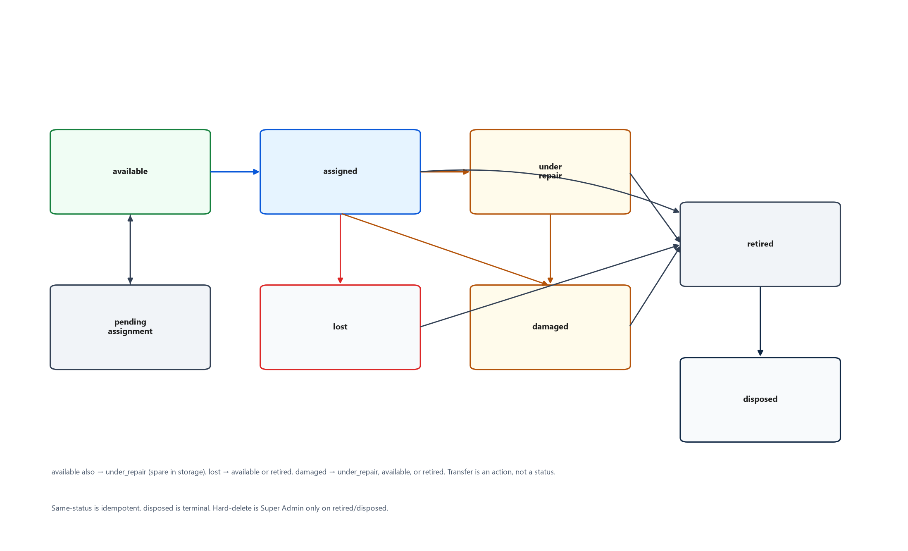
Figure. Asset status transitions (lifecycle.ts).
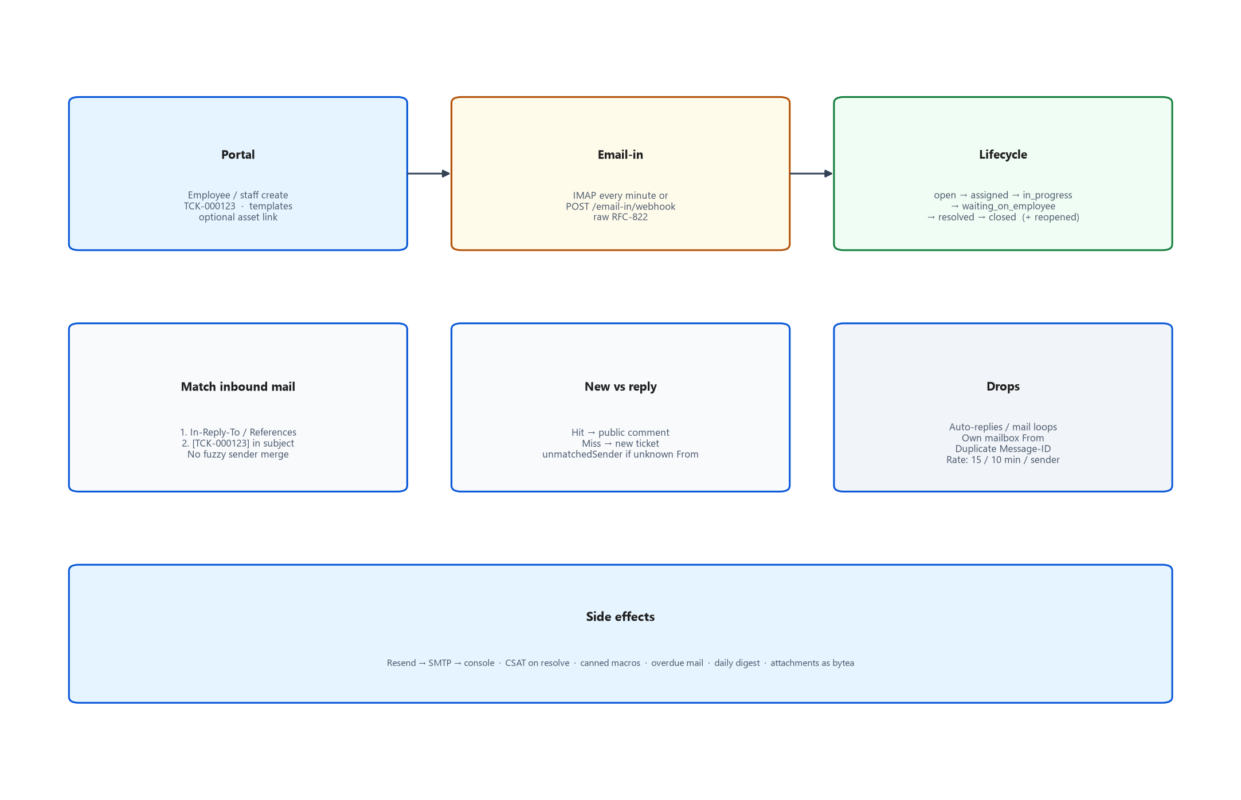
Figure. Ticket channels and lifecycle (simplified).
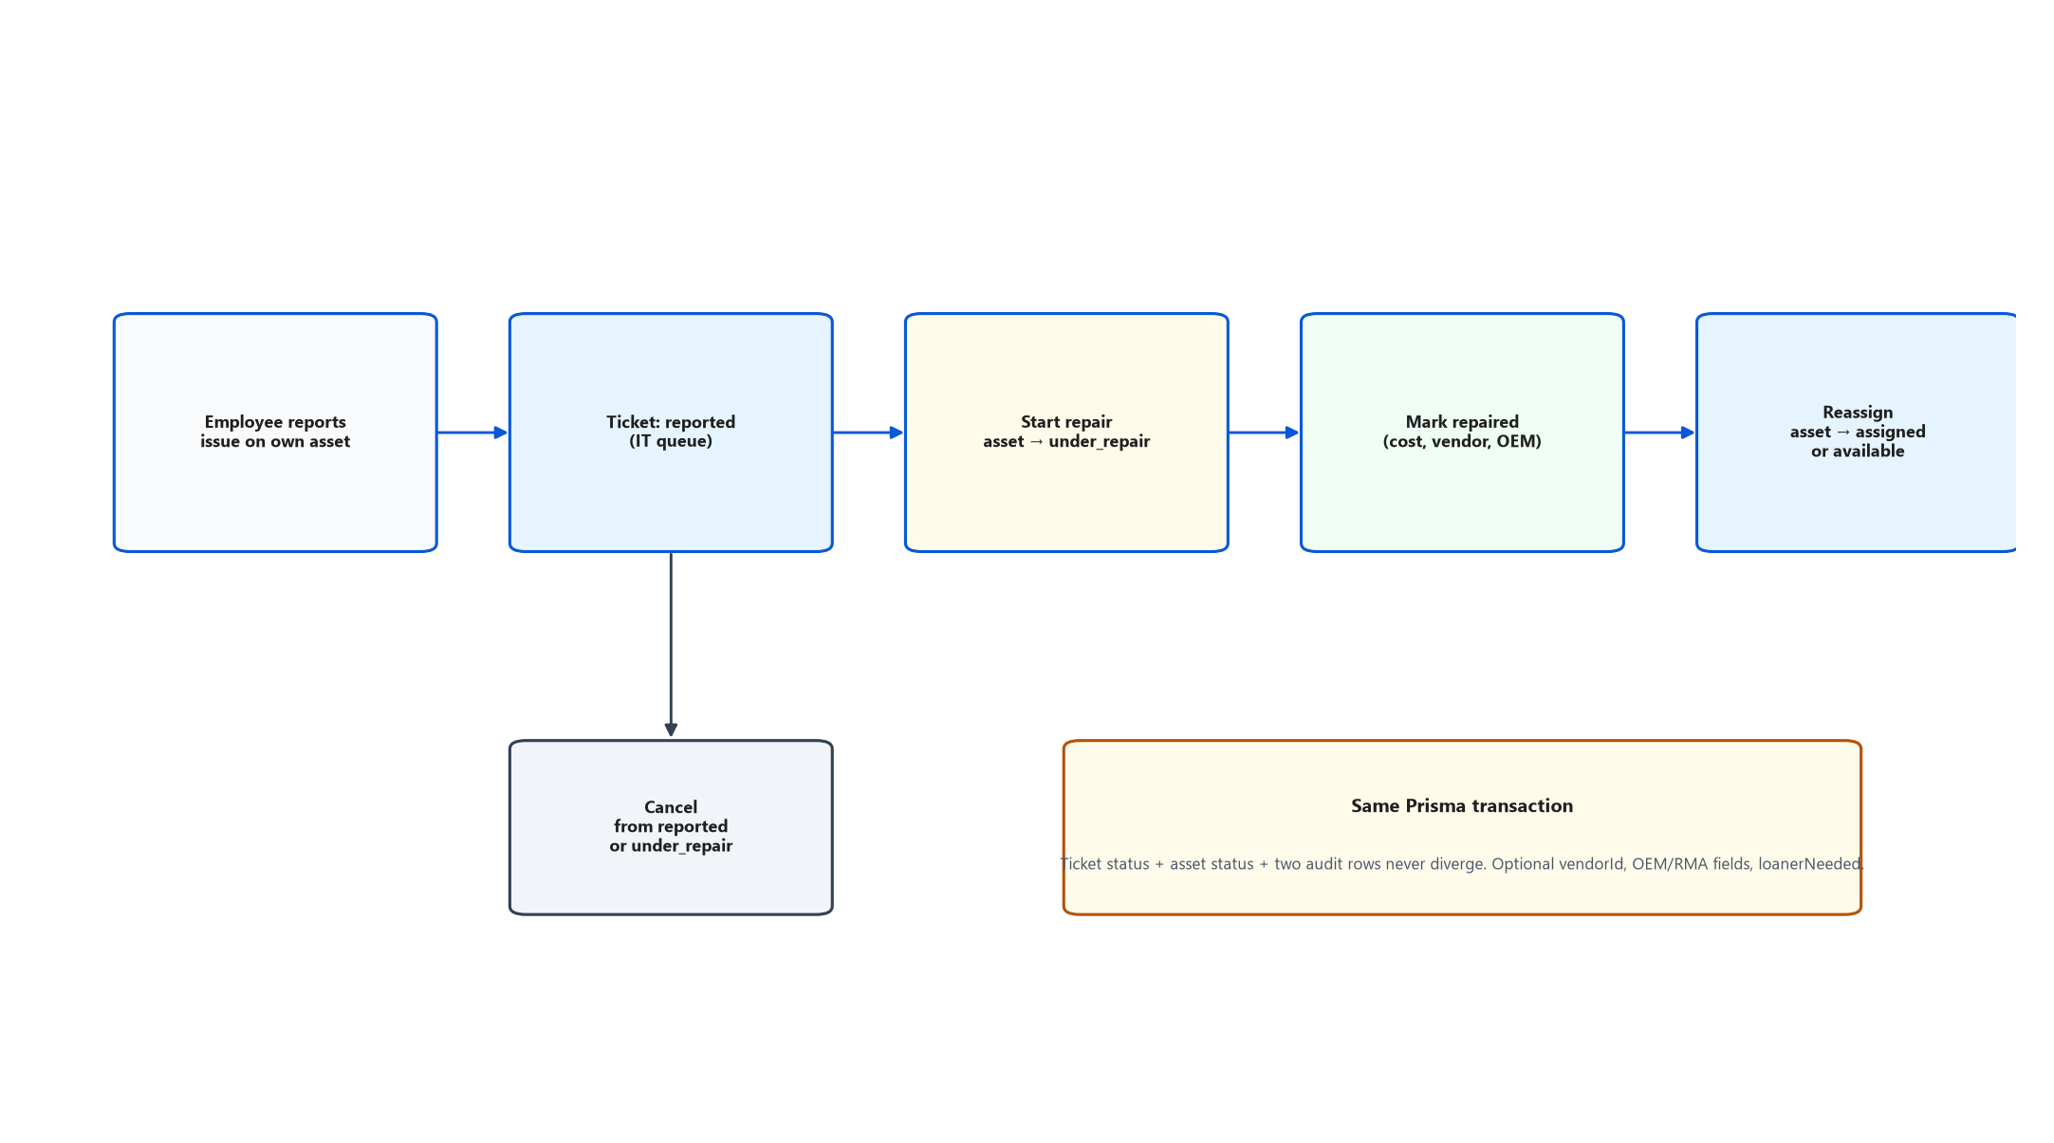
Figure. Maintenance ticket coupled to asset status.
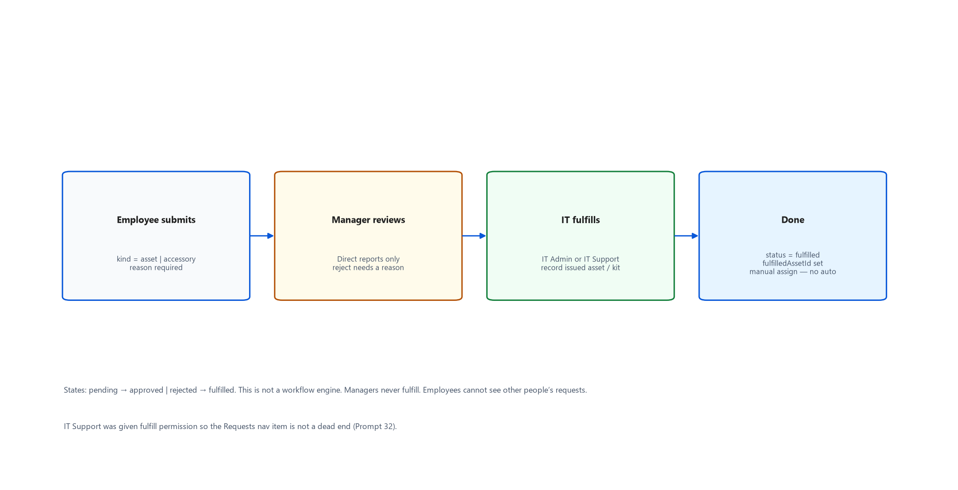
Figure. Asset request: pending → approved/rejected → fulfilled.
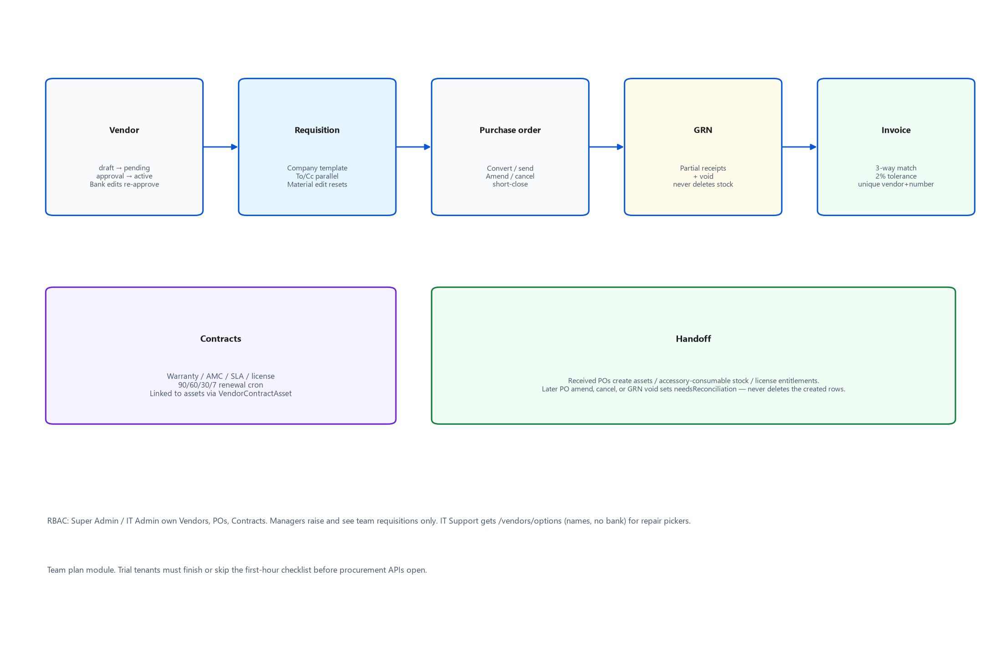
Figure. Procurement chain.
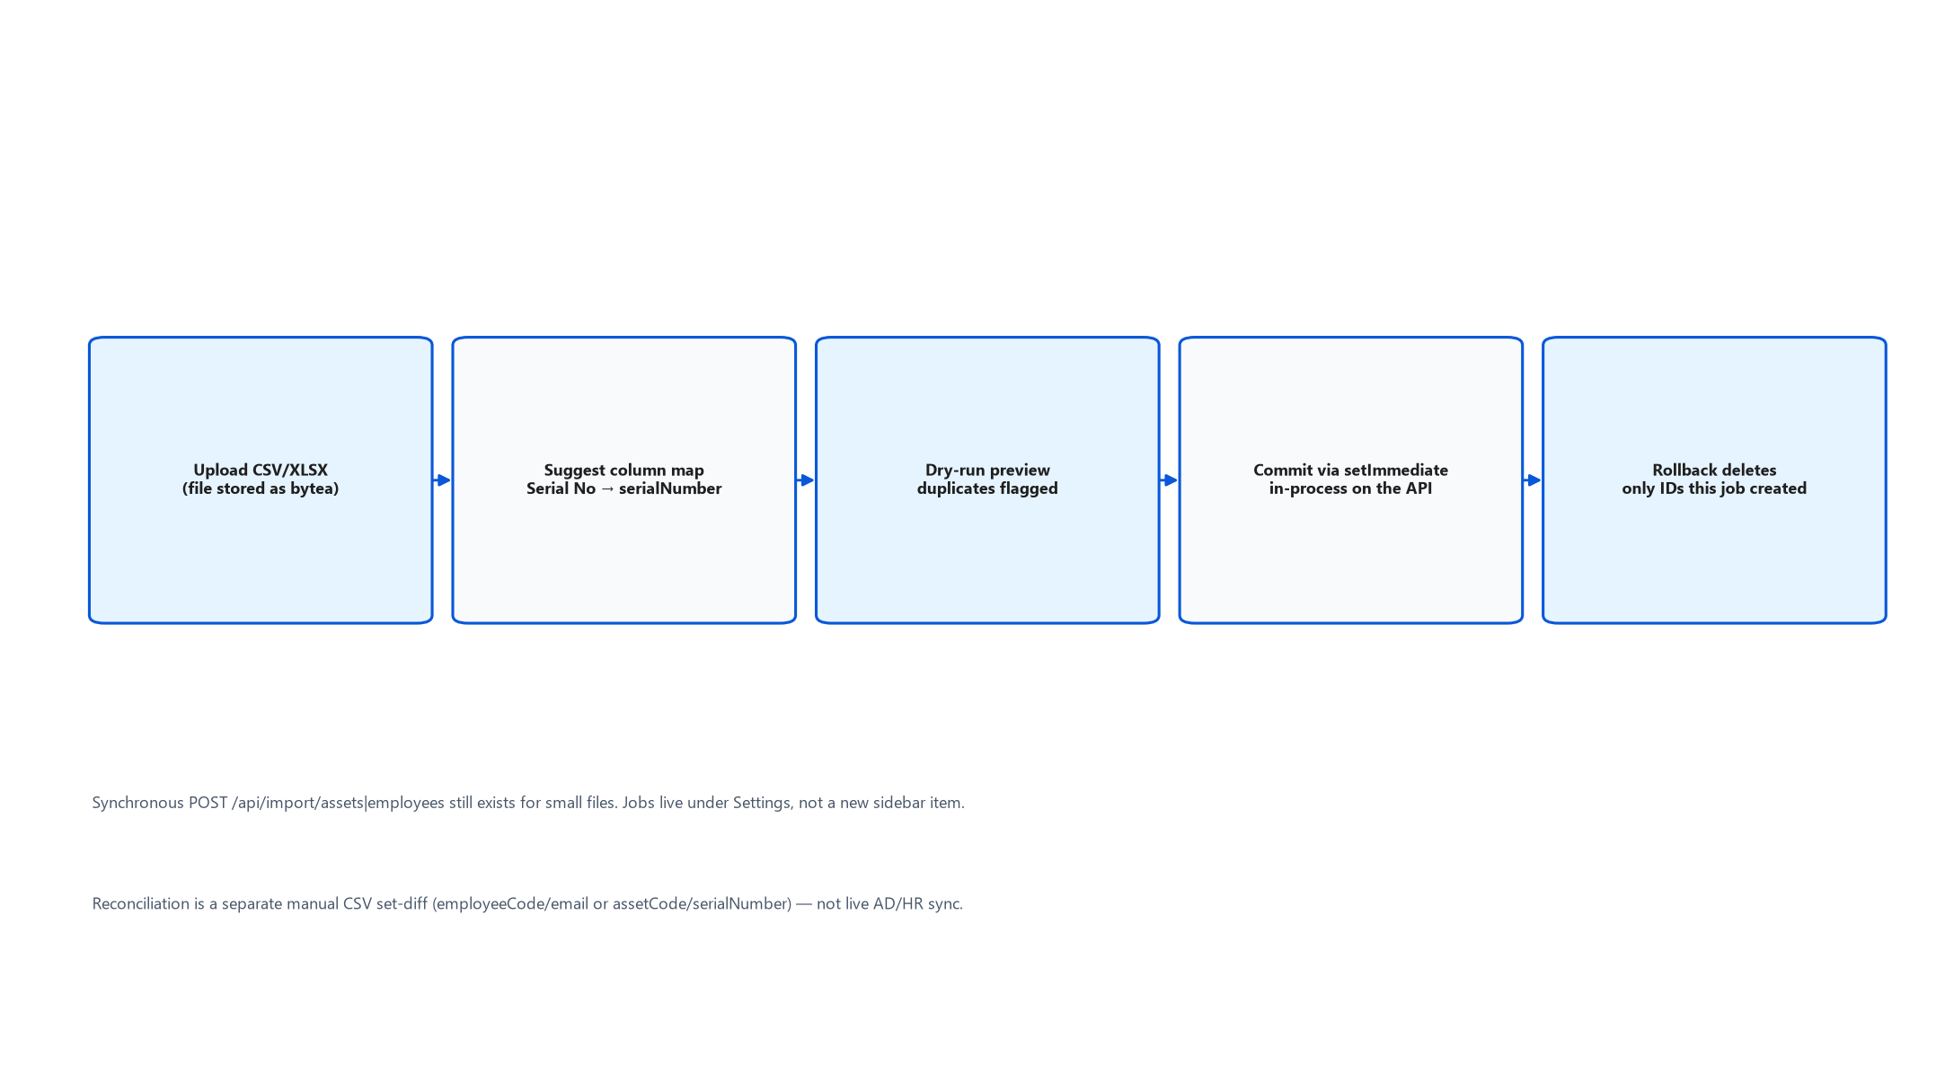
Figure. Import job states.

5. Cross-module workflows
Detailed steps: docs/WORKFLOWS.md. Highlights:
- New hire: employee record → user login → assign asset or issue kit → employee sees My kit.
- Broken device: employee ticket and/or IT maintenance; asset may enter under_repair.
- Request: employee submits → manager approves/rejects (reason required) → IT fulfills.
- Procurement: requisition approvals → PO → goods receipt → assets/invoices.
- Email-in: reply with [TCK-…] adds comment; unmatched sender flagged.
- QR audit: public scan card; staff audit stamps drive dashboard KPIs.

6. Notifications and automation
Trigger | Channel | Source
Asset request to manager | In-app | asset-requests.service.ts
Request approved/rejected | In-app | asset-requests.service.ts
Warranty 90/60/30 days | In-app + email | warranty-alert.service.ts
Ticket digest / overdue | Email | tickets.digest.ts
Contract renewal | Cron | contracts.service.ts
IMAP poll | Ticket comment | email-inbox.service.ts

7. Known functional gaps
Severity | Issue
HIGH | /signup and /trust pages exist but are not registered in App.tsx (REFERENCED only).
MEDIUM | Help articles say no public signup; login page promotes trial signup.
MEDIUM | Help copy may lag code — verify against services and e2e.

8. Glossary (selected)
Term | Meaning
My kit | Employee nav label for assigned devices
Team devices | Manager view of assets
TCK-###### | Ticket token in email subject
Starter / Team | Tenant plan tiers
unmatchedSender | Email-in ticket from unknown address

9. Related documents
- docs/FUNCTIONAL_SPECIFICATION.md — full markdown spec
- docs/WORKFLOWS.md — workflow diagrams (Mermaid in repo)
- docs/ROLE_PERMISSION_MATRIX.md — permission tables
- NewVision_System_Flow_and_Usage_Guide.docx — end-user flows
- NewVision_Developer_Handoff.docx — technical architecture

