NewVision
IT Asset Management — System Flow & Usage Guide
Prepared for business users
September 16, 2026

Table of Contents
Open in Microsoft Word and press Update Table (or F9) to refresh page numbers.

System Overview
NewVision (branded in the app as NewVision IT Asset Management) is a multi-tenant cloud workspace for Indian companies to track IT hardware, who has it, warranties, helpdesk tickets, optional staff chat, and procurement. Each company’s data is isolated in its own tenant. You sign in with a work email; what you see in the menu depends on your role.
- Employees use My IT — home, assigned devices, requests, and tickets.
- Managers see their team’s people, devices, requests, tickets, and can raise purchase requisitions.
- IT Support handles tickets, maintenance, and chat; they can read the estate but not change procurement or users.
- IT Admin runs day-to-day inventory, helpdesk, imports, and procurement.
- Super Admin has full access, including user accounts and workspace settings.
Figure 1 — High-level paths by role after sign-in
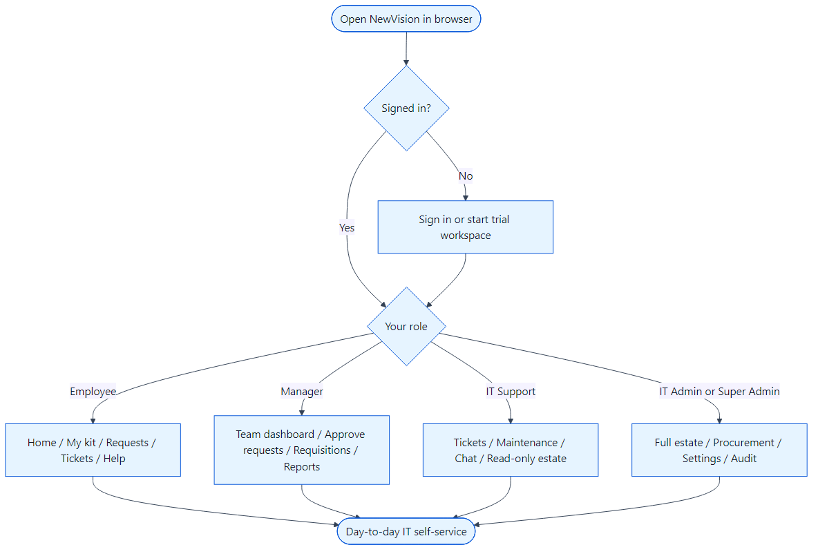

Sign In, Password Reset, and Multi-Factor Authentication
Open the application URL provided by your organisation. Enter your work email and password, then choose Sign in. Super Admin accounts in production may be required to enroll in multi-factor authentication (authenticator app) on first login or when prompted.
Figure 2 — Sign-in and account recovery
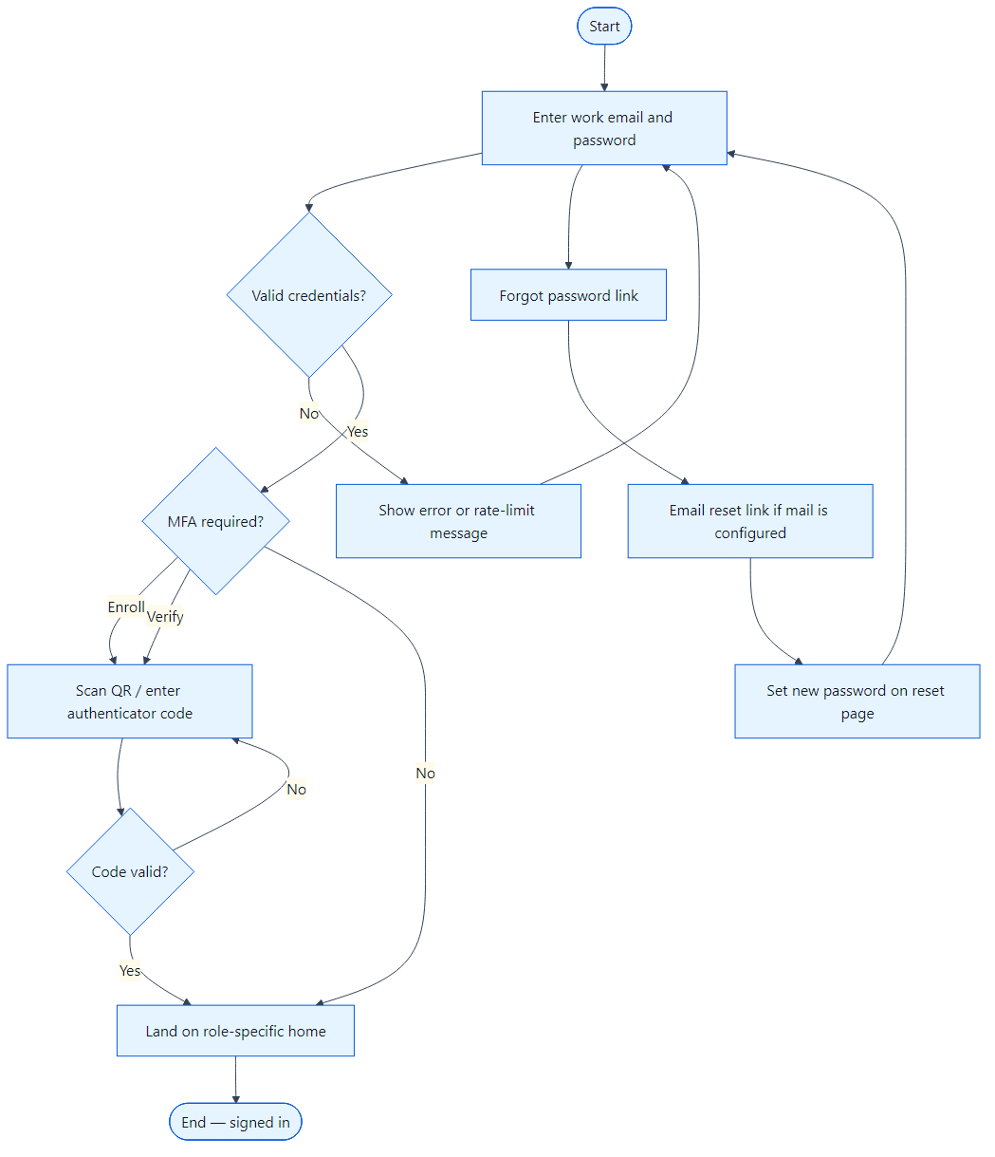

- Go to the login page and enter your email and password.
- If credentials are wrong, you see a generic error; repeated failures may trigger a 15-minute lockout.
- If MFA is required, enter the six-digit code from your authenticator app.
- Use Forgot password to request a reset link. The link works only if outbound email is configured; otherwise your administrator may reset the password from Settings → Users.
- After a successful sign-in you land on Home (employees), Team (managers), or Dashboard (IT roles).

New Workspace and First-Time Setup
New companies can start a 14-day Team trial (company name, admin details, optional sample laptops). Alternatively, a hosted deployment can create a single Super Admin on an empty database. In both cases, IT admins use the dashboard welcome checklist: import or add employees, import or create assets, assign kit, and optionally run a QR audit and a test ticket.
Figure 3 — Getting a workspace ready for staff
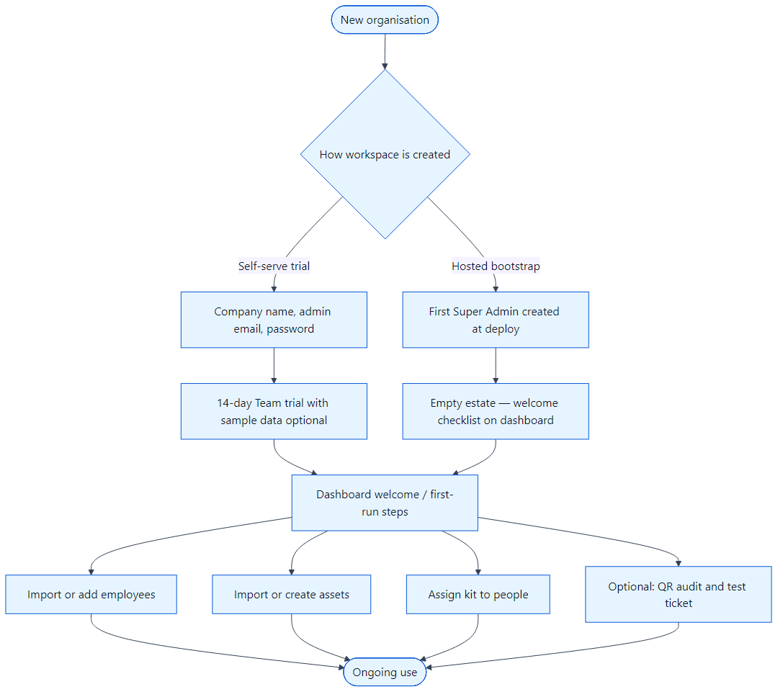

- Confirm locations and asset categories (Settings → Categories for admins).
- Add employees manually or upload a spreadsheet via Settings → Import jobs or the welcome card.
- Create or import assets, then use Assign on an available device to link it to an employee.
- Configure helpdesk email under Settings → Helpdesk when mail is available.
- Optional: define issue kits under Settings → Issue kits for standard new-hire bundles.

Raising and Fulfilling Equipment Requests
When someone needs new hardware or an accessory, they use Raise a request (employees) or Requests in the sidebar. The employee’s direct manager approves or rejects (IT Admin and Super Admin may also approve any request). IT Support and IT Admin then mark approved items fulfilled by issuing a specific asset or an issue kit.
Figure 4 — Asset and accessory request lifecycle
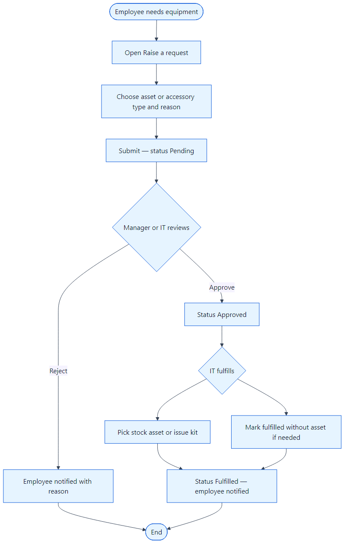

- Employee opens Raise a request, chooses asset or accessory, category or name, and a business reason.
- The request stays Pending until the employee’s manager, IT Admin, or Super Admin approves or rejects with a reason.
- On approval, IT opens the request and uses Fulfill to pick stock or an issue kit.
- The employee receives an in-app notification; status becomes Fulfilled.
- Managers track team requests from the Requests page; IT sees all pending items on the dashboard attention widgets.

Support Tickets (Helpdesk)
Use tickets for software, access, VPN, or general IT problems. Employees create tickets from Home or Support Tickets; IT Support and admins work queues from Support Tickets. Employees see public replies only; internal notes stay on the IT side. Email can create or update tickets when inbound mail is configured; replies include a ticket reference in the subject.
Figure 5 — Ticket workflow
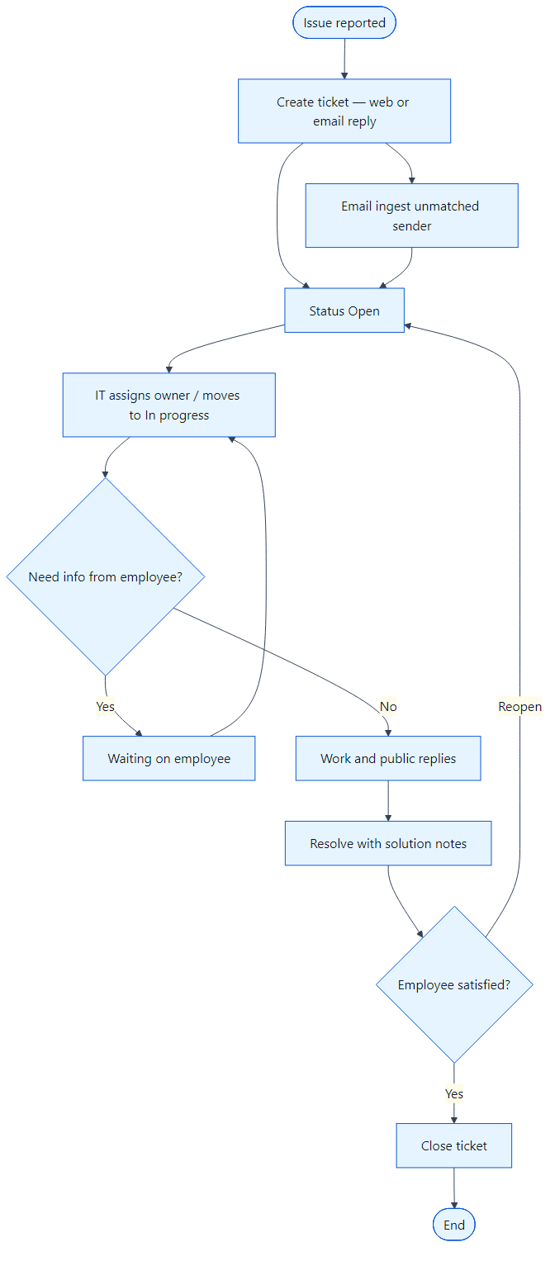

- Create a ticket with category, priority, description, and optional screenshot or attachment.
- IT assigns the ticket and moves it through Open → Assigned → In progress as work happens.
- Use Waiting on employee when you need the requester; they reply from the ticket or by email.
- Resolve with a clear solution summary, then Close when done. Reopen if the issue returns.
- Optional: use canned replies from Settings → Helpdesk and ticket reports under Tickets → Reports.

Asset Lifecycle — From Stock to Retire
IT Admin and Super Admin manage the full asset register. Support staff can view assets and drive maintenance but cannot create or retire devices. Assigning updates the employee’s My kit view immediately.
Figure 6 — Typical asset states and actions
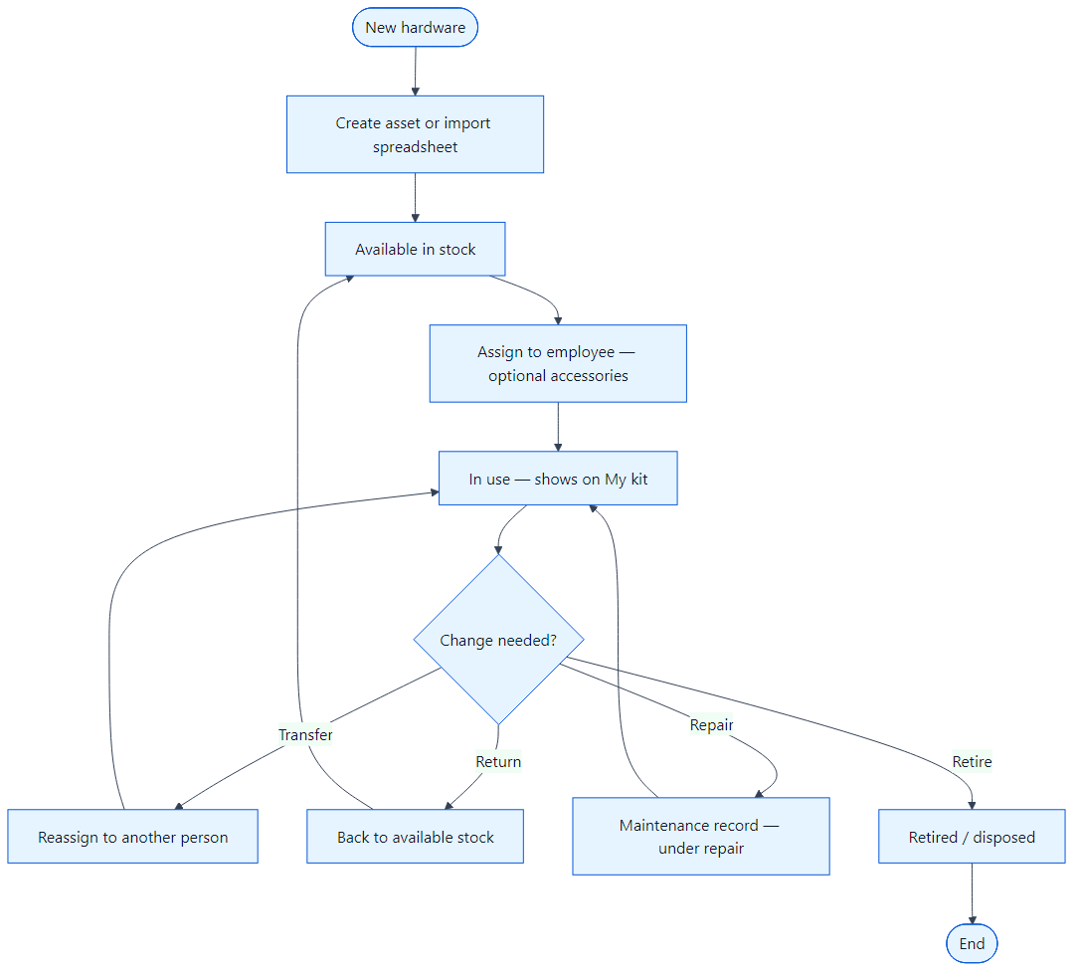

- Create a single asset from Assets → Create or bulk-import from a spreadsheet.
- While unassigned, status is available in stock; use Assign to give it to an employee (optional accessories or loaner return date).
- Use Transfer to move custody; Return when hardware comes back to the pool.
- Open Maintenance or report repair to send a device under repair; complete maintenance to put it back in service.
- Retire when the device is disposed or written off (admins only for hard delete).

QR Stickers and Physical Audits
Each asset can show a QR code. Scanning opens a mobile-friendly public card (make, model, status) without exposing personal data. IT staff who are signed in can record an audit from that page, confirming the device was physically seen.
Figure 7 — Scan and audit flow
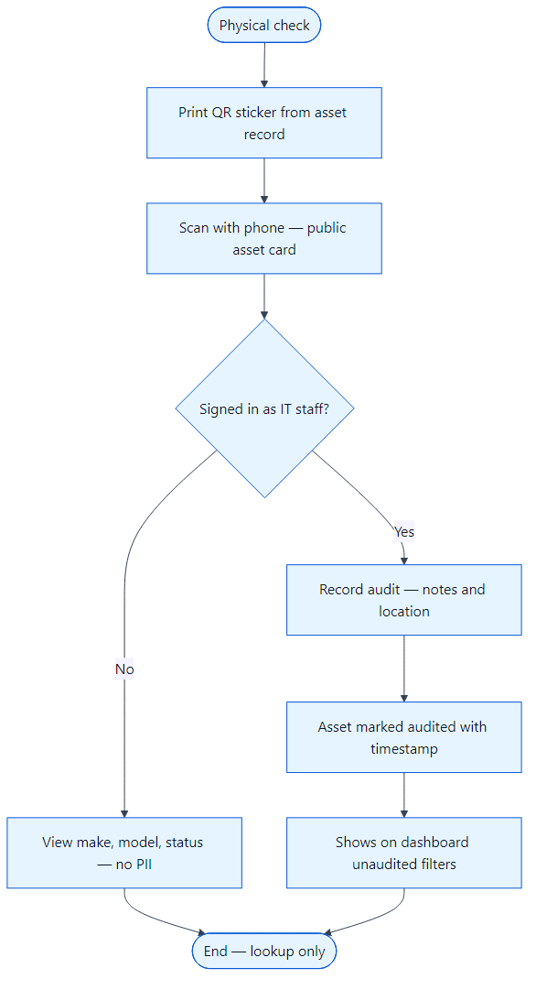

- From the asset detail page, print or download the QR label and attach it to the device.
- Scan with a phone camera; the browser opens the scan URL for that asset code.
- Anyone can verify basic device facts; only IT roles see the Record audit action.
- Enter optional notes and location, then submit — the asset’s last-audited date updates.
- Use dashboard and asset filters for unaudited devices during inventory checks.

Bulk Import (Employees and Assets)
Spreadsheet import avoids retyping large rosters. Upload Excel or CSV, map columns, preview rows, then commit. Duplicate detection and row-level errors are reported so you can fix the file and retry.
Figure 8 — Import job flow
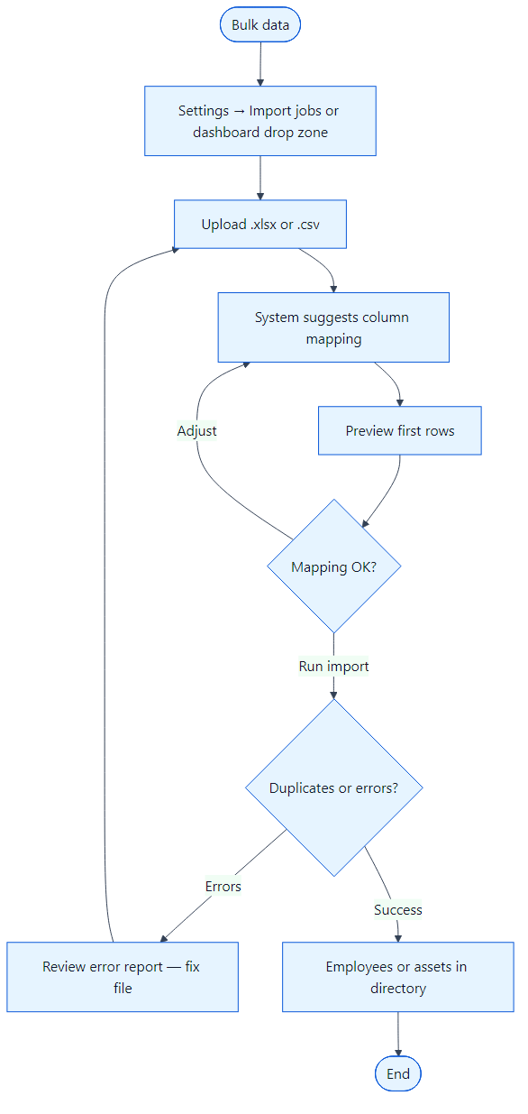

- Go to Settings → Import jobs (admins) or use the welcome card drop zone on the dashboard.
- Choose employees or assets and upload your file.
- Review suggested column mapping and adjust if headers differ from the template.
- Run preview, then commit the import when the sample rows look correct.
- For employees who need logins, enable Create login during import or add users later under Settings → Users.

Procurement (Requisitions and Purchase Orders)
On Team plan (trial or subscribed), IT Admin and Super Admin manage vendors, requisitions, purchase orders, and contracts. Managers can create and submit requisitions for approval. After approval, admins raise a purchase order against the requisition.
Figure 9 — Requisition to purchase order
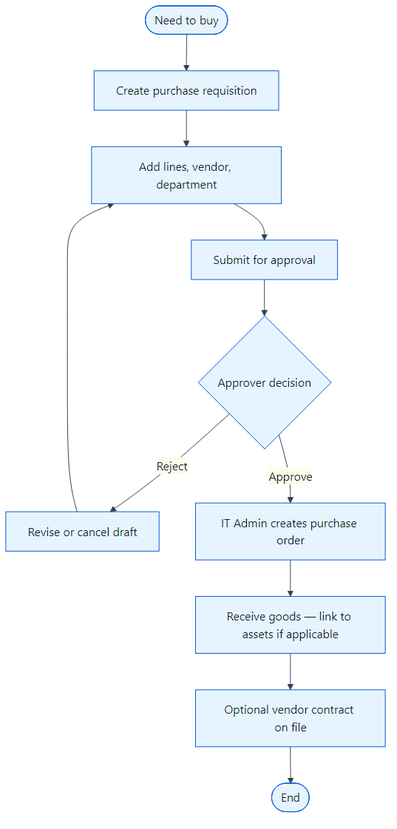

- Maintain approved vendors under Procurement → Vendors (admin only).
- Create a requisition with line items, department, and preferred vendor.
- Submit for approval; approvers accept or reject with comments.
- Once approved, create a purchase order from the requisition and track receipt.
- Link received hardware into assets when devices arrive.

Maintenance and Repairs
Track repairs with vendors, costs, and status. While under repair, the asset status reflects that it is not available for assignment. Employees can report problems via a ticket or through maintenance linked to their assigned device.
Figure 10 — Maintenance workflow
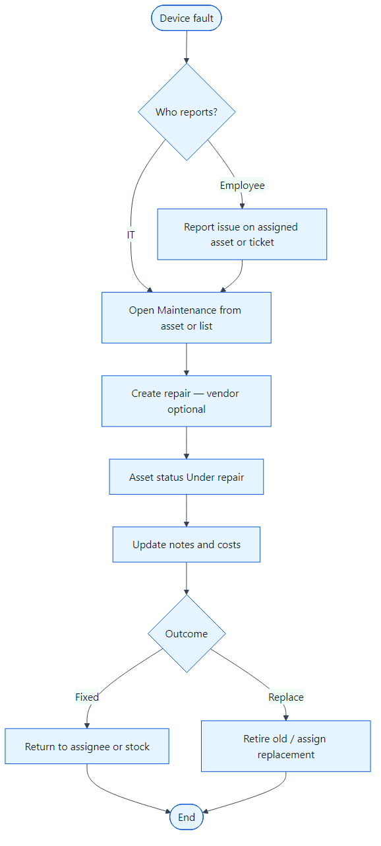

- Open Maintenance from the sidebar or start from an asset’s actions.
- Create a repair record; optionally pick a vendor from the approved list.
- Asset moves to under repair until the job is completed.
- Record outcome, cost, and notes; reassign or return to stock when fixed.
- If the device is beyond repair, retire it and fulfill any replacement request separately.

FAQ and Troubleshooting

I cannot see a menu item my colleague has
Menus are role-based. Employees never see Settings, Audit Log, or procurement. Chat and full procurement require the Team module; after a trial expires, Starter workspaces hide chat and procurement until upgraded.

Forgot password email never arrives
Password reset and ticket mail need Resend or SMTP configured for your environment. Ask a Super Admin to reset your password from Settings → Users if email is not live.

My device is on my desk but not in My kit
The asset must be assigned to your employee record. Scanning a QR code does not assign hardware to you.

Trial signup link on login page
Self-serve trial registration is offered on the login screen for new companies. If your organisation already provisioned accounts, use Sign in instead — IT creates users under Settings → Users.

Glossary
Tenant / workspace — Your company’s isolated copy of data in NewVision.
Asset code — Unique label for a device (used in QR URLs and search).
Issue kit — Predefined bundle of assets/accessories issued together to new hires.
My kit — Employee view of hardware assigned to you.
Public comment — Ticket message visible to the employee who raised the ticket.
Internal note — Ticket note visible only to IT staff.
Requisition — Internal request to purchase goods before a purchase order is raised.
Starter vs Team plan — Starter is limited (no chat/procurement); Team includes those modules during trial or subscription.

