TRASHBOT
Project Guide: how it works, how we build it, how we use it
A low-budget Physical AI robot dustbin that finds small trash, scoops it into its own bin, and can be commanded in Hinglish and English.
Item | Detail
Owner | Satyam Chouksey, QA Automation Engineer, Bhopal
Brain | XIAO ESP32S3 Sense (camera on board), on-device vision (Edge Impulse FOMO)
Agent layer | Optional AI agent over MCP, driven from Cursor on a laptop
Code | github.com/SatyamChouksey-88/trashbot (MIT licence)
Status (Sept 2026) | Software built, simulated and covered by automated tests and CI. Hardware not yet assembled or field-tested.
Document version | 1.0, 30 Sept 2026

Contents
1. Project at a glance
2. How the robot works
3. Hardware
4. Software and repository
5. The phone interface
6. Giving commands: Bolo (Hinglish + English)
7. Controlling the AI agent
8. Teaching the AI
9. Who does what
10. Build roadmap and gates
11. Planned: Auto-collect mode (G12)
12. Safety and limitations
13. Upgrade ideas (later)
14. Glossary
How to read this guide: sections 1-3 explain what the robot is and what to buy, 4-6 explain the software and commands, 7-8 explain control and learning, 9-10 tell you what to do and in what order.

1. Project at a glance
TrashBot is a small four-wheel robot with a bin on top and a servo-driven scoop at the front. It looks at the floor with its camera, spots small trash such as paper, wrappers and chips packets, drives to it, scoops it, tips it into the bin, and repeats. The safety logic that decides whether any motor may move lives on the robot itself, so a bad command or a crashed laptop cannot make it unsafe.

What makes this project different
- On-device vision. A small FOMO model runs on the ESP32-S3 itself. No cloud and no internet are needed to spot trash.
- Safety first. Every motor command passes through one safety layer: obstacle stop, command expiry, motor lease, watchdog and stuck recovery.
- Speaks your language. The “Bolo” command layer understands Hinglish, English and Devanagari, such as “kachra saaf karo” or “20 cm aage chalo”.
- Optional AI agent. From Cursor you can chat with the robot through an MCP server, with three safety modes.
- Testable without hardware. A digital-twin simulator, unit tests and CI let the software be checked before a single wire is soldered.

Where the project stands
Area | Software | Hardware
G0 Boot self-test | Done | Pending your test
G1 Drive | Done | Pending your test
G2 Vision | Done (needs your trained model) | Pending your test
G3-G5 Autonomous cleaning | Done, simulated | Pending your test
G6 Extras | Done | Pending your test
G7 AI agent | Done, tested against a mock robot | Pending your test
G11 Bolo commands | Done, tested | Pending your test
Honest status. Nothing here claims the robot works on a real floor yet. “Done” means built and tested in software. Each gate must be proven on the real robot, one at a time.

2. How the robot works
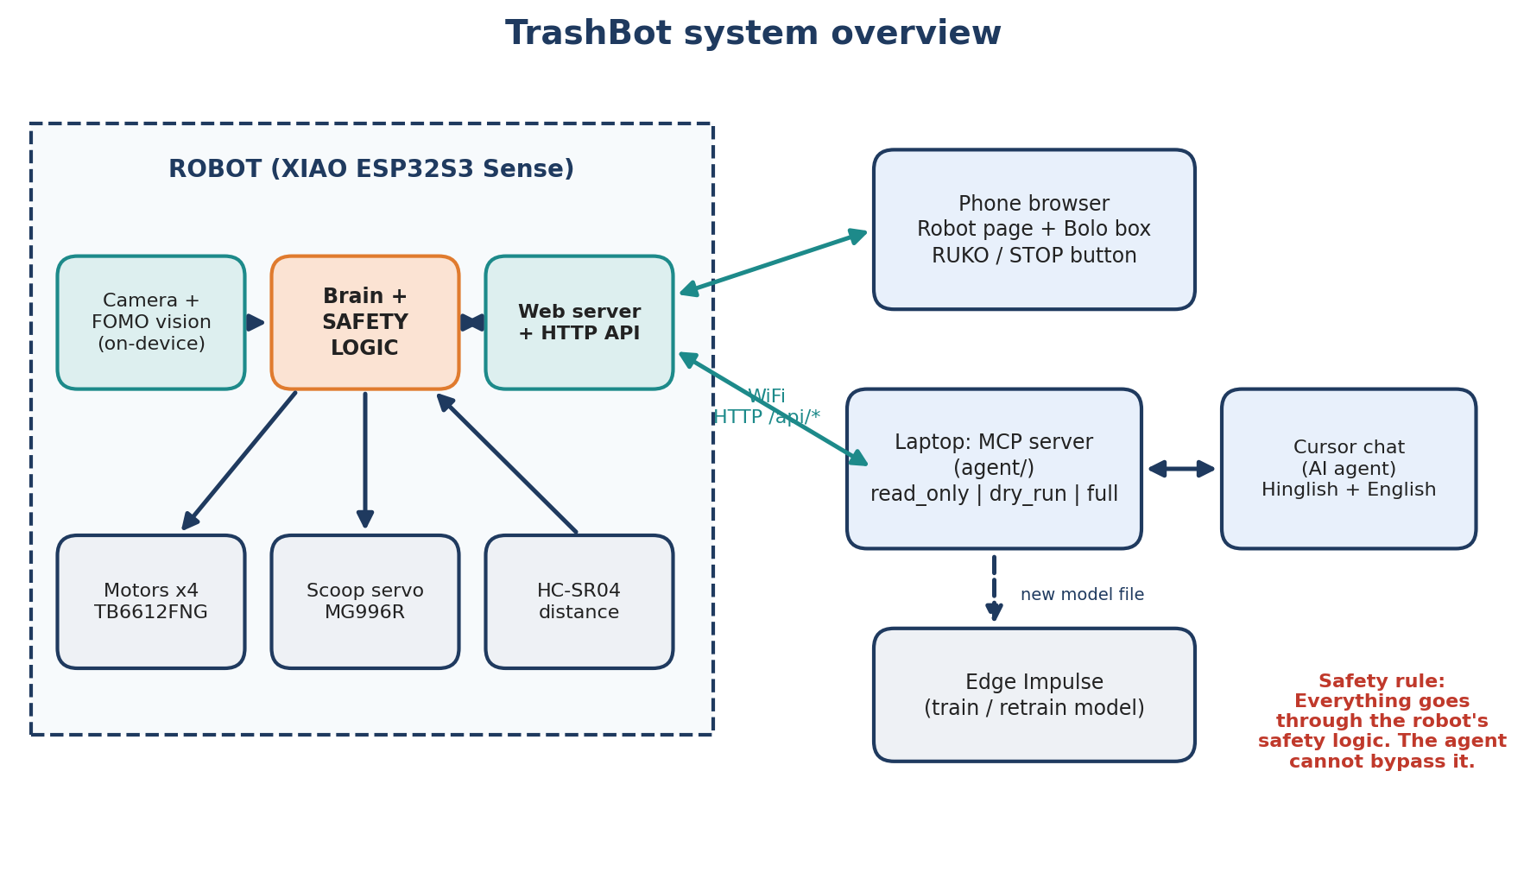
Figure 1. System overview: robot, phone, laptop agent and model training

The parts and what each does
Part | Job
Camera + FOMO vision | Looks at the floor and returns boxes around trash. Runs on the ESP32-S3, no internet.
Brain + safety logic | Decides what to do next (search, approach, scoop, deposit) and vets every motor command before it moves.
Web server + HTTP API | Serves the phone page and the /api/* endpoints. Phone, laptop agent and tools all use this same door.
Motors + TB6612FNG | Four geared motors on a driver board, left and right pairs.
Scoop servo (MG996R) | Three positions: DOWN, CARRY and TIP.
HC-SR04 ultrasonic | Distance ahead. Used for obstacle stop.
MCP server (agent/) | Runs on the laptop. Turns the API into tools an AI agent can call, with mode limits.
Edge Impulse | Online tool where you label photos and train the vision model.

What one cleaning run looks like
- You press Saaf karo · Clean on the phone (or say it in Bolo or Cursor).
- Pre-flight checks run: health OK, bring-up done, battery sensible.
- Robot scans, sees trash, and turns to face it while watching for obstacles.
- It drives up slowly, lowers the scoop, drives forward a little, lifts to CARRY.
- Camera checks whether the item is really gone. The result is scored for learning.
- It tips the scoop into the bin, then repeats until the item count or time limit is reached.
- At any point, low battery, an obstacle, a stuck wheel or a stop command ends the run safely.
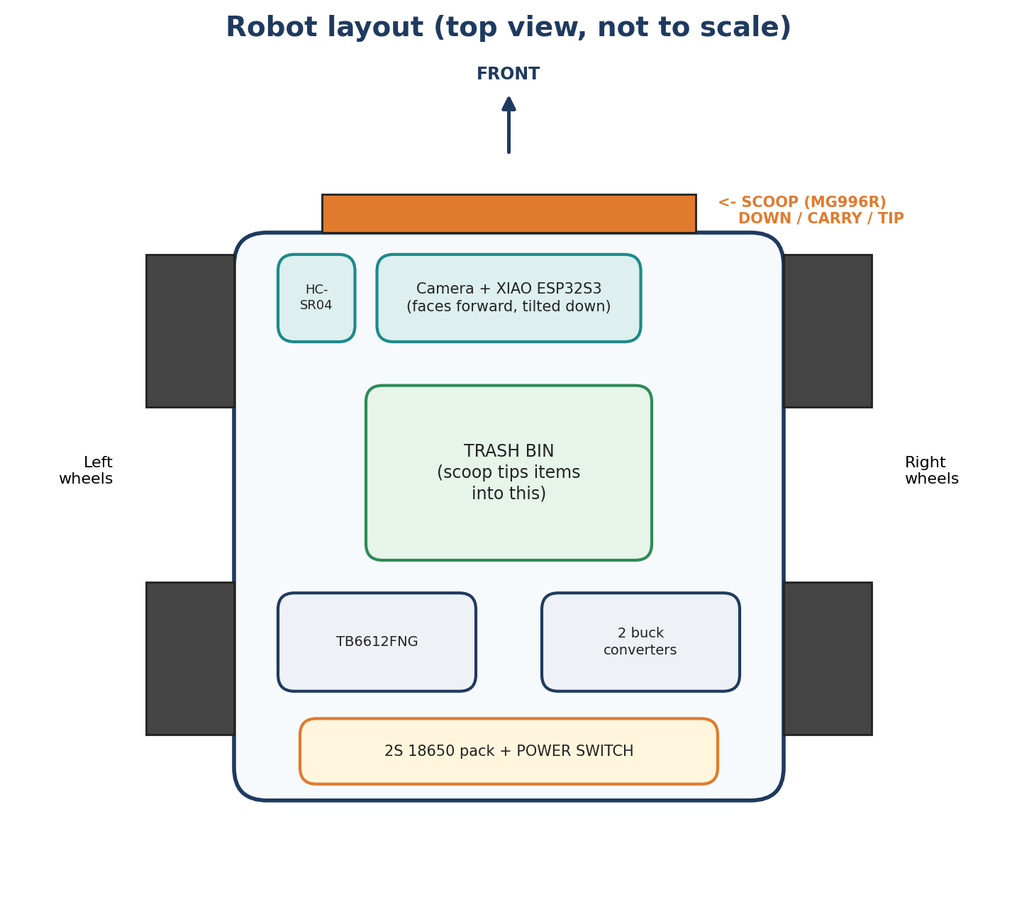
Figure 2. Robot layout, top view (not to scale)

3. Hardware

Bill of materials (approximate, India)
Part | Price (INR) | Notes
XIAO ESP32S3 Sense | ~1,585 | Camera + PSRAM on board
TB6612FNG motor driver | ~157-194 | Dual H-bridge
4WD chassis + motors | ~499-649 | Yellow TT motor style kit
MG996R 180° servo | ~212 | Scoop arm
HC-SR04 + resistors | ~99 | 1k / 2k divider on ECHO
2x 18650 + holder + charger | ~500-800 | Prefer protected cells
2x buck converters | ~200-400 | 5 V logic, 6 V servo
Bin, wire, switch, capacitors | ~200-300 | Power switch is your real e-stop
Total roughly INR 3,500-4,500. Prices change; check current listings before ordering.
Battery safety. Use two 18650 cells in series (2S). Check polarity twice, use protected cells, never charge unattended, and never leave a pack shorted in a bag. A 2S BMS with a USB-C charger board (INR 200-400) is a safer way to charge.

Wiring
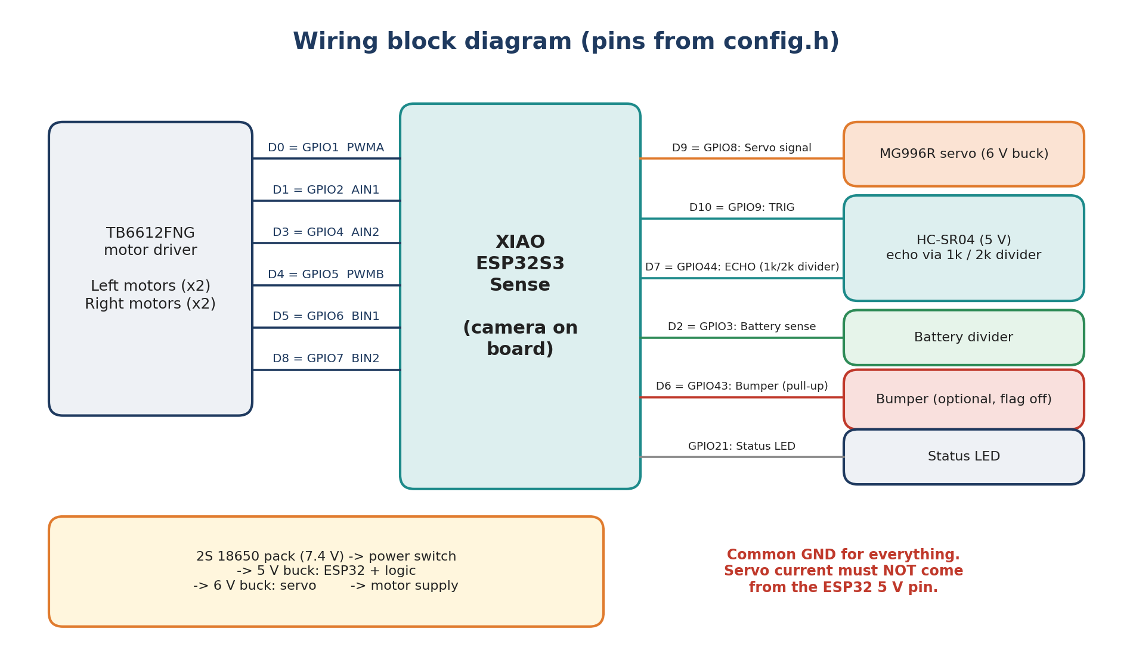
Figure 3. Wiring block diagram with GPIO numbers from config.h
XIAO pin | GPIO | Signal | Goes to
D0 | 1 | PWMA | TB6612 PWMA (left motor speed)
D1 | 2 | AIN1 | TB6612 AIN1
D3 | 4 | AIN2 | TB6612 AIN2
D4 | 5 | PWMB | TB6612 PWMB (right motor speed)
D5 | 6 | BIN1 | TB6612 BIN1
D8 | 7 | BIN2 | TB6612 BIN2
D9 | 8 | Servo | MG996R signal wire
D10 | 9 | TRIG | HC-SR04 TRIG
D7 | 44 | ECHO | HC-SR04 ECHO through 1k / 2k divider (5 V to 3.3 V)
D2 | 3 | Battery sense | Resistor divider from battery
D6 | 43 | Bumper | Optional switch, INPUT_PULLUP with 1k in series; feature off by default
- | 21 | LED | On-board status LED

Wiring rules that prevent damage
- All grounds are common: battery, both bucks, TB6612, servo, ESP32 and sensor.
- Servo power comes from its own 6 V buck, never from the ESP32 5 V pin.
- HC-SR04 ECHO is a 5 V signal. Always divide it down before the ESP32 pin.
- Put a large capacitor near the servo and near the motor supply to avoid brown-outs.
- Put the power switch on the battery positive so it cuts everything.
- Pin map is tested: an automated test fails if two signals ever share one GPIO.

4. Software and repository
The whole project lives in one GitHub repository. The table shows what each folder is for.
Folder | What it holds
firmware/ | ESP32-S3 code (PlatformIO, Arduino framework). lib/core is pure logic with unit tests; lib/hw, lib/net, lib/store are hardware, web and storage layers.
agent/ | MCP server in TypeScript: tools, safety modes, mock robot for tests, lessons memory.
shared/lang/ | The Bolo parser: lexicon, limits, executor and the small browser UI script. Pure JavaScript, heavily tested.
tools/ | Python scripts: photo collection, dataset helpers, model evaluation and regression gate, simulator, release check.
e2e/ | Playwright browser tests for the robot web page and API.
docs/ | Guides, API reference, wiring, plan, decisions and reports.
.cursor/ | Cursor rules, slash commands (/trashbot, /ruko, /saaf-karo) and MCP config.
.github/workflows/ | CI: builds firmware, runs all tests and the simulator on every push.
dataset/ | Only a README; photos are never committed.

How we build it
- Cursor builds the code from long prompts. Each prompt is split into phases; each phase must build, pass tests, and then commit.
- One rule set for everyone. AGENTS.md tells any coding agent: safety first, config in one file, no secrets in Git, tests for every feature.
- Feature template. A feature is finished only with a config flag, pure logic plus unit tests, a simulator scenario, reason codes in events, an API entry, and docs.
- Simulator. Sixteen JSON scenarios (obstacle, low battery, stuck, camera timeout, scoop failure and more) run the real brain code in a virtual room.
- CI. GitHub Actions rebuilds the firmware, runs unit tests, agent tests, Bolo tests, Python tests and browser tests.

How we work on a restricted computer
Some development machines block new native programs. The project handles that: native unit tests and the simulator run in CI, while the local machine builds the firmware and runs the JavaScript and Python tests. Flashing the robot is done from a personal computer with USB.

5. The phone interface
Connect your phone to the robot’s WiFi and open its page. Nothing is loaded from the internet, so it works anywhere. The page is designed so that the biggest, most obvious control is STOP.
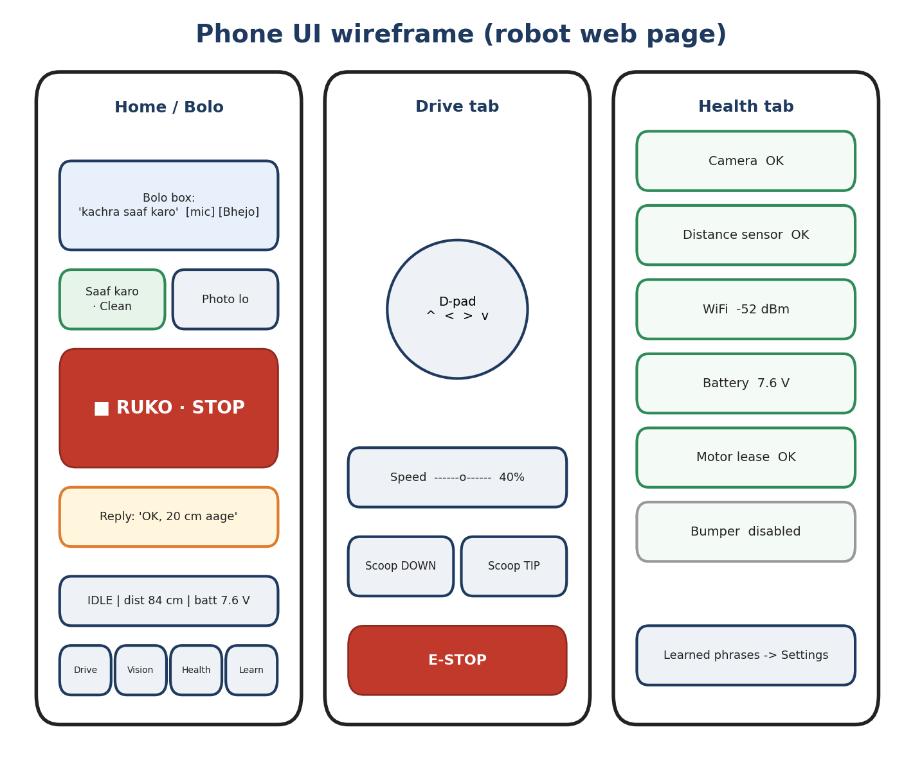
Figure 4. Phone UI wireframe: Home with Bolo box, Drive tab, Health tab
Screen | What you do there
Home / Bolo box | Type or speak (phone keyboard mic) a command. Big red ■ RUKO · STOP. Saaf karo · Clean starts a run. Photo lo shows what the robot sees.
Drive tab | D-pad, speed slider, scoop DOWN / TIP buttons, and E-STOP (latched; reset only from the phone).
Vision tab | Live detections, confidence zones, photo capture.
Health tab | Camera, distance sensor, WiFi, battery, motor lease, bumper status. Also the bring-up wizard.
Learning tab | Scoop recipe scores, mistake frames, Reset learning, learned phrases.

6. Giving commands: Bolo (Hinglish + English)
Bolo lets you talk to the robot the way you speak. The parser runs in your phone browser or in Cursor, never on the ESP32. It turns your words into ordinary API calls, so the robot’s own safety logic still has the last word.
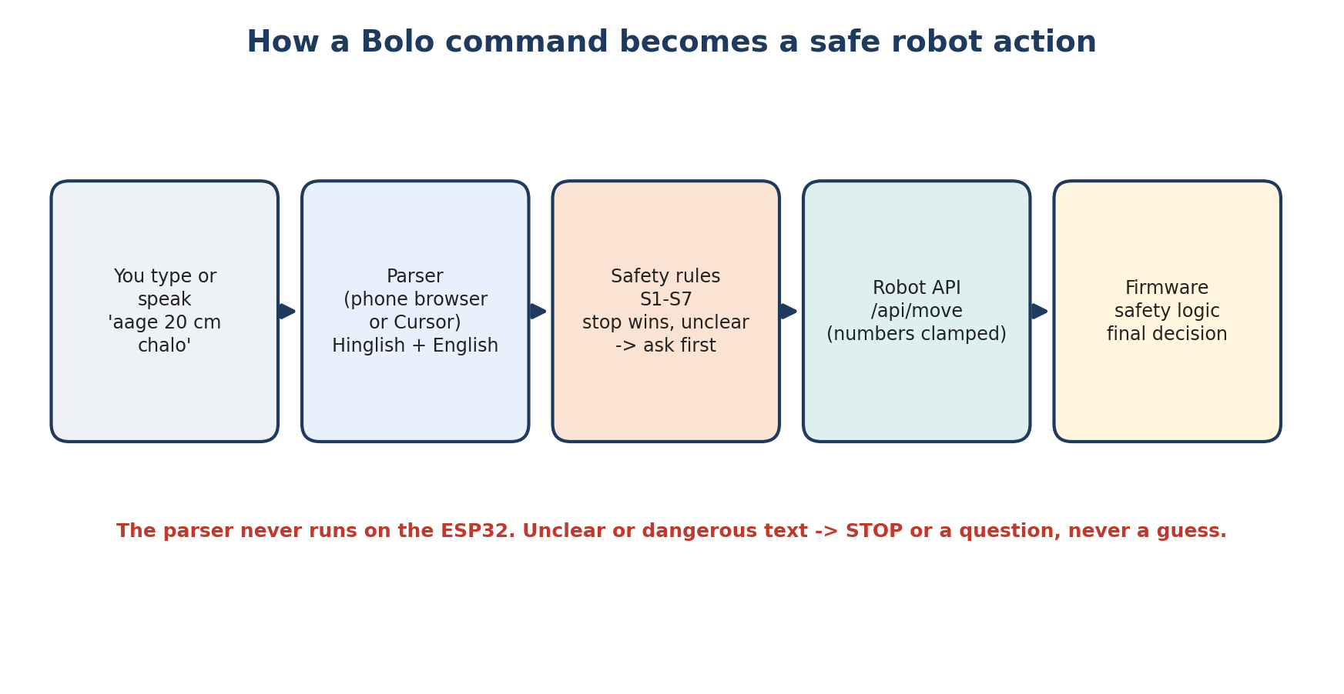
Figure 5. From words to a safe robot action

Example commands
What it does | Hinglish | English
Stop now | ruko, ruk jao, bas karo, band karo | stop, wait, hold on
Emergency stop | emergency, bachao | emergency stop, e-stop
Clean | kachra saaf karo, 3 kachre uthao | clean the room, pick up the trash
Move | 20 cm aage chalo, thoda peeche | forward 20 cm, go back a little
Turn | 90 degree left ghumo, palat jao | turn left 90, u-turn
Scoop | scoop neeche karo, scoop khali karo | scoop down, dump the scoop
Photo / status | photo lo, kya haal hai | take a photo, status
Battery / report | battery kitni hai, hisaab batao | battery level, report
Correct a mistake | ye kachra nahi hai, ye mera hai | this is not trash, that is mine

Safety rules (always on)
- Stop words always win (ruko, bas, stop, wait) even inside a longer sentence or a question.
- “Mat / nahi / don’t” + an action = stop. “Aage mat jao” never moves the robot.
- Typos only get a question. A misspelled move command asks “Did you mean…?” and never moves.
- Unclear means ask first: unknown words, a question, a place name, or two numbers.
- Limits per command: forward 50 cm, back 20 cm (no rear sensor), turn 180°, 20 items, 10 minutes.
- Learned phrases can never contain or override safety words.
Remember. Chat is not an emergency stop. An AI reply takes seconds. For an instant stop use the power switch or the STOP button.

Where you can type commands
Place | How
Robot web page, Bolo box | Type, or tap the mic on the phone keyboard and speak.
Cursor chat | Start with /trashbot or attach the operator rule; laptop and robot on the same WiFi.
Cursor shortcuts | /ruko stops. /saaf-karo starts cleaning.
Clap (optional) | One clap starts cleaning when idle. Never used to stop.

7. Controlling the AI agent
The agent chooses what to do, but it cannot decide how much power it has. There are five layers of control; the lower layers are out of its reach.
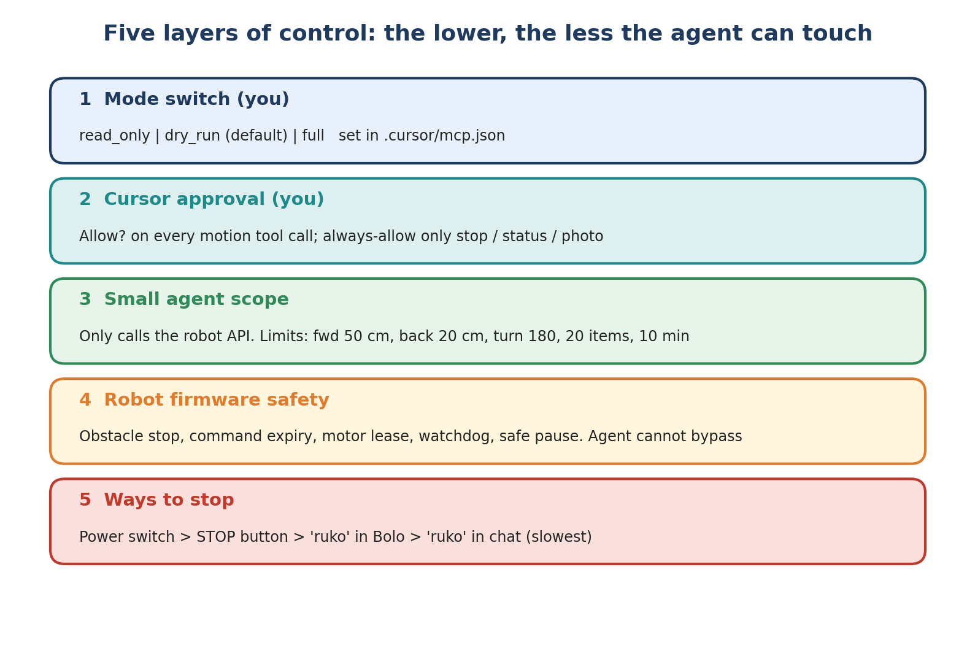
Figure 6. Five layers of control

Layer 1: the mode switch
Set TRASHBOT_MODE in .cursor/mcp.json. The agent cannot change it; you edit the file and restart the MCP server.
Mode | What the agent can do
read_only | Only look: status, photo, battery, report. Refuses to move. Stop and e-stop still work.
dry_run (default) | Says “DRY RUN: I would…” and does not move the robot.
full | Actually drives the robot.

Layers 2 to 5 in short
- Cursor approval: Cursor asks “Allow?” for every motion tool. Set always-allow only for stop, e-stop, get_status and take_photo.
- Small scope: The agent only calls the robot API, at most 10 tool calls per message. It cannot reset an e-stop, and it saves a new phrase only after your “haan”.
- Firmware safety: Obstacle stop, expiring manual commands, motor lease, watchdog. If the laptop or WiFi disappears, the robot ends its mission safely on its own.
- Ways to stop, fastest first: power switch, STOP button, “ruko” in the Bolo box, “ruko” in Cursor chat.

Recommended way to start
- Days 1-3: dry_run only. Try commands in Hinglish and English and watch what it says it would do.
- Next: wheels lifted in the air, mode full. Check every direction and STOP.
- Finally: on the floor, short distances, someone watching, power switch within reach.

8. Teaching the AI
Learning here means saving data and choosing between safe options. There is no language model or Python on the robot, and you approve every change.
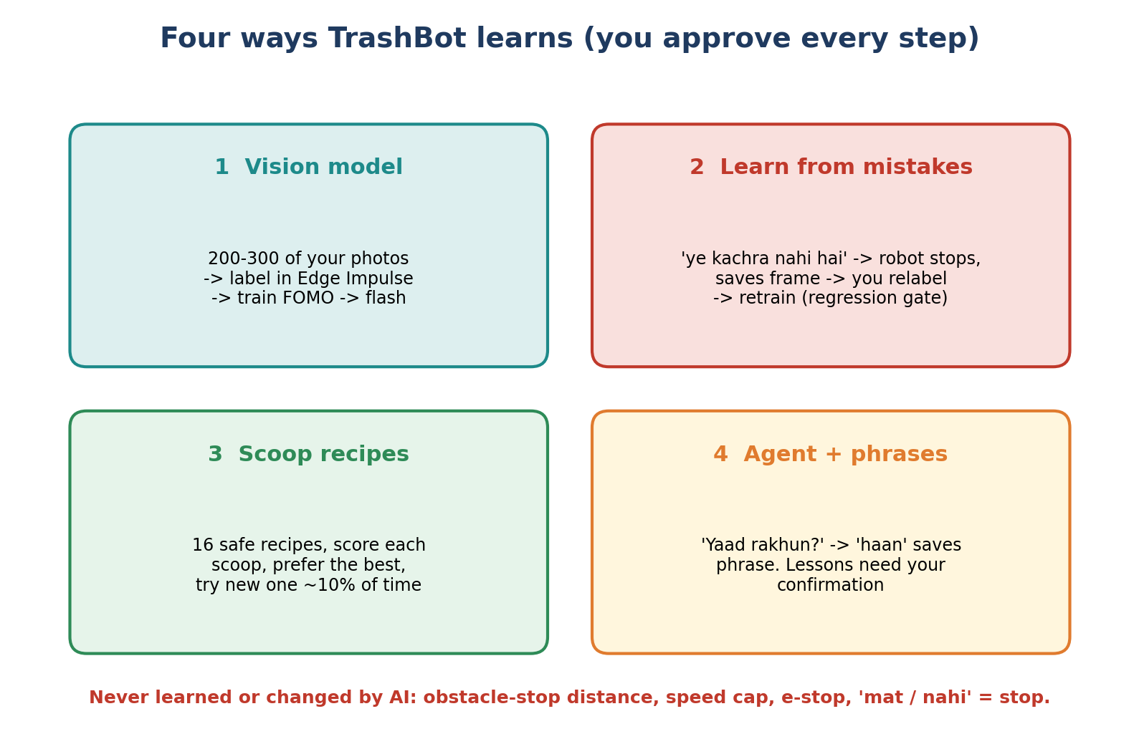
Figure 7. Four ways TrashBot learns

1. The vision model (biggest job, done by you)
- Collect 200-300 photos with tools/collect_photos.py: different light, angles and trash (paper, wrappers, chips packets, chai cups, tissue).
- Also collect things that are not trash (phone, keys, earphones, wallet, cable). The robot must learn to leave them.
- Create a project in Edge Impulse, upload, draw boxes and labels, and train a FOMO model.
- Put the generated library in the firmware and flash again.
- Test on photos the model never saw. The key number is how often a keep-item is mistaken for trash.

2. Learning from mistakes
If the robot picks the wrong thing, say “ye kachra nahi hai”. It stops and saves the frame as a mistake. Failed scoops and uncertain skips are saved too (last 20). Pull them to the laptop with tools/mistakes_pull.py, label them correctly, add them to the dataset and retrain. A new model is used only if it passes the regression gate: F1 must not drop and the false-trash rate must not rise. You approve retraining; the robot never swaps its model by itself.

3. Scoop recipes
The scoop has 16 pre-approved recipes (how far to creep, how fast, how much to align). After each scoop the camera checks whether the item was picked up and scores the recipe. Mostly the best recipe is used; about 10% of the time a different one is tried. This never changes speed, distance or obstacle limits. The Learning panel shows the scores and has Reset learning.

4. Teaching the agent and new phrases
- New phrase: say something it did not understand, pick the suggestion, it asks “yaad rakhun?”, you say “haan”, and it is saved on the robot.
- Lessons: the agent may note something it learned (for example, white cable = keep). It applies only if you confirmed it or there is evidence. Stored in agent/memory/lessons.json, which you can read and edit.
Never learned or changed: obstacle-stop distance, motor speed cap, emergency stop, and “mat / nahi” meaning stop. Not by AI, not by a profile.

9. Who does what
Cursor does (you paste a prompt) | Only you can do
All code, tests, docs, simulator | Order and assemble parts, wiring, chassis, scoop
Audits, bug fixes, cleanup, CI | Flash the firmware (from a personal computer)
Bolo parser and integration | Take 200-300 photos of trash and non-trash
Reports after each phase | Label photos in Edge Impulse and press Train
 | Hardware test and calibration of every gate
 | Approve a new model and approve full mode

Things the robot does by itself after it runs
- Chooses the best of the 16 scoop recipes.
- Saves mistake frames when you say “ye kachra nahi hai”.
- Remembers a new phrase after you say “haan”.

Ways to reduce the effort
- Photos: tools/taco_subset.py gives some public trash photos, but photos from your own home are essential. Scatter trash and shoot for 20-30 minutes.
- Labelling: Edge Impulse auto-labelling helps, but you must check the results.
- One gate at a time: first only drive (G1), then vision.

First-week checklist
Done | Task
☐ | Order the parts from the BOM and the battery safety extras
☐ | Assemble the chassis, mount the motors, bin and scoop
☐ | Wire per Figure 3, check every joint with a multimeter before power
☐ | Flash the firmware, open the robot page on your phone, run the bring-up wizard
☐ | G1: wheels in the air, then drive on the floor, test STOP and E-STOP
☐ | Take the first 100 photos with collect_photos.py
☐ | Try 10 Bolo commands in dry_run mode in Cursor

10. Build roadmap and gates
A gate is a checkpoint that must pass on the real robot before the next one starts. This keeps problems small and easy to find.
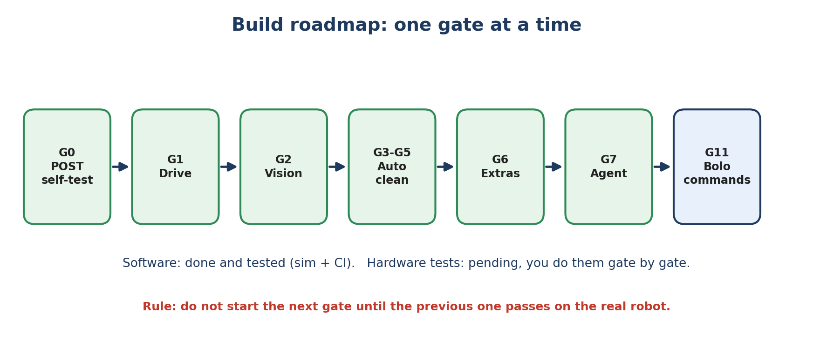
Figure 8. Gates in order
Gate | Name | Pass when
G0 | Boot self-test (POST) | Camera, sensors, storage and motors report healthy at boot
G1 | Drive | Forward, back, turns, STOP and E-STOP all work with wheels on the floor
G2 | Vision | Model detects trash and ignores keep-items on your test photos
G3-G5 | Autonomy | Search, approach, scoop, deposit and recovery work on a real floor
G6 | Extras | Battery monitor, bumper (if fitted), calibration and profiles
G7 | Agent | Cursor can read status and drive in the chosen mode, stop always works
G11 | Bolo | Hinglish and English commands do what they say, and stop wins every time

Software checks you can run any time
Command | Checks
python -m platformio run -d firmware -e xiao | Firmware builds
python -m pytest tools/tests -q | Python tools, pin map, sim, link checks
cd agent && npm ci && npm run build && npm test | MCP agent
cd shared/lang && npm test && npm run test:fuzz | Bolo parser and fuzz test
python tools/release_check.py | Full GO / NO-GO summary before flashing

11. Planned: Auto-collect mode (G12)
Taking hundreds of photos by hand is the heaviest part. An Auto-collect mode would let the robot drive slowly around the room and pick its own moments to take photos. This is an idea; it is not built yet.
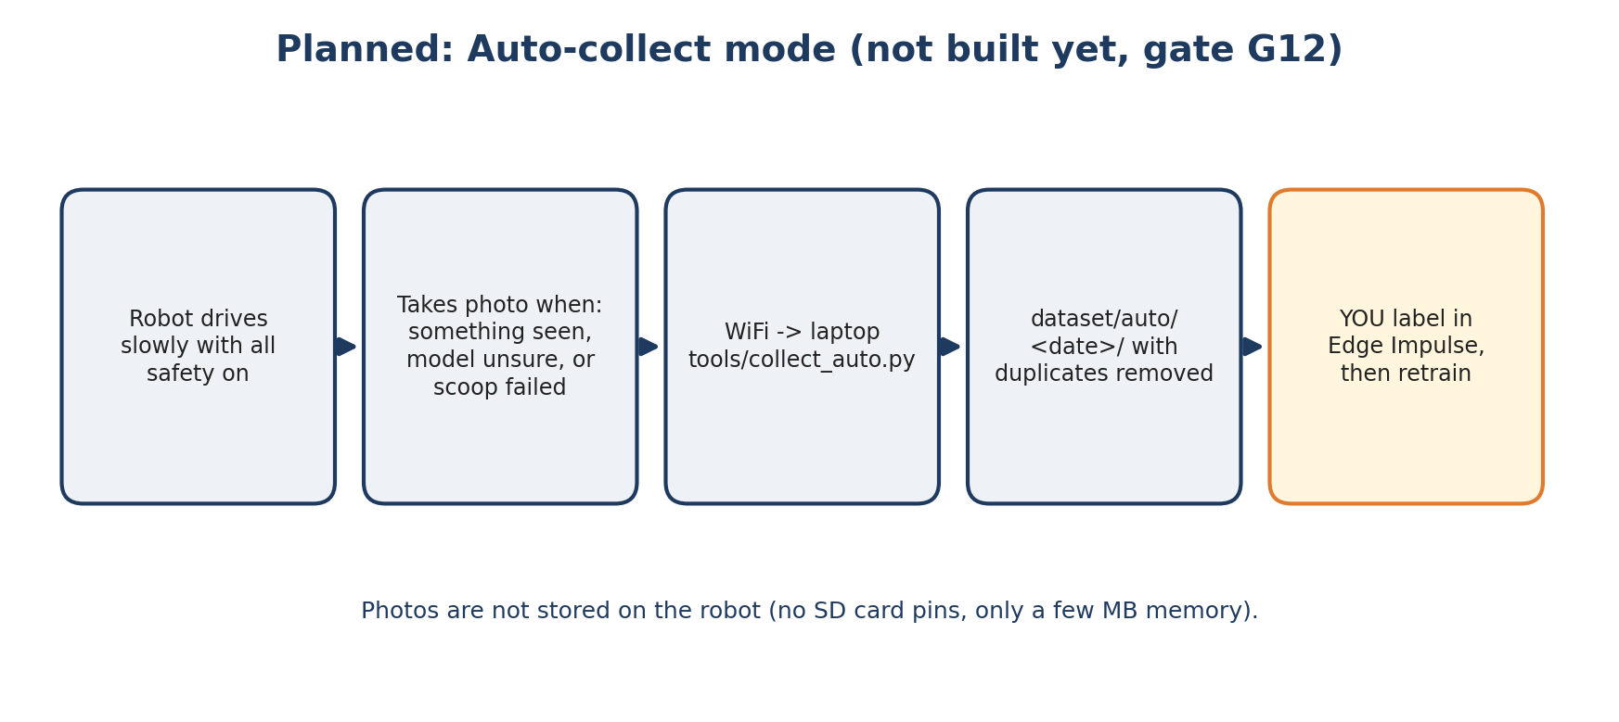
Figure 9. Auto-collect flow (planned)
- Photos are sent over WiFi to the laptop, not stored on the robot (no spare SD card pins, only a few MB of memory).
- A laptop script (tools/collect_auto.py) would save them to dataset/auto/<date>/ and drop near-duplicates.
- You still label the photos. No AI can be trusted to decide alone what is trash and what is yours.
- Only run with full safety on, small moves, and after G1 passes. Check battery and temperature before leaving it for long.

12. Safety and limitations
Topic | Rule
Real stops | Power switch, then STOP button. Chat is too slow to be a stop.
Environment | Indoor, flat floor, good light. Not for stairs or outdoors.
Items | Small, light items only. Tall or heavy objects (bottles, cans) are out of scope for the scoop.
Pets and children | Do not run unattended near pets or children. Moving parts and a servo arm.
Batteries | Protected 18650 cells, correct polarity, supervised charging.
Rear | No rear sensor; backward moves are limited to 20 cm.
Privacy | Photos stay on your laptop. Datasets and secrets.h are never committed to Git.
Untested hardware | Everything on real hardware is unproven until each gate passes.

13. Upgrade ideas (later)
One upgrade at a time, behind a config flag, with tests. Safety is never loosened. Prices are rough.
# | Upgrade | Why
B1 | Rubber lip on the scoop edge (INR 0-30) | Flat paper slides in instead of being pushed away; often the biggest single improvement
B2 | Front white LED (INR 50-150) | Much better detection in dim rooms
A1 | Bin-full counter | Ends the mission when the bin is likely full
A2 | Mission summary card | Collected / failed / skipped with the last mistake photo
A3 | “Desi kachra” dataset | Chips packets, chai cups, biscuit wrappers for better home detection
B3 | I2C ToF distance + gyro (INR 600-1,100) | Accurate turns, lift and tilt detection, better stuck detection
A4 | Telegram bot (status, photo, stop only) | Check on the robot from anywhere; no remote driving on purpose
C | Gripper arm, mapping, wake word | Bigger projects, see docs/UPGRADES.md

14. Glossary
Term | Meaning
ESP32-S3 / XIAO | The small microcontroller board that is the robot’s brain
FOMO | A tiny object-detection model from Edge Impulse that runs on small chips
Edge Impulse | Web tool to label photos and train the model
MCP | Model Context Protocol: a standard way to give an AI agent tools
Bolo | This project’s Hinglish + English command layer (“bolo” = speak)
dry_run | Agent mode that only describes what it would do
Gate | A checkpoint that must pass on the real robot before moving on
Regression gate | A check that a newly trained model is not worse than the old one
Motor lease | Motors run only while commands keep renewing a short timer
Ruko | Hindi for “stop”

