CICIoT2023 Dataset
Exploratory Data Analysis & Preprocessing Pipeline
Stage 1 — FL-IDS Research Foundation
April 2026

1. Overview
This document summarises the complete EDA and preprocessing pipeline applied to the CICIoT2023 dataset as the foundation for Stage 1 research on the impact of non-IID heterogeneity on poisoning defences in Federated IoT Intrusion Detection Systems.

Property | Value
Dataset | CICIoT2023 (Canadian Institute for Cybersecurity)
Source | University of New Brunswick (UNB)
Format | 63 CSV files (MERGED_CSV)
Raw rows | 45,019,243
Final clean rows | 21,005,152
Features | 39 numeric flow-level features
Attack classes | 34 (including Benign)
Attack categories | 8 broad groups
Research task | Binary + multiclass IoT intrusion detection

2. Exploratory Data Analysis (01_EDA.ipynb)

2.1 Data Loading
All 63 CSV part-files from the MERGED_CSV directory were loaded and concatenated into a single dataframe using glob and pd.concat. The resulting raw dataset contained 45,019,243 rows and 40 columns (39 numeric features + 1 Label column). All 39 features were confirmed to be numeric (float64/int64) with no text encoding required.

2.2 Data Quality Checks

Check | Finding | Action Taken
Missing values | 1,498 total across dataset | Dropped affected rows
Inf values | 991 found in Rate column only | Replaced with NaN, then dropped
Duplicate rows | 24,013,505 (53% of dataset) | Removed all duplicates
Constant columns | None found | No action needed

The 24 million duplicate rows are a known artefact of CICFlowMeter, the tool used to generate the dataset. Their removal is standard practice and does not introduce bias.

2.3 Label Distribution (after deduplication)
The dataset contains 34 unique attack classes with severe class imbalance. Selected class counts after deduplication:

Attack Class | Count | Category
DDOS-UDP_FLOOD | 1,964,173 | DDoS
DDOS-ICMP_FLOOD | 1,907,584 | DDoS
DOS-UDP_FLOOD | 1,851,659 | DoS
BENIGN | 1,047,367 | Benign
DICTIONARYBRUTEFORCE | 12,520 | BruteForce
RECON-PINGSWEEP | 2,161 | Recon
UPLOADING_ATTACK | 1,196 | Web

2.4 Attack Category Distribution
The 34 fine-grained attack labels were mapped to 8 broad categories for higher-level analysis:

Category | Count | % of Dataset | Research Significance
DDoS | 12,292,320 | 58.5% | Dominant class — skews global defences
DoS | 4,178,945 | 19.9% | Second largest
Mirai | 2,359,308 | 11.2% | Botnet-specific attacks
Benign | 1,047,367 | 5.0% | Normal traffic baseline
Recon | 655,477 | 3.1% | Scanning behaviour
Spoofing | 436,084 | 2.1% | ARP and DNS spoofing
Web | 23,708 | 0.1% | Minority — missed by global thresholds
BruteForce | 12,520 | 0.06% | Minority — missed by global thresholds

Key research finding: The extreme imbalance between DDoS (58%) and minority classes such as Web (0.1%) and BruteForce (0.06%) directly motivates the non-IID heterogeneity problem. FL clients observing different slices of this distribution will produce fundamentally different model updates, causing global threshold defences to fail.

2.5 Feature Statistics
Notable observations from feature-level statistics:
- Rate feature: range spans 0 to 15.7 million — requires normalisation
- IAT (Inter-Arrival Time): contains small negative values (-0.018) — CICFlowMeter artefact
- IPv and LLC features: identical mean and std — perfectly correlated, candidate for removal in later ablation
- Variance feature: extreme range (0 to 135 million) — another scaling candidate

2.6 EDA Outputs Saved
File | Description
eda_outputs/category_distribution.png | Bar chart of 8 attack categories
eda_outputs/feature_statistics.csv | Mean, std, min, max per feature
extracted/ciciot_clean.csv | Full cleaned dataset (21M rows)
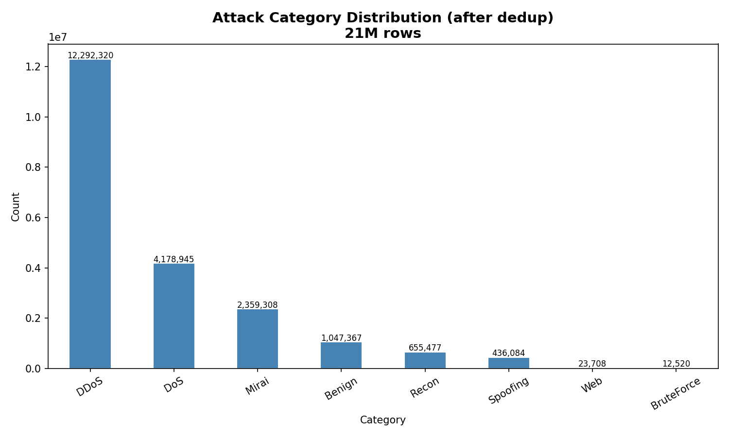

3. Preprocessing Pipeline (02_Preprocessing.ipynb)

3.1 Data Loading
The clean dataset was loaded directly from ciciot_clean.csv (21,005,152 rows x 41 columns). This eliminated the need to reprocess 63 raw CSV files in subsequent sessions.

3.2 Target Variable Creation
Two target variables were created for different modelling tasks:

Target | Type | Encoding | Distribution
target_binary | Binary classification | 0 = Benign, 1 = Attack | 1,047,308 benign vs 19,957,844 attack (19:1 ratio)
target_multi | 34-class classification | LabelEncoder (0-33) | 34 classes, BACKDOOR_MALWARE=0 to XSS=33

The binary target was prioritised for the first baseline as recommended practice — simpler, more interpretable, and better suited for establishing FL defence baselines.

3.3 Feature Definition
39 numeric columns were used as features. Excluded from features: Label, Category, target_binary, target_multi.

3.4 Train/Test Split
Parameter | Value | Reason
Split ratio | 80% train / 20% test | Standard practice for large datasets
Strategy | Stratified on binary target | Preserves 19:1 imbalance ratio in both splits
Random state | 42 | Reproducibility
Train size | 16,804,121 rows
Test size | 4,201,031 rows

3.5 Feature Scaling
MinMaxScaler was applied to normalise all 39 features to the range [0, 1].

Step | Detail
Scaler fitted on | Training set only
Scaler applied to | Both train and test using same fitted object
Leakage prevention | Test data statistics never used in fitting — standard ML best practice
Result | All feature values confirmed in range [0.0, 1.0]

3.6 Class Imbalance Strategy
SMOTE was deliberately not applied at this stage. Reasons:
- 16.8 million training rows makes SMOTE computationally prohibitive (hours of runtime, high memory risk)
- The baseline model uses class_weight='balanced' in Random Forest — built-in, fast, and effective
- The imbalance is itself a feature of the research problem, not a bug to be eliminated before FL simulation
- SMOTE will be revisited if baseline minority-class recall is insufficient

3.7 Saved Preprocessing Artifacts
File | Description
extracted/X_train.csv | 16.8M x 39 scaled training features
extracted/X_test.csv | 4.2M x 39 scaled test features
extracted/y_train_binary.csv | Binary labels for training set
extracted/y_test_binary.csv | Binary labels for test set
extracted/y_train_multi.csv | 34-class labels for training set
extracted/y_test_multi.csv | 34-class labels for test set
extracted/scaler.pkl | Fitted MinMaxScaler object
extracted/label_encoder.pkl | Fitted LabelEncoder object
extracted/label_mapping.json | Class name to integer mapping

4. Key Decisions and Rationale

Decision | Rationale
Remove duplicates before any analysis | 53% were exact duplicates — keeping them would inflate model accuracy artificially and misrepresent the true data distribution
Replace Inf before NaN handling | CICFlowMeter produces Inf values in rate features; these must be converted to NaN before standard missing value handling applies
Binary target before multiclass | Simpler baseline, cleaner evaluation, standard entry point for IDS research. Multiclass follows once binary is solid.
Fit scaler on train only | Prevents data leakage — test set statistics must never influence any fitted transformation object
Save all splits separately | Downstream notebooks load instantly without any reprocessing of 63 raw files
Retain Category as analysis column only | Category is useful for visualisation and grouping but is not a training target — using it as a target would skip fine-grained label detail
class_weight='balanced' over SMOTE | Dataset size makes SMOTE impractical at this stage; class weighting achieves imbalance correction with negligible overhead

5. Next Steps

Session | Notebook | Task
Next | 03_Baseline.ipynb | Train Random Forest on binary task. Evaluate accuracy, F1, per-class recall. Produce first results table.
Week 2 | 04_FL_Simulation.ipynb | Partition dataset into non-IID FL clients using Dirichlet label skew. Run FedAvg baseline.
Week 2-3 | 05_Heterogeneity.ipynb | Measure per-client update norms, cosine similarities, label distributions. Prove clients differ systematically.
Week 3-4 | 06_Attack.ipynb | Implement first poisoning-by-mimicry attack. Show global defences fail.
Week 4+ | 07_Detector.ipynb | Build client-conditioned D_i threshold detector. Compare against global baselines.

6. Dataset Summary Statistics

Metric | Before Cleaning | After Cleaning
Total rows | 45,019,243 | 21,005,152
Duplicate rows removed | — | 24,013,505 (53%)
Inf values fixed | — | 991 (Rate column)
NaN rows dropped | — | 586
Feature columns | 39 | 39
Label classes | 34 | 34
Attack categories | 8 | 8
Train / Test split | — | 16,804,121 / 4,201,031
Binary imbalance ratio | — | 19:1 (Attack:Benign)

