# **Laboratory Assignment File**

For

**Computer Vision Laboratory(CSPC-358)**

**B.Tech (CSE) 6th Semester (Sec-B)**

**Prepared during (Jan-June 2024) By**

Name: Satyam Gupta

Roll no.: 21103136

Submitted to: Dr. Shweta Mahajan

**Department of Computer Science and Engineering**

**DR. B.R. AMBEDKAR NATIONAL INSTITUTE OF TECHNOLOGY JALANDHAR, PUNJAB-144027**

**Week 2**

**Assignment Problem Statements**

**Aim: Compute Mean, Median, Mode, Variance and Standard Deviation of different images and compare their results**

**.**

**Theory:**

Mean, Median, Mode, Variance and Standard Deviation are descriptive statistical measures commonly used in computer vision to analyse and describe the characteristics of data. Here's a brief overview of each concept in the context of computer vision:

**Mean**

In computer vision, the mean represents the average value of a set of data points, such as pixel intensities in an image. Calculation involves summing up all values and dividing by the total number of data points. Useful for tasks like image normalization, where adjusting pixel values based on the mean enhances or prepares images for processing.

**Median**

The median is the middle value of a dataset when sorted in ascending or descending order.In computer vision, the median is less sensitive to extreme values (outliers) compared to the mean. Commonly used in image processing to reduce the impact of noise or outliers in pixel values.

**Mode**

Mode represents the value that appears most frequently in a dataset. Applied in computer vision to identify dominant colors or patterns in images. For instance, in image segmentation, the mode might indicate the prevalent color or texture in a specific region.

**Variance**

Variance measures the spread or dispersion of pixel intensities in an image. In computer vision, high variance may indicate regions with diverse textures or detailed patterns, while low variance may correspond to more uniform areas. Relevant for tasks like image quality assessment, texture analysis, and noise detection.

**Standard Deviation**

Standard deviation measures the amount of variation or dispersion of a set of values. Useful in computer vision for understanding the spread of pixel intensities in an image. Higher standard deviation may indicate a greater diversity of pixel values, which could be relevant for tasks like detecting edges or texture variations.

**Applications:**

1. **Image Enhancement and Normalization:**

Mean: Used for normalization and enhancing images by adjusting pixel values based on the mean.

Variance and Standard Deviation: Help in understanding the distribution of pixel intensities, valuable for contrast enhancement.

1. **Noise Reduction:**

Median: Employed in median filtering to reduce noise in images, especially salt-and-pepper noise.

Variance: Used to identify noisy regions, as high variance may indicate the presence of noise.

**Code:**

import cv2

import matplotlib.pyplot as plt

import numpy as np

from scipy import stats

import pandas as pd

def display(img, title):

plt.imshow(img)

plt.title(title)

def statistics(image):

image = image.flatten()

means = np.mean(image)

median = np.median(image)

mode = stats.mode(image).mode

std = np.std(image)

variance = np.var(image)

return means, median ,mode, std

rgb_image = cv2.cvtColor(img, cv2.COLOR_BGR2RGB)

grayscale_image = cv2.cvtColor(rgb_image, cv2.COLOR_RGB2GRAY)

binary_image = cv2.threshold(grayscale_image, 128, 255, cv2.THRESH_BINARY)[1]

display(rgb_image, "RGB Image")

display(grayscale_image, "GRAYSCALE Image")

display(binary_image, "BINARY Image")

# Values of binary Image

height, width = binary_image.shape

value = {}

for i in range(height):

for j in range(width):

if binary_image[i,j] in value:

value[binary_image[i,j]] = value[binary_image[i,j]] + 1

else:

value[binary_image[i,j]] = 1

value

data = {'Statistic': ['Mean', 'Mode', 'Median', 'Standard Deviation'],

'RGB Image': statistics(rgb_image),

'Gray Image': statistics(grayscale_image),

'Binary Image': statistics(binary_image)}

df = pd.DataFrame(data)

# Define colors for the cells in the table

colors = ['#A7C7E7', '#ADD8E6', '#87CEEB', '#CCCCFF']

# Display the statistics table with color in a separate window

fig, ax = plt.subplots(figsize=(8, 3))

ax.axis('off')

table = ax.table(cellText=df.values,

colLabels=df.columns,

cellLoc='center',

loc='center',

cellColours=[colors] * len(df), # Replicate colors for each row

bbox=[0, 0, 1, 1])

plt.show()

labels = ['Mean', 'Median', 'Mode', 'Std']

values_b = statistics(rgb_image)

values_g = statistics(grayscale_image)

values_r = statistics(binary_image)

bar_width = 0.2

index = np.arange(len(labels))

plt.bar(index, values_b, bar_width, label='RGB Image', color='red')

plt.bar(index + bar_width, values_g, bar_width, label='Grayscale Image', color='green')

plt.bar(index + 2*bar_width, values_r, bar_width, label='Binary Image', color='yellow')

plt.xlabel('Statistics')

plt.ylabel('Values')

plt.xticks(index + bar_width, labels)

plt.legend()

**Output:**

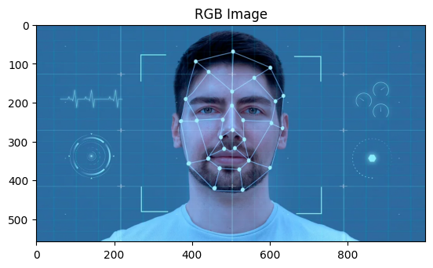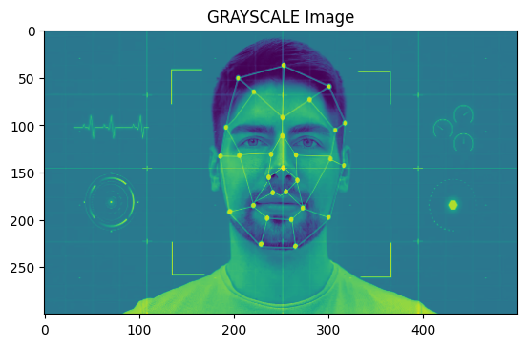

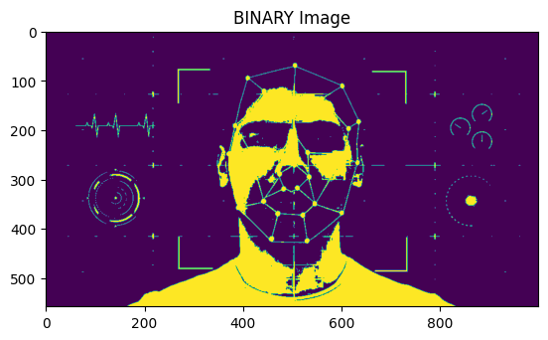

**Values of Binary Value : {0: 476919, 255: 81081}**

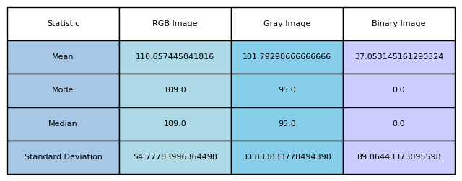

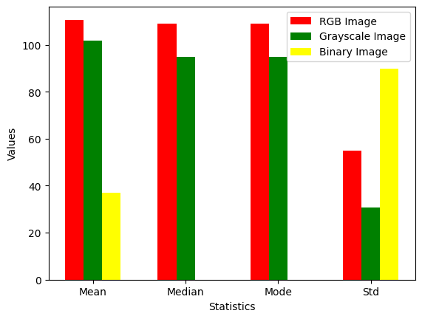

**Inference:**

The computed statistical values for the three types of images (RGB, grayscale, and binary) offer valuable insights into their pixel intensity characteristics, allowing us to draw several noteworthy inferences:

**a)** **Mean:**

- The mean value for the RGB image tends to be higher, primarily attributable to the presence of diverse color information.

- In contrast, grayscale and binary images generally exhibit lower mean values, reflecting a concentration of pixel intensities without color variations.

**b) Mode:**

- In the RGB image, the mode can signify prevalent colors, capturing the most frequently occurring color values.

- For grayscale and binary images, the mode is instrumental in highlighting dominant shades or values, providing insights into the predominant intensity levels.

**c) Median:**

- In the RGB image, the median may be influenced by the distribution of colors, representing the middle value in the sorted intensity sequence.

- Grayscale and binary images, being devoid of color complexities, have medians that reflect the central intensity value, offering a robust measure against extreme outliers.

**d) Standard Deviation:**

- A higher standard deviation in the RGB image suggests a broader range of colors, indicating increased variability in pixel intensities.

- Conversely, lower standard deviation values in grayscale and binary images point to more uniform pixel intensities, signifying a reduced range of intensity variations.

In summary, these inferences deepen our understanding of the pixel intensity characteristics across different image types, paving the way for informed analysis and tailored processing approaches based on statistical insights.

**Generalizing Results**

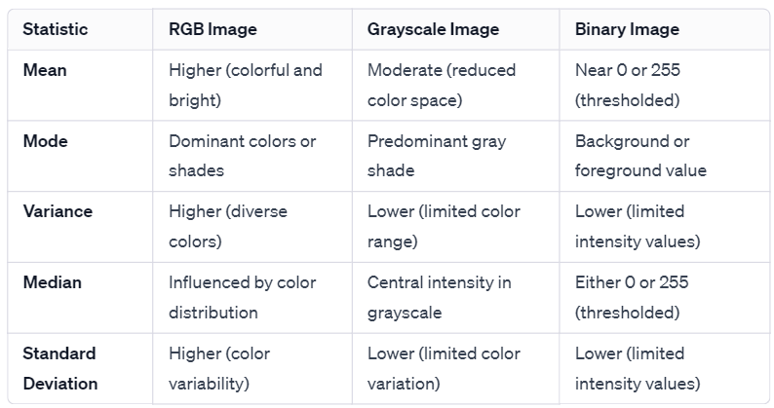

**Result :**

Mean, Median, Mode, Variance and Standard Deviation of different images are successfully computed.