**Visualization Dashboard**

*The objective of this assignment is to create a data visualization dashboard as per as instructions given below.*

**Data**

Json file: jsondata.json

**Data Visualization Dashboard**

* You can visualize data using examples given below. It has to be either same as the below examples or even better than them.
* Develop any creative visualization that you like most from the example below. Remember, it has to be either similar to the below example chart or better than them.

**Example Dashboard 1**

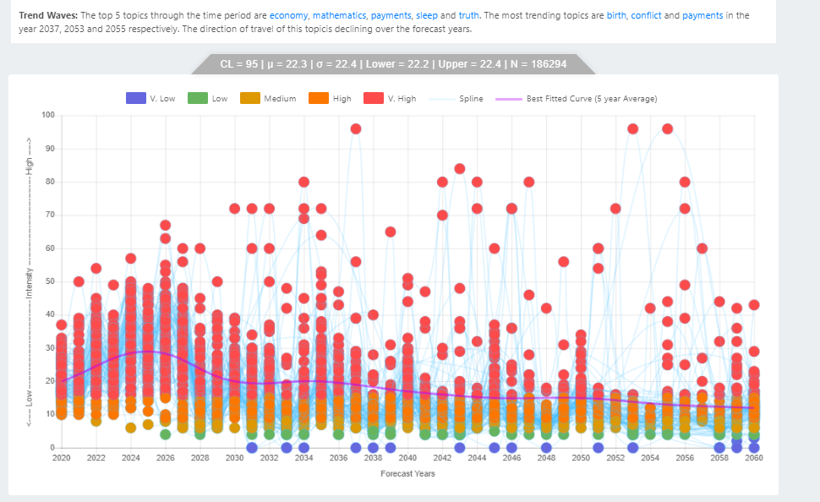

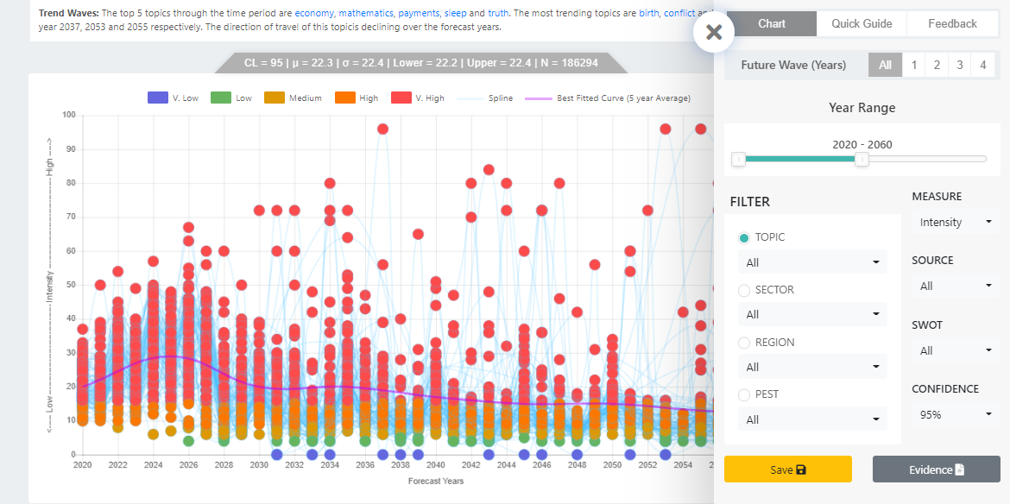

**Example Dashboard 2**

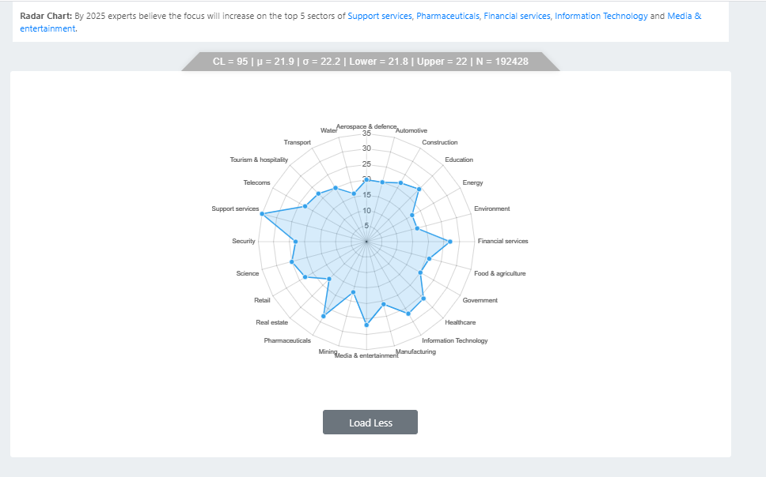

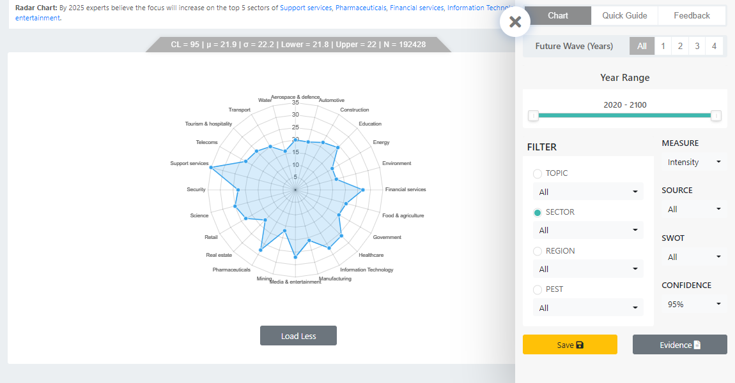

**Example Dashboard 3:**

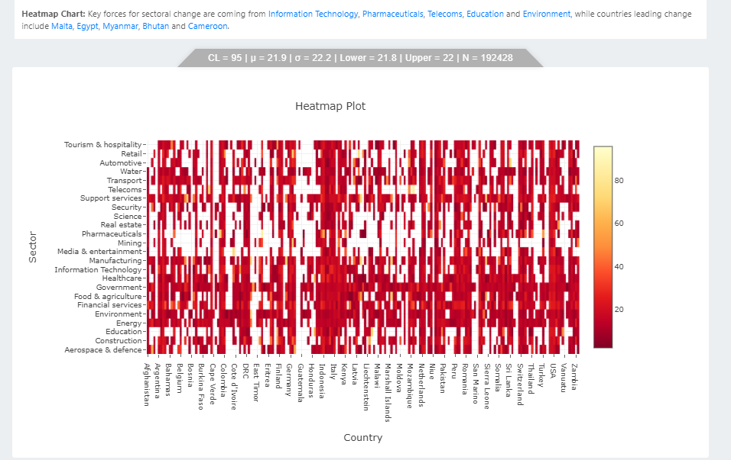

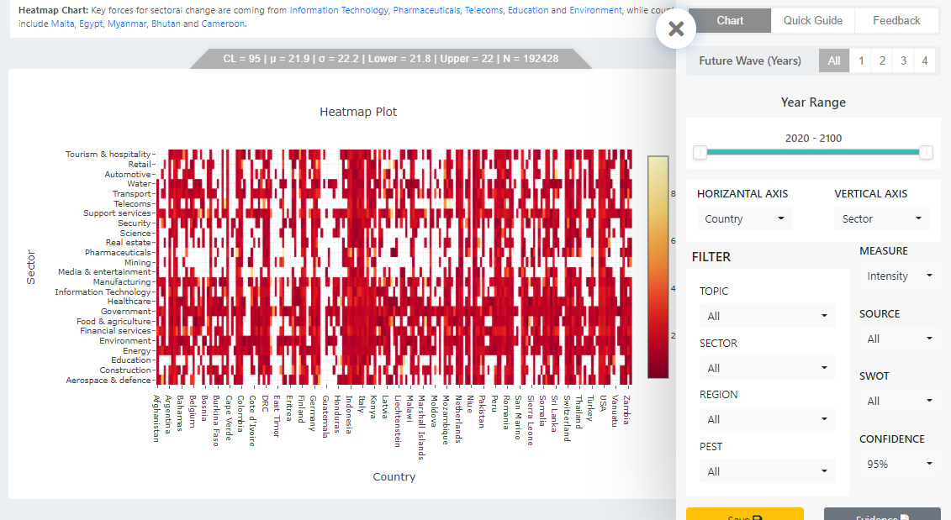

**Note:** You can work on either example 1 or example 2 or example 3 using the provided data set in JSON. Examples are built on exactly the same JSON dataset.

Hint: You can use Google Charts: <https://developers.google.com/chart/> or D3, or chart.js or any other libraries available in the javascript or **React.js**

**Where to submit?**

Inform Completion of the assignment at [uday@blackcoffer.com](mailto:uday@blackcoffer.com), and we will set up a demo and interview.

1. Send your submission to [uday@blackcoffer.com](mailto:uday@blackcoffer.com)
2. Fill this google form: <https://forms.gle/WgEzLUfXfqWYWmXS7>
3. Inform us at uday@blackcoffer.com

**Timeline**

Timeline: 8 Days. Sooner is better.

**Questions?**

Text message on Skype id “usravidas” if you have any questions.