Docker Architecture

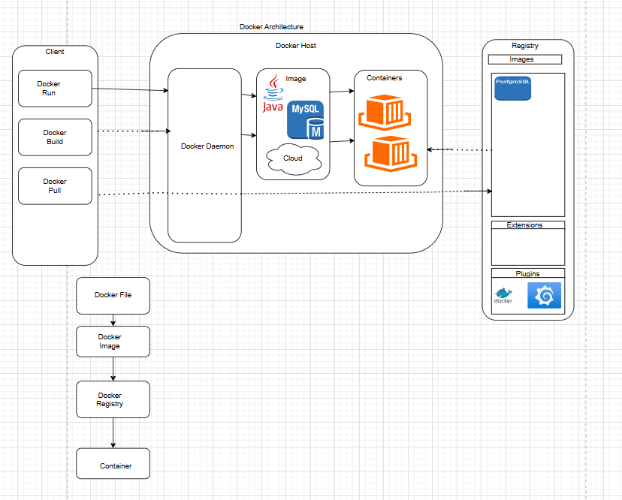

[The Docker daemon](https://docs.docker.com/get-started/docker-overview/#the-docker-daemon)

The Docker daemon listens for Docker API requests and manages Docker objects such as images, containers, networks, and volumes. A daemon can also communicate with other daemons to manage Docker services.

[The Docker client](https://docs.docker.com/get-started/docker-overview/#the-docker-client)

The Docker client is the primary way that many Docker users interact with Docker. When you use commands such as docker run, the client sends these commands to dockered, which carries them out.

[Docker registries](https://docs.docker.com/get-started/docker-overview/#docker-registries)

A Docker registry stores Docker images. Docker Hub is a public registry that anyone can use, and Docker looks for images on Docker Hub by default.

[Docker objects](https://docs.docker.com/get-started/docker-overview/#docker-objects)

When you use Docker, you are creating and using images, containers, networks, volumes, plugins, and other objects. This section is a brief overview of some of those objects.

[Images](https://docs.docker.com/get-started/docker-overview/#images)

An image is a read-only template with instructions for creating a Docker container. Often, an image is based on another image, with some additional customization.

[Containers](https://docs.docker.com/get-started/docker-overview/#containers)

A container is a runnable instance of an image. You can create, start, stop, move, or delete a container using the Docker API or CLI..