Query 1 results
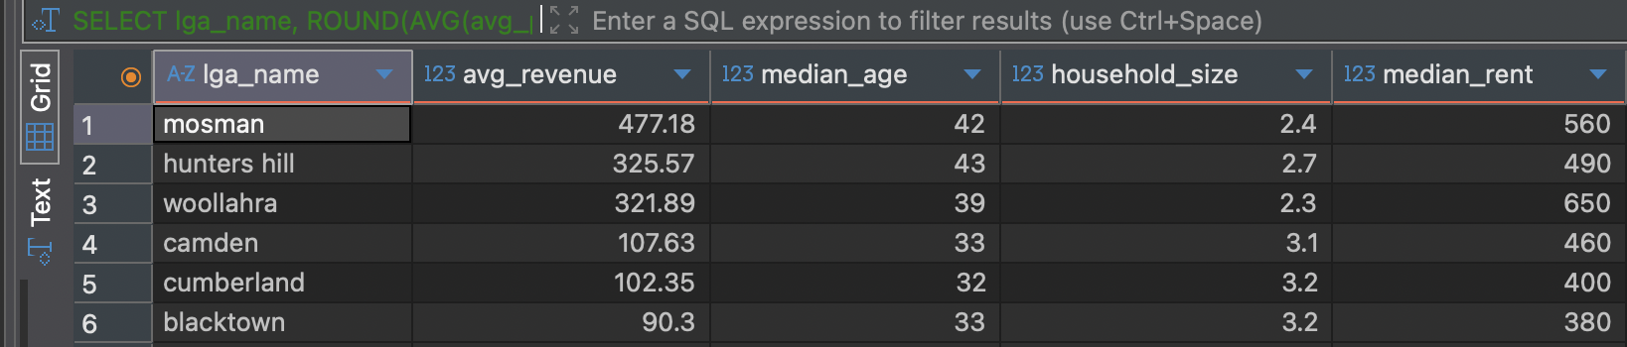

Query 2 results

Query 3 results
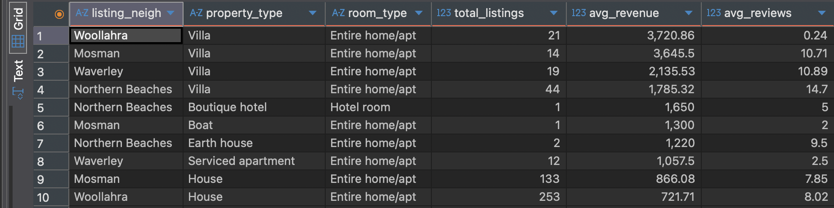

Query 4 results
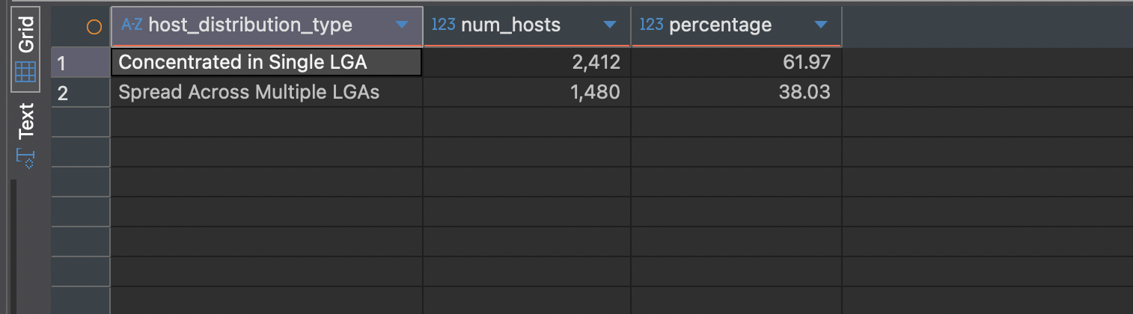
Query 5 results
