Advanced Data Visualization and Storytelling with Python
Week 2 — Data Science Internship Task
Dataset: World Happiness Report (Gallup World Poll / UN Sustainable Development Solutions Network)

1. Introduction
This report builds a data-driven narrative around global happiness using the World Happiness Report dataset, which ranks 153 countries on a happiness score derived from Gallup World Poll surveys, alongside six explanatory factors: GDP per capita, social support, health/life expectancy, freedom, generosity, and perceived corruption. The goal is not just to display numbers, but to tell a coherent story: what actually separates the happiest nations from the least happy, and what that means for policymakers, businesses, and researchers.
The narrative is built in stages: first showing who is happiest and least happy, then explaining regional patterns, then testing which underlying factors actually drive the differences, and finally decomposing the top performers to see how their happiness is 'built.'

2. Methodology
Data was loaded and cleaned with Pandas: column names were standardized, and the small number of missing values in Job Satisfaction (2 rows) were left as-is since that field was used only for supplementary correlation and did not affect the core happiness ranking. All visualizations were built with Matplotlib and Seaborn, chosen deliberately for each chart type to match the shape of the story being told at that point (ranking, distribution, relationship, or composition).
import pandas as pd
df = pd.read_csv("happiness.csv")
df.columns = [c.strip() for c in df.columns]
df = df.dropna(subset=["Happiness Score"])

3. The Data Story

3.1 Who Is Happiest — and Who Isn't
The story opens with the most direct comparison: which countries top and bottom the ranking. A horizontal bar chart was chosen over a vertical one specifically because country names are long and read far more naturally on the y-axis.
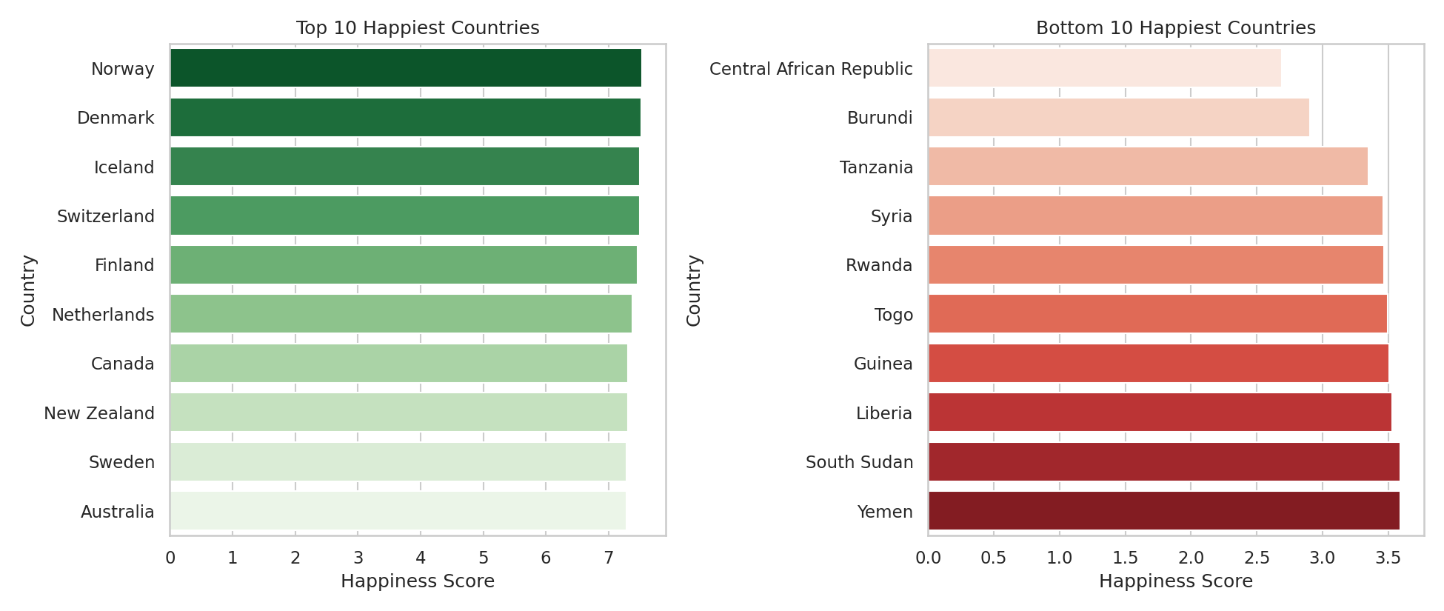
Figure 1. Top 10 and bottom 10 happiest countries by Happiness Score.
Norway, Denmark, and Iceland lead the rankings, all Nordic countries with strong welfare systems. The bottom is dominated by countries affected by conflict or extreme poverty (Central African Republic, Burundi, Syria, South Sudan, Yemen) — immediately suggesting that stability and basic security, not just wealth, underpin happiness.

3.2 The Regional Pattern
Rather than jumping straight to individual-country explanations, the story zooms out to regions, since patterns at the regional level reveal whether happiness clusters around geography, economic development, or culture.
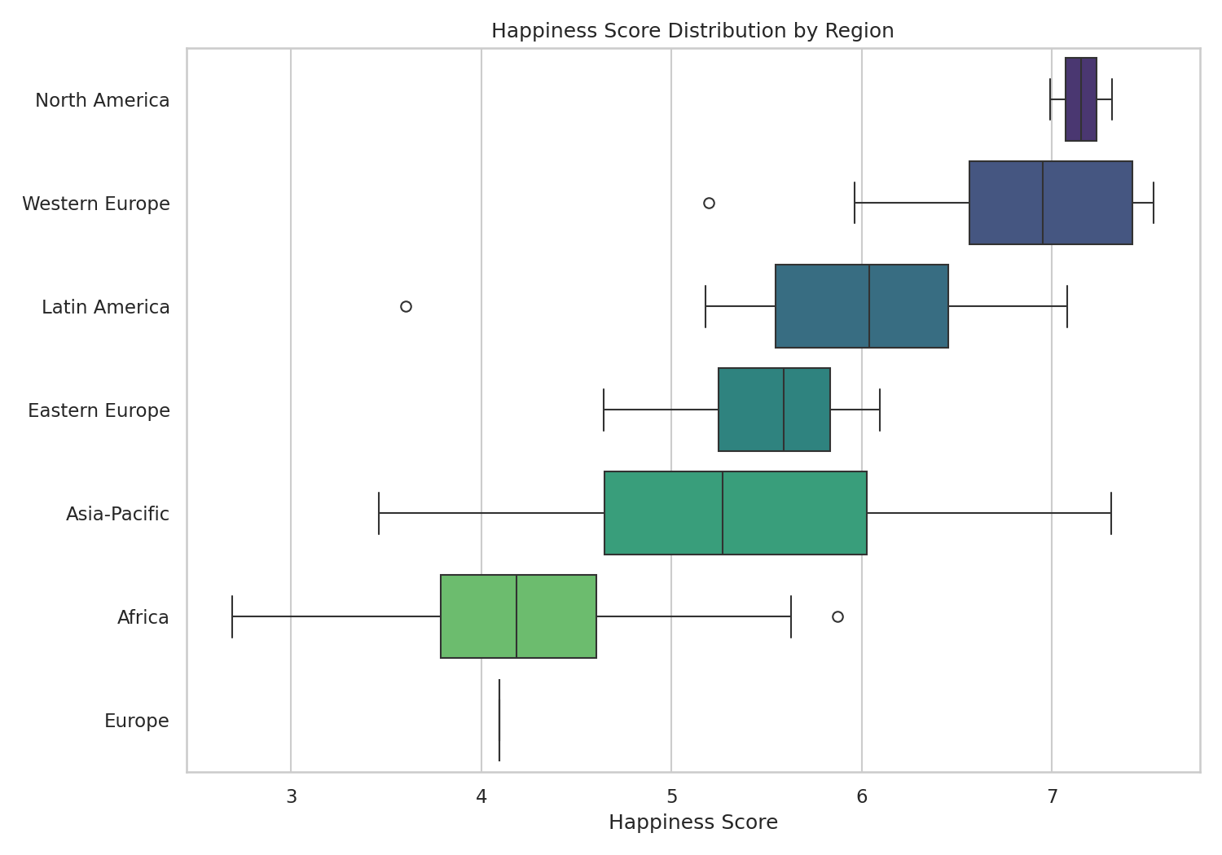
Figure 2. Distribution of Happiness Score by world region, ordered by median score.
North America and Western Europe have both the highest median scores and the tightest distributions (little variation between countries), while Africa shows both the lowest median and widest spread — some African nations score close to the global average, while others are far below it. This tells a more nuanced story than a single average would: regional happiness gaps aren't uniform, and within-region inequality matters too.

3.3 What Actually Drives Happiness: GDP and Beyond
A common assumption is that happiness is mainly about wealth. To test this directly, GDP per capita is plotted against happiness score, with bubble size representing each country's health/life-expectancy contribution — adding a third dimension without needing a 3D chart, which would be harder for a non-technical audience to read.
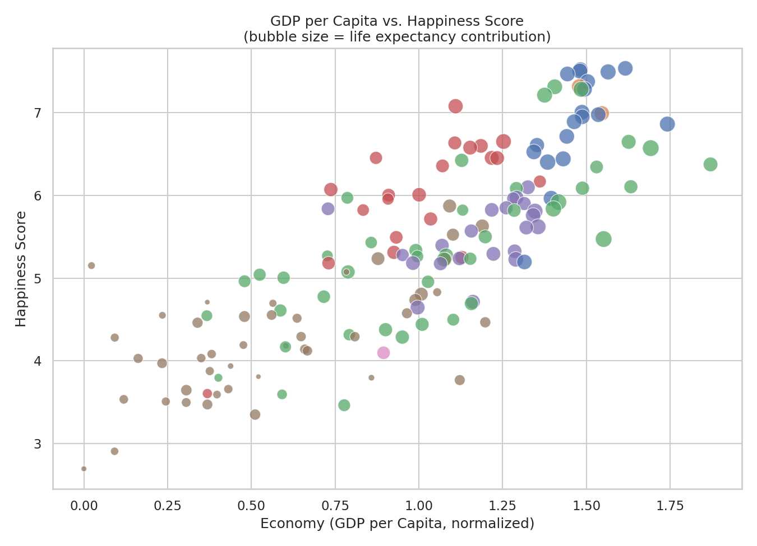
Figure 3. GDP per capita vs. Happiness Score, bubble size representing health contribution.
There is a clear positive relationship, but it is not perfectly linear — some mid-income countries score higher than wealthier ones, and the largest bubbles (best health outcomes) cluster in the upper-right, suggesting GDP and health reinforce each other rather than acting independently.

3.4 Quantifying the Drivers
To move from visual impression to evidence, a correlation heatmap quantifies how strongly each factor relates to happiness across all 153 countries.
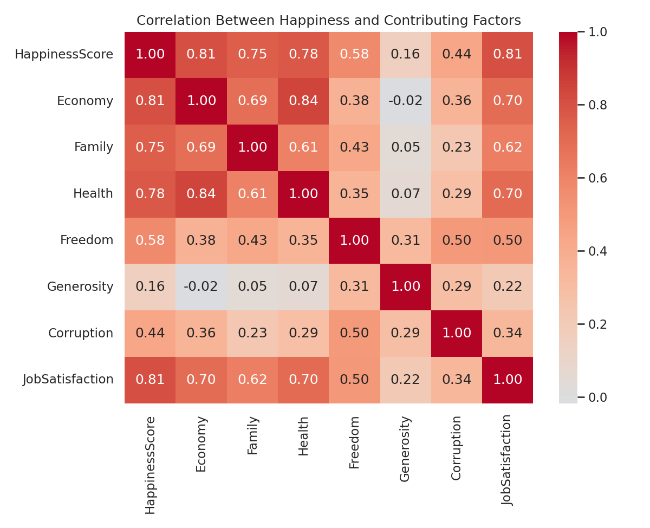
Figure 4. Correlation matrix between Happiness Score and its contributing factors.
GDP (r = 0.81), Job Satisfaction (r = 0.81), and Health (r = 0.78) are the strongest correlates of happiness, followed closely by Family/social support (r = 0.75). Freedom shows a moderate relationship (r = 0.58), while Generosity is only weakly related (r = 0.16) — a genuinely counter-intuitive finding worth highlighting: how generous a nation's citizens are does not strongly predict how happy that nation is.

3.5 Regional Averages at a Glance
A lollipop chart summarizes the regional story from section 3.2 into a single clean visual, ideal for a closing summary slide or exec-level takeaway — it strips away distribution detail and focuses purely on the headline number per region.
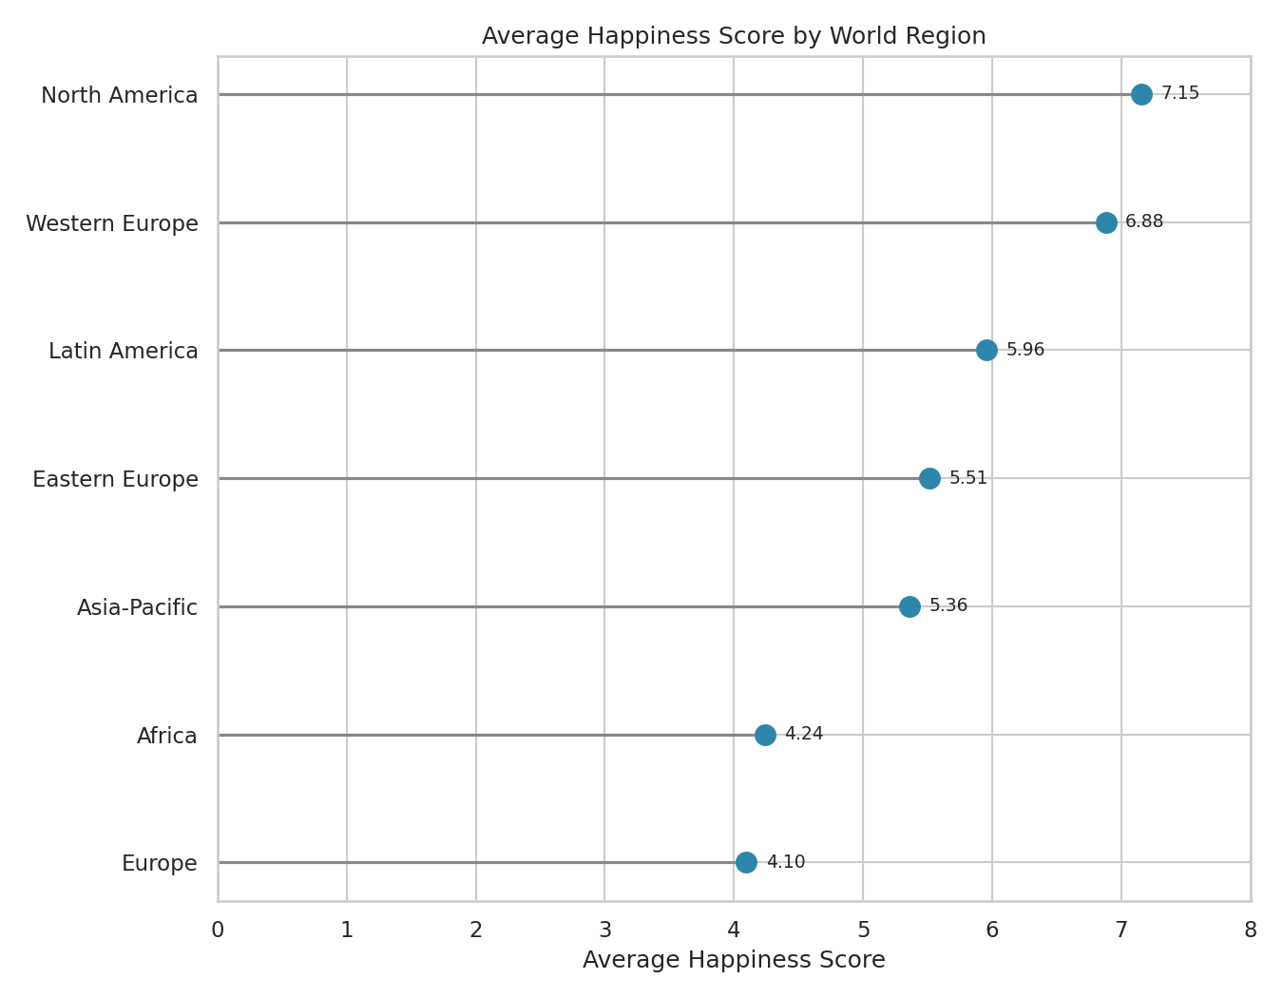
Figure 5. Average Happiness Score by world region, sorted lowest to highest.
North America (7.15) and Western Europe (6.88) lead by a wide margin over Africa (4.24) and Europe's non-Western sub-region (4.10) — a gap of roughly 3 full points on a 10-point scale, among the largest and most policy-relevant findings in the dataset.

3.6 How Happiness Is Built: Decomposing the Top 10
The final chart shifts from 'how much' to 'how' — decomposing the happiness score of the top 10 countries into their underlying factor contributions, closing the narrative loop by showing precisely which ingredients make up each country's success.
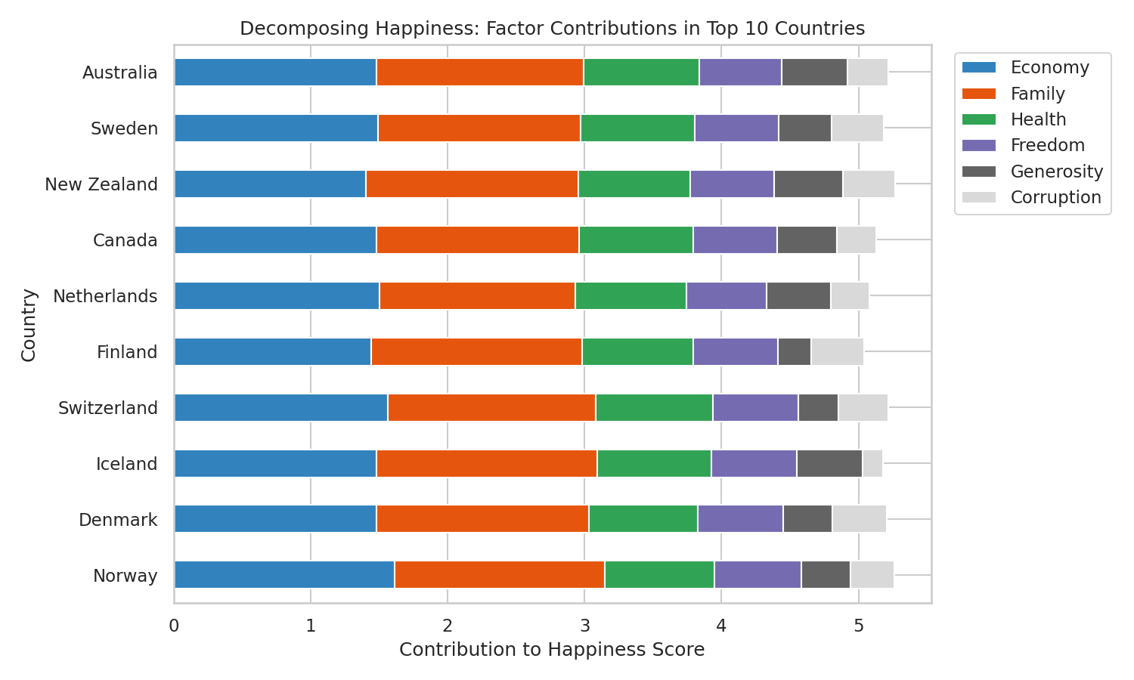
Figure 6. Stacked contribution of each factor to the Happiness Score, top 10 countries.
Economic output and Family/social support are consistently the two largest bars across nearly every top-10 country, reinforcing the correlation findings above — but the exact mix varies: some countries lean more heavily on health, others on freedom, showing there is more than one path to a high happiness score.

4. Summary of Insights
- Nordic and North American countries dominate the top of the happiness rankings; the bottom is dominated by countries experiencing conflict or extreme poverty.
- GDP, Job Satisfaction, and Health are the three strongest quantitative predictors of national happiness (all r > 0.75).
- Generosity is only weakly correlated with happiness (r = 0.16) — a country's citizens being generous does not, on its own, translate into a happier population.
- Regional inequality within Africa is wide — some nations approach the global average, while others sit far below it, meaning regional averages alone can obscure meaningful variation.
- The gap between the happiest and least happy regions is roughly 3 points on a 10-point scale — a substantial, policy-relevant disparity.
- No single factor fully explains happiness; the top 10 countries reach their scores through different combinations of GDP, family support, and health.

5. Business & Scientific Implications
- Policy: Investment in social support systems and healthcare appears at least as important as raw GDP growth for improving national wellbeing, since both show similarly strong correlations with happiness.
- Corporate/HR: The strong correlation between Job Satisfaction and Happiness Score suggests employee wellbeing initiatives may have outsized impact on broader life satisfaction, relevant for multinational companies designing regional HR policy.
- Market research: Companies expanding into new regions could use regional happiness and its drivers as a proxy for consumer sentiment and market stability, alongside traditional economic indicators.
- Further research: Because Generosity is a weak predictor while Freedom and Corruption perception show moderate relationships, future work could investigate whether institutional trust, rather than individual behavior, is the more meaningful lever for national wellbeing.

6. Tools & Environment
Python 3 with Pandas, NumPy, Matplotlib, and Seaborn was used for all data manipulation and visualization, chosen for full control over chart styling and layout suited to a static, print-quality report intended for a non-technical audience.

