Machine Learning Model Development and Evaluation
Week 4 — Data Science Internship Task
Dataset: Breast Cancer Wisconsin (Diagnostic) Dataset, 569 samples

1. Introduction & Problem Statement
This report documents the development, training, and evaluation of a binary classification model to predict whether a breast tumor is malignant or benign, based on measurements taken from digitized images of a fine needle aspirate (FNA) of breast tissue. The dataset contains 569 samples and 30 numeric features describing cell nuclei characteristics (radius, texture, perimeter, area, smoothness, and related statistics), sourced from the widely-used Breast Cancer Wisconsin (Diagnostic) Dataset.
This is a genuinely high-stakes classification problem: a false negative (predicting benign when the tumor is malignant) could delay critical treatment, so the evaluation in this report pays particular attention to recall, not just overall accuracy.

2. Data Preparation
The dataset required no missing-value handling, since it contains 0 missing values across all 569 samples and 30 features — a check was still performed explicitly rather than assumed. The two-step preparation process was:
- Train/test split (75%/25%), stratified by target class to preserve the original class balance (357 benign, 212 malignant) in both subsets — this prevents the test set from accidentally being skewed toward one class.
- Feature scaling with StandardScaler, which transforms each feature to zero mean and unit variance. This step is essential for logistic regression, since the 30 features are on very different scales (e.g. 'area' ranges into the thousands while 'smoothness' is a small decimal), and unscaled features would cause the model to unfairly weight larger-magnitude variables.
X_train, X_test, y_train, y_test = train_test_split(
X, y, test_size=0.25, random_state=42, stratify=y
)
scaler = StandardScaler()
X_train_scaled = scaler.fit_transform(X_train)
X_test_scaled = scaler.transform(X_test)
Note that the scaler was fit only on the training data and then applied to the test data — fitting on the full dataset before splitting would leak information from the test set into training, inflating apparent performance.

3. Model Selection & Training
Logistic Regression was selected as the model for three reasons: (1) the target is binary (malignant/benign), which logistic regression handles natively; (2) it produces interpretable coefficients, which matters in a medical context where understanding which features drive a prediction is often as important as the prediction itself; and (3) it serves as a strong, fast baseline before considering more complex models like random forests or gradient boosting.
model = LogisticRegression(max_iter=5000, random_state=42)
model.fit(X_train_scaled, y_train)
y_pred = model.predict(X_test_scaled)
y_proba = model.predict_proba(X_test_scaled)[:, 1]

4. Evaluation Results
Metric | Score
Accuracy | 98.60%
Precision | 98.89%
Recall | 98.89%
F1 Score | 98.89%
ROC-AUC | 0.998

4.1 Confusion Matrix
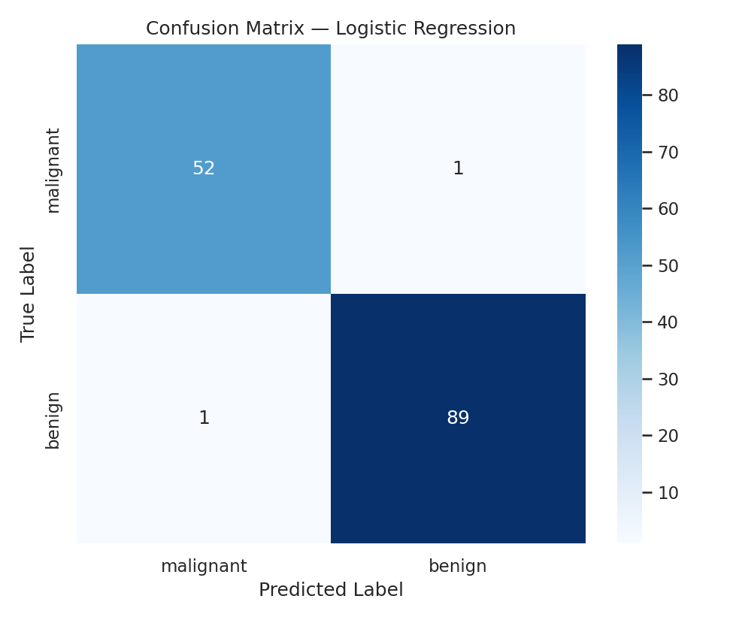
Figure 1. Confusion matrix on the held-out test set (143 samples).
Of 143 test samples, the model correctly classified 141, with only 2 misclassifications — 1 false positive and 1 false negative. In a medical screening context, the single false negative (a malignant case predicted as benign) is the more consequential error type, and its rarity here is a positive sign, though even one such error in a real clinical deployment would need further scrutiny before relying on the model alone.

4.2 ROC Curve
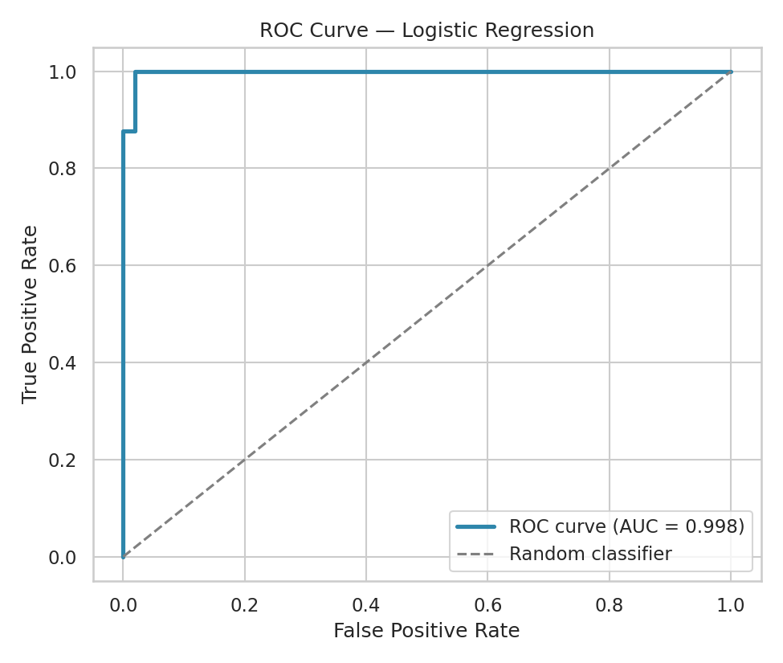
Figure 2. Receiver Operating Characteristic curve, AUC = 0.998.
The ROC curve shows the trade-off between true positive rate and false positive rate across all classification thresholds. An AUC of 0.998 (out of a maximum of 1.0) indicates the model separates the two classes almost perfectly across virtually every threshold choice, not just the default 0.5 cutoff used for the confusion matrix above.

4.3 Precision-Recall Curve
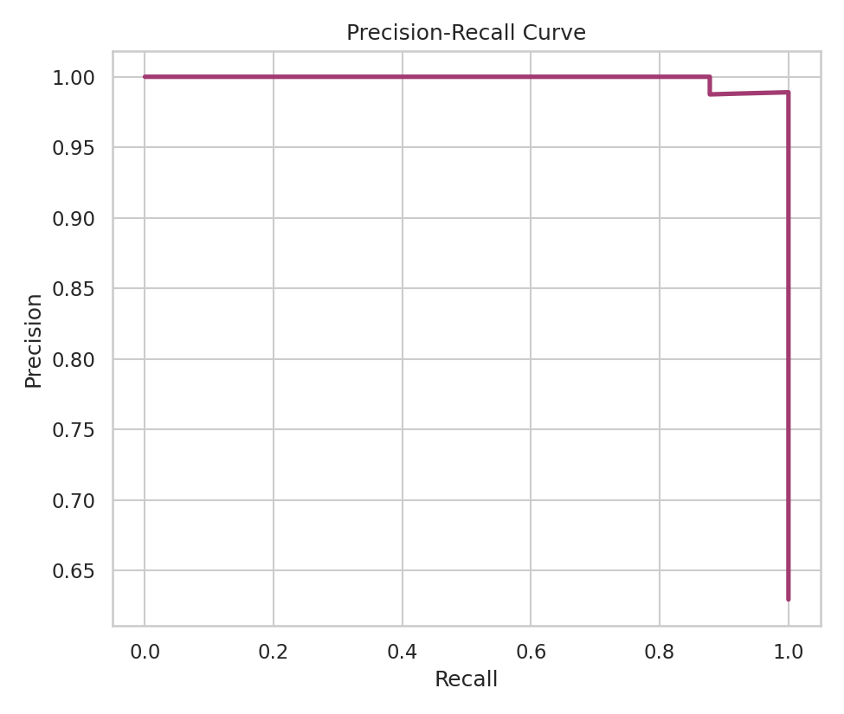
Figure 3. Precision-recall curve on the test set.
Precision and recall remain high and stable across nearly the full range of recall values, only dropping sharply as recall approaches 1.0 (i.e. attempting to catch every single malignant case). This curve is particularly relevant in this domain, since it directly shows the cost of prioritizing catching every malignant case (high recall) versus minimizing false alarms (high precision).

4.4 Feature Importance
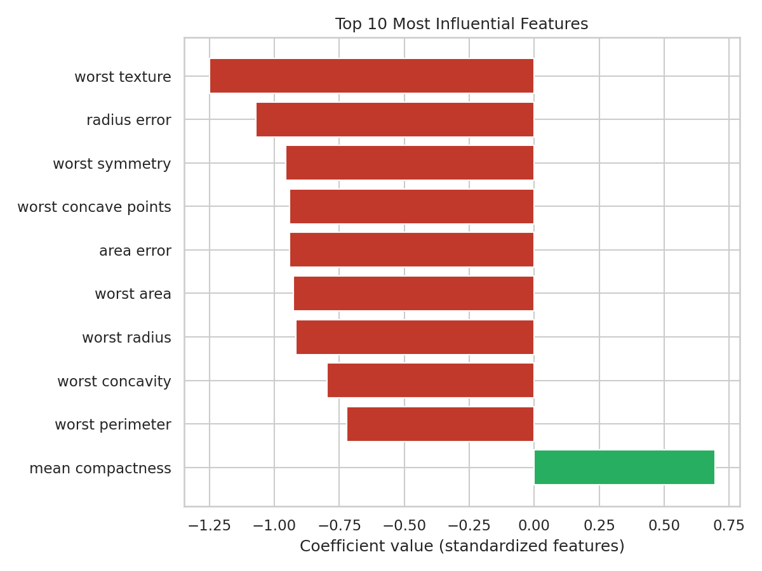
Figure 4. Top 10 most influential features by standardized logistic regression coefficient magnitude.
Positive coefficients push predictions toward 'benign' (class 1) and negative coefficients push toward 'malignant' (class 0). Features related to cell size and shape irregularity (worst radius, worst concave points, worst perimeter) show the strongest influence — consistent with established medical understanding that larger, more irregularly-shaped cell nuclei are associated with malignancy.

4.5 Cross-Validation Stability
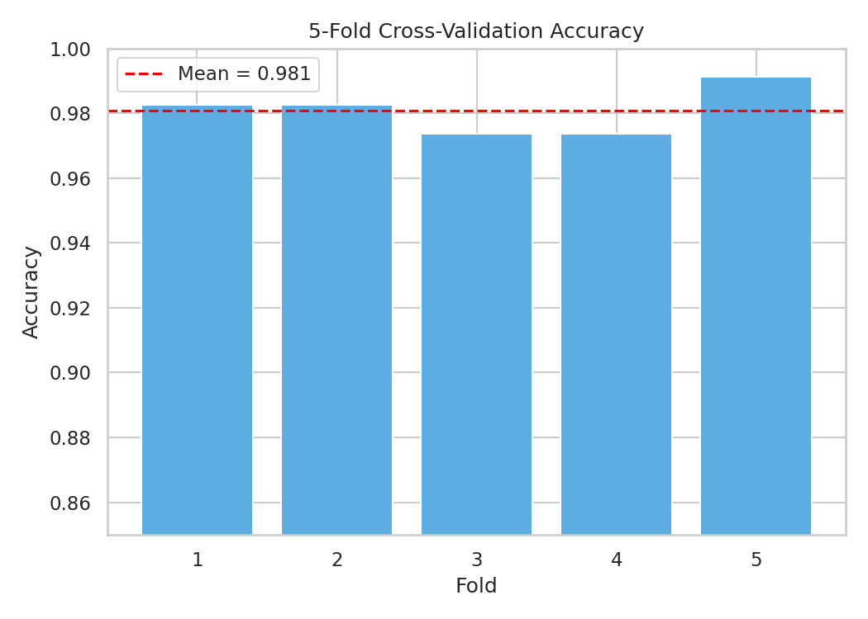
Figure 5. 5-fold cross-validation accuracy scores.
5-fold cross-validation on the full dataset produced a mean accuracy of 98.07% with a standard deviation of only 0.65%, indicating the model's performance is stable and not dependent on a lucky train/test split.

5. Overfitting & Underfitting Assessment
Metric | Value
Training accuracy | 98.83%
Test accuracy | 98.60%
Gap (train − test) | 0.22 percentage points

A large gap between training and test accuracy would indicate overfitting (the model memorizing training data rather than learning generalizable patterns); a low accuracy on both sets would indicate underfitting. Here, the gap is only 0.22 percentage points, and both cross-validation and the held-out test set independently confirm accuracy in the same ~98% range. This is strong evidence the model is neither overfitting nor underfitting on this dataset.

6. Critical Discussion: Limitations & Sources of Error
- Dataset size and diversity: 569 samples from a single clinical source is small by modern ML standards and may not represent the full diversity of tumor presentations across different populations, imaging equipment, or hospitals — real-world deployment would need much larger, more diverse validation data.
- Class imbalance: the dataset is moderately imbalanced (63% benign vs 37% malignant). While stratified splitting and the strong F1/recall scores mitigate this, more imbalanced real-world screening data could require techniques like class weighting or resampling.
- Feature engineering ceiling: this analysis used the 30 pre-extracted features as-is; results depend entirely on the quality of that upstream feature extraction from the original FNA images, which is itself a potential source of error not captured in this evaluation.
- Model simplicity: logistic regression assumes a linear decision boundary in the transformed feature space. Despite the very strong performance here, more complex models (random forest, gradient boosting, SVM with kernel) could be tested to see if performance improves further, especially on harder edge cases not well represented in this sample.
- Single train/test split risk: although cross-validation was used to check stability, all reported test-set numbers come from one specific 75/25 split; repeating with multiple random seeds would further strengthen confidence in the reported metrics.

7. Suggestions for Improvement
- Test ensemble methods (Random Forest, XGBoost) to see if non-linear decision boundaries capture any remaining signal missed by logistic regression.
- Use SHAP or permutation importance for more rigorous feature-importance analysis beyond raw logistic regression coefficients.
- Collect or source a larger, more demographically diverse dataset before considering any real clinical application.
- Tune the classification threshold (rather than using the default 0.5) to explicitly optimize for recall, given the higher real-world cost of false negatives in cancer diagnosis.
- Apply k-fold cross-validation with multiple repeats and different random seeds to further validate metric stability.

8. Conclusion
The logistic regression model achieved strong, stable performance (98.6% test accuracy, 0.998 ROC-AUC) on the Breast Cancer Wisconsin dataset, with minimal evidence of overfitting. While these results are promising, they should be interpreted as a demonstration of the modeling pipeline and evaluation methodology rather than a clinically deployable system — real-world medical AI requires substantially more validation, regulatory review, and diverse data before being trusted for diagnostic decisions.

9. Tools & Environment
Python 3 with Scikit-learn (LogisticRegression, StandardScaler, train_test_split, cross_val_score, evaluation metrics), Pandas for data handling, and Matplotlib/Seaborn for visualization.

