Soil Health Management Advisory – PWA Functional Specification

Table of Contents
1. Overview 1
2. User Roles and Permissions 1
3. Sign Up Flows 1
3.1. Shahayak 1
3.2. Shahayak signing up a Farmer 2
4. Authentication Flows 2
4.1. Farmer 2
4.2. Shahayak and Admin 2
5. Dashboard 2
5.1. Farmer 2
5.2. Shahayak 2
5.2.1. Navigation Structure 3
5.2.2. Dashboard Content 3
5.2.3. Farmer Management Page 4
5.2.4. Land Parcel Management Page 4
5.2.5. Soil Sample & Test Results Page 4
5.2.6. Soil Health Advisory Page 5
5.3. Admin 5
6. Screens & Wireframes 5
6.1. Login (Farmer) 5
6.2. Login (Shahayak and Admin) 5
6.3. Shahayak Dashboard Mock-up 6
6.4. Dashboard (Farmer) 6
6.5. View Soil Health Report 7
6.6. Fertilizer Recommendation 7
7. Base Entities 7
7.1. Farmer profile 7
7.2. Sahayak Profile 7
7.3. Land Parcels 8
7.4. Soil sample and Test Result 8
8. UX Considerations 9
8.1. Mobile-First Adjustments 9
8.2. Key Design Principles 9
9. Backend Integration 9

Overview
Target Platform: Android, Mobile Web (PWA)
User Roles:
- 👨‍🌾 Farmer
- 🧑‍💼 Shahayak (Co-ordinating Agent)
- 🧑‍💼 Admin

User Roles and Permissions
Role | Capabilities
Farmer | - View land parcels,  - view test results,  - view soil health advisory for a crop
Shahayak | - Add/manage farmers,  - add/view land parcels,  - add/view soil test results,  - view soil health advisory for a crop
Admin | - Bulk upload soil test results,  - Manage Shahayak  - Manage farmers  - Analytics

Sign Up Flows
  - Shahayak
  - [Email & Password, RetypePassword] → [Send OTP to email] → [Input OTP] → [Verify] → EmailVerified
  - [Mobile Number] → [Send OTP to mobile] → [Input OTP] → [Verify] → MobileVerified
  - [Add Profile – SahayakProfile ]
Status: Admin Approval Pending!
  - [Approval by Admin] → Status Change → [login]
  - Shahayak signing up a Farmer
- [Farmer’s Mobile Number] → [Send OTP to mobile] → [Input OTP] → [Verify] →MobileVerified
  - [Add Profile – FarmerProfile ]

Authentication Flows
  - Farmer
- Login via OTP
  - [Input Mobile Number] → [Send OTP] → [Input OTP] → [Verify/Login]
  - Shahayak and Admin
- Login via Email & Password, then OTP
  - [Email & Password] → [Verify Email/Password] → [Mobile Number] → [Send OTP to mobile] → [Input OTP] → [Verify/Login]

Dashboard
  - Farmer
Functionalities
- View Land Parcels
- View Soil Test Results
- Select Crop → Get Recommendation → Save/Print/Share

+------------------------------------+
| Hello, [Farmer Name] |
| Section 1: My Land Parcels |
| Section 2:My Soil Health Reports |
| Section 3:My Soil Health Advisory |
+-----------------------------------+
  - Shahayak
Functionalities:
- Manage Farmers
- Manage Land Parcels
- Manage Soil Samples & Test Results
- Generate & share Soil Health Advisories
- Navigate quickly between core actions
    - Navigation Structure
Top Navigation Bar
- Logo & App Name
- Home
- Farmers
- Parcels
- Soil Test Results
- Advisories
- Reports
- Profile / Logout
Left Sidebar (Collapsible for Mobile)
- Quick Add
  - ➕ Add Farmer
  - ➕ Add Parcel
  - ➕ Add Soil Test Results
- Shortcuts
  - View All Farmers
  - Pending Test Results
  - Recently Generated Advisories
    - Dashboard Content
Section 1 – KPIs (Info Cards)
- Total Farmers: Count & trend
- Total Parcels: Count
- Pending Soil Tests: Count
- Advisories Generated (This Month)
Section 2 – Quick Actions
- [➕ Add Farmer]
- [➕ Add Parcel]
- [➕ Add Soil Sample]
- [⚡ Generate Advisory]
Section 3 – Latest Activity Feed
- Farmer Added: “Ramesh Kumar – 2 Parcels”
- Soil Sample Uploaded: “Parcel #102”
- Advisory Generated: “Parcel #54 – Wheat Crop”
    - Farmer Management Page
Table View
Farmer Name | Phone | Village | District | Parcels | Actions
Ramesh Kumar | 9876xxxxxx | Kanpur | Lucknow | 3 | [Edit] [View Parcels]
Actions
- Search by name/phone/village
- Add/Edit/Delete Farmer
- Click to view linked parcels
    - Land Parcel Management Page
Table View
Parcel ID | Farmer | Survey No | Area (ha) | Soil Type | Samples | Actions
P-102 | Ramesh Kumar | 112 | 2.5 | Loamy | 2 | [Edit] [View Samples]
Actions
- Add/Edit/Delete Parcel
- Link to Farmer
- GPS location view on map
    - Soil Sample & Test Results Page
Table View
 | Sample ID | Parcel | Date Collected | Depth (cm) | Status | Actions
 | S-504 | P-102 | 2025-06-12 | 20 | Results Pending | [Edit] [Enter Results]
 |  |  |  |  |  | [Enter Results]
Test Result Entry Form
- pH, EC
- N, P, K values
- Micronutrients (Zn, Fe, Mn, B, Cu)
- [Save Results]
    - Soil Health Advisory Page
Form
- Select Parcel → Select Crop
- Auto-load soil test values
- [Generate Advisory] → [Preview] → [Download PDF] / [Share via WhatsApp]
Table View (Past Advisories)
Advisory ID | Parcel | Crop | Date | Actions
A-340 | P-102 | Wheat | 2025-06-15 | [View] [Download]

  - Admin
Functionalities:
- All of Shahayak’s functionalities
- Manage Shahayaks
- Generate analytics reports – TBD.

Screens & Wireframes
  - Login (Farmer)
+---------------------------+
| Enter Mobile Number |
| [______________] |
| [Send OTP] |
+---------------------------+
+---------------------------+
| Enter OTP |
| [____] [Verify] |
+---------------------------+

  - Login (Shahayak and Admin)
+---------------------------+
| Email: [__________] |
| Password: [__________] |
| [Next] |
+---------------------------+

+---------------------------+
| Mobile Number: [____] |
| [Send OTP] |
| OTP: [____] [Verify] |
+---------------------------+

  - Shahayak Dashboard Mock-up
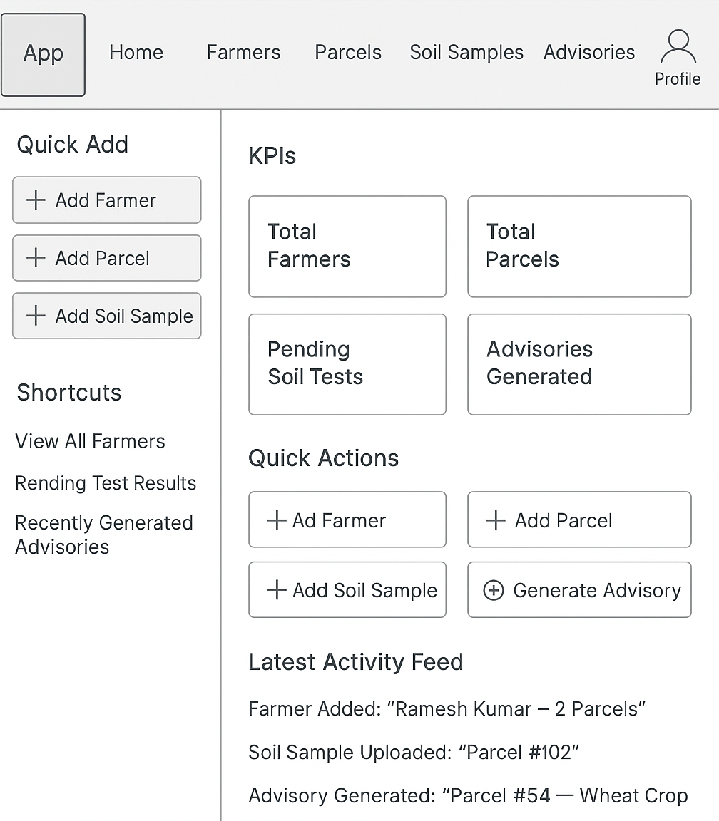

  - Dashboard (Farmer)
+---------------------------+
| Hello, [Farmer Name] |
| [📍] My Land Parcels |
| [🌱] Soil Health Reports |
| [🧪] Soil Health Advisories |
+---------------------------+
  - View Soil Health Report
+-----------------------------+
| 📍 Farmer: |
| 📍 Parcel: |
| Sample Date: |

| pH: 6.3 |
| N: Low 🔴 |
| P: Sufficient 🟢 |
| K: High 🟡 |
| Zinc: Deficient ⚠️ |
| ... |
| [Get Recommendations] |
+-----------------------------+
  - Fertilizer Recommendation
+-------------------------------------+
| Recommended Crop: <crop Name> |
| UREA: 45 kg |
| DAP: 25 kg |
| Zinc Sulphate: 4 kg |
| Gypsum: 10 kg |
+-------------------------------------+
| Total Cost: ₹850 |
| Subsidy: ₹300 |
| 💰 Estimated Cost: ₹550 |
| [Download PDF] [Share SMS] |
+-------------------------------------+

Base Entities

Farmer profile
+------------------------------+
| First Name: [__________]* |
| Last Name: [__________]* |
| Phone: [__________]* |
| Aadhar: [__________] |
| Gender: [__________]* |
| Address: |
| House No: [____] |
| Village: [____]* |
| Tehsil: [____]* |
| District: [____]* |
| Pincode: [____]* |
+------------------------------+

Sahayak Profile

+------------------------------+
| First Name: [__________]* |
| Last Name: [__________]* |
| Phone: [__________]* |
| Aadhar: [__________]* |
| Gender: [__________]* |
| Address: |
| House No: [____]* |
| Village: [____]* |
| Tehsil: [____]* |
| District: [____]* |
| Pincode: [____]* |
| Educational Qualification: [__________]* |
+------------------------------+

Land Parcels
+--------------------------------------------------------+
| State: [__________]* (defaults to farmer’s State). |
| District: [__________]* (defaults to farmer’s district)|
| Tehsil: [__________]* (defaults to farmer’s Tehsil). |
| RI Circle: [__________]* |
| Village: [__________]* (defaults to farmer’s Village) |
| SurveyNo/Khata No: [__________]* |
| Plot No: [__________]* |
+--------------------------------------------------------+

Soil sample and Test Result
+------------------------------------------------------------+
| 📍 Farmer Detail: |
| 📍 Parcel Detail: |
| 📅 Sample Date: |
| 🌡️ Sample Depth (cm): |
| 📅 Test Result Date [Date Picker] (Defaults to sample date)|
| 🌡️pH |
| 🌡️EC |
| 🌡️N |
| 🌡️P |
| 🌡️K |
| 🌡️Zinc |
| 🌡️Copper |
| 🌡️Boron |
| 🌡️Sulfur |
| 🌡️Iron |
| 🌡️Manganese |
+-------------------------------------------------------------+

UX Considerations

Mobile-First Adjustments
- Floating Action Button (FAB) for Quick Add
- Collapsible Sidebar
- Card-based views instead of wide tables
- One-click call to farmer (phone icon in farmer list)

Key Design Principles
- Minimal clicks (2–3 max) to complete any action
- Information grouped by entity (Farmer → Parcel → Sample → Advisory)
- Quick search & filter always available
- Color-coded statuses (Pending, Completed, Urgent)
- Icons for visual cues (🧪 = Soil Sample, 🌱 = Advisory)
- Local Language Support
- Icons + Labels for low literacy
- Minimal Input (Dropdowns/Date pickers)
- Optimized for single-thumb navigation

Backend Integration
UI Module |  | Backend Entity / API
Login | OTP/Auth API
Farmer Profile | Farmer
Land Parcel | LandParcel
Soil Sample | SoilSample
Test Result | SoilTestResult
Fertilizer Advice | FertilizerRecommendation + FertilizerCost
Advisory View | Advisory
Crop List | CropRequirement
Cost & Subsidy | FertilizerCost

