Week-2 Hands-on-Exerise

Advance SQL Server

SQL EXERCISE - Advanced Concepts

Exercise 1: Ranking and Window Functions

Goal: Use ROW_NUMBER(), RANK(), DENSE_RANK(), OVER(), and PARTITION BY.

Scenario:

Find the top 3 most expensive products in each category using different ranking functions.

Steps:

1. Use ROW_NUMBER() to assign a unique rank within each category.

2. Use RANK() and DENSE_RANK() to compare how ties are handled.

3. Use PARTITION BY Category and ORDER BY Price DESC.

Sql commands for creating and inserting random data:-

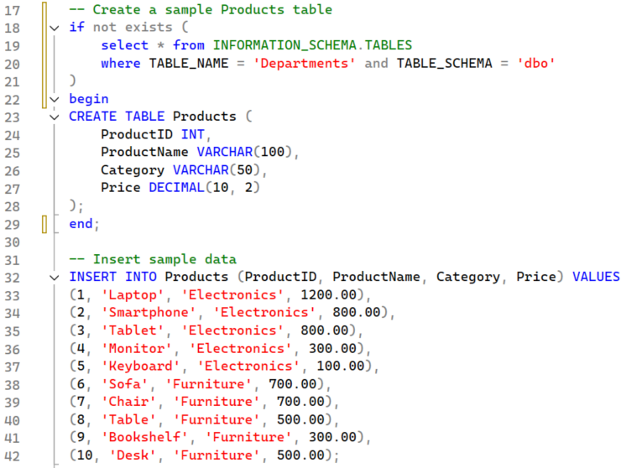

Following out show the database:-

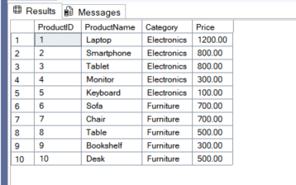

Following code is for displaying ROW_NUMBER() , RANK() and DENSE_RANK()

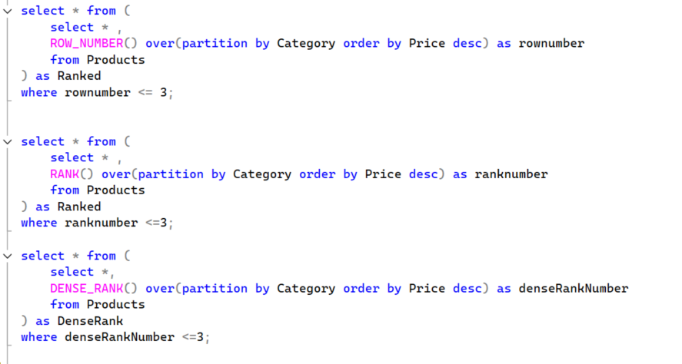

The output of above code including ROW_NUMBER() , RANK() and DENSE_RANK():-

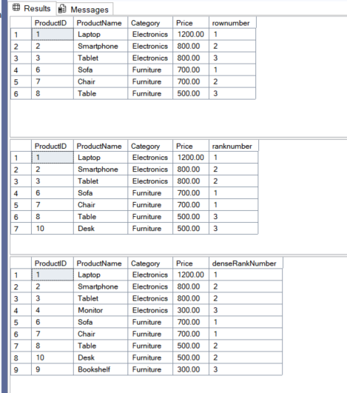

SQL EXERCISE - Stored Procedure

Exercise 1: Create a Stored Procedure

Goal: Create a stored procedure to retrieve employee details by department.

Steps:

1. Define the stored procedure with a parameter for DepartmentID.

2. Write the SQL query to select employee details based on the DepartmentID.

3. Create a stored procedure named `sp_InsertEmployee` with the following code:

CREATE PROCEDURE sp_InsertEmployee

@FirstName VARCHAR(50),

@LastName VARCHAR(50),

@DepartmentID INT,

@Salary DECIMAL(10,2),

@JoinDate DATE

AS

BEGIN

INSERT INTO Employees (FirstName, LastName, DepartmentID, Salary, JoinDate)

VALUES (@FirstName, @LastName, @DepartmentID, @Salary, @JoinDate);

END;

Creating the database schema and inserting the data into it