**Café Desktop App**

Group01

Satyam Bhatt (Leader), Tannu, Ramandeep, and Navdeep.

Table of Contents

1 Introduction 3

1.1 Scope 3

1.2 Project TimeLine 3

2 Project Design 4

2.1 Software Design 4

2.1.1 Class Diagram 4

2.1.2 Sequence Diagram: Login/Registration. 4

2.2 User Interface Design 5

2.2.1 Persona 5

2.2.2 Scenario 5

2.2.3 Storyboard 6

2.2.4 Wireframes 6

3 Use of Agile 9

3.1 Adapting AGILE in developing the project 9

3.2 Managing the GitHub Backlog board 9

3.2.1 Daily Standups 9

3.2.2 Sprint planning and Sprint Review meetings 9

4 Version Controlling 11

5 Contributions 11

References 11

# Introduction

## Scope

This project's scope highlights the development of a café desktop application using Windows Forms. This application is developed to enable clients to take their café business online and reach avenues beyond their suburbs. Customer satisfaction is at the center of the whole development.

## Project TimeLine

|  |  |
| --- | --- |
| Milestone | Date |
| Project Selection. | 23/04/2024 |
| First meeting with the client. | 30/04/2024 |
| Initial project planning. | 03/05/2024 |
| Design Phase (Persona, Storyboard, and wireframes) | 11/05/2024 |
| Class Diagram | 17/05/2024 |
| Sequence Diagram | 20/05/2024 |
| Starting development. | 23/05/2024 |

# Project Design

## Software Design

### Class Diagram

### Sequence Diagram: Login/Registration.

## User Interface Design

### Persona

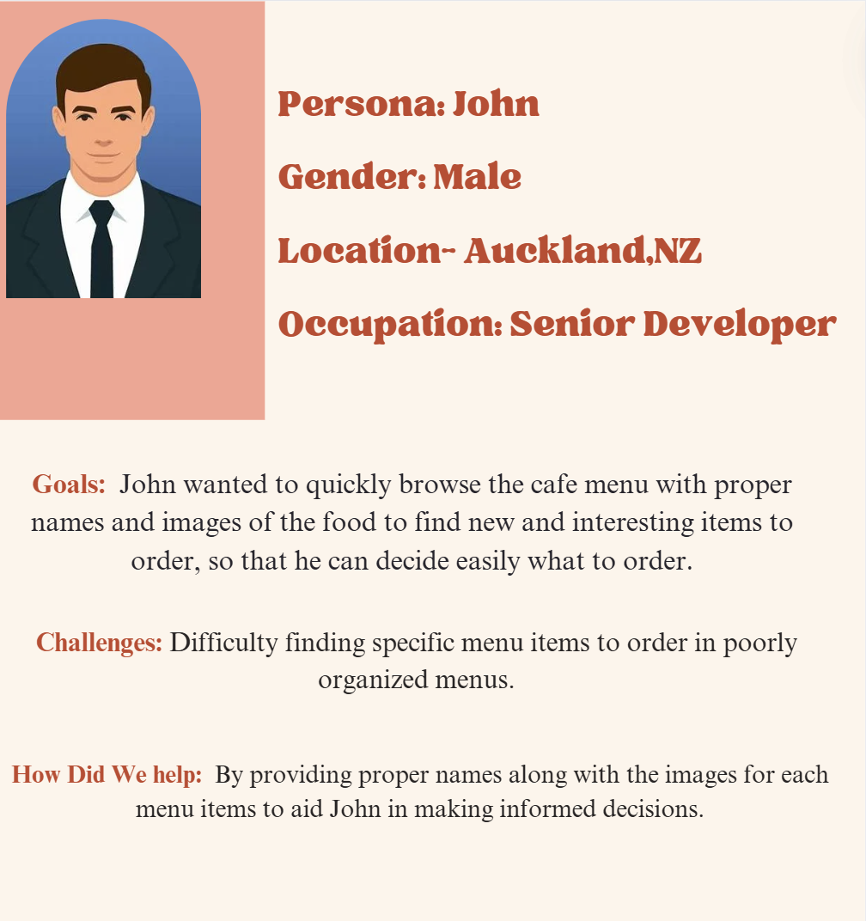

### Scenario

John opens the cafe application to browse the menu. He wants to see the proper names of the food items along with the images of the items to help him decide what to order. He uses the desktop application to explore menu options and make informed choices.

### Storyboard

### Wireframes

User Story: As a visitor, I would like to register for the website so that I can access the customers-only features such as ordering.

Low-fidelity wireframe

High-fidelity wireframe

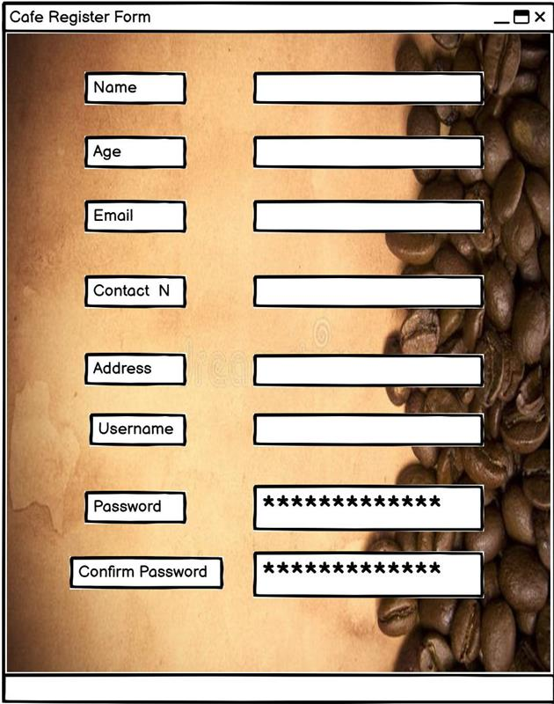

# Use of Agile

## Adapting AGILE in developing the project

Our group implemented Agile methodology for the Café Desktop app. We benefited in certain ways.

Iterative development allowed us to divide our huge workload into smaller and manageable tasks called sprints. Client feedback gathered from several client meetings we did across the block provided us with valuable feedback, making sure that the development team and the client were on the same page.

We were swiftly and flexibly able to make changes in the desktop app based on the client’s feedback and changing requirements. With the use of Agile, the team was able to isolate any and every issue and work on it without affecting the rest of the project. Each team member was given a specific set of tasks that they were supposed to take ownership of and collaborate with others if needed, thus providing us with the maximum efficiency.

So, all in all, it can be safely said that Agile methodology has been nothing but immensely beneficial to us.

## Managing the GitHub Backlog board

### Daily Standups

I (Satyam) as a team leader would divide the workload among the team members giving them instructions as to what needs to be done, mostly when we are in the lecture.

Our primary mode of conversation when not face-to-face was Microsoft Teams, where we would share our progress and feedback.

We also conducted standup meetings to update each other and our lecturer on our progress and devise a plan for what is ahead of us.

Each task for every team member was also used to create a backlog item on GitHub enabling us to keep proper track of the whole project.

### Sprint planning and Sprint Review meetings

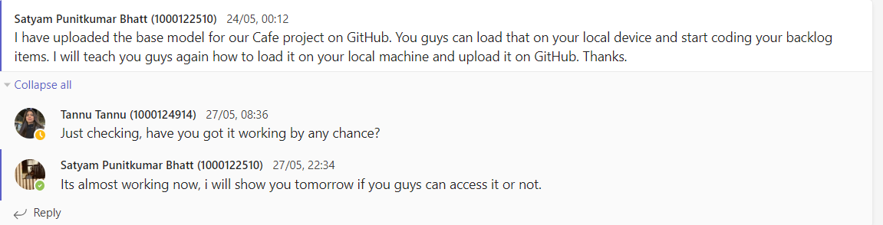

GitHub backlog Board:- <https://github.com/users/Satyamb-03/projects/3>

# Version Controlling

Using GitHub for version control was very essential for maintaining the source code.

Numerous different branches were made based on the main branch for each team member to work on. It proved to be a very vital tool for accessing changes made by other team members into the individual local device and pushing your changes to the main branch of the repository.

Initially, there were some hurdles in setting up GitHub along with Visual Studio as there were some problems faced by us regarding conflicts while committing our changes, all of which were solved later on.

GitHub repo:- https://github.com/Satyamb-03/Cafe_Studio02

# Contributions

Satyam: Home page, ContactUs page, uniformity in theme, class diagram, sequence diagram, reviewing codes, and solving errors.

Tannu: Promotions page, persona, and scenarios

Ramandeep: Menu page, cart (along with Satyam), and Storyboard.

Navdeep: Login, registration (along with Satyam), and Wireframes.

# References

For inspiration of the café app:

Sorella - <https://www.sorellacafe.co.nz/>

For bits of codes and error solving:

Chatgpt - <https://chatgpt.com/>

Stackoverflow - <https://stackoverflow.com/>