MALINANT.AI

**Project Title**:  
**MALIGNANT.AI**: Early Cancer Detection and Classification Using CT Scan Data and Generative AI

**Team Members**:

* **Sujal** – AI/ML Engineer (Lead Developer and Data Miner)
* **Satyam** – AI/ML Engineer (Lead Developer)

**Abstract**:  
MALIGNANT.AI is an innovative AI-driven platform designed to detect and classify cancer at its early stages using CT scan data. By leveraging Generative AI models, such as GANs, the system identifies subtle abnormalities in medical imaging, providing healthcare professionals with accurate and timely insights for diagnosis. The AI model processes high-dimensional CT scan images and classifies different types of cancer, offering predictions with a high degree of accuracy. This early detection capability can help reduce the risk of delayed diagnoses, improve patient outcomes, and facilitate more personalized treatment plans. MALIGNANT.AI aims to support oncologists and radiologists with an automated, reliable, and scalable solution for cancer diagnosis, ultimately enhancing the quality of healthcare delivery.

**Problem Statement**:  
Early detection of cancer is critical for improving patient outcomes, yet current diagnostic methods are prone to missing subtle signs in early-stage cancer. This often results in late diagnoses, leading to reduced survival rates. The challenge lies in the immense volume of CT scan data and the complexity of cancer growth patterns, which vary significantly across different types. Manual analysis by healthcare professionals is time-consuming and susceptible to human error, making it difficult to detect cancer at an early stage when treatment is most effective.

**Proposed Solution**:  
MALIGNANT.AI addresses this problem by using Generative AI to analyse CT scan images and predict cancer in its early stages. The key features and functionalities include:

* **Automated Image Analysis**: The AI processes high-resolution CT scan images, detecting subtle cancerous patterns.
* **Early Detection**: Capable of identifying cancer in its early stages, even when symptoms are not apparent.
* **Cancer Classification**: The system classifies the type of cancer based on imaging data, providing actionable insights for personalized treatment.
* **Progression Simulation**: The Generative AI can simulate potential disease progression, giving doctors a clearer picture of what to expect.
* **Cloud Integration**: Scalable cloud architecture using Vultr services for processing, storage, and real-time data analytics.

**Target Audience**:  
The primary target audience includes:

* **Healthcare Providers**: Oncologists, radiologists, and hospitals who require AI-driven diagnostic tools for early cancer detection.
* **Medical Research Institutions**: Organizations researching cancer progression and treatment methods.
* **Patients**: Indirect beneficiaries, as they receive timely and accurate diagnoses, leading to improved treatment outcomes.

**Feasibility Analysis**:  
MALIGNANT.AI is technically feasible due to the availability of high-quality medical imaging data and the maturity of AI techniques such as convolutional neural networks (CNNs) and generative models. The integration with Vultr services ensures that the platform can scale effectively while minimizing infrastructure costs. However, regulatory compliance (e.g., HIPAA) and access to medical imaging data may pose challenges, which will need to be addressed through partnerships with healthcare institutions.

**Preliminary Diagram**:

The below fig is the interface of the web application:

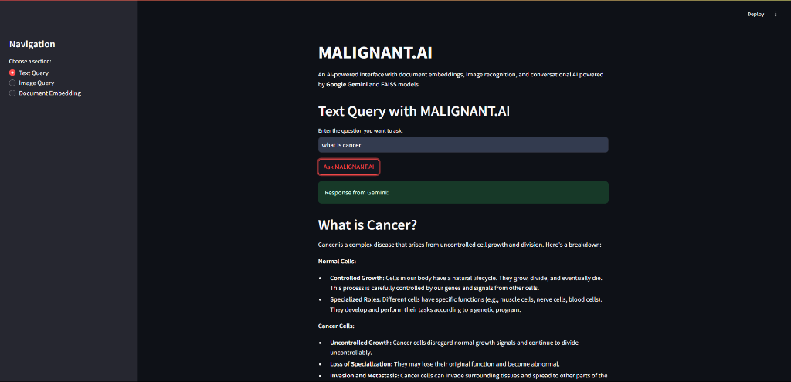

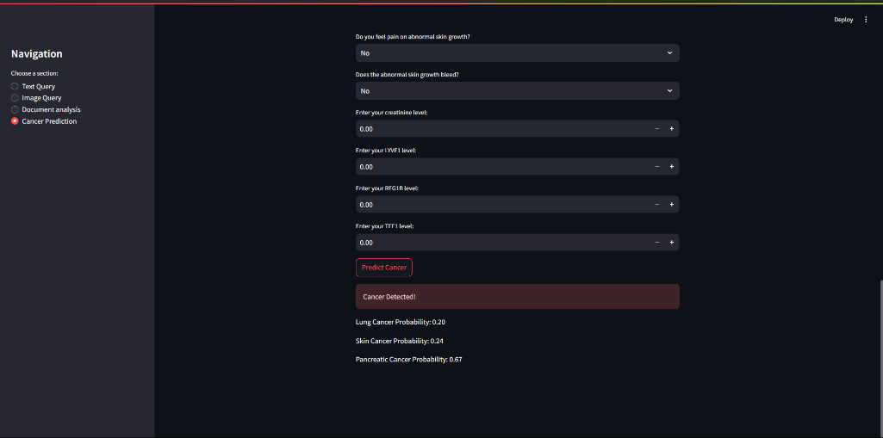\

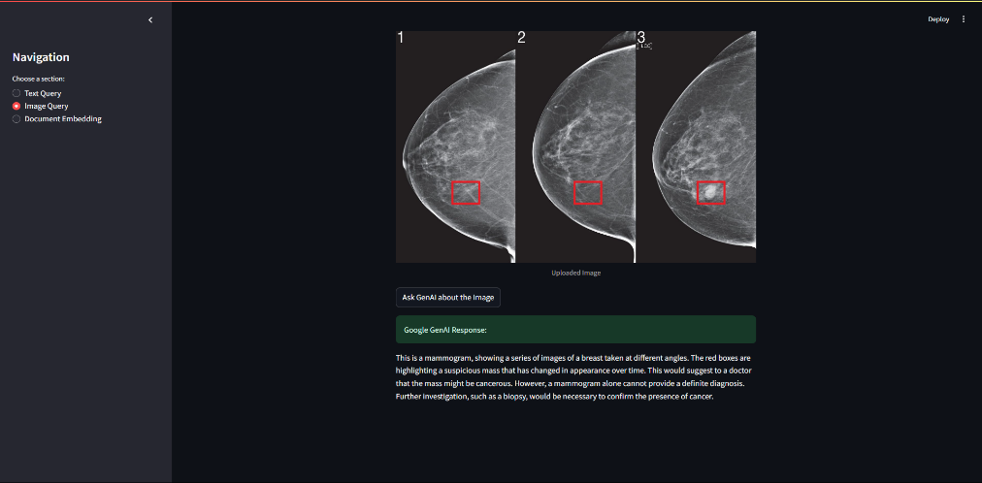

**Expected Outcomes**:  
The MALIGNANT.AI project aims to:

* Detect cancer in its early stages with high accuracy.
* Provide healthcare professionals with a reliable, AI-powered tool for diagnosing and classifying cancer.
* Reduce diagnostic time, allowing for quicker decision-making and patient care.
* Enhance patient outcomes through timely interventions and personalized treatment planning.