OISI Results and Evidence
Submission-ready results narrative, tables and figures
Equal-component index | 112 infrastructures | Four components

Executive Results
The all-entry equal-component OISI has a mean of 56.97 (SD 13.64), median 57.54, interquartile range 48.34–66.61, and observed range 23.57–86.05 across 112 infrastructures. The four component means are Community Engagement 60.75, Governance Practices 64.18, Organizational Capacity 57.27, and Development Activity 45.67. Development Activity has the lowest mean in the current zero-filled view; this reflects measured scores and the availability of platform-specific data, so it should not be interpreted as a standalone verdict on infrastructure quality.
Only 6 infrastructures have all 31 metrics observed. Their complete-data mean is 70.42; because this is a small subset, it is a diagnostic comparison, not a replacement for the all-entry result. The available-component diagnostic mean is 71.77, but its varying denominator makes it descriptive rather than a directly comparable performance ranking.
The index is hierarchical: metrics are equally weighted within each component, and each component contributes 25% to OISI. Missing metrics are zero-filled in the all-entry score, with observation flags retained. Accordingly, report the result as an evidence-adjusted score and show component scores and coverage alongside it.
Result item | Value | Reading
Infrastructures scored | 112 | All-entry OISI population.
All-entry OISI mean / median | 56.97 / 57.54 | Zero-filled; evidence-adjusted.
All-entry OISI SD / range | 13.64 / 23.57–86.05 | Describes cross-entry dispersion.
Complete across 31 metrics | 6 | Small complete-data comparison subset.
Complete-data mean | 70.42 | Different cohort from all-entry mean.
Available-component diagnostic mean | 71.77 | Variable denominator; diagnostic only.

1. Analysis Basis
This report summarizes the integrated equal-component index workbook and the four component scoring workbooks. The unit of analysis is one infrastructure/service. Community Engagement uses six metrics, Governance Practices seven, Organizational Capacity five, and Development Activity thirteen. All metric scores are on a 0–100 scale and are averaged within their component; the four component scores are then averaged with a fixed denominator of four.
The Development Activity observation window is 1 October 2025 00:00 UTC inclusive to 1 October 2026 00:00 UTC exclusive. The first three components are based on the Infra Finder dataset fields; the fourth combines repository history and GitHub API-derived activity as defined in its scoring workbook.
Overall score
$$OISI = \frac{CE + G + OC + DA}{4} = 0.25CE + 0.25G + 0.25OC + 0.25DA$$
The workbook reports three views: the all-entry zero-filled OISI; a complete-data comparison restricted to entries with all 31 metrics observed; and an available-component diagnostic averaging observed metrics/components. These views answer different questions and should not be presented as interchangeable rankings.
Figure 1. Data-to-index workflow used to construct the reported results.

2. Overall Score Distribution
The zero-filled OISI spans 23.57 to 86.05; its mean (56.97) is below its median (57.54), indicating that lower-scoring entries pull the mean downward. Scores are distributed across the 0–100 scale rather than concentrated in a single narrow band. The histogram describes the observed index output, not an underlying normal population distribution.
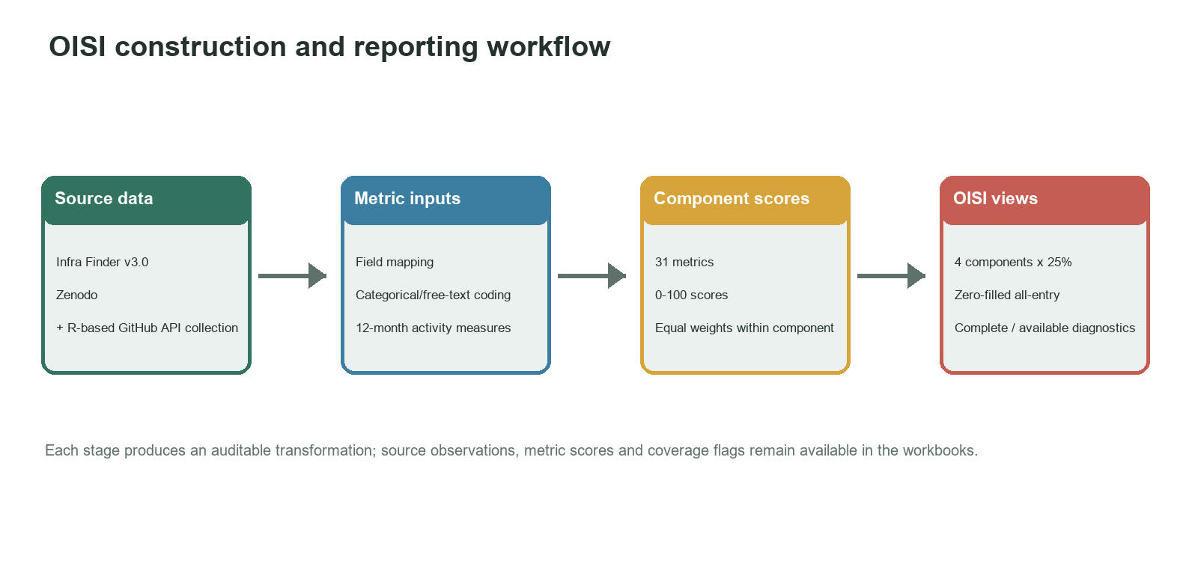
Figure 2. Distribution of the all-entry zero-filled OISI (10-point bins). Source: integrated OISI workbook; authors' calculations.
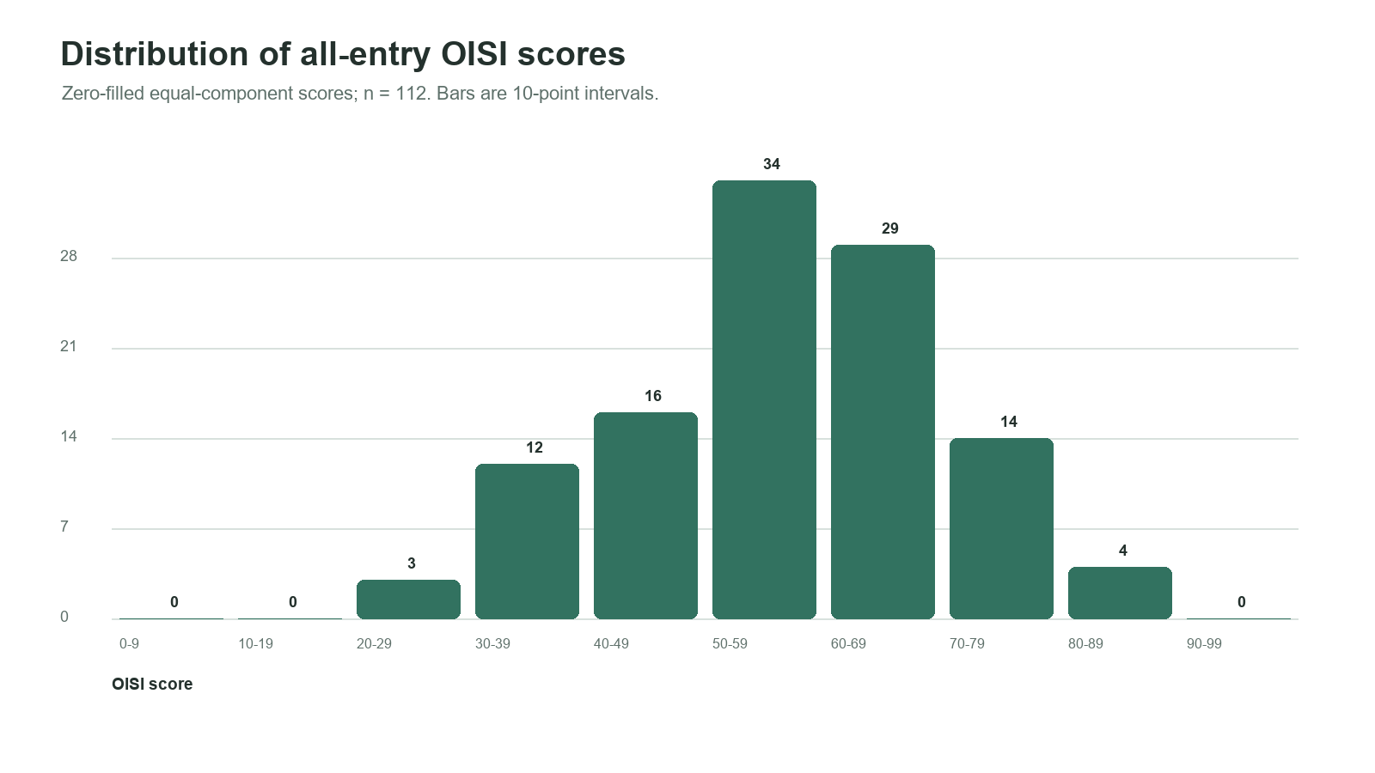
Figure 3. Ten highest and ten lowest zero-filled OISI results. Interpret with metric coverage and component profiles.
Rank | Infrastructure | OISI | CE | Governance | Org. capacity | Development | Observed / 31
1 | ArchivesSpace | 86.05 | 78.2 | 100.0 | 85.0 | 81.0 | 30/31
2 | Galaxy | 85.76 | 66.7 | 95.3 | 90.0 | 91.1 | 29/31
3 | DSpace | 83.91 | 88.6 | 100.0 | 62.5 | 84.5 | 30/31
4 | VuFind® | 80.61 | 85.5 | 100.0 | 60.0 | 77.0 | 27/31
5 | Open Journal Systems (OJS) | 79.53 | 81.1 | 95.3 | 60.0 | 81.8 | 29/31
6 | Open Monograph Press (OMP) | 77.91 | 81.1 | 95.3 | 60.0 | 75.3 | 29/31
7 | Hyku | 77.51 | 81.0 | 90.4 | 65.0 | 73.6 | 30/31
8 | Open Preprint Systems (OPS) | 77.44 | 81.1 | 95.3 | 60.0 | 73.4 | 29/31
9 | Zotero | 76.52 | 69.0 | 92.9 | 60.0 | 84.2 | 30/31
10 | Hyrax | 76.25 | 82.8 | 85.9 | 65.0 | 71.3 | 31/31

The top and bottom lists are descriptive rankings under the stated zero-fill assumptions. They do not establish causal explanations for score differences. Entries with sparse evidence may rank lower because missing metrics contribute zero.

3. Component Results
Component means differ, with Governance Practices highest and Development Activity lowest. Since each component has a fixed 25% OISI share, the difference is not caused by the number of metrics in a component. The metric-level table in each subsection reports both the all-entry zero-filled mean and the observed-only mean, as well as observed count and coverage. The observed-only mean is conditional on the subset with source data and is not directly comparable to the zero-filled mean without noting that denominator.
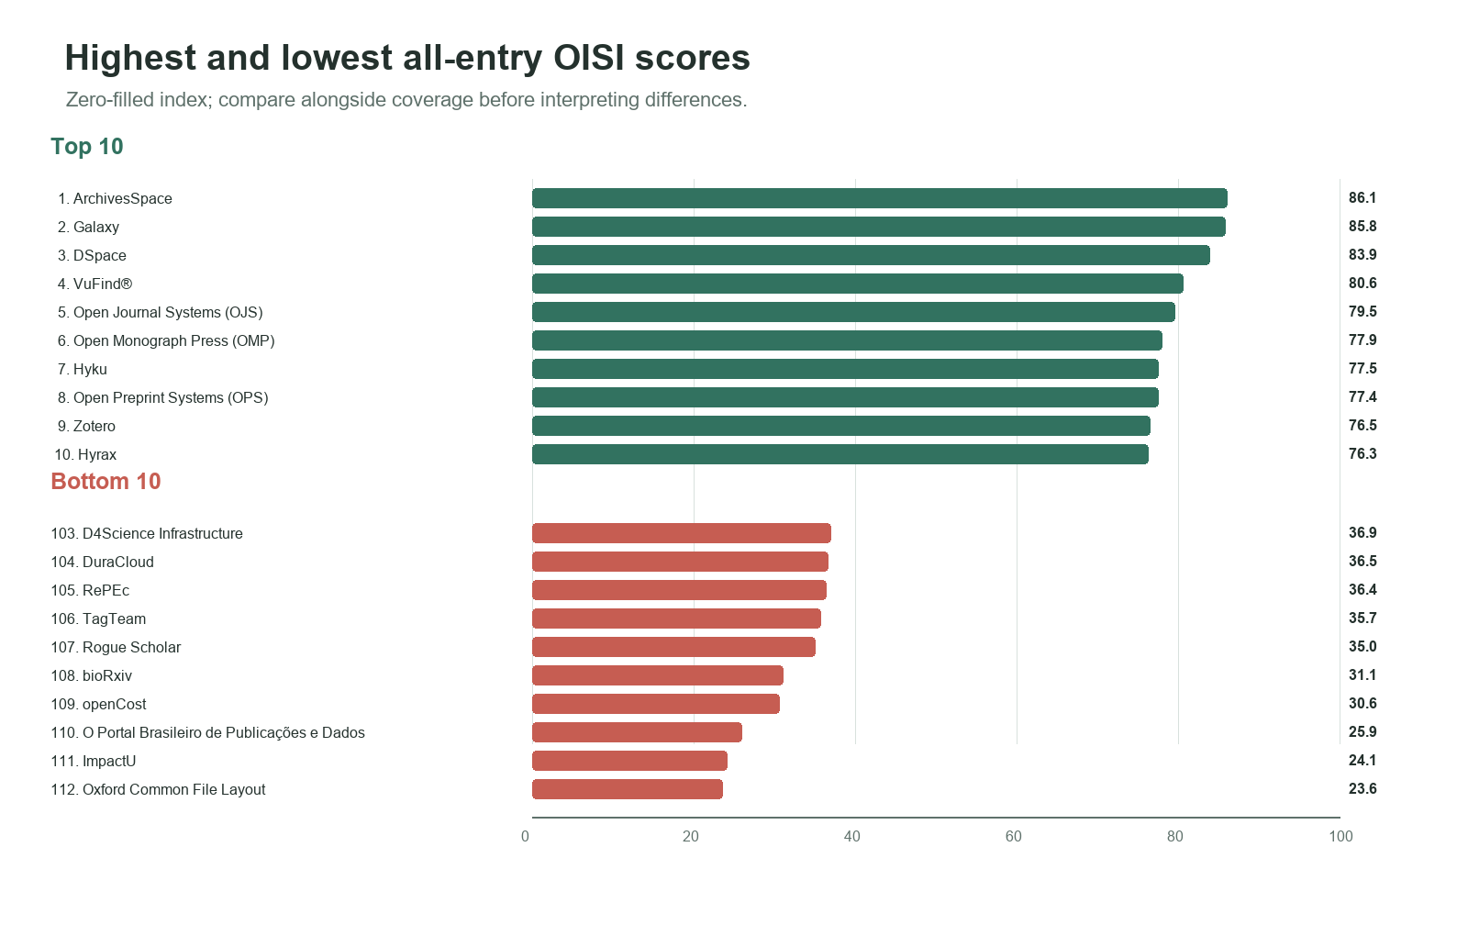
Figure 4. Component mean and median scores. Bars show means; vertical marks show medians.
Component | Mean | Median | Observed metrics / total (mean) | Mean observed coverage
Community Engagement | 60.75 | 63.46 | 4.90 / 6 | 81.7%
Governance Practices | 64.18 | 70.21 | 6.31 / 7 | 90.2%
Organizational Capacity | 57.27 | 60.00 | 3.57 / 5 | 71.4%
Development Activity | 45.67 | 51.66 | 10.03 / 13 | 77.1%

3.1 Community Engagement
The Community Engagement zero-filled component mean is 60.75, with a mean of 4.90 of six metrics observed per entry (81.7% average metric coverage). Contribution guidance and breadth measures have lower availability than the status and repository fields. The largest all-entry metric means are in public repository presence and engagement status, while breadth scores are lower, reflecting fewer supported activity/contribution types under the defined denominators.
Code | Metric | Observed / coverage | All-entry mean (zero-filled) | Observed-only mean
E1 | Engagement status | 111/112 (99.1%) | 90.48 | 91.30
E2 | Engagement activity breadth | 77/112 (68.8%) | 30.43 | 44.26
C1 | Contribution opportunity breadth | 73/112 (65.2%) | 29.37 | 45.05
C2 | Contribution guidance | 75/112 (67.0%) | 48.66 | 72.67
C3 | Public contribution repository | 108/112 (96.4%) | 94.20 | 97.69
N1 | Code of Conduct status | 105/112 (93.8%) | 71.39 | 76.15

Submission interpretation: distinguish the availability of a public repository or policy/status response from the breadth and practical usability of community participation. URL matching is a scoring proxy, not an audit of link functionality.

3.2 Governance Practices
The Governance Practices zero-filled mean is 64.18, with 6.31 of seven metrics observed on average (90.2% average coverage). Governance structure and board/body presence have relatively high all-entry metric means. Formal bylaws and reported commitments show more variation. The score represents reported structures and statuses rather than an assessment of their quality or effectiveness.
Code | Metric | Observed / coverage | All-entry mean (zero-filled) | Observed-only mean
G1 | Governance structure status | 107/112 (95.5%) | 78.88 | 82.57
G2 | Bylaws or formal rules | 83/112 (74.1%) | 51.48 | 69.47
G3 | Board/steering-body presence | 107/112 (95.5%) | 72.32 | 75.70
G4 | Web accessibility status | 102/112 (91.1%) | 57.15 | 62.75
G5 | Equity commitment status | 103/112 (92.0%) | 57.12 | 62.11
G6 | Privacy commitment status | 99/112 (88.4%) | 70.23 | 79.45
G7 | Community governance formality | 106/112 (94.6%) | 62.05 | 65.57

3.3 Organizational Capacity
The Organizational Capacity zero-filled mean is 57.27, with 3.57 of five metrics observed on average (71.4% average coverage). Technology readiness and maintenance have high observed coverage and high all-entry means. Human-resource capacity and institutional affiliation/support have lower availability and substantially lower zero-filled means, so their contribution reflects both reported scores and gaps in records. Hosted/service-delivery scores measure reported availability, not service quality, uptime or affordability.
Code | Metric | Observed / coverage | All-entry mean (zero-filled) | Observed-only mean
M1 | Technology readiness | 112/112 (100.0%) | 98.51 | 98.51
M2 | Maintenance status | 111/112 (99.1%) | 98.21 | 99.10
H1 | Human-resource capacity | 56/112 (50.0%) | 15.07 | 30.13
I2 | Institutional affiliation/support | 59/112 (52.7%) | 25.45 | 48.31
O1 | Hosted/service-delivery capacity | 62/112 (55.4%) | 49.11 | 88.71

3.4 Development Activity
The Development Activity zero-filled mean is 45.67, with 10.03 of thirteen metrics observed on average (77.1% average coverage). Git-derived continuity and recency measures are available for more entries than the issue-response and issue-closure rates, which require at least ten eligible events and a complete follow-up interval. Response and decision rates should therefore be read with their observed counts. Stars and forks are activity/attention proxies, not direct evidence of quality or successful downstream reuse.
Code | Metric | Observed / coverage | All-entry mean (zero-filled) | Observed-only mean
m1_commits | Human commits | 101/112 (90.2%) | 63.42 | 70.32
m2_active_weeks | Active weeks | 101/112 (90.2%) | 56.23 | 62.36
m3_recency | Commit recency | 101/112 (90.2%) | 82.29 | 91.25
m4_releases | Release activity | 101/112 (90.2%) | 62.95 | 69.80
m5_contributors | Active contributors | 101/112 (90.2%) | 47.29 | 52.44
m6_effective_contributors | Effective contributors | 101/112 (90.2%) | 42.69 | 47.33
m7_retention | Contributor retention | 101/112 (90.2%) | 55.80 | 61.88
m8_issue_response | Issue response <=14 days | 54/112 (48.2%) | 21.53 | 44.65
m9_pr_response | PR response <=7 days | 65/112 (58.0%) | 33.65 | 57.98
m10_issue_close90 | Issue closure <=90 days | 52/112 (46.4%) | 19.71 | 42.46
m11_pr_decision30 | PR decision <=30 days | 65/112 (58.0%) | 48.40 | 83.40
m12_stars | Stars gained | 90/112 (80.4%) | 28.24 | 35.15
m13_forks | Forks created | 90/112 (80.4%) | 31.55 | 39.26

4. Metric Coverage and Missing Data
Metric availability varies substantially. In this integrated workbook, the least observed fields include staffing/affiliation and event-rate measures that require sufficient GitHub activity; the most observed fields include technology readiness, maintenance, and several governance/status measures. A zero-filled value can be a measured zero or a policy zero assigned to unavailable data. The workbook's observed flags must accompany interpretations.
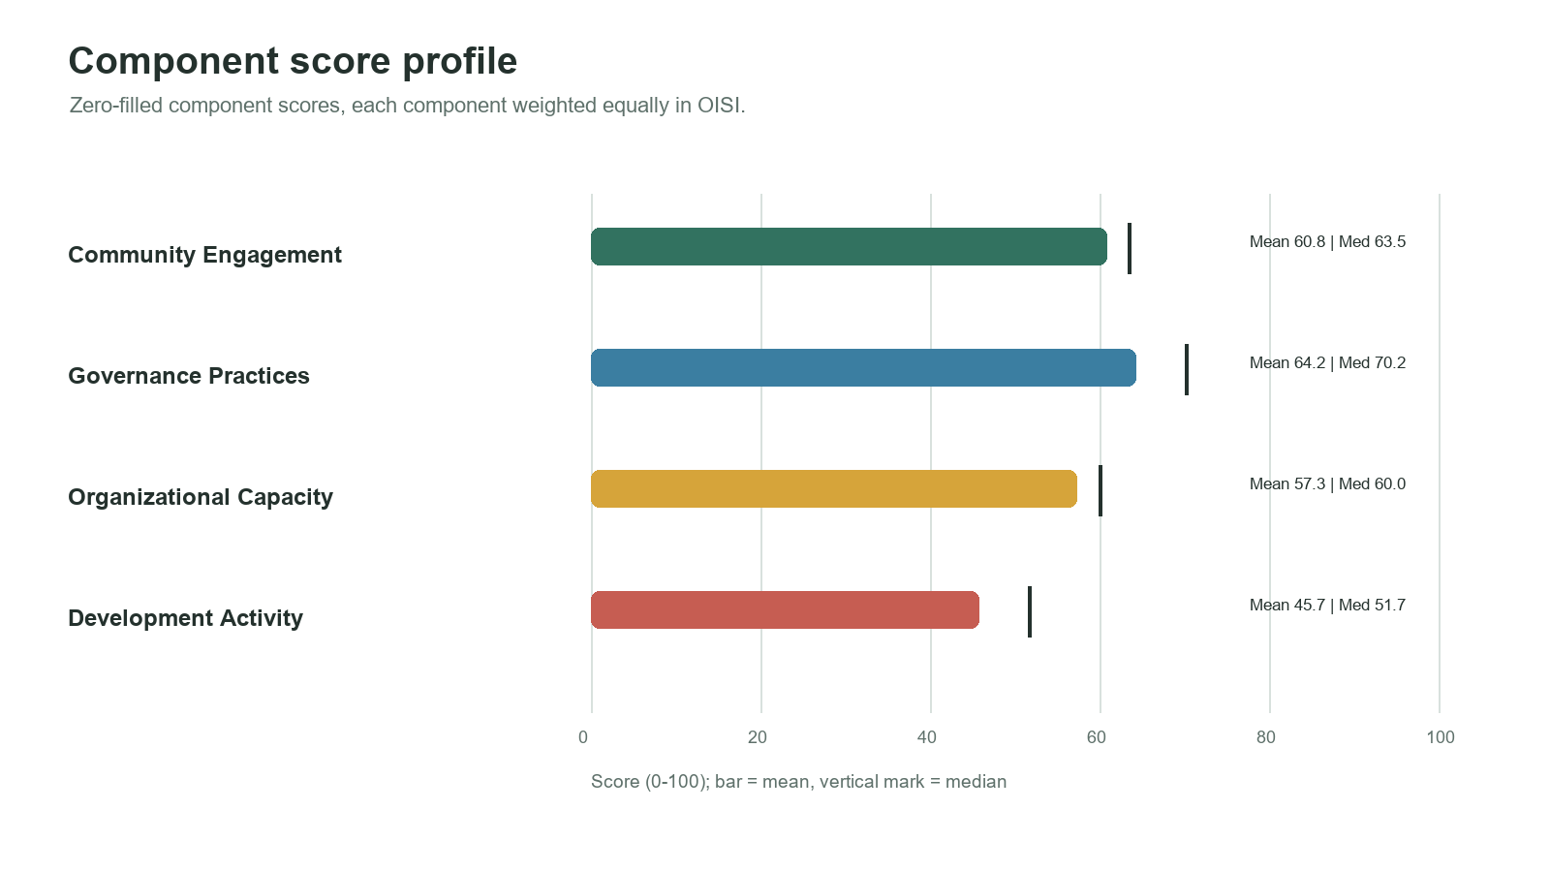
Figure 5. Number of entries with an observed source value for each metric. The component colors follow the report palette.
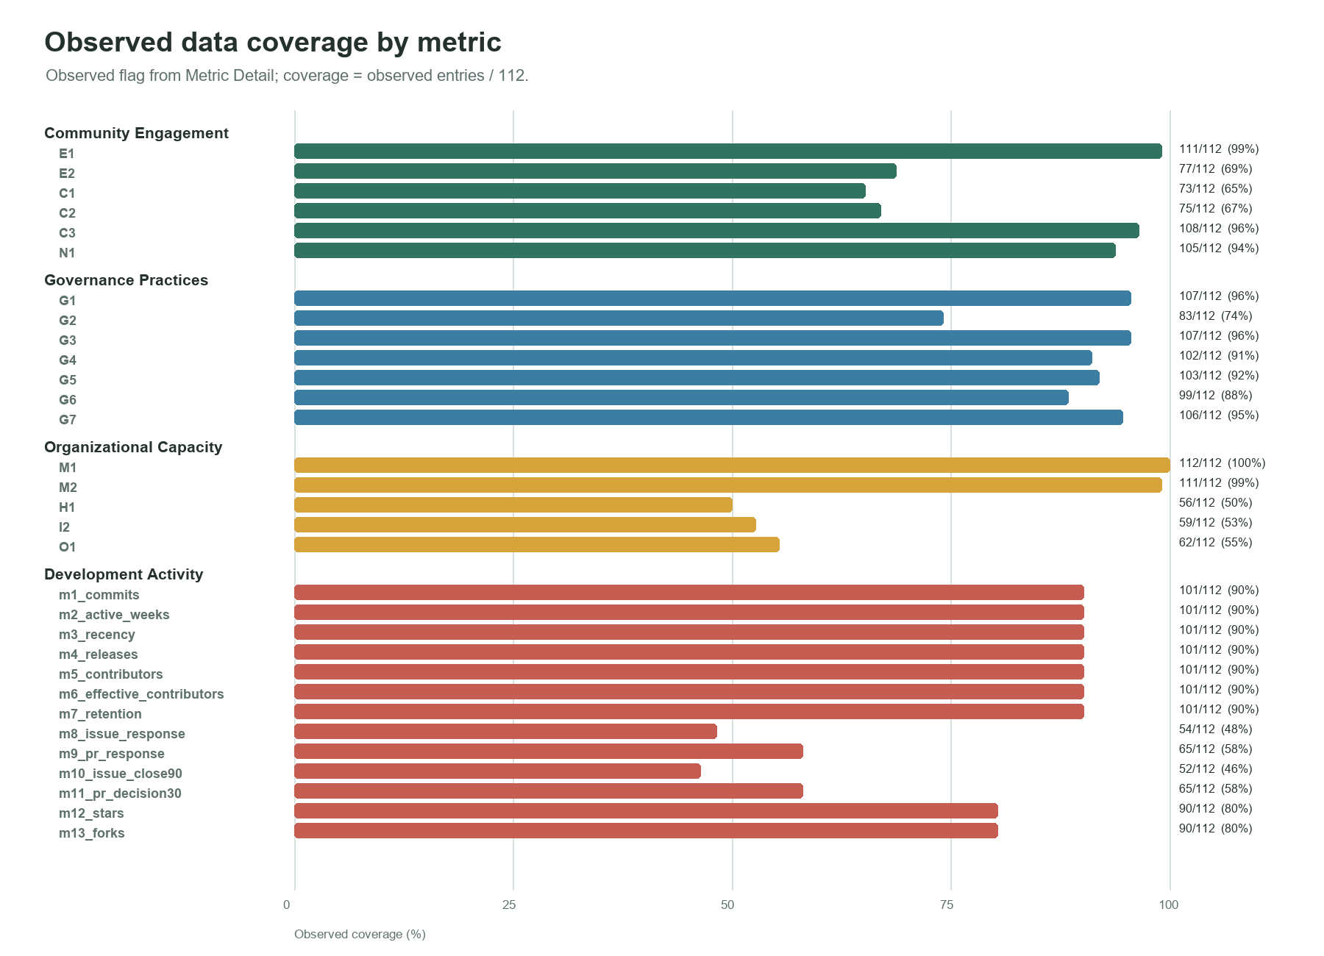
Figure 6. Observed metric count versus zero-filled OISI for each infrastructure. This is descriptive and reflects the construction of the zero-filled score.
The plotted association between observed metric count and zero-filled score is partly built into the scoring rule: unavailable metrics are set to zero. It must not be interpreted as evidence that better reporting causes better infrastructure performance. For comparisons, report component values and coverage, and distinguish measured zero, zero-filled unavailable metric, and a missing component result.

5. Comparative Score Views
Score view | Cases | Mean | Use in reporting
All-entry zero-filled OISI | 112 | 56.97 | Primary full-population evidence-adjusted view; reflects scores and evidence coverage.
Complete-data OISI | 6 | 70.42 | Strict all-31-metric comparison; small cohort, interpret cautiously.
Available-component diagnostic | 112 with >=1 component available | 71.77 | Descriptive variable-denominator diagnostic; not a comparable ranking.

The complete-data mean should not be compared as if it represented all 112 entries: the six complete cases are a selected subset. The available-component mean is higher because it excludes unavailable metrics within components and averages only observed component results; it is not the same estimand as the fixed-denominator all-entry index. The three views are complementary reporting lenses, not substitutes.

6. Results Text for Submission
The final integrated OISI included 112 infrastructures and combined four equally weighted components: Community Engagement, Governance Practices, Organizational Capacity, and Development Activity. Each component contributed 25% of the overall score, with equal metric weights within each component. In the all-entry zero-filled view, the mean OISI was 56.97 (SD 13.64; median 57.54; range 23.57–86.05). Component means were Community Engagement: 60.75; Governance Practices: 64.18; Organizational Capacity: 57.27; Development Activity: 45.67. These are evidence-adjusted results because unavailable metric values were assigned zero while their observed status was retained.
Six infrastructures had observed values for all 31 component metrics. Their mean score was 70.42; this small complete-data subset is reported as a diagnostic and should not be generalized to the full population. The available-component diagnostic mean was 71.77; since it uses a variable denominator, it is descriptive rather than a directly comparable ranking. Metric-level availability differed across components and indicators, particularly for narrative staffing/support fields and GitHub event-rate measures. Results should therefore be interpreted alongside component scores and observed-data coverage.

7. Submission Checklist
Report aspect | Include in submission
Index construction | Four component definitions, metric counts, hierarchical equal-weight rule, and overall formula.
Results | All-entry mean, median, spread, component means, and clearly labeled top/bottom examples if ranking is reported.
Evidence coverage | Metric observed counts/percentages and explicit explanation that zero-filled unavailable data are not confirmed absence.
Comparability | Separate all-entry, complete-data, and available-component views; state different denominators and the six-case complete-data size.
Visual evidence | Figures 1–6 with captions, source notes, readable labels and consistent score definitions.
Reproducibility | Final workbook, data provenance, R extraction script and outputs, metric coding/rules, and observation-window dates.
Interpretation | Describe OISI as a composite of selected indicators, not a validated measure of quality, impact or sustainability.

Appendix A. Full All-Entry Ranking
All 112 entries are listed below using the zero-filled equal-component OISI. The observed count is the number of source-observed metrics out of 31. This appendix is intended to keep the report's ranking traceable; interpret rank alongside score composition and evidence coverage.
Rank | Infrastructure | OISI | CE | Governance | Org. capacity | Development | Observed /31
1 | ArchivesSpace | 86.05 | 78.21 | 100.00 | 85.00 | 81.00 | 30/31
2 | Galaxy | 85.76 | 66.67 | 95.29 | 90.00 | 91.08 | 29/31
3 | DSpace | 83.91 | 88.60 | 100.00 | 62.50 | 84.54 | 30/31
4 | VuFind® | 80.61 | 85.47 | 100.00 | 60.00 | 76.96 | 27/31
5 | Open Journal Systems (OJS) | 79.53 | 81.05 | 95.29 | 60.00 | 81.80 | 29/31
6 | Open Monograph Press (OMP) | 77.91 | 81.05 | 95.29 | 60.00 | 75.30 | 29/31
7 | Hyku | 77.51 | 80.98 | 90.43 | 65.00 | 73.64 | 30/31
8 | Open Preprint Systems (OPS) | 77.44 | 81.05 | 95.29 | 60.00 | 73.44 | 29/31
9 | Zotero | 76.52 | 69.02 | 92.86 | 60.00 | 84.21 | 30/31
10 | Hyrax | 76.25 | 82.83 | 85.86 | 65.00 | 71.31 | 31/31
11 | VIVO | 75.00 | 72.95 | 85.71 | 82.50 | 58.84 | 31/31
12 | OSF (Open Science Framework) | 74.98 | 61.82 | 100.00 | 60.00 | 78.09 | 28/31
13 | Fedora | 73.93 | 85.97 | 90.43 | 62.50 | 56.82 | 28/31
14 | NumPy | 73.46 | 66.67 | 76.29 | 57.50 | 93.40 | 28/31
15 | GeoServer | 73.23 | 76.21 | 57.14 | 80.00 | 79.59 | 29/31
16 | iRODS | 72.22 | 92.45 | 50.00 | 75.00 | 71.42 | 31/31
17 | Arches Heritage Data Management Platform | 71.93 | 66.67 | 71.43 | 70.00 | 79.62 | 28/31
18 | Thoth Open Metadata | 70.13 | 71.37 | 90.57 | 72.50 | 46.07 | 30/31
19 | Data Stewardship Wizard | 69.19 | 88.75 | 59.57 | 70.00 | 58.44 | 29/31
20 | InvenioRDM | 68.82 | 77.21 | 81.00 | 37.78 | 79.30 | 28/31
21 | DOAJ (Directory of Open Access Journals) | 68.21 | 70.80 | 100.00 | 40.00 | 62.02 | 25/31
22 | Dataverse | 68.04 | 69.59 | 59.57 | 60.00 | 83.00 | 28/31
23 | Academic Preservation Trust (APTrust) | 68.01 | 84.12 | 76.14 | 72.50 | 39.27 | 31/31
24 | Archipelago Commons | 67.92 | 81.20 | 90.43 | 60.00 | 40.06 | 27/31
25 | Islandora | 67.91 | 85.40 | 71.43 | 60.00 | 54.82 | 27/31
26 | DataCite | 67.80 | 65.17 | 95.29 | 40.00 | 70.75 | 28/31
27 | Blacklight | 67.79 | 85.67 | 55.00 | 65.00 | 65.49 | 30/31
28 | Public Utility Data Liberation (PUDL) | 67.25 | 76.92 | 54.86 | 55.00 | 82.22 | 30/31
29 | PubPub | 66.40 | 70.87 | 78.57 | 57.78 | 58.37 | 26/31
30 | Open Data Editor | 66.29 | 73.65 | 80.86 | 67.50 | 43.17 | 28/31
31 | Omeka | 66.19 | 56.54 | 88.14 | 60.00 | 60.07 | 28/31
32 | Avalon Media System | 65.80 | 75.85 | 71.43 | 52.50 | 63.43 | 31/31
33 | RSpace | 65.27 | 69.73 | 47.57 | 67.50 | 76.26 | 31/31
34 | PREreview | 64.75 | 85.40 | 73.86 | 42.50 | 57.24 | 28/31
35 | OA.Report | 63.48 | 38.83 | 90.43 | 85.00 | 39.67 | 26/31
36 | arXiv | 63.01 | 69.02 | 85.71 | 40.00 | 57.31 | 25/31
37 | Renku | 62.88 | 71.88 | 23.71 | 80.00 | 75.94 | 30/31
38 | Janeway | 62.70 | 48.20 | 73.86 | 60.00 | 68.75 | 26/31
39 | Crossref Metadata Retrieval | 62.49 | 77.85 | 95.29 | 40.00 | 36.81 | 22/31
40 | Vireo ETD | 62.44 | 59.12 | 71.43 | 72.50 | 46.71 | 29/31
41 | PKP Preservation Network | 62.28 | 66.67 | 95.29 | 60.00 | 27.17 | 24/31
42 | Research Organization Registry (ROR) | 62.02 | 88.75 | 80.86 | 40.00 | 38.48 | 26/31
43 | CLOCKSS | 61.83 | 38.83 | 95.29 | 62.50 | 50.70 | 23/31
44 | Biodiversity Heritage Library | 61.81 | 77.49 | 80.86 | 62.50 | 26.41 | 26/31
45 | Public Access Submission System | 60.90 | 68.57 | 76.14 | 40.00 | 58.89 | 28/31
46 | ARGOS | 60.19 | 60.26 | 95.29 | 70.00 | 15.22 | 24/31
47 | Dryad | 60.01 | 62.54 | 81.00 | 40.00 | 56.50 | 25/31
48 | Fulcrum | 59.84 | 58.83 | 64.29 | 60.00 | 56.26 | 25/31
49 | OpenAIRE Graph | 59.67 | 53.21 | 90.43 | 50.00 | 45.06 | 21/31
50 | Episciences | 59.48 | 33.33 | 78.57 | 62.50 | 63.50 | 27/31
51 | DART (Digital Archivist's Resource Tool) | 59.08 | 60.13 | 81.00 | 52.50 | 42.71 | 28/31
52 | OpenCitations | 58.78 | 65.40 | 80.86 | 57.50 | 31.36 | 26/31
53 | BitCurator Environment | 58.59 | 76.57 | 90.43 | 65.00 | 2.35 | 27/31
54 | CORE | 58.36 | 65.17 | 90.43 | 40.00 | 37.86 | 22/31
55 | Openverse | 57.87 | 66.67 | 64.29 | 55.00 | 45.53 | 28/31
56 | Creative Commons Licenses | 57.55 | 77.35 | 57.14 | 37.78 | 57.92 | 27/31
57 | Tropy | 57.53 | 52.86 | 73.71 | 40.00 | 63.56 | 29/31
58 | COUNTER Code of Practice | 57.19 | 70.80 | 95.29 | 40.00 | 22.70 | 22/31
59 | OpenAlex | 56.65 | 47.36 | 76.14 | 40.00 | 63.10 | 25/31
60 | Synapse | 56.53 | 55.13 | 33.29 | 70.00 | 67.72 | 27/31
61 | Zenodo | 55.58 | 57.41 | 54.71 | 40.00 | 70.22 | 25/31
62 | Pressbooks | 55.53 | 46.95 | 42.86 | 60.00 | 72.32 | 27/31
63 | DLCM Backend | 55.49 | 63.46 | 38.00 | 75.00 | 45.50 | 24/31
64 | Europe PMC | 55.09 | 72.86 | 100.00 | 47.50 | 0.00 | 16/31
65 | Browsertrix | 54.99 | 54.99 | 14.29 | 72.50 | 78.18 | 28/31
66 | COAR International Repository Directory (IRD) | 54.64 | 61.67 | 64.29 | 52.50 | 40.10 | 28/31
67 | Mirador | 54.10 | 69.59 | 40.43 | 40.00 | 66.37 | 26/31
68 | ViPER | 54.05 | 70.50 | 71.43 | 55.00 | 19.28 | 25/31
69 | veraPDF | 53.80 | 50.91 | 42.86 | 52.50 | 68.93 | 28/31
70 | DLCM Portal | 53.75 | 63.46 | 38.00 | 75.00 | 38.55 | 24/31
71 | Archivematica | 53.63 | 50.00 | 33.14 | 70.00 | 61.39 | 28/31
72 | JHOVE | 52.73 | 64.37 | 69.14 | 52.50 | 24.91 | 28/31
73 | MyCoRe | 52.67 | 33.33 | 35.71 | 77.50 | 64.11 | 25/31
74 | 2i2c | 52.60 | 52.56 | 47.57 | 40.00 | 70.27 | 25/31
75 | OA Switchboard | 52.06 | 81.05 | 71.43 | 40.00 | 15.76 | 20/31
76 | IIIF | 52.01 | 82.34 | 85.71 | 40.00 | 0.00 | 14/31
77 | fido | 51.89 | 62.98 | 71.43 | 55.00 | 18.17 | 25/31
78 | Sciety | 51.85 | 38.83 | 71.29 | 52.50 | 44.77 | 25/31
79 | AtoM | 51.23 | 27.83 | 38.00 | 70.00 | 69.10 | 25/31
80 | Manifold | 50.75 | 43.52 | 38.14 | 60.00 | 61.36 | 22/31
81 | Érudit | 50.51 | 62.04 | 100.00 | 40.00 | 0.00 | 14/31
82 | CollectiveAccess | 49.63 | 41.67 | 16.71 | 65.00 | 75.15 | 28/31
83 | DMP Tool | 49.47 | 43.59 | 28.57 | 62.50 | 63.22 | 28/31
84 | Mukurtu CMS | 48.64 | 57.82 | 69.14 | 60.00 | 7.61 | 24/31
85 | OpenAPC | 47.42 | 63.46 | 14.29 | 52.50 | 59.45 | 27/31
86 | pyOpenSci | 47.13 | 61.17 | 54.86 | 72.50 | 0.00 | 13/31
87 | Peer Community In | 47.06 | 50.00 | 57.14 | 40.00 | 41.09 | 21/31
88 | EPrints | 46.95 | 44.50 | 19.14 | 70.00 | 54.15 | 22/31
89 | LA Referencia | 45.70 | 33.33 | 61.86 | 40.00 | 47.62 | 22/31
90 | COAR Notify | 45.27 | 62.84 | 40.43 | 60.00 | 17.81 | 26/31
91 | International Generic Sample Number (IGSN) | 45.17 | 38.83 | 61.86 | 80.00 | 0.00 | 14/31
92 | FAIR Wizard | 43.24 | 37.27 | 45.29 | 72.50 | 17.92 | 23/31
93 | BrCRIS | 42.52 | 44.50 | 50.00 | 40.00 | 35.58 | 17/31
94 | Database Information System | 42.41 | 49.66 | 50.00 | 70.00 | 0.00 | 22/31
95 | OpenEdition | 42.21 | 44.53 | 80.86 | 20.00 | 23.46 | 22/31
96 | Archival Resource Key | 41.87 | 67.59 | 45.29 | 31.11 | 23.49 | 19/31
97 | dokieli | 41.58 | 68.30 | 14.29 | 31.11 | 52.62 | 23/31
98 | Data Citation Corpus | 39.12 | 59.54 | 40.43 | 48.61 | 7.90 | 26/31
99 | AfricArXiv | 39.08 | 22.17 | 69.14 | 65.00 | 0.00 | 13/31
100 | medRxiv | 38.78 | 35.56 | 59.57 | 60.00 | 0.00 | 13/31
101 | Pundit | 38.66 | 38.98 | 23.71 | 70.00 | 21.95 | 26/31
102 | Metadata Encoding and Transmission Standard (METS) | 38.53 | 51.64 | 50.00 | 52.50 | 0.00 | 24/31
103 | D4Science Infrastructure | 36.90 | 19.33 | 33.29 | 95.00 | 0.00 | 13/31
104 | DuraCloud | 36.54 | 66.67 | 0.00 | 60.00 | 19.48 | 18/31
105 | RePEc | 36.36 | 45.87 | 59.57 | 40.00 | 0.00 | 14/31
106 | TagTeam | 35.72 | 41.67 | 50.00 | 50.00 | 1.22 | 23/31
107 | Rogue Scholar | 34.97 | 38.89 | 35.71 | 40.00 | 25.29 | 21/31
108 | bioRxiv | 31.08 | 24.73 | 59.57 | 40.00 | 0.00 | 11/31
109 | openCost | 30.62 | 48.08 | 0.00 | 50.00 | 24.40 | 25/31
110 | O Portal Brasileiro de Publicações e Dados Científicos em Acesso Aberto (The Brazilian Open Access Publications and Scientific Data Portal) (Oasisbr) | 25.95 | 27.67 | 28.43 | 40.00 | 7.69 | 20/31
111 | ImpactU | 24.10 | 16.67 | 0.00 | 70.00 | 9.72 | 18/31
112 | Oxford Common File Layout | 23.57 | 30.56 | 23.71 | 40.00 | 0.00 | 11/31

Appendix B. Complete-Data Cases
These six infrastructures have observed data for all 31 metrics. Their component observed-only scores and total are shown for strict complete-data comparison; do not generalize this small cohort's mean to all 112 entries.
Complete rank | Infrastructure | OISI | CE | Governance | Org. capacity | Development
1 | Hyrax | 76.25 | 82.83 | 85.86 | 65.00 | 71.31
2 | VIVO | 75.00 | 72.95 | 85.71 | 82.50 | 58.84
3 | iRODS | 72.22 | 92.45 | 50.00 | 75.00 | 71.42
4 | Academic Preservation Trust (APTrust) | 68.01 | 84.12 | 76.14 | 72.50 | 39.27
5 | Avalon Media System | 65.80 | 75.85 | 71.43 | 52.50 | 63.43
6 | RSpace | 65.27 | 69.73 | 47.57 | 67.50 | 76.26

References
1. Invest in Open Infrastructure. (2026). Data for Infra Finder, version 3.0. Zenodo record 18225266. https://zenodo.org/records/18225266
2. Nardo, M., Saisana, M., Saltelli, A., Tarantola, S., Hoffmann, A., & Giovannini, E. (2008). Handbook on Constructing Composite Indicators: Methodology and User Guide. OECD/JRC. https://doi.org/10.1787/9789264043466-en
3. Principles of Open Scholarly Infrastructure (POSI), version 1.0. https://doi.org/10.24343/C34W2H
4. NASA. Technology Readiness Levels. https://www.nasa.gov/directorates/somd/space-communications-navigation-program/technology-readiness-levels/
5. CHAOSS. Starter Project Health Metrics Model. https://www.chaoss.community/starter-project-health-metrics-model/
6. Avelino, G., et al. (2019). On the abandonment and survival of open source projects: An empirical investigation. ESEM 2019. https://doi.org/10.1109/ESEM.2019.8870181
7. Borges, H., & Valente, M. T. (2018). What's in a GitHub Star? Understanding Repository Starring Practices in a Social Coding Platform. Journal of Systems and Software. https://doi.org/10.1016/j.jss.2018.09.016
8. Kalliamvakou, E., et al. (2014). The Promises and Perils of Mining GitHub. MSR 2014. https://doi.org/10.1145/2597073.2597074
9. Yehudi, Y., Goble, C., & Jay, C. (2023). Individual context-free online community health indicators fail to identify open source software sustainability. arXiv:2309.12120. https://arxiv.org/abs/2309.12120

