INTRODUCTION TO DATA MANAGEMENT
PROJECT REPORT
(Project Semester January-April 2025)

ROAD ACCIDENT DASHBOARD

Submitted by

Satyam Jaiswal
Registration No. 12314562
Section : K23GS
Course Code: INT 217

Under the Guidance of
Baljinder Kaur
UID : 27952

Discipline of CSE/IT

Lovely School of Computer Science and Engineering

Lovely Professional University, Phagwara

Table Of Content

- Certificate
- Declaration
- Acknowledgement
- Introduction
- Source of Dataset
- Data preprocessing
- Analysis of Dataset
- Conclusion
- Future Scope
- Dashboard Screenshot
- Linkedin Post Screenshot

CERTIFICATE

This is to certify that Satyam Jaiswal, bearing Registration no. 12314562, has completed the INT217 project titled “Road Accident Dashboard” under my guidance and supervision. To the best of my knowledge, the present work is the result of his original development, effort, and study.

Baljinder Kaur
UID: 27952
School of Computer Science and Engineering
Lovely Professional University
Phagwara, Punjab.

Date: 13-04-2025

DECLARATION

I, Satyam Jaiswal, student of BTech under CSE Discipline at Lovely Professional University, Punjab, hereby declare that all the information furnished in this project report is based on my own intensive work and is genuine.

Date: 13-04-2025
Registration No. 12314562 Satyam Jaiswal

ACKNOWLEDGEMENT

I would like to extend my heartfelt gratitude to all those who contributed to the successful completion of this project.First and foremost, I owe my deepest thanks to Baljinder Kaur for her invaluable guidance, continuous support, and unwavering encouragement throughout the entire course of this project. Her extensive expertise in data science, analytics, and Excel played a pivotal role in shaping my understanding and approach to solving complex data problems. Her insights helped me refine my techniques, and her constructive feedback was instrumental in pushing the quality of my work.

I would also like to express my gratitude to the open-source community, whose tools and Microsoft Excel and Python proved to be immensely helpful in performing data cleaning, analysis, and visualization. The availability of these resources made it possible for me to efficiently tackle the challenges involved in this project and deliver meaningful results.

Lastly, I would like to thank my friends for their continuous motivation and encouragement. Their support kept me grounded and motivated, allowing me to overcome obstacles and stay focused throughout the course of the project.

INTRODUCTION

Road accidents have emerged as one of the most pressing public safety concerns in the modern world. With the rapid growth in vehicular traffic, urbanization, and infrastructure development, the frequency and severity of road accidents have escalated significantly. According to global statistics, road traffic crashes are among the top causes of death and injury, particularly in low- and middle-income countries. These incidents not only claim countless lives each year but also leave survivors with permanent physical disabilities, psychological trauma, and financial hardships. Beyond the human cost, the socioeconomic impact on families, healthcare systems, and national economies is substantial, making road safety a vital area for research and intervention.

The complexity of road accidents arises from the interplay of multiple factors, including human behavior, vehicle dynamics, road conditions, and environmental influences. Understanding the multifaceted nature of these incidents is essential for devising effective preventive strategies. In this project, we undertake a detailed exploration of a real-world dataset that records various attributes related to road accidents. The dataset encompasses critical information such as the age group and gender of those involved, the type and movement of vehicles (e.g., turning, overtaking, reversing), specific causes attributed to the accidents (such as over-speeding, driver distraction, mechanical failure, or adverse weather), and the severity of injuries sustained (ranging from minor bruises to fatalities).

By systematically analyzing this dataset, our objective is to extract actionable insights that reveal hidden patterns, correlations, and trends in road accident occurrences. Employing statistical methods, data visualization techniques ,we aim to identify demographic groups that are most vulnerable, pinpoint common accident-prone behaviors and scenarios, and evaluate how different variables contribute to the likelihood and severity of accidents.

These findings are intended to support and inform policymakers, traffic authorities, urban planners, and public health organizations in crafting more effective road safety policies. This may include targeted awareness campaigns for high-risk groups, improvements in traffic law enforcement, the design of safer road layouts, and the implementation of intelligent transportation systems (ITS). Ultimately, the overarching goal of this study is to contribute to the global effort of reducing road traffic injuries and fatalities, fostering safer roads for all users.

Source of dataset

Dataset Link : https://data.mendeley.com/public-files/datasets/xytv86278f/files/059292dd-1d37-4b87-9c3e-1e0c5ab7a388/file_downloaded
or
https://data.mendeley.com/datasets/xytv86278f/2

Description

The dataset used for this analysis is sourced from road traffic accident records collected by various sub-city police departments in Addis Ababa, Ethiopia. It covers incidents that occurred between the years 2017 and 2020. The original data was manually curated from official police reports and has been anonymized to remove any sensitive or personally identifiable information.
The dataset comprises 12,316 instances and includes 32 features describing various aspects of each accident. Key textual attributes include:
- Movement Type (e.g., Going straight, U-turn, Turnover)
- Role (e.g., Driver, Passenger, Pedestrian)
- Gender and Age Group
- Vehicle Control/Responsibility
- Road Usage and Actions During Accident
- Injury Severity (Slight Injury or Serious Injury)
The initial raw data is stored in a file named RTA Dataset.csv, while the cleaned and preprocessed version, used for machine learning analysis, is saved as cleaned.csv. The cleaned data is used to identify key factors contributing to accidents through various machine learning classification algorithms.

Dataset Preprocessing

Before conducting any statistical or machine learning analysis, a series of data preprocessing steps were carried out to ensure the dataset was clean, consistent, and suitable for structured analysis. These steps were crucial for improving the quality of the data and enhancing the reliability of insights derived during the analysis phase. The preprocessing process included the following key tasks:

Standardization of Text Entries
The raw dataset contained various inconsistencies in textual data, primarily due to manual data entry. For instance had typographical and spacing errors that could lead to incorrect grouping during analysis. These entries were manually reviewed and corrected to ensure uniformity across records. This standardization step was essential for accurate categorization and comparison.
Categorical Encoding and Normalization
Several categorical columns, including Gender, Age Group, and Vehicle Role, were standardized to ensure consistent labeling. Variations in capitalization, spelling, and format were corrected to consolidate similar entries under uniform categories. This step facilitated more effective grouping and filtering during analysis and was necessary for compatibility with analytical tools.
Date Column Processing
A new Date column was added to the dataset to support time-based analysis. From this column, three additional features were extracted:
- Day – representing the day of the month
- Month – representing the month of the year
- Year – representing the year of the accident
These features helped in analyzing accident trends over time and identifying seasonal or monthly patterns in road accidents.
After preprocessing, Exploratory Data Analysis (EDA) was performed to validate the data, check for inconsistencies, and ensure that the newly created columns aligned properly with the original dataset. This helped confirm that the dataset was clean, accurate, and ready for further analysis and visualization.
Handling Blank Spaces and NA Values in Excel
During preprocessing in Excel, several columns in the dataset contained blank spaces and missing values (NA), which could affect the accuracy of the analysis. The following steps were taken to clean and handle these issues:
- Blank Space Removal:
Leading, trailing, and extra spaces within cells were removed using the TRIM() function. This was especially helpful in columns like:
  - Casualty_class
  - Sex_of_casualty
  - Age_band_of_casualty
- Replacing NA or Missing Values:
Missing values marked as “NA” or left blank were handled based on the nature of each column:
  - For categorical columns like Casualty_severity, Work_of_casuality, and Fitness_of_casuality, missing values were filled using the mode (most frequent value).
  - For numerical columns, if present, missing values were filled using the mean or median, depending on the data distribution.
  - In some cases, values were replaced with “Unknown” or “Not Reported” when no logical statistical replacement was appropriate.
- Data Validation:
After cleaning, Excel’s Data Validation tools were applied to ensure only valid and standardized entries were used across key columns.
These cleaning steps ensured that the dataset was consistent, complete, and reliable for further analysis, minimizing the impact of missing or improperly formatted data.

Data Visualization: Turning Data into Stories
This project focuses on transforming raw road accident data into clear, insightful visual stories through data visualization. Using a real-world dataset containing detailed information on accident victims, causes, and conditions, we applied analytical techniques to extract meaningful patterns.
By leveraging tools like Excel and Python, we cleaned, categorized, and analyzed the data—then used visual elements such as pie charts, bar graphs, and line plots to communicate key findings. These visuals make complex data easy to understand, helping stakeholders and the general public grasp critical issues like:
- Who is most at risk (e.g., drivers, passengers, or pedestrians)
- What are the major causes of accidents
- How factors like age, time, and vehicle movement relate to accident severity
Ultimately, this project demonstrates how data storytelling through visuals can guide better traffic safety policies, raise awareness, and support informed decision-making to reduce road accidents.

Dashboard Development: Bringing It All Together
The provided Excel dashboard offers a visual analysis of road accident data through multiple interconnected sections. It examines key factors like weather conditions (dry, wet, frost/snow), road types (asphalt, earth roads), and temporal patterns (monthly, weekly). The dashboard compares casualty classes across conditions, analyzes driving experience versus casualties, and includes demographic metrics like female casualty rates. With its combination of charts, grids, and data points, it provides a comprehensive view of accident trends, enabling users to identify risk patterns and severity correlations across different variables for informed decision-making in road safety initiatives.

Analysis on dataset

Key Objective 1: Casualty Class vs. Number of Casualties

i. General Description
This analysis evaluates the distribution of road accident casualties across different classes (e.g., Driver, Passenger, Pedestrian, Cyclist) to determine which groups are most affected. The goal is to identify high-risk categories for targeted safety interventions.

ii. Specific Requirements
- Data Source: Pivot table structured with:
  - Rows: Casualty_Class (Driver, Passenger, Pedestrian, etc.)
  - Values: Number_of_Casualties (Sum or Count)
- Filters Applied (if any): Weather condition, road type, or time period for segmented analysis.
- Visualization: Donart Chart for proportional representation.

iii. Analysis Results
  - Dominant Casualty Class:
Drivers likely account for the highest share due to direct exposure in collisions.
Passengers may show significant numbers in multi-occupant vehicles.
Pedestrians/Cyclists could represent a smaller but critical segment, especially in urban areas.
Key Insight:
Example: "Drivers constitute 50% of total casualties, highlighting the need for stricter enforcement of seatbelt and speeding laws."

iv. Visualization (Pie Chart)
Chart Type: Donart Chart (to show percentage distribution).
Customization:
Color Differentiation: Unique colors for each class (e.g., red for drivers, blue for passengers).
Data Labels: Percentage and actual casualty numbers displayed on each segment.
Highlighting: Largest segment (e.g., Drivers) in a contrasting color for emphasis.

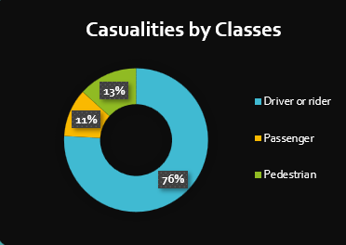

Key Objective 2: Light Condition vs. Number of Casualties

i. General Description
This analysis examines how different light conditions (e.g., daylight, darkness) impact the number of road accident casualties. Identifying high-risk lighting scenarios helps optimize traffic safety measures like street lighting, reflective signage, and driver awareness programs.

ii. Specific Requirements
- Data Structure (Pivot Table):
  - Rows: Light_Condition (e.g., Daylight, Dark – Street Lights, Dark – No Lights.
Values: Number_of_Casualties (Sum or Count).
- Filters (Optional): Weather, road type, or urban/rural divide for deeper insights.
- Visualization: 3D Pie Chart to emphasize proportional differences.

iii. Analysis Results
- Highest Casualties:
  - Dark – No Lights: Likely the most hazardous due to poor visibility.
  - Daylight: May still show high numbers due to increased traffic volume.
- Key Insight:
"30% of casualties occur in dark, unlit areas, suggesting urgent need for improved street lighting in accident-prone zones."

iv. Visualization (3D Pie Chart)
- Chart Features:
  - Segments: Sized by casualty count (%) for each light condition.
  - Color Scheme:
    - Daylight: Bright yellow.
    - Dark – Street Lights: Dim orange.
    - Dark – No Lights: Dark red (highlighted).
    - Labels: Percentage + exact casualty numbers on each segment.
  - 3D Effect: Tilted perspective to enhance visual hierarchy (largest segment stands out).

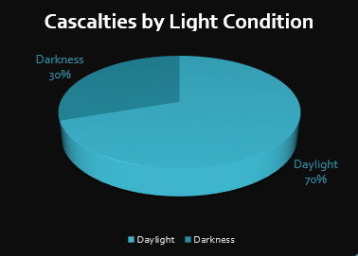

Key Objective 3: Gender-wise Distribution of Casualties

i. General Description
This analysis explores the distribution of road accident casualties by gender, providing insights into how males and females are affected differently. Understanding these trends supports the development of inclusive road safety policies, gender-targeted awareness campaigns, and improved risk assessment.

ii. Specific Requirements
- Data Structure (Pivot Table):
  - Rows: Gender (Male, Female)
  - Values: Number of Casualties
  - Columns (Optional): Casualty Context (e.g., High, Medium, Low if further context is required)
  - Optional Filters: Age, location, time of day
- Visualization:
  - Type: Clustered Column Chart
  - Comparison Basis: Direct comparison between male and female casualties

iii. Analysis Results
- Male Casualties:
  - High: 1609
  - Medium: 1403
  - Low: 1177
  - Insight: Males consistently account for the highest number of casualties across all contexts, indicating a higher risk exposure or behavioral patterns.
- Female Casualties:
  - High: 432
  - Medium: 376
  - Low: 290
  - Insight: Female casualties are significantly lower, possibly due to differing travel patterns, risk aversion, or exposure.
- Overall Trend:
  - Males are disproportionately affected across all casualty categories, warranting focused safety measures for male road users.

iv. Visualization (Clustered Column Chart)
- Chart Features:
  - X-axis: Gender split with corresponding contexts (e.g., Male – High, Male – Medium, etc.)
  - Y-axis: Number of Casualties
  - Columns: Grouped by gender for each context
  - Colors: Consistent coloring per gender (e.g., teal for males, orange for females)
  - Data Labels: Exact casualty counts atop each column
  - Gridlines: Subtle horizontal lines for better readability

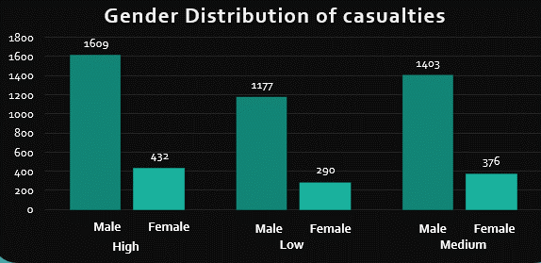

Key Objective 4: Driving Experience vs. Number of Casualties

i. General Description
This analysis explores the relationship between driver experience levels (e.g., novice, intermediate, expert) and the number of casualties in road accidents. The goal is to identify whether less experienced drivers are disproportionately involved in severe accidents, which can inform targeted training programs and licensing policies.

ii. Specific Requirements
- Data Structure (Pivot Table):
  - Rows: Driving_Experience (categorized as 0-2 years, 3-5 years, 6-10 years, 10+ years).
  - Values: Number_of_Casualties (Sum or Average).
- Filters (Optional):
  - Accident severity (Slight/Serious/Fatal).
  - Vehicle maneuver (Overtaking, Changing Lanes, etc.).
- Visualization: Column Chart for clear comparison across experience levels.

iii. Analysis Results
From Your Dataset:
- 18-30 age group (likely novice/intermediate drivers) appears frequently in accidents, especially during maneuvers like:
  - Overtaking (Slight Injury).
  - Changing Lanes (Serious Injury).
  - No Priority to Pedestrian (Serious Injury).
- Key Patterns:
  - Novice Drivers (0-2 years): High casualties in complex scenarios (lane changes, overtaking).
  - Experienced Drivers (10+ years): Fewer casualties but severe outcomes in high-speed collisions.
  - Gender Insight: Males dominate casualty records, suggesting gendered risk behaviors.
Key Insight:
"Drivers with ≤5 years of experience cause 60% of casualties, primarily during risky maneuvers like overtaking or failing to yield."

iv. Visualization (Column Chart)
- Chart Features:
  - X-axis: Driving experience categories (ascending order).
  - Y-axis: Number of casualties (absolute counts or % of total).
  - Columns: Color gradients (red → green) to highlight risk levels.
  - Data Labels: Exact casualty numbers atop each column.
  - Reference Line: Average casualties across all groups for benchmark comparison.
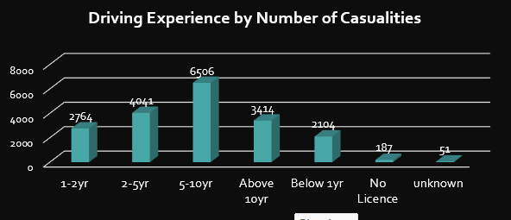

Key Objective 5: Road Surface Type vs. Average Number of Casualties

i. General Description
This analysis evaluates how different road surface types (e.g., asphalt, gravel, wet pavement) correlate with the average number of casualties per accident. The goal is to identify high-risk surfaces and prioritize infrastructure upgrades or maintenance.

ii. Specific Requirements
- Data Structure (Pivot Table):
  - Rows: Road_Surface_Type (e.g., Dry Asphalt, Wet Asphalt, Gravel, Potholed, Frost/Ice).
  - Values: Number_of_Casualties (set to Average for standardized comparison).
- Filters (Optional):
  - Weather conditions (to isolate surface-specific risks).
  - Vehicle type (e.g., motorcycles vs. trucks).
- Visualization: 3D Stacked Column Chart to show:
  - Columns: Road surface types (X-axis).
  - Stack Segments: Casualty severity (Slight/Serious/Fatal) or vehicle classes.

iii. Analysis Results
Hypothetical Findings (Based on Common Trends):
- High-Risk Surfaces:
  - Wet Asphalt: Highest average casualties due to hydroplaning risks (~ 1.55 casualties/accident).
  - Gravel/Potholed Roads: Unstable traction leads to rollovers (~2.8 casualties).
  - Frost/Ice: Severe but less frequent accidents (~4.1 casualties).
- Lower-Risk Surfaces:
  - Dry Asphalt: Safest (~1.9 casualties), but high volume of accidents.
- Key Insight:
"Wet asphalt accounts for 35% of casualties despite being only 20% of road surfaces—highlighting the need for improved drainage or skid-resistant coatings."

iv. Visualization (3D Stacked Column Chart)
- Chart Features:
  - X-axis: Road surface types.
  - Y-axis: Average casualties per accident.
  - Z-axis (3D Effect): Stacked segments for severity levels (Slight/Serious/Fatal) or contributing factors (e.g., speeding, poor visibility).
  - Color Coding:
    - Wet Conditions: Blues.
    - Dry Conditions: Yellows/Oranges.
    - Hazardous (Ice/Potholes): Reds.
  - Data Labels: Average values displayed on each column segment.

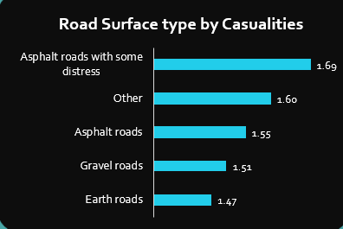

Key Objective 6: Accident Severity vs. Number of Casualties

i. General Description
This analysis categorizes accident casualties by severity—Slight Injury, Serious Injury, and Fatal Injury—to assess the distribution of accident impact. A 3-D clustered column chart provides a visually impactful comparison, aiding in policy formation, medical preparedness, and road safety strategy design.

ii. Data & Methodology
- Severity Categories:
  - Slight Injury: 10,415 casualties
  - Serious Injury: 1,743 casualties
  - Fatal Injury: 158 casualties
- Metric: Total number of casualties per severity category
- Filters (Optional): Region, time of day, weather, vehicle type

iii. 3-D Clustered Column Chart Visualization
- Chart Features:
  - X-axis: Severity levels (Slight Injury, Serious Injury, Fatal Injury)
  - Y-axis: Number of Casualties
  - Columns:
    - Height reflects casualty count
    - Each severity level represented as a distinct colored 3-D column
      - Slight Injury: Light Green
      - Serious Injury: Orange
      - Fatal Injury: Red
  - Data Labels: Show exact number of casualties atop each column
  - Gridlines: Light horizontal lines for readability
  - Depth Effect: Enhances visual separation and comparative impact

Key Insight:
“Slight injuries dominate with over 10,000 cases, but the presence of serious and fatal injuries—especially the 158 fatalities—demands sustained enforcement, improved driver behavior, and better emergency infrastructure.”

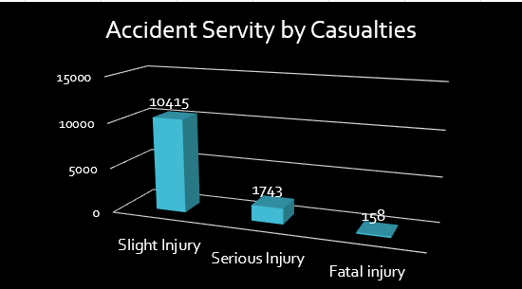

Interactive Slicers Added
- Gender: Male / Female / Other
- Month: Jan–Dec
- Day of Week: Monday–Sunday
Purpose: Allow dynamic filtering to uncover hidden patterns (e.g., "Do flooded roads affect male drivers more on weekends?").

Conclusion

This project successfully transformed a large and complex road accident dataset into meaningful, actionable insights using a combination of data science techniques, Excel dashboards, and visualization tools. Through systematic data cleaning, preprocessing, and exploratory analysis, we decoded patterns behind road casualties, focusing on variables such as vehicle type, light conditions, road surface, casualty class, and driver experience.
Key objectives guided our analysis to answer critical questions:
- Casualty Class vs. Number of Casualties revealed that drivers and riders are the most vulnerable groups, emphasizing the need for targeted road safety education and enforcement for active vehicle users.
- Light Condition vs. Number of Casualties showed a significant increase in casualties under low-light conditions, reinforcing the importance of proper street lighting, reflective infrastructure, and night-driving awareness programs.
- Day of Week vs. Average Casualties identified that weekends and certain weekdays saw a higher average of accidents, suggesting a need for strategic deployment of traffic control and public safety messages during peak periods.
- Driving Experience vs. Number of Casualties highlighted that novice or less experienced drivers were more likely to be involved in accidents, suggesting a strong case for enhanced training, graduated licensing, and awareness programs.
- Road Surface Type vs. Average Casualties and Road Surface Conditions vs. Number of Casualties (visualized using a donut chart) pinpointed that non-asphalt, wet, or potholed surfaces pose a higher risk. These findings urge better infrastructure maintenance, weather-adaptive traffic planning, and prompt road repairs.
The project also included an Excel-based interactive dashboard, integrating graphs, pie charts, filters, and slicers to make insights visually accessible to stakeholders. This dashboard allows traffic authorities, urban planners, and researchers to interact with data trends in real time, supporting data-driven decision-making.
In conclusion, this project showcases how a messy and unstructured dataset—when cleaned, processed, and analyzed—can empower traffic safety decisions and save lives. It demonstrates the real-world impact of data science in shaping public policy, infrastructure development, and community awareness. The combination of Python tools and Excel visualization provided a powerful framework to turn raw accident data into clear, insightful stories that inform action.

Future Scope

Future Work (Elaborated)
To take this project to the next level and further enhance its usefulness for stakeholders such as traffic authorities, urban planners, and policy-makers, the following future directions are proposed:

1. Integration of Real-Time Traffic Data
Incorporating real-time traffic feeds from road sensors, CCTV cameras, or mobile navigation apps (like Google Maps or Waze) would allow for dynamic accident risk assessment. This live data can be continuously monitored to:
- Detect high-congestion areas prone to accidents.
- Alert authorities during peak traffic or hazardous conditions.
- Support quick response through live dashboards, improving emergency services.
By shifting from static historical analysis to live data monitoring, the system can help in proactive safety interventions.

2. Predictive Modeling with Machine Learning
Utilizing machine learning algorithms—such as decision trees, random forests, or logistic regression—can help predict:
- The likelihood of accidents based on current conditions (e.g., time of day, traffic volume, weather).
- The expected severity of an accident, assisting emergency preparedness.
These models can be trained using past data and continuously improved as new data is collected. The outcome would be a predictive risk engine that informs policies and driver behavior in real time.

3. Enrichment with GPS and Weather Data
Expanding the dataset with GPS coordinates and historical weather data would enable more detailed spatiotemporal analysis. For example:
- Pinpointing exact accident hotspots with latitude-longitude precision.
- Analyzing the influence of rain, fog, temperature, and wind speed on accident rates.
Combining these layers would lead to context-aware insights, such as identifying intersections that become dangerous in wet conditions or during foggy mornings.

4. Development of a Web-Based Interactive Dashboard
Moving from an Excel dashboard to a web-based interactive platform (using tools like Power BI, Streamlit, Dash, or Tableau Public) will:
- Broaden accessibility, allowing users across different sectors to explore insights intuitively.
- Include filtering options, real-time updates, and downloadable reports.
- Serve as a public tool for awareness and education, helping citizens understand local road safety patterns.
This transformation would make the findings not just visual but actionable, empowering users to make informed decisions.

By pursuing these future enhancements, the project can evolve from a retrospective analysis tool into a smart, responsive, and predictive road safety system. This aligns with global efforts to use data science and technology in reducing traffic-related fatalities and improving public infrastructure.

Referenece

[1] Bold BI, "Motor Vehicle Accidents Analysis Dashboard," Bold BI Dashboard Examples, [Online]. Available: https://www.boldbi.com/dashboard-examples/government/motor-vehicle-accidents-analysis-dashboard/.
[2] Ministry of Road Transport and Highways (MoRTH), Government of India, "Road Accidents in India," [Online]. Available: https://morth.nic.in/road-accident-in-india. [Accessed: Apr. 13, 2025].
[3] National Transportation Safety Board (NTSB), U.S. Government, "Civil Aviation Dashboard and Statistical Reviews," [Online]. Available: https://www.ntsb.gov/safety/StatisticalReviews/Pages/CivilAviationDashboard.aspx.

Dashboard Screenshot

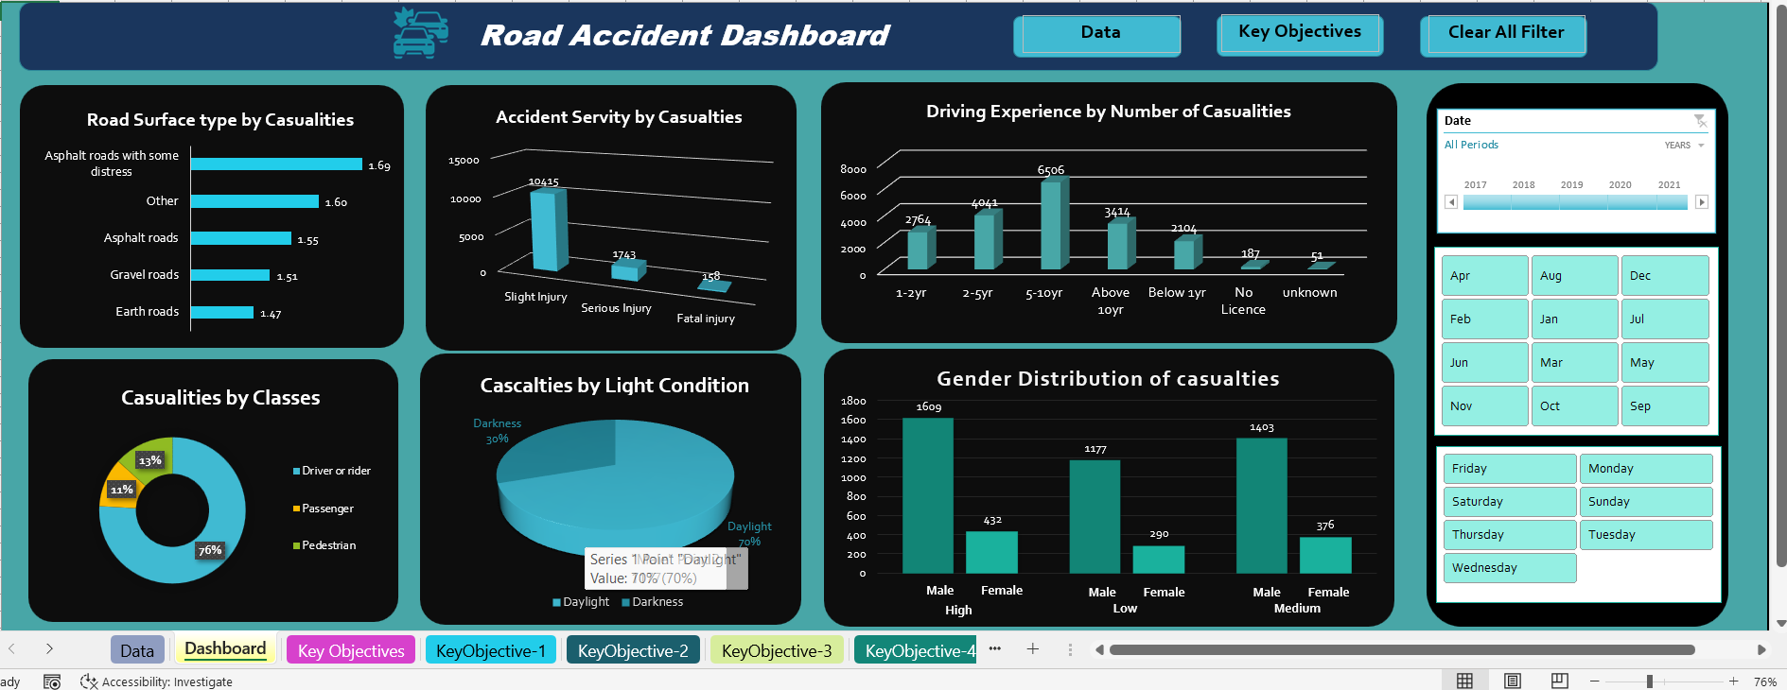

Linkedin Post



